Turkish Journal of Engineering – 2025, 9(3), 00-0X

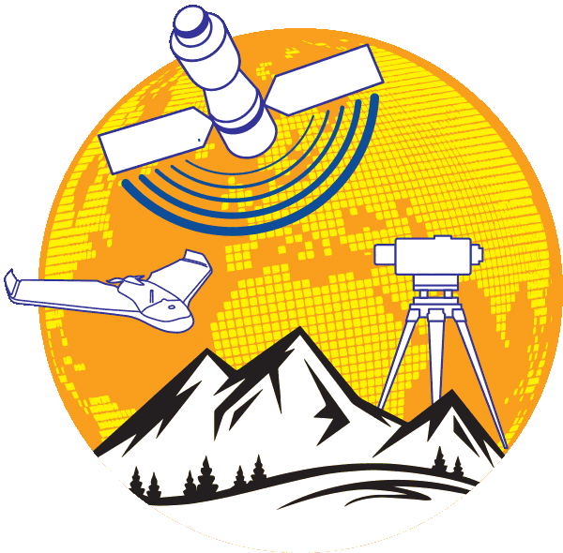 | Turkish Journal of Engineering  https://dergipark.org.tr/en/pub/tuje  e-ISSN 2587-1366 | 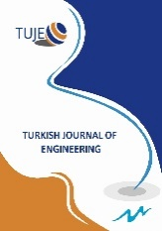

Title 12 font size cambria left aligned and bold

Full Name^{*1}, Full Name ², Full Name ³

¹University, Department, Country, e-mail
²University, Department, Country, e-mail
³University, Department, Country, e-mail

Cite this study: | Surname, N., & Surname, N. (Year). Title of the study. Turkish Journal of Engineering, Volume (Issue), page numbers.

https://doi.org/10.31127/

Keywords |  | Abstract
Remote sensing  UAV  Photogrammetry  DEM  Camera Calibration |  | Cambria, 9 font size. Abstract should be at most 300 words. Key words that will consist of at least 3 and maximum 5 words should be written on the left side. Mathematical expressions should not be included in essence. Cambria, 9 font size Abstract should be at most 300 words. Key words that will consist of at least 3 and maximum 5 words should be written on the left side. Mathematical expressions should not be included in essence. Cambria, 9 font size Abstract should be at most 300 words. Key words that will consist of at least 3 and maximum 5 words should be written on the left side. Mathematical expressions should not be included in essence. Cambria, 9 font size Abstract should be at most 300 words. Key words that will consist of at least 3 and maximum 5 words should be written on the left side. Mathematical expressions should not be included in essence. Cambria, 9 font size Abstract should be at most 300 words. Key words that will consist of at least 3 and maximum 5 words should be written on the left side. Mathematical expressions should not be included in essence. Cambria, 9 font size Abstract should be at most 300 words. Key words that will consist of at least 3 and maximum 5 words should be written on the left side. Mathematical expressions should not be included in essence. Key words that will consist of at least 3 and maximum 5 words should be written on the left side. Mathematical expressions should not be included in essence. Key words that will consist of at least 3 and maximum 5 words should be written on the left side. Mathematical expressions should not be included in essence.
Research/Review Article

Received:
Revised:
Accepted:
Published:



Introduction

Content should be written in 2 columns with Cambria 10 font size. The first line of each paragraph should be written by 0.5 cm indentation.
The article should begin with an introduction section, which includes the ideas and the basic objectives and approaches of the article, combining scientific knowledge, evidence-based information and logical discussions in different disciplines. This section should be written considering all readers. Technical terms, symbols and abbreviations should be defined when first used in the article.
The main sections of the manuscript are “introduction”, “method” “results” “discussion” and “conclusion” and they should be written in 10 font size, justify, bold and capital letters.
All of the empty lines should have 8 font size.
This template explains how to design the manuscript. If the author (s) uses this template file, no settings change will be required since settings such as font and size, line spacing, spaces before paragraphs, indents, etc. are made in styles. If you want to avoid problems when copy and paste texts or with the text format, you can use “Applying styles to the article” section which is at the end of template.

Method

Content should be written in 2 columns with Cambria 10 font size.
“Introduction” part should be followed by “Method”, “Results”, “Discussion” and “Conclusion” parts.
The article should be saved in MS Office Word as either .doc or docx. Text should be written as A4 size with 1.5 cm spacing at top, bottom, left and right side. Text should be written with single line spacing. Page numbers should not be added.
Articles prepared in accordance with the principles of writing and approved by the review board are published.

  - The second level headings

Content should be written in 2 columns with Cambria 10 font size.
The second level headings should be written with left aligned, 10 font size, first character capital, bold. Each paragraph should seperate with one line from former paragraph. You can delete this section and write the article text without disturbing the formatting.
No spaces should be left between paragraphs in the text.

  - The second level headings

The second level headings should be written with left aligned, 10 font size, first character capital, bold. Each paragraph should seperate with one line from former paragraph. You can delete this section and write the article text without disturbing the formatting.
No spaces should be left between paragraphs in the text.

Figure 1. This is the example of figure formatting

Figures should be left and right aligned and numbered. Figure caption should be written 10 font size, cambria, first letter of first word capital. It should not be written as bold or italic. A dot should be placed after the figure number.
Figures should have at least 400 dpi.
Text in the figure should be 9 font size. A line should not be exist between figure and figure caption. A line should exist between text and figure. Figure caption should be located under the figure. Figures should be cited in the text as “Figure 1”.

    - Third level heading

Only first letter of first word is capital, left aligned, 10 font size, bold. It should be separated from the former paragraph with single line.

Results

References, tables, figures to be used must be prepared in accordance with APA 6. Articles that do not comply with the rules of writing and APA are eliminated in the first stage by the editor. You should review your references and check their compliance with APA 6. Tables must be cited in the text together with the table number as “Table 1”.

Table 1. This is the example of table formatting
Items | x | y | z
a | 5 | 2 | 5
b | 6 | 1 | 6
c | 8 | 3 | 9

Tables should be numbered and the title of the table should be written in 10 pt. Table title should not be bold or italic. The table number should be followed by a dot and the table name should be written. No dot should be placed after the table name is written. Please do not use vertical lines in Tables.
In-table values / inscriptions should be 9 pt. No spaces should be left between the table title and the table. Tables should be specified in the text with the number of tables. Tables should be used in the text or on the following page. Related notes and references should be indicated at the bottom of the table after “Note:” or “Source:”. The space between the text and the table before and after the table must be 1 row.

- Discussion

First level headings should be 10 font size, Cambria, bold, left aligned.

Conclusion

Citation in text should be as;
One citation [1]
Consecutive citations [1-5]
Non-Consecutive citations [2,5]
Non-consecutive Three or more citations [1,3, 6-11]

Bibliography should be prepared in accordance with the APA 6 Publication Manual publication guidelines. For more information; See http://www.apa.org.
References should be written with 10 pt including title. The paragraph indent is 0.5 cm hanging from the right.
The second and subsequent lines of each bibliography should be indented 0.5 cm inward as shown in this text.
Thesis should be written as Master’s Thesis or Doctoral Thesis in the reference list.

Acknowledgement

Acknowledgements of support for the project/paper/author are welcome.

Author contributions

Murat Yakar: Conceptualization, Methodology, Software, Field study Kali Toady: Data curation, Writing-Original draft preparation, Software, Validation., Field study Kosman Minion: Visualization, Investigation, Writing-Reviewing and Editing.
.

Conflicts of interest

The authors declare no conflicts of interest.

References

References should be written like this. Please do not use any web-site [URL] as a citation. Do not put an empty line between references.

- Yakar, M. (2011). Using close range photogrammetry to measure the position of inaccessible geological features. Experimental Techniques, 35(1), 54-59.3.
- Şasi, A., & Yakar, M. (2018). Photogrammetric modelling of Hasbey Dar’ülhuffaz (Masjid) using an unmanned aerial vehicle. International Journal of Engineering and Geosciences, 3(1), 6-11. https://doi.org/10.26833/ijeg.328919
- Pellicani, R., Spilotro, G., & van Westen, C. J. (2016).Rockfall trajectory modeling combined with heuristic analysis for assessing the rockfall hazard along the Maratea SS18 coastal road (Basilicata, Southern Italy). Landslides, 13(5), 985–1003. https://doi.org/10.1007/s10346-015-0665-3

 | © Author(s) 2026. This work is distributed under https://creativecommons.org/licenses/by-sa/4.0/

