Title

Abstract

Keywords: Keyword; Keyword; Keyword; Keyword; Keyword

Title (Turkish)

Öz (Turkish abstract)

Anahtar Kelimeler: Anahtar kelime; Anahtar kelime; Anahtar kelime; Anahtar kelime; Anahtar kelime (Turkish keywords)

1. Introduction
(The Introduction should set the scene fully and clearly. Indicate the reasons why the study was carried out, any previous work relating to the study should be summarized by a few relevant references),

2. Materials and Methods

(Relevant details should be given about the materials and methods. Must contain all details of the experimental procedure for the successful repetition of the experiment),
2.1. Materials

2.2. Methods

3. Result and Discussion
(Results should be presented with information, figures and/or tables and references, and discussion of other work should not be repeated in the section. Tabular material and figures are especially important for providing comparative results without resorting to detailed textual descriptions,

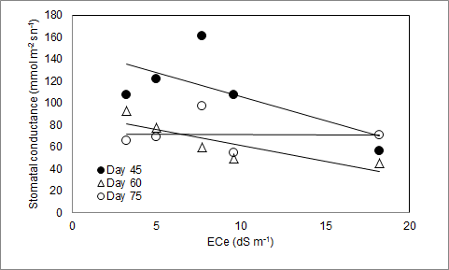
Figure 1. The relationships between stomatal conductance and EC_{e} on different growth stage

Table 1. Average yield (kg da⁻¹)
Properties | Irrigation interval | Rainfed | S1 | S2 | S3 | S4 | Average
Yield | D3 | 1420 | 1659 | 1936 | 2677 | 2869 | 2112
 | D6 | 1420 | 1770 | 2120 | 2536 | 2440 | 2057
 | Average | 1420 c | 1714 bc | 2027 b | 2606 a | 2654 a
D (irrigation interval): ns, S (irrigation level):**, D×S: ns
Ns and **, not significant and significant 1%

4. Conclusion

(Authors should interpret the significance of the findings as they relate to other relevant literature, describe any limitations of the study, and make recommendations for future research),

Acknowledgements
Acknowledgements must be typed without page number, as brief as possible and referring to the contribution, in 11 point.

Literature Cited
Güneş, T., & Arıkan, R. (1988). Tarım Ekonomisi İstatistiği. Ankara Üniversitesi Ziraat Fakültesi Yayınları: 1049, Ders Kitabı:305, 293 s., Ankara.
Baysal, Ö., & Teixeria da Silva, J.A. (2006). Induced Resistance: A new approach in plant protection for floriculture and ornamental plants. pp. 231-237. In: Teixeria da Silva, J.A. (Ed.), Floriculture, Ornamental and Plant Biotechnology Advances and Topical Issues. Global Science Books, UK.
Kara, S., Altındişli, A., Çoban, H., & İlter, E. (1997). Dormeks uygulamalarının yuvarlak çekirdeksiz üzüm çeşidinin uyanma, olgunlaşma ve sofralık üzüm kalitesine etkisi üzerine araştırmalar. Ege Üniversitesi Ziraat Fakültesi Dergisi, 34(2):1-2.
Tandoğan, S., Uzun, H.İ., & Pekmezci, M. (1992). Asmalara farklı zaman ve dozlarda uygulanan hidrojen siyanamidin erkencilik üzerine etkileri. Türkiye I. Ulusal Bahçe Bitkileri Kongresi, s:505-509.
TÜİK (2010). Bitkisel Üretim İstatistikleri. http://www.tuik.gov.tr. Erişim tarihi: 16 Ekim 2012.
Akpınar, I. (1990). Değişik turunçgil anaçları üzerine aşılı washington navel, valencia ve moro portakal meyvelerinin muhafazası üzerine araştırmalar. Yüksek Lisans Tezi, Çukurova Üniversitesi, Adana

