Title of the Manuscript

Abstract
Your abstract should be one paragraph and should not exceed 300 words. It is a summary of the most important elements of your paper. The Abstract is conceptually divided into the following three sections: Background, Methodology/Principal Findings, and Conclusions/Significance. However, the Abstract should be written as a single paragraph without these headers. Do not include any citations in the Abstract. Avoid abbreviations.
Keywords: keyword1, keyword2, keyword3
Türkçe Başlık
Öz
Makalenizin özünü buraya yazınız. Öz 300 kelimeyi aşmayacak şekilde yazılmalıdır ve birinci sayfaya sığmalıdır. Öz bölümünde araştırmanın temel dayanağına, yöntemsel açıklamalara, temel bulgulara ve çıkarımlara yer verilmelidir. En az üç anahtar kelime yazılmalıdır. Öz bölümü tek bir paragraf olarak yazılmalı, alt başlık kullanılmamalı, atıf yazılmamalı, kısaltma kullanılmamalıdır.
Anahtar Sözcükler: sözcük1, sözcük2, sözcük3

INTRODUCTION
This section should define the background to research, significance and research problem(s). While writing your manuscript, please regard APA 7, format-free article template, and keep your name anonymous throughout the manuscript. You may change the titles in the manuscript. Please use this style when you are writing text in the body of your manuscript. Arrange your tables as shown below:
Table 1. Capitalize Each Word in Table Title
Variables | Category 1 | Category 2 | SS
 | N | M
Variable one | 307 | 67.87 | 9.20
Variable two | 230 | 66.27 | 8.84
Variable three | 218 | 67.17 | 10.46
Notes should be in 8pt.

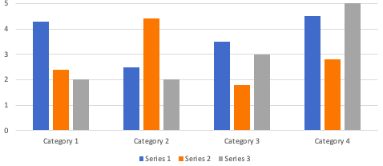
Figure 1. Figure title should be in sentence case
After every table, it is suggested that you describe the given table by, for example, using statements such as Table 1 explains... Table 1 shows... As seen in Table 1... You must not leave blank space after tables. In case you want to emphasize a word, phrase or a sentence, you may use italics in text but not in table.
METHOD
Method section may include research design, the study group or participants of the study, data collection tools, data analysis.
Research Design
Research design employed in the research should be explained
Data Collection
You should tell about data collection procedures.
Data Analysis
Please write about how the collected data were analyzed in the research.
Research Ethics
There must be a research ethics sub-section dedicated in your article under Method section. Please explain your ethical procedures in your study. Do NOT write anything about approval of ethics committee here (date, document number, etc.) before publication.
FINDINGS
The Results section should provide details of all of the findings that are required to support the conclusions of the paper.
Table 2. Another Table Sample
 |  | Sample |  |  |  |  |  | Total
 |  | Example 1 | Example 2 | Example 3 | Example 4 | Example 5 | Example 6
Content 1 | Titles | 1 | 1 | 1 | 1 | 1 | 1 | 1
 | Titles | 1 | 1 | 1 | 1 | 1 | 1 | 1
 | Titles | 1 | 1 | 1 | 1 | 1 | 1 | 1
 | Titles | 1 | 1 | 1 | 1 | 1 | 1 | 1
Content 2 | Titles | 1 | 1 | 1 | 1 | 1 | 1 | 1
 | Titles | 1 | 1 | 1 | 1 | 1 | 1 | 1
 | Titles | 1 | 1 | 1 | 1 | 1 | 1 | 1
 | Titles | 1 | 1 | 1 | 1 | 1 | 1 | 1

When Table 1 is examined, it is understood that...
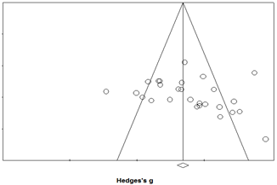
Figure 1. Sample figure

When Figure 1 is examined, it is understood that...
DISCUSSION AND CONCLUSION
This section may include the discussion of your findings, and conclusions with comparison to the literature, implications, and recommendations.
Implications
Under this title, you can write about your implications on your paper.
Limitations
Please explain your limitations in this paper.
Statements of Publication Ethics
Please declare that you obey the principles of publication ethics.
Researchers’ Contribution Rate
Please specify the contribution rate of each author in the manuscript. Please do not change Author information; you may change or add titles according to the manuscript. No Table title is needed for this table.
Authors | Literature review | Method | Data Collection | Data Analysis | Results | Conclusion
Author 1’s name | ☒ | ☒ | ☒ | ☒ | ☒ | ☒
Author2’s name | ☒ | ☒ | ☒ | ☒ | ☒ | ☒
Author 3’s name | ☒ | ☒ | ☒ | ☒ | ☒ | ☒
Author 4’s name | ☐ | ☐ | ☒ | ☐ | ☒ | ☒
Conflict of Interest
Please specify if this study has any conflict of interest, or not.
REFERENCES
PLEASE ADD [THE ENGLISH TITLE OF THE REFERENCE IN BRACKETS] AS SHOWN BELOW. YOU MAY TRANSLATE THE TITLE OF THE SOURCE IF IT DOES NOT INCLUDE AN ENGLISH TITLE:
Karasar, N. (2015). Bilimsel araştırma yöntemleri (28. basım). [Scientific research methods (28th ed.)] Nobel.
Cronbach, L. J. (2004). My current thoughts on coefficient alpha and successor procedures. Educational and Psychological Measurement, 64, 391–418. https://doi.org/10.1177%2F0013164404266386
Embretson, S. E., & Reise, S. P. (2013). Item response theory. Psychology Press.

APPENDIX
Each Appendix appears on its own page.

