**IS THERE ANY RELATIONSHIP BETWEEN MILITARY EXPENDITURE AND ARMS TRANSFER? A RESEARCH FOR THE PERIOD 2000-2019**

**Rukiye CAN YALÇIN[1], Yunus GÖKMEN[2]**, Memduh BEGENİRBAŞ[3]***, Hakan Ömer TUNCA[4]\*\*\*\***

**Abstract**

*The objective of this study is to examine whether there exists a relationship between military expenditure (ME) and arms transfer (AT) level of top thirty most military spending countries. For empirical investigation, the data of top thirty countries in cumulative ME consisting of 2000-2019 period has been adopted from Stockholm International Peace Research Institute (SIPRI) official web site (SIPRI, 2020). To explore the association between ME and AT of top thirty countries, Correlation Analysis (CA), which is commonly used for determining relations among variables, has been conducted. The empirical results reveal significant relationships between ME and AT for 9 countries (Turkey, China, South Korea, India, USA, Australia, Russia, Norway, and Spain) with same direction and no significant relationship for other countries (Colombia, Taiwan, Saudi Arabia, Pakistan, Iran, Poland, Brazil, Singapore, Japan, Greece, Canada, Sweden, Netherlands, Israel, Italy, France, Germany, and UK).*

***Article Type:*** *Research Article*

***Key Words:*** *Military Expenditure, Arms Transfer, Economic**Growth*

***JEL Code:*** *M19*

***Author’s Note:*** *This study was prepared in compliance with the scientific search and publication ethics. There is no content necessitating any permission from Ethical Board or any legal/special permission in this study. We, as the authors of the article, signed our declaration certifying that there was no conflict of interest within the article preparation process.*

**Askerî Harcamalar ve Silah İhracatı Arasında İlişki Var mıdır?**

**2000-2019 Sürecini Kapsayan Bir Araştırma**

**Özet**

*Bu çalışmanın amacı, en çok askerî harcama gerçekleştiren otuz ülkenin askerî harcamaları ve silah ihracatı oranları arasındaki ilişkiyi incelemektir. Ampirik çalışma için (Stockholm International Peace Research Institute) SIPRI’den elde edilen, 2000-2019 yılları arasında en çok kümülatif askerî harcama gerçekleştiren 30 ülkeye ait veri seti kullanılmıştır. 30 ülkeye ait Askerî Harcamalar ve Silah İhracatı arasındaki ilişki bu dönemi kapsayacak şekilde Korelasyon Analizi ile test edilmiştir. Korelasyon Analizi sonuçlarına göre 9 ülke için (Türkiye, Çin, Güney Kore, Hindistan, ABD, Avustralya, Rusya, Norveç, ve İspanya) askerî harcamalar ile silah ihracatı arasında aynı yönde anlamlı ilişkiye ulaşılmışken, 18 ülke için (Kolombiya, Tayvan, Suudi Arabistan, Pakistan, İran, Polonya, Brezilya, Singapur, Japonya, Yunanistan, Kanada, İsveç, Hollanda, İsrail, İtalya, Fransa, Almanya, İngiltere) anlamlı bir ilişkiye rastlanmamıştır.*

***Makalenin Türü:*** *Araştırma Makalesi*

***Anahtar Kelimeler****: Askerî Harcama, Silah İhracatı,Ekonomik Büyüme.*

***JEL Kodu:*** *M19*

***Yazarın Notu:*** *Bu çalışma bilimsel araştırma ve etik kurallarına uygun olarak hazırlanmıştır. Bu çalışmada etik kurul izni veya yasal/özel izin gerektirecek bir içerik bulunmamaktadır. Çalışma ile ilgili herhangi bir çıkar çatışmasının bulunmadığı SAVSAD Savunma ve Savaş Araştırmaları Dergisine yazar imzası ile beyan edilmiştir.*

**INTRODUCTION**

Security has come with an increasing momentum as a very important concept and it has been essential for people since ancient times. For people, the need for security, which comes after physical needs such as eating and drinking, is a necessity to survive. In this context, accepting countries as organizations with socio-technic systems, the importance given to the security of countries is increasing day by day. In recent years, especially with the development of technology, there have been changes in the understanding of security and the war has gained different dimensions by going beyond classical warfare. It is predicted that the most striking and distinctive features of the future security and combat environment will be uncertainty, instability, risk and multiple threats in the developing environment (Yalçın, 2017). Being one of the asymmetric threats, terrorism will replace traditional Cold War-era threat expectations from the state conventionally (Kormazyürek, 2018). While past conflicts were based on enormous manpower and ground troops, the new face of war is now weapons of mass destruction. These uncertainties, instability, risk and multi-faceted environment of threat brings along different policies and strategies to ensure the security of countries and allocate a significant share from the budget for defense expenditures (NATO, 2019).

Defense (military) expenditure is one of the most critically observed components of public spending. Therefore, the study of military spending is an important subject for economics in general and defense economics in particular (Kumar, 2017). While countries are fundamentally different and free to define military spending according to their own wishes and interests, military spending in general is the amount of financial resources allocated by a country to maintain defense armed forces and other essential services (SIPRI, 2016). With regard to NATO definition, defense expenditure is defined as payments made by a national government specifically to meet the needs of its armed forces, Allies or the Alliance.

At first glance, although it is believed that defense expenditures have a negative effect on the current economic growth of countries, it can be said that such expenditures do not have a direct effect on the detriment or development of countries (Benoit, 1978). It can be considered that defense expenditure has several possible positive external effects on the economies of countries, particularly in relation to infrastructure, technological progress and human capital formation (Ram, 1995). Especially using the resources allocated for defense in the field of defense technologies will accelerate Research and Development (R&D) activities. Defense-related R&D studies play an important role in the implementation of new strategic concepts in most of the leading industrial countries (Altmann et al., 1998). In this context, it is possible to use civilian technologies in R&D activities in the field of defense with an open innovation approach. With the same thought, the technological knowledge obtained in the field of defense, especially in the guided basis, later applied or experimental research phase, has been used in the civilian field (EU Commission, 2013). For example, the information obtained from R&D activities on the working principles of laser beams for the production of laser guns can be used in the field of health in the civil sector. This understanding provides an enormous opportunity to operate the spending and resources used in the field of defense in other areas and can be termed as dual-use (Meunier, 2019). This policy and strategy has recently been implemented by many developed countries, especially by the USA, and has provided the opportunity to turn the adverse effects of defense expenditures on the national budgets into a value.

Considering the above mentioned reasons, this study aims to reveal the relationship between the level of defense expenditures and arms transfers of countries. The research is considered to be important in terms of showing the fact that the countries do not see defense expenditures as a burden and that the resources and expenditures allocated to the defense in question can actually be turned into opportunities and have especially positive contributions to defense exports. In this context, the data of 30 countries with the highest defense expenditures in the database of Stockholm International Peace Research Institute (SIPRI) consisting of 2000-2019 term were discussed. In the study, the secondary data belonging to the countries related to 2000-2019 term were handled as time series data and scrutinized by employing Correlation Analysis (CA) and the relations between them, if any, have been examined. As a result of the analysis, the data of these 30 countries’ defense expenditures and arms transfer levels were presented on tables and figures, and the findings were evaluated and discussed. In addition, according to the findings and evaluation results, some suggestions were made to the countries by making forward-looking projections that include technological developments for the defense expenditures that countries have made to ensure their security.

**The Impact of Defense Expenditures on Economy**

While developing countries generally export labor-intensive products and raw materials, they import products of advanced technology from developed countries. However, such way of foreign trade has negative consequences for developing countries and these countries generally have foreign trade deficit. Especially since the 1980s, many countries abandoned closed economy models or production based on import substitution and adopted export-oriented economic growth models (Göçer, 2013). In this respect, the export and growth performance of particularly Far Eastern countries, which adopt an open economic growth model, has set an example for many developing countries.

What is more is that in the competitive environment of globalization, the driving force of economic growth has been the superiority in technological competition. It has been assumed that continuous increase in the resources spent on developing new technologies will lead to a continuous increase in economic growth (Romer, 1989). The determining factor in technological competition has been the superiority in advanced technology production areas such as space, medicine, information and defense sectors.

On the other hand, while countries tend to cut their investment on defense industry after the collapse of the USSR; the Gulf War, September 11 attacks and the following operations in Afghanistan, Iraq and Syria have led nearly all countries to allocate more on the defense-oriented investments throughout the world. As a result of the change in the defense share in the state budget, a great number of studies have been made to attempt to explain the relationship between defense and economy.

War and economy mutually and continuously affect each other (Ergun, 1995). Security and defense are the basic requirements for the establishment of economic relations in a society. In this respect, sovereignty and defense services have been considered as a basic necessity for the market economy to operate (Bulutoğlu, 1981). Defense expenditures are the share of national income that countries allocate at the expense of their welfare in order to ensure the continuity of sovereignty and national existence (Koban, 1998). In other words, the term “defense expenditures” refers to the share a country allocates to defense from public spending in a certain period and it is stated that the ratio of the mentioned expenditures in total public expenditures tends to increase day by day (Ball, 1983). Though they are not productive, it is not possible to give up defense expenditures due to their strategic and political ties.

The seminal study about the effects of defense expenditure on economy was carried out by Benoit (1973, 1980) suggesting a positive relationship between the two variables for developing countries. He revealed that developing countries with a greater defense expenditure performed greater economic growth and vice versa. After this seminal study, the relationship between defense expenditure and economic growth, especially for less developed countries, has been extensively investigated through empirical works with opposing results. Literature on the relationship between the two variables seems to be classified into mainly two groups as the studies concluding a significant relationship though with opposing directions of causality and studies revealing no significant correlation.

First, a great number of studies state the existence of casual relationship between military expenditure and economic growth but they differ about the direction of this relationship. In this context, the opposing results of the studies seem to stem from the two differing perspectives of Keynesian and Neoclassical approaches. To begin with, military spending has a considerable impact on economic growth according to Keynesian approach. In other words, military spending fosters economic growth via aggregate demand impact. Namely, higher military spending increases the aggregate demand and this leads to higher capital utilization, employment and profit rates. Thus higher investments occur which may lead to economic growth via its multiplier effect. Accordingly, Keynesians can be said to suppose a one-way causal relationship from military spending to economic growth (Dakurah et al., 2001: 652; Deger, 1986: 181-182; Dunne et al., 2005). Similarly, Hassan et al. (2003), Sezgin (2000, 2001), Biswas (1992) and Dunne et al. (1998) concluded that there is a significant positive correlation between military expenditure and economic growth. However, there are several other studies indicating a unidirectional relationship but from economic growth to military expenditure (Gokmenoğlu et al., 2015; Topcu and Aras, 2013; Kollias et al., 2004).

In the Neoclassical approach, military expenditures are considered to be a public property and it is argued that economic effects can be evaluated by comparing the opportunity costs between military spending and other expenditures. (Duyar ve Koçoğlu, 2014: 704). Besides, since military spending may take share from the resources to be used for growth in other areas, it may negatively impact or slowdown the growth as a result of crowding out effect. In other words, dealing with the effects of defense expenditures on economic growth as demand oriented, Neoclassical approach claims that the cost caused by defense expenditures reduces the share that can be allocated for education, health and other industries from the state budget and prevents the allocation of state resources directly for human factors. Neoclassics, as the Keynesians, recognize the existence of a significant causal relationship between military spending and economic growth albeit with different ways of interaction (Dakurah et al., 2001:652; Deger, 1986: 181-182). Korkmaz (2015), Deger and Smith (1983, 1985), Heo, (1998), Khalid et al. (2015) and Dunne et al. (1999) revealed the negative effect of military expenditure on economic growth. Cappelen et al (1984) similarly concluded that military expenditure has an overall negative effect on economic growth.

Second, beside those studies indicating relationship referring different directional causalities, Kollias and Makrydakis (1997), Biswas and Ram (1986); Dakurah et al (2001), Pradhan (2010) and Abdel-Kalek et al. (2020) could find no evidence for any kind of causal relationship between the two variables.

Regardless of the significance or direction of relationship between variables, defense expenditures are increasing in the world and the rate of increase in defense expenditures in developing countries is even higher than in developed countries.

As Benoit (1978) states, defense programs of most countries unintentionally make tangible contributions to the civilian economies via several indirect impacts. In this respect, defense programs provide a number of people not only feeding, clothing and housing but also education, medical care, vocational and technical training that may have a high civilian utility. Likewise, the engagements of defense programs in a variety of public works such as roads, dams or airports may serve civilian uses. In particular, the need of defense programs for scientific and technical specialties in a variety of R&D activities may also contribute to the civilian economy through engaging in or financing certain items for both military and civilian use, which otherwise may not be economically produced for civilian demand. Thus, especially high tech products of defense industry may be directly used in other sectors such as health, transportation or education in some cases. Similarly, Wilkerson and Williams (2008) argue that defense expenditures can benefit an economy-for example, by creating or maintaining a climate of national security necessary for both domestic and foreign private investment to flourish. Additionally, it provides sizable public infrastructure investments, development of advanced technology and skilled training workers.

On the other hand, in today’s world, technological and industrial base of countries represents the crucial part of national power. Though countries may supply their defense needs from internal or external sources, basically, the defense industry is regarded as a vital interest and the core of national security concerns. Therefore, they allocate large resources to develop and maintain their national defense industry in terms of R&D and the production of indigenous technology and equipment (Ikegami, 2013). This enables the defense industry to become “national” by nature, since the government and private industry closely cooperate for the shared interests of maintaining indigenous technological and industrial bases for defense R&D and production (Ikegami, 1992). The large “national” defense industry is crucial even in terms of employment and the national economy. Almost all industrial states basically prefer “self-sufficiency” in armaments. Though Abdel-Khalek et al. (2020) have found no significant causal relationship between military expenditure and economic growth they state that Indian military industry has supported Indian development and economic growth through technological spillover to the civilian sectors, thereby raising productivity and enhancing growth. Moreover, especially R&D activities, manufacturing basic components and electronic systems enhanced civilian industry and export levels by getting the marketing rights of foreign military equipment and systems produced in India via licenses.

To investigate our research question, Top Thirty Countries in Cumulative Military Expenditure consisting of 2000-2019 term have been presented with Figure-1 below. The US defense expenditure is, undoubtedly, that of military superpower and it is not by chance. The US devotes the largest income share to defense of all NATO members (Aufrant, 1999). Besides, the US has almost five times military expenditure of its closest follower China.

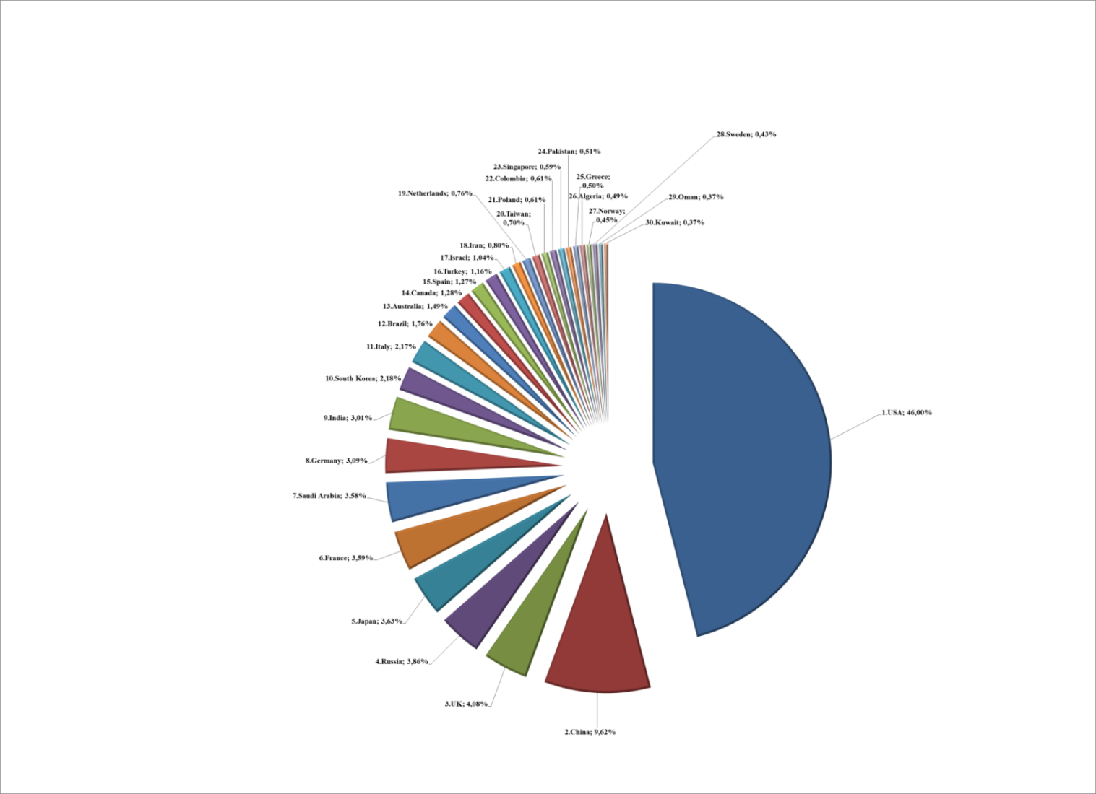

**Figure1:** Top Thirty Countries in Cumulative Military Expenditure Related to 2000-2019 Term.

Especially the top ten of the list, presented in Figure 1, reveals the determining role of economic power in defense expenditures. However beyond the size of the defense expenditure of the countries, the context of the expenditures seems more critical. This is because the main issue to be considered first is to what extend these expenditures contributing to the domestic production of defense needs rather than the size of defense expenditures. In this regard, the critical point is whether defense spending refers to direct defense imports or mainly domestic production since the countries spending their defense budget especially for the production of indigenous defense technologies are considered to be arms exporter after fulfilling its military needs.

Figure 2 provides the ranking of top thirty countries in cumulative arms transfers between related 2000-2019 term. The fact that USA, Russia, France, Germany, UK and Italy, the most developed countries of the world, ranked in the top ten among arms transferring countries can be considered as an indicator of how attractive this sector is for countries economically. In addition, the fact that countries such as Sweden, Italy, Norway and Spain though neither of which has been subjected to immediate external threats, export a significant amount of defense industry products, reveals the economic importance of this sector.

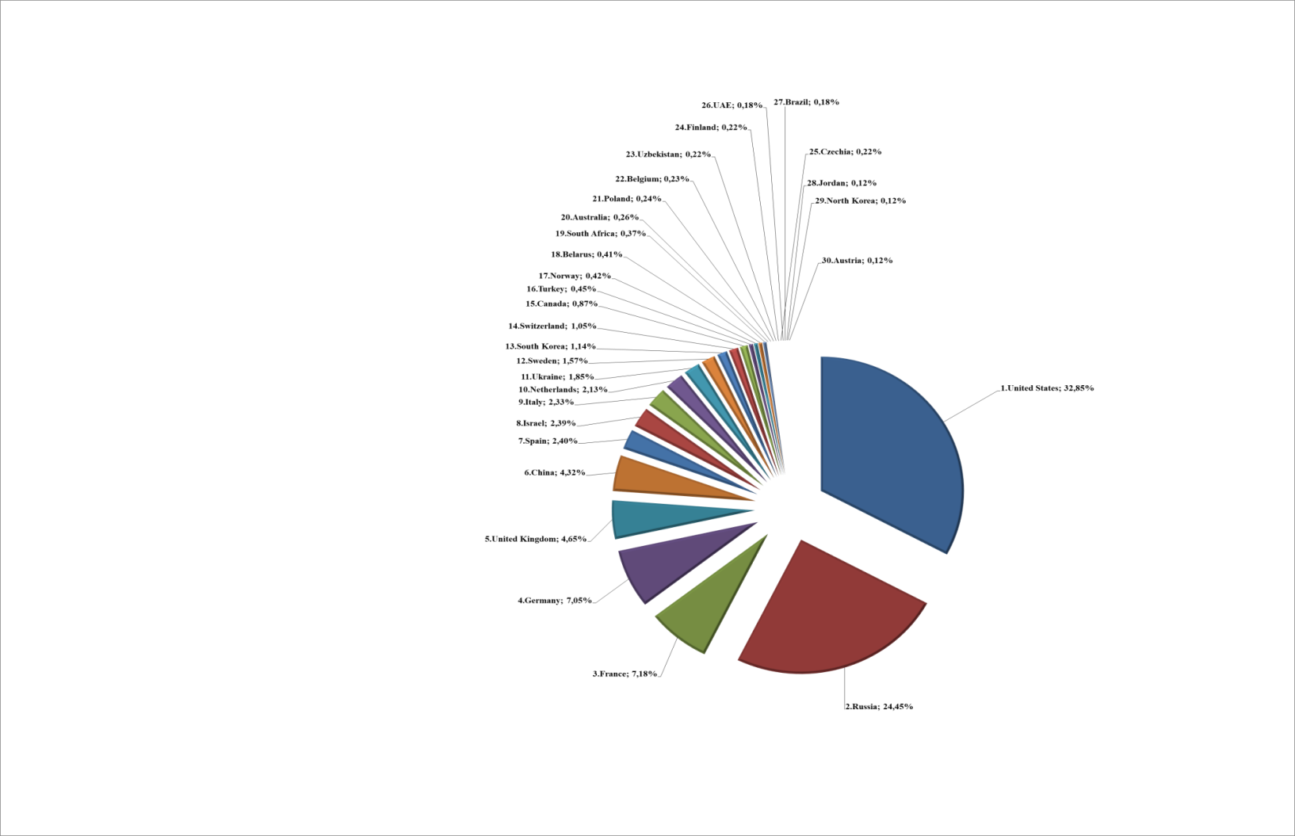

**Figure 2:** Top Thirty Countries in Cumulative Arms Transfers Related to 2000-2019.

Considering the existing status of countries’ arms transfer levels presented above, we assume that as the share allocated from the state budget to the defense field increases, these countries firstly begin to manufacture domestic and national defense products to fulfill their own needs and then may start to export their domestic defense products which in general will lead to economic growth as well.

**Data and Methods**

In this research, for releasing the relationship between Military Expenditure (ME) and Arms Transfers (AT), we focus on the data of top thirty countries in cumulative ME consisting of 2000-2019 period. The relevant data of these countries is gathered from SIPRI official web site (SIPRI, 2020), which is an independent international institute devoting investigate issues such as clash, armaments, arms control and disarmament. Descriptive statistics of top thirty countries in military expenditure and arms transfers are illustrated in Table 1.

**Table 1:** Descriptive Statistics of Top Thirty Countries in Military Expenditure and Arms Transfers Related to 2000-2019.



In this study, to explore the association between ME and TA of top thirty countries, we conduct Correlation Analysis (CA), which is commonly used for determining relations among variables in literature.

CA is widely defined to as the degree of relationship between the two variables. In CA, it is trying to explore the association between two variables, not proposing or focusing whether or not one deduces the other. The two variables researched are both interested in equally, and neither is proposed to be the explanatory or explained variable (Crawford, 2006). The null hypothesis of CA is that the correlation coefficient is equal to zero (no an association) indicating that variable 1 and variable 2 are not related (Overholser and Sowinski, 2008). There are three kinds of correlation coefficients commonly used:

**Pearson’s Correlation Coefficient:** This correlation coefficient is the most common correlation method for specifying monotonic linear relationship. It is related to the covariance of the two variables normalized by their standard deviations (Schober, Boer and Schwarte, 2018).

$r_{xy}=\frac{cov(x,y)}{{SD}_{x}×{SD}_{y}}$ (1)

**Spearman’s Rank Correlation Coefficient:** A non-parametric measure of correlation, which can be practical for non-normally distributed continuous data, utilized for ordinal data and evaluates monotonic relationships (whether linear or not). .Confidence Intervals (CI) for Spearman’s correlations are calculated by using the Fieller, Hartley, and Pearson (1957) correction.

$r_{s_{xy}}=\frac{cov({rank}_{x},{rank}_{y})}{SD({rank}_{x})×SD({rank}_{y})}$ (2)

**Kendall’s Rank Correlation:** the Kendall’s rank correlation is chosen instead of the Spearman correlation, due to a lower Gross Error Sensitivity (GES) and a lower Asymptotic Variance (AV). However, the commenting of Kendall’s tau is less direct contrasted with Spearman’s rho, since it quantifies the distinction between the % of compatible and incompatible pairs among all probable pairwise events. CI of Kendall’s correlation coeffient are also calculated by utilizing the Fieller, Hartley, and Pearson (1957) correction (see Bishara and Hittner, 2017).

$r_{xy}=\frac{2}{n\left(n-1\right)}\sum_{i>j}{sign(x_{i}-x_{j}})×sign(y_{i}-y_{j})$ (3)

**Results of Analysis**

For dissecting the association between ME and TA, CA is employed for the data of thirty countries in accumulative ME related to 2000-2019 term by computing Pearson’s correlation coefficient, which is the most widely used correlation coefficient for determining monotonic linear relationship. The result of CA is demonstrated in Table 2.

**Table 2:** The Results of CA

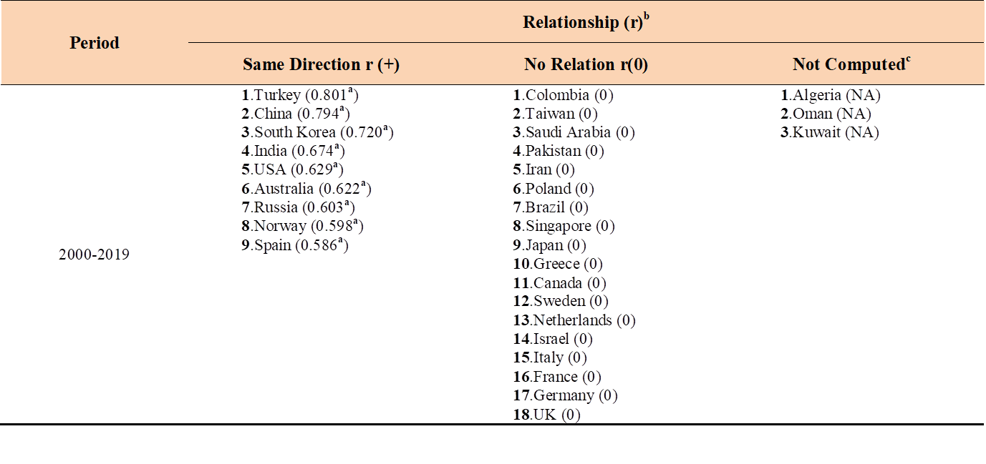

**(a)**: Pearson correlation is significant at α= 0.05 level and correlation values are shown in parenthesis.

**(b)**: r(0.00-0.20): Slight correlation (negligible relationship),

r(0.20-0.40): Low correlation (definite but small relationship),

r(0.40-0.70): Moderate correlation (substantial relationship),

r(0.70-0.90): High correlation (marked relationship)

r(0.90-1.00): Very high correlation (very dependable relationship) (Guilford,1950) [5].

**(c)**: Since there is no data in Arms Transfers database concerning with these countries, the correlation analysis is not perform.

As examining the findings obtained from Table 2, it can be concluded that there are significant relationships between ME and TA in 9 countries (Turkey, China, South Korea, India, USA, Australia, Russia, Norway, and Spain) with same direction. Turkey, China and South Korea have significant high positive (same direction) correlations (0.70-0.90) between ME and TA successively referring marked relation. The other countries (India, USA, Australia, Russia, Norway, and Spain) have significant moderate positive correlation between ME and TA expressing substantial relationship. On the other way, there are not associations between ME and TA in the rest of the countries (Colombia, Taiwan, Saudi Arabia, Pakistan, Iran, Poland, Brazil, Singapore, Japan, Greece, Canada, Sweden, Netherlands, Israel, Italy, France, Germany, and UK). The scatterplots of CA of countries having the same direction relationships between ME and AT is expressed in Figure 3.

|  |  |  |
| --- | --- | --- |
| **Turkey (r=+0.801)** | **China (r=+0.794)** | **South Korea (r=+0.720)** |
|  |  |  |
| **India (r=+0.674)** | **USA (r=+0.629)** | **Australia (r+=0.622)** |
|  |  |  |
| **Russia (r=+0.603)** | **Norway (r=+0.598)** | **Spain (r+=0.586)** |
|  |  |  |

**ME: Military Expenditure(x million $), AT: Arms Transfer (x million $).**

**Figure 3:** Scatterplot of Correlation Analysis

As scrutinizing the results in Figure 2, the association between ME and AT is significantly positive with the same direction. The power of the relationship level between ME and AT of these countries is shown in descending order. In particular Turkey, China and South Korea have accomplished in the military expenditure triggering the volume of arms transfer. In other words, in these countries, the more military expenditure occurs, the more arms transfer comes about.

**CONCLUSION**

The security for an individual, a society or a country is raison d’être (reason for being) since the beginning of time known. In order to ensure security as a phenomenon somehow countries have to build a defense system against others. Continuously, they make efforts to establish better and more efficient defense systems than the existing ones. This ambition results in security dilemma and making countries spend more and sometimes sacrificing social interest. This was much-debated in the history, “butter” versus “guns” referring butter as social needs (hospitals, schools, roads, railways, bridges, parks etc., shortly public needs) guns as defense systems (tanks, artillery, fighter planes, weapons, troops etc. shortly military goods). At the end defense expenditure firmly stand in public spending. In the literature, there exist many studies about relationship among public spending, economic growth, military expenditure and their determinants. There is also no consensus in the results of these studies, since military expenditure-as one portion of GDP and public spending- is depended on some factors like political, economic, geographical and time frame factors. The analysis in these studies mainly showed the three different results. First, ME suggests positive contribution to civilian economy with indirect impacts especially in developing countries. Second, ME reduces the portion of capital allocated to public services like health, education and industry, thus effects negatively. Last, with multiple and complex reasons ME is neutral.

The present study was designed to determine the relation between ME and AT in the last 20 years and investigate whether there is significant relationship between ME and AT for relevant countries. Correlation analysis of this study has indicated that in some 9 countries (namely Turkey, China, South Korea, India, USA, Australia, Russia, Norway, and Spain) ME has moderate and above positive relationship with AT. As ME increases in these 9 countries, with different approaches and policies to defense-which can be seen in their expenditures and their involvement to international interventions-, with giving more importance to making their military goods national, with increasing GDP, with non-decreasing and efficient size of armed forces and with political consistency, so do AT.

Considering the 9 countries; Turkey; being a bridge between east and west, bordering the conflicted areas, partnering in NATO but not utilizing more of resources of NATO thus approaching to Russia when needed, trying to produce national military goods, has had a positive contribution to her AT with her ME. Big economic growth boomed together with its on-going military modernization have made China a major player in the world’s arms trade. For many years, Beijing imported several times more conventional weapons than it sold overseas, but for most of the last decade, China has been a net arms exporter. North Korea being the eternal enemy of South Korea, South Korea’s foreign policy has been focused on deterring acts of her for more than fifty years. But South Korea is planning to change its defense industry into an exporting industry. South Korea depends on defense industry’s latest sales of fighters and frigates. The defense industry of India is a strategically important sector in India. Australia has produced new defense policy to increase export over import and enrich national manufacturing. In the United States and Russia, the defense industry is for their armed forces and to guarantee self-reliance and to act independent world powers. Australia currently promotes the export of arms and related staff and services. Norway and Spain are the two of the world’s largest exporter of weapons and ammunition. In both countries defense industry generates direct and indirect jobs.

The other findings of this research by using CA provide insights for the other 18 countries (including Pakistan, Iran, Brazil, Japan, Greece, Canada, Israel, France, Germany and UK) that ME and AT have no relation. This “no relation” does not mean 18 countries do not have significant AT. The defense policy of governments being one of the most important determinants of ME, similar expenditure trends and strong military industry with huge sell out might be reasons having this neutral relationship. On the other hand, it seems that the change in defense expenditures did not have any effect on arms exports for countries such as Saudi Arabia. It can be evaluated that since they do not have domestic defense industries or initiatives in this direction they transfer the majority of defense expenditures to arms imports. Taken together, these findings do support mix solution depicted in the previous literature saying ME suggests positive contribution in some examples and neutral for others to the economies of countries (Ikegami, 2013; Wilkerson and Williams, 2008; Dakurah et al., 2001; Pradhan, 2010).

Two points would be particularly worth for further research. Firstly, analyzing the effects of other determinants such as R&D share in ME on AT levels for other regions or nations in international alliances of different periods is considered to be a valuable contribution to the literature. Secondly, it is considered to be beneficial to provide recommendations for countries via projections including technological developments in terms of defense expenditures.

**REFERENCES**

Akgül, A. (1987). *Dünyada savunma harcamalari ve savunma sanayiilerinin yapısı*, Ankara: Başbakanlık Basımevi.

Altmann J., Liebert W., Neuneck G. and Scheffran J. (1998). *Dual-use and conversion of military-related R&D in Germany*. In: Reppy J. (eds) Conversion of Military R & D. London: Palgrave Macmillan.

Anlağan, Ö. (2002). Savunma sanayiinde Ar-Ge’nin rolü. *Savunma Sanayiisinde Stratejik İlişkiler Sempozyumu Tebliğ Kitabı*. Ankara: Pelin Ofset.

BalI, N. (1983). Defense and development: A critiuque of Benoit study, *Economic Development and Cultural Change*, *31*, 507.

Benoit, E. (1973). *Defense and economic growth in developing countries*. Lexington: Lexington Books.

Benoit, E. (1978). Growth and defense in developing countries, *Economic Development and Cultural* Change, 26, 271-280.

Bishara, A. J., and Hittner, J. B. (2017). Confidence intervals for correlations when data are not normal. *Behavior Research Methods*, *49*(1), 294-309.

Biswas, Basudeb, (1992). *Defense spending and economic growth in developing countries.* Economic Research Institute Study Papers. Retrieved from 18.https://digitalcommons.usu.edu/eri/18 on 05.09.2020

Biswas, B. and Ram, R. (1986). Military expenditures and economic growth in less developed countries: An augmented model and further evidence, *Economic Development and Cultural Change*, *34*(2).

Bulutoğlu, K. (1981). *Kamu ekonomisine giriş*, Kırklareli: Sermet Maatbası.

Canbay, S. and Mercan, D. (2017). Savunma harcamalarının ekonomik büyüme ve cari işlemler dengesine etkisi: Türkiye örneği. *Journal of Emerging Economies and Policy*, 2(2), 86-104.

Cappelen, A., Gleditsch N.P. and Bjerkholt, O. (1984). Military spending and economic growth in the OECD countries, *Journal of Peace Research*, 21(4), 361-373.

Crawford, S. L. (2006). Correlation and regression. *Circulation*, 114(19), 2083-2088.

Dakurah, H., Davies, S. and Sampath, R. (2001). Defense spending and economic growth in developing countries: A causality analysis, *Journal of Policy Modeling*, *23*(6), 651-658.

Deger, S. and Smith, R. (1983). Military expenditure and growth in less developed countries, *Journal of Conflict Resolution*, 27(2).

Deger, S. and Smith, R. (1985). Military expenditure and development: The economic linkages, *IDS Bulletin*, 16(4).

Deger, S. (1986). Economic development and defense expenditure. *Economic Development and Cultural Change*. 35(1). 179-196.

Dunne, J.P. and Nikolaidou, E. (2012). Defence spending and economic growth in the EU15. *Defence and Peace Economics*, *23*(6), 537-548.

Dunne, P., Nikolaidou, E. and Vougas, D. (1998). Defence spending and economic growth: A causal analysis for Greece and Turkey. *Defence and Peace Economics*, *12*(1), 5–26.

Dunne, J.P., Nikolaidou, E. and Smith, R.P. (1999). *Arms race models and econometric applications*, Paper presented at the Conference on the Arms Trade, Security and Conflict, Middlesex University Business School.

Dunne, J. P., Smith, R., and Willenbockell, D. (2005). Models of military expenditure and growth: A critical review. *Defence and Peace Economics*, *16*(6), 449– 461.

Duyar, M., and Koçoğlu, M. (2014). Askeri harcamaların ekonomik büyüme üzerine etkisi; Sahra altı Afrika örneği. *Uluslararası Sosyal Araştırmalar Dergisi,* *7*(33), 702-722.

Erdeni, F. (1997). *Türkiye'de olağanüstü durumlarda savunma harcamaları*, (Yayınlanmamış Yüksek Lisans Tezi).Bursa: Uludağ Üniversitesi, Sosyal Bilimler Enstitüsü.

Ergun, R. O. (1995). Harp ekonomisi, *Silahlı Kuvvetler Dergisi*, 297.

Europian Commission (2013). *Towards a more competitive and efficient defence and security sector*, A New Deal for European Defence.

Fieller, E. C., Hartley, H. O. and Pearson, E. S. (1957). Tests for rank correlation coefficients. *I. Biometrika*, *44*(3/4), 470-481.

Giray, F. (2004). Savunma harcamalari ve ekonomik büyüme, *Cumhuriyet Üniversitesi İktisadi ve İdari Bilimler Dergisi*, *5*(1), 181-199.

Gokmenoglu, K.K., Taspinar, N. and Sadeghieh, M. (2015). *Military expenditure and economic growth: The case of Turkey*. 16th Annual Conference on Finance and Accounting. Prague.

Göçer, İ. (2014). Ar-Ge Harcamalarının yüksek teknolojili ürün ihracatı, dış ticaret dengesi ve ekonomik büyüme üzerindeki etkileri”, *Maliye Dergisi*, 164: 215-240.

Guilford, J. P. (1950). *Fundamental statistics in psychology and education*.

Hassan, M., Kabir, M., Rahman W. and Aminur H. (2003). Defense expenditure and economic growth in the SAARC countries. *The Journal of Political, Social and Economic Studies*, *28*(3), 275-293.

Heo, U. (1998). “Modeling the defense-growth relationship around the globe”, *Journal of Conflict Resolution*, *42*(5).

Hirnissa M. T., Habibullah, M. S. and Bahorom, A. H. (2016). Military expenditures and economic growth in selected developing countries: 208 TESAM Akademi Dergisi/ Turkish Journal of TESAM Academy TESAM causality analysis using panel error-correction approach. *JER Serials Publications, 13(5)*, 2113-2130.

Ikegami, M. (1992). *The military-industrial complex: The cases of Sweden and Japan*. Brookfield, VT: Dartmouth Publishing Company.

Ikegami, M. (2013). The end of a national defence industry?: Impacts of globalization on the Swedish defence industry, *Scandinavian Journal of History,* 38:4, 436-457.

Karagöl, E. (2005). Defence expenditures and external debt in Turkey, *Defence and Peace Economics*, *16*, 117-125.

Khalid, M., A. Munadhil, A.,J. and Razaq, A. (2015). The impact of military spending on economic growth: evidence from the US economy. *Research Journal of Finance and Accounting, 6*(7), 183-190.

Koban, E. (1998). Savunma harcamaları, ekonomik etkileri ve Türkiye’deki gelişimi, Gnkur. *Askeri Tarih ve Stratejik Etüt Başkanlığı*, 355.

Kollias, C. (1997). Defence spending and growth in Turkey 1954–1993: A causal analysis, *Defence and Peace Economics*, *8*(2), 189-204.

Kollias, C.G. and Makrydakis, S. (1997). Defence spending and growth in Turkey 1954–1993: A causal analysis. *Defence and Peace Economics*, *8*, 189–204.

Kollias, C., Manolas, G. and Paleologou, S. (2004). Defence spending and economic growth in European union: A causality analysis”, *Journal of Policy Modeling*, *26* (5).

Korkmaz, S. (2015). The effect of military spending on economic growth and unemployment in Mediterranean countries. *International Journal of Economics and Financial Issues*. *5*(1), 273-280.

Korkmazyürek, H. (2018). *Strategic defense management basic concepts and principles*, Hiperyayın, İstanbul.

Kumar, G. (2017). Countries military expenditures: Definitions and determinants, *Economic Affairs*, 62(4), 647-654.

Meunier, F. (2019). Construction of an operational concept of technological military/civilian duality. *Journal of Innovation Economics & Management,* *29*(2), 159-182.

NATO (2019). *Defence expenditure of NATO countries* (2013-2019), Public Diplomacy Division Press Release, Brussel Belgium.

Overholser, B. R., and Sowinski, K. M. (2008). Biostatistics primer: part 2. *Nutrition in Clinical Practice*, *23*(1), 76-84.

Pan, C.-I., Tsangyao, C. and Yemane W. R. (2015). Military spending and economic growth in the Middle East countries: Bootstrap panel causality test. *Defence and Peace Economics, 26*(4), 443–456.

Pradhan, R.P. (2010). Defense spending and economic growth in China, India, Nepal and Pakistan: Evidence from cointegrated panel analysis, *International Journal of Economics and Finance*, *2*(4).

Ram, R. (1995). *Defense expenditure and economic growth*, Handbook of Defense Economics, Volume 1, Edited by K. Hartley and T. Sandler, Elsevier Science.

Romer, P.M. (1989). What determines the rate of growth and technological change? *World Bank Working Paper*, 279.

Saunders, P. (1992). *Recent trends in the size and growth of government in OECD countries*”, Social Policy Research Centre, UNSW, 17-33.

Schober, P., Boer, C., & Schwarte, L. A. (2018). Correlation coefficients: Appropriate use and interpretation. *Anesthesia & Analgesia*, 126(5), 1763-1768.

Sezgin, S. (1997). Country survey X: Defence spending in Turkey. *Defence and Peace Economics,* 8:4, 381-409.

Sezgin, S. (2000). Defence expenditure and economic growth in Turkey and Greece: A cointegration analysis. *Muğla Üniversitesi SBE Dergisi*, *1* (1), 191-202.

Sezgin, S., (2001). An empirical analysis of Turkey’s defence–growth relationships with a multi-equation model (1956–1994). *Defence and Peace Economics*, *12* (1), 69–86.

Sezgin, S. (2004). An empirical note on external debt and defence expenditures in Turkey." *Defence and Peace Economics*, *15*(2), 199-203.

SIPRI(2016). *Year book 2016 armaments, disarmament and international security*, Oxford University Press.

Stockholm International Peace Research Institute (*SIPRI*). Retrieved from https://www.sipri.org/databases/ arms transfers on 4 September 2020.

Saunders, P. (1992). *Recent trends in the size and growth of government in OECD countries*, Social Policy Research Centre, UNSW, 17-33.

Topcu, M. and Aras, I., (2013). Economic impacts of military expenditures: A comparative analysis on superpowers of the world. *Actual Problems of Economics*, *142* (4), 495-506.

Yalçın, H.B. (2017). *National security strategy*, İstanbul: Turkuaz Haberleşme ve Yayıncılık.

Wilkerson, C. R. and Williams, M. D. (2008). How is the rise in national defense spending affecting the tenth district economy? *Economic Review*. Federal Reserve Bank of Kansas City, *93*(2), 49-79

Zekey, A.H. (1998). Savunma sanayii ve Türkiye, *KHO Bilim Dergisi*, *8*(2), 98.

**GENİŞLETİLMİŞ ÖZET**

**Askerî Harcamalar ve Silah İhracatı Arasında Bir İlişki Var mıdır? 2000-2019 Dönemine Ait Bir Çalışma**

**Giriş**

Savunma harcamaları, kamu harcamaları arasında sıklıkla eleştirilen bileşenlerinden biridir. Bu nedenle, savunma harcamalarının incelenmesi genel olarak iktisat ve özel olarak savunma ekonomisi için önemli bir alandır (Kumar, 2017). Ülkeler temelde askerî harcamaları kendi istek ve amaçlarına göre tanımlama konusunda farklı düşünseler de genel anlamda askerî harcama, bir ülke tarafından savunma amaçlı silahlı kuvvetleri ve diğer temel hizmetleri sürdürmek için tahsis edilen mali kaynak miktarıdır (SIPRI, 2016). NATO savunma harcamalarını, ulusal bir hükûmet tarafından özellikle silahlı kuvvetlerinin, müttefiklerin veya ittifakın ihtiyaçlarını karşılamak için yapılan ödemeler olarak tanımlamaktadır.

İlk bakışta savunma harcamalarının ülkelerin mevcut ekonomik büyümeleri üzerinde olumsuz bir etkisi olduğu düşünülse de aslında bu tür harcamaların ekonomik büyümeyi destekleyebileceği de ifade edilmektedir (Benoit, 1978). Savunma harcamalarının ülke ekonomilerinin üzerinde, özellikle altyapı, teknolojik ilerleme ve insan sermayesi oluşumu ile ilgili olarak birkaç olası olumlu dış etkileri olduğu değerlendirilmektedir (Ram, 1995). Özellikle savunmaya ayrılan kaynakların savunma teknolojileri alanında kullanılması Araştırma- Geliştirme (Ar-Ge) faaliyetlerine hız kazandırmakta ve Ar-Ge çalışmaları, ileri sanayi ülkelerinin çoğunda yeni stratejik kavramların uygulanmasında önemli rol oynamaktadır (Altmann vd., 1998). Bu kapsamda sivil teknolojilerin açık yenilik anlayışıyla savunma alanındaki Ar-Ge faaliyetlerinde kullanılması, yine aynı düşünce ile savunma alanındaki özellikle güdümlü temel daha sonraki uygulamalı ve deneysel araştırmalar safhasında elde edilen teknolojik bilgilerin sivil alanda kullanımını ön plana çıkarmıştır (EU Commission, 2013). Örneğin lazer silahlarının üretilmesine yönelik, lazer ışınlarının çalışma prensipleri konusundaki Ar-Ge faaliyetlerinden elde edilen bilgilerin sivil sektördeki sağlık alanında da kullanımını beraberinde getirebilmektedir. Bu anlayış savunma alanında yapılan harcama ve kullanılan kaynakların başka alanlarda kullanımına (dual-use) fırsat vermektedir (Meunier, 2019). ABD başta olmak üzere pekçok gelişmiş ülke bu yaklaşım ile savunma harcamalarının ülke bütçeleri üzerindeki olumsuz etkilerini azaltarak, fırsata çevirme imkânı sağlamıştır.

Savunma harcamalarının doğru değerlendirildiğinde, ülkelere faydalı olabileceği gerçeğinden hareketle bu araştırma ülkelerin savunma harcamalarının savunma ihracatlarıyla olan ilişkisini ortaya koymayı amaçlamaktadır. Araştırmanın ülkelerin savunma harcamalarını bir yük olarak görmemesi ve söz konusu savunmaya ayrılan kaynak ve harcamaların aslında fırsata çevrilerek başta savunma ihracatı olmak üzere farklı sektörlerdeki ihracata olumlu katkıları olabileceği gerçeğini göstermesi açısından önemli olduğu değerlendirilmektedir. Bu kapsamda Stockholm International Peace Research Institute (SIPRI)’nin veri tabanında yer alan ve 2000-2019 yılları arasında dünyada savunma harcamaları en yüksek olan 30 ülke verileri ele alınmıştır. Araştırmada ülkelere ait söz konusu ikincil veriler, zaman serisi şeklinde ele alınarak ilgili ülkelerin 2000 yılından başlayarak 2019 yılına kadar olan hem savunma harcamaları hem de silah ihracatlarına bakılarak, varsa aralarındaki ilişki düzeyi ortaya konmaya çalışılmıştır. Öncelikle, söz konusu 30 ülkenin savunma harcamaları ile savunma ihracatları ile ilgili betimsel istatistikler tablo ve şekiller üzerinde gösterilmiş ve yapılan analizler sonucunda elde edilen bulgular değerlendirilmiş ve tartışılmıştır. Ayrıca yine bulgu ve değerlendirme sonuçlarına göre ülkelerin güvenliklerini sağlama konusunda yapmış oldukları savunma harcamalarına yönelik ileri dönük ve teknolojik gelişmeleri de içine alan projeksiyonlar yaparak ülkelere bazı önerilerde bulunulmuştur.

**Savunma Harcamalarının Ekonomiye Etkileri**

Savunma harcamalarının ekonomiye etkileri ile ilgili en dikkat çekici çalışmalardan birisi Benoit (1973, 1980) tarafından gerçekleştirilmiş ve iki değişken arasında pozitif ilişkiyi ortaya koymuştur. Benoit, gelişmekte olan ülkeler üzerinde yaptığı çalışmasında daha fazla savunma harcaması yapan ülkelerin daha yüksek ekonomik büyüme performansına sahip oldukları sonucuna ulaşmıştır. Benoit’in bu çarpıcı sonuçlarından sonra ise özellikle daha az gelişmiş ülkeler ile ilgili farklı sonuçlara ulaşan pek çok ampirik çalışma yapılmıştır. İki değişkenin ilişkisi ile ilgili yazın incelendiğinde sonuçların genel olarak karşıt sonuçlarla olsa dahi anlamlı ilişkiler ortaya koyan ve herhangi bir anlamlı ilişkiye ulaşamayan çalışmalar olmak üzere iki grupta toplandığı görülmektedir. İlk olarak, iki değişken arasında anlamlı ilişkiye ulaşan çalışmalardan bir kısmı bu ilişkinin askerî harcamalardan ekonomik büyümeye doğru olduğunu ifade ederken (Dakurah et al., 2001: 652; Deger, 1986: 181-182; Dunne et al., 2005; Hassan et al., 2003; Sezgin, 2000, 2001; Biswas, 1992 and Dunne et al., 1998); söz konusu nedensellik ilişkisinin ekonomik büyümeden askerî harcamalara doğru olduğu sonucuna ulaşan çalışmalar da bulunmaktadır (Gokmenoğlu et al., 2015; Topcu ve Aras, 2013; Kollias vd., 2004). Diğer yandan, bazı araştırmacılar (Korkmaz, 2015; Deger ve Smith, 1983, 1985; Heo, 1998; Khalid vd., 2015; Dunne vd., 1999; Cappelen vd., 1984) da iki değişken arasında anlamlı ilişkiyi askerî harcamaların ekonomik büyümeye negatif etkisi ile ortaya koymuştur. İkinci olarak, Kollias ve Makrydakis (1997), Biswas ve Ram (1986); Dakurah vd., (2001), Pradhan, (2010) ve Abdel-Kalek vd., (2020) ise iki değişken arasında anlamlı bir ilişkiye ulaşamamıştır.

2000-2019 yılları arasında kümülatif en yüksek savunma harcaması gerçekleştiren 30 ülke arasında birinci sıradaki ülke yakın takipçisi olan Çin’in beş katı daha fazla harcama ile Amerika Birleşik Devletleri’dir. ABD’nin savunma harcamalarındaki liderliğinin temel nedeni ise ABD’nin NATO ülkeleri arasında savunmaya en fazla kaynak ayıran ülke olmasıdır (Aufrant, 1999).

Söz konusu listedeki özellikle ilk 10 ülke (sırasıyla ABD, Çin, İngiltere, Rusya, Japonya, Fransa, Suudi Arabistan, Almanya, Hindistan ve Güney Kore) ekonomik gücün savunma harcamasındaki belirleyici rolünü ortaya koymaktadır. Diğer yandan, savunma harcamasının büyüklüğünden öte aslında daha önemli olan bu harcamaların bağlamıdır. Öyle ki bu harcamaların savunma ihtiyaçlarının yerli üretimine ne oranda yansıdığı miktarından daha önemlidir. Bu bağlamda, savunma harcamalarının doğrudan savunma ithalatına aktarıldığı yoksa temel olarak yerli üretime mi yönlendirildiği oldukça kritiktir. Bunun sebebi ise savunma bütçesini özellikle yerli üretime harcayan ülkelerin öncelikle kendi ihtiyaçlarını giderip belli bir aşamadan sonra ihracatçı konumuna geçecekleri değerlendirilmektedir.

2000-2019 yılları arasında en çok silah ihracatı yapan ülkelere bakıldığında ise ABD, Rusya, Fransa, Almanya, İngiltere ve İtalya’nın ilk 10 sırada olduğu görülmektedir. Söz konusu ülkelerin aynı zamanda dünyanın en gelişmiş ülkeleri arasında olduğu da düşünülürse savunma sanayinin ülke ekonomileri için ne kadar cazip olduğu da anlaşılacaktır. Dahası, somut herhangi bir dış tehditle karşı karşıya olmayan İsveç, İtalya ve İspanya gibi ülkelerin yüksek savunma ihracat oranları bu sektörün ekonomik değerini ayrıca ortaya koymaktadır.

Yukarıda ifade edilen silah ihracatında lider ülkeler göz önünde bulundurulduğunda ülkelerin devlet bütçesinden savunma alanına ayrılan pay arttıkça öncelikle ülkenin kendi savunma ihtiyaçlarını gidermek üzere yerli ve milli üretimi gerçekleştirecekleri ve daha sonrasında da yerli savunma ürünlerinin ihracatına başlayarak ekonomik büyümeye katkı sağlayabileceklerini değerlendirmekteyiz.

**Yöntem**

Bu araştırmada SIPRI’den elde edilen 2000-2019 yılları arasında en çok kümülatif askerî harcama gerçekleştiren 30 ülkeye ait zaman serisi veri seti kullanılmıştır. 30 ülkeye ait Askerî Harcamalar ve Silah İhracatı arasındaki ilişki bu dönemi kapsayacak şekilde Korelasyon Analizi ile test edilmiştir.

Korelasyon Analizi sonuçlarına göre Türkiye, Çin, Güney Kore, Hindistan, ABD, Avustralya, Rusya, Norveç ve İspanya olmak üzere 9 ülke için Askerî Harcama ve Silah İhracatı arasında aynı yönde anlamlı ilişki söz konudur. Türkiye, Çin ve Güney Kore için bu ilişki pozitif yönde yüksek düzeyde gerçekleşmişken (0.70-0.90), Hindistan, ABD, Avustralya, Rusya, Norveç ve İspanya için bu ilişki ise pozitif yönde orta düzeyde tespit edilmiştir. Diğer yandan, Kolombia, Tayvan, Suudi Arabistan, Pakistan, İran, Polonya, Brezilya, Singapur, Japonya, Yunanistan, Kanada, İsveç, Hollanda, İsrail, İtalya, Fransa, Almanya ve İngiltere için iki değişken arasında anlamlı ilişki tespit edilememiştir. Bilhassa belirtilen dönemde Türkiye, Çin ve Güney Kore için savunma harcamaları arttıkça daha fazla silah ihracatı gerçekleştirdikleri düşünülebilir.

**Sonuç**

Bu çalışma son 20 yılda askerî harcamalar ve silah ihracatı arasında ülkeler açısından anlamlı bir ilişki olup olmadığını belirlemek üzere yapılmıştır. Korelasyon analizi sonuçlarına göre 9 ülke için (Türkiye, Çin, Güney Kore, Hindistan, ABD, Avustralya, Rusya, Norveç ve İspanya) askerî harcamalar ile silah ihracatı arasında bazı ülkeler için orta bazıları içinde daha yüksek pozitif düzeyde anlamlı bir ilişki olduğu görülmüştür. Söz konusu 9 ülkede askerî harcamalar arttıkça silah ihracatının da arttığı düşünülebilir. Bu ülkelerden doğu ve batı arasında köprü vazifesi gören, çatışma alanlarında sınırlara sahip ve NATO üyesi olan Türkiye için askerî harcamaların ulusal askerî ürünler üretiminde kullanıldığı ve bu durumun silah ihracatı oranlarına pozitif yansıdığı değerlendirilmektedir. Türkiye’nin aksine somut bir yakın terör tehdidi ile karşı karşıya olmayan Norveç gibi ülkelerin silah ihracatı düzeyi de dikkat çekicidir. Dolayısıyla savunma harcamalarının bir devlet için temel olarak ulusal güvenlik odaklı gelişirken diğeri için ihracat (ekonomik) odaklı gerçekleşebildiği düşünülebilir.

Diğer yandan Pakistan, İran, Brezilya, Japonya, Yunanistan, Kanada, Fransa, İngiltere ve Suudi Arabistan’ın da aralarında bulunduğu 18 ülke için askerî harcamalar ve silah ihracatı arasında anlamlı bir ilişkiye rastlanmamıştır. Bu durum elbette söz konusu ülkelerin silah ihracatı yapmadığı anlamına gelmemektedir. Askerî harcamaların en önemli belirleyicilerinden olan devletlerin savunma politikaları, benzer harcama trendleri ve İngiltere, Fransa gibi gelişmiş ülkelerin teknolojik olarak gelişmiş savunma sanayileri bulunması, savunma harcamalarındaki değişimden bağımsız olarak yüksek seviyede silah ihracat yapan ülkeler arasında yer almasının neden olabilir. Öte yandan özellikle Suudi Arabistan gibi ülkelerin yerli savunma sanayilerinin olmaması, yeterince gelişmemesi veya bu yönde herhangi bir girişim olmaması nedeniyle savunma harcamalarındaki değişimin silah ihracatı üzerinde herhangi bir etkisinin bulunmadığı, dolasıyla bu sürecin savunma harcamalarının büyük bölümünün silah ithalatına aktarılması şeklinde gerçekleştiğine yönelik yapılan bir değerlendirme yanlış olmayacaktır. Çalışmada askerî harcamalar ve silah ihracatı arasındaki ilişkinin ülkeler açısından farklılaşan sonuçları aslında literatürde iki değişkenin ilişkisine dair farklı bulguları da destekler niteliktedir.

Gelecekte yapılacak çalışmalar için iki konu önem arz etmektedir. İlk olarak, farklı bölgelerde bulunan ya da farklı uluslararası kuruluşlara üye ülkeler için değişik dönemlere ait Ar&Ge’nin savunma harcamalarındaki payı gibi diğer etkenlerin savunma ihracatı ile ilişkisinin ele alınacağı çalışmaların yazına değerli katkılar sağlayacağı düşünülmektedir. İkinci olarak, savunma harcamalarına ilişkin teknolojik gelişmeleri de içeren projeksiyonlarla ülkelerde tavsiyelerde bulunulmasının faydalı olacağı değerlendirilmektedir.

1. Dr. Öğ.Üyesi, MSÜ Kara Harp Okulu Dekanlığı, Savunma Araştırmaları Bölüm Başkanlığı, rcyalcin[@kho.edu.tr](mailto:mbegenirbas@kho.edu.tr), ORCID: 0000-0003-4500-6935
2. **Doç.Dr. MSÜ Kara Harp Okulu, Endüstri Mühendisliği Bölüm Başkanlığı, [yunusgokmen@gmail.com](mailto:yunusgokmen@gmail.com), ORCID: 0000-0002-6107-0577
3. ***Doç.Dr., MSÜ Kara Harp Okulu Dekanlığı, Savunma Araştırmaları Bölüm Başkanlığı, [mbegenirbas@kho.edu.tr](mailto:mbegenirbas@kho.edu.tr), ORCID: 0000-0003-0917-0973
4. ****Dr. (E.)Alb., [hotunca@hotmail.com](mailto:hotunca@hotmail.com), ORCID: 0000-0002-1180-2549

   Geliş Tarihi / Arrived : 13.11.2020

   Kabul Tarihi / Accepted : 30.11.2020
5.