Evaluation of Commercial Type of Split Air Conditions by Using Condenser Waste Heat in a Boiler
Alper Ergün¹*, Engin Gedik¹, Mehmet Özkaymak¹, Bahtiyar Şanslı²
Karabük University, Technology Faculty, Department of Energy Systems Engineering, 78050, 100. yıl/Karabük, Turkey.
²Karabük University, Graduate School of Natural and Applied Sciences, 78050, 100. yıl/Karabük, Turkey.
*Corresponding Author email: alperergun@karabuk.edu.tr

Publication Info  Paper received:  19 February 2017  Revised received:  15 December 2015  Accepted:  18 December 2015 | Abstract  Air conditioners are used for reducing the ambient temperature and they are manufactured in different versions. Especially, split type air conditioners are used widely. Because of increasing use of air conditioners, energy consumption has also increased, so researchers have attracted to search for production of more efficient air conditioners. The main objective of this study is to investigate thermal performance of the whole split type air conditioner system. For this purpose, an experimental system was designed and manufactured by adding a boiler unit to the conventional split air conditioners condenser. At the end of the study, coefficient of performance (COP) of the system increased from 3.64 to 4.54. In addition, boiler which added to system increases temperature of water from 10ºC to 40 ºC. When economical benefit is considered, electrical consumption is decreased 0.61 $ supposing that the device works 10 hours in a day. Only 132.5 $ is paid for the device in addition to existing split air conditioners. Besides, domestic water at 40 ºC was produced.
Key words
Split air conditioner, boiler, energy efficiency, condenser

Introduction
Cooling is a technique that is decreasing the temperature of substance or local environment below the surrounding volume temperature [1]. Recently, local cooling has been popular in order to supply thermal comfort conditions. Besides, the devices that work according to the vapor compressing cooling cycle has used. Home type split air conditioners that work using vapor compressing cooling cycle phenomena has widely been used nowadays. According to the researches, energy in the world is consumed about 16% to 50% by cooling and heating systems in buildings [2]. Energy consumption of residential buildings is 30% of the total energy consumption in Turkey and 80% of this consumption is related to the heating and cooling systems [3-5]. Thus, it can be seen that energy which is used to perform home cooling and prepare domestic hot water is massive. Nowadays, there are many studies has been carried out to improve the performance of split type air conditioners Martinez et al. [6] covered the condenser unit of split type air conditioner with evaporative cooling pads that have various thicknesses and examined the energy performance of this system. Sumeru et al. [7] used an ejector as an expansion element in order to perform experiments and numerical analysis. Padalkar et al. [8] changed the HCFC-22 refrigerant to HC-290 of a split type air conditioner and determined the performance of this new refrigerant. Kumlutaş et. Al [9] performed heat and flow analysis in internal unit of split type air conditioner. Jie and Lee [10] placed a storage-enhanced heat recovery room into the split type air conditioner. They used a capillary tube and expansion valve in order to determine the system performance. Besides, [11] they used phase changed material in storage-enhanced heat recovery room and performed the analysis of modified system.
In this study, energy analysis were performed by adding boiler unite onset of the condenser unit in split type air conditioner that works with R-22 refrigerant.

MATERIAL AND METHODS
In this study, split type air conditioner with boiler unit was designed and manufactured. The designed and produced system is shown in Figure 1. The system consists of compressor, evaporator, condenser, expansion valve and four way valve. The boiler unit was designed to prepare domestic hot water and placed in between condenser and four-way valve. Assembled boiler unit and built-in system can be seen in Figure 2.
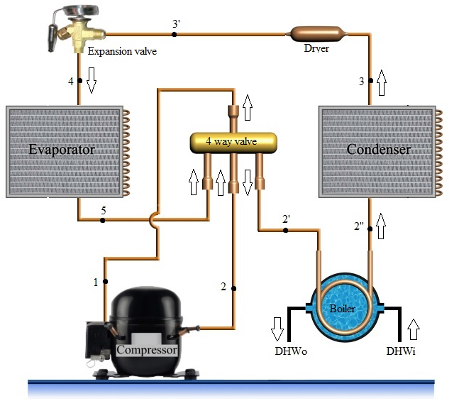
Figure 1. Schematic view of the experimental setup.

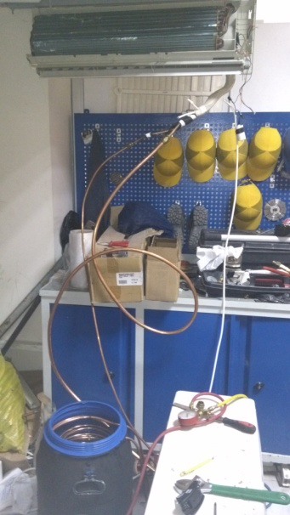
Figure 2. Designed boiler unit and assembled experimental setup
Designed boiler unit that have 40 l volume and 3/8” copper pipe with 18 m length was placed in. Boiler unit was covered with rubber isolation material that have 1cm thickness to prevent heat loses. In the unit, 0.15 gr refrigerant was added for each 1 m pipe length.
When high pressured refrigerant as superheated steam exited from outlet of the compressor, the heat of refrigerant is transferred to water in boiler unit instead of atmosphere air. The heat was sent to the boiler unit water when the condensation pressure was about 4.5-5 bar. At this stage, there was no need to work condenser fan. If this heat transfer is higher than boiler capacity, condenser fan started. This system works with a thermostat that opens at 55°C and closes at 35°C to regulate condenser unit properly. When the refrigerant transferred its heat, the refrigerant was accomplished its cycle by passing expansion valve and evaporator. The system can be by-passed using boiler valves. Thus, the analysis can be performed with and without boiler unit in terms of comparison between both designs.

THERMODYNAMIC ANALYSIS OF SYSTEM

The coefficient of performance was calculated for boiler and without boiler conditions. Energy balance of steady-flow condition can be determined as follow;
$q_{net}-w_{net}=∆h+∆ke+∆pe$ (1)
Here, q_{net} and w_{net} are described heat and work input, Δh, Δke and Δpe are impressed changing of enthalpy, kinetic energy and potential energy respectively. The changing of kinetic and potential energies can be neglected. Thus, steady-flow energy equation on a unit-mass basis reduces to;
$(q_{i}-q_{o})+(w_{i}-w_{o})=h_{0}-h_{i}$ (2)
In equation 2, q, w and h are the heat, work and enthalpy respectively while i and o describe the subtitle of input and output.
Compressor work, condenser load and evaporator load were calculated related to energy equations. Energy transfer was not occurred because of the fact that there was not any enthalpy changes in expansion valve. When the loss of pressure in fittings equipment and loss of heat in pipes were ignored, the equation of conservation of energy principle can be expressed as follow;
$W_{comp}+Q_{evap}=Q_{cond}$ (3)
From this equation, compressor work, evaporator and condenser load can be calculated as follows;
Compressor work;
${\dot{W}}_{comp}=\dot{m}\left(h_{2}-h_{1}\right)$ (4)
Condenser load;
${\dot{Q}}_{cond}=\dot{m}\left(h_{2}-h_{3}\right)$ (5)
Evaporator load;
${\dot{Q}}_{evap}=\dot{m}\left(h_{5}-h_{4}\right)$ (6)
The most crucial parameter that determines the performance of vapor compressing cooling cycle is coefficient of performance (COP) and it can be calculated as follow;
$COP=\frac{{\dot{Q}}_{evap.}}{{\dot{W}}_{comp.}}=\frac{h_{5}-h_{4}}{h_{2-}h_{1}}$ (7)
The power of system (P) can be calculated as follow;
$P=U×I$ (8)
In there, U is the voltage of the device (220V) and I is the current.
All the calculations were performed both boiler and without boiler unit conditions and analyzed.

Result and dıscussions

The results were classified into two parts, with and without boiler cases. According to the inlet and outlet temperatures of each devices, the enthalpy values have been obtained from the thermodynamic tables of R-22 working fluid. Thermodynamic properties and energy values of both with and without boiler unit is given in Table 1 and Table 2 respectively.
Table 1. Thermodynamic properties and energy values for non-boiler unit condition
Point | Component | Temperature  (°C) | Pressure  (Bar) | Mass flow rate  (kg/s) | Enthalpy  (kj/kg) | Q  (kW)
1 | Compressor inlet | 14 | 4.8 | 0.05151 | 415.777 | 21.4167
2 | Compressor outlet | 98 | 22 | 0.05151 | 459.992 | 23.6942
2' | Condenser inlet | 95 | 22 | 0.05151 | 457.26 | 23.5535
3 | Condenser outlet | 43 | 21 | 0.05151 | 253.682 | 13.0672
3' | Expansion valve inlet | 43 | 21 | 0.05151 | 253.682 | 13.0672
4 | Expansion valve outlet | 6 | 4.5 | 0.05151 | 253.682 | 13.0672
4’ | Evaporator inlet | 6 | 4.5 | 0.05151 | 253.682 | 13.0672
5 | Evaporator outlet | 12 | 4.5 | 0.05151 | 414.913 | 19.6572

Table 2. Thermodynamic properties and energy values for boiler unit condition
Point | Component | Temperature  (°C) | Pressure  (Bar) | Mass flow rate  (kg/s) | Enthalpy  (kj/kg) | Q  (kW)
1 | Compressor inlet | 12 | 4.5 | 0.03878 | 414.913 | 16.089
2 | Compressor outlet | 90 | 22 | 0.03878 | 452.289 | 17.5383
2' | Boiler inlet | 90 | 22 | 0.03878 | 452.289 | 17.5383
2'' | Boiler outlet | 43 | 21 | 0.03878 | 405.618 | 15.7286
2'' | Condenser inlet | 43 | 21 | 0.03878 | 405.618 | 15.7286
3 | Condenser outlet | 35 | 19 | 0.03878 | 243.101 | 9.42668
3’ | Expansion valve inlet | 35 | 19 | 0.03878 | 243.101 | 9.42668
4 | Expansion valve outlet | 4 | 6 | 0.03878 | 243.101 | 9.42668
4’ | Evaporator inlet | 4 | 6 | 0.03878 | 243.101 | 9.42668
5 | Evaporator outlet | 8 | 4 | 0.03878 | 413.048 | 16.0167

Compressor work, evaporator load and condenser load for boiler and non-boiler unit conditions are given in Table 3 by the helping of Table 1 and Table 2 data.

Table 3. Compressor work, evaporator load and condenser load for boiler and non-boiler unit conditions.
Device | W_{comp} | Q_{cond} | Q_{evap}
Boiler | 1.449321 | 8.11164 | 6.59
Non-Boiler | 1.807201 | 8.32085 | 6.59

The energy graphics of equipment of boiler and non-boiler unit conditions are shown in Figure 3.
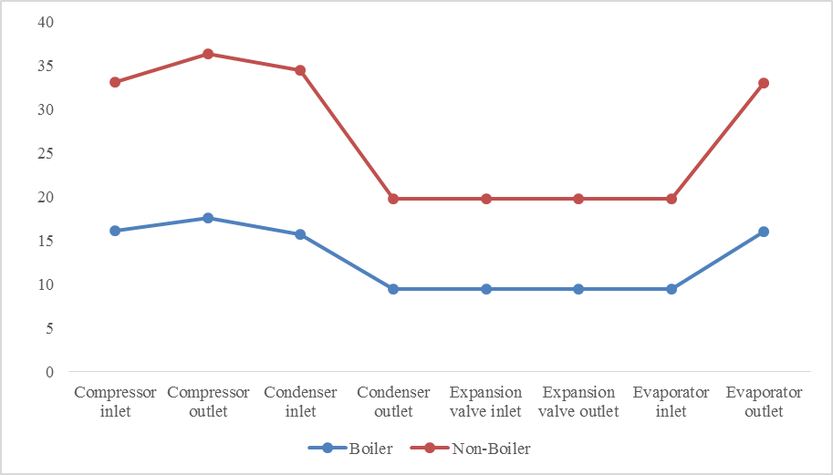
Figure 3. Energy graphics for Boiler and Non-Boiler unit conditions
COP values and operating currents for both conditions are given in Table 4.

Table 4. COP values and currents of systems
Device | COP Values | Current (A)
Boiler | 4.54 | 8
Non-Boiler | 3.64 | 10

It was determined that designed system with boiler unit operated 2A less current what it is compared with the system without boiler unit. From equation 8, it can be calculated that the power of system was decreased about 0.44kW. When the cost of electricity was taken into account, the electricity kW per an hour is 0.139 $ and it can be seen that if the designed system works during 10 hours per a day, the cost of electricity will decrease about 222.04$ per a year.

Moreover, designed system with boiler produce 40°C domestic hot water. When the boiler with 50LT consumes 1.5kW electricity per a day, it can be calculated that designed system with boiler has profits about 75.34$ per a year.

Conclusions

In this study, the boiler unit system was added to split type air conditioner with R22 refrigerant and the experimental results were analyzed thermodynamically. The results can be listed as follows;
- Using the boiler unit, the COP of the system was increased from 3.64 to 4.54.
- Compressor work and condenser load were decreased using boiler unit. Thus, the more efficient working condition was obtained.
- The operating current was decreased about 2A by means of boiler system.
- City water entered the boiler system about 10°C and exited from boiler about 40°C. Thus, domestic hot water at 40°C was produced without another energy sources.
- The consumed electricity of the system was decreased and the cost of electricity about 296.48$ as well.

ACKNOWLEDGMENT
The authors would like to thank the Karabük University Scientific Research Projects Unit, Karabük/TURKEY for providing the financial supports for this study under the KBÜ-BAP- 16/1-YD-021 project

REFERENCES
- T. Menlik, A. Demircioğlu, and M.G. Özkaya, “Energy and Exergy Analyses of R22 and its Alternatives R407c and R410a in a Vapor Compression Refrigeration System”, Journal of Exergy, vol. 12 (1), pp. 11-30, 2013.
- R. Saidur, H.H. Masjuki and M.Y. Jamaluddin, “An application of energy and exergy analysis in residential sector of Malaysia”, Energy Policy, vol. 35, pp. 1050–1063, 2007.
- A. Ergün, T. Menlik, T. and M.G. Özkaya, “Energy and Exergy Analyses of the Heating System in a Multipurpose Building”, Gazi Journal of Engineering Science, vol. 1, pp. 195-218, 2015.
- A. Ergün, T. Menlik, T. and M.G. Özkaya, “First and Second Law Analysis of Central Cooling System of a Multipurpose Buildings”, International Symposium on Innovative Technologies in Engineering and Science, vol. 12(A) pp. 1974-1983, Karabuk Turkey. 2014.
- A. Ergün, “Energy and Exergy Analyses of a Shopping Center Which Needs 80.000 M² Heating and Cooling”, Master Thesis, Gazi University Graduate School of Natural and Applied Sciences, Ankara, 2010.
- P. Martínez, J. Ruiz, C.G. Cutillas, P.J. Martínez, A.S. Kaiser and M. Lucas, “Experimental study on energy performance of a split air-conditioner by using variable thickness evaporative cooling pads coupled to the condenser”, Applied Thermal Engineering, In press (doi: 10.1016/j.applthermaleng.2016.01.06.) 2016.
- K. Sumeru, S. Sulaimon, H. Nasution and F. N. Ani, “Numerical and experimental study of an ejector as an expansion device in split-type air conditioner for energy savings”, Energy and Buildings, vol. 79, pp. 98–105. 2014.
- A. S. Padalkar, K.V. Mali and S. Devotta, “Simulated and experimental performance of split packaged air conditioner using refrigerant HC-290 as a substitute for HCFC-22”, Applied Thermal Engineering, vol. 62, pp. 277-284, 2014.
- D. Kumlutas¸ Z. H. Karadeniz and F. Kuru, “Investigation of flow and heat transfer for a split air conditioner indoor unit”, Applied Thermal Engineering, vol. 51 pp. 262-272, 2013.
- J. Jia and W.L. Lee, “Experimental investigations on the use of capillary tube and thermostatic expansion valve in storage-enhanced heat recovery room air-conditioner”, Energy and Buildings, vol. 101, pp. 76–83, 2013.
- J. Jia and W.L. Lee, “Experimental investigations on using phase change material for performance improvement of storage-enhanced heat recovery room air-conditioner”, Energy, vol. 93 pp. 1394-1403, 2015.

