A Special Type of Time-Dependent Deformation in Clays: Osmotic Compression

Uğur Eren YURTCAN ^{¹*}

^{¹*} Bingöl Üniversitesi, Teknik Bilimler Meslek Yüksek Okulu, Bingöl, Türkiye.
ORCID No: 0000-0001-5040-2786, e-mail: ueyurtcan@bingol.edu.tr

(Alınış/Arrival: 08.02.2023, Kabul/Acceptance: 14.06.2023, Yayınlanma/Published: 15.06.2023)

Abstract
Many studies on the chemical interaction of clay are carried out by ensuring that the clay samples are completely exposed to the chemical effect. However, the contact of clays with pollutants is a gradual process that takes time, including the infiltration process. For example, with tsunamis, it is possible for clay soils, which have been away from the effect of salt water for years, to meet with sea water again, although it is marine clay. Therefore, structures built on clay soils that interact with sea water. may experience additional settlements. For such cases, it is essential to understand the basic concepts of osmotic compression phenomenon whic is specific to clay soils. Within the scope of this study, osmotic compressionwhich is a special type of time-dependent deformation and specific to clays, is discussed by considering the water retention mechanisms of the clay, the structure and fabric, the principles of time-dependent deformation behavior, the basic mechanisms of the osmotic effect in clays, the estimation of osmotic compression and the usability of the related theory.

Keywords: Osmotic compression, clay-chemical interaction, consolidation, water adsorption

Killerde Özel Bir Zamana Bağlı Deformasyon Türü: Ozmotik Sıkışma

Öz
Kil kimyasal etkileşimi üzerine yapılan birçok çalışma, kil numunelerin tamamen kimyasal etkisine maruz kalması sağlanarak yürütülmektedir. Ancak killerin kirleticilerle teması, sızma sürecinin de dahil olduğu zaman alan tedrici bir süreçtir. Örneğin tsunamilerle denizel kil olmasına rağmen yıllarca tuzlu su etkisinden uzak olan kil zeminlerin deniz suyuyla buluşması olası hale gelmektedir. Deniz suyu ile etkileşime geçen kil zeminler üzerinde inşa edilmiş yapılarda ilave oturmalar gerçekleşmesi olası hale gelmektedir. Bu nedenle kil zeminlerde görülebilen ozmotik sıkışma olgusunun iyi anlaşılması önem kazanmaktadır. Çalışma kapsamında killere özel bir davranış olan zamana bağlı deformasyonun özel bir türü olan ozmotik sıkışma konu alınmıştır. Kapsamlı bir konu olan kilin ozmotik etkiyle sıkışması, kilin su tutma mekanizmaları, yapı ve doku, zamana bağlı deformasyon davranışının esasları, killerde ozmotik etkinin temel mekanizmaları, ozmotik sıkışmanın tahmini ve ilgili teorinin kullanılabilirliği izah edilmeye çalışılmıştır.

Anahtar Kelimeler: Ozmotik sıkışma, kil-kimyasal etkileşim, konsolidasyon, su adsorpsiyonu

1. INTRODUCTION
Under geostatic loading conditions, total stress state of any point in the soil medium is in equilibrium with effective stress and hydrostatic porewater pressure (σ=σ’+u_{hydrostatic}). When soil medium is exposed to additional stress, depending upon the permeability and drainage boundary conditions of the medium, it may not be completely transmitted to the soil skeleton in the first place. In cases when drainage occurs very slowly, the additional stress is first met by the porewater resulting in sudden increase in pore water pressure. This additional porewater pressure in excess of hydrostatic pressure is called excess porewater pressure (Δu_{excess}). As time goes on, drainage occurs and excess pore water pressure decreases. The additional stress once carried by the porewater is then transferred to the soil skeleton s a new internal force balance is formed. When enough time has passed, excesspore water pressure is completely dissipated and the entire load is carried by the soil skeleton. While the excess pore water pressure decreases the void ratio decreases as well and consequently, settlement occurs. However, this settlement takes place depending on the drainage conditions of the pore water and the deformation of the soil structure over time. Due to the low permeability of the soil, the delay between the application of the load and the drainage of the pore water, thus during settlement, corresponds to the time-dependent deformation.
In classical soil mechanics, the time-dependent deformation of clays is basically handled under the headings of consolidation and secondary compression. The axial deformation of cohesive soils under load is described in a time-dependent theoretical expression. Here, the structural load is meant rather than the chemomechanical load effect. The drainage time of porewater is one of the key points in the deformation of clays under load. The soil deforms faster than until the excess pore water pressure is dissipated. Afterwards, a settlement process which can be defined as non-ending begins to take place. During settlement of clay, the pore water drains faster than the adsorbed water which brings about two different processes in the deformation of clay soils; (i) consolidation and (ii) secondary compression (Figure 1). Consolidation occurs when free pore water leaves the environment as it drains. Secondary compression includes deformation in the structure, re-equilibrium of internal forces, drainage of adsorbed water, and different mechanisms that have not yet been clearly explained [1,2]. Therefore, identification of how clay soil adsorbs water and the related mechanisms is of great importance in terms of compression behavior.
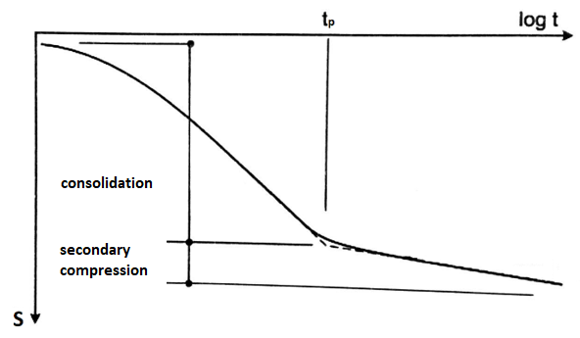
Figure 1. Load-logarithm time graph obtained by uniaxial loading test for clay soils.
In summary, time-dependent deformation of clay soils represents the compression behavior that occurs when free and/or adsorbed water is drained depending on the effect of an external load. On the other hand, osmotic effect caused by the increase in the salt concentration in the pore water creates an external load effect in the clay soil, causing the pore water to drain and creates a compression effect. In many ways, it is very similar to time-dependent deformation. Within the scope of this article, osmotic consolidation, which is specific to clay soils, and which occurs under the effect of hydromechanical load caused by osmotic rather than axial external load will be explained

2. TIME DEPENDENT DEFORMATION

Free / Adsorbed Pore Water and Double Diffuse Layer Concept

The interaction of clay with water, which includes the intermolecular forces and electromagnetic forces generated by adsorption of water, and water retention mechanisms are fundamental for the mechanical behavior of clay. There are different water retention mechanisms; hydrogen bond, hydration of exchangeable cations, osmosis retention, charged surface – dipole interaction, london dispersion force retention and capillary condensation (Figure 2) [3]. The void water held by clay due to aforementioned mechanisms is called adsorbed water. On the other hand, water unaffected by void water and which can move freely in the ground voids is called free pore water. Clay's affinity for water prevents movement of water easily under load. In particular, the water retention behavior has an important effect on the compression behavior of clay under load.
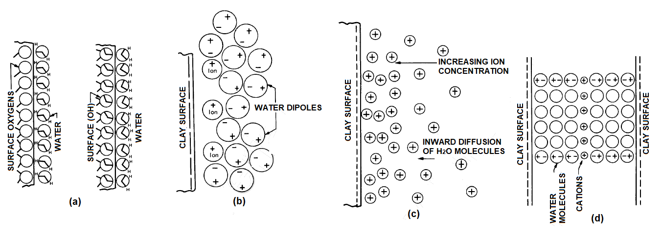
Figure 2. Water retention mechanisms for clay: (a) hydrogen bonding, (b) ion hydration, (c) osmosis retention, (d) dipole attraction [3]
The adsorbed water on the clay surface is in dynamic equilibrium with the effect of the internal forces in equilibrium and is called the double diffuse layer (DDL). The negatively charged clay surface attracts the oppositely charged ions due to Couloumb attractive forces, while the osmotic pressure forces push the oppositely charged ions away from the surface. The dynamic balance created by these two opposing forces creates the double diffuse layer (DDL). The general view of double diffusion layers is shown in Figure 3. The density of oppositely charged ions increase as they approach the surface. The density of the positively charged ions is less compared to oppositely charged ions. When moving away from the double layer boundary, the ion density reaches the ion concentration (C^{ꝏ}) in the free solution (not absorbed) (Figure 3)
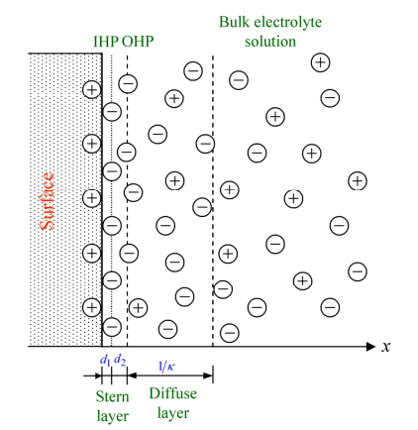
Figure 3. Stern and Gouy – Chapman Layers [4]
The double diffused layer thickness is highly affected by the electrolyte density in the solvent. With the increase in the electrolyte density, the area affected by the double layer (thickness of DDL), will decrease due to the charge increasing on the liquid-solid contact surface on the surface (Figure ). The reduction of the double diffused layer thickness due to electrolytes can be listed as follows according to their composition: 1:1<1:2=2:1<2:2<1:3=3:1. Divalent and trivalent ions are more effective for lowering the surface potential [4,5].
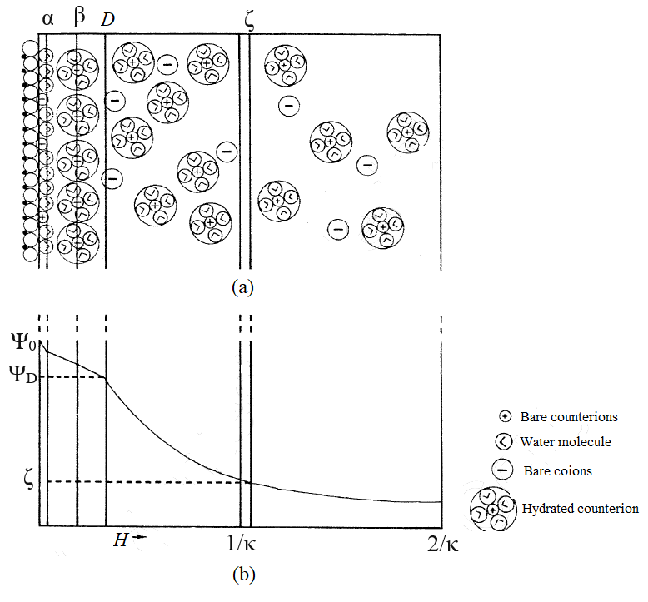
Figure 4. (a) Multilayer arrangement of water and ions near the clay surface (b) Damping of the surface potential with distance [3]
It shows the distribution of water and ions adjacent to the clay surface according to the hypothetical model proposed in Figure 4. In this way, the α plane is formed by the water molecule dipoles on the clay surface. Inner surface cations are already in this plane on this surface. The β plane is the plane of the hydrated ions closest to the surface. The D plane is the beginning of the diffuse layer. The 1/κ (debye length) plane is within the diffuse zone. The ζ plane is the shear plane that moves with the bound water and cations and particles and separates the remaining water and cations from the pore water in the electrokinetic flow [3]. The Debye length can be calculated with the help of the following equation:
$\frac{1}{κ}={\left(\frac{DkT}{8πn_{o}ϵ^{2}υ^{2}}\right)}^{1/2}$ (1)
1/κ : double diffuse layer thickness (debye length) k : Boltzmann constant
T : absolute temperature (ºK)
n_{o} : solution electrolyte concentration (ion/cm³)
ν : cation valence
Figure 5. Double diffused layer overlap formed by the convergence of two charged surfaces. [4]
When two double diffuse layers get close enough to overlap, a repulsive force occurs between the two surfaces (Figure 5). This repulsion effect prevents surfaces from approaching. However, the adhesion of oppositely charged ions to the surface will decrease the surface potential, the repulsion between the particles will decrease significantly and it will be possible for the particles to come closer. This will also have a beneficial effect on the flocculation of the grains. [3,4]

Change in Structure and Texture with Salt Effect

Clays with a very high specific surface and typical mineral crystal thickness of around 3 nm, in which montmorillionite (2:1 smectite group) is the dominant mineral, have a very high water holding capacity, while kaolinite with a relatively small specific surface and typical mineral crystal thickness around 50-2000 nm (1 :1 kaolinite group) is the dominant mineral and the water holding capacity of the clays is relatively low [2]. Due to this difference in water retention behavior, the dominant mineral type in the clayey soil will also create differences in its mechanical behavior.
In the study carried out with bentonite (montmorillionite), which is used to represent smectite group clays in many publications, it is stated that the double diffused layer (DDL) thickness is important in fabric formation. Especially after 0.5-1M NaCl concentration, the grains converge at a level that can lead to flocculation, and there is no big difference in the decrease of water holding capacity at densities above [6–8].
In the studies carried out with kaolin, which is also used to represent the kaolinite group clays, even though it is not as effective as the smectite group clays, the double diffused layer is effective in fabric formation. However, since the specific surface of the kaolin mineral is low and has a very short double diffused layer (DDL) thickness compared to the mineral thickness, the double diffused layer (DDL) that shortens rapidly under the influence of salt causes the particles to approach each other rapidly. Approaching grains are aggregated by forming face-edge (E-F) type at low salt density (below 0.2M) and face- face (F-F) type fabric at high salt density (above 0.2M). As a result of face-edge type agglomeration formed at low salt density, an increase in void ratio and an increase in water holding capacity are observed. At high salt density, the DDL becomes very shortened, causing a decrease in water holding capacity as a result of F-F aggregation

3. OSMOTIC COMPRESSION BEHAVIOR
The consolidation of saturated clays is the volume change with the removal of the adsorbed and/or free water in the soil with the flow depending on time. In this process, soil voids resisting fluid flow and deformation in the soil structure are effective. In the consolidation theory, the flow of water through the clay is expressed by Darcy's law and the deformation of the soil structure is expressed by a basic equation. The basic deformation equation is related to the effective stress [9]. If the interaction between the solid and liquid phase has not changed with the physiochemical effect, the effective stress provides a suitable explanation for the soil compression behavior. On the other hand, the presence of salts in the environment will change the pore water pressure distribution in the soil with the physicochemical interaction between the solid and liquid phases. This pore water pressure change will lead to a change in the mechanical behavior of the system.
3.1. The Concept of Osmotic Pressure
Osmotic pressure is the force applied to prevent movement of water into or out of clay. It is obtained by expressing the interparticle distance as a function of void ratio and water content. Osmotic pressure can be explained by an analogy in Figure 6 showing the interaction of liquids of different densities separated by a semipermeable membrane [3].
Here, the two sides of the cell are separated by a semipermeable membrane. While the membrane prevents ions from passing, it allows water to pass. Since the ion concentration on the left side is higher than on the right side, the free energy of the left side and the chemical potential of water are less than the right side. It cannot move to the right side to balance the solute concentration. However, the solvent can move to the left.
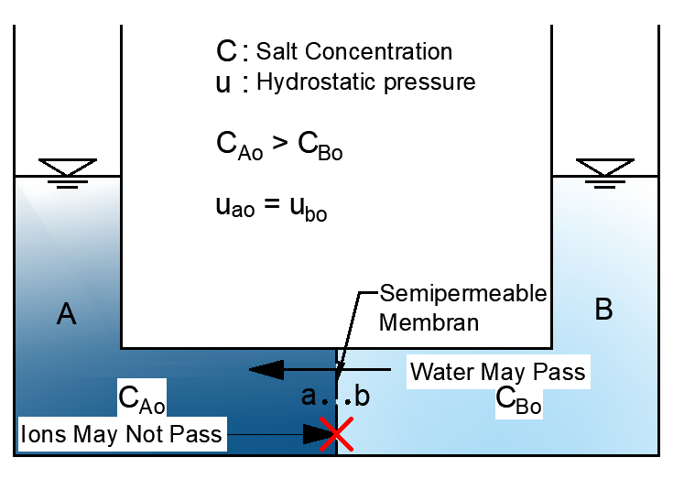
Figure 6. Osmotic pressure: Initial conditions: before equilibrium is established [3]
In the process of establishing the equilibrium, the solute concentration on the left side decreases and that on the right-side increases. which in turn balances the concentration of both sides. Secondly, a hydrostatic pressure difference occurs between the two sides. The free energy of water varies directly with the difference in pressure and oppositely with the concentration difference. These two effects reduce the balance between the two sides. The flow continues until the free energy of water becomes equal on both sides. (Figure 7).
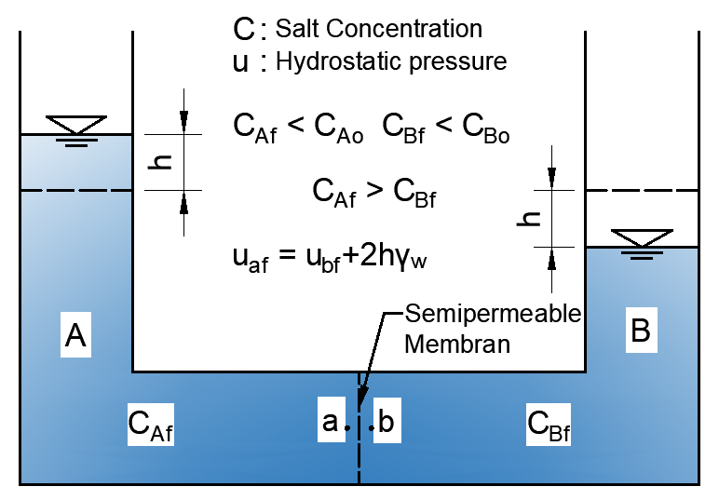
Figure 7. Osmotic pressure: Final conditions: equilibrium state [3]
The pressure to be applied to the left side to completely block the flow is called osmotic pressure (π). And for salt solutions it can be calculated by the Van't Hoff equation. As can be seen from the equation, the osmotic pressure is directly proportional to the concentration difference on both sides of the membrane (Figure 8).
$π=kT\sum{\left(n_{iA}-n_{iB}\right)}=RT\sum{\left(c_{iA}-c_{iB}\right)}$ (2)
$k=R/{N_{A}}$ (3)
π : ozmotic pressure (kPa)
k : Boltzmann constant
T : absolute temperature (ºK)
R : universal gas constant (8,32 kPa*lt/K*mol)
N_{A} : Avagadro sayısı (6,12x10²³)
n : concentration (number of particles per unit volume)
c : molar concentration (mol/lt)
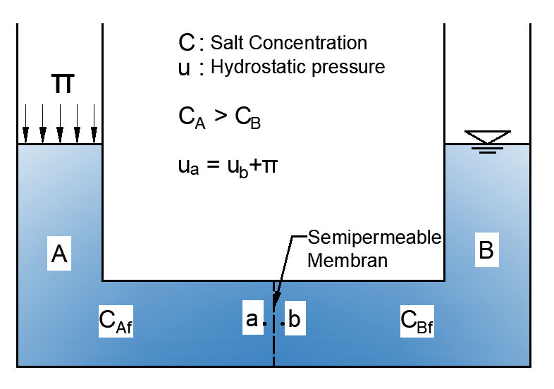
Figure 8. Osmotic pressure balance and definition of osmotic pressure [3]
3.2. Semipermeable Behavior Mechanism of Clay, Osmotic Flow and Osmotic Pressure
When a clay is exposed to a concentrated salt solution, its volume changes due to the combined effect of osmotic flow and osmotic compressibility. When the clay exhibits semi-permeable membrane behavior, osmotic flow occurs with the concentration difference. There is no semi-permeable membrane separating high and low salt concentration regions on the clay soil. The limiting membrane effect is caused by the effect of cations absorbed on the negatively charged clay surface. Due to the interaction of the absorbed cations on the clay particle surface, the cations cannot diffuse freely and as long as the double diffused layer of the adjacent clay particle overlaps, the concentration differences are effective in the formation of osmotic pressure [3,10].
The difference in the osmotic pressure in the middle of the clay particles and in the equilibrium solution surrounding the clay is the inter-particular repulsive pressure or swelling pressure (P_{S}). And can be expressed in terms of midplane potentials [11].
$P_{S}=π=RT\sum{\left(c_{iC}-c_{i0}\right)}$ (4)
For single cation and anion species of the same valence
$P_{S}=RTc_{0}\sum{\left(\frac{c_{C}}{c_{0}}+\frac{c_{0}}{c_{C}}-2\right)}$ (5)
c₀ and c_{C} : equilibrium solution concentration and midplane solution concentrations
The osmotic flow in the soil can be found with the help of the following equation:
$q_{π}=k_{π}\frac{∆π}{∆x}=σk_{h}\frac{∆π}{∆x}$ (6)
q : water flow (m/s)
k_{π} : osmotic permeability coefficient (m/s)
k_{h} : hydrolic permeability coefficient (m/s)
σ : osmotic efficiency
x : distance (m)
π : osmotic pressure (π/ρ_{f}g)
ρ_{f} : pore water density (kg/m³)
g : gravitational acceleration
If the soil behaves like a perfect semi-permeable membrane, the osmotic conductivity coefficient will be equal to the hydraulic conductivity coefficient. Under these conditions, only pure water can pass against the osmotic gradient. In imperfect conditions, the osmotic permeability coefficient will be equal to the hydraulic conductivity coefficient multiplied by the osmotic efficiency coefficient. The osmotic efficiency coefficient was defined by Staverman [12] and is expressed as the ratio of the osmotic permeability coefficient to the permeability coefficient ($σ={k_{π}}/{k_{h}}$). So osmotic efficiency is the rate at which clay behaves like a perfect semipermeable membrane. [3,12].
3.3. Osmotic Volume Change
It has been mentioned that volume change with chemo-osmotic effect in clayey soils can be identified with two theoretical definitions: osmotic-induced consolidation and osmotic consolidation [13].
Osmotic-induced consolidation occurs with the flow of water out of the soil by osmotic gradient. With this flow, a decrease in pore water pressure occurs within the soil and consolidation occurs in the soil with an increase in effective stress. Compression with effective stress increase is similar to the known consolidation, but effective stress increase occurs by osmotic process.
Osmotic consolidation, occurs with the change of pore water chemistry and electrostatic interactions between clay particles. These interactions are also affected by the distribution of charged ions in the pore water adjacent to the clay particles. Since the particle-particle interaction in clays is largely controlled by long-range forces, the magnitude of these forces is affected by the absorbed cations and the double diffused layer. Osmotic consolidation in clays, occurs with long-range forces altered by pore water concentrations and changes in double diffused layer thickness. The overlapping double diffused layers act as a semipermeable membrane. A charge contrast occurs between the free solution in the pore and the solution in the middle of the clay plates. The osmotic pressure between the solution in the cavity and the solution between the clay plates is then equalized to the swelling pressure by the repulsive forces. The change of external forces changes the intergranular distance until a new osmotic pressure differential equilibrium is established. Similarly, the change in the concentration of the pore solution, that is, the osmotic pressure, also changes the void ratio and compression occurs in the clay (Figure 9).
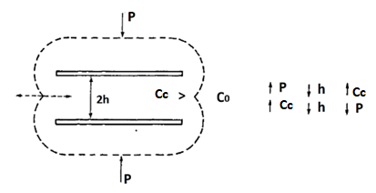
Figure 9. Explanation of osmotic consolidation with the concept of osmotic pressure [10]
P : Applied stress
C_{C} : Inter-particle pore water concentration
C_{O} : Free pore water solution concentration
h : Half distance between particles
Bolt [11] proposed a three-step approach for estimating the osmotic consolidation or swelling-induced deformation-pressure relationship:
For the calculation of the void ratio in the system, he first proposed an equation depending uponthe double diffused layer theory. The relationship between the inter-particle distance and the cation concentrations in the midplane is expressed as:
$υ\sqrt{βc_{o}}\left(x_{o}+d\right)=2\sqrt{\frac{c_{o}}{c_{c}}}\int_{ϕ=0}^{π/2}{\frac{dϕ}{\sqrt{1-{\left({c_{o}}/{c_{c}}\right)}^{2}\sin^{2}ϕ}}}$ (7)
ν : exchangeable cation valence
C_{C} : Inter-particle pore water concentration
C_{O} : Free pore water solution concentration
d : Half distance between particles
x_{o} : a constant that depends on the surface charge density of the clay. (for illite 0,1/ν nm, for kaolinite 0,2/ν nm, for montmorillionite 0,4/ν nm)
φ : surface charge density. (a variable depending on the central charge density and the variable, independent of its current value for the solution of the elliptic integral)
The eequation for the osmotic swelling pressure is as follows.. This equation evaluates the swelling pressure as the difference between the osmotic pressure in the central plane and the osmotic pressure of the free pore water:
$P_{S}=RTc_{0}\sum{\left(\frac{c_{C}}{c_{0}}+\frac{c_{0}}{c_{C}}-2\right)}$ (8)
c₀ and c_{C} : equilibrium solution concentration and midplane solution concentrations
In saturated clays, the distance between clay particles can be expressed as follows, based on the system void ratio:
$d=\frac{e}{G_{S}γ_{w}A_{s}}$ (9)
e : void ratio
G_{S} : Clay specific gravity
A_{S} : Specific surface area
d : Half distance between particles
γ_{w} : Unit weight of water
The k $υ\sqrt{βc_{o}}\left(x_{o}+d\right)$ - $log\left({P_{S}}/{RTc_{0}}\right)$ relationship can be obtained with the combination of (7) and (9). These values can be used to theoretically calculate the void ratio (e) – consolidation or swelling pressure graph. For any value of $log\left({P_{S}}/{RTc_{0}}\right)$ consolidation or swelling pressure values and for corresponding value of $υ\sqrt{βc_{o}}\left(x_{o}+d\right)$ void ratio can be calculated.
Figure 10 shows the theoretical void ratio pressure graph obtained by Bolt [11] in his study. In the study conducted with Na-montmorillionite and Ca-montmorillionite, it is seen that the theory is quite compatible with the actual results. The biggest reason for this harmony is that the clay used in the experiment is in the smectite group and with pure structure, and the mono-ionic (solution prepared with a single type of salt) solution is used. When the clay type or solution properties change, the agreement between theory and experimental results decreases.
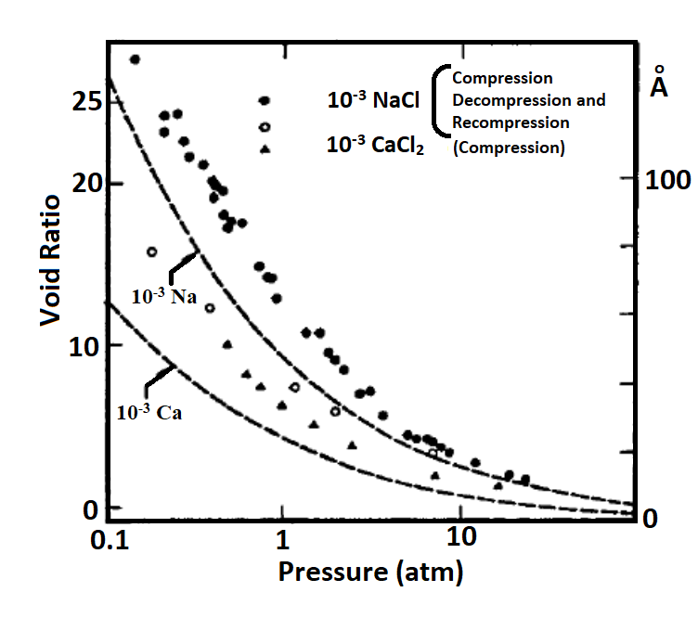
Figure 10. Compression curve of Na-Montmorillionite and Ca-montmorillionite (<2μm grain size, balanced with 10⁻³M NaCl and CaCl₂. Theoretical curves for dotted curves As=800m²/g.)[11]
3.4. Limits and Applicability of the Osmotic Pressure Concept
The concept of osmotic pressure can be applied in the presence of the following conditions [3,11,13]:
- The clay structure should consist of parallel grains. Thus, the applicability of the double diffused layer theory increases and the theory gives more consistent results. In studies carried out with clay suspensions or kneaded clay samples, results that consistent with theory were obtained.
- Osmotic pressure should be calculated with the van't Hoff equation. In this case, the structure of the clay should support the semi-permeable membrane behavior of the clay. In other words, the clay structure consisting of parallel particles will increase the efficiency of the osmotic pressure calculation.
- The void ratio should be calculated from the half distance between the clay particles. For this, the void ratio can also be calculated by calculating the debye length (double diffused layer thickness). Again, the structure of the clay should be in an ideal structure consisting of parallel parallel.
Considering the aforementioned basic conditions, the theory will give reliable results in smectite group clays prepared by kneading and in which the double diffuse layer thickness is decisive in shaping the chemomechanical behavior and structure. On the other hand, factors such as the presence of different clay minerals in the environment, the presence of different types of cations, the natural structure of the clay, and the magnitude of external loads will reduce the usability of the theory.

4. CONCLUSION
The current consolidation theory, which is used in the estimation of time-dependent deformation and proposed by Terzaghi [14], indiscriminately evaluates osmotic compression within the total consolidation compression. The estimation difference caused by osmotic compression is evaluated within the margin of error of the theory. It is known that consolidation experiments are carried out using distilled water in accordance with current international and national regulations. In soils with pore water with high solution density, the margin of error will increase due to osmotic reasons. Therefore, the estimation of the osmotic effect is important. In its current form, the proposed theory for osmotic compression prediction is capable of addressing the solution of a very limited number of cases, considering the total case. The theory needs to be developed to include different types of structures and different pore water properties. Since the theory was introduced, many studies have been carried out by many academics to fully understand the phenomenon and develop the theory. [3,6,11–23].
Considering the studies as a whole, the basic behavior was investigated by using mostly solutions containing only one type of ion of materials consisting of a single type of mineral such as pure montmirillionite or pure kaolinite. However, clay soils in nature consist of different minerals and many different organic/inorganic components as well as the clay part containing many clay mineral types. On the other hand, natural pore water components can also be composed of many dissolved components such as salts and organic solutions. The positioning of so many variables as parameters in a theory brings with it many complications and makes it almost impossible for the theory to mature. On the other hand, the consolidation theory put forward by Karl Von Terzaghi is simple, but an approach that accepts many unknowns in natural conditions is exhibited. For the estimation of osmotic consolidation, as all soil mechanics experiments do, it is best to focus on estimating the actual behavior of the soil by modeling the natural conditions as best as possible. To begin with, in the analysis of soil behavior in experiments, it would be wise to abandon the use of pure water and add a procedure that includes the analysis of pore water in the natural environment. In the next step, it should focus on making the existing test devices and experimental procedure more representative of natural conditions with technological possibilities.[3,6,11–23]

REFERENCES
[1] Das BM. Advanced Soil Mechanics (1983). Mc-GrawHill, New York 1983.
[2] Holtz RD, Kovacs WD, Sheahan TC. An introduction to geotechnical engineering 2011.
[3] Mitchell JK, Soga K. Fundamentals of soil Behavior. John Wiley& Sons, Hoboken, New Jersey, USA 2005.
[4] Ghosh P. Chemical Engineering - Interfacial Engineering . Intermolecular and Surface Forces 2012.
[5] Koper GJM. An Introduction to Interfacial Engineering. VSSD Delft; 2007.
[6] di Maio C. Exposure of bentonite to salt solution: Osmotic and mechanical effects. Geotechnique 1996;46:695–707. https://doi.org/10.1680/geot.1996.46.4.695.
[7] Calvello M, Lasco M, Vassallo R, di Maio C. Compressibility and residual shear strength of smectitic clays: influence of pore aqueous solutions and organic solvents 2005.
[8] Jang J, Cao SC, Stern LA, Jung J, Waite WF. Impact of Pore Fluid Chemistry on Fine‐Grained Sediment Fabric and Compressibility. J Geophys Res Solid Earth 2018;123:5495–514.
[9] Terzaghi K, Peck RB, Mesri G. Soil mechanics in engineering practice. John Wiley & Sons; 1996.
[10] Barbour SL. Osmotic Flow and Volume Change in Clay Soils. Dissertation. University of Saskatchewan, 1986.
[11] Bolt GH. Physico-Chemical Analysis of the Compressibility of Pure Clays. Géotechnique 1956;6:86–93. https://doi.org/10.1680/geot.1956.6.2.86.
[12] Staverman AJ. The theory of measurement of osmotic pressure. Recueil Des Travaux Chimiques Des Pays-Bas 1951;70:344–52. https://doi.org/https://doi.org/10.1002/recl.19510700409.
[13] Barbour SL, Fredlund DG. Mechanisms of osmotic flow and volume change in clay soils. Canadian Geotechnical Journal 1989;26:551–62.
[14] Thyagaraj T, Rao SM. Osmotic swelling and osmotic consolidation behaviour of compacted expansive clay. Geotechnical and Geological Engineering 2013;31:435–45.
[15] Nguyen XP, Cui YJ, Tang AM, Deng YF, Li XL, Wouters L. Effects of pore water chemical composition on the hydro-mechanical behavior of natural stiff clays. Eng Geol 2013;166:52–64. https://doi.org/10.1016/j.enggeo.2013.08.009.
[16] Kaczmarek M, Hueckel T. Chemo-mechanical consolidation of clays: analytical solutions for a linearized one-dimensional problem. Transp Porous Media 1998;32:49–74.
[17] Zhang T, Deng Y, Zhang D, Liu S. Preliminary Study of Pore Water Salinity Effects on the Swelling Behavior of Ca-Bentonite. Soil Behavior and Geomechanics, 2014, p. 54–64. https://doi.org/doi:10.1061/9780784413388.006.
[18] Zhang T, Wang S. Explanation of the influence of sodium chloride solution on volume deformation and permeability of normally consolidated clays. Materials 2019;12:1671.
[19] Rao SM, Thyagaraj T. Swell–compression behaviour of compacted clays under chemical gradients. Canadian Geotechnical Journal 2007;44:520–32.
[20] Rao SM, Thyagaraj T, Thomas HR. Swelling of compacted clay under osmotic gradients. Geotechnique 2006;56:707–13.
[21] Yang D, Yan R, Ma T, Wei C. Compressive behavior of kaolinitic clay under chemo-mechanical loadings. Acta Geotech 2023;18:77–94. https://doi.org/10.1007/s11440-022-01554-0.
[22] Scelsi G, Della Vecchia G, Musso G. An Elasto-Plastic Framework for the Chemo-Mechanical Behavior of Low to Medium Activity Clays. In: Barla M, Di Donna A, Sterpi D, editors. Challenges and Innovations in Geomechanics, Cham: Springer International Publishing; 2021, p. 648–55.
[23] Pubudu J, Buddhima I, Ana H. Influence of Salinity-Based Osmotic Suction on the Shear Strength of a Compacted Clay. International Journal of Geomechanics 2021;21:04021041. https://doi.org/10.1061/(ASCE)GM.1943-5622.0001988.

