STRUCTURAL DEFORMATION MEASUREMENT USING MATLAB IMAGE PROCESSING TOOLBOX

Zeynep Fırat Alemdar¹, Senem Bilici²

^{1,2}Yıldız Technical University, Department of Civil Engineering, Istanbul, TURKEY.
(E-mail: zalemdar@yildiz.edu.tr, snmbilici@gmail.com)

ABSTRACT

This paper describes the use of digital photogrammetry for measurement of deflections in concrete beams during the bending test. This new method to measure displacements in the experimental mechanics without applying digital sensors to the specimens is described. The optical technique uses a camera, a computer with frame grabber board and image analysis techniques within the MATLAB Image Processing Toolbox. The displacements at the surface of the test specimens are obtained by the analysis of the movements of dots painted on the specimen. The image analysis algorithm makes it possible to automatically track the motions of the dots and compute their centroid coordinates in a sequence of images. The aim of the study is to examine the surface deformations of the reinforced concrete under uniaxial loading and to compare with the results obtained from traditional instruments.

Keywords: bending test, deflection measurement, digital image processing

INTRODUCTION

Conventional deformation gauges produce recordings only for one or a few points and they are very difficult to use when it comes to small specimens or a small area of a specimen. In contrast to conventional instrumentation, photogrammetry is non-contact, requires no manual reading of dials, yields three-dimensional measurements and provides visual records of the testing. It is ideally suited for destructive testing since only a set of inexpensive targets is lost or damaged rather than expensive LVDTs or dial gauges. The new method to measure displacements in mechanical test pieces without applying sensors to the specimens is comprised of a camera and digital image analysis techniques within the MATLAB Image Processing Toolbox. Therefore, they are used to investigate relative displacements by the use of distinct markers on the specimen.

A literature survey shows that digital image processing has been widely used in a range of engineering topics in recent years. Austrell et al. (1995) investigated measuring displacements and strains in mechanical test pieces without applying sensors to the specimens. The image analysis algorithm made it possible to automatically track the motions of the dots and computed their centroid coordinates in a sequence of images. A method to interpolate displacements and compute surface strains have also been devised, by the use of finite element shape functions. An automatic procedure for detection of the dots on the first image would be time saving. The application of the dots on the test specimen also can be made more effective.

Yue et al. (2003) focused that a digital image processing based finite element method for the two-dimensional mechanical analysis of geomaterials and their materials had inhomogeneities and microstructures. Digital image techniques were used to acquire the inhomogeneous distributions of geo-materials including soils, rocks, asphalt concrete and cement concrete in digital format. The numerical results show that this new digital image process based finite element method can take into account the material inhomogeneities in the geomechanical analysis which can have significant effects on the tensile stress distribution along the loading axis of the Brazilian indirect tensile tests.

Whiteman et al. (2002) used digital photogrammetry for measurement of deflections in concrete beams during destructive testing. Results were presented from several tests of different types of beams. Some of advantages over contact methods including three-dimensional measurement of deformation components, unrestricted measurement range and immunity to nonlinear systematic errors were demonstrated. Comparison was made of photogrammetric and linear variable differential deflection measurements.

Jauregui et al. (2002) studied vertical deflection measurement of bridges using digital close-range terrestrial photogrammetry. First of all, the initial camber and dead load deflection of 31.1 m (102 ft) prestressed concrete bridge girders were measured photogrammetrically and compared with level rod and total station readings. Secondly, the vertical deflection of a 14.9 m (49 ft) noncomposite steel girder bridge loaded with two dump trucks was measured. Finally, Photogrammetric results are compared with deflections estimated using elastic finite-element analysis, level rod readings, and curvature-based deflection measurements.

Comak et al. (2011) investigated the potential for the utilization of image processing techniques in the area of civil engineering, specifically in concrete technology. The evaluation of the investigated parameters yielded that the utilization of image processing techniques in construction technologies, specifically in studies regarding the determination of the properties of concrete, has been progressively increasing.

Fırat Alemdar et al. (2011) studied the determination of the location of nonlinear response in structural systems which were under different loading conditions. Data was collected during the NEESR investigation of the seismic performance of four-span large-scale bridge systems that details deformations in column hinging regions during response to strong shaking events. A photogrammetry method was applied using a reference grid on the top and bottom column surfaces to record and analyze deformations in the plastic hinging regions. The surface deformations and rotations of a reinforced concrete bridge column under dynamic loading has been examined and compared with the results obtained from traditional instruments. The photogrammetry method performed very well to track the lateral and vertical displacements at the points on the grid surface as well as the deformed shape of the hinging regions, but the results of secondary calculations, such as rotations of the column, had limited success.

METHODS

The experiments were done as a graduate thesis at construction laboratory of Yıldız Technical University (Öztürk, 2016). The purpose of our study is that recorded video data during the experiments are converted to images and processed by using MATLAB program.

In general, the implementation of the DIC method comprises the following three consecutive steps, namely (1) specimen and experimental preparations; (2) recording the videos of the beam surface during loading; (3) processing the acquired images by converting the recorded videos using a computer program to obtain the desired displacement information. In this section, issues on specimen preparation and image capture are introduced first. Then, the basic principles and concepts of DIC are described.
Geometry of beams

In this study; the polypropylene fiber reinforced concrete beams without stirrups are subjected to the point load in the middle of the beams and the displacements have been examined. In the experiment, so as to distribute 1%, 2% and 3% volumetric content of polypropylene fiber in the concrete homogeneously, polypropylenes were added in the 3 different mixers and stirred for 10 minutes. Then, fiber reinforced concrete evacuated in the molds. In the experimental specimens, the ratio of the shear distance to the effective height of the beam was taken respectively 2.5, 3.5 and 4.5. The series of the beams are called as B25, B35 and B45. Due to consisting of 1% and 2% volumetric contents of polypropylene fiber, the beams are named as B35P10 and B35P20. The mechanical behaviors of these beams were investigated (Öztürk, 2016; Arslan et al., 2017).

The cross section of the beams used in the experiment, boundary conditions and loading conditions are given in Figure 1. Width of beam (b_{w}) is taken 150mm, height of beam (h) is taken 240mm. In the produced beams; tension reinforcements is used as 2Ф16 (Öztürk, 2016).

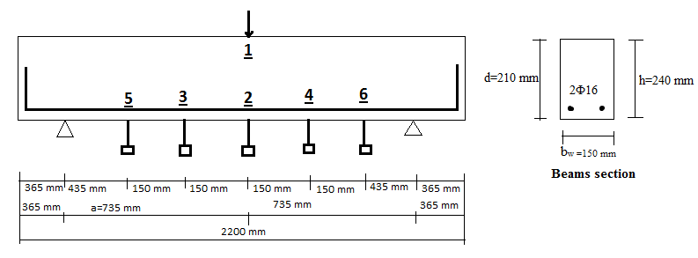
Figure 1. Beam sections, reinforcement settlements and locations of the linear variable displacement transducers (LVDTs)

The point at which vertical displacements on the load cell are measured by PDT (potentiometric displacement transducer) is defined as "1", and the point at which displacements of in the middle of the beam is defined as "2". For B35 series, the defined points “3” and “4” are 15 cm far away from the right and left side of the middle of the beam, the defined points “5” and “6” are 30 cm far away from the the right and left side of the middle of the beam as shown in Figure 1 (Öztürk, 2016).

Using Digital Image Processing

The video recordings were unaware that the image processing method could be used, for this reason records were taken by a normal camera and the effect of daylight was not prevented. These camera records have been converted to images by using VirtualDub-1.10.4 program. Front surfaces of the beams were divided into grids before the experiment (Figure 2). By means of the image processing method, displacements are captured from these grids which are closest to the midpoint of the beam, and the measured values ​​using the LVDTs at the middle point are compared.
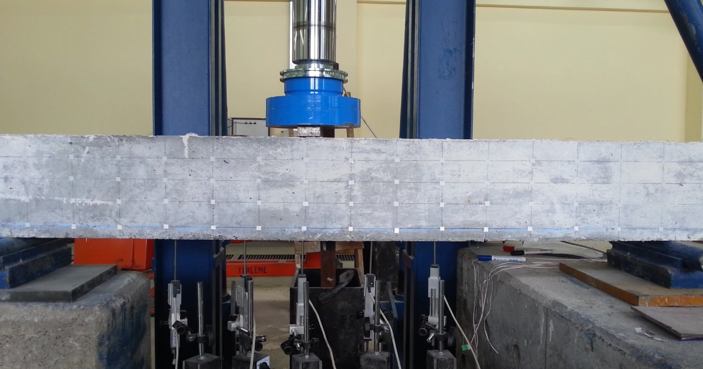

Figure 2. Front surface of the B35P10 beam

RESULTS AND DISCUSSION

While the image processing program was running, the colors in the grid were getting lighter as displacements increase. Therefore, these color differences caused deviations from the actual displacement due to the poor quality images. First of all, displacements of the beam called as B35P10 during the test was calculated and compared with the result of the LVDT numbered as 2. There is a different trend between the plots (Figure 4). The maximum measured value by the LVDT was 7.54 mm, the captured value using Digital Image Correlation was 6.69 mm. The error rate is equal to 11 %. The reason is considered that the video recording was in poor quality.

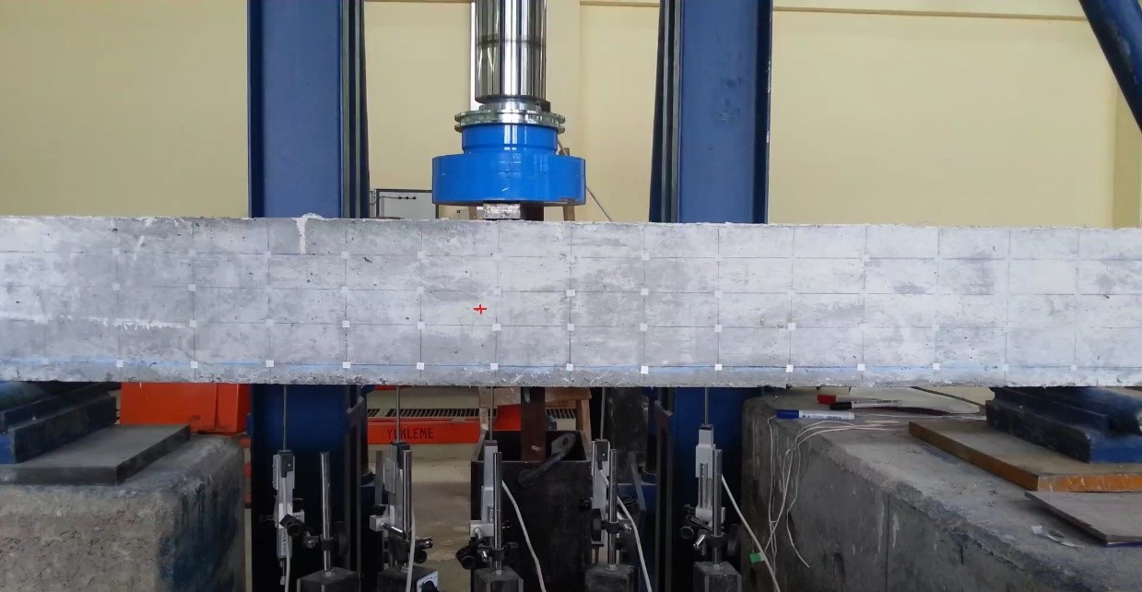

Figure 3: Reference point of recorded displacement of the B35P10 beam

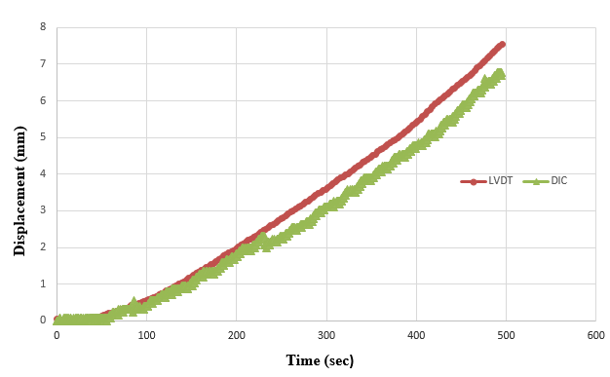

Figure 4. Comparison of the results of LVDT and DIC methods

Secondly, displacements of the B35P20 beam were calculated and compared to the result of LVDT. Almost the same trends and nearly the same maximum displacements were obtained as shown in Figure 6. The measured value of LVDT was 8.17 mm, the obtained value via Digital Image Correlation was 8.16 mm. The error rate is around 0.1 %. It can be seen that as the color difference decreases and the quality of the picture increases, the error rate decreases and the method gives a closer result comparing to the measured values.

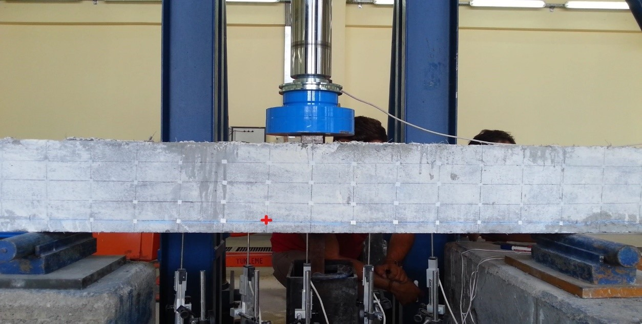

Figure 5: Reference point of recorded displacement of the beam B35P20

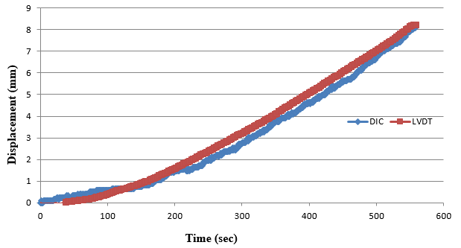

Figure 6. Comparison of the results of LVDT and DIC methods

Digital image correlation method generally suffers some disadvantages: (1) surface of the tested beam section may have a random gray intensity distribution; (2) the measurements depend heavily on the quality of the imaging system; (3) During recording video of the specimen surface, various noises (e.g. shot noise, thermal noise, cut off noise) are unavoidably presented in the digital images (Pan et al., 2009).

Compared with other interferometric techniques for deformation measurement, one significant advantage of the DIC is that it has fewer requirements in experimental environment, and can easily be implemented with a simple experimental setup. However, this does not mean that the measurement accuracy of DIC is not or less affected by the measuring system.

CONCLUSION

A simple photogrammetry analysis method was applied to evaluate the deformations of several beam specimens. The experiments were done as a post graduate thesis at construction laboratory of Yıldız Technical University and the video recordings were unaware that the image processing method could be used. Natural light prevented us from getting homogenous images of the beam specimens and video quality was also insufficient for the using image processing method. Such external factors have prevented us from getting close results to the image processing method. However, a near-realistic trend was obtained from the second sample thanks to good image quality and the error rate is relatively low compared to the other sample. In this study, only two beam specimens were used and other samples can also be used to improve this method. In addition, increasing the resolution of the camera and improving the capacity of the image processing machine gives better precision. Though having limitations, this method is cost-effective and accurate. Besides, it is of great importance when it comes to measurement of distances and deflections in inaccessible areas.

References

Arslan G., Keskin R.S.O. & Öztürk M. 2017 Shear Behavior of Polypropylene Fiber-Reinforced Concrete Beams without Stirrups, Structures & Buildings, 170 (3), 190-198.

Austrell P.E., Enquist B., Heyden A. & Spanne S. 1995 Contact Free Strain Measurement Using MATLAB Image Processing Toolbox, Nordic MATLAB Conference, Stockholm.

Çomak B., Beycioğlu A., Başyiğit C. & Kılınçarslan Ş. 2011 The Use of Image Processing Techniques in Concrete Technology, International Advanced Technologies Symposium, Elazığ.

Fırat Alemdar Z., Browning J. & Olafsen J. 2011 Photogrammetric Measurements of RC Bridge Column Deformations, Journal of Engineering Structures, 33 (8), 2407-2415.

Jauregui D.V., Leitch K.R., White K.R. & Woodward C. 2002 Vertical Deflection Measurement of Bridge Structures with Digital Close-Range Terrestrial Photogrammetry, First International Conference on Bridge Maintenance, Safety and Management, Barcelona, Spain.

Öztürk M. 2016 Shear Strength Of Polypropylene Fiber Reinforced Concrete Beams without Stirrups. MSc. thesis, Department of Civil Engineering, Graduate School Of Natural And Applied Sciences, Yıldız Technical University, Turkey.

Pan B., Qian K., Xie H. & Asundi A. 2009 Two-Dimensional Digital Image Correlation for In-Plane Displacement and Strain Measurement, Measurement Science And Technology Conference, UK.

Whiteman T., Lichti D.D. & Chandler I. 2002 Measurement of Deflections in Concrete Beams By Close-Range Digital Photogrammetry, Symposium on Geospatial Theory, Processing and Applications, Ottawa.

Yue Z.Q., Chen S. & Tham L.G. 2003 Finite Element Modeling of Geomaterials Using Digital Image Processing. Computers and Geotechnics, 30, 375–397.

