A Tribute to Professor Jan Szargut

09.09.1923 – 21.11.2017

Professor Jan Szargut passed away on November 21, 2017. He was a well-recognized name in the field of thermodynamics and mechanical engineering. His contributions to the field of exergy analysis, are widely cited by the international scientific community. He also inspired a whole generation of young scientists and engineers who made considerable contributions in science and engineering. His death is a great loss for the scientific community.

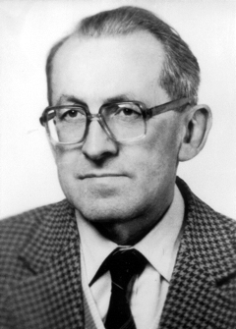
Professor Jan Szargut, Full Member of Polish Academy of Science
Honoris causa doctor of Silesian University of Technology, Częstochowa University of Technology and AGH Krakow University of Science and Technology

Jan Szargut, was born on September 9th, 1923 in Lwów (at that time Poland, currently in the Ukraine). There, he spent his younger years, attending primary and secondary school, and in 1941 he passed his GCSE. In 1942, he became a student at the Faculty of Mechanical Engineering at the Technical University of Lwów, which during the German occupation existed under the name Technische Fachkurse. After the War, in 1946, he moved to Gliwice, as did the whole TU Lwów, and he was continuing his studies at the Technical University of Silesia. He graduated in 1948 and in the same year he was employed as a senior research assistant. During 1951–1954 Jan Szargut participated in Ph.D. studies under the supervision of Professor Stanisław Ochęduszko (a former Ph.D. student of Wilhelm Nusselt), and in 1955 Professor Szargut received his doctoral degree based on the dissertation ‘Balance equations resulting from the 1st and 2nd Law of Thermodynamics’. In 1957 he became Head of the Chair of Thermal Engineering. During 1960–1962 Jan Szargut was Dean of the Faculty of Mechanical and Power Engineering, Technical University of Silesia. After 1971 he was Head of the Institute of Thermal Technology, and he held this position until his retirement in 1993. In 1976, he was elected a member of the Polish Academy of Sciences.

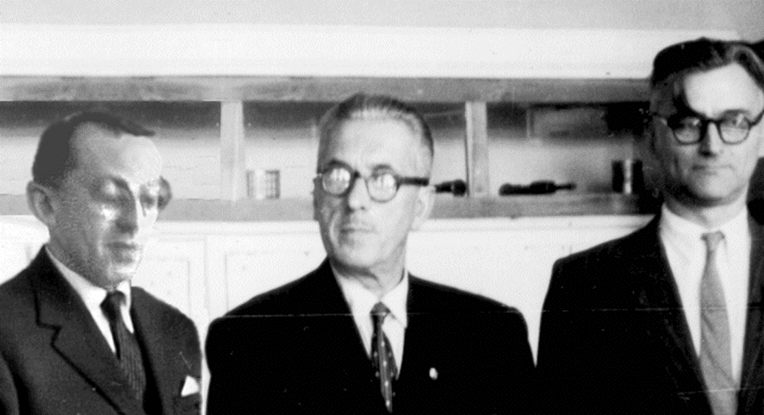
Creators of the Silesian School of Thermodynamics
and Faculty of Mechanical and Power Engineering, Technical University of Silesia
Prof. Jan Szargut - Prof. Stanisław Ochęduszko - Prof. Witold Około-Kułak

The scientific activities of Prof. Szargut began in the early 1950’-s mainly on the exergy analysis of thermal processes. This initiative started in 1956 Szargut with a paper titled ‘Balance of potentials in physical processes resulting from the second law of thermodynamics’ (in Polish) and opened a new avenue in using the second law of thermodynamics in design of thermal processes with heat and flows. His work on chemical exergy of elements on Earth had a vital impact on complete exergy analysis of physical and chemical processes. Professor Szargut also proposed some ecological and economic applications of exergy such as the concept of Cumulative Exergy Consumption (CExC), Thermo-Economics, and Thermo-Ecology. In the 1950’-s, Professor Szargut also worked on the application of the least squares adjustment method to measurement data reconciliation for mass and energy balances in chemical processes. This helped the exergy analysis become one of the important tools of thermodynamic analysis.
The achievements of Szargut in the field of exergy analysis were published in four important monographs: 1. Szargut J., Petela R. Exergy. PWN Warszawa 1965 (in Polish) and Eksergija, Moscow 1968 (in Russian), 2. Szargut J., Moris D. R., Steward F.R. Exergy Analysis of Thermal, Chemical and Metallurgical Processes. Hampshire, New York 1988 (in English), 3. J. Szargut. Exergy – Technical and Ecological Applications. WIT Press 2005 (in English) and 4. J. Szargut Exergy – Handbook of Calculation and Application. SUT Press 2007 (in Polish). Besides, Professor Szargut published many academic textbooks on the fundamentals of engineering thermodynamics, e.g.: ‘Thermodynamics’ (1971 and reissues), ‘Theory of Thermal Processes’ (1973), ‘Applied Thermodynamics’ (1991 and reissues) and ‘Exercises in Applied Thermodynamics’ (1979 and reissues; co-author), ‘Thermodynamic and Economic Analysis in Industrial Thermal Engineering’ (1983), ‘Fundamentals of Thermal Engineering’ (1998 and reissues; co-author). For many years until today, these books have been an invaluable source of knowledge for students learning thermodynamics and thermal engineering at the Silesian University of Technology. In total, Professor Szargut published 327 articles, 24 books and 12 handbooks, and he presented above 130 conference papers. For these scientific and didactic activities Professor Szargut is considered to be the creator of the Polish school of thermal engineering and one of the creators of the Silesian school of thermodynamics.
In 1993, Professor Szargut officially retired, but he did not give up his scientific activities. In addition to some books already listed, he was subsequently author, co-author or editor of several books: ‘Industrial Waste Energy’ (1993, in Polish, co-author), ‘Reducing the Energy Consumption in Industrial Plants’ (1994, in Polish, co-author), ‘Fundamentals of Energy Management’ (1995, in Polish, co-author), ‘Combined heat and power production – cogeneration plants’ (2007, in Polish, co-author), ‘Exergy – Handbook of Calculation and Application’ (2007, in Polish).

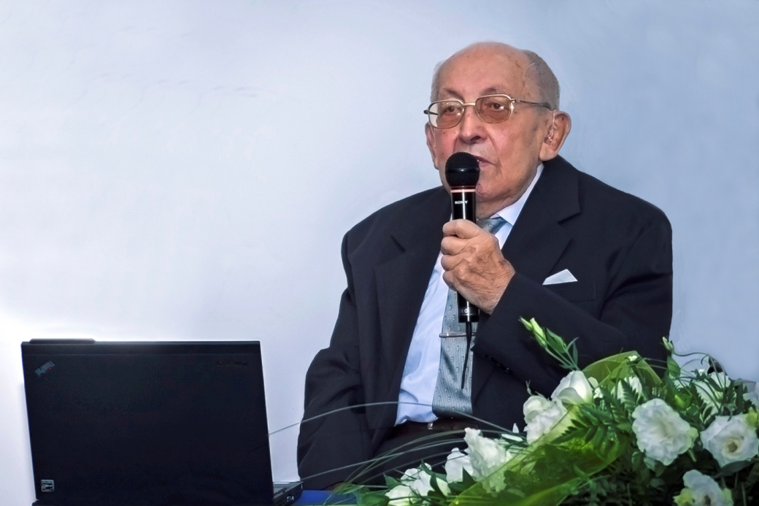 | 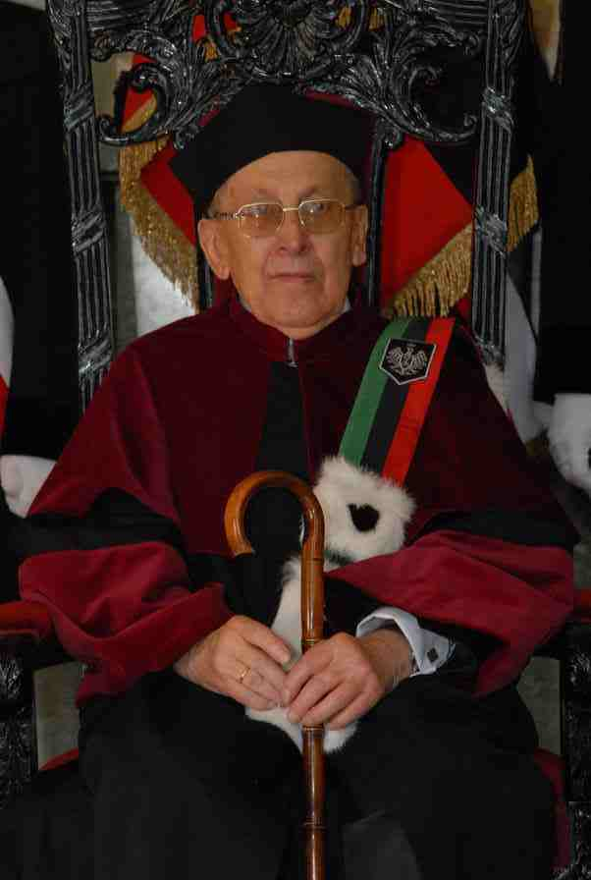
Professor Jan Szargut speaks during the 3rd Conference on Contemporary Problems of Thermal Engineering, Gliwice, September 2012 | Ceremony of honorary doctorate at the AGH Krakow University of Science and Technology

Twenty eight Ph.D. theses were prepared under his guidance, and fifteen of his former PhD students became full professors. Jan Szargut was a member of the editorial board of ‘Energy – the International Journal’, and a honorary editor of the ‘International Journal of Thermodynamics’. He also was a member of scientific committees of numerous scientific conferences.
Many of his former Ph.D. students became recognized scientists, i.a.: Ryszard Petela, Zygmunt Kolenda, Edward Kostowski, Andrzej Ziębik, Joachim Kozioł and others. Professor Szargut is a honoris causa doctor of three Polish Universities: the Silesian University of Technology, Częstochowa University of Technology and AGH Krakow University of Science and Technology. He was awarded numerous honorary state distinctions and rewards as well.
Closing this tribute we all would like to thank Professor Szargut for being an example of highest reliability, honesty and scientific quality, for all his inspiring life of a Great Scientist.

Professor Szargut rest in peace!
Wojciech STANEK, Andrzej SZLĘK and Wojciech KOSTOWSKI
Institute of Thermal Technology, Silesian University of TechnologyGliwice, January 2018.
Özer ARNAS  Adrian BEJAN  Ryszard BIAŁECKI  Janusz COFAŁA  Rene CORNELISSEN  Ibrahim DINCER  Yaşar DEMIREL (IJoT- Editor-In-Chief)  Daniel FAVRAT  Michael FEIDT  Christos A. FRANGOPOULOS  Richard GAGGIOLI  Abel HERNANDEZ GUERERO  Zornitza KIROVA-YORDANOVA  Signe KJELSTRUP  Zygmunt KOLENDA  Andrea LAZZARETTO  Noam LIOR  Lidia LOMBARDI  Henrik LUND (ENERGY – Editor-In-Chief)  Giampaolo MANFRIDA | Alberto MIRANDOLA  Tatiana MOROSUK  Silvia A. NEBRA  Silvio de OLIVEIRA JUNIOR  Krzysztof PTASINSKI  Constantine RAKOPOULOS  Dominick SAMA  Enrico SCIUBBA  Luis M. SERRA  Michael R. von SPAKOVSKY  Ireneusz SZCZYGIEL  Marcin SZEGA  George TSATSARONIS  Sergio ULGIATI  Sergio USON  Alicia VALERO  Antonio VALERO  Vittorio VERDA  Ruzhu WANG  Ron ZEVENHOVEN  Andrzej ZIĘBIK

