IMPROVING COMMUNICATION AND PRESENTATION SKILLS
IN ENGLISH FOR ENGINEERING STUDENTS
FOR SUSTAINABILITY

Assist. Prof. Dr. Mohammed Ghazy

Alexandria University, Egypt
mohghazy@gmail.com

Abstract: Improving communication skills in English becomes one of the primary engineering education outcomes. Engineering students should be aware of this fact and put this outcome as one of their targets while pursuing their bachelor’s degree and even after graduation. Instructors find some challenges achieving this goal when teaching humanity courses like communication skills and oral presentation skills. In the current approach we use a student survey along with experience obtained from teaching undergraduate engineering students technical and humanity courses. Experience from teaching in English in different universities makes this study more valuable. Case study analysis was done on the second year engineering students during the course of Academic Oral Presentation Skills. This analysis helps in uncovering some of the sources of communication difficulties in English and further helping tackling the problem in different ways. Results can be generalized to a global scale making it more applicable even though some of the difficulties are related to the local society in which engineering institution exists. Results from data analysis recommend allowing undergraduate students to give more presentations in English during their course work and team presentation at the final project of a course. Actually, this may require modifying the syllabus of some courses and allow utilizing new communication technology products. Also, a mathematical scheme to measure students’ improvements at the end of the course is proposed.

Keywords: [engineering education, oral presentation skills, communication skills, sustainability]

Introduction
In engineering education when talking about education for sustainable development it is important to remember the skills required from engineering students to help their societies. Consequently, instructors are required to teach or convey some of these skills to their students, especially oral presentation and communication skills in English. On the other hand, teaching in English in engineering institutions becomes more important than before. Nowadays, many higher institutions in non-English speaking countries have English as medium of instruction in their engineering courses. On the other hand, some institutions enforce certain percentage of their undergraduate courses to be taught in English. Some instructors who have been teaching in English for years have difficulties when interacting with engineering students in classes. Encouraging students to learn and communicate in professional English becomes their main concern. Nature of difficulties may vary from humanity courses to technical engineering courses with different grading and examination systems. Some of the difficulties that students face when communicating or interacting in English in classes may not appear during technical courses as their English may be sufficient for them just to understand mathematical formulas. The first step to alleviate these difficulties is to convince engineering students to make a strong correlation between proficiency in English language and progress in engineering education. Engineering students will not gain this proficiency immediately rather they should work on it while pursuing their engineering degree. But, it is noticed that they show less seriousness regarding humanity courses compared with other basic engineering courses. They should realize that mastering in their engineering careers after graduation is strongly related to their English communication skills.

It is common that most of the success comes from communication ability while technical ability gives smaller contributions [Worth, R.], [Barker, A.]. This fact should be taken into consideration when planning a new curriculum for undergraduate engineering students. In addition, successful engineers should be able to understand and use new technology in their works after graduation and their proficiency in English helps them doing this. Some of these engineers work in multinational companies and multicultural environments in which English may be the main language of communication. Actually, the need for a skilled engineer in the era of globalization was focused in the literature [Riemer, M.]. Communication and presentation skills will help students continuously developing their knowledge after graduation and throughout their career. Sometimes students from different engineering departments need a special seminars concentrating on communication skills as their English language courses are not sufficient [Kazamia, V.]. Corporations are also invited to supplement students with real company team practicing in parallel with the university education in communication and technical writing [Gover, J.], especially with the tremendous growth in technology [Wulf, W.]. Furthermore, to equip engineering students with necessary communication skills to be helpful to their societies and the human living will serve also in the sustainable development as an important target of universities [Filho, W]. Actually, Universities should satisfy the demands for the industry and also works on the welfare and development of the local society [Kostoulas-Makrakis, N.]. In addition, engineering education was considered within the context of education for sustainable development [Salem, T.]. Beside curriculum, students and instructors play important role in performing and disseminating university plan about sustainability [Harpe, B.], [Mcmillin, J.]. Within a global scale, the problem of teaching in English for non-English speaking engineering students has a worldwide importance [Başıbek, N.], [Gyong, E.]. Actually, one way to elucidate causes behind difficulties in learning in English for engineering students is to approach students themselves through questionnaires and surveys. This approach is a corner stone in our research, upon which statistical analysis helps in determining methodologies and techniques to improve learning in English for engineering students. A survey is done on the second year engineering students during the course of academic oral presentation skills given by the author. English was the language of instructions and examination in this course and students have natural variations in their English language proficiency.

This study was conducted to investigate and improve oral presentation and communication skills in English for engineering students. In this research a case a study including a sample of undergraduate engineering students was considered. At the beginning of the course Academic Oral Presentation Skills students were given an arbitrary survey to explore their realization and expectations about the course. They had introductory knowledge about the instructor and the course contents. They also knew that the course will be taught completely in English. As a matter of fact this is the first time they know about the course and there is no previous knowledge affecting their judgments and their perception to the information. Survey was conducted by instructor who has experience in teaching both technical and humanity courses in order to make the findings as general as possible. In the second section data obtained from a survey conducted on the course of academic oral Presentation skills are analyzed. In the third section findings and results are discussed, and then improvement index model is introduced with recommendation for future work.

Method

Figure 1 shows a copy of the survey which includes nine statements. There are five choices corresponding to each statement and a student has to fill the circle under his choice. The student should choose whether he or she strongly agrees, agrees, disagrees, strongly disagrees, with the statement or he or she doesn’t know. A student can also write additional comments if he or she wants at the end of the survey. But, he or she shouldn’t write his or her name or any personal information on the survey paper.
The results obtained from this survey are presented in the following figures. From figure 2 one may notice that that 71.4% of students see that the course is important for their career while figure 3 shows that almost 51.4% of them disagree or strongly disagree that they know clearly the objective of this course. It is obvious that more than half of them didn’t get clearly the objective of the course. Though only 42.9% of them perceived the message of the course or its intended learning outcomes they believe that the material that will be taught is important for their career. This reflects their trust in the institution and more importantly represents a basis or a fact which can be considered as the first motivation for them.

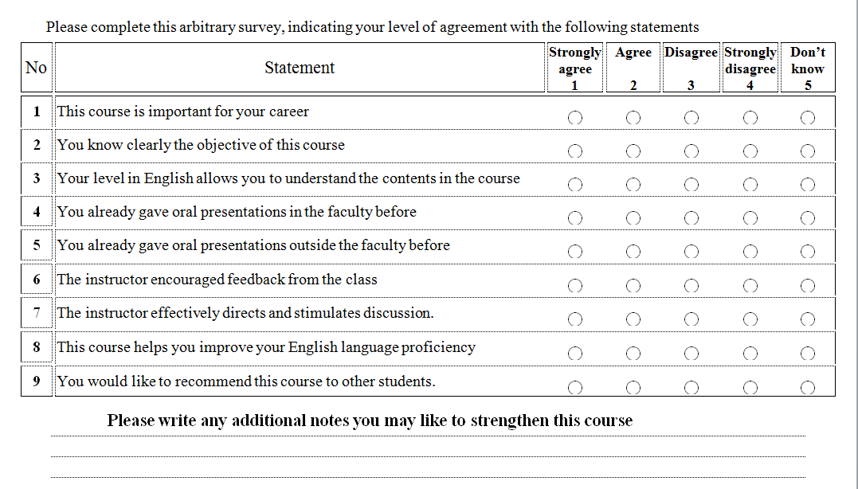

Figure 1. The Survey which was given to Students
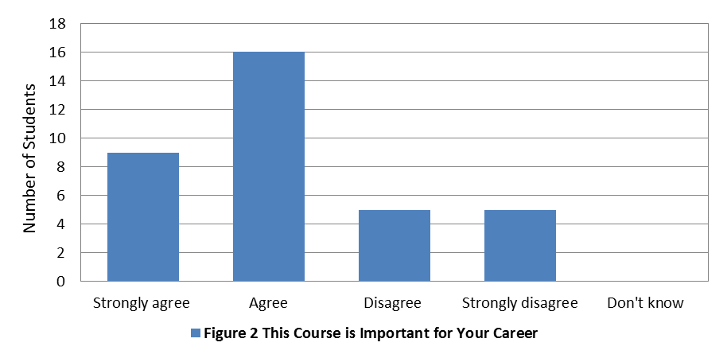

Figure 4 shows that 45.7% of students see that their English level allows them to understand the course material while 51.4% of them see the opposite and about 3% don’t know. It is obvious that they are quite split about this statement and the basic source of communication difficulties is clear. Though, students are split regarding their ability to understand the course in English, it may present a positive point when combined with results from figure 5. In figure 5 about 62.9% believe that the course will help them improve their English language. Now, their objective of understanding the course contents is aligned with the objective of improving their English language capabilities.

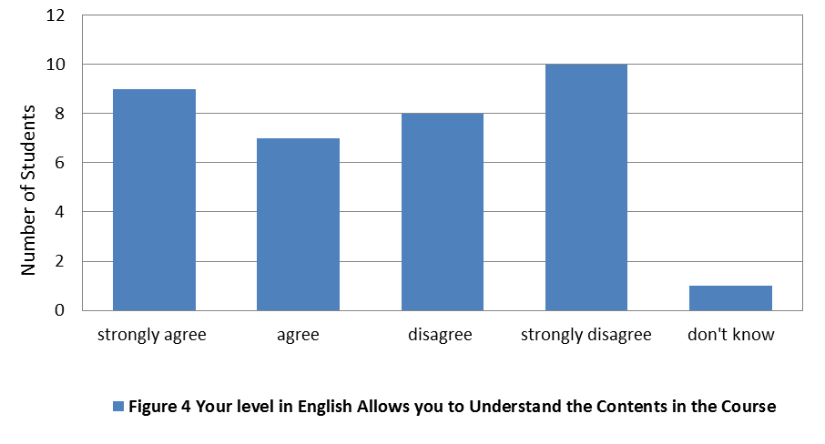

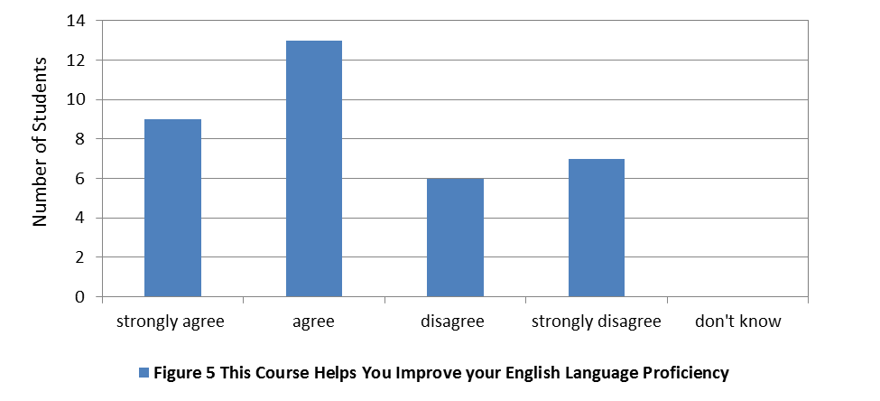
Figure 6 shows that only 31% of students have academic experience related to the course material and Figure 7 shows that 34.3% of them gave academic presentations outside the university. The majority then have no experience about the subject. This can be justified as students in the second year have mostly basic courses with no emphasis on presentations. For those who have experience it might be a chance to add to their knowledge and improve their communication skills and body language. Their target should be turning their communication skills from just some experience to developed professional expertise. On the contrary, those who have no experience with oral presentation may need some additional efforts to put them on the track with the former ones. However, it might be interesting for them to try something new. Actually, a student added a comment to the survey suggesting they give more presentations during the course to help them later when they go to a job interview.

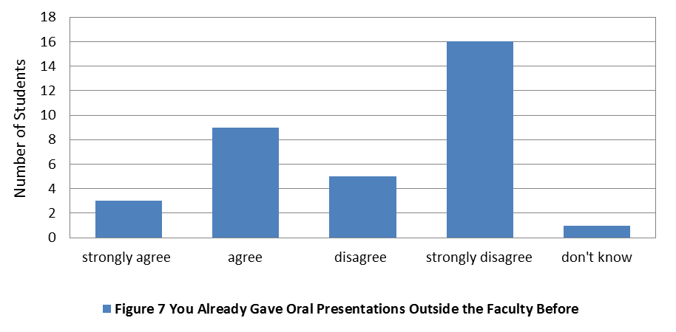
Figure 8 shows that 68.6% of students agree that the instructor effectively directs and stimulates discussion in the class room. Though this statement is specific and depends on the behavior of the instructor, it gives a positive measure about interaction in the class room. As a matter of fact such a measure can’t be neglected as the instructor is a corner stone in the learning process. And his reflections inside or outside the class room are important for motivating students to improve their communication in English. A comment was written on a survey paper saying that students should be more active in class otherwise they will be listening all the time to instructor without real gain.
Figure 9 shows that about 48.6% of students see that an instructor encourages feedback while equal numbers of students don’t and the rest don’t know. Actually this statement should be more specific about nature of the feedback. Is it immediate feedback through discussion in class or general feedback inside or outside class?

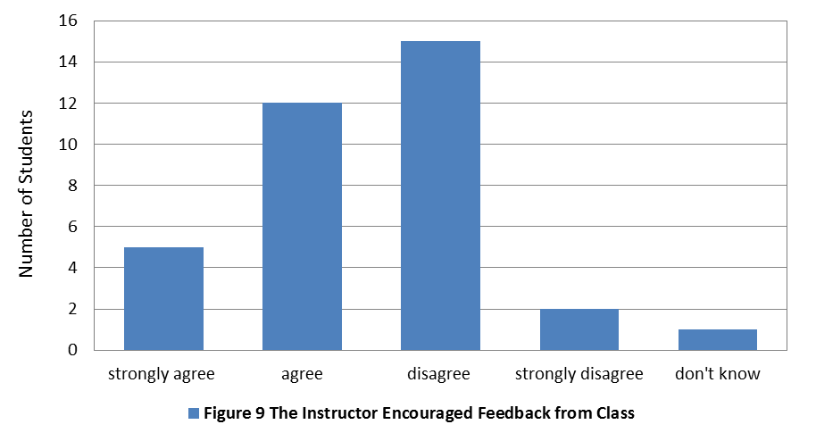
Figure 10 shows that about 54.3% of students would like to recommend this course to other students while 45.7% don’t like to recommend it. This is reasonably satisfactory results where more than half of students recommend this course to their friends or colleagues even though they didn’t finish the course yet.
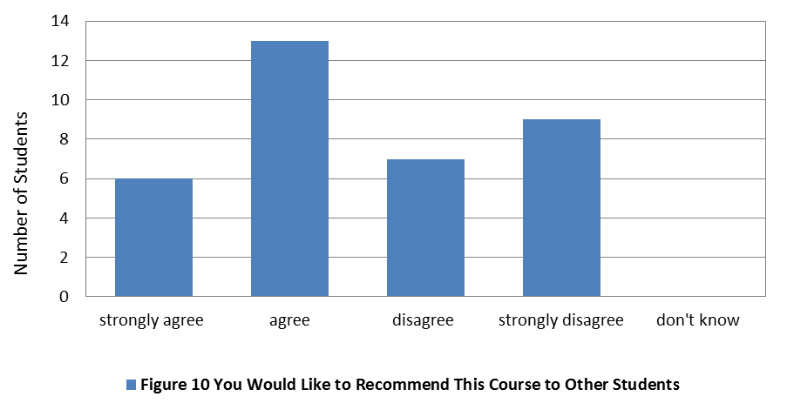

- Results and Discussion

The analysis indicates that students need more oral presentations practicing during their early undergraduate courses. This may require modifying the course curricula to give more time for class activities and more importantly to assign some marks for this purpose, taking advantage of growing use of social media products in communication. Furthermore, the course syllabus can be modifies to allow for more discussion and team work. Also, aligning between progress in engineering education, engineering career and improved English communication skills was important. As a result, students with improved presentation and communication skills will help themselves, their universities, and their societies. They will help promoting sustainable development plan inside their universities and later on inside their companies and their societies. More importantly, their better presentation and communication skills will help them to distribute concepts of sustainability and their understanding to apply these concepts from one society to other societies in the world.
Definitely, one straight forward measure of improvement is that students talk and communicate much more in English, as one of students hoped in his comments on the survey. But, still such a measure is a qualitative one and institutions may need to measure or compare success or failure and this task will be easier if improvement is measured in terms of numbers. Thus quantification of improvement measures is very important i.e. constituting an improvement index which is a function of individual variations in statements. This can be done on two scales; the individual scale for one student and total scale for all students in the course. On the individual scale an improvement index can be constructed as a function of variations in statements related to each student. On the course scale an improvement index will be a function of variations of statements for all students.
Assume that is the number of statements in a survey and , is the variation in the i^{th} statement where takes one of the values from 0 to 4 so that means no variation at all, means small variation, means medium variation, means big variation, and means very big or huge variation. The individual improvement index takes the form
, (1)
where is a scalar valued function of the variation vector . Likewise assuming that is the number of students and is the j^{th} index where a total improvement index takes the form
, (2)
Whereis a scalar valued functional and is the vector of individual improvement indices. The forms of the function and the functional are not proposed yet, they might be linear or nonlinear depending on the nature of each course.

Recommendations for Further Studies

The improvement index detailed modeling and calculations may be the subject of a second version of this paper in which numerical values for the variations exist. The effect of social media products on students’ communications can also be considered as important parameter.

References

Worth, R. (2004). Career Skills Library: Communication Skills Library. 2nd ed. Ferguson, New York. USA.
Barker, A. (2006). Improve Your Communıcation Skills. 2nd ed. Kogan Page, Philadelphia. USA.
Riemer, M. (2002). English and Communication Skills for Global Engineer. Global J. of Engng. Educ., (Vol. 6 No. 1, PP. 91-100).
Kazamia, V. (2012). Training Engineers on Communication Skills in English. European Society for Engineering Education, 40th Annual conference, Thessaloniki, Greece 23-26.
Gover, J. and Huray, P. (2007). Educating 21st Century Engineers. Meeting the Growing Demand for Engineers and Their Educators 2010-2020 International Summit, 2007 IEEE, Munich, pp. 1-30.
Wulf, W. (2000). How Shall We Satisfy the Long-Term Educational Needs of Engineers? Proceeding of the IEEE, (Vol. 88, No. 4, pp. 593-596)
Filho, W. (2011). About the Role of Universities and their Contribution to Sustainable Development. Higher Education Policy, (Vol. 24, pp.427 – 438)
Kostoulas-Makrakis, N. and Makrakis, V. (2012). Processes, Strategies and Practices for Turning the University of Crete into a Sustainable University. Discourse and Communication for Sustainable Education, (Vol. 3, pp. 5-22, 2012)
Salem, T. and Harb, J. (2012). Education for Sustainable Development: Assessment of Current Situation at the Faculty of Engineering of Notre Dame University-Louaize. Discourse and Communication for Sustainable Education, (Vol. 3, pp. 100-108)
Harpe, B. and Thomas, I. (2009) Curriculum Change in Universities: Conditions that Facilitate Education for Sustainable Development. Journal of Education for Sustainable Development (Vol.3, No.1, pp. 75-85)
Mcmillin, J. and Dyball, R. (2009) .Developing a Whole-of-University Approach to Educating for Sustainability: Linking Curriculum, Research and Sustainable Campus Operations. Journal of Education for Sustainable Development (Vol. 3, pp. 55-64)
Başıbek, N. et al (2014). Lecturers’ Perception of English Medium Instructions at Engineering Department of Higher Education: A Study on Partial English Medium Instruction at Some State Universities in Turkey. Procedia-Social and Behavioral Sciences, (Vol. 116, pp. 1819-1825)
Gyong, E. and Shin, A. (2014). Seeking an Effective Program to Improve Communication Skills of Non-English-Speaking Graduate Engineering Students: The Case of Korean Engineering School. IEEE Transactions of Professional Communication, (Vol. 57, No.1, pp. 41-55)

