DIAGNOSIS OF STUDENTS' PRECONDITIONS AND THE DEVELOPMENT OF ADAPTIVE TEACHING BY USING THE EXAMPLE OF THE GERMAN ENERGY TRANSITION

Katharina Hiller
Augsburg University, Faculty of Philosophy and Social Sciences, Chair for Civic Education and Civic Education Didactics
katharina.hiller@phil.uni-augsburg.de

Abstract
The research project at hand is embedded in the so called LeHet project at Augsburg University.The main aim of the LeHet project is to improve the future teachers' abilities and competencies to cope with pupils' heterogeneity. Therefore, based on a heuristic work model and a wider understanding of heterogeneity, four different fields of competencies were derived: (1) adaptive teaching based on students' preconditions, (2) individual counselling and encouragement, (3) use and analysis of educational media, (4) language learning and language encouragement. To advance all of the four fıelds, compatible, interdisciplinary and subject specific teaching and learning proposals are going to be developed, implemented and integrated into the regular course offer. The research project at hand is integrated into the first field, adaptive teaching. By analyzing the preconditions of students concerning knowledge of and attitudes towards sustainable development an ideal use of adaptive teaching methods should be developed to foster a deeper understanding of the topic in the sense of strong sustainability. Pupils as future consumers must be enabled to decide which actions, both individual and collective, can promote strong sustainable development. Automobiles and mobility as one important part of the energy transition was chosen as the major issue to present a concrete and vivid example to the pupils aged fifteen and sixteen. Cars are an integral part of the students’ life. They are necessary for their own mobility but moreover they also represent a status symbol. A holistic approach, using methods of dilemma and scenario technique, revealing the different interests, views and actors should be used to deal with the topic at hand in lessons of social studies in German grammar schools. Teaching post students but also present teachers of social studies should be trained to fulfill the task and to become aware of the different challenges, keeping in mind the guidelines of the Beutelsbach consensus. An empirical study of the teaching unit plan is planned to make the results of the project visible.

Keywords: [Teacher, Adaptive Teaching, Education for Sustainable Development, Energy transition, Automotive industry Quantitative study.]

Introduction

The research project at hand presents an approach to foster the topic “Education for Sustainable Development” (ESD) by focusing on the topic energy transition and, within this major content, the aspect of mobility to improve the understanding and importance of that issue first regarding the students' understanding as future teachers but also and in the end the pupils ‘understanding at German grammar schools. To fulfill this aim adaptive teaching methods have to be developed using the methods of dilemma and scenario technique after a diagnosis of pupils ‘perceptions and preconditions concerning this topic using concept maps as the diagnostic tool. Only with the knowledge of pupils’ perceptions a teacher can create an ideal use of proper contents and setting focal points to make sure that a complex topic in class is understood by pupils. Teacher‘s training courses are developed concerning diagnostic tools and the creation of adaptive teaching competence. After the study teachers should receive a “package“ to teach “ESD using the example of German energy transition“ by using adaptive teaching. The research project is embedded within the so-called LeHet project (“Teachers’ proficiency dealing with heterogeneity”), which is boosted by the German Federal Ministry of Education with the general aim to improve teachers’ education nationwide. In the long run, teaching and learning proposals are going to be developed, implemented and integrated into the regular course offer to prepare the students to cope with ESD in school. Therefore, a module “ESD and adaptive teaching“ will be implemented in the regular course offer at Augsburg University. The LeHet project started at Augsburg University in the year 2015. Together with 19 other German universities Augsburg University got the award to be part of the qualities initiative within teachers ‘education. The main aim of the LeHet project is to improve the future teachers' abilities and competencies to cope with pupils' heterogeneity. Therefore, based on a heuristic work model and a wider understanding of heterogeneity, four different fields of competencies were derived: (1) adaptive teaching based on students' preconditions, (2) individual counselling and encouragement, (3) use and analysis of educational media, (4) language learning and language encouragement. To advance all of the four fields, compatible, interdisciplinary and subject specific teaching and learning proposals are going to be developed, implemented and integrated into the regular course offer. Different departments work within this project. The innovative point is the fact, that interdisciplinary teamwork of lectures and tandem teaching is an integral part within this project. As said, the research project at hand is located within the first field of competency: adaptive teaching. By analyzing the students’ preconditions concerning knowledge of and attitudes towards sustainable development an ideal use of adaptive teaching methods should be developed to foster a deeper understanding in the sense of strong sustainability. Taking into account the two general options of efficiency and sufficiency concerning sustainable development only the latter way is appropriate to create a substantial turn towards a sustainable living in a long term perspective (Ohlmeier&Brunold, 2015, p. 87ff). Therefore, ESD must be a dominant part of teachers ‘education at university but also a prominent topic in social science at school.
As mentioned above, Education for Sustainable Development must find a prominent role within the subject of social studies. This study wants to find an optimal way to foster a deeper understanding of sustainability and empower pupils to decide on sustainable or not-sustainable developments in the long run. Therefore, the complexity of the topic especially regarding the different actors and dimensions must become familiar to them. Keeping in mind the “Magic Square Frame of Aims” (Brunold 2004, 2015) a holistic approach must be chosen to cope with the topic:
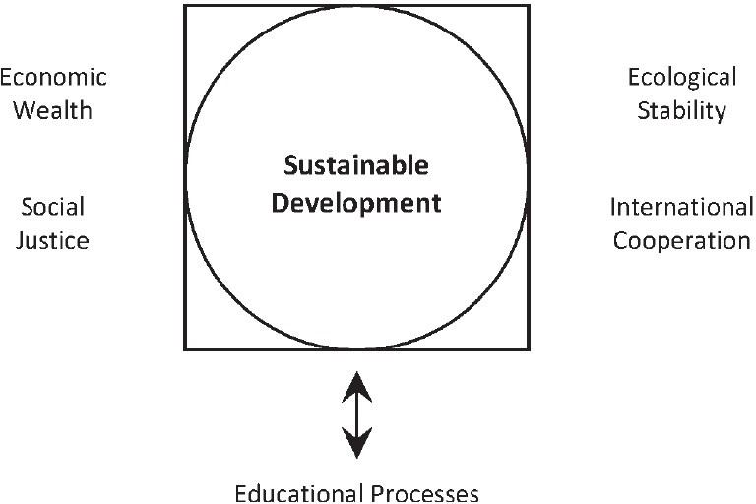

Figure 1: Magic Square Frame of Aims (Brunold, 2015, p. 31)

The meaning of education for a deeper understanding of sustainable development and its role for desirable changes towards sustainability becomes evident (Brunold, 2015).
The challenge of the study at hand is to diagnose the different perceptions, maybe misconceptions and views concerning the different factors and to build up an appropriate lesson unit with adjusted use of suitable methods to reach this major goal.

Literature Review

For the study at hand, different scientific areas are crucial and so is the literature within these fields. Regarding the importance of Civic Education for Education for Sustainable Development the works of A. Brunold and B. Ohlmeier are of crucial meaning. For the wide field of diagnosis and the use of concept maps different sources are crucial: especially Mosch's dissertation on diagnosis in the field of social studies was of importance. Moreover, Weifieno's findings concerning empirical work within political didactics are also of big interest. Concerning concept maps the standard work of Novak&Gowin but also the theoretical part of Stracke' s dissertation paper serve as relevant sources. In this context Nesbit&Adesope and their meta-analysis is also of importance. Mosch is again to mention when thinking of concept maps in social studies. There is a wide field of literature concerning perceptions. The researcher concentrated on works of Reinmann/Mandl and again Mosch and Möller. Beck et al. is a significant source when working on the topic of adaptive teaching. Other findings of importance are the works of Wang and Corno. More and more literature exists concerning changes within automotive industry and the aspect of sustainability. Hetterich, Barbian and Brunner can be mention here. All three authors deal with new ways of integrating aspects of sustainability into automotive companies. To illustrate pupils ‘perceptions regarding the given topic in different age groups few studies are used to investigate the given state: the Hessenstiftung 2008/2013, Lüschen 2015, Van Deth/Abendschön/Rathke/Vollmar 2007 and Hauenschild 2002.

Aim of the Study

The aim of the study is to create an ideal use of adaptive teaching using the methods of dilemma and scenario technique to gain a deeper understanding for sustainable development. Besides this major goal a contribution should be made to minimize the scientific gap existing in civic education concerning the use of quantitative studies (Rieh 2006, Weifieno 2012). In this context it has to be stated that the use of concept maps in the field of social science is underrepresented as this tool is predominantly used in natural sciences (Stracke, 2004). In addition to this aim concerning methodological aspects the whole research project is meant to improve on the one hand the teacher’s abilities in using adaptive teaching methods and on the other hand to strengthen the teacher’s knowledge of sustainable development in general and the understanding of the German energy transition in particular.

Method - Projected study

For a deeper understanding of the research project the major issues concerned with the study should be introduced in the following to give the reader an overview. Since the 70s, in the context of the anti-nuclear movement in Germany, a social discourse started to exert pressure on the government’s work regarding a shift in energy policy. In the year 2000 the coalition of social Democrats and the Green Party signed the so-called Nuclear Consensus to change nuclear policy in a long term. (Kopatz, 2014) However, after the change of government in the year 2005 a lot of decisions were revised. In the end, the catastrophe of Fukushima in 2011 brought a rethinking and the German coalition started to foster climate protection, energy efficiency and an extension of renewable energy resources within energy policy (Kopatz, 2014). Directly after this rethinking crucial decisions were made and immediately implemented: eight nuclear power plants were closed and all others should be closed by the year 2022. The German energy policy goes hand in hand with the European energy policy and its goals (Fischer/Geden, 2014). Concerning the general meaning and impact, it must be stated that the energy transition means an enormous political, economic and technical exertion with complex differing views and many agents involved (Kopatz, 2014). Within the energy transition three core areas can be identified: energy, heat and mobility. The research project puts the focus on mobility and within this major topic the aspect of automotive. The motivation for this decision is evident: cars belong to the every-day life experience of pupils. Even though not being drivers yet, they know and experience their use for own mobility and flexibility. Moreover, cars also represent a status symbol, especially German cars of the premium sector. Vehicles seem to be a desirable product for the pupils’ future. Moreover, the automotive industry itself seems to change. And this strengthens the decision for this topic as core content for the study as well. Responsibility reports of different OEMs, new approaches in development and productions but also new administrative requirements seem to introduce this shift (Barbian, 2011; Brunner 2006; Hetterich 2013). A critical examination of these developments seems desirable and necessary when thinking of pupils as the future consumers and decision makers.

Participants

The projected study will take place at German grammar schools. Approximately 10 classes of the 10* grade should be involved. The average amount of pupils can be fixed by 30 persons per class. The 10* grade was chosen because of different factors and assumptions:
- Pupils of the 10* grade are aged sixteen. Questions of further developments in general and regarding one’s own life in particular start to be on focus. The pupils begin to prepare for A-level qualification. Some of them maybe search for alternatives: e.g. training. It’s the age when pupils are allowed to vote on municipal or federal state level. Therefore, certain contents of the subject social studies become vivid and important for them.
- Mobility seems to be very important at that age. Either these pupils have older friends already owning a driving license or they practically plan their own driving license. Therefore, cars are likely an issue at that age. Especially the question of status might be of certain importance. Thoughts of owning a car and saving for a special one might occur during that age. This might be an appropriate connecting point to
introduce the topic of energy transition.
- School structure and certain requirements play a further role: social studies as a subject starts at Bavarian grammar schools in this grade (exception: grammar schools with a social science focus, then up from 8* grade). Moreover, the 10* grade doesn’t belong to the qualification period of the upper grades before A-level. From a teacher’s point of view this fact makes participation more likely.
There are diverse studies which show the interests of young pupils for climate change and prove a certain understanding of factors, actors and implications. Even at elementary level and the beginning of secondary level pupils show an awareness of the topic.
Haunschild's study (Haunschild, 2002a, 2002b) puts a focus on action situations among pupils aged nine to thirteen:
- there are personal experiences concerning the topic of air pollution and cars,
- collective and indirect measures concerning air pollution and plants,
- minor expectations in results concerning climate change and nature.
In general it must be stated that children are aware of local actions and global effects even at that age.
Another study (Hessenstiftung 2008) with participants aged nine to fourteen shows some interesting points and regarding the projected study at hand some crucial information:
- an active participation in environmental protection seems to be a rather exotic experience,
- the biggest gap can be identified between the subjectively experienced difficulties in using environmentally friendly means of transport and the actual use of it,
- there is a general guilty conscience concerning the topic of climate change followed by anxiety; the bigger the knowledge concerning that issue the bigger the pupils ‘guilty conscience,
- the lower the knowledge the bigger the lack of interest for that issue, but more knowledge for the topic increases the willingness to participate in environmental protection,
- with increasing age that willingness for own contribution seems to decline.
A newer study by Hessenstiftung, LBS-Kinderbarometer, also offers some data regarding the awareness of the energy transition itself (Hessenstiftung 2013, pp. 58-59).
- 42% of the children participating in the survey at hand have not heard about energy transition at all,
- there is a significant link between valuation and understanding: the bigger the understanding of energy transition, the bigger the acceptance and positive valuation of it and vice versa,
- another link exists between valuation and anxiety: the stronger the anxiety the less positive the valuation of energy transition and vice versa.
Lüschen (Lüschen 2015) found out that children aged ten to eleven
- just partly recognize environmental problems as global issues,
- but have differentiated ideas and explanation patterns.
And Van Deth/Abendschön/Rathke/Vollmar (2007) found out that children aged six to seven find the topic of climate change less interesting than war and terror.
All these given studies prove the necessity to foster issues of sustainable development in higher grades, first of all to strengthen and widen the pre-existing knowledge and therefore support a willingness to participate and second to avoid a decrease of interest. Moreover, it becomes clear that certain knowledge and perceptions are already there which must be incorporated into the work and planning of effective teaching units.

Sampling Procedures

Within the framework of the LeHet project a network of different school forms around Augsburg University was built up (this is still an ongoing process) and periodic meetings take place. For the study at hand interested grammar schools were asked to join the research project. Teachers of social studies were contacted and a first meeting took place in which the project and its intentions were introduced. The first three teachers served also as multipliers and more teachers have already been asked by these colleagues. The target amount of ten classes will be reached. The fact, that the given research project is promoted by the Ministry of Education (and all needed permissions are therefore given) makes it easier for the schools to join in.

Instruments / Scales

The importance of diagnosis becomes evident when thinking of a constructive approach in teaching and learning (Reinmann/Mandl, 2006). Those who want to teach must be aware of pupils ‘perceptions and previous knowledge. Especially concerning civic education with a strong link to “every day life” topics, views and problems, knowledge of students ‘perceptions seems to be very crucial (Mosch, 2013). Moreover, as mentioned before, diverse studies prove that a certain knowledge concerning the given topic exists which must be taken into consideration. Perceptions and preconditions are mental tools to act reasonable in the world. They represent learners' views, ideas and conceptions “learned“ before school in different and diverse amounts and shapes. They can be detected independently concerning age, gender, cognitive skills and cultural background (Wandersee/Mintzes/Novak, 1994; Kron 1993). Their occurrence might be in form of deep structures or current constructions, e.g. spontaneous decisions. To change misconceptions or to expand vague “every-day life” perceptions can be achieved by two different strategies: the conflict strategy, in which learners should be convinced that their views/perceptions are limited and have to be changed and therefore a mental conflict must be created, or by tying strategies, which mean a differentiation and expansion of suitable but vague previous views. Both strategies have the main goal of a conceptual change. (Möller, 2010) Taking into account the given topic of mobility one can surely say that diverse perceptions exist (Winkel 2002). Moreover, as one mentioned study shows, the choice of transport seems to be one dominant climate protection measure for pupils (Hessenstiftung 2008). These perceptions have to be considered while planning an ideal lesson unit. Of course there are diverse ways of investigating these perceptions: Interviews, questionnaires but also “simple methods” as brainstorming or mind maps used in class. All these methods can help to give the teacher a picture of his pupils he is working with. However, in the research project at hand, the use of concept maps as a diagnostic tool was chosen.
In the following this tool should be presented and chances of this method should be shortly discussed.
“A concept map is a schematic device for representing a set of concept meanings embedded in a framework of propositions“ (Novak&Gowin, 1984, p.15). They are graphic organizers which “were conceived as an entailment of Ausubel’s theory of meaningful learning, according to which learners actively subsume new concepts within pre-existing, superordinate cognitive structures” (Nesbit&Adesope, 2006, p. 413).. Clearly, the main function is to draw conclusions from the results on pupils' preconditions, perceptions knowledge and misconceptions. Using them before the start of a lesson unit they can help the teaching person to adapt to the present “structure” in his or her class. Moreover, due to the schematic form of concept maps pupils can more easily see and recognize their position in the process of learning:
“... learners become the agents of their own learning since they are actively participating in their own learning process. Moreover, the learner exhibits how he/she plans to learn more and this is very important for the teacher to be able to collaboratively build a learning programme which would be relevant to the learners' way of responding to new information and so prove to be truly motivating and meaningful.” (Vanhear & Pace 2008)
There is some evidence that especially low-ability students can benefit from this method because of its regular and simple structure. (Nesbit&Adesope, 2006)
Although originally meant and predominantly used in natural science, concept maps have now found their way into social science and show certain benefits especially in these language intensive subjects (Fürstenau 2011; Nesbit&Adesope, 2006).
The composition of concept maps might be hierarchical (from abstract to concrete) or in form of networks with crosslinks (Jüngst 1992; Novak&Gowin 1984). Moreover, the extent of individual activity may also vary: full constructions of individual concept maps, comparison with or analysis of a master map or concept maps with gaps are possible ways (Fürstenau 2011). In the given study the focus will be on a concept map which should be completed. The knots will be given. The task will be to find the right links and labels for these links.
The evaluation of concept maps can be carried out in the following ways:
- quantitative evaluation (Stracke, 2004, p. 69ff.) with the following indices: extent, density of connections, rugged structure, correspondence analysis,
- qualitative evaluation: e.g. interview of test persons.
The given study will only use quantitative elements for evaluation. In the course of further detailed planning decisions will be made concerning potential selections of certain indices.
After introducing the importance and ways of diagnosis, adaptive teaching as, one can say, consequence of the previous thoughts, should be in the focus.
Adaptive teaching means the adjustment of teaching (including instructions, choice of methods etc.) to the specific class conditions and individual student's needs. (Beck et al, 2008). Therefore, adaptive teaching systems recommend the best places to start new content and when to review old content.
The goals of adaptive teaching can be identified as follows (Corno, 2008; Hardy et al. 2011):
- every child should be encouraged in such a way that his or her potential is optimally used to the maximum,
- the (minimum-) standards of the curriculum should be accomplished,
- all children should extend their knowledge,
- no (high-risk-) group of pupils should fall back,
- individual differences in learning should become less visible,
- variation in class should not be extended.
Adaptive teaching competency means the teacher’s ability to adjust instruction to the individual learning processes of pupils in such a way as to create favorable conditions for each student’s learning for understanding. (Beck et al, 2008).
“Providing adaptive instruction requires that alternate means of instruction are matched to students on the basis of knowledge about each individual's background, talents, interests, and past performance. An individual child' s abilities and styles are assessed, both upon entrance to and during the course of learning, and the information obtained is used in selecting subsequent alternative learning opportunities“ (Wang, 1980, p. 122).
As two methods, namely, dilemma and scenario technique, are on focus in the given study they should be shortly introduced at this point as well. Using them in an adaptive way both can contribute to a deeper understanding of the given topic.
1) Dilemma method
The goals of the dilemma method can be shortly defined as followed (Kaiser&Kaminski, 2012):
- a critical approach with conflicts of values,
- awareness and reflection with own moral concepts and standards,
- ability to deal with different reasons and thinking patterns,
- conflict management with regards to democratic legal systems,
- ability to self-critically realize the potential mismatch between ethical-economic knowledge and practical action,
- ability to decide due to information material by weighing pros and cons.
The use of the dilemma method in class consists of different steps (Kaiser&Kaminski, 2012):
- presentation of the moral dilemma: introduction, terminological explanations, given problems,
- personal position determination, overview of other positions, collecting reasons for different positions,
- review of justification: choice of appropriate approach, discussion of different individual positions within class or group, discussion of reasons concerning sounding questions,
- consideration of a certain justification: summary of the discussed reasons, note of one justification.

Concerning the topic, “ESD using the example of the German energy transition” (with the focus on mobility) one can state, that this method is especially appropriate to reveal the different interests of the diverse agents and also to make the difficulty of decision making visible.
The following figure illustrates the conflicts existing in the four different dimensions within sustainable development. Within these general conflict lines the diverse interests shortly mentioned above can be located.

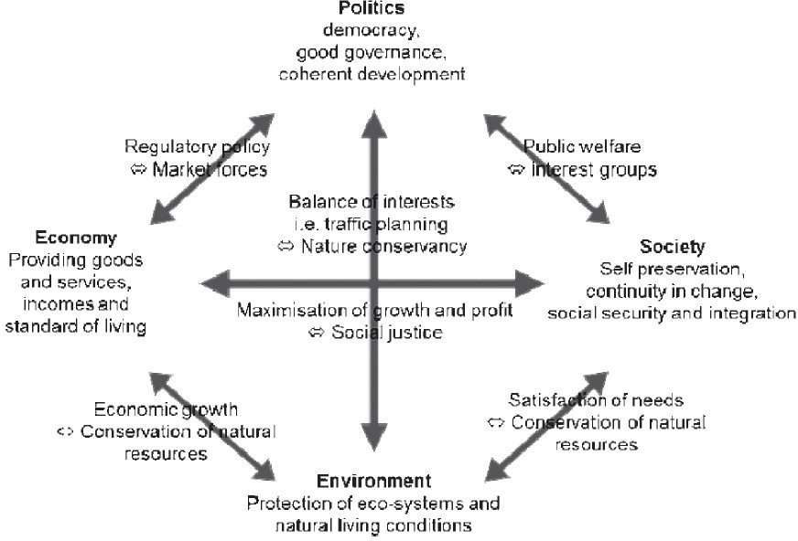

Figure 2: Conflict of goals between development components (Ohlmeier, 2013, p. 15; Source: BMZ & KMK, 2008, p. 30)

2) Scenario technique
The scenario technique puts another emphasis a different aspect: the question of future implication of present developments. Technology assessment is the key word when using this method in the given context.
The overall goal of this technique is to form a potential future scenario based on present facts and development factors (Albers & Broux, 1999). Normally, three different types of scenarios can be formed: the best-case scenario, the worst-case scenario and the
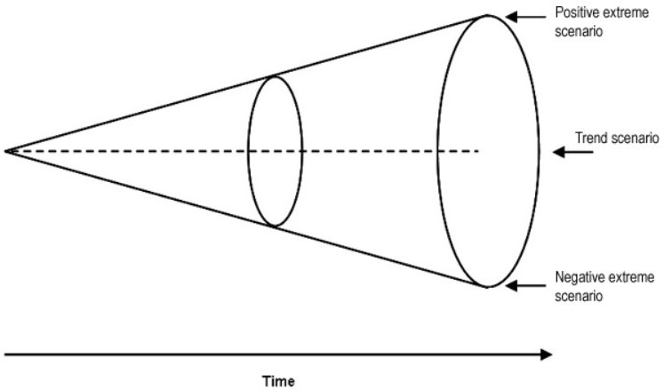
trend scenario:

Figure 3: Scenario funnel with three basic scenarios. (Source: Albers & Broux (1999), modified)

The development of scenarios in class should enable the learner to deal with a future-oriented question in a systematical and constructive way (Albers & Broux, 1999). Moreover, this method takes the constructivist view of learning into account. (Meixner & Müller, 2004).
The use of the scenario technique in class consists of the following steps (Peterhen, 2009):
- determination of current problem for which a solution should be found,
- assessment and organization of all known and important data regarding specific spheres of influence (present knowledge),
- investigation of (groups of) factors regarding the way of influence on the given problem, projection of the different influences into the future and discussion of the probable future meaning for the problem at hand. (future knowledge),
- modelling of scenarios and their evaluation among best possible and worst possible solution (practical knowledge),
- decision for the best possible scenario and revision until implementation (action model).

The following figure illustrates the different steps (here in five steps):
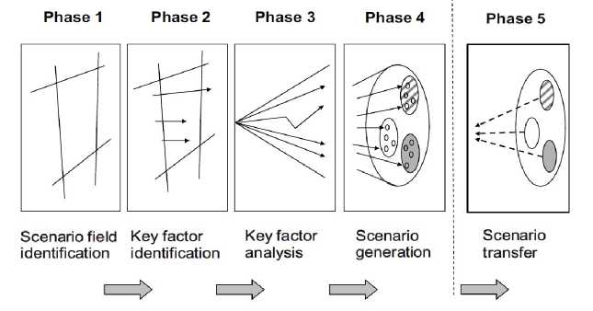
Figure 4: The general scenario process in five phases. (Source: Kosow, GaBner 2008)

“Effective ESD at formal education institutions is dependent on a change in praxis” (Vanhear & Pace 2008, p. 53). Therefore new methods as the two methods presented before can serve to promote ESD in school and make the learner not only knowing about the given issue but transform the pupils into active participants and future critical consumers.
“In this way, ESD must seek to foster individuals who are capable of independent thought and action. To this end, educational policy must consider citizens in their entirety, as both rational and emotional actors” (Ohlmeier, 2013, p.18).
To reach this important aim, different competencies, including the dimensions of knowledge, values and skills, must be in the focus and an integral part of all considerations. In this context Brunold (2015) and Ohlmeier and Brunold (2015) recommend a political-democratic competency model for civic ESD which is based on De Haans'eigth competencies in ESD (De Haan 2004).
These are
- the competency to recognize and evaluate forms and conflicts of aims of political, economic, ecological and social value orientation and their interests, as well as being able to act upon it,
- the competency to develop skills of participation and intervention for own interests and interests related to the common welfare, as well as being able to act upon it,
- the competency to engage in the civil society and civic involvement in democracy,
- the competency to percept global challenges from multiple perspectives,
- the competency to perceive human and civil rights and being able to represent them actively,
- the ability to understand and form the link between local experiences and their global context in the global society,
- the competency to anticipate future risks and reflect on the individual and global alternatives of acting and taking the responsibility of it, and
- the competency to reflect the individual and cultural models which are provided by the media as well as to reflect consumption patterns and life styles as a politically mature citizen. (Ohlmeier, 2013, Brunold, 2015).
The critical, reflective and empowered citizen that is the overall goal in civic education sees the “tragedy of the commons” (Hardin, 1968) in the given context when dealing with and reflecting on the topic of sustainability. Within the framework of ESD due to the choice of the two given methods the pupil recognizes the fundamental problem of the commons by experiencing on the one hand the socio-ecological dilemma and on the other hand experience maybe some future implications of the “common environment” when particular developments and decisions will be continued. The key recognition of the commons is that:
“Whenever one person cannot be excluded from the benefit that others provide, each person is motivated not to contribute to the joint effort, but to free-ride on the efforts of others. If all participants choose to free-ride, the collective benefit will not be produced. The temptation to free-ride, however, may dominate the decision process, and thus all will end up where no one wanted to be” (Ostrom 1999, p. 6).
Regarding the question of mobility and automotive in particular in relation to pollution and taking into consideration the role of all consumers, the following figure illustrates a dilemma which is in line with the model of “the tragedy of the commons “or, to mention another model, “the prisoner' s dilemma”:

car no car
comfort plus polluted air | comfort plus good  air quality
no comfort plus polluted air | no comfort plus good air quality

Figure 5: Decision regarding pollution as prisoners’ dilemma

Ostrom developed some design principles of how to avoid the “tragedy of the commons” or the “prisoner ' s dilemma”:
- user boundaries: clear and locally understood boundaries between legitimate users and nonusers are present,
- resource boundaries: clear boundaries that separate a specific common-pool resource from a larger socio-ecological system are present,
- congruence with local conditions: appropriation and provision rules are congruent with local social and environmental conditions,
- appropriation and provision: appropriation rules are congruent with provision rules; the distribution of costs is proportional to the distribution of benefits,
- Collective-choice arrangements: most individuals affected by a resource regime are authorized to participate in making and modifying its rules.
- monitoring users: individuals who are accountable to or are the users monitor the appropriation and provision levels of the users,
- monitoring the resource: individuals who are accountable to or are the users monitor the condition of the resource,
- graduated sanctions: sanctions for rule violations start very low but become stronger if a user
repeatedly violates a rule,
- conflict-resolution mechanisms: rapid, low-cost, local arenas exist for resolving conflicts among users or with officials,
- minimal recognition of rights: the rights of local users to make their own rules are recognized by the government,
- nested enterprises: when a common-pool resource is closely connected to a larger social-ecological system, governance activities are organized in multiple nested layers. (Ostrom 2009)
As Ostrom shows there are ways to deal with commons in an effective way without negative consequences for society and all its members. However, the awareness and acceptance of these ways must become known to the majority of decision makers. ESD can here be a tool to reach this aim in the future.

Research Design

Before the investigation in class will start, training for the involved teachers is planned. In these training teachers will be once more acquainted with the most important facts of the study. As Education for Sustainable Development needs teachers who are aware and competent concerning this issue a common ground of background knowledge must be generated before starting to teach this topic at school. Especially due to the complexity of that topic with its different dimensions, factors etc. and combined with the fact, that the topic is not a compulsory and explicit issue during teacher training courses at university this first step of generating a common knowledge ground among the participating teachers seems highly reasonable. The focus then will be on two major issues: on the one hand teachers will be again introduced into the method of concept mapping, its definition, structure and evaluation and on the other hand they will be acquainted with the principles of adaptive teaching. As mentioned before, concept maps are quite new diagnostic tools in social studies. Therefore they must be trained and introduced at this meeting. The overall goal of this training is to create a master concept map used for a common understanding of the topic expressed in this map and a construction of a possible tool (concept map to be completed by pupils) to use in class. The training should also be a platform to think about the two methods to use in class and an adaptive way of implementing them.
In a second step the teachers will start the planned lesson unit by evaluating the perceptions concerning the topic by using concept maps. After analyzing this data an adaptive way of using the two methods at hand will be created. Both methods will be used in class during the lesson unit. After finishing the unit, an evaluation will be carried out, again using concept maps, which will be more complex. Classes without a specific use of these methods and an adaptive way of teaching should serve as control groups. The comparisons of the final evaluation in both groups should serve for a deep investigation of possible profits resulting from the implementation of the described procedure. After finishing this project, the “package” of the planned lesson unit will be accessible for interested teachers and schools. Moreover a permanent module at Augsburg University will be implemented with the purpose of teaching students during their teacher training course as preparation for their future careers as teachers for social studies. Details concerning the exact amount of pupils in both groups (groups with and without the described intervention) are still in working progress.

Results and Discussion

As the study at hand is still in progress and will be carried out in autumn this year, no specific results can be presented. However, a seminar took place in the winter term 2015/2016 at Augsburg University in which students developed concept maps for the given topic and used them in different classes of different school forms. Therefore some first results out of this explorative approach can be described. Four concept maps were developed by students: one for a 4* grade class of an elementary school, one map for a 8* grade class of a general school (offering a lower secondary education level) and two maps used in the 10* and 11* grade of a grammar school. Although different age groups were part of this investigation, some interesting observations could be made and should now be presented.
In all four groups the actors of “state” and “economy” (represented by automotive companies) were not linked at all or wrongly labelled regarding their connection. Even in higher grades the knowledge and perceptions of these two dimensions within ESD were rudimental. Moreover, some misconceptions could be identified regarding the energy transition, e.g. different factors and their mutual influence (e-mobility and consequences for energy policy to name just one example). What seems to be present in all classes is the role the pupil her-/himself owns. Personal measurements concerning climate protection were visible. Even younger pupils at primary school named possibilities how to reduce CO2 emissions. However, the awareness of interdependence with other dimensions or even a global perspective was rudimental. These first findings correspond to the results of the named studies above.
In the current summer semester (2016) a seminar is still proceeding in which a further investigation of these results is taking place. The focus in this seminar lies on the development of an appropriate use of the given methods for these four groups. First of all the students were asked to evaluate the data of the former semester. Their findings were similar to the first evaluation. In a second step the students are asked to develop ways of adaptive teaching within this frame. Taking into account the first observations one can state a certain focus within these two methods which must be set:
Within the dilemma method the different agents and their diverse interests must play a prominent role:
- politicians and decisions makers who obviously are in a certain dilemma: economic welfare and therefore political success and ecological necessities which become more and more prominent among the average population,
- companies, especially in a key industry as the automotive industry in Germany, and their dilemma of fulfilling new administrative requirements, meeting consumers ‘needs and wishes and reaching good sales figures,
- consumers and their different interests and needs on the one hand and different levels of awareness concerning personal responsibility regarding sustainability
Pupils don’t simply get to know the different positions but by analyzing and taking over the different roles they are able to construct and experience the dilemma. The same is true for the students at university. Students develop their adaptive teaching competency at this stage of their teacher training.
Within the scenario technique the different impacts of present decisions and needs can be used to prognosticate a possible or probable future. Here again pupils are not just receivers of knowledge and passive observers of certain developments but are put into the position to become active participants of future developments. Especially regarding the topic of sustainable development both methods are therefore suitable to create a deeper understanding of sustainability and above all to encourage critical and reflective thinking which is crucial because
“Critical and reflective thinking is acknowledged as one of the key skills within education for sustainable development (ESD). Sustainable development requires a shift in the mental models which frame our thinking and inform our decisions and actions. Thus, the attainment of sustainable development requires transformative change at social and cultural level; a change that involves experiencing a deep, structural shift in the basic premises of thought, feelings and actions about our being in this world.” (Dovros, Makrakis 2012, p.75)
Therefore both methods as presented above are important tools to reach a deeper understanding and respond to the demand of using holistic, critical and reflective ways within the classroom. (Dovros, Makrakis 2012). Through this approach the demand for sufficiency in the sense of strong sustainability instead of efficiency can be followed up.
These first findings may lead to some interesting hypotheses concerning the research project at hand which should be part of the following short discussion.
Although no findings can be discussed at this early point of the study, some important issues can be in focus at the end of this paper. First of all, this study will clearly contribute to the claim for more quantitative studies within civic education. By using concept maps as a diagnostic tool and a quantitative evaluation of them in pre- and post-tests the dominance of qualitative approaches can be diminished. Moreover, the use of concept maps as a (quite) new approach within social science can also be seen as a promising strategy within the given study which can prove the benefits of this instrument for the topic ESD and in general for the subject social studies. Especially concerning the question of diagnosis this tool seems to be highly suitable. A first explorative approach within the seminar work led to some interesting findings: the political dimension in the context of sustainable development seems to be weakly pronounced. Taking into account the demand for the extension of the goal tries of sustainable development (ecological balance, social justice and economic welfare) to political dimension (good governance) (Brunold, 2009), these observations make clear that targeted measures are needed to fill this gap in knowledge and reach a change in perception.

References

Albers, O. & Broux, A. (1999). Zukunftswerkstatt und Szenariotechnik. Ein Methodenbuch für Schule und Hochschule. Weinheim.
Barbian, D. (2001). Ökonomie und Sustainable Development: Entwicklung eines Ansatzes zur Umsetzung von Nachhaltigkeit. Aachen.
Beck, Erwin et al. (2008)Adaptive Lehrkompetenz, in: Padagogische Psychologie undEntwicklungspsychologie.
Brunner, M. (2006). Strategisches Nachhaltigkeitsmanagement in der Automobilindustrie. Eine empirische Untersuchung. Wiesbaden
Brunold, A. (2009). Politische Bildung für nachhaltige Entwicklung und das Konzept des Globalen Lernens, in: Oberreuther, H. (ed.), Standortbestimmung Politische Bildung. Schwalbach, pp. 307-333.
Brunold, A. (2015). Civic Education for Sustainable Development and its Consequences for German Civic Education Didactics and Curricula of Higher Education, in: Journal of Teacher Education for Sustainability, vol. 6, pp. 30- 49, 2015.
Corno, L. (2008). On teaching adaptively. EducationalPsychologist, 43 (3). pp.161-173.
De Haan, G. (2004). Politische Bildung für Nachhaltigkeit, in: Aus Politik und Zeitgeschichte, vol. 7-8, pp. 39- 46.
Dovros N., Makrakis V (2012). Transforming the classroom into a reflective community: a blended learning
instructional approach, in: Journal of Teacher Education for Sustainability, vol. 14, no. 2, pp. 73-88, 2012.
Fürstenau, B. (2011). Concept Maps im Lehr-Lern-Kontext, in: DİE Zeitschrift für Erwachsenenbildung, 18.Jg., vol. 1, pp. 46-48. (http://www.diezeitschrift.de/12011/lehr-lernforschung-01.pdf. [27.05.2016]).
Hardin, G. (1968). The Tragedy of the Commons, in: Science 162, 1968, pp. 1243-1248
Hardy, I. et al. (2011). Adaptive Lerngelegenheiten in der Grundschule: Merkmale, methodisch-didaktische Schwerpunktsetzungen und erforderliche Lehrerkompetenzen, in: Zeitschrift für Padagogik 57 6, pp. 819-833.
(http://www.pedocs.de/volltexte/2014/8783/pdf/ZfPaed_6_2011_Hardy_et_al_Adaptive_Lerngelegenheiten .pdf [28.05.2016]).
Hauenschild, K. (2002a). Kinder in nachhaltigkeitsrelevanten Handlungssituationen: Eine Studie zur Kontrollwahrnehmung, in: Bolscho, D. and Michelsen, G. (ed.), Ergebnisse empirischer Untersuchungen undpadagogische Konsequenzen (pp. 85-125). Opladen.
Hauenschild, K. (2002b). Kinder in nachhaltigkeitsrelevanten Handlungssituationen. Hannover.
Hessenstiftung (2008). Kinderbarometer 2008, pp. 81-102. (http://www.hessenstiftung.de/studien.htm [21.06.2016]).
Hessenstiftung (2013), LBS-Kinderbarometer Deutschland 2013 - Landerbericht Hessen, pp. 58-60. (http://www.hessenstiftung.de/studien.htm [21.06.2016]).
Hetterich, J. (2013). Integration von ökologischer Nachhaltigkeit als Kundenbedürfnis. Ein ganzheitlicher Ansatz zur Entwicklung von Fahrzeuginnenraumkomponenten. Göttingen.
Kopatz, M. (2014). Die Energiewende, in: Bundeszentrale für politische Bildung.
(http://www.bpb.de/gesellschaft/umwelt/klimawandel/177825/energiewende [28.10.2015]).
Kosow, H., GaBner, R. (2008). Methods of future and scenario analysis. Overview, assessment, and selection
criteria, in: German Development Institute. Bonn.
Lüschen, I. (2015). Der Klimawandel in den Vorstellungen von Grundschulkindern: Wahrnehmung und Bewertung des globalen Umweltproblems.
Meixner, J./Müller, K. (2004). Angewandter Konstruktivismus. Ein Handbuch für die Bildungsarbeit in Schule und Beruf. Aachen 2004.
Mosch, M. (2013). Diagnostikmethoden in der politischen Bildung Vorstellungen von Schüler/-innen im Unterricht erheben und verstehen.
(http://geb.uni-giessen.de/geb/volltexte/2013/9404/pdf/MoschMirka_2013_02_21.pdf [310.05.2016]).
Möller, K. (2010). Lernen von Naturwissenschaft heisst: Konzepte verandern, in: Labudde, P. (ed.). Fachdidaktik Naturwissenschaft 1.-9. Schuljahr, Stuttgart, pp. 57-72.
Nesbit, J.&Adesope, O. (2006). Learning with concept maps and knowledge maps. A meta-analysis, in: Review of Educational Research, Vol. 76, No. 3, pp. 413-448.
Novak, J. D. & Gowin, D. B. (1984). Learning how to learn. New York.
Ohlmeier, B., Brunold, A. (2015). Politische Bildung für nachhaltige Entwicklung. Eine Evaluationsstudie. Wiesbaden.
Ostrom, E. (1999). Governing the commons. The evolution of instituions for collective action. Cambrigde University Press.
Ostrom, E. (2009). BeyondMarkets and States: Polycentric Governance of Complex Economic Systems. (http://www.nobelprize.org/nobel_prizes/economic-sciences/laureates/2009/ostrom_lecture.pdf [22.06.2016]).
Peterhen, W. H. (2009). Szenario-Technik, in: Peterhen, W. H.: Kleines Methoden-Lexikon. Oldenbourg, pp. 280-282.
Fischer, S./ Geden, O. (2014). Die Verhandlungen über die EU-Energie- und Klimapolitik nach 2020 und ihr Einfluss auf die deutsche Energiewende, in:Bundeszentrale für politische Bildung.
(http://www.bpb.de/politik/wirtschaft/energiepolitik/181293/die-verhandlungen-ueber-die-eu-energie-und-k limapolitik-nach-2020-und-ihr-einfluss-auf-die-deutsche-energiewende [28.05.2016]).
Reinmann, G., & Mandl, H. (2006). Unterrichten undLernumgebungen gestalten, in: A. Krapp, M. Prenzel & B. Weidenmann (ed.). Padagogische Psychologie: Ein Lehrbuch, pp. 613-658. Weinheim.
Kron, Friedrich (1993). Grundwissen Didaktik. Stuttgart.
Riefi, W. (2006). Grundlagen der empirischen Forschung zur Bildung für eine nachhaltige Entwicklung, in: Bildung für eine nachhaltige Entwicklung. Aktüelle Forschungsfelder und -ansatze. Wiesbaden.
Stracke, I. (2004). Einsatz computerbasierter ConceptMaps zur Wissensdiagnose in der Chemie. Münster.
van Deth, J., Abendschön, S., Rathke, J., Vollmar, M. (2007). Kinder und Politik. Politische Einstellungen von jungen Kindern im ersten Grundschuljahr. Wiesbaden.
Vanhear, J., Pace, PJ. (2008). Integrating knowledge, feelings and action: using vee heuristics and concept mapping in education for sustainable development, in: Journal of Teacher Education for Sustainability, vol. 10, 2008, pp. 42-55.
Wandersee, J.H., Mintzes, J.J., & Novak, J.D. (1994). Research on alternative conceptions in science, in D.L.
Gabel (Ed.), Handbook of research on science teaching and learning, pp. 177-210.
Wang, M.C. (1980). Adaptive Instruction: Building on Diversity. Theory into Practice, 19 (2), pp. 122-128.
Weifieno, G. (2012). Zum Stand empirischer politikdidaktischer Forschung, in: Juchler, I. (ed.), Unterrichtsleitbilder in der Politischen Bildung. Schwalbach.
Winkel, J. (2004). Mobilitat und Nachhaltigkeit. Chancen zur Förderung des Umweltbewusstseins bei Lehrlingen, in: Bolscho, D./Michelsen, G. (ed.). Umweltbewusstsein unter dem Leitbild Nachhaltige Entwicklung. Ergebnisse empirischer Untersuchungen undpadagogische Konsequenzen. Opladen.

To discuss the importance of ESD in social studies in contrast to other subjects at school would go beyond the scope of this paper. However, to understand all actors and their interrelationship within sustainable development and developing a critical and clear mind of these relationships which is crucial for interaction in a reasonable and responsible way to reach the goal of a strong sustainable living, need a focus on civic education (Brunold, 2009).

