İstanbul Commerce University Journal of Science, 24(47), Spring 2025, 135-175.
 | İSTANBUL TİCARET ÜNİVERSİTESİ  FEN BİLİMLERİ DERGİSİ  İstanbul Commerce University Journal of Science  http://dergipark.org.tr/ticaretfbd | 

Research Article / Araştırma Makalesi

INTEGRATING ECONOMETRIC AND DEEP LEARNING MODELS FOR ENERGY PRICE PREDICTION: A HYBRID APPROACH USING WEATHER AND MARKET DATA

ENERJİ FİYATI TAHMİNİ İÇİN EKONOMETRİK VE DERİN ÖĞRENME MODELLERİNİN ENTEGRASYONU: HAVA DURUMU VE PİYASA VERİLERİNİ KULLANAN KARMA BİR YAKLAŞIM

Cemal ÖZTÜRK¹

https://doi.org/10.55071/ticaretfbd.1578209

Corresponding Author  (Sorumlu Yazar)  cemalo@pau.edu.tr | Received  (Geliş Tarihi)  05.11.2024 | Revised  (Revizyon Tarihi)  25.02.2025 | Accepted  (Kabul Tarihi)  06.03.2025

Abstract |  | Öz
This study proposes a hybrid approach that integrates econometric and deep learning models—specifically, Vector Autoregression (VAR), Long Short-Term Memory (LSTM), and Gated Recurrent Unit (GRU)—to enhance electricity price forecasting. By combining historical data with external factors like weather and market indicators, this hybrid approach aims to improve prediction accuracy in volatile energy markets. The model captures complex temporal dependencies through a hybrid VAR, LSTM, and GRU structure and is tested on historical electricity price data supplemented with weather and market variables. Performance is evaluated using mean absolute error (MAE), root mean square error (RMSE), symmetric mean absolute percentage error (SMAPE), and root mean squared logarithmic error (RMSLE). Results show that deep learning models, particularly GRU, outperform VAR regarding MAE, RMSE, and RMSLE, suggesting superior predictive accuracy for absolute and relative forecasting tasks. However, SMAPE results highlight that the VAR model performs better in capturing proportional errors, suggesting its relative robustness in volatile price environments. Including weather and market data significantly improves the model’s robustness and accuracy. This study’s hybrid approach combines the interpretability of econometric models with the predictive power of deep learning, offering insights into the impact of external factors on energy prices. The model supports better decision-making and risk management for energy market participants in dynamic market environments.  Keywords: Energy price forecasting, Gated Recurrent Unit (GRU), Long Short-Term Memory (LSTM), deep learning models, time series analysis. |  | Bu çalışma, elektrik fiyat tahminini geliştirmek için üç farklı modeli, ekonometrik (Vektör Otoregresyon, VAR) ve derin öğrenme tekniklerini (Uzun Kısa Süreli Bellek, LSTM ve Geçitli Tekrarlayan Birim, GRU) entegre ederek hibrit bir yaklaşım önermektedir. Geçmiş verileri hava durumu ve piyasa göstergeleri gibi dış faktörlerle birleştiren bu hibrit yaklaşım, değişken enerji piyasalarında tahmin doğruluğunu artırmayı amaçlamaktadır. Model, hibrit bir VAR, LSTM ve GRU yapısı aracılığıyla karmaşık zamansal bağımlılıkları yakalar ve hava durumu ve piyasa değişkenleri ile desteklenen geçmiş elektrik fiyatı verileri üzerinde test edilir. Performans, ortalama mutlak hata (MAE), kök ortalama kare hata (RMSE), simetrik ortalama mutlak yüzde hata (SMAPE) ve kök ortalama karesel logaritmik hata (RMSLE) kullanılarak değerlendirilmiştir. Sonuçlar, özellikle GRU olmak üzere derin öğrenme modellerinin MAE, RMSE ve RMSLE açısından VAR'dan daha iyi performans gösterdiğini ve mutlak ve göreceli tahmin görevleri için üstün tahmin doğruluğu sağladığını ortaya koymaktadır. Bununla birlikte, SMAPE sonuçları VAR modelinin oransal hataları yakalamada daha iyi performans gösterdiğini vurgulamakta ve bu da değişken fiyat ortamlarında göreceli sağlamlığını ortaya koymaktadır. Hava durumu ve piyasa verilerinin dahil edilmesi, modelin sağlamlığını ve doğruluğunu önemli ölçüde artırmaktadır. Bu çalışmanın hibrit yaklaşımı, ekonometrik modellerin yorumlanabilirliği ile derin öğrenmenin tahmin gücünü birleştirerek dış faktörlerin enerji fiyatları üzerindeki etkisine dair içgörüler sunmaktadır. Model, dinamik piyasa ortamlarında enerji piyasası katılımcıları için daha iyi karar alma ve risk yönetimini desteklemektedir.  Anahtar Kelimeler: Enerji fiyat tahmini, Geçitli Tekrarlayan Birim (GRU), Uzun Kısa Süreli Bellek (LSTM), derin öğrenme modelleri, zaman serisi analizi.

¹ Pamukkale University, Department of Economics, Denizli, Türkiye.
cemalo@pau.edu.tr.
1. INTRODUCTION

Electricity price prediction is a critical area of research that has gained significant attention due to the increasing complexity of power systems and the volatility of electricity markets. Accurate forecasting of electricity prices is essential for market participants, including utilities, consumers, and investors, as it directly impacts decision-making processes related to energy trading, consumption, and investment strategies. This essay explores various methodologies and approaches for predicting electricity prices, highlighting the challenges and advancements in the field.

The traditional methods for electricity price forecasting have primarily relied on time series analysis techniques, such as the Autoregressive Integrated Moving Average (ARIMA) (Zhang et al., 2018; Dash et al., 2019), vector auto-regression (VAR) (Meher, 2019) and Generalized Autoregressive Conditional Heteroskedasticity (GARCH) models (Liu et al., 2010). These models utilize historical price data to identify patterns and trends, allowing for estimating future prices based on past values. Similarly, Zhong discusses integrating deep learning techniques with traditional time series methods to enhance forecasting accuracy, particularly in complex power systems (Zhong, 2023). Nonetheless, the volatile and nonstationary nature of electricity price data often poses significant challenges for purely statistical approaches, leading researchers to seek more sophisticated methods (Lehna et al., 2022).

In response, advanced machine learning and deep learning models have gained prominence for their superior ability to capture nonlinearities in complex energy markets. Various neural network–based architectures have been proposed, each aiming to enhance day-ahead price accuracy. For instance, Deep Belief Networks (DBN) have been utilized to conduct deep feature extraction, showcasing robust predictive performance (Cao et al., 2022). Likewise, Recursive Neural Networks have been tailored for specific markets such as PJM, highlighting the role of temporal dependencies in volatile pricing environments (Mandal et al., 2010).

Recurrent Neural Networks (RNN), particularly Long Short-Term Memory (LSTM) networks, are frequently cited for their effectiveness in handling sequential data in electricity price forecasting. Their memory capabilities enable them to track evolving price dynamics more accurately over time (Uğurlu et al., 2018). Moreover, integrating LSTM with optimization algorithms—such as differential evolution—has proven beneficial for robust forecasting in rapidly fluctuating electricity markets (Peng et al., 2018).

Hybrid approaches that combine multiple techniques have further advanced the field. Guo and Zhao (2017) proposed a hybrid Bayesian-Fruit Fly Optimization-Least Squares Support Vector Machine (BND-FOA-LSSVM) model, emphasizing the value of optimization methods for improved forecast precision. Yao et al. (2021) similarly demonstrated that a backpropagation (BP) neural network optimized by Simulated Annealing Particle Swarm Optimization (SAPSO) can mitigate overfitting and expedite convergence in short-term price prediction.

Beyond electricity price forecasting, parallel research trends in predictive maintenance for machinery degradation also underscore the value of hybrid and deep learning models. For example, Kara (2021) integrated deep learning with other methodologies to refine Remaining Useful Life (RUL) predictions, aligning with similar efforts in bearing performance (Geetha et al., 2024) and multi-stage degradation analysis (Sun et al., 2024; Wang et al., 2024). Such studies highlight the adaptability of deep architectures, including LSTM and attention-based transformers, which can be extended across diverse forecasting and prognostic tasks (Liang et al., 2024; Cao et al., 2024; Hu et al., 2024).

Finally, recent work by Zhong (2023) illustrates a unified model that integrates Artificial Neural Networks (ANN), LSTM, and transformer networks for load forecasting and electricity price prediction. This composite approach signals an emerging trend in EPF research: leveraging multiple neural architectures within a single framework to address the growing complexity of power markets.

Electricity price forecasting has gained significant attention due to the complexities of deregulated energy markets, driven by the integration of renewable energy, volatile supply-demand dynamics, and external influences like weather conditions. Traditional econometric models, like Vector Autoregression (VAR), offer the advantage of interpretability and can effectively model linear relationships among variables. However, they often fail to capture the nonlinear and nonstationary nature of electricity price data. On the other hand, deep learning models, such as Long Short-Term Memory (LSTM) and Gated Recurrent Unit (GRU), excel at capturing these complexities and identifying long-term dependencies, but they lack the transparency needed for informed decision-making. This study addresses these limitations by introducing a novel hybrid modeling framework that integrates econometric and deep learning approaches. The proposed method combines VAR’s interpretability and temporal insights with LSTM and GRU’s ability to model complex patterns and long-term trends, offering a comprehensive solution for electricity price forecasting.

Additionally, this research emphasizes the integration of external variables, such as weather and market data, which significantly enhance the model’s robustness and prediction accuracy. Unlike previous studies that primarily focus on standalone econometric or deep learning models, this research highlights the synergy of combining both approaches, bridging a critical gap in the literature. The findings demonstrate that this hybrid framework outperforms traditional methods, providing more accurate forecasts and actionable insights for energy market participants. This not only contributes to advancing forecasting methodologies but also supports practical decision-making in the context of increasingly volatile and complex energy markets.

The remainder of this paper is organized as follows: Section 2 presents a detailed overview of the dataset and the variables utilized for modeling; Section 3 introduces the methodology, as well as the deep learning techniques, namely LSTM and GRU models, used for forecasting; Section 4 discusses the empirical findings, highlighting the interplay between meteorological factors and energy market dynamics; finally, Section 5 concludes the study, summarizing the main insights and proposing directions for future research

2. DATA DESCRIPTION AND CHARACTERISTICS

This study uses a diverse dataset to forecast the electricity production and consumption of Estonian energy customers equipped with solar panels (Kaggle, 2024). The dataset includes various meteorological and market data, enabling an in-depth analysis of the factors influencing energy behavior. This section provides a detailed overview of the variables used for model development.

The dataset consists of time-series data, which includes weather information, energy market prices, and records of photovoltaic capacity installed by customers. Specifically, we focus on predicting the amount of electricity produced and consumed based on these variables. Table 1 presents the features included in the dataset.

Table 1. Summary of Variables Used in the Forecasting Model

Variable Name | Unit | Description
Electricity Price | Euros per megawatt hour (€/MWh) | The price of electricity in euros per megawatt-hour (MWh) on the day-ahead market.
Gas Price | Euros per megawatt hour (€/MWh) | The lowest and highest prices of natural gas on the day-ahead market for the trading day, are expressed in euros per megawatt-hour equivalent.
Temperature | Degrees Celsius (°C) | The temperature is measured at the end of each hour.
Dewpoint | Degrees Celsius (°C) | The dew point temperature is measured at the end of each hour.
Rainfall | Millimeters (mm) | The rainfall from large-scale weather systems during the hour.
Snowfall | Centimeters (cm) | The snowfall during the hour.
Surface Pressure | Hectopascals (hPa) | The air pressure at the surface.
Cloud cover [low/mid/high/total] | Percentage (%) | Cloud cover at different atmospheric levels is categorized into low (0-3 km), mid (3-8 km), and high (above 8 km), along with total cloud cover.
Windspeed | Meters per second (m/s) | The wind speed was measured at 10 meters above ground level.
Wind Direction | Degrees (°) | The wind direction at 10 meters above ground.
Shortwave Radiation | Watt-hours per square meter (Wh/m²) | The global horizontal irradiation.
Direct Solar Radiation | Watt-hours per square meter (Wh/m²) | The direct solar radiation.
Diffuse Radiation | Watt-hours per square meter (Wh/m²) | The diffuse solar irradiation.

This comprehensive set of variables allows us to create a robust model considering meteorological and economic factors. By integrating these features, the model aims to accurately predict energy production and consumption, facilitating better energy management strategies for solar panel customers.

Figure 1 illustrates the temporal evolution of various variables relevant to forecasting electricity production and consumption in October 2022 and April 2023. The graphs provide detailed visualizations of electricity and gas prices (in €/MWh), alongside meteorological data, including temperature (°C), dewpoint (°C), rainfall (mm), snowfall (mm), surface pressure (hPa), and cloud cover percentages at different altitudes (low, mid, high, and total). Additional variables such as wind speed (m/s), wind direction (°), shortwave radiation (W/m²), direct solar radiation (W/m²), and diffuse radiation (W/m²) are also presented.

The visualization reveals significant seasonal and temporal variations in these variables. For instance, temperature and solar radiation levels show a clear cyclic pattern corresponding to seasonal changes, peaking in summer and reaching their lowest in winter. The electricity price fluctuates significantly, with observable peaks in winter months, likely influenced by increased demand and variability in energy supply conditions. Gas prices also display a gradual downward trend over the observed period.

Meteorological elements like rainfall and snowfall exhibit sporadic yet notable peaks during colder months, particularly around winter. Wind speed and cloud cover percentages present fluctuations throughout the period, which could impact the efficiency and predictability of solar energy production. Understanding these temporal dynamics is essential for developing robust forecasting models that integrate these variables to accurately predict energy consumption and production patterns.

This comprehensive view of the data underscores the importance of considering economic and meteorological factors when modeling energy systems, especially for renewable energy sources like solar power that are heavily influenced by weather conditions.

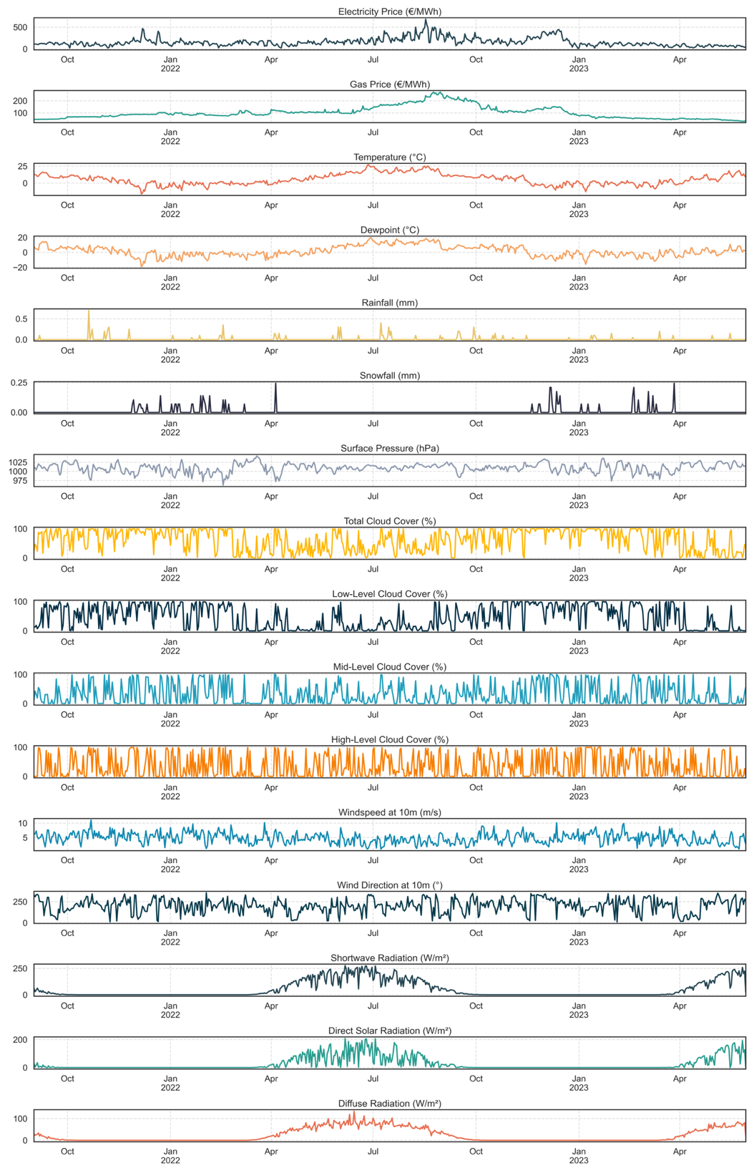

Figure 1. Temporal Patterns of Electricity Price, Weather, and Atmospheric Variables
Figure 2 presents histograms depicting the distribution of key variables in the dataset, including electricity prices, gas prices, temperature, and various meteorological variables such as cloud cover, rainfall, and solar radiation. These distributions provide critical insights into the variability and skewness of the data, which have important implications for model training and performance.

The histogram for electricity prices shows a right-skewed distribution, with most prices concentrated in the lower range and occasional extreme spikes. Gas prices and temperature follow more balanced, near-normal distributions, indicating less volatility compared to electricity prices. Other variables, such as rainfall, snowfall, and solar radiation, exhibit highly skewed distributions, with values clustered around low ranges and rare high-value occurrences. Cloud cover variables display bimodal or skewed patterns, reflecting distinct weather conditions. These visualizations highlight the diversity and complexity of the dataset, emphasizing the challenges of capturing extreme values and variable-specific behaviors in forecasting models.

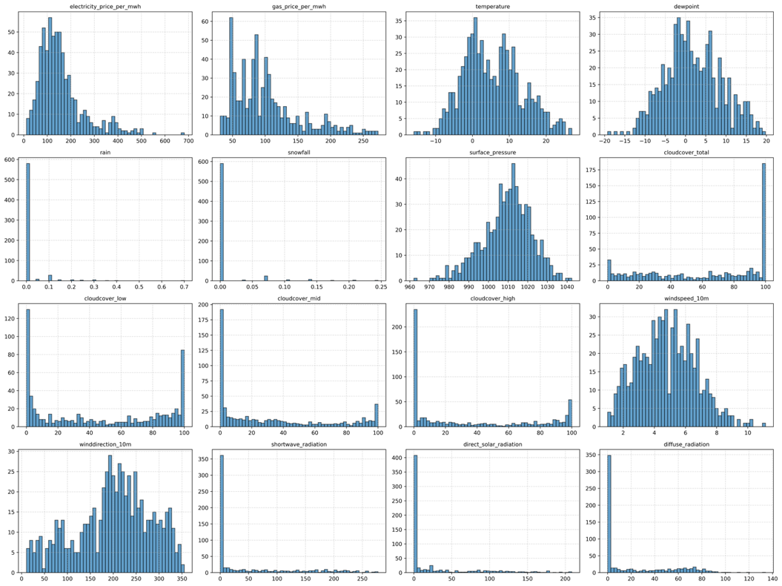

Figure 2. Distribution of Electricity Prices, Market Variables, and
Meteorological Factors

Figure 3 presents the correlation matrix of the variables used in forecasting electricity production and consumption. The matrix visually represents the strength and direction of linear relationships between different variables. Positive correlations are indicated in shades of red, while negative correlations are represented in shades of blue. The intensity of the color corresponds to the magnitude of the correlation coefficient.

Key observations from the correlation matrix include a strong positive correlation between dewpoint and temperature (0,94), indicating that these variables tend to increase or decrease together. Similarly, shortwave radiation and direct solar radiation show a high positive correlation (0,95), which is expected as both are related to solar energy input. Conversely, surface pressure and temperature demonstrate a negative correlation (-0,27), suggesting that the other decreases as one increases. This correlation matrix is essential for understanding the relationships among variables, which can inform the selection of features for predictive modeling and highlight potential multicollinearity issues that may need to be addressed in the analysis.

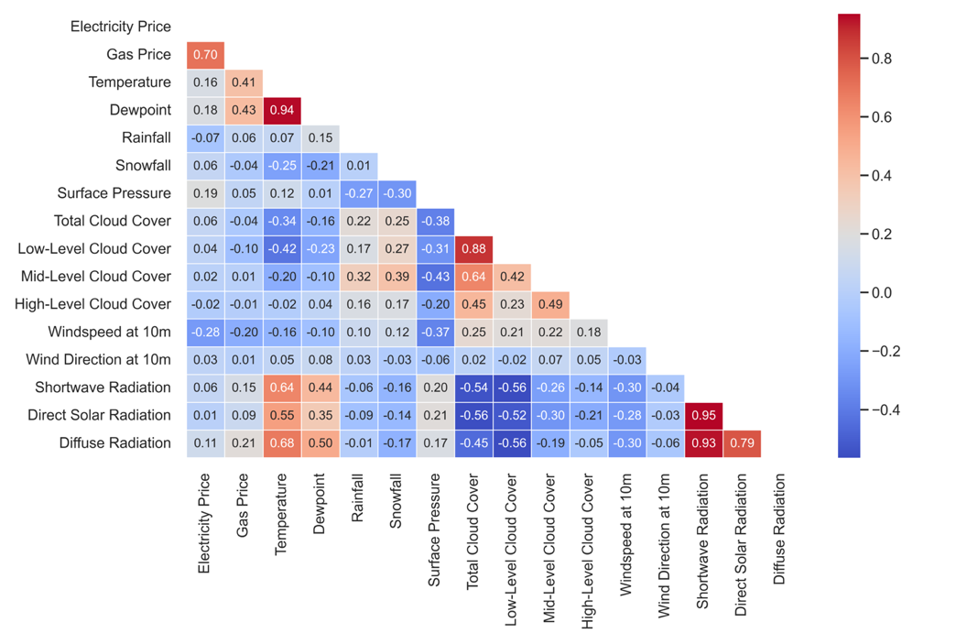
Figure 3. Correlation Matrix of Variables Influencing Electricity Production and Consumption

Figure 4 displays the feature importance values derived from the predictive model for forecasting electricity production and consumption. The bar chart highlights the relative significance of each variable in contributing to the model's performance. Higher values indicate a greater impact on the model’s predictive capability.

The Gas Price variable stands out as the most influential factor, suggesting that fluctuations in gas prices significantly impact electricity production and consumption patterns. Other notable variables include Dewpoint, Surface Pressure, and Diffuse Radiation, indicating their relevance in the forecasting model. In contrast, variables such as Mid-Level Cloud Cover and Wind Direction appear to have a lower impact, contributing minimally to the model. This analysis is crucial for understanding which factors are most influential, guiding further refinement of the model by focusing on the most impactful features and potentially reducing complexity by excluding less relevant ones.

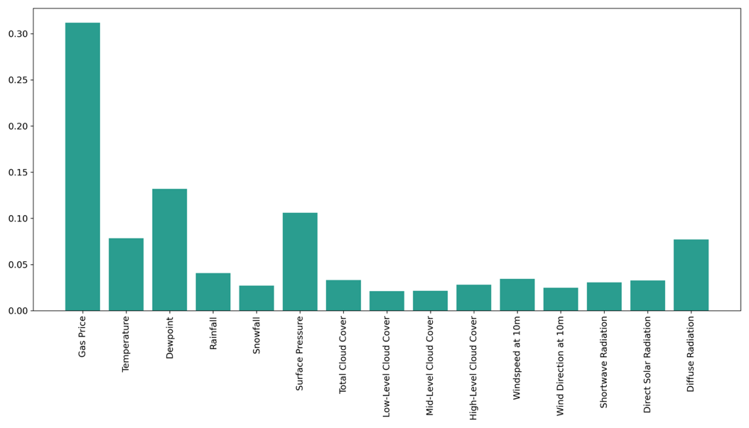
Figure 4. Feature Importance for Predicting Electricity Price

3. METHODOLOGY

The VAR model allows for the simultaneous modeling of multiple time series variables, where each variable is regressed on its own lagged values and the lagged values of other variables in the system. It is particularly effective when dealing with macroeconomic data, where multiple variables interact dynamically (Sims, 1980).

The primary advantage of VAR models is their ability to provide information about the direction and magnitude of the interactions between variables. Additionally, its dynamic structure allows using tools such as impulse response functions (IRFs) to analyze how variables respond to shocks within the system (Lütkepohl, 2005).

The VAR model is based on a system of equations where $Y_{t}$ represents a vector of k time series variables. Each variable in the system is modeled as a function of its lags and the lags of the other variables. The model can be expressed as follows:

$$Y_{t}= A_{1}Y_{t-1}+ A_{2}Y_{t-2}+ …+ A_{p}Y_{t-p}+ ε_{t}$$ | (1)

where $Y_{t}$ $k$-dimensional vector of time series variables, $A_{i}$ $k×k$ coefficient matrices for each lag, capturing the influence of past values of all variables in the system, $p$ the lag length of the model, $ε_{t}$ a vector of error terms or innovations, assumed to be white noise with zero mean and constant variance.

Long Short-Term Memory (LSTM) cells are highly relevant as they enable the model to capture both short-term fluctuations and long-term dependencies within the data. For instance, changes in weather patterns, market conditions, and other external factors that influence energy prices often exhibit both immediate and lingering effects. By leveraging the cell and hidden states in the LSTM, the model can effectively learn to retain critical information across multiple time steps, which is crucial for accurate forecasting.

The forget, input, and output gates allow the LSTM to dynamically control the information flow, making it suitable for time series applications where relevant patterns may recur over varying time horizons. This capability aligns with the objectives of hybrid modeling approaches that integrate econometric and deep learning models for robust energy market predictions.

LSTM networks are Recurrent Neural Networks (RNN) designed to capture long-term dependencies in time series data. Due to their ability to retain information over long sequences, LSTM models have become a popular choice in time series forecasting, including in applications like energy price prediction, where complex dependencies exist between past prices, weather data, and other external factors (Chang et al., 2019; Zhou et al., 2019; Wang et al., 2020). LSTM networks were introduced to overcome the vanishing gradient problem associated with traditional RNNs. They are designed with memory cells that can store information for long periods, making them particularly effective for time series forecasting, where patterns may span over long data sequences (Hochreiter & Schmidhuber, 1997).

The architecture of an LSTM network includes three main gates: the input gate, the forget gate, and the output gate. These gates regulate the flow of information through the network, enabling it to selectively remember or forget information, which is critical in modeling the dependencies in sequential data like energy prices and their influencing factors (e.g., weather conditions, market dynamics) (Gers et al., 2000).

An LSTM model is composed of a series of LSTM cells. Cell State ($c_{t}$​) represents the "memory" of the LSTM, storing relevant information over time. The cell state is updated based on the input and forget gates.

LSTM models use three gates to control the flow of information. Forget Gate ($f_{t}$) decides what information to discard from the cell state. It is defined as:

$$f_{t}=σ\left(W_{f}⋅\left[h_{t-1}, x_{t}\right]+b_{f}\right),$$ | (2)

where $f_{t}$ is the forget gate output, $W_{f}$ and $b_{f}$​ are the weight matrix and bias for the forget gate, $h_{t-1}$​ is the previous hidden state, $x_{t}$​ is the current input, and $σ$ is the sigmoid activation function.

Input Gate determines which new information is stored in the cell state. It is expressed as:

$$i_{t}=σ\left(W_{i}⋅\left[h_{t-1}, x_{t}\right]+b_{i}\right),$$ | (3)

where $W_{i}$​ and $b_{i}$​ are the weight matrix and bias vector for the input gate. The candidate values to be added are calculated as:

$${\tilde{c}}_{t}=tanh\left(Wc⋅\left[h_{t-1}, x_{t}\right]+b_{c}\right).$$ | (4)
Output Gate decides the next hidden state based on the updated cell state:

$$o_{t}=σ\left(W_{o}⋅\left[h_{t-1}, x_{t}\right]+b_{o}\right),$$ | (5)

where $W_{o}$​ and $b_{o}$​ are the weight matrix and bias vector for the output gate.

The hidden state is then:

$$h_{t}=o_{t}⋅tanh\left(c_{t}\right).$$ | (6)

The cell state is updated based on the input and forget gates:

$$c_{t}=f_{t}⋅c_{t-1}+i_{t}⋅{\tilde{c}}_{t}.$$ | (7)

These equations control what information is added to or removed from the memory, effectively allowing the model to capture and leverage long-term dependencies (Hochreiter & Schmidhuber, 1997).

Figure 5 illustrates the Long Short-Term Memory (LSTM) cell architecture, highlighting the roles of the forget, input, and output gates in managing both long-term ($c_{t}$) and short-term ($h_{t}$​) memory states. This design allows the LSTM to retain relevant information over extended sequences. It is particularly effective for applications involving temporal data with complex dependencies, such as energy price forecasting influenced by external factors

Figure 5. LSTM Cell Architecture: Gate Mechanisms for Long-Term and Short-Term Memory Management

In the context of energy price prediction, where long-term dependencies and temporal patterns play a significant role, the GRU model's gating mechanism allows it to capture these dependencies effectively without overcomplicating the model. The GRU can focus on relevant time steps by selectively retaining or forgetting past information through the reset and update gates. It is suitable for modeling complex time series data such as energy prices influenced by external factors (e.g., weather data, market trends).

The GRU model is a variant of the Recurrent Neural Network (RNN) architecture designed to improve the learning of long-term dependencies. GRUs are particularly useful when computational efficiency is a priority, as they have fewer parameters than LSTM models while maintaining performance (Cho et al., 2014). GRU model’s ability to efficiently capture dependencies in time series data makes it a powerful component in hybrid models that forecast complex energy markets. The GRU has fewer parameters than the LSTM, leading to faster training times and lower computational costs (Chung et al., 2014).

A GRU cell uses two main gates to manage information: the reset gate ($r_{t}$) and the update gate ($z_{t}$). These gates control what information is kept and what is discarded, allowing the GRU to manage long-term dependencies efficiently while minimizing computational complexity.

The reset gate determines how much of the past information ($h_{t-1}$​) should be forgotten:

$$r_{t}=σ\left(W_{r}⋅\left[h_{t-1}, x_{t}\right]+b_{r}\right),$$ | (8)

where $W_{r}$​ and $b_{r}$ are the weight matrix and bias vector for the reset gate, $σ$ is the sigmoid activation function, $h_{t-1}$​ is the previous hidden state, and $x_{t}$ is the current input.

The update gate controls how much of the past information is retained and how much of the new information is added:

$$z_{t}=σ\left(W_{z}⋅\left[h_{t-1}, x_{t}\right]+b_{z}\right),$$ | (9)

where $W_{z}$​ and $b_{z}$​ are the weight matrix and bias vector for the update gate.

The candidate hidden state (${\tilde{h}}_{t}$) is computed based on the reset gate’s influence:

$${\tilde{h}}_{t}=tanh\left(W_{h}⋅\left[r_{t}*h_{t-1}, x_{t}\right]+b_{h}\right),$$ | (10)

where $r_{t}$​ is the reset gate output, determining how much of the previous hidden state ($h_{t-1}$) contributes.

The final hidden state ($h_{t}$) is computed using both the update gate and the candidate hidden state:

$$h_{t}=\left(1-z_{t}\right)*h_{t-1}+z_{t}*{\tilde{h}}_{t}. ​$$ | (11)

This equation appropriately combines the previous hidden state and the new candidate state, balancing new and old information.

Figure 6 provides a detailed schematic representation of the GRU cell architecture, showcasing the role of its gating mechanisms—reset gate and update gate—in controlling information flow within the network. This figure visualizes how the GRU cell processes and combines the current input $x_{t}$ and the previous hidden state $h_{t-1}$​ to produce an updated hidden state $h_{t}$​, propagated forward in the sequence.

Figure 6. Schematic Representation of the GRU Cell and Its Gating Mechanisms

4. EMPIRICAL FINDINGS

This section presents the empirical results of analyzing the interaction between meteorological variables and energy market dynamics using multiple modeling approaches. To gain a comprehensive understanding, we employed the Vector Autoregression (VAR) model alongside Long Short-Term Memory (LSTM) and Gated Recurrent Units (GRU) methods. This combination of models allows for both statistical inference and advanced forecasting capabilities, enabling the extraction of valuable insights from the dataset.

The VAR model was used to analyze the dynamic interrelationships between variables, focusing on understanding how the past values of meteorological and market factors impact energy prices over time. Meanwhile, LSTM and GRU methods, known for their ability to handle sequential data, were used to make precise and long-term forecasts of electricity consumption and production patterns, leveraging their capability to capture long-range dependencies.

To prepare the dataset for the VAR model, several data preprocessing steps were undertaken to ensure data quality and feature selection, focusing on enhancing both the interpretability and statistical soundness of the model. Initially, the coefficient of variation (CV) was calculated for each variable in the dataset. This metric—computed as the ratio of the standard deviation to the mean—was used to assess the relative variability of each variable over time. Variables with a CV greater than 0,5 were retained for analysis, ensuring that the model captured only those variables with significant variability. This step helped eliminate static variables that could introduce noise rather than meaningful insights.
To address the potential issue of multicollinearity, a correlation matrix was computed, and columns with a correlation coefficient greater than 0,8 were dropped. By removing one variable from each pair of highly correlated features, the model was optimized to reduce redundancy and multicollinearity, ultimately improving the reliability of estimated relationships among variables.

In Table 1, the Augmented Dickey-Fuller (ADF) test is presented under two specifications: one with only a constant term ($ADF(c)$) and one with both a constant and a linear trend ($ADF(ct)$). The results show that several variables, including Rain, Snowfall, Total Cloud Cover, Mid-Level Cloud Cover, and High-Level Cloud Cover, appear to be strongly stationary in both specifications since their test statistics exceed the relevant critical values at the 1% level. In these cases, adding a trend component does not alter the conclusion that the series is stationary.

Conversely, Gas Price, Temperature, and Shortwave Radiation fail to reject the unit root hypothesis at conventional significance levels under both $ADF(c)$ and $ADF(ct)$. Thus, these three appear to be nonstationary in their current forms, suggesting potential benefits of differencing or transformation if they are to be used in models requiring stationarity. Electricity Price exhibits mixed results: it is significant under the constant-only specification at the 5% level but not under the constant+trend specification, indicating possible partial stationarity or sensitivity to trend. Overall, the ADF tests imply that some weather-related series (e.g., rainfall, snowfall, cloud cover) are level-stationary, while certain price measures and temperature data may require further transformation.

Table 2. ADF Test Results

Variable | $$ADF(c)$$ | $p-$value | $$ADF(ct)$$ | $p-$value
Electricity Price | -3,016** | 0,0335 | -3,024 | 0,1256
Gas Price | -1,393 | 0,5854 | -1,413 | 0,8572
Temperature | -1,854 | 0,3540 | -1,853 | 0,6786
Rain | -11,711*** | 0,0000 | -14,410*** | 0,0000
Snowfall | -7,778*** | 0,0000 | -7,772*** | 0,0000
Total Cloud Cover | -3,895*** | 0,0021 | -3,967*** | 0,0098
Mid-Level Cloudcover | -14,072*** | 0,0000 | -14,065*** | 0,0000
High-Level Cloud Cover | -15,098*** | 0,0000 | -15,085*** | 0,0000
Shortwave Radiation | -1,463 | 0,5516 | -1,519 | 0,8224
Notes: $ADF(c)$refers to the test specification with constant, and $ADF(ct)$ refers to the specification with constant and trend. The reported test statistic values should be compared with the critical values at the 1%, 5%, and 10% significance levels to assess stationarity. For $ADF(c)$, the critical values are approximately -3,441 (1%), -2,866 (5%), and -2,569 (10%). For $ADF(ct)$, the critical values are approximately -3,973 (1%), -3,418 (5%), and -3,131 (10%). The maximum lag length was set to 12, and the final lag was determined by the significance of the last lagged dependent variable at the 10% level. Statistical significance at the 1%, 5%, and 10% levels is denoted by ***, **, and *, respectively.

Table 2 reports the Zivot–Andrews test, which allows for a single endogenously determined structural break. The results under the Level Break ($c$) and Level + Trend Break ($ct$) models show that Rain, Snowfall, Total Cloud Cover, Mid-Level Cloud Cover, High-Level Cloud Cover, and Electricity Price are statistically significant at least at the 5% level. This outcome suggests these variables become stationary once one accounts for a specific break date. For instance, Electricity Price has break dates around late 2022, and its p-values (< 0,02) confirm stationarity with a shift.

In contrast, Gas Price, Temperature, and Shortwave Radiation do not exhibit stationarity under either Zivot–Andrews model; their test statistics remain above the critical thresholds, and the corresponding $p-$values indicate that the unit root hypothesis cannot be rejected. While a break date is still computed (e.g., 2022-12-14 for Gas Price), the test statistic is insufficiently large in absolute value to confirm stationarity. Consequently, these variables likely contain a persistent unit root behavior, even when a single structural break is considered.

In the context of Vector Autoregression (VAR) modeling, stationarity is a critical assumption to ensure the validity of the analysis. Given that certain variables, such as Gas Price, Temperature, and Shortwave Radiation, were identified as non-stationary, their first differences were taken before their inclusion in the VAR model. This transformation ensures that all variables in the analysis satisfy the stationarity requirement, facilitating accurate and robust results.

Table 3. Zivot–Andrews Test Results

Variable | $$ZA(c)$$ | $p-$value | Break Date | $$ZA(ct)$$ | $p-$value | Break Date
Electricity Price | -5,168** | 0,0167 | 2022-12-16 | -5,478** | 0,0153 | 2022-07-27
Gas Price | -3,217 | 0,8330 | 2022-12-14 | -4,340 | 0,2926 | 2022-06-28
Temperature | -3,187 | 0,8459 | 2022-10-16 | -3,422 | 0,8477 | 2022-11-12
Rain | -14,600*** | 0,0000 | 2022-05-25 | -14,589*** | 0,0007 | 2022-05-25
Snowfall | -8,284*** | 0,0000 | 2022-11-19 | -8,597*** | 0,0009 | 2022-02-22
Total Cloud Cover | -5,660*** | 0,0022 | 2022-09-12 | -5,768*** | 0,0051 | 2022-09-12
Mid-Level Cloudcover | -14,429*** | 0,0000 | 2022-11-18 | -15,072*** | 0,0007 | 2022-11-18
High-Level Cloud Cover | -15,294*** | 0,0000 | 2023-02-24 | -15,714*** | 0,0007 | 2023-01-06
Shortwave Radiation | -3,668 | 0,5691 | 2022-08-14 | -2,967 | 0,9691 | 2022-08-14
Notes: This table shows the Zivot–Andrews test results under two model specifications: Level Break ($c$) and Level and Trend Break ($ct$). The break date is endogenously determined and reported in the final column for each specification. Critical values for the level-break model ($c$) are approximately -5,276 (1%), -4,811 (5%), and -4,566 (10%), while for the level and trend model ($ct$) they are -5,576 (1%), -5,073 (5%), and -4,827 (10%). Statistical significance at the 1%, 5%, and 10% levels is denoted by ***, **, and *, respectively. A maximum of 12 lags was allowed, with the final lag determined at the 10% significance level for the last lagged dependent variable.

Figure 7 illustrates the decomposition of three non-stationary variables—Gas Price, Temperature, and Shortwave Radiation—into their respective components: original series, trend, and residuals. The decomposition highlights persistent trends and significant variations in the residuals for each series, consistent with the results presented in Tables 2 and 3. For Gas Price, the trend component shows distinct long-term fluctuations, likely influenced by external market dynamics, while the residuals reveal high-frequency variability that further supports non-stationarity. Similarly, Temperature exhibits pronounced seasonal trends that align with climatic cycles and irregular residuals indicative of stochastic influences. Finally, Shortwave Radiation displays distinct periodic trends, reflecting solar radiation patterns, with residuals capturing short-term anomalies.

The persistence of trends and irregularities in the residuals for all three variables supports the conclusion that these series are non-stationary in their current forms. This finding aligns with the Augmented Dickey-Fuller (ADF) test results, which fail to reject the null hypothesis of a unit root for these variables under constant-only and constant-with-trend specifications. Furthermore, the Zivot–Andrews test confirms that even after accounting for structural breaks, the unit root behavior remains for these variables, suggesting that differencing or transformation is necessary to achieve stationarity.

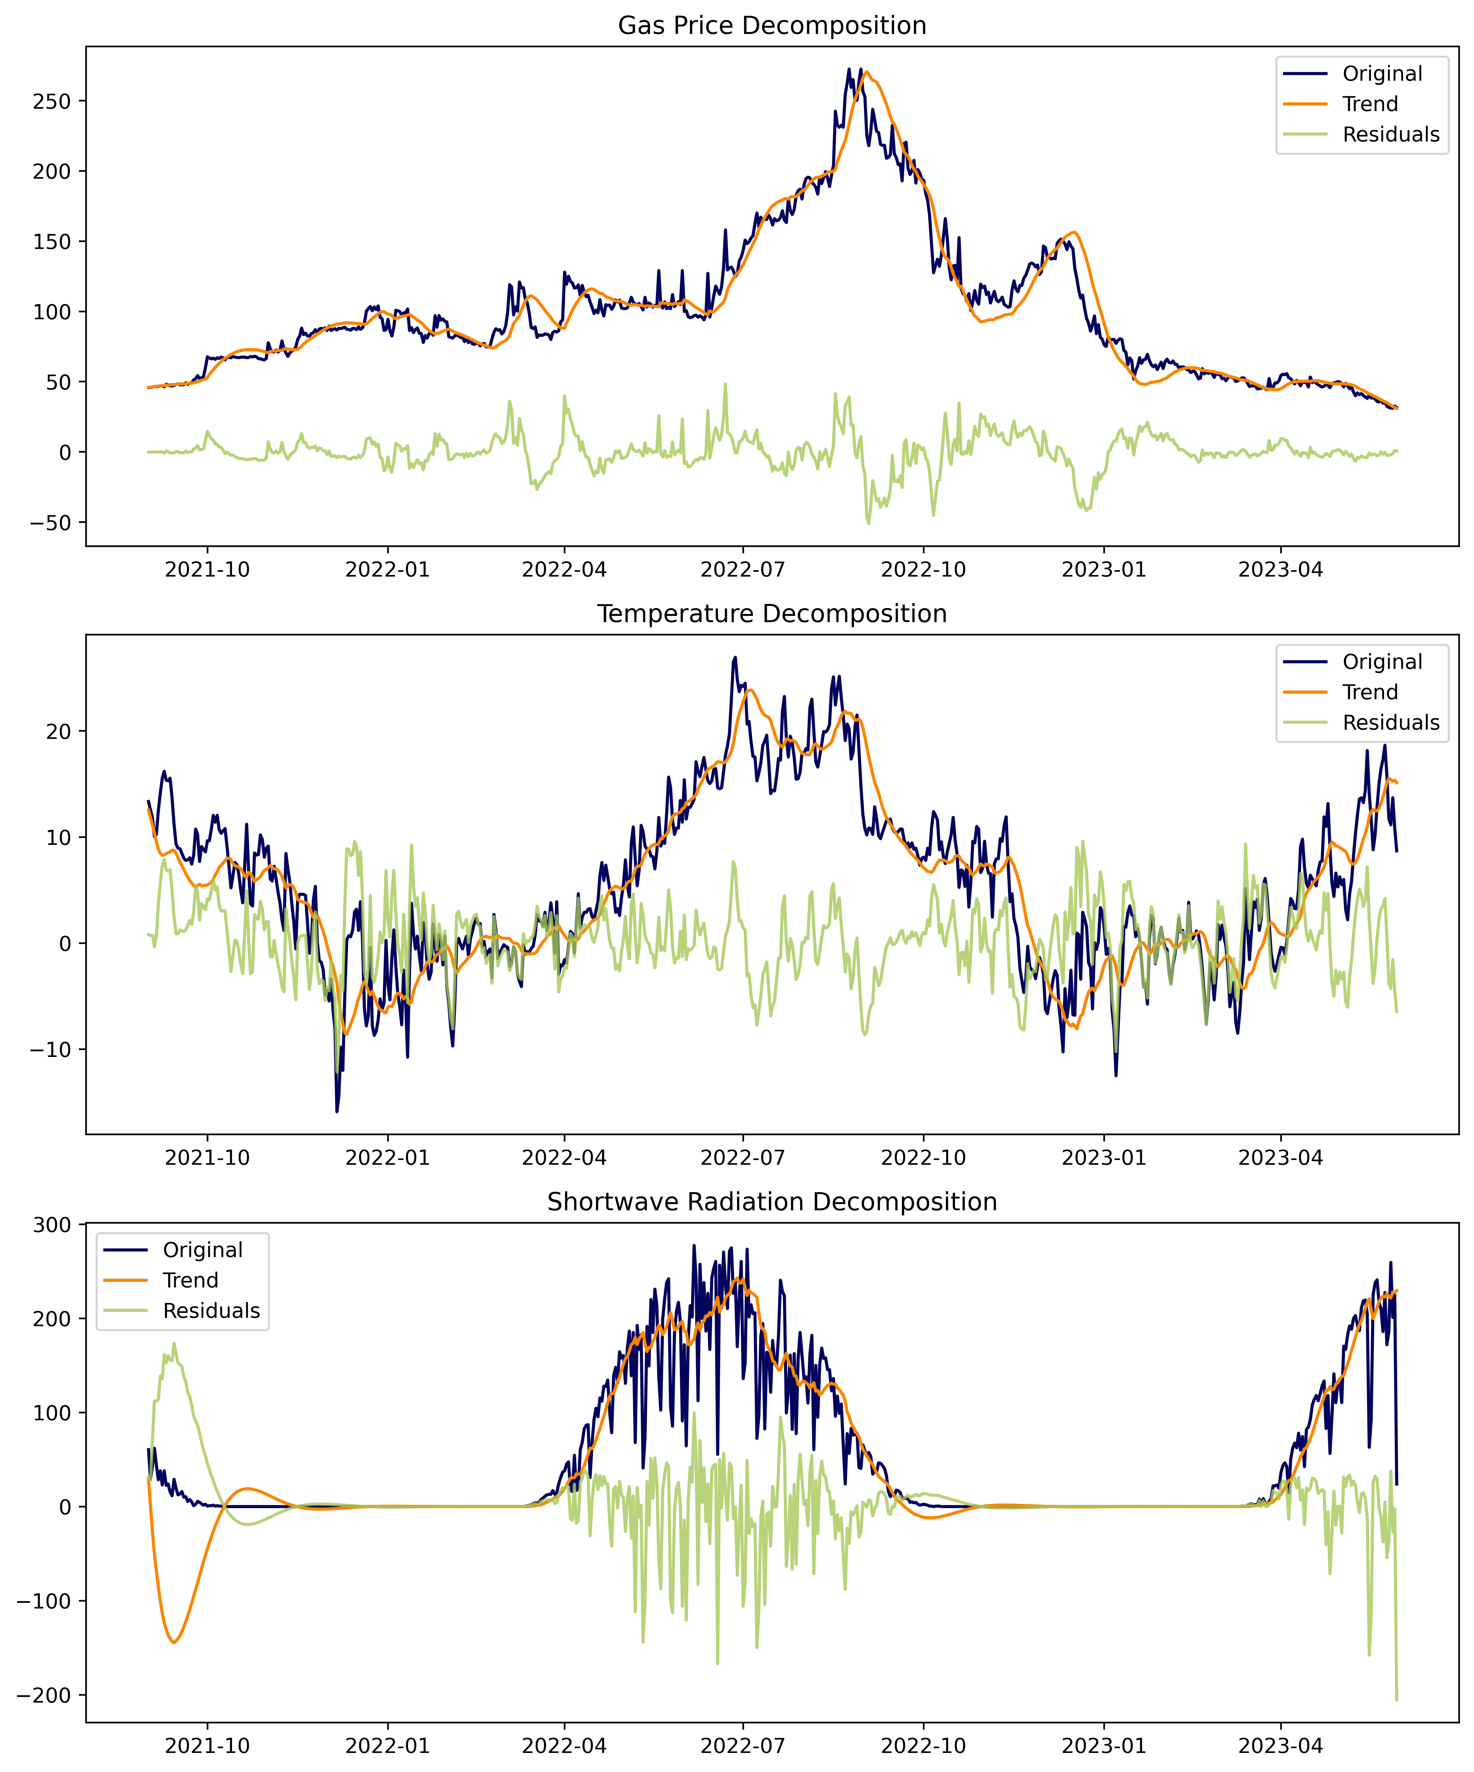

Figure 7. Decomposition of Non-Stationary Variables:
Gas Price, Temperature, and Shortwave Radiation

Figure 8 presents the historical and forecasted electricity prices in euros per megawatt hour (€/MWh), derived using the VAR model. The graph illustrates the historical and forecasted values, providing a comparative perspective on how the model predicts future electricity prices based on previous data. The forecasted prices and a 95% confidence region are displayed in the shaded orange area, highlighting the uncertainty range around the model's predictions.

The historical segment of the plot shows the variations in electricity prices over time, indicating seasonal patterns and volatility, which are crucial for understanding energy market dynamics. The forecasted values extend into the future and suggest potential trends that decision-makers can use for planning and resource allocation. The wide confidence region in the forecast period signifies the uncertainty in predictions, emphasizing the influence of external factors on electricity prices. In this context, the VAR model’s strength lies in its ability to capture interdependencies between variables, providing insights into price movements and the associated risk.

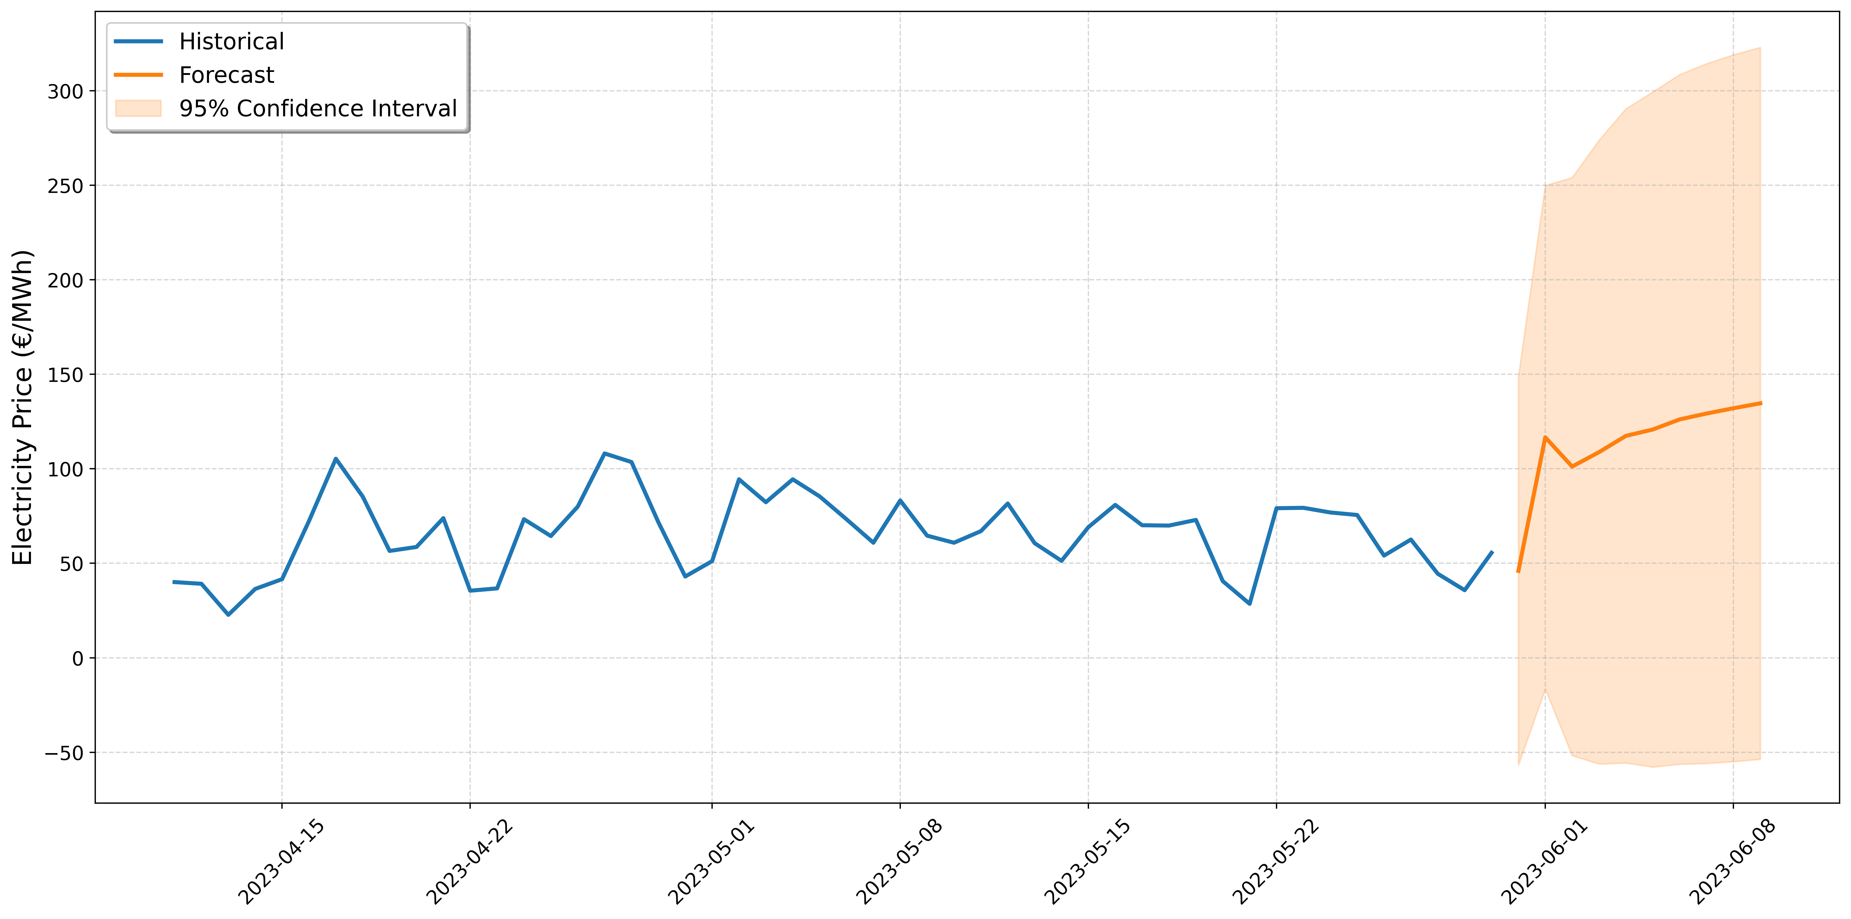

Figure 8. Historical and Forecasted Electricity Prices Using The VAR Model

Figures 16 to 24, presented in the appendix, display the impulse response functions (IRFs) for the variables included in the Vector Autoregression (VAR) model over a 10-step horizon. They illustrate how each variable responds to a shock in another variable over time. The responses are plotted over ten periods following an initial shock, with solid lines representing the estimated impulse response and dashed lines indicating the 95% confidence intervals.

The results reveal significant interactions between electricity prices and external factors such as gas prices, temperature, and shortwave radiation, highlighting the critical role of both market and climatic dynamics in energy pricing. Weather variables like cloud cover (total, mid-level, and high-level) demonstrate hierarchical feedback relationships, influencing each other and interacting with electricity and gas prices. Rain and snowfall, on the other hand, exhibit relatively isolated impacts with limited influence on the broader system.

These IRFs provide valuable insights into the magnitude and duration of shocks, showcasing the complex interdependencies in the energy-climate nexus. The figures collectively enhance the understanding of the temporal adjustments and feedback mechanisms governing electricity prices and related variables.

Figure 9 presents the Forecast Error Variance Decomposition (FEVD) analysis for the Vector Autoregression (VAR) model variables. The FEVD quantifies the proportion of the forecast error variance of each variable that can be attributed to shocks in the other variables over time. This analysis provides insights into the relative importance of different shocks in explaining the variability of each variable in the model.

The y-axis represents the percentage contribution to the forecast error variance, while the x-axis indicates the forecast horizon (up to four periods). The bars represent the variance decomposition results, showing the contribution of each shock to the forecast error variance of a specific variable. For instance, the variance in electricity prices can be influenced by other factors such as temperature, gas price, and cloud cover.

This analysis is crucial for understanding the extent to which different factors, such as weather and energy market conditions, influence the variability of the forecasted outcomes. It highlights which variables have the most significant impact on the others, allowing for a deeper understanding of the dynamic relationships within the energy and meteorological dataset. This type of analysis is particularly useful for policymakers and energy analysts in identifying key drivers of variability and assessing the interconnectedness of different market and weather factors.

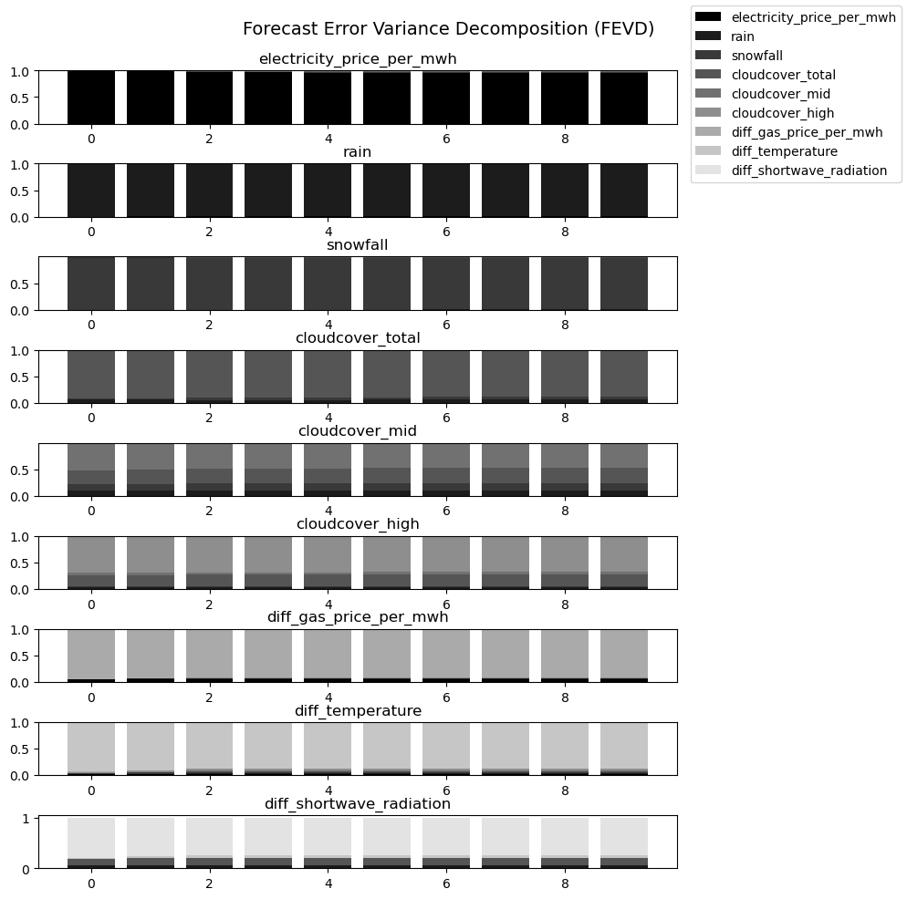

Figure 9. Forecast Error Variance Decomposition (FEVD) for Variables in the
VAR Model
In this study, we implemented a Bidirectional Long Short-Term Memory (Bi-LSTM) model for predicting energy prices based on historical time series data and external variables like weather and market factors. The Bi-LSTM model was constructed using the Keras library. The model consists of a bidirectional LSTM layer followed by dense layers, enabling the network to effectively capture past and future temporal dependencies. The first layer is a Bidirectional LSTM layer with 128 units. Bidirectionality allows the model to process information from both past and future states, improving its ability to understand complex dependencies in the time series data. Following the LSTM layer, the model includes two fully connected dense layers. The first dense layer has 64 units, acting as a feature abstraction layer, while the final dense layer outputs predictions with the required shape.

The hyperparameter selection for the Bi-LSTM model was performed using Bayesian Optimization from the bayes_opt Python package (Nogueira, 2014). This library provides a convenient and efficient framework for exploring the hyperparameter space and identifying optimal configurations for complex machine-learning models. Specifically, the Bayesian Optimization framework systematically searched the hyperparameter space, including learning rate (LR), batch size, and the number of epochs. This process identified the best combination of hyperparameters: an LR of approximately 0,022, a batch size of 167, and 97 epochs. The optimization utilized a predefined range for each parameter (e.g., LR: [1e-5, 1e-1], batch size: [16, 264], epochs: [10, 100]) and aimed to minimize the validation loss during training.

The optimized LR was implemented with the Adam optimizer, allowing the model to make stable and incremental weight updates, avoiding overshooting while ensuring convergence. The batch size 167 provided an efficient balance between computational speed and gradient stability. Similarly, 97 epochs were identified as the optimal duration to capture the data's underlying temporal dependencies without overfitting, as confirmed by the stable validation loss curve. These hyperparameters, determined through Bayesian Optimization, were subsequently validated using metrics such as Mean Absolute Error (MAE), Mean Squared Error (MSE), and Root Mean Squared Error (RMSE) on the test set, achieving robust predictive performance.

The model’s performance over training epochs was visualized by plotting the training and validation loss curves (Figure 10). This plot provides insights into the convergence of the model. Training Loss is shown in solid blue, representing the model’s error on the training set. Test Loss is shown in dashed orange, indicating how well the model generalizes to unseen data. Both loss curves were visualized to ensure the model did not overfit the training data. A stable or decreasing validation loss relative to the training loss indicates good generalization.
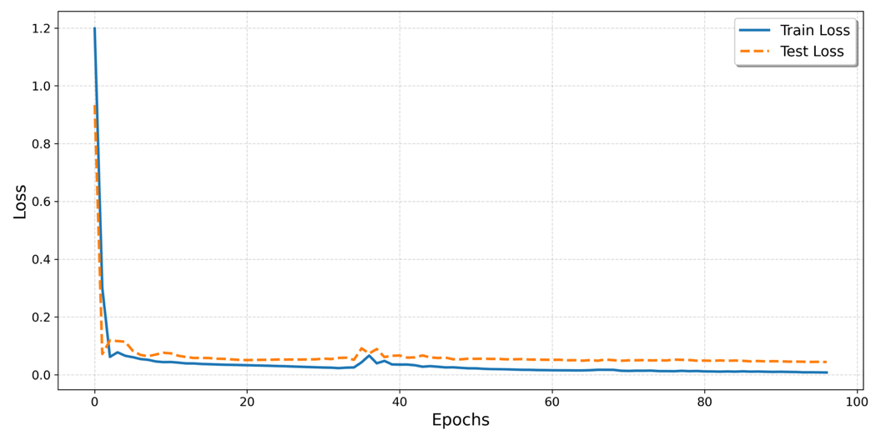
Figure 10. Training and Testing Loss Convergence for the LSTM Model

Figure 11 depicts the training performance of the Bi-LSTM model in forecasting electricity prices, comparing the real electricity prices (blue) and the predicted prices generated by the model (orange) over the training period. This visualization evaluates the model’s ability to learn temporal dependencies and the underlying dynamics of historical electricity price data, which are influenced by factors such as weather conditions, market fluctuations, and past price trends.

The figure highlights the Bi-LSTM model’s capability to closely align with real electricity prices, effectively capturing key trends, seasonal patterns, and significant price spikes during high-demand periods. The model demonstrates robust performance in tracking short-term price variations and long-term dependencies, underscoring its suitability for energy market forecasting. Furthermore, the model successfully predicts major price fluctuations, critical for operational decision-making and risk mitigation in volatile markets.

Although minor discrepancies are observed between the predicted and actual values, these deviations are consistent with the inherent volatility and noise in electricity price data. Such variability is typical in complex time series forecasting tasks. Overall, the results validate the Bi-LSTM model's effectiveness and reliability in accurately modeling and predicting electricity price movements during the training phase.

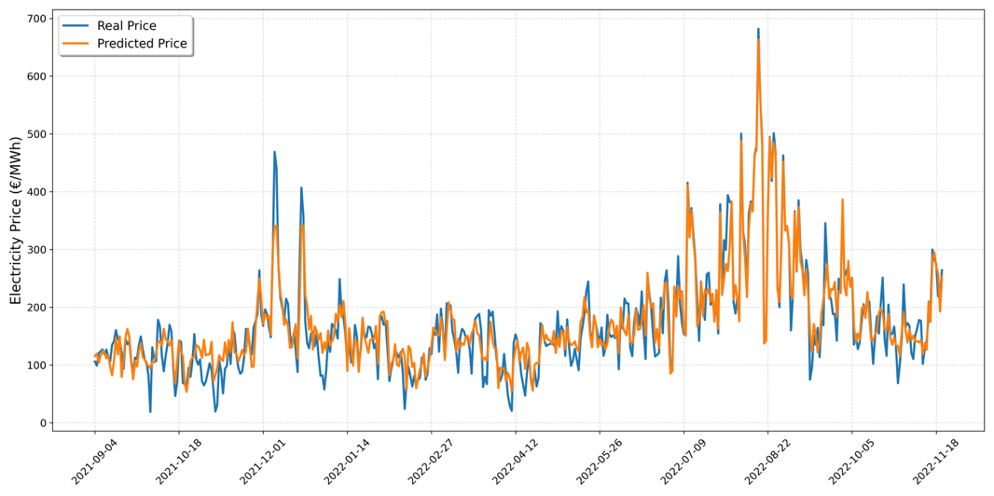

Figure 11. Training Results of the Bi-LSTM Model:
Comparison of Real and Predicted Electricity Prices

Figure 12 illustrates the testing performance of the Bidirectional Long Short-Term Memory (Bi-LSTM) model, demonstrating its ability to forecast electricity prices on previously unseen data. The figure compares real electricity prices (blue) with the predicted prices generated by the model (orange) over the testing period. This phase evaluates the model's generalization capacity and predictive accuracy, which are critical for practical applications in dynamic energy markets influenced by factors such as weather conditions and market behavior.

During the testing phase, the Bi-LSTM model effectively captures the overall trend and trajectory of electricity prices, including the gradual decline observed in the data. This alignment between real and predicted values highlights the model's ability to generalize and adapt to new, unseen data, further validating its robustness in modeling long-term dependencies.

While the Bi-LSTM model demonstrates strong predictive performance, certain discrepancies are evident during periods of sharp price spikes and dips. These deviations are typical in forecasting volatile markets, where extreme price fluctuations can occur due to sporadic external factors. Despite these challenges, the model maintains a reasonable proximity to actual values, even during periods of significant variability. This indicates the Bi-LSTM model's suitability for forecasting tasks where trend recognition and adaptability are critical for operational decision-making.

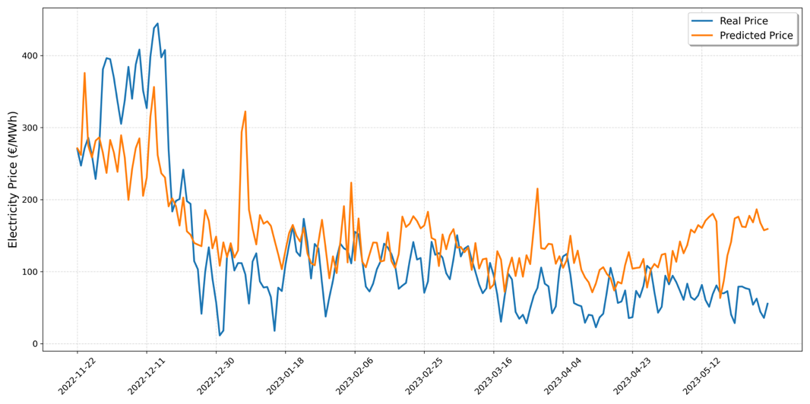

Figure 12. Testing Results of the Bi-LSTM Model:
Real vs. Predicted Electricity Prices

Figure 13 depicts the convergence behavior of the Gated Recurrent Unit (GRU) model during the training and testing phases. The training loss (solid blue) and testing loss (dashed orange) are plotted over 97 epochs, reflecting the optimization process. The loss metric used is Mean Squared Error (MSE), which effectively captures the prediction errors in continuous data, making it highly suitable for regression tasks like energy price forecasting.

The figure shows a sharp decline in training and testing loss during the initial epochs, indicating rapid learning of underlying patterns. After approximately 20 epochs, the losses stabilize, with the training loss gradually decreasing, while the testing loss remains relatively steady. This convergence pattern demonstrates that the model successfully generalizes to unseen data while avoiding overfitting, as evidenced by the consistent testing loss throughout the latter epochs. This highlights the effectiveness of the selected hyperparameters and the model's ability to learn temporal dependencies in the dataset.

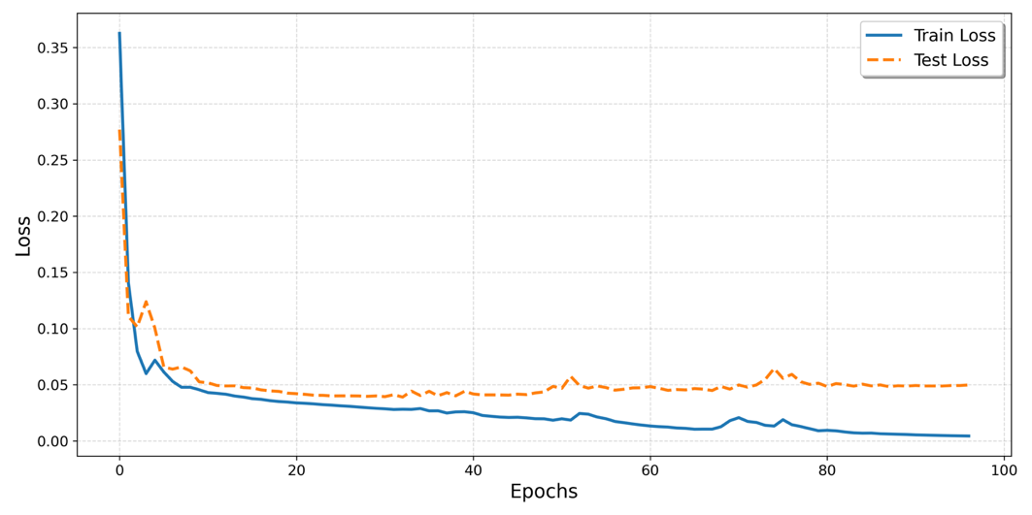
Figure 13. Training and Testing Loss Convergence for the GRU Model

This study developed a Gated Recurrent Unit (GRU) model to forecast energy prices using historical data and additional features such as weather conditions and market indicators. The GRU model was chosen for its capability to capture long-term dependencies, which is essential in energy markets where historical trends and external factors can significantly influence future price movements. The model architecture consists of two sequential GRU layers and fully connected (dense) layers. The first GRU layer contains 128 units, and the second GRU layer contains 64 units. The sequence is transformed into a final state representation that feeds into the dense layers, effectively learning both short-term fluctuations and long-term dependencies.

The dense layers following the GRU layers refine the extracted temporal features and produce the final predictions. The first dense layer consists of 128 units, a feature abstraction layer that reduces the data complexity. The subsequent two dense layers contain 32 units each, further simplifying the learned features and enhancing the model's generalization ability. The final output layer matches the target variable’s dimensions, ensuring the model’s predictions are compatible with the expected output format.

The hyperparameters for the GRU model were optimized using Bayesian Optimization to ensure an efficient and systematic search for the best configuration. This process explored the hyperparameter space for the learning rate (LR), batch size, and the number of epochs, ultimately selecting the following optimal values: a learning rate of 0,0021, a batch size of 191, and 97 epochs. These values were identified by minimizing the validation loss during training, resulting in a model that balances predictive accuracy and training efficiency.

The selected learning rate, implemented with the Adam optimizer, provides a stable convergence path, allowing for effective gradient updates without overshooting the optimal solution. The batch size of 191 offers a trade-off between computational efficiency and gradient stability, ensuring robust training on the diverse energy price dataset. Additionally, the training duration of 97 epochs was sufficient to capture complex temporal dependencies in the data while minimizing the risk of overfitting. These hyperparameters, determined through Bayesian Optimization, improved the GRU model's ability to accurately forecast electricity prices, as evidenced by its strong performance across evaluation metrics such as MAE, RMSE, and MAPE.

Figure 14 presents the training performance of the Gated Recurrent Unit (GRU) model in forecasting electricity prices. This plot compares the real electricity prices and the predicted prices generated by the model over the training period. This comparison evaluates how well the GRU model learns the underlying patterns in historical energy price data, influenced by complex factors such as market conditions and weather variables.

In the training phase, the GRU model demonstrates a high alignment between the real and predicted electricity prices. The model captures the overall trend and seasonal fluctuations in the data, including major price peaks and troughs. It effectively learns both short-term and long-term dependencies within the dataset. This alignment is crucial for validating the model’s ability to represent the dynamic behavior of electricity prices, which are known for their volatility and susceptibility to external influences.

While the GRU model performs well in capturing the general price movements, slight discrepancies are observed in areas with extreme price spikes. This is a common challenge in energy price forecasting due to the sudden and often unpredictable nature of these fluctuations. Nonetheless, the model maintains a close track of the actual values, which is indicative of robust training performance.

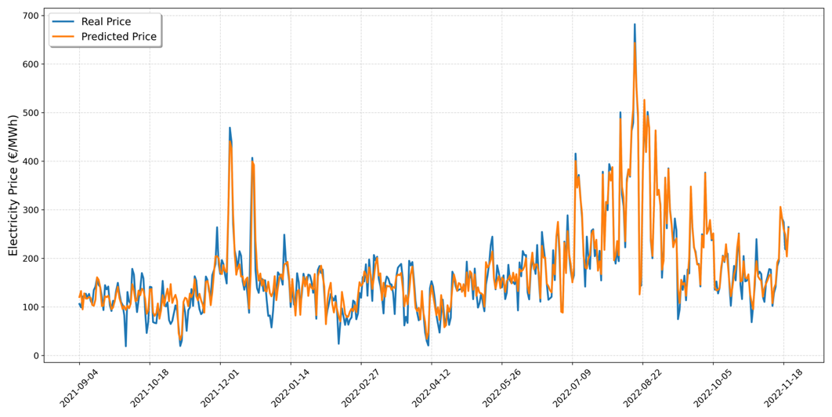

Figure 14. Training Results of the GRU Model:
Comparison of Real and Predicted Electricity Prices

Figure 15 illustrates the testing performance of the Gated Recurrent Unit (GRU) model in forecasting electricity prices, showcasing the comparison between real electricity prices (blue) and the predicted prices (orange) over the testing period. This phase evaluates the model’s ability to generalize its learning to unseen data, which is critical for practical forecasting applications in volatile energy markets.

The GRU model effectively captures the overall trends in electricity prices, including the gradual decline observed during the latter part of the testing period. It successfully tracks major price fluctuations and general price trajectories, demonstrating its ability to model both short-term variations and long-term patterns. However, some discrepancies are evident, particularly during extreme price spikes, reflecting the challenges posed by the highly volatile and nonlinear dynamics of electricity markets.

Despite these deviations, the model achieves a reasonable alignment with real prices, maintaining its generalization capabilities. The consistent tracking of real values during stable periods emphasizes the model's robustness and reliability. This performance underscores the GRU model’s utility in forecasting tasks, where accuracy and the ability to handle market volatility are paramount for informed decision-making and risk management.

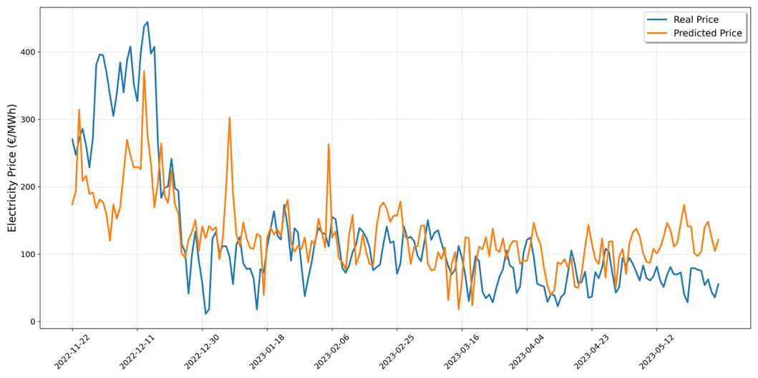

Figure 15. Testing Results of the GRU Model: Comparison of Real and Predicted Electricity Prices

Table 4 provides a multifaceted comparison of Vector Autoregression (VAR), Gated Recurrent Unit (GRU), and Long Short-Term Memory (LSTM) models, evaluated using four distinct performance metrics—Mean Absolute Error (MAE), Root Mean Squared Error (RMSE), Symmetric Mean Absolute Percentage Error (SMAPE), and Root Mean Squared Logarithmic Error (RMSLE). These metrics collectively offer insights into the models’ ability to handle absolute deviations and relative or proportional errors across varying ranges of energy prices.

A key observation in Table 2 is the stark contrast in MAE and RMSE between the deep learning methods (GRU and LSTM) and the VAR baseline. Specifically, the MAE for GRU and LSTM hovers around 0,16–0,17, whereas VAR’s MAE stands at approximately 35,57. This disparity implies that recurrent neural models capture price dynamics far more effectively, minimizing large forecast deviations and excelling at overall absolute accuracy. The RMSE values follow a similar pattern, with GRU and LSTM remaining close to 0,22, contrasting sharply with the VAR model’s RMSE surpassing 51,59. These findings underscore the advantage of non-linear sequence models in managing the inherent complexity and volatility of daily energy prices.

Despite their clear superiority in absolute terms, GRU and LSTM show higher SMAPE values (35,50% and 39,11%, respectively) compared to the VAR model’s 24,97%. This outcome indicates that, relative to moderate or lower price points, the deep learning models may introduce more pronounced percentage deviations. A plausible explanation lies in the data’s distribution: periods where energy prices approach certain lower bounds can yield smaller denominators, thus inflating proportional errors. While VAR suffers more in absolute measures, its more uniform percentage error suggests it balances deviations more consistently across different price levels.

When examining RMSLE, both GRU and LSTM outperform VAR considerably, suggesting superior handling of multiplicative or relative errors. Their RMSLE values of approximately 0,12–0,13 demonstrate an enhanced capacity to accommodate significant shifts in the price data, reflecting the flexibility of recurrent neural architectures in modeling non-linear dynamics. By contrast, VAR’s RMSLE of 0,35 implies that large log-scaled discrepancies occur more frequently, further highlighting the limitations of linear approaches in highly variable energy markets.

Table 4. Performance Metrics Comparison of VAR, LSTM, and GRU Models in Electricity Price Forecasting

Model | MAE | RMSE | SMAPE | RMSLE
VAR | 35,5669 | 51,5929 | 24,97% | 0,3479
GRU | 0,1639 | 0,2233 | 35,50% | 0,1275
LSTM | 0,1735 | 0,2184 | 39,11% | 0,1245

Table 2’s results emphasize two important implications for energy price forecasting. First, GRU and LSTM prove especially effective where mitigating large absolute deviations is paramount—such as in budgeting, trading, or bidding contexts that cannot tolerate large swings. Second, while VAR fares better in percentage-based errors (SMAPE), it exhibits significant weaknesses in overall accuracy and log-scale fit, making it less suitable for capturing abrupt or non-linear market shifts. Consequently, for stakeholders prioritizing minimal absolute errors, the deep learning models offer a robust solution, whereas contexts emphasizing proportional stability might still find certain advantages—albeit limited—in the VAR approach.

5. CONCLUSION

This study presents a hybrid framework integrating econometric (VAR) and deep learning models (LSTM and GRU) to address the challenges of electricity price forecasting in highly dynamic and volatile markets. By leveraging the strengths of both methodologies—VAR’s interpretability and the deep learning models’ capability to capture nonlinear temporal patterns—this approach provides a robust solution for energy price prediction. The inclusion of weather and market variables further enhances the model’s accuracy and adaptability, highlighting the importance of incorporating external factors in forecasting frameworks.

The findings highlight the superiority of deep learning models over the VAR approach in terms of absolute error metrics such as MAE and RMSE. The GRU model achieves the best performance with the lowest MAE and RMSE, followed closely by the LSTM model. Both deep learning approaches successfully capture the nonlinear temporal patterns and dependencies inherent in electricity price time series. However, the VAR model demonstrates relatively better performance in terms of SMAPE, indicating its ability to handle proportional errors effectively. Additionally, the RMSLE results underscore the deep learning models' capacity to manage extreme value fluctuations, with LSTM achieving the lowest RMSLE.

Despite the clear advantages of the deep learning models, their limitations in fully capturing sudden price spikes and drops remain a challenge. These extreme fluctuations, often driven by unpredictable market or environmental events, introduce volatility that is inherently difficult to model. While this study demonstrates that GRU and LSTM models possess strong generalization capabilities, a more detailed investigation into the impact of extreme values on their performance is necessary. Understanding these limitations will further enhance their applicability in real-world forecasting scenarios where robustness against extreme volatility is crucial.

The unique contribution of this study lies in its hybrid framework, which combines the interpretative power of econometric models with the predictive accuracy of deep learning models. This dual approach not only enhances the robustness of predictions but also provides a structured and interpretable tool to inform policy-making and strategic decisions in energy markets. Furthermore, the inclusion of weather and market data proves critical in capturing the multifaceted nature of electricity price fluctuations, emphasizing the importance of external variables in improving forecasting accuracy. This aligns with existing hypotheses suggesting that environmental and market factors are key drivers of energy price variability.

In a broader context, these findings underscore the importance of adopting hybrid methodologies to address the challenges posed by complex and volatile data structures in electricity markets. By successfully integrating econometric and deep learning methods, this study contributes a novel framework for energy forecasting with implications for risk management, operational efficiency, and policy development in energy-intensive industries.

Future research directions include refining the hybrid models by incorporating additional factors such as real-time demand-supply imbalances, seasonal variations, or geopolitical influences. Exploring advanced architectures, such as attention mechanisms or transformer-based models, could further enhance predictive accuracy. Moreover, expanding datasets to include high-frequency and real-time market data would provide deeper insights into rapid shifts in energy prices, enabling more responsive and robust forecasting systems tailored for dynamic market environments.

Research and Publication Ethics Statement
This research adheres to established standards of research and publication ethics.

REFERENCES

Cao, M., Wang, Y., Liu, J., Yin, Z., Guo, X., & Ren, X. (2022). Day ahead electricity price forecasting based on the deep belief network. Wireless Communications and Mobile Computing, 2022, 1–8. https://doi.org/10.1155/2022/3960597

Cao, H., Xiao, W., Sun, J., Gan, M. G., & Wang, G. (2024, July). Fusing data-and model-driven methods for RUL prediction in smart manufacturing systems. 2024 43rd Chinese Control Conference (CCC), 6945–6949. IEEE.

Catalão, J. P. S., Mariano, S. J. P. S., Mendes, V. M. F., & Ferreira, L. A. F. M. (2007). Short-term electricity prices forecasting in a competitive market: A neural network approach. Electric Power Systems Research, 77(10), 1297–1304. https://doi.org/10.1016/j.epsr.2006.09.022

Chughatta, K. (2023). Short-term electricity price forecasting using EEMD and GRU-NN. International Journal of Advanced Natural Sciences and Engineering Researches, 7(4), 420–427. https://doi.org/10.59287/ijanser.772

Chung, J., Gulcehre, C., Cho, K., & Bengio, Y. (2014). Empirical Evaluation of Gated Recurrent Neural Networks on Sequence Modeling. ArXiv. https://arxiv.org/abs/1412.3555

Dash, S. K., & Dash, P. K. (2019). Short-term mixed electricity demand and price forecasting using adaptive autoregressive moving average and functional link neural network. Journal of Modern Power Systems and Clean Energy, 7(5), 1241–1255. https://doi.org/10.1007/s40565-019-0535-0

Gers, F. A., Schmidhuber, J., & Cummins, F. (2000). Learning to forget: Continual prediction with LSTM. Neural Computation, 12(10), 2451-2471. https://doi.org/10.1162/089976600300015015

Geetha, G., Shanthini, C., & Geethanjali, P. (2024). Non-conventional feature-based LSTM model for prediction of bearing performance degradation. Engineering Research Express. https://doi.org/10.1088/2631-8695/ad8d33

Grifa, M. (2018). Electric energy price forecasting: Descriptive analysis and features selection. International Journal of Pure and Applied Mathematics, 117(1), 15. https://doi.org/10.12732/ijpam.v117i1.15

Guo, W., & Zhao, Z. (2017). A novel hybrid BND-FOA-LSSVM model for electricity price forecasting. Information, 8(4), 120. https://doi.org/10.3390/info8040120

Hamilton, J. D. (2020). Time series analysis. Princeton University Press.

Hochreiter, S., & Schmidhuber, J. (1997). Long short-term memory. Neural Computation, 9(8), 1735-1780. https://doi.org/10.1162/neco.1997.9.8.1735

Hu, G., Fu, S., Zhong, S., Lin, L., Liu, Y., Zhang, S., & Guo, F. (2024). Remaining useful life prediction of mechanical equipment based on time-series auto-correlation decomposition and CNN. Measurement Science and Technology. https://doi.org/10.1088/1361-6501/ad5c8c

Kaggle. (2024). Predict energy behavior of prosumers [Data set]. Retrieved November 4, 2024, from https://www.kaggle.com/competitions/predict-energy-behavior-of-prosumers/data

Kara, A. (2021). A hybrid prognostic approach based on deep learning for the degradation prediction of machinery. SAUCIS, 4(2), 216–226. https://doi.org/10.35377/saucis.04.02.912154

Lütkepohl, H. (2005). New introduction to multiple time series analysis. Springer.

Lago, J., De Ridder, F., & De Schutter, B. (2018). Forecasting spot electricity prices: Deep learning approaches and empirical comparison of traditional algorithms. Applied Energy, 221, 386–405. https://doi.org/10.1016/j.apenergy.2018.02.069

Lehna, M., Scheller, F., & Herwartz, H. (2022). Forecasting day-ahead electricity prices: A comparison of time series and neural network models taking external regressors into account. Energy Economics, 106, 105742. https://doi.org/10.1016/j.eneco.2021.105742

Liu, X., Shen, J., & Li, Y. (2010). A generalized auto-regressive conditional heteroskedasticity model for system marginal price forecasting based on weighted double Gaussian distribution. Power System Technology, 34, 139–144.

Liang, J., Liu, H., & Xiao, N. (2024). A hybrid approach based on deep neural network and double exponential model for remaining useful life prediction. Expert Systems with Applications, 249, 123563. https://doi.org/10.1016/j.eswa.2024.123563

Mandal, P., Senjyu, T., & Funabashi, T. (2006). Neural networks approach to forecast several hour ahead electricity prices and loads in deregulated market. Energy Conversion and Management, 47(15–16), 2128–2142. https://doi.org/10.1016/j.enconman.2005.11.015

Mandal, P., Srivastava, A. K., Senjyu, T., & Negnevitsky, M. (2010). A new recursive neural network algorithm to forecast electricity price for PJM day-ahead market. International Journal of Energy Research, 34(6), 507–522. https://doi.org/10.1002/er.1569

Marín, J. B., Orozco, E. T., & Velilla, E. (n.d.). Forecasting electricity price in Colombia: A comparison between neural network, ARMA process and hybrid models.

Meher, S. (2020). Estimating and forecasting residential electricity demand in Odisha. Journal of Public Affairs, 20(3), e2065. https://doi.org/10.1002/pa.2065

Muniain, P., & Ziel, F. (2020). Probabilistic forecasting in day-ahead electricity markets: Simulating peak and off-peak prices. International Journal of Forecasting, 36(4), 1193–1210. https://doi.org/10.1016/j.ijforecast.2019.11.006

Nogueira, F. (2014). Bayesian Optimization. Retrieved from https://github.com/fmfn/BayesianOptimization.

Peng, L., Liu, S., Liu, R., & Wang, L. (2018). Effective long short-term memory with differential evolution algorithm for electricity price prediction. Energy, 162, 1301–1314. https://doi.org/10.1016/j.energy.2018.05.052

Sims, C. A. (1980). Macroeconomics and Reality. Econometrica, 48(1), 1–48. https://doi.org/10.2307/1912017

Su, H., Peng, X., Liu, H., Quan, H., Wu, K., & Chen, Z. (2022). Multi-step-ahead electricity price forecasting based on temporal graph convolutional network. Mathematics, 10(14), 2366. https://doi.org/10.3390/math10142366

Sun, A., Miao, X., Xu, K., & Jia, C. (2024). An adaptive method for predicting bearing remaining useful life across various degradation stages. Measurement Science and Technology, 36(1), 016154. https://doi.org/10.1088/1361-6501/ad903e

Uğurlu, U., Öksüz, İ., & Taş, O. (2018). Electricity price forecasting using recurrent neural networks. Energies, 11(5), 1255. https://doi.org/10.3390/en11051255

Wang, J., Du, Y., & Wang, J. (2020). LSTM based long-term energy consumption prediction with periodicity. Energy, 197, 117197. https://doi.org/10.1016/j.energy.2020.117197

Wang, D., Gryshova, I., Kyzym, M., Salashenko, T., Khaustova, V., & Shcherbata, M. (2022). Electricity price instability over time: Time series analysis and forecasting. Sustainability, 14(15), 9081. https://doi.org/10.3390/su14159081

Wang, Y., Lu, K., Dong, R., Fan, Y., & Jiang, X. (2024). Review of rolling bearings performance degradation trend prediction. Noise & Vibration Worldwide, 55(11), 585–604. https://doi.org/10.1177/09574565241282690

Xie, X., Li, M., & Zhang, D. (2021). A multiscale electricity price forecasting model based on tensor fusion and deep learning. Energies, 14(21), 7333. https://doi.org/10.3390/en14217333

Xuan, H., Nepal, R., & Jamasb, T. (2020). Electricity market integration, decarbonization and security of supply: Dynamic volatility connectedness in the Irish and Great Britain markets.

Yan, L., Yan, Z., Li, Z., Ma, N., Li, R., & Qin, J. (2023). Electricity market price prediction based on quadratic hybrid decomposition and THPO algorithm. Energies, 16(13), 5098. https://doi.org/10.3390/en16135098

Yao, M., Xie, W., & Mo, L. (2021). Short-term electricity price forecasting based on BP neural network optimized by SAPSO. Energies, 14(20), 6514. https://doi.org/10.3390/en14206514

Zareipour, H., Canizares, C., & Bhattacharya, K. (2010). Economic impact of electricity market price forecasting errors: A demand-side analysis. IEEE Transactions on Power Systems, 25(1), 254–262. https://doi.org/10.1109/TPWRS.2009.2030380

Zhang, J., & Cheng, C. (2008, October 6–7). Day-ahead electricity price forecasting using artificial intelligence. In Proceedings of the Electric Power Conference (pp. 1–5). Vancouver, BC, Canada. https://doi.org/10.1109/EPC.2008.4763350

Zhang, J., Wei, Y., Li, D., Tan, Z., & Zhou, J. (2018). Short term electricity load forecasting using a hybrid model. Energy, 158, 774-781. https://doi.org/10.1016/j.energy.2018.06.012

Zhong, B. (2023). Deep learning integration optimization of electric energy load forecasting and market price based on the ANN–LSTM–transformer method. Frontiers in Energy Research, 11, 1292204. https://doi.org/10.3389/fenrg.2023.1292204

Zhou, S., Zhou, L., Mao, M., Tai, H., & Wan, Y. (2019). An optimized heterogeneous structure LSTM network for electricity price forecasting. IEEE Access, 7, 108161-108173. https://doi.org/10.1109/ACCESS.2019.2932999

APPENDIX

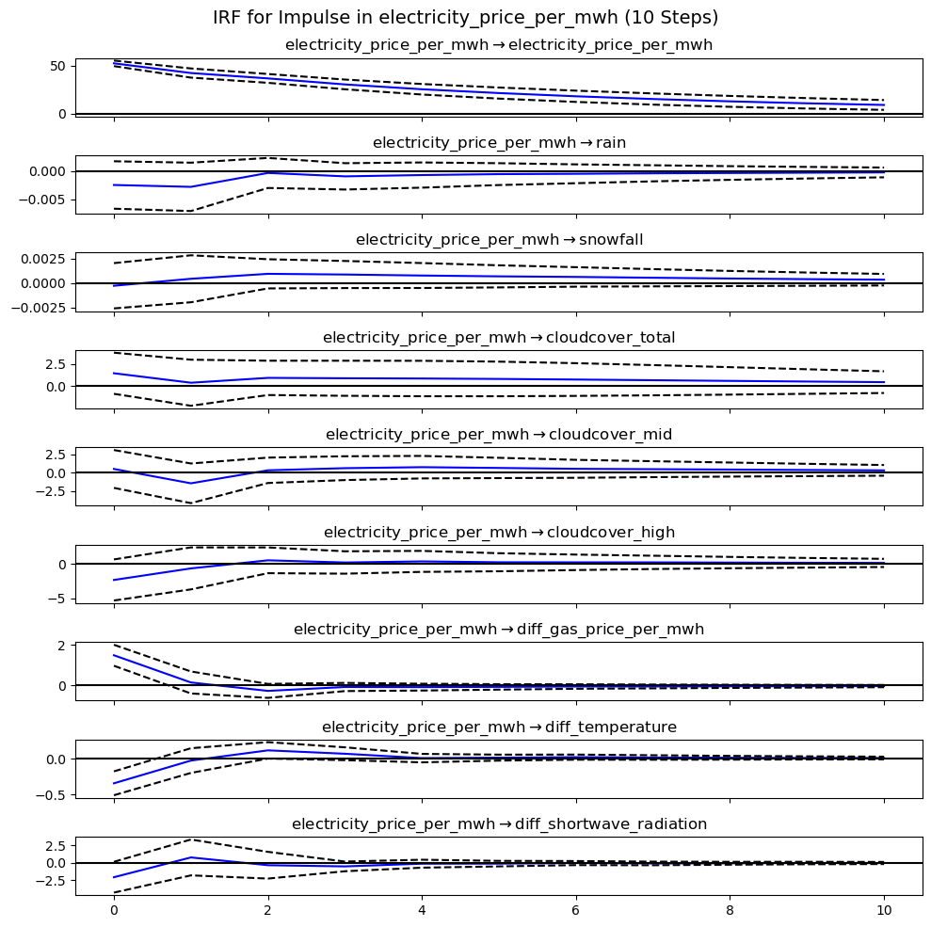

Figure 16. Impulse Response Function (IRF) for Electricity Price

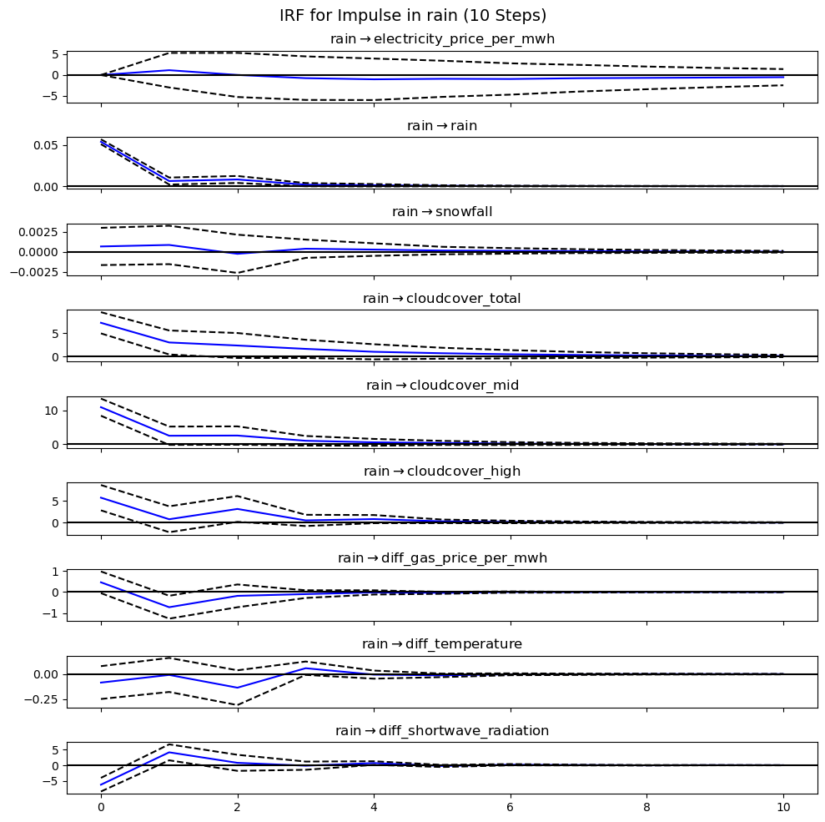

Figure 17. Impulse Response Function (IRF) for Rain

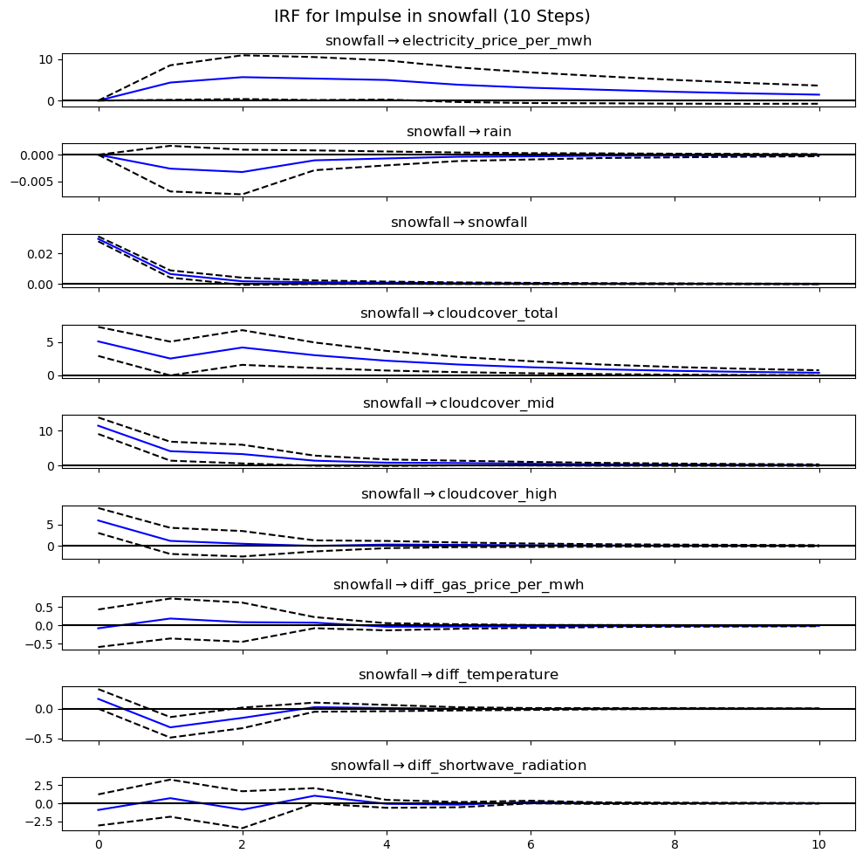

Figure 18. Impulse Response Function (IRF) for Snowfall

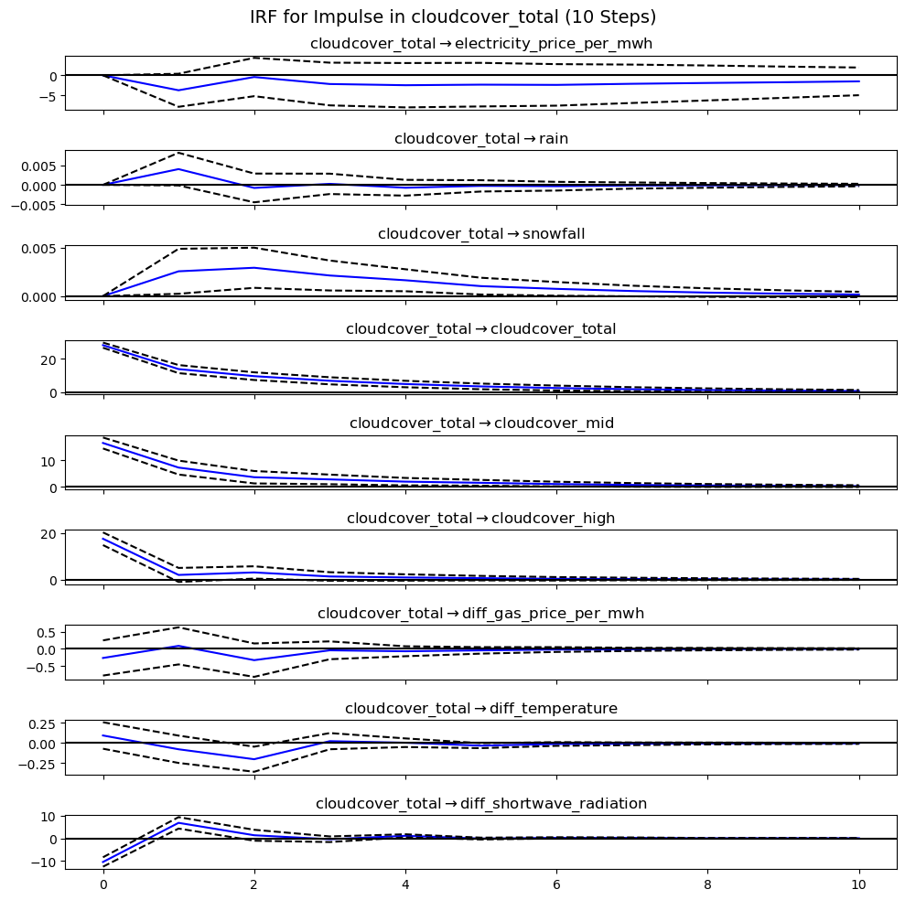

Figure 19. Impulse Response Function (IRF) for Total Cloud Cover

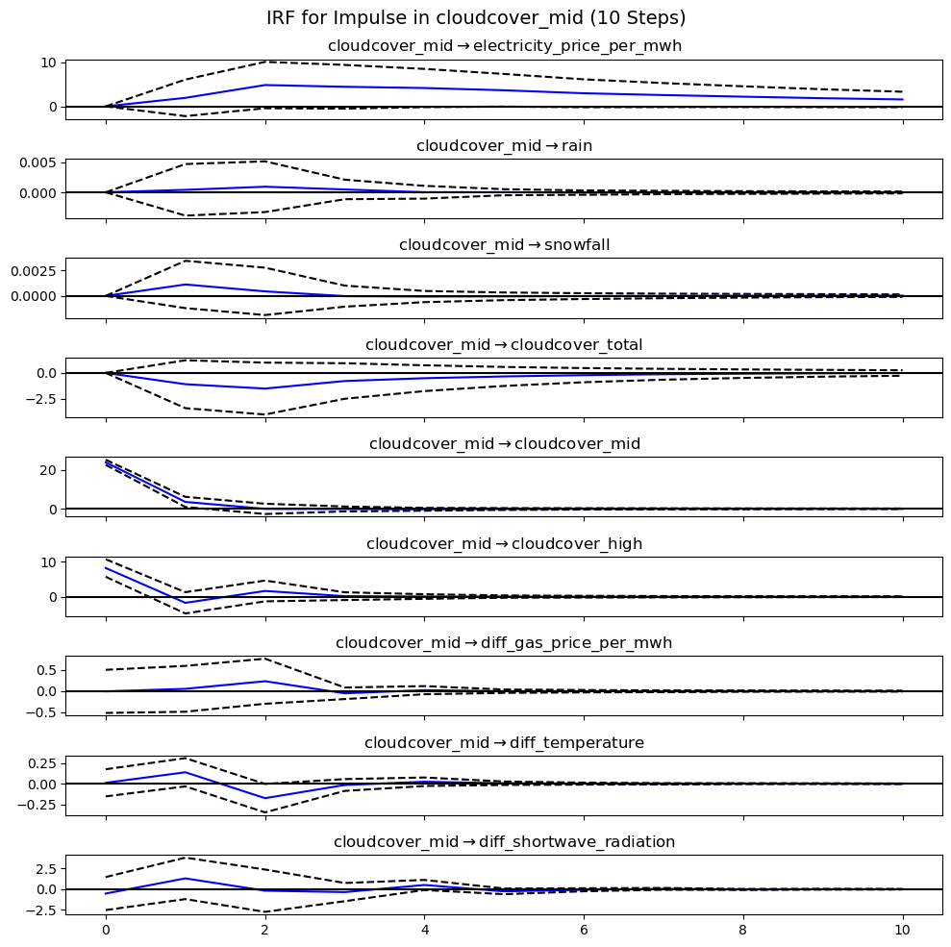

Figure 20. Impulse Response Function (IRF) for Mid-Level Cloud Cover

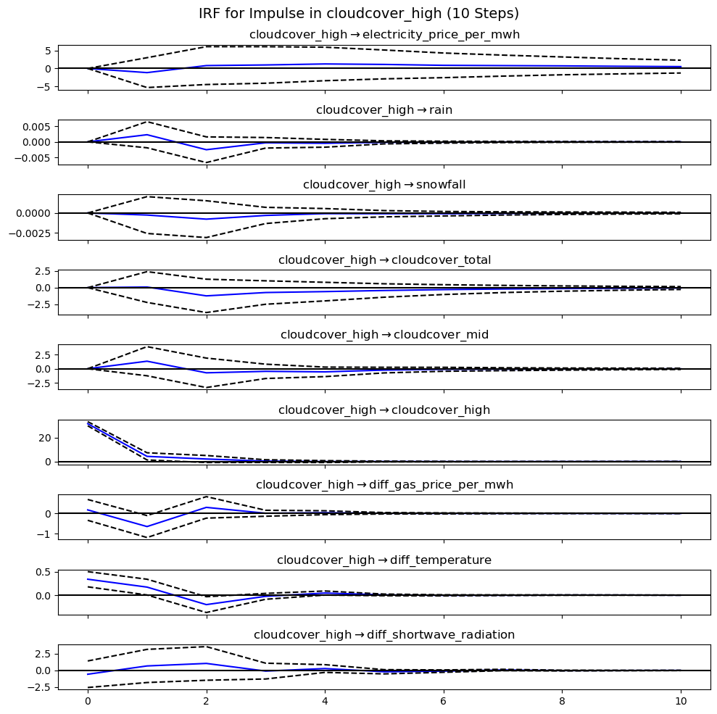

Figure 21. Impulse Response Function (IRF) for High-Level Cloud Cover

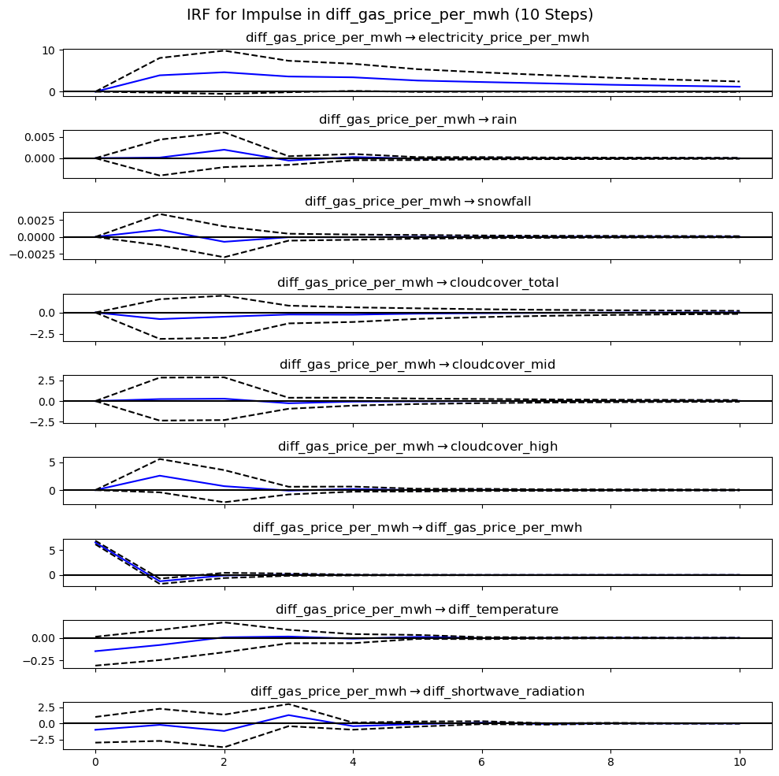

Figure 22. Impulse Response Function (IRF) for Gas Price (Differenced)

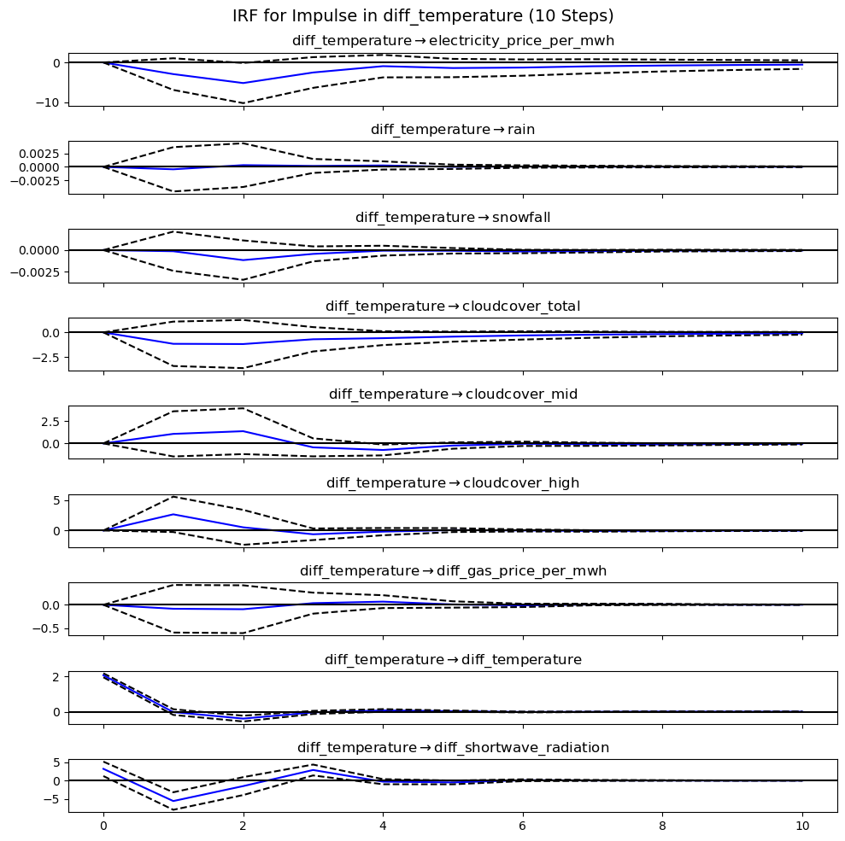

Figure 23. Impulse Response Function (IRF) for Temperature (Differenced)

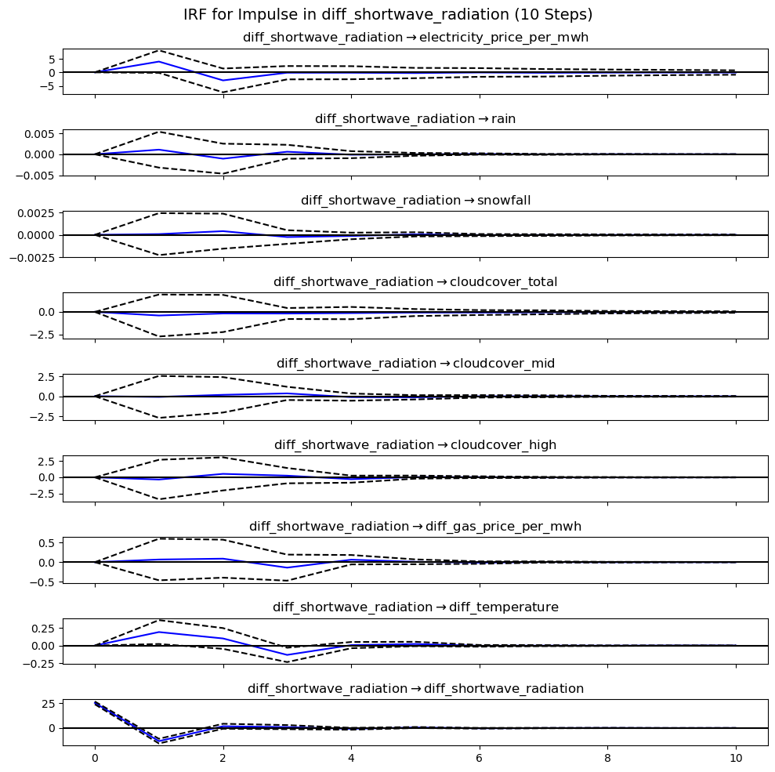

Figure 24. Impulse Response Function (IRF) for Shortwave Radiation (Differenced)

