AUSBD, 2018; 1(2): 23-34 ausbdergi@gmail.com
e-ISSN: 2651-3064 DOI:

PEDAGOGİCAL ANALYSİS ON THETRANİNG MODULES PRODUCTED: SCİENCE TRAİNİNG PROGRAM FOR YOUNG REFUGEES İN THE AGE OF 12-18 (MİDDLE AND HİGH SCHOOL LEVEL)

Ebru Yalçıntuğ∗
BüşraBayramoğlu∗∗
H.Mustafa Eravcı∗∗∗

Özet
Suriyeli göçmenlerin eğitim proğramları için üretilen eğitim modülleri, hedef kitlenin içinde bulunduğu formal ve informal eğitim proğramları için son derece önemlidir. İşte bu çalışmada, ilgili yapıların ürettiğideğişik alanlarda uygulanabilecek modüllerin pedogojik bakımdan değerlendirmesi yapılacaktır.
Anahtar Kelimeler: Eğitim, Göçmenler, Modüller

Abstract
Training modules for Syrian refugees' training programs are very important for formal and unformal education programs involving the target audience. In this study, the pedagogical evaluation of the modules that can be applied in different areas of related structures will be done.

Key Words: Education, Migrants, Modules

Introduction
Education is an important way for development of children from all countries and it is a fundemental right. So every country must provide educational opportunity and equity to their people. With regard of this fact, a science training program is tried to develop for this project which name is Let’s Science. This program consists of games and experiments in which is aimed at mathematics and science learning of young refugees. Let’s Science program contains 22 games and experiments for middle and high school students and four games and experiments for primary school students. The program is evaluated from the point of students’ development, classroom size, time and teachers.
The Tower of Hanoiis the first gamein this program which aims mathematicstraining of young refugees between the ages of 12 and 18. This game has quite simple materials in terms of using. Teachers need only three rods and a number of disks of different size, which can slide onto any rod. Rules of the game are very simple and also effective for students who will try to find how many steps they need to take. Students can move only one disk at a time and place it on the top of another stack or empty rod and not place a disk on top of the smaller disk. However,a teacher using this game for mathematics training should be careful about the number of disks and students’ motivation for the game. In Turkey, a middle or high school class includes 25-30 students. Playing this game requires additional time for the teacher to pay attention to eachstudent who has different learning levels. If the number of disks using at this game is stated, the underlying calculation will be $2^{n}-1.$Primary objective of this game which is reached this calculation by students themselves. Teachers can mention the solution of the underlying calculation and Fibonnacci sequence at end of the game session. At the table in which given numerical numbers examples can striking for students, so extending examples like this can benefical.The teachers can be advised to use this game out of lessons time, activity time sor the last 15 or 20 minutes of lessons. The recommended ages for this game, between the ages of 12 and 18 are not appropriate since at the high school level students can loose their attention as they can found it simple especially after 10th grade.
Spaghetti Bridge activity can be used for enhancing both motor and architecture skills.The activity can be practiced with only spaghetti and gluef.. Using this activity in classes could have some challenges like lack of time and area. Students need to exhibit what they do or achieve to demonstrate other people, teachers, and classmate. In this way, students doing this activity support and remember their knowledge. Applying this activity in their science lessons has some difficulties for teachers. If teachers let students begin with difficult and complicated ones, students can not understand the basic rules of doing a bridge. At the end of doing a simple bridge, students construct a hanger system with a little bucket for the crash test and the teacher must pay attention for this test. Science lessons which are planned for using this activity have some information related to do the bridge and the crash test. The teacher can get students’ attention to architecture and activity through associating the bridge and crash test with the information which the teachergives. Through associating the bridge and crash test with the information, teachers’ aim is scaffolding, so students can reach new knowledge by related their old ones. But experiencing difficulties with time and area remains the same on condition that teachers will not plan effectively this lessons. Besides that, if students have done this activity at middle school, doing this activity at the high school could seem easy. Teachers must pay attention to this situation when plan lessons.
Teachers who target enhancing students’ physics knowledge by using their body can deploy Atom Trap in which students use one,two or three pellets and a wooden disk. It is a balance game which aims to navigate one, two or three pellets from the outer periphery of a wooden dick to the inner trap with help of body balance. This game is fulfilled by high school students who are 17-18 years old because students need to know the basics of physics, chemistry,and atom for understanding why play this game. Although playing this game is needed some knowledge, students have to be informed before playing the game to make sense. Learning objectives of the game are so complicated for mention two other experiments. Students’ past knowledge or given information before the game become important for understanding atom movements. After this informing, the teacher can ask students first to navigate one pellet the outer periphery to the inner trap and then ask the same thing two and three pellets for showing movement principles of the atom. Asking students to plat this balancing game is broughtwith placeissues. First, there is not enough free space in classes in Turkey to do activities like this. Secondly, even if science teachers want to have students play this game respectively, their time will not be enough for this. Finally, this game can be unavailable for using the end of the science lesson to reiterate knowledge, Atom Trap has had rather do at another time like exercise lessons.
In grammar lessons, students can learn meanings and spellings of words and using appropriately this words in their life and written language.Guessing Homonyms game aims to enhancethis information with not only using the word oneself but also making students describe their meanings. This game requires grouping students third by third. Two of the students in this groups choose a word which has two meanings, then every partner undertakes one meaning and describes one by one with one sentence and without using the word itself. The third student in the group has to find the word as soon as possible. This game could be used in Turkish grammar lessons as well as in English grammar lessons. Students can learn new words and their utilization both in their language and foreign languages by this way. Explanations of homonyms and synonyms words could be needed first years of middle school, but this need decrease the years ahead to high school. This game could be shared at lessons periodically like once o month. Words which is used in this game could be chosen by teachers so teachers can determine difficulty levels of this words.
Caesar Cipher could be used before, in or after history lessons because of the learning objectives of this game and given information about history. The basic rules of this game are sending a ciphertext to the chosen person and to decipher text via a determinated key. Playing this game in classrooms is caused disorder as a teachercannot specify ciphertexts and keys for each pair of students. In this situation, teachers can identify different ciphertexts for each student which send the same message and can ask students decipher the message. So teachers can restrain disorder by this way. Age of target group for this game, 10-12, is made difficult linking learning objectives with the game. Therefore when the game isplanned to add in lessons, playing the game after giving information about cryptography should be considered by teachers. Besides that, the number of Enigma’s and Digital Encryption Standard ‘s possible keys specified in the learning objectives given by teachers can be incomprehensible for students who are targeted group for this game.
In science lessons, conducting an experiment is very significant for students since information is became very remarkable and is enabled by remembering this information via experiments. Targetted age group for Surface Tensionexperiment is appropriate. Science lessons can be tough for students, but beginningwith an experiment makes understanding information easier. Surface Tension experiment can be done at the beginning of the science lessons because the experiment takes a little time and materials that are needed for conduct the experiment, a glass of water, paper clip and a drop of liquid soap, can be found anywhere and do not occupy much space. At the end of the experiment, teachers prepare students to the science lessons by asking questions about the experiment. Learning objectives which is planned given after the experiment is very important for students to associate their experience with information. This experiment could be varied with different materials and repeated at different times.
Chinese Checkers game is targeted students group who are between the ages of 10 and 15, but also it could be taught at younger ages. It has simple rules and moves that aim to improve students’ tactical and thinking skills. Students who play this game need to know rules and moves like no capturing in Chinese Checkers. It is aimed in this game that is raced pieces all home into the opposite corner. At this ages which are targetted group in this game, students became aware of what they doing. The game is appeared important. Although learning objectives of this game are linked with biology, it can be used mathematics lessons and mathematicsexercise time. If the game is used at biology lessons, students have confusion since they cannot be able to associate the game with routes of ants. If the game is used at mathematics lessons or exercise times, then given learning objectives cannot be linked with the game either. Thus, teachers who want to use this game for reaching these learning objectivescan plan a mathematics lesson in which students can play this game and right after this lesson teachers may talk about learning objectivities in biology or science lessons by mentioning the Chinese Checkers game. Beside this linking problem, teachers have trouble using time effectively when playing this game since each student may want to play.
Observing star is a good experience for the 10-12 age group. Twinkle, Twinkle Little Star is a long-term study more than being an activity. So students need informing about how they can conduct a long-term study and looking after what they do. Students need a star map which explains constellation at night sky and could be installed a smartphone or tablet, and nigh sky for watching stars and founding the constellations. While students do this, teachers can give some information about constellations at science lessons and why finding them is so important, how people can use them in their lifes. If the questions which are asked Searching for Constellations study are desired to reply, students must conduct this study nearly a year. Therefore teachers must be careful about following students’ outputs for observing their improvement and when students have difficulty in doing this study, they can help them. If teachers want to help students, they should set time aside once in a month for examining students’ output.
What is missing on the table?The game can be used for various objectives. First teachers who play this game with students can test students’ memory. Secondly, teachers applying this game after a while can evaluate their students’ improvement. Finally, the game could be played not only with objectsbut also with pictures, things that students have seen before in their environments. The game can be entertaining and challenging for students but this can bring difficulties to teachers like the game could be wanted to play by each of the students. Determined learning objectivities for this game might become more meaningful with videos about how the brain works and why brain and computer work the same way. In this way, students targetted age group for this game can understand better how people can remember things. But teachers should inform students about this is not the only way, there are so many tests which aredone to investigate or understand the working of the human brain. Teachers maybe mention about an animal experiment on the brain for example chimpanzees in turn students can be able to compare human with animals and computers. It is assumed that students have some information about short-term and long-term memory and consequently teachers associate the game with short-term and long-term memory in learning objectivities. Teachers should be sure about students at least have an idea what is the meaning of short-term and long-term memory.
Age of the target group is important for planning and playing game. If the age of the target group is chosen elementary school level, planning activity is easier for teachers of these students than middle and high school teachers because one teacher determines what is taught to students. The lessons where activities and games are implemented should be promoted each other because in middle and high schools student learn different things at different lessons. Although games like Dodge Ball could play only gym lessons or break times, the learning objectivities which are chosen to be taught at the end of the game could mention at science or biology lessons. Gym teachers cannot be able to enlighten students about the virus as science or biology teachers cannot be able to take the student out of the classroom and play with them while teaching a lesson. Thus teachers should work and plan process together by which they can support students’ learning. When planning this lessons, teachers should be careful about time for there is not so many times between these lessons, and to support the content of these lessons each other.
How to Produce Energy From Light? is an experiment in which is aimed to show student oxygen production. Age of target group for this experiment is 16-18. It can be recommended that students who are under this age group can be involved in the experiment because it is not dangerous and not so complicated. Students have learned photosynthesis since fourth grade. So they have had an idea what the mechanism of photosynthesis is. Doing this experiment and sharing what they learn from the experiment is important for students to enhance their knowledge and experience. Teachers can use both experiment and learning objectives in one biology lesson as a result of that they don’t face with time, planning and area difficulties. Information which is in the given table at the end of the experiment is remarkable and appropriate knowledge for the target group. Thus teachers can use this knowledge in their lessons. The experiment using for taught energy can be effective to teach students how plants generate sugar and oxygen with light energy.

Mathematics can use in various ways. Playing with Möbius strips activity is designed for one of a sub-section of mathematics, topology. It is simple and effective to teach and not take time. Teachers can plan a mathematics lesson which includes the activity and introducing Möbius strips. But teachers should ensure that students have information about geometry so teachers can inform students about typology. After students take a stripe of paper and produce a Möbius strip, the teacher should want to walk their fingers along the surface of the strip and then ask students where they arrive. So students can reach the information which is aimed for this activity after that teachers explain why they arrive back side of the Möbius strip. The informationbecomes more permanent in this way. Although students can reach the information, the target group of this activity cannot be able to use it for understanding mathematics. Before doing suchlike this activity, students should be informed about why they learn this and where this informationis used.
Understanding Nano World is difficult because people cannot measure or see it. For making a compare,using one thing known by students as hair with a measure as a triangle ruler will be meaningful for students. Before this step teachers should ask students how we can measure molecules which are shown before at videos. So students wonder how they can measure it. Thenteachersexplain the experiment and show it in class. Since teachers use an overhead projector to do the experiment, students don’t need to do the experiment by themselves. Students can see and measure hair as teacher shoe hair and triangle ruler on the overhead projector. It makes sense for students in this way. Describing students how people use the nanotechnology which is given in learning objectivities arouse their attention this technology. Teachers can plan a science lesson in which they associate the experiment with the nanotechnology information so that students use their knowledge bringing from the experiment.
All Around theSun experiment is asked to do from students. But all students may not have field glass, so teachers either supply field glass or do this experiment in the classroom as students can watch it. It can be predicted that students cannot be able to see all aspect of the sun. If teachers want to talk about learning objectives like the mass of the sun, they should support the lesson with a video about the sun or a model of the sun. In this way, they can show students magnitude of the sun and the world. So students can make a comparison between the sun and the world and other planets. Age of target group is between 14 and 17 for this experiment. Students at a younger age in this target group have had information about the solar system but not about the speed of the turning surface of the sun even if the world. Teachers should be careful about students’ age and previous knowledge when planning this experiment and give information after the experiment. It is recommended that teachers should do this experiment in science lessons when they teach the solar system since they cannot plan a lesson about one thing.
Some of our knowledge comes from observing. In the classroom context, if teachers want to rebuild this observing context, they have to spend time that is used for lessons. Because of this sometimes teachers should give information first, then should do experiments with students while continue informing students and show the consequences of their experiments end of the lessons. Planning a lesson like that is useful for experiments asWhy is the Stomach Acidic? which takes time to do. Age of target group can do this experiment without any harm and each of student in the classroom can do it because experiment can be done at the same time and every student can get cabbage, vinegar and baking powder. Through given information, students can reach by themselves which one is acid and which one is base. At the end of the experiment, teachers can inform students about the gastric juice which is produced by the stomach. They can use models and internet to show students how the gastric juice help the processing of food and keeping away bacterial invaders. After that teacher can ask students for giving to one glass a drop of vinegar and giving to the other glass a little bit baking powder, then want to students examining what happens. So students can link between the experiment and working of the stomach.
In Invisible Sun Rays experiment, teachers aim that the students get first ideas about invisible UV light. Thus it can be said that it is an important experiment for the target group. Not only because they will get the first ideas but also students in this age will interest in different areas. For doing this experiment, the teacher can prepare classroom with dark curtains and hold the UV lamb on students filter paper one by one so students can see UV raw. Then do the same thing after students put the filter paper into a glass of water. Age of target group is appropriate to do the experiment and they can understand it’s consequences. It is planned that teacher talk about sun rays and how the colors occur while students examining UV ray. Beside that teacher should mention why UV rays could be harmful to people and what they do people’s skin. Taught students why they learn, especially at this age group is important since students can develop their metacognition skills in this way. Thus teachers should inform students not only about learning objectives but also about linking information.

Bottle Under Pressure is implemented as the previous experiment to the explanation of Mariotte’s bottle. After this experiment teachers explain what is the logic of working of Mariotte’s bottle. So students can see static pressure via this experiment. At physicslessons, students learn about too many things about basic formulas but they cannot be able to see how these formulas work in daily life. The experiments like Bottle Under Pressure provide students understanding these formulas. Besides that the information which ones are learned from this experiment become more permanent for students. It can be said that this experiment can be used in every school by every physics teachers and students can do this experiment even by themselves. Age of target group for this experiment is appropriate since teachers instruct learning objectives to students. Although using this experiment with the age of the target group is planned, students at a younger age can do this experiment without giving learning objectives or giving less information. In this way, younger students can use this informations future.
Students age between 10 and 12 could be defined as children and games are important for their learning process. Like What is missing on the table?Hard Disk in our Head is a game which is targetted 10-12 age group. It is aimed that students find picture pairs in 30 pictures which are inverted. The number of pictures could be increased at the second time. Although it can be used for teaching students short-term and long-term memory, it is difficult to plan how the game could be incorporated into a lesson. Since it has no topic for brain working. In science lessons, children do experiments about how plants grow or bacterias reproduce. Playing games at these ages has benefits as difficulties. The teacher cannot play one student across a class, every student wants to play this game especially with teachers. So time is not sufficient for playing every student. Teachers should implement this game in activity times before the lesson in which they will link the game and learning objectives.Learning objectives for this game are very useful for the years ahead. Students can use this information in the future.
As mentioned above, the game is provided important opportunities for learning especially for ages between 10 and 12. But playing games bring along some challenges as distracting attention. When students in this age group play a game, they use some skills; paying attention, playing in order, watching their pair etc. Along with acquiring this skills, teachers sometimes aim purposely to give some information as in Good Resolutiongame. In this game, teachers show two students four pictures of the same objects in different resolutions to ask them to identify the picture. The one who identifies the picture at the first time will win the round. After or within the game teachers give information about the phenomena of pixels and different degrees of resolution. So, it can be said that the game is effective for teaching students about the link between pixels and resolution. Althoughstudents can learn pixels and resolution, teachers should decide to give information through which lesson. Because when students play the game at activity time, they do not want to learn something directly and teachers should be careful about giving instruction undirectly. It is aimed that students can associate this game with the information so it becomes more permanent. Teachers could achieve this goal by using this game in their lessons. Students who are 10-12 age are in a transition period in which they transfer from primary school to middle school. Thus teachers’ lessons plan change at this period. When a lesson is planned, all of these conditions should be taken into consideration.
In the Yellow and The Yellow is not Always the Same experiment, teachers need few things to do the experiment as a mirror, bowl, waterand light. So every teacher can use this experiment in every class. Targetted group’s age range for the experiment is appropriate to do and teach. It can be said that teacher could use the experiment at science lessons at primary schools and at physics lessons at middle schools. They should give information about colors and how people can see colors. Students who are at this age group can understand this information, besides that they see this colors via the experiment. When doing this experiment teachers should show students how the colors occur or split into groups so students can do the experiment and see it’s consequences.In this way teachers can use time effectively. Maybe primary school teachers can do this experiment with younger students.
It is indicated that students associate information with games and experiments, so the information becomes knowledge for students. But when students could not associate information with games and experiments, this process is interrupted. In My Voice is My Passport game this situation in which students could not information with games could come to exist. Because in this game, teachers ask students to close his or her eyes and guess what another student whispers as fewer trails as possible and linked the game with learning objectives is difficult for students. It can be said that given information to students which is planned to give after, is not related to the game and age of the target group is not appropriate for this game although learning objectivities is appropriate. The game can be boring for students at this age group as they have to wait for other students guessing. Because teachers cannot make each student play and give them information at one lesson time. Given information after the game is so complicated than the game. Teachers should be careful about the link the game with information. Besides that, the game can be played with students at younger ages.
The Bigger The Choice, The Harder It Is to Choose game is designed to teach Monty Hall Dilemma. Both of them are about probability and finding the way which is statistically the most effective one. Teachers can use this game at their class when they give instruction about probability. Teachers can plan a mathematics lesson in which they can both use the game and give information about probability. Age of target group for this game is appropriate to learn, play and understand. Through playing this game students could understand the logic of probability and statistic. After playing the game explanations which is given by teachers is important for learning of students so teachers information about this topic is significant and given information by teachers should be varied in regard to previous knowledge of students. Teachers should show the game and ask every student their opinion about which strategy is statistically the most effective one.
Science Training Program for Young Refugees in the Age of 6-9 (Primary School Level)
At Geomagic game teachers aim to enhance more than one skill. It is a card game in which one of the students hold cards and the other student a table with numbered images. It can be said for the planning process of the game that objectives of the game is well explained. The duration, number of participant, general and specific goals is determined before teachers planning it. Thus teachers have informations about what they expect at the end of the game. Time is an important determinant for primary school teachers when they choose a gamet o play, as they have to teach so many things. The game duration is appropriate for using. Determinated group age for the game is transational period for students that they bring along some habits which is acquired at pre-school time. Therefore a game which is taken a long time could be distracting for students. At age between 6 and 8 students need some help for playing this game, they cannot be able to understand game rules and how they play just telling so they need to show them how it is played. Teachers can evaluate both themselves and students learning process the questions which is given at the end of the introduction of the game. It is recommended that teachers shoul use this game after the mathematics lesson in which they give informations about geometric shapes.

Every game is an opportunity to enhance social skills however in some games is put a emphasis on this than other games. In this games, objectives which is determined before for students is based on social skills more than maathematics or science. This situation is applied to Viper game. General and specific goals of the game included develop students’ communication skills, team work, concentate and respect for the rules as well as counting skills. These social skills is important for students relationships so enhance these skills as important as devoloping mathematics or science knowledge. Designed duration of the game is neary a lesson time thus it could be recommended to teachers that they should use the game at activity times. After using this game more than one time they should change action cards as students do the same thing when play the game. When play the game, teachers seperate students into groups so they could control class and besides that teachers can use time effectively in this way. Teachers can evaluate both themselves and students learning process the questions which is given at the end of the introduction of the game. Depending upon determinated outcomes and competencies they can evaluate efficency of the game for students.
At primary school levels teachers provide a basis for students learning so it can be said that this period is very important for their knowledge. When Reflector activity is done, students learn symmetry implicitly. It is aimed that students create different pavement identifying the possibility of existence or not of symetry axes in this activity. There is not another objective stated neither in general goal nor in specific goal. It is planned that the activity take 15 minutes, but students have diffuculty to understand how they can create different pavements at 6 and 7 ages, thus it could take more than 15 minutes. Symetry concept could be diffucult to understand at 6 and 7 ages so in such a case given informations must be simplified by teachers. As the activity is planned, teachers can use given tips in introduction of the activity. Teachers should use this activity after they give information about symetry so they can plan a mathematic lesson which is involved symetry and the activity. Teachers can evaluate both themselves and students learning process the questions which is given at the end of the introduction of the activity. If teachers implement this activity by seperating into the students groups, they expect to develop colloboration and teamwork. But doing this activity indivudually is better than doing as groups.
In Action Table activity it is aimed that students collect, organize and treat observed situations. Students fill action table as they roll the dice and take out an action card and it is recommended that repeat it at least 20 times. Although this practice is necessary for learning how develop a data set, it could be boring for students at 8 and 9 ages. Thus action cards which is planned to use in this activity should be changed in time. When this activityis done, it is aimed that students develop their organizational technique and learn how to collect data. But the activity cannot implemented at mathematics lesson, it shoud be done at activity time. Duration which is planned for this activity approximately 20 minutes is not take all activity time, so teachers should think about another activity when implement the Action Table activity.
Conclusion
Games and experiments can be facilitated learning and recall of informatıon espicially for children. In this way, students can associate their former knowledge with new information and can use their former knowledge for games and experiments. However using this methods in lessons could be useful for teachers, they should be careful about time, varying components of games and experimentx and giving opportunity for each student. With using the program, students can gain positive outcomes like learning to learn. Thus if teachers could be careful about planning and appşying the program in their lessons, the program can be useful for young refugeess.

APPENDIX

Appendix I: The Tower of Hanoi

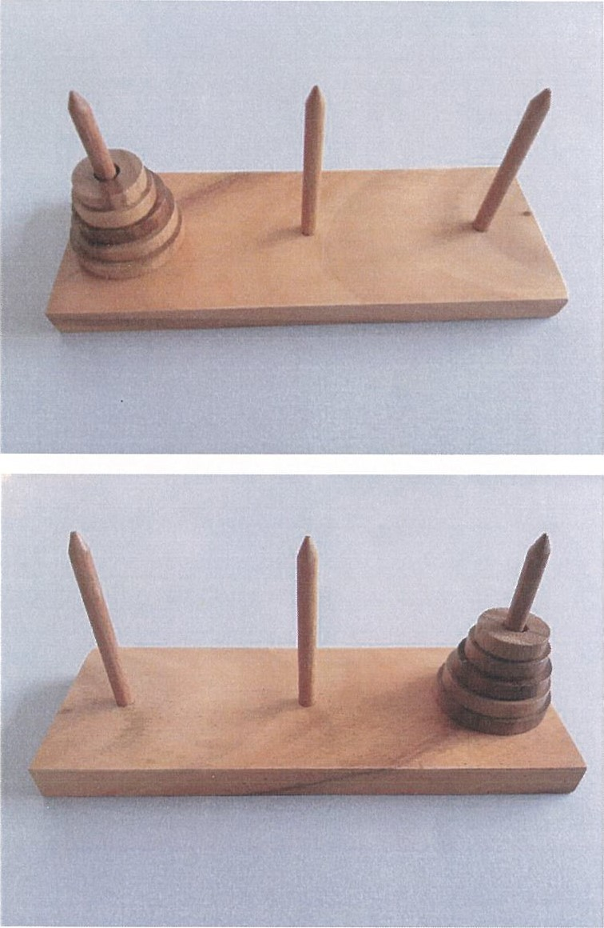

Appendix II: Atom Trap

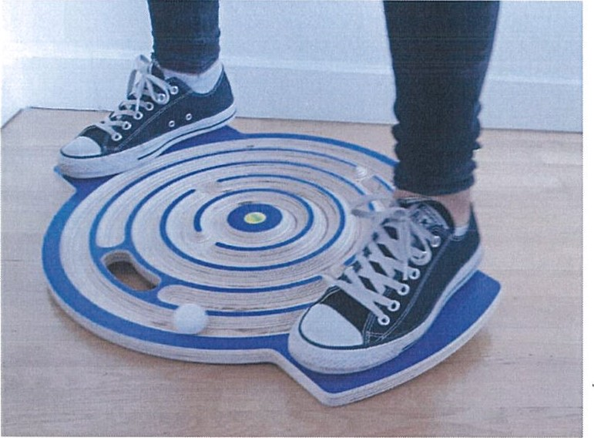

Appendix III: Hard Disc in Our Head

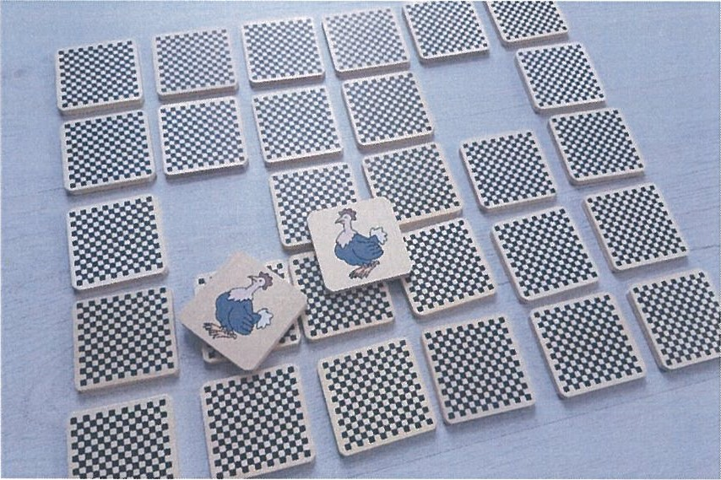

∗ Arş. Gör. Anadolu Üniversitesi Özel Eğitim Bölümü İşitme Engelliler Öğretmenliği Anabilim Dalı
∗∗ YLS. Öğrencisi Yıldıırm Bayezit Üniversitesi
∗∗∗ Prof.Dr. Yıldırım Beyazit Üniversitesi, İTBF Tarih Bölümü
The Modules of Let’s Science Training Program for Young Refugees, p.5 Başvuru/Submitted: 06.12.2018 Kabul/Accepted: 25.12.2018
Op.cit. p. 8
Op.cit.,p. 11.
Op.cit., p. 16.
Surface Tension, https://www.britannica.com/science/surface-tension.
The Modules of Let’s Science Training Program for Young Refugees,p.21.
Dodgeball Rules, http://www.rulesofsport.com/sports/dodgeball.html.
The Modules of Let’s Science Training Program for Young Refugees, p.31-32.
The Modules of Let’s Science Training Program for Young Refugees, p.42.
Op.cit., p.43.
Op.cit., p. 45-46.
Op.cit ,p. 48.
Op.cit., p. 55.
Op.cit., p. 59-60.
Op.cit. p.63-64.
Op.cit. p. 67.

