Sixth Grade Students’ Preferences on Multiple Representations Used in Fraction Operations and Their Performance in their Preferences
Altıncı Sınıf Öğrencilerinin Kesir İşlemlerinde Yer Verilen Farklı Temsillere Yönelik Tercihleri ve Tercih Ettikleri Temsillerdeki Başarı Durumları
Fatma Kara, MoNE, fatmakara7581@gmail.com, ORCID: 0000-0003-2036-8382
Lütfi İncikabı, Kastamonu University, lutfiincikabi@gmail.com, ORCID: 0000-0002-7912-780X

Abstract. The aim of this study is to determine the representation preferences (numerical, area model, number line and verbal) of the sixth-year students for the addition and subtraction of fractions and to reveal their successes in their preferences. Being descriptive in nature, this research has been conducted as a survey study. The study group consists of 59 students, 31 of whom are boys and 28 of whom are girls, who are in the sixth grade of three middle schools affiliated to MoNE in the city of Kastamonu. A purposeful sampling selection method was used to select participants. The data were collected by " Multiple Representations in Fraction Operations Test " and analyzed in accordance with predefined transition criteria. Representation preferences of students and interpretations of their success in their preferences were presented through descriptive statistics (percentage and frequency). While area model representations take the first place in preferences, verbal representations are the least preferred type of representation. When students’ performances in the representations are examined, the most successful representations of students in addition and subtraction of fractions are numerical and area model representations. On the other hand, it has been seen that the achievement status of students in the verbal and numerical representation types is considerably low.

Keywords: Multiple representations, adding and subtracting fractions, middle school mathematics education, representation preferences

Öz. Bu çalışmanın amacı altıncı sınıf öğrencilerinin kesirlerde toplama çıkarma işlemine yönelik temsil (sayısal, alan modeli, sayı doğrusu ve sözel) tercihlerini belirlemek ve kendi tercihlerindeki başarı durumlarını ortaya koymaktır. Betimleyici doğaya sahip olan bu çalışma tarama çalışması olarak yürütülmüştür. Çalışma grubu Kastamonu şehrinde MEB'e bağlı üç ortaokulun altıncı sınıfında olan 31'i erkek ve 28'i kız olmak üzere 59 öğrenciden oluşmaktadır. Katılımcıları seçmek için amaçlı örnekleme seçim yöntemi kullanılmıştır. Veriler "Kesir işlemlerinde Çoklu Temsiller Testi" ile toplanmış ve önceden tanımlanmış temsiller arası geçiş kriterlerine göre analiz edilmiştir. Öğrencilerin temsil tercihleri ​​ve tercihlerindeki başarılarının yorumlanması betimsel istatistikler (yüzde ve frekans) ile sunulmuştur. Alan modeli temsilleri tercihlerde ilk sırada yer alırken, sözel temsiller en az tercih edilen temsil tipidir. Öğrencilerin temsillere ait performansları incelendiğinde, öğrencilerin kesirlerde toplama ve çıkarma işlemlerinde en başarılı oldukları temsil türleri sayısal ve alan model temsillerdir. Öte yandan, öğrencilerin sözel ve sayısal temsil türlerindeki başarı durumlarının oldukça düşük olduğu görülmüştür.

Anahtar Sözcükler: Çoklu temsiller, kesirlerde toplama ve çıkarma, ortaokul matematik eğitimi, temsil tercihleri.

INTRODUCTION
Educational programs aim at educating individuals who can cope with everyday life problems with their questioning, suspicious and different viewpoints and can adapt to changing living conditions. With the statement "Ability to express concepts with different types of representation" (p.II) among general objectives of mathematics education in the curriculum of secondary school mathematics course (Ministry of National Education [MoNE], 2013), the phrase "expression with multiple representations" was included in general objectives for the first time, underlining the development of students' skills in transition between different representations.
In the literature, there are different definitions of the concept of representation (Ainsworth, 2006; Ainsworth, Bibby, & Wood, 1997; 2002; diSessa & Sherin, 2000; Eisner, 1997; English,1997; Goldin, 1998; Hatfield, Edwards & Bitter, 1993; Janvier, 1987; Kaput, 1994; Padalkar & Hegarty, 2015; Zacharia & Olympiou, 2011). Kaput (1989) considers the representations as a model and defines them as a bridge established between abstract concepts and everyday life by means of concretization. The concept of representation is also included among the general aims of the recently released Turkish mathematics teaching program so as that students are expected to be able to express concepts in different forms of the representations (MEB, 2018, p. 5). In the report published in 2000, NCTM used a separate section to highlight the use of multiple representations in teaching. Also the report emphasizes that field teaching knowledge, subject area knowledge and affective characteristics of teachers may be effective in the learning environment through multiple representations (NCTM, 2000).
Mathematics education literature provides two interrelated categories for representations: External representations and internal representations (Goldin, 1998; Goldin & Kaput, 1996). External representations are defined as “acts stimuli on the senses or embodiments of ideas and concepts” (Janvier, Girardon & Morand, 1993, p. 81) and refer to the physically embodied, observable configurations such as words, pictures, graphs, tables, and equations (Goldin & Kaput, 1996). On the other hand, internal representations are regarded as “cognitive or mental models, schemas, concepts, conceptions, and mental objects” which are illusive and not directly observed” (Janvier et al., 1993, p.81). Lesh, Post and Behr (1987) proposed a representation model for learning mathematics and solving problems. The model consisted of five types of representations: (i) pictures (illustartions), (ii) written symbols (or numericals), (iii) oral language; (iv) real-world situations (including problem posing) and (v) manipulative models. In this model, not only these five representation modes but also the translations within and among representations are important to develop learners’ conceptualizations because this model proposes that if a student understands a mathematical concept, s/he is able to make translations between the types of representations of that concept.
Studies suggest that the presentation of information in different forms supports the realization of meaningful learning (Ainsworth, 1999; Akkoç, 2005, 2006; Özgül & İncikabı, 2017; İncikabi, Biber, Takıcak, & Bayam, 2015; Van Der Meij, 2007). Information can be transferred better with appropriate representations. Therefore, it is a necessity to enrich these contents with different representations in order to prepare a complete learning environment in which various information is involved.
The use of multiple representations plays an important role in conceptual understanding of fractions and fraction operations, learning advanced mathematical subjects such as algebra and bringing in the problem-solving skills (Bayik & İncikabi, 2019; Misquitta, 2011; Tirosh, 2000). Fractions are among the mathematical topics in which students experience difficulty. It was found that the misconceptions that secondary school students encounter in fractions include the topics related to part-whole relationship, division of mating parts, comparison of fractions, determination of unit and fraction operations (Alacacı, 2010). The difficulty that children display regarding the arithmetical learning of fractions has long been recognised (Charalambous & Pantazi, 2005; Doğan & Yeniterzi, 2011; Işık, 2011; Işıksal, 2006; Küçük & Demir, 2009; Zembat, 2007). Many of the difficulties stem from the fact that children apply their knowledge of whole numbers to the arithmetic of fractions (e.g., Gelman & Meck, 1992; Kerslake, 1986; Lamon, 1999; Pitkethly & Hunting, 1996; Sophian, Garyantes & Chang, 1997; Streefland, 1991). Furthermore, traditional teaching tends to value the use of symbols, which can often be an obstacle to the comprehension of logic subjacent to algorithmic actions in adding and subtracting with fractions (e.g., Bezerra, Magina & Spinillo, 2002).
In order to overcome misconceptions that students have in fractions, teachers are required to use different representations of fractions (including area models, set models, number line, verbal statements, and symbolic and numeric models) (Bezerra et al., 2002). Students who have internalized representations have been found to be more successful in understanding fractions and performing operations on fractions (Charalambous & Pantazi, 2005). On the other hand, students’ internalization of a concept is to be depended on teachers` creation of an appropriate learning environment. Teachers` preferences for teaching affect their students` preferences for learning and their skills in mathematics. In order to overcome obstacles standing for students` learning of fraction addition and subtraction, teachers should use multiple representations for fraction operations. Students` preferences for the fraction operation would also be a reflection of their learning experiences in classroom.
Upon consideration of above statements, this study aims to determine the representation preferences of sixth grade students in terms of the addition and subtraction of fractions and to reveal their successes at their preferences. In line with this purpose, the research problem is as follow:
What are the preferences of sixth grade students in numerical, area model, verbal and number line representations in addition and subtraction operations of fractions and what is their success in their preferences?

METHOD
Being descriptive in nature, the current study has been conducted as survey study, which includes collection of data in order to determine some characteristics of a sample (Fraenkel, Wallen, & Hyun, 1993).
Study Group
The study group of the research is the sixth grade students of three middle schools in the Kastamonu province center. Purposeful sampling was used for sample selection. Classes in which gains regarding addition operation in fractions were taken into account, and in this context, sixth grade students participated in the study. In determining the schools to be worked with, the provincial general achievement average was taken into account and three schools with average level of achievement were included in the study. Initially, a total of 73 students, including 38 males and 35 females, participated in the research. However, as a result of the evaluation of application, it was determined that 14 students did not provide any answer to the questions at all and they were excluded from the study. Finally, the study participants consisted of 59 students, including 31 males and 28 females.
Data Collection and Data Analysis Processes
At the beginning, students were completed the "Multiple Representations in Fraction Operations Test" (MRFOT) and then, their representation preferences for fraction operations were sought by analyzing their responses to the question: “Among the representations that you operate in fractions, which one do you prefer at most?”
Data Collection Tools
The only data collection tool was the "Multiple Representations in Fraction Operations Test" was used (Appendix 1). In order to construct the test, firstly the achievements related to the subject were examined. In accordance with the number of achievements and the course load, a trial test was prepared with 30 test items consisting of 8 main questions and sub-questions. In order to determine the validity and reliability of the test, three expert opinions were taken from the mathematics education field. In terms of scope coverage, the experts indicate whether each test item is eligible by marking the "Suitable" or "Not Suitable" options according to their intelligibility, quality and level criteria.
In order to determine the validity and reliability of the 30-question trial test, the pre-test was conducted on 59 students in two middle schools in Kastamonu province center. According to the results of the application, item difficulty index and item discrimination index were calculated for each question (Table 1). Each correct solution received one point while the items responded wrong or without response evaluated as zero point. According to the item difficulty and discrimination analysis, it was found that the items with the item discrimination index between -1 and 0 were removed from the test, the items between 0 and 0.30 were corrected and the items higher than 0.30 were used directly in the test (Büyüköztürk, 2001).

Table 1. Results of multiple representation test item analysis in addition and subtraction operations in fractions
Item | Difficulty | Distinctive | Item | Difficulty | Distinctive
No |  | ness | No |  | ness
1 | 0,75 | 0,49 | 16 | 0,51 | 0,75
2 | 0,81 | 0,49 | 17 | 0,58 | 0,72
3 | 0,25 | 0,78 | 18 | 0,29 | 0,76
4 | 0,32 | 0,54 | 19 | 0,22 | 0,69
5 | 0,69 | 0,49 | 20 | 0,66 | 0,64
6 | 0,31 | 0,83 | 21 | 0,37 | 0,85
7 | 0,63 | 0,62 | 22 | 0,56 | 0,65
8 | 0,34 | 0,56 | 23 | 0,24 | 0,74
9 | 0,25 | 0,63 | 24 | 0,27 | 0,70
10 | 0,64 | 0,70 | 25 | 0,49 | 0,82
11 | 0,61 | 0,69 | 26 | 0,47 | 0,81
12 | 0,27 | 0,75 | 27 | 0,22 | 0,74
13 | 0,36 | 0,81 | 28 | 0,27 | 0,74
14 | 0,73 | 0,47 | 29 | 0,44 | 0,85
15 | 0,76 | 0,53 | 30 | 0,39 | 0,78

The KR-20 reliability coefficient of this test was calculated as 0.96. As a result, "Multiple Representations in Fraction Operations Test" prepared in line with item analysis and expert opinions was used as data collection tool (See Appendix A). The final state of the test consists a total of 30 open ended questions (8 main questions and their sub-questions requiring to transit to the other forms of representations). The distribution of the questions in the test is given in Table 2.

Table 2. Multiple representations in fraction operations test question distributions
The type of representation in the problem | Question number |  | Type of representation required to pass
The type of representation in the problem | Addition | Subtraction | Type of representation required to pass
Area model | 1 | 5 | Area model
Area model | 1a | 5a | Numerical
Area model | 1b | 5b | Number line
Area model | 1c | 5c | Verbal
Numerical | 2 | 6 | Numerical
Numerical | 2a | 6a | Number line
Numerical | 2b | 6b | Area model
Numerical | 2c | 6c | Verbal
Number line | 3 | 7 | Number line
Number line | 3a | 7a | Numerical
Number line | 3b | 7b | Area model
Number line | 3c | 7c | Verbal
Verbal | 4 a | 8a | Number line
Verbal | 4b | 8b | Area model
Verbal | 4c | 8c | Numerical

Picture 1 shows the item 1 and sub-questions 1a, 1b, and 1c. The main question (#1) requires from students to compute fraction addition on area model form. Then sub questions ask them to transit from area model to numerical form (1a), to number line (1b) and to verbal form (1c).

- Perform the operation given below and answer the questions a, b, c accordingly.
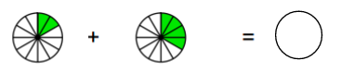
- Perform this operation using numerals.
- Perform this operation on the number line.
- Pose a problem related to this operation.
PICTURE 1. Sample question
Coding Processes
Two researchers who worked independently were involved in the data coding process. One of the coders is a researcher of this study, and the other is an academician with expertise in mathematics education. As a result of the first coding, the agreement percentage (reliability coefficient) between coders was calculated as 88.7% according to the Miles and Huberman's (1994) formula. The researchers came together and discussed the materials causing the conflict and reached an agreement on each item.
Data Analysis
Interpretations related to representation preferences of students and their success in preferences in line with the data obtained from coding processes are provided using descriptive statistics (percentage and frequency). Then, the success of students in the representations they preferred were identified by their successes in transitions from their preferred representations to other representations. Also, each student's individual success was compared (a) with the success of all students (b) within the same representation. The values were calculated by subtracting the true answer percentages of the students who preferred a representation from the true answer percentages of all students (a-b) and the results are provided with graphs.

RESULTS
In this section, the results regarding the students’ preferences of the representations of fraction addition and subtraction were first presented. Then, the success of the students in their preferences were investigated and compared with the success of all students.
Preferences on Representations
Table 3 presents the findings as percentages related to representations that the students preferred in the addition and subtraction of fractions. According to the table, almost half of the students (42%) preferred area model representations in the addition and subtraction of fractions. While Numerical representation was the second most preferred representation (27%), verbal representations were the least preferred representation. However, 15% of the students did not provide any preference for the representations.

Table 3. Preferences for representations
Representations | %
Area model | 42
Numerical | 27
Number line | 12
Verbal | 3
Not specified | 15
Grand Total | 100

Achievement in Preferred Representations
The success of students in the representations they preferred is presented specific to each representation.
Transition to Other Representations by Students who Preferred Area model Representation
Table 4 shows the percentage of transition to other representations from area model operations by students who preferred area model representation. The table indicates that the students who preferred the area model representation in the addition operation (n=25) showed highest success (76%) in the Numerical representation. Likewise, while the majority of students were successful in transition from one area model to another, these students were often unsuccessful in transition to verbal and number line representations in both addition and subtraction operations. Moreover, contrary to the addition operation, it is interesting that students who preferred area model representation in subtraction operation were generally less successful in transition to other representations.

Table 4. Transition to other representations by those who preferred area model representation (%)
 | Area model |  | Numerical |  | Verbal |  | Number line
 | True | False | True | False | True | False | True | False
Addition | 60 | 40 | 76 | 24 | 20 | 68 | 8 | 84
Subtraction | 40 | 60 | 12 | 76 | 8 | 60 | 12 | 76

Figure 1 is based on sample averages. In Figure 5.2, the point 0 was considered as the average success of sample. In the figure, success of students in transition to other representations from the area model representation was compared with the success of entire sample in transition to other representations from the area model representation. The figure shows that success of students who preferred area model representation did not generally differ significantly from the success of sample in this representation. However, success of students who preferred area model representation in subtraction operation in numerical and number line representations is well below the success of classroom compared with the success of sample in transition to these representations (the difference is 35% for numerical and 22% for number line).

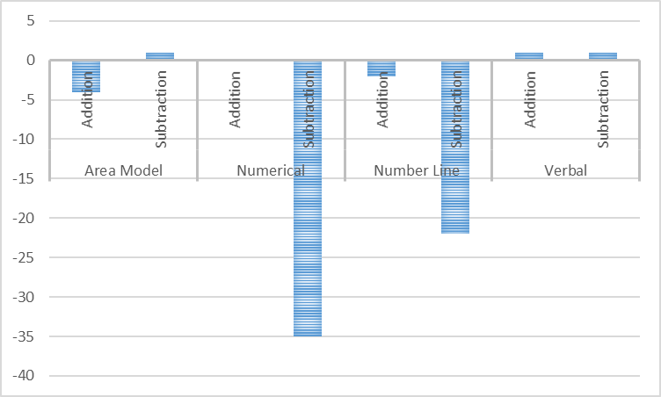
FIGURE 1. Comparison of success of those who preferred area model representation with other students
Transition to Other Representations by Students who Preferred Numerical Representation
Table 5 shows the percentage of transition to other representations from numerical operations by students who preferred numerical representation. The table indicates that the students who preferred numerical representations in the addition of fractions (n= 8) achieved the same (69%) and higher level of success in area model representation and their own preferences (numerical). It was observed that students are successful in their preferred type of representation and area model representation in transition from numerical representation to others in addition operation with fractions, while they are unsuccessful in transition to verbal and number line representations relatively with numerical and area model representations. Also, students who preferred numerical representation were more successful in transition to number line representation from numerical representation in subtraction of fractions compared with the addition operation.

Table 5. Transition to other representations by those who preferred numerical representation (%)
 | Area model |  | Numerical |  | Verbal |  | Number line
 | True | False | True | False | True | False | True | False
Addition | 69 | 31 | 69 | 31 | 19 | 63 | 31 | 56
Subtraction | 63 | 26 | 50 | 38 | 25 | 44 | 56 | 18

In the Figure 2, success of students in transition to other representations from the numerical representation was compared with the success of sample in transition to other representations from the numerical representation. The figure shows that students who generally preferred questions with numerical presentation were more successful in transition from this representation to others compared with average success of the sample. However, students who preferred numerical representation were below the success of sample in subtraction operation in transition to numerical representation and subtraction operation in verbal representation.

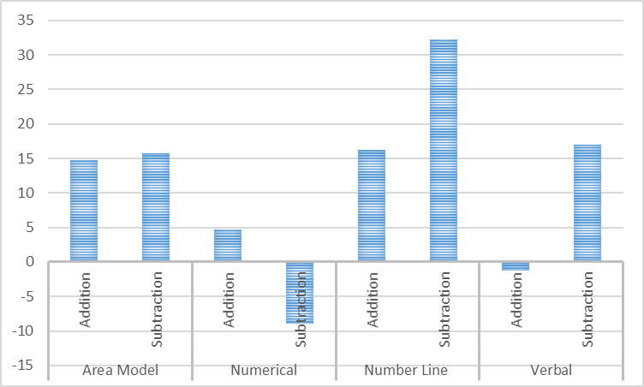
FIGURE 2. Comparison of success of those who preferred numerical representation with other students

Transition to Other Representations by Students who Preferred Number Line Representation
Table 6 shows the percentage of transition to other representations from number line operations by students who preferred number line representation. The table indicates that the students who prefer number line representation (n=5) are relatively more successful in transition to area model and numerical representations in addition operations, and more unsuccessful in transitions to verbal and number line representations. Also, those who preferred number line representation were more successful in subtraction (29%) than in addition (14%) operation in their preferred representation.

Table 6. Transition to other representations by those who preferred number line representation (%)
 | Area model |  | Numerical |  |  | Verbal |  | Number line
 | T | F | T | F | T |  | F | T | F
Addition | 43 | 29 | 43 | 57 | 29 |  | 43 | 14 | 29
Subtraction | 29 | 57 | 43 | 57 | 14 |  | 57 | 29 | 14

In Figure 3, success of students in transition to other representations from the number line representation was compared with the success of entire sample in transition to other representations from the number line representation. The figure shows that students who preferred number line representation were successful in their preferred representation and verbal representation. Students who preferred number line representation were below the success of sample in addition operation in area model representation and numerical representation.
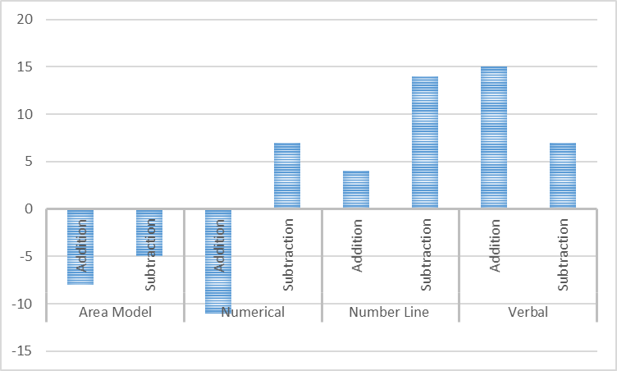
FIGURE 3. Comparison of success of those who preferred number line representation with other students
Transition to Other Representations by Students who Preferred Verbal Representation
Table 7 presents the percentage of transition to other representations from verbal operations by students who preferred verbal representation. The table shows that students succeeded at 100% (n=3) in transition to numerical representation and area model representation in addition operation, while all students who preferred verbal representation failed in transition to number line.

Table 7. Transition to other representations by those who preferred verbal representation (%)
 | Area model |  | Numerical |  | Number line
 | T | F | T | F | T | F
Addition | 100 | 0 | 100 | 0 | 0 | 100
Subtraction | 50 | 50 | 50 | 50 | 0 | 100

Figure 4 shows the success of students who preferred verbal representation in transition to other representations from this representation. Students who preferred verbal representation were generally more successful than the sample average in transition to area model representation and numerical representation; but they were below the average success of sample in transition to number line representation and both addition and subtraction operations compared with the success of sample in transition to number line representation.
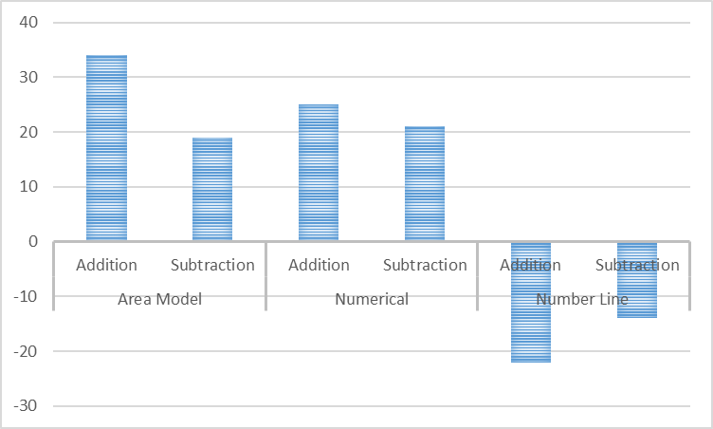
FIGURE 4. Comparison of success of those who preferred verbal representation with other students

DISCUSSION and CONCLUSION
This study aimed to determine the representation preferences of sixth grade students in terms of the addition and subtraction of fractions and to reveal their successes at their preferences. The study is limited to the data collection tools used and the participants involved in the study.
According to study findings, the most preferred type of representation is the area model representation (42%). While numerical representation was the second most preferred representation, verbal representations were the least preferred representation. On the other hand, number line and verbal representation were not preferred that much. Herman (2002) examined the representation preferences of students about functions and students preferred to use only one representation (numerical) type, although they were allowed to use more than one representation when solving the problems. Those who only used numerical representation explained this situation indicating that this representation is covered more in their classes by their teachers and textbooks and therefore, it is more familiar to them and they find the numerical representation more "mathematical". Studies conducted on representations used in middle school mathematics textbooks indicated that numerical representations are used significantly, especially in numbers and operations (İncikabı, 2016; 2017). Likewise, it is also evident in the literature that representation preferences of students are influenced by types of representations used by teachers when teaching (Akkuş & Çakıroğlu, 2006; Herman, 2002; Özgün-Koca, 2001a; Stylianou, 2010). Another reason for this finding of study would be the fact that numerical representation enables finding the solution and is suitable for finding solution with previously known rules (Özgün-Koca, 2001b).
Study also indicated that students are more successful in computing with the numerical and area model representations compared to number line and verbal representations in both operation types. This situation is in parallel with the different studies that reveal student achievement towards numerical and model representations (Herman, 2002, Pitts, 2003, Şiap and Duru, 2004). In order overcome these impediments, teachers should provide students with the opportunity to express themselves in a textual and linguistic way in order to improve their problem-solving skills in lessons. Again, while the textual questions are being asked, the scenario part should be cut in half and the students should be asked to complete or the part of the question root should be left empty, students should be gained expressing fractions. A study conducted by Kara and Incikabi (2018) also indicates that students encountered various mistakes especially in constructing number line and verbal models of fraction addition and subtraction. For example, students encountered problems while expressing fractions (verbally or in number line) and performing the operation in number line (İncikabi & Kara, 2018). Işık and Kar (2012), in the study they conducted, have also identified problems such as the inability of the students to perceive the quantities specified by the numbers in the fraction operations and the inability to reflect the operation to the root of the question. Student’s weaknesses in transiting among or to multiple representations of fractions operation signals for their conceptual understanding of fraction operations (addition and subtraction in our case). However, it is necessary to develop students’ conceptual understanding in addition to procedural knowledge. Multiple representations provide significant contributions to the development of conceptual understanding about any mathematical concept (Ainsworth, 2006; NCTM, 2000). Hence teachers are required to employ different representations of a concept in order to support students’ meaningful learning of mathematics (Ainsworth, 2006).
This study was conducted in the form of special case analysis. It is also believed that qualitative or interventional studies that focus on classroom practices of teachers, preferences of students for representation and their ability to use representations will support the result of this study. Also, the tools developed to determine the competencies or skills to use representation and perceptions or attitudes of students (or teachers) towards representations will contribute to quantitative and qualitative studies that will be conducted on "multiple representations and mathematics learning".
REFERENCES
Ainsworth, S. (1999). The functions of multiple representations. Computers and Education, 33,131-152.
Ainsworth, S. (2006). DeFT: A conceptual framework for considering learning with multiple representations. Learning and Instruction, 16(3), 183–198.
Ainsworth, S. E., Bibby, P.A. & Wood, D. J. (1997). Information technology and multiple representations: New opportunities-new problems. Journal of Information Technology for Teacher Education, 6 (1), 93-105.
Ainsworth, S. E., Bibby, P.A. & Wood, D. J. (2002). Examining the effects of different multiple representational systems in learning primary mathematics. The Journal of the Learning Sciences, 11(1), 25-61.
Akkuş, O. & Çakıroğlu, E. (2006). Seventh grade students’ use of multiple representations in pattern related algebra tasks. Hacettepe Üniversitesi Eğitim Fakültesi Dergisi, 31, 13-24.
Akkoç, H. (2005). Fonksiyon kavramının anlaşılması: Tanımsal özellikler ve çoğul temsiller. Eğitim Araştırmaları, 20, 14-24.
Akkoç, H. (2006). Bilgisayar destekli matematik öğretimi: Grafik analiz yaklaşimi: İlköğretim ikinci kademe ve liseler için. Toroslu Kitaplığı: İstanbul.
Alacacı, C. (2010). Öğrencilerin kesirler konusundaki kavram yanılgıları. E. Bingölbali ve M.F. Özmantar (Ed.), Matematiksel Zorluklar ve Çözüm Önerileri. Ankara: PegemA Yayıncılık.
Bayik, F., & Incikabi, L. (2019). Incorporating Representation-Based Instruction into Mathematics Teaching: Engaging Middle Schoolers with Multiple Representations of Adding Fractions. In J Keengwe (Ed.), Handbook of Research on Pedagogical Models for Next-Generation Teaching and Learning (pp. 311-336). Hersley, PA: IGI Global.
Bezerra, F., Magina, S. & Spinillo, A. G. (2002). How to promote children’s understanding of fractions? An exploratory study. Proceedings of the 26th International Conference for the Psychology of Mathematics Education (PME), vol. 2, pp. 89-96, Norwich, UK, July.
Büyüköztürk, Ş. (2001). Deneysel desenler. Ankara: PegemA Yayıncılık.
Charalambous C. Y. & Pantazi, D. P. (2005). Revisiting a theoretical Area model on Fractions: Implications for teaching and Research. In Chick, H.L. ve Vincent, J. L. (Eds.), Proceedings of the29th Conference of the International Group for the Psychology of Mathematics Education, (vol2, pp.233 – 240).
diSessa, A. A. & Sherin, B. (2000). Meta-representation: An introduction. Journal of Mathematical Behavior,19(4), 385-398.
Doğan, M. ve Yeniterzi, B. (2011). İlköğretim 7. Sınıf Öğrencilerinin Rasyonel Sayılar Konusundaki Hazır Bulunuşlukları. Selçuk Üniversitesi Ahmet Keleşoğlu Eğitim Fakültesi Dergisi, 31,217-237.
Eisner, E. W. (1997). The promise and perils of alternative forms of data representation. Educational Researcher, 26(6), 4-10.
English, L. D. (1997). Mathematical reasoning: analogies, Metaphors, and Images. New Jersey: Lawrence Erlbaum Associates.
Fraenkel, J. R., Wallen, N. E., & Hyun, H. H. (1993). How to design and evaluate research in education (Vol. 7). New York: McGraw-Hill.
Gelman, R. & Meck, B. (1992). Early principles aid initial but not later conceptions of number. In J. Bideaud; C. Meljac & J-P. Fischer (Eds.), Pathways to number: children’s developing numerical abilities (pp.171-190). Hillsdale, NJ: Lawrence Erlbaum.
Goldin, G. A. (1998). Representational systems, learning, and problem solving in mathematics. Journal of Mathematical Behavior, 17 (2), 137-165.
Goldin, G. A., & Kaput, J. J. (1996). A joint perspective on the idea of representation in learning and doing mathematics. In L. Steffe, P. Nesher, P. Cobb, G. A. Goldin, & B. Greer (Eds.), Theories of mathematical learning (pp. 397–430). Hillsdale: Erlbaum.
Hatfield, M. M., Edwards, N. T. & Bitter, G. G. (1993). Mathematics methods for the elementary and middle school (2nd edition). USA: Allyn and Bacon.
Herman, M. F. (2002). Relationship of college students' visual preference to use of representations: Conceptual understanding of functions in algebra. Unpublished PhD dissertation, Columbus: Ohio State University.
Işık, C. (2011). İlköğretim Matematik Öğretmeni Adaylarının Kesirlerde Çarpma ve Bölmeye Yönelik Kurdukları Problemlerin Kavramsal Analizi. Hacettepe Üniversitesi Eğitim Fakültesi Dergisi, 41, 231-243.
Işık, C. ve Kar, T. (2012). Matematik Dersinde Problem Kurmaya Yönelik Öğretmen Görüşleri Üzerine Nitel Bir Çalışma. Milli Eğitim Dergisi, 194, 199-215.
Işıksal, M. (2006). A study on pre-service elementary mathematics teachers‟ subject matter knowledge and pedagogical content knowledge regarding the multiplicatıon and division of fractions (unpublished doctoral dissertation). Middle East Technical University, Turkey.
İncikabi, L. Biber, A. C, Takıcak, M., & Bayam, S. B. (2015). An investigation of seventh grade students’ performances on conceptual, procedural and graphical problems regarding circles. Turkish Journal of Computer and Mathematics Education (TURCOMAT), 6(1), 1-17.
İncikabı, S. (2016). Ortaokul Matematik Ders Kitaplarının Farklı Temsilleri Kullanım Biçimlerinin Araştırılması. Yayımlanmamış yüksek lisans tezi, Kastamonu Üniversitesi, Fen Bilimleri Enstitüsü.
İncikabı, S. (2017). Multiple representations and teaching mathematics: An analysis of the mathematics textbooks. Cumhuriyet International Journal of Education, 6(1), 66-81.
Janvier, C. (1987). Representations and understanding: The notion of function as an example. In C. Janvier (Ed.), Problems of representations in the learning and teaching of mathematics (pp. 67-73). New Jersey: Lawrence Erlbaum Associates.
Janvier, C., Girardon, C., & Morand, J. C. (1993). Mathematical symbols and representations. In P. S. Wilson (Ed.), Research ideas for the classroom: High school mathematics (pp. 79–102). Reston, VA: NCTM.
Kaput, J. J. (1989). Linking representations in the symbol systems of algebra. In S. Wagner ve C. Kieran (Eds). Research issues in the learning and teaching of algebra (pp. 167-194). Hillsdale, NJ: LEA.
Kaput, J. J. (1994). The representational roles of technology in connecting mathematics with authentic experience. In R. Biehler, R. W. Scholz, R. Strasser ve B. Winkelman (Eds.), Didactics in Mathematics as a ScientificDiscipline, 379-397. Netherlands: Kluwer Academic Publishers.
Kara, F., & Incikabi, L. (2018). Sixth grade students' skills of using multiple representations in addition and subtraction operations in fractions. International Electronic Journal of Elementary Education, 10(4), 463-474.
Kerslake, D. (1986). Fractions: children’s strategies and errors: a report of the strategies and errors in secondary mathematics project. Windsor: NFER-Nelson.
Küçük, A. ve Demir, B. (2009). İlköğretim 6-8. sınıflarda matematik öğretiminde karşılaşılan bazı kavram yanılgıları üzerine bir çalışma. Dicle Üniversitesi Ziya Gökalp Eğitim Fakültesi Dergisi, 13, 97-112.
Lamon, S.J. (1999). Teaching fractions and relations for understanding: essential content knowledge and instructional strategies for children. Mahwah, NJ.: Lawrence Erlbaum.
Lesh, R., Post, T. & Behr, M. (1987). Representations and translations among representations in mathematics learning and problem solving. In C. Janvier (Ed.), Problems of Representation in the Teaching and Learning of Mathematics, (pp. 33-40). New Jersey: Lawrence Erlbaum Associates.
Miles, M. B. & Huberman, A. M. (1994). Qualitative data analysis: An expanded sourcebook. Sage.
Milli Eğitim Bakanlığı (MEB) (2013). Ortaokul matematik dersi (5, 6, 7 ve 8. Sınıflar) öğretim programı. Ankara.
Milli Eğitim Bakanlığı (MEB) (2018). Matematik dersi öğretim programı (İlkolkul ve ortaokul 1, 2, 3, 4, 5, 6, 7 ve 8. sınıflar). Ankara.
Misquitta, R. (2011). A review of the literature: Fraction instruction for struggling learners in mathematics. Learning Disabilities Research ve Practice, 26(2), 109–119.
National Council of Teachers of Mathematics (NCTM) (2000). Standarts for School Mathematics. Reston, VA: NCTM
Özgül, İ., & İncikabı, L. (2017). Prospective teachers’ representations for teaching note values: An analysis in the context of mathematics and music. Journal of Education and Training Studies, 5(11), 129-140.
Özgün-Koca, S. A. (2001a). Computer-based representations in mathematics classrooms: The effects of multiple-linked and semi-linked representations on students' learning of linear relationship. Published PhD dissertation. Ohio: Ohio State University.
Özgün-Koca, S. A. (2001b). The graphing skills of students in mathematics and science education. ERIC Digest.
Padalkar, S. & Hegarty, M. (2015). Models as feedback: Developing representational competence in chemistry. Journal of Educational Psychology, 107(2), 451.
Pitkethly, A. & Hunting, R. (1996). A review of recent research in the area of initial fraction concepts. Educational Studies in Mathematics, 30, 5-38.
Pitts, V. R. (2003). Representations of functions: An examination of pre-service mathematics teachers' knowledge of translations between algebraic and graphical representations. Unpublished PhD Dissertation. Pittsburg: University of Pittsburg
Sophian, C., Garyants, D. & Chang, C. (1997). When three is less than two: early developments in children’s understanding of fractional quantities. Developmental Psychology, 33 (5), 731-744.
Stylianou, D. A. (2010). Teachers’ conceptions of representation in middle school mathematics. Journal of Mathematics Teacher Education, 13(4), 325343
Şiap, İ. ve Duru (2004). A. Kesirlerde Geometrik Area modelleri Kullanabilme Becerisi. Kastamonu Eğitim Dergisi, 12(1), 89-96.
Streefland, L. (1991). Fractions in realistic mathematics education: a paradigm of developmental research. Dordrecht: Kluwer Academic Publishers.
Tirosh, D. (2000). Enhancing prospective teachers‟ knowledge of children‟s conception: The case of division of fraction. Journal for Research in Mathematics Education, 31(1), 5-25.
Van der Meij, H. (2007). What research has to say about gender-linked differences in CMC and does elementary school children’s e-mail use fit this picture? Sex Roles, 57(5-6), 341-354.
Zacharia, Z. C. & Olympiou, G. (2011). Physical versus virtual manipulative experimentation in physics learning. Learning and Instruction, 21, 317-331.
Zembat, İ.Ö. (2007). Sorun Aynı – Kavramlar; Kitle Aynı - Öğretmen Adayları. Elementer Education Online, 6(2), 305-312, [Online]: http://ilkogretim-online.org.tr. Erişim tarihi: 14.05.2015.

APPENDIX A
Multiple Representations in Fraction Operations Test
This test consists of 8 questions. There are 3 sub-questions in each question. Please answer carefully.
Activities
- Perform the operation given below and answer the questions a, b, c accordingly.
- Perform this operation using numerals.
- Perform this operation on the number line.
- Pose a problem related to this operation.

- Perform the operation given below and answer the questions a, b and c accordingly.
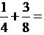
- Perform this operation on the number line.
- Perform this operation using an area model.
- Pose a problem related to this operation.

- Perform the operation given below and answer the questions a, b, c accordingly.
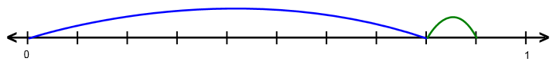
- Perform this operation using numerals.
- Perform this operation using an area model.
- Pose a problem related to this operation.

- "Ezgi read three tenths of her story book first, and then two tenths." So, how many of the book did Ezgi read?" Express the problem given in this text verbally and solve it, and answer the questions in a, b, c accordingly.

- Perform this operation on the number line.
- Perform this operation using area model representation.
- Perform this operation using numerals.

- Perform the operation given below and answer the questions a, b, c accordingly.
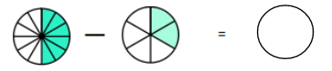

- Perform this operation using numerals.
- Perform this operation on the number line.
- Pose a problem related to this operation.

- Perform the operation given below and answer the questions a, b, c accordingly.
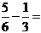
- Perform this operation on the number line.
- Perform this operation using an area model.
- Pose a problem related to this operation.

- Perform the operation given below and answer the questions a, b, c accordingly.
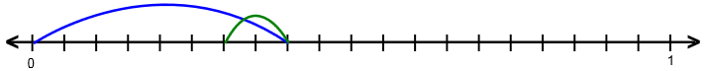
a) Perform this operation using numerals.
b) Perform this operation using an area model.
c) Pose a problem related to this question.

- "How much more pizza did Ahmet, who ate one half, ate compared to Zeynep, who ate one fourth of the pizza?" Express the problem given in this text verbally and solve it, and answer the questions in a, b, c accordingly.

  - Perform this operation on the number line.
  - Perform this operation using an area model.
  - Perform this operation using numerals.

This study has been produced from the master’s thesis referenced as “Kara, F. (2017). An investigation of sixth grade students’ skills of using multiple representations in addition and subtraction of fractions. Unpublished master’s thesis, Kastamonu University, Graduate School of Science.”

