THE BEGINNINGS OF PROFESSIONAL MUSIC IN ALBANIA

Arnavutluk'ta Profesyonel Müziğin Başlangıcı

Ols Cinxo*
Kabul Tarihi: 24.03.2019
(Accepted)
GelişTarihi: 13.02.2019
(Received)
Abstract: The instrumental miniature in Albanian music is related to the beginnings of the professional music composition. The instrumental miniature in general and especially the miniature for piano have got very rich history compared to the other genres , starting with the first composition of Martin Gjoka “March in D major” for piano. The development of small forms at the time, although its simple musical language , shows the effort to create an Albanian national music. As to the period after the Second World War, the development of music had a new momentum and during this time were created a big number of works which were called miniatures. The priority to the miniatures in general and the miniature for piano in particular has got different reasons , but the main are the creation of a music education system which brought about the opening of the piano class and the necessity of developing a national pedagogical and concert repertoire.
Key Words: Instrumental miniature, Albanian music, piano

1.GİRİŞ
The beginnings of professional music in Albania date from 1920. The most significant inheritance of the artistic education in our country was mainly formed inside two cities that served as two big centers of our national culture: Shkodra and Korça. Despite the absence of genuine professional schools, the subject of music education in the general education system of that time was taken very seriously in the non-artistic schools. A considerable number of the students who studied in non-artistic schools were active participants not only in artistic school activities but also out of school, becoming protagonists of the artistic life in our country.

Figure 1: Early 20th Albenian Musicians
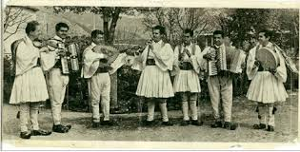

After our country was declared independent (1912) in the main cities started to develop their activities the Cultural and Artistic Societies which became very important sources of youth artistic education. Let us mention here the very known societies of Shkodra city; Rozafa(1918) and Bogdani(1919), as well as the Society of Fine Arts (1920) in Korça city. These societies were run by important Albanian personalities related to the art of music. Some of the most important personalities who were highly estimated at that time are: Palok Kurti (1860 – 1920), Frano Ndoja (1867 – 1923), both creators and managers of first artistic groups in Albania; Father.
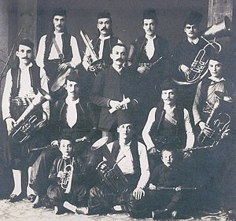
Figure 2: Societies of Shkodra city 1920

- Martin Gjoka (1890 – 1940)
Educated in Salzburg, Austria for technology and composition. Father Martin Gjoka offered a great contribute in the Franciscan Convention of Shkodra city where he worked as a leader and guide of the future artists of our country.
Figure 2: Martin Gjoka
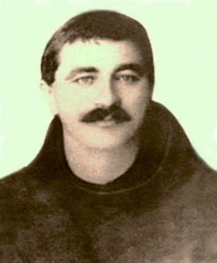

- Lec Kurti (1889 – 1948)
Another significant personality of the music realm of that time is Lec Kurti (1889 – 1948), a composer, translator and well-known diplomat who graduated in 1914 at “Benedetto Marcelo” conservator in Venice. He is the composer of the first Albanian opera, “Arbëreshja”(an opera that was not performed), as well as the composer of Albanian anthembased on the lyrics of Father GjergjFishta. He wrote pieces for violin, piano, canto and many orchestral works, mainly wind instruments.
Figure 3: Lec Kurti
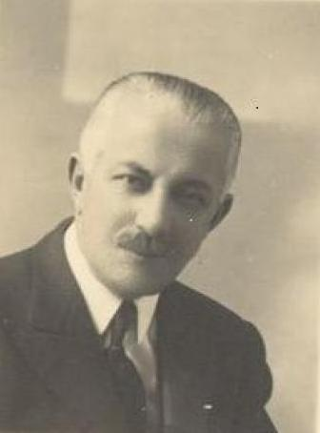

Different musical formations were spread all over Albania, starting from Korca city with popular personalities as Thoma Nasi (1892 – 1964) to be followed by the musical society “Drita” and “Vllaznia” in Durres city and different musical societies in Elbasan city initiated by Thanas Floqi.
Figure 4: Thanas Floqi
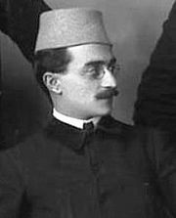

Figure 5: Thoma Nasi
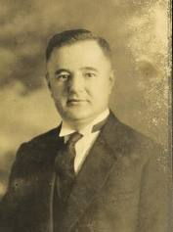

A big constellation of professionally prepared artists in the best European schools, conservatories and academies appeared in Albania in the 30s. They were composers, singers, instrumentalists who would very soon give their precious contribution on the artistic schools and stages of our country. Let us mention here the composer Kristo Kono (22.01.1907), who composed “Karnavalet e Korces” (Korca’s city Carnival) and many other vocal – instrumental works; Vath Cangu, Tahsmi Hashafi, Pjetër Durangu, Abdulla Grimci.
Figure 6: Thoma Nasi Kristo Kono (22.01.1907)
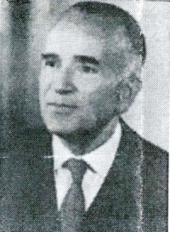

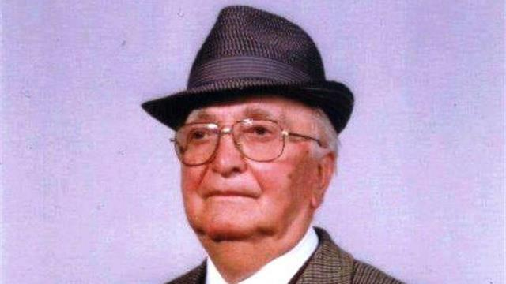
Figure 7: Abdulla Grimci (2.07.1919)

As one of the most popular composers, our great composer Prenk Jakova (27.06.1917 – 16.09.1969) is the author of the first Albanian opera “Mrika”. He wrote the famous opera, entitled “Skënderbeu” and many other songs, masses and cantatas. He played the clarinet and accordion. He studied clarinet in the conservatory of “Santa Cecilia” in Rome.
Figure 8: Prenk Jakova
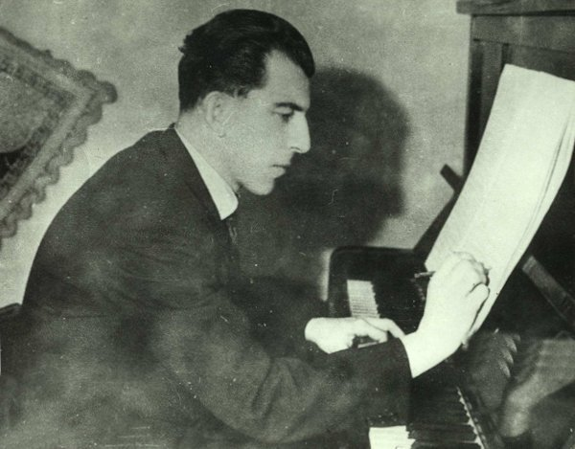

Another famous personality of the time is Kozma Lara. He was a famous pianist and composer. He studied at “Pjotr Ilic Cajkovski” academy in Moscow. He wrote many pieces for piano such as sonatas, preludes and five concerts. He wrote operas, ballets, symphonies, chamber music, trios, quartets etc.
Figure 9: Kozma Lara
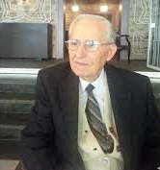

Feim Ibrahimi (1935 – 1997) wrote pieces for piano, movies soundtracks, concerts for violoncello, oboe etc. He composed the ballet “Plaga e dhjetë e Gjergj Elez Alisë” (The tenth wound of Gjergj Elez Alia) and the symphony entitled “Tragjike” (Tragic).
Figure 10: Feim Ibrahimi
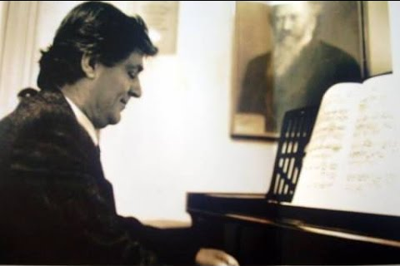

Tonin Harapi a rare talent in the piano instrument and a wide musical range composer as well. During the 1942-1943 years as a very young piano player he performed with the known german violinist AlfonsTracki. Despite the communist persecution of the communist regime in Albania (1946-1990), his talent and iron will, taking reference from his predecessors, flourished. He studied composition in the Moscow Conservatory ‘P.I.Tchaikovsky’. He wrote concerts and pieces for piano, rhapsody, miniatures for piano and other instruments, trios, quartets etc. He is the author of the operas ‘Zgjimi’ (Wake up), ‘Mira prejMujsit’. Tonin Harapi finished his creativity with the major work the ‘Requiem’ for soloists, choir and orchestra
Figure 11: Tonin Harapi(1926-1992)
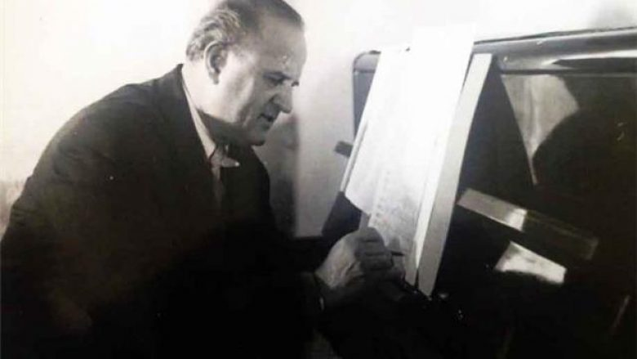

Nikolla Zoraqi was a violinist pedagogue and distinguished composer. He was a young prominent violinist and during the 60’s he studied composition at the ‘P.I.Tchaikovsky’Conservatory in Moscow. His creativity includes almost all composing forms. Among the most known compositions are the five concerts for violin and orchestra, the ballet ‘Shota dhe Azem Galica’ and the ‘Festive Overture’.
Figure 12: Nikolla Zoraqi (1929-1991)
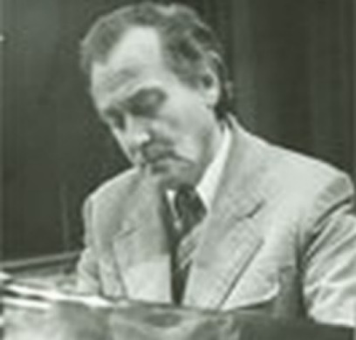

Tish Daija (1926-2003) is surely one of the most prominent Albanian composers. He was the student that studied for the longest time composition in the ‘P.I.Tchaikovsky’Conservatory in Moscow from 1950-1956. His opus was very rich in all music gender like operettas, romances, cantatas, movies track sounds, dances etc. He wrote the operettas ‘Pranvera’ (The Spring), ‘Vjosa’ and the first Albanian ballet ‘Halili dhe Hajria’ (Halili and Hajria) in 1963 and has since been shown more than 250 times at the ‘National Theatre of Opera and Ballet’ of Albania, a record for the Albanian theatre.
Figure 12: Nikolla Zoraqi (1929-1991)
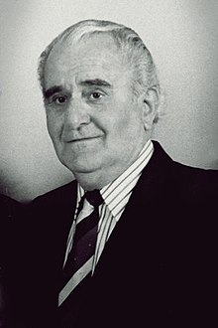

BIBLIOGRAPHY
Kraja Marie, The History of Music, Albania, 2005
Lazri, Gj., The Artistic Lyceum "Jordan Misja" in the years 1946-1991, Albania, 2009
Shuteriqi, Zana, The History of the Albanian Music, Albania, 1986
Shupo, Sokol, The Encyclopedia of the Albanian Music, Albania, 2002
Shupo, Sokol, The Encyclopedia of the Albanian Music, Albania, 2006

* Öğr. Elm., Hacettepe Üniversitesi, olscinxo@gmail.com

