TREATMENT OF AURAL HEMATOMAS IN DOGS WITH THE MEDICINAL LEECH, HIRUDO MEDICINALIS

* İbrahim CANPOLAT, ** Naim SAĞLAM

*Fırat Üniversitesi, Veteriner Fakültesi Cerrahi Anabilim Dalı-ELAZIĞ.
**Fırat Üniversitesi, Su Ürünleri Fakültesi-ELAZIĞ
_____________________________________________________________________________________________________________

ABSTRACT

In this study, hematomas were induced with trauma to the arteries and veins of the external surface of the ears of five healthy adult dogs. The following day, three medicinal leeches (H. medicinalis) were attached to the area of the hematoma in unanesthetised dogs allowed them stay until they were full and self detached. This treatment was continued daily for three days. In most cases, the leeches attached to hematoma quickly and detached themselves when they completed the blood sucking, usually after 10–15 minutes. In all case, aural hematoma of the ear resolved soon after the cessation of the treatment without complications.

Keywords: Aural Hematoma, Leech Therapy, Dog.
_____________________________________________________________________________________________________________

ÖZET
KÖPEKLERDE DENEYSEL OLARAK OLUŞTURULAN KULAK HEMATOMUNUN TIBBİ SÜLÜK İLE SAĞALTIMI

Bu çalışmada, ergin ve sağlıklı 5 köpekte kulağın dış yüzündeki arter ve venalar travmatize edilerek kulak hematomu oluşturuldu. Bir gün sonra köpek anestezi edilmeden oluşan hematom üzerine 3 Tıbbi sülük (Hirudo medicinalis) uygulanarak doyup kendiliğinden bırakıncaya kadar emmeleri sağlandı. Bu uygulama üç gün süreyle devam etti. Çoğu olgularda, sülükler çabucak hematom bölgesine tutunup 10-15 dakika süresince kan emdikten sonra doyunca, kendiliklerinden tutundukları bölgeyi bıraktılar. Bütün olgularda uygulama sonrasında hiçbir komplikasyon oluşmaksızın kulak hematomunun rezorbe olduğu gözlendi.

Anahtar Kelimeler: Kulak Hematomu, , Sülükle Sağaltım, Köpek
_____________________________________________________________________________________________________________

- INTRODUCTION
Leeches have been used for medicinal purposes for centuries, with the earliest reports coming from India. In the Roma Empire, the systematic foundation for the treatment of patients with leeches were laid. Leeches experienced a considerable boom particularly in Europe in the 19th century, when they virtually became a fashion. Researchers have calculated that leeches were abstracting in Paris alone a total of 84 000 L blood per year at the beginning of the 19th century. The utilization of leeches, however, decreased in the early 20th century with the advent of modern medicines. Even by the 18th and 19th centuries, the populations of the medicinal leech (Hirudo medicinalis) in Central Europe were unable to meet the considerable demand. Leeches were then imported into Central European states from the Ottoman Empire (Anatolia), North Africa and Russia (Kasparek et al.,2000, Sağlam, 1998).

In recent years, medicinal leeches are used mainly for two purposes. The first is the classical blood-letting therapy, which has experienced a certain revival in recent years in the context of the revival of natural remedies and tradional curing practices. The second is the production of remedies containing an extract of Medicinal leeches. The main areas of application are for blunt injuries (traumas) with or without haematomas, superficial inflammations of the veins, haemorrhoids, perianal thromboses and anal eczemas (Halton, 1989; Kasparek et al., 2000; Sawyer, 1986.). Medicinal leech, H. medicinalis is used in humans for hematomas of the tongue (Grossman and Karlovitz, 1998), testis (Goessl et al., 1997; Isgar and Turner, 1989), orbit (Menage and Wright, 1991.) and toe (Halton, 1989.). The leech produces a number of diverse salivary secretions that include anesthetic, anticoagulant (hirudin), local vasodilator (histamine), and enzyme (hyaluronidase) (Sawyer, 1986, Anonymous 2003, Yurevich, 2003).
The aural hematomas of dogs is a important problem and results from blunt injuries (traumas), bites, itchs and frictionals. The aural hematoma is formed with laceration of arterys and veins of the ear (Dubielzig et al., 1984). The haematomas is treated medically and surgically. If ıt is not treated with chronicity, fibrosis and contraction thicken and deform the ear (Cowley F,1976).
In this study, alternative treatment of experimentally formed aural hematoma in dogs with medicinal leech, was investigated.
- MATERIAL AND METHODS
In this study, ten ears from five healthy adult dogs (2 males and 3 females, weight between 16-35 kg) were used. In each case, subcutaneous aural hematoma of 5-7 cm in diameter was induced by traumating its vessels with a spinal needle (14 gauge, 8 cm) In the next day, three medicinal leeches were attached (Figure 1) to the hematoma of the awake dog. To atract further attachment the area was soaked with sugared water. The treatment continued daily for three days.
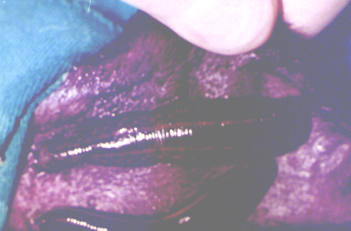
Fig.1: Medicinal leeches attached to the hematoma
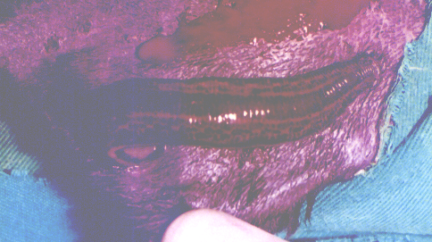
Fig.2: Haemorrhage at the bitten leeches ear.

RESULT AND DISCUSSION
Attached leeches were defined to become distant from haematoma area. This was prevented with use a glass cover. Attached leeches were observed sucking blood with peristalsis. In most cases, the leeches attached to the area of haematoma quickly and self detach ed when they completed the blood meal, usually after 10–15 minutes. After leeches detachment, the haemorrhage continued in the bitten ears for 60 second (Figure 2). The aural hematoma reduced greadually and resolved after first day the treatment. After three applications, hematoma recovered all case without complication. After treatment fibrosis, enflamation and deformation on the ear were not defined.
The application of leeches are one of the oldest recorded medical treatments with the first account documented approximately 2500 years ago. Until the advent of newer therapies in the mid 1800's the application of leeches was considered as standard medical practice for a variety of illnesses (Eldor et al. 1996, Sağlam, 1998).
The aural hematomas are treated medically or surgically. Large hematomas are not easily cured with therapeutics. In this hematomas surgical therapy is usually used. In the surgical therapy are waited for become coagulated of blood for 8-10 day. Medical and surgical therapies sometimes cause fibrosis, inflation and deformation on the ear (Dubielzig et al., 1984, Cowley F,1976). In this study, no complication was not observed in the therapy of hematoma with leech (H. medicinalis).
It has been reported that leech therapy may sometimes be complicated by Aeromonas hydrophila in man. This Gram-negative bacterium is a normal enteric organism of the leech. Therefore, in the leech therapy to patients an antibiotic as prophylactic are given (Eldor et al. 1996). In this study, no infection was seen on the dogs after leech therapy.
Advantages of leech therapy are quickly positive response to treatment and no need to anaesthesia when compared to operative treatment.
- REFERENCES
- Anonymous. 2003a. Medical Use of Leeches. http://www.amonline.net.au.
- Anonymous. 2003b. Medical Use of Leeches. http://www.austmus.gov.au
- Cowley F 1976. Treatment of hematoma of the canine ear. Vet.Med SmallAnim.Clin 71:283.
- Dubielzig RR,Wilson JW and Seireg AA.1984 Pathogenesis of canine aural hematomas. JAVMA 185(8):873

- Eldor, A., Orevi, M., and Rigbi, M. 1996. The role of the leech in medical therapeutics. Blood Riviews, 10, 201-209.

- Goessl C, Steffen-Wilke K, and Miller K., 1997. Leech therapy for massive scrotal hematoma following percutaneous transluminal angioplasty. J Urol., 158(2), 545.

- Grossman, M.D. and Karlovitz, A., 1998. Lingual trauma: the use of medicinal leeches in the treatment of massive lingual hematoma. J Trauma. Jun;44(6):1083-5

- Halton, C.M., 1989. Those-Amazing Leeches. Dillon Press. Inc. Minneapolis, Minnesota. 120 p.

- Isgar B. and Turner AG., 1989. Large scrotal haematoma treated with medicinal leeches. Br J Urol., 64(5), 549-50.
- Kasparek, M. Demirsoy, A. Akbulut, A. Akbulut (Emir), N. Çalışkan, M. and Durmuş, Y. 2000. Distiribution and status of the medicinal leech, (Hirudo medicinalis L.) in Turkey. Hydrobiologia, 441, 37-44,

- Menage M.J. and Wright G., 1991. Use of leeches in a case of severe periorbital haematoma.Br J Ophthalmol., 75(12), 755-6.

- Sağlam, N., 1998. Tıbbi Sülük Hirudo medicinalis 'in (L., 1758, Hirudinidae) İncelenmesi, Sümder Su Ürünleri Mühendisleri Derneği Dergisi, 1, 28-30.

- Sawyer, R.T., 1986. Leech Biology and Behaviour. Clarendan, Oxford, 1065 p.

- Yurevich, S., 2003. Leech Therapy for Small Animals. http://www.geocities.com/leechlady5/ index.html

