INVESTIGATION OF MONOCLINIC DISTORTION PARAMETERS OF A SHAPE MEMORY CuZnAl ALLOY BY MEANS OF X - RAY DIFRACTION DUE TO THE COOLING RATE EFFECT

*Murat ESKİL, **Nejdet KAYALI

*University of Gaziantep, Muallim Rıfat Education Faculty – KILIS, TURKEY
**University of Firat, Faculty of Science and Arts, Department of Physics – ELAZIG, TURKEY
__________________________________________________________________________________________________________________________________________________

ABSTRACT

Monoclinic distortion parameter (s) is important for Copper-based shape memory alloys which transforms from austenitic phase to M18R martensitic phase because the value of s shows the ideally close packed structure[1]. CuZnAl alloys are very sensitive to the thermal effects before and after the transformation, and this effects may cause important changes on crystallographic, morphologic and mechanical properties or the other transformation parameters of the alloys. In this study, the changes which occured on monoclinic distortion parameters of a shape memory CuZnAl alloy due to the effects of various thermal procedures have been calculated by using X-ray diffraction measurements.

Keywords: Monoclinic Distortion Parameter, CuZnAl Alloys, Shape Memory Effect, M18R Martensitic Structure, Cooling Rate Effects.
__________________________________________________________________________________________________________________________________________________

SOĞUTMA HIZI ETKİLERİNE GÖRE ŞEKİL HAFIZALI BİR CuZnAl ALAŞIMIN X-IŞINI DİFRAKSİYONU İLE MONOKLİ-NİK DİSTORSİYON PARAMETRELERİNİN İNCELENMESİ

ÖZET

Austenitik fazdan M18R martensitik faza dönüşüm gösteren bakır bazlı şekil hatırlamalı alaşımlar için ideal sıkı paket yapıyı göstermesi açısından monoklinik distorsiyon parametresi (s) çok önemlidir[1]. CuZnAl alaşımları dönüşümden önce ve sonra uygulanan termal etkilere çok duyarlıdırlar, ve bu etkiler alaşımların kristalografik, morfolojik ve mekanik özelliklerinde önemli değişikliklere yol açabilir. Bu çalışmada farklı termal işlemlerin etkilerine bağlı olarak şekil hafızalı bir CuZnAl alaşımın monoklinik distorsiyon parametreleri X-ışını difraksiyonu kullanılarak hesaplandı.

Anahtar Kelimeler: Monoclinic Distorsiyon Parametresi, CuZnAl Alaşımları, Şekil Hatırlama Etkisi, M18R Martensitik Yapısı, Soğutma Hızı Etkileri.

__________________________________________________________________________________________________________________________________________________

- INTRODUCTION

Copper based shape memory alloys (SMA), owing to easy fabrication and low cost, have been held in greater and greater importance by researc-hers and industrial employers[2]. Shape memory effects observed in a great variety of metallic alloys results from a displacive, first-order phase transition called martensitic transformation, which is one of the most interesting variants of structural phase transition in solids[3]. Martensitic transformation is a co-operative (diffusionless) motion of a group of atoms accross of an interface causing a shape chan-ge and sound[4]. Shape memory effects observed in many alloy systems are a direct result of a thermoe-lastic martensitic transformation. Shape memory alloys deform by means of variant to variant trans-formations when they are stressed in the martensitic condition after post quench heat treatment, and the forming variants return to the parent phase with the original orientation on heating over Af (Austenit finish temperature), covering the original shape[5]. As often claimed, the degree of stabilization de-pends on quenching conditions. Among various heat conditions, the direct quenching from high tempera-tures to the martensite phase is the most effective [6]. But the stabilization problem can be also redu-ced by step-quenching process[7]. In the noble-me-tal alloys, the high-temperature-matrix phase is disordered bcc (A2) at elevated temperatures. The bcc phase undergoes two ordering transition upon cooling. The first transition occurring on cooling is a first-nearest-neighbour (nn) ordering reaction which results in a B2 (CsCl type) superlattice, de-signated as β2. Further cooling induces the next-ne-arestneighbour (nnn) ordering and the crystal struc-ture has been suggested to become DO3(Fe3Al type) superlattice, designated in our an other study [8].

In present work, we investigate the transfor-mation process of martensite phase and analyse the phase structure during the reverse transformation on the basis of X-ray analysis.

2. EXPERIMENTAL DETAILS

A shape memory actuator of CuZnAl alloy was supplied by Delta Materials Research Ltd., Ipswich, England. This alloy, received in the closed-coil form called shape memory actuator, originally have open-coil form in austenitic condition and is given the closed-coil form deforming in martensitic condition.

Alloy composition is shown in Table 1. Elec-tron-atom ratio (e/a) is 1.4462. Powder specimens for X-ray examinations were prepared by filing the alloy. These specimens were then heated in evacuated quartz capsules at 820°C for 20 min. and immediately quenched into different conditions explained below. The powder specimens of the alloy were given post-quench heat treatments described on Table 2.

The heat threatments were labeled as metni-oned as A, B, C and D as shown on Table 2. X-ray diffiactograms were taken immediately after practi-cing the conditions told before from samples of the alloy. All the samples were then kept at room temperature and X-ray diffiactograms were taken at intervals. For X-ray measurements, a Shimadzu XRD-6000 X-ray diffractometer was used. Powder diffractograms were taken with Cu-Kα radiation with wavelength 1.54056 °A. The scanning speed of the Geiger counter was chosen as 2°, 2θ for all the diffractograms.

Table 1. The Chemical Composition of The Alloy

 | Cu | Zn | Al
Weight % | 72.70 | 21.62 | 5.68
Atomic % | 67. 88 | 19.62 | 12.50

Table 2. The Heat Threatments Which Were Induced to The Specimens.

A | Directly quenched in water
B | Directly quenched in water then aged at boiling water for 1 hour and quenched in water again.
C | Cooled to 100 °C in oil bath step quenched and then cooled to water.
D | Cooled to boiling water bath step quenched and then cooled to water.

3. RESULTS AND DISCUSSION

Typical powder diffractograms obtained from the specimens are shown in Figure l (a), 1 (b), (c) and (d) with indexed peaks, respectively.

Structural ordering is one of the important conditions for the shape memory effect exhibited in most marmem alloys[8], and the structure of mar-tensite in CuZnAl alloys is inhibited from the parent phase existing prior to the transformation.

The lattice parameters of monoclinic M18R structure for Alloy A, B, C and D were calculated
(1)

equation and given in Table 3 the monoclinic distortion parameters were calculated using

(2)

equation [1]. Where a, c and β are the lattice parameters of the M18R martensite. It shows that the ideally close packed structure is corresponding to s=1/3 value[1]. The values of monoclinic distortion parameter are shown in Table 3 for treatments A, B, C and D, respectively. From this calculations we can say that monoclinic distortion parameter changes with cooling condition. Another establishment which can be thoughtfrom the x-ray diffractograms is that there is a small amount of bct α′ martensitic phase with the large amount of M18R martensite phase after all cooling cooling conditions we used.

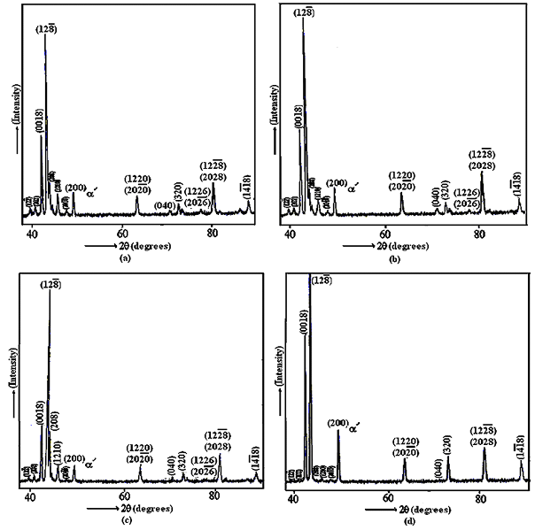
Figure 1. X-ray Powder Diffractograms of The Samples of Alloy a) A b) B c) C d) D

Table 3. Lattice Parameters And Monoclinic Distortion Parameters of The Specimens.

 | Lattice parameters for M18R monoclinic structure |  |  |  | s (monoclinic distortion parameter)
Heat treatments | a (Å) | b (Å) | c (Å) | β | s (monoclinic distortion parameter)
A | 4.486 | 5.339 | 38.432 | 89.47° | 0.346
B | 4.487 | 5.320 | 38.360 | 89.95° | 0.334
C | 4.488 | 5.341 | 38.465 | 89.51° | 0.345
D | 4.485 | 5.332 | 38.364 | 89.75° | 0.339

4. CONCLUSIONS

1. The tansformation from β phase to martensitic phase is L21→M18R in all cooling conditions. Where upon it has been thought that M18R monoclinic martensitic structure transformed from β phase is ordered [8].
2. The ideally close packed structure has been for-med on slow cooled specimens according to the s parameters of heat treatments B, D, C and A on specimens, respectively.
3. It has been seen that monoclinicity angle β decreased by increasing the cooling rate. This decrease in β angle is a result of atomic disorder and strong martensite stabilization after quenching.
4. From the X-ray diffractograms, it can be seen that there is bct α′ phase with the large amount of M18R martensite phase.

5. REFERENCES

- W. Dong, Roh, E. Lee, Y.G. Kim, 1992, Metall. Trans., A, Phys. Metall. Mater. Sci. 23A, p.2753–2760.

- W. Jıanxın, J. Bohong and T. Y. Hsu, 1988, Acta Metall. Vol 36, No. 6, p.1521-1526.

- A. Aydoğdu, Y. Aydoğdu, O. Adigüzel,1997, Ma-terials research bulletin, Vol. 32, No. 5,p 507-513.

- P.C. Clapp, R. Gotthardt, J.Van Humbeeck, “How would we recognise a Martensitic Transformation if it bumped into us a dark & austy night?”, Proc. of ICOMAT’95, Lausanne; Switzerland, August 20-25, J. de Physique IV, C8, 5, 11, (1995).

- N. Kayali, S. Özgen, O. Adıgüzel, 1997, Mater. Res. Bull. Vol. 32, No. 5, p. 569–578.

- T. Suzuki, R. Kojima, Y. Fujii, A. Nagasawa, 1989, Acta Metall. Vol 37, No. 1, p. 163–168.
- S.S. Leu, C.T. Hu, 1991, Metall. Trans., A, Phys. Metall. Mater. Sci. 22A, p. 25–33.

- M. Eskil, N. Kayalı, 2006, Materials Letters, 60, 630-634.

