Received: 24.06.2019  Accepted: 26.08.2019 |  | Dokuz Eylül Üniversity  Maritime Faculty Journal
Published Online: | Vol:11 Issue:1 Year:2019 pp:
DOI: |  | ISSN:1309-4246
Research Article |  | E-ISSN: 2458-9942

THE TURKISH MODEL FOR IMPROVING IMO SURVEY
RESULTS AND REDUCING SHIP ACCIDENTS

Tayfun ACARER

ABSTRACT

The purpose of the IMO is to reduce the number of ship accidents, which have both economic and human costs. IMO regulations define what is required for voyages to be safe. The primary mechanism for checking compliance are surveys which are performed by member states. These check both technical and human-related aspects of the ship. The first includes the features of the ship and the equipment on board. The latter is regarding competencies of the personnel. There are significant discrepancies in the effectiveness of surveys in different regions. Over recent years Turkish ships have transitioned from performing poorly in surveys to performing well. We argue this is the result of a series of legislative decisions. We identify which legislative decisions these are and present them as a repeatable recipe. Countries facing similar difficulties can follow this example with the aim of improving IMO compliance; which in turn means economic benefits, less accidents and less lives lost.

Key Words: Ship Accidents, Flag State, Whitelist, Black List, IMO Regulations.

IMO DENETİMİNİN GELİŞTİRİLMESİ VE GEMİ KAZALARININ AZALTILMASI İÇİN TÜRKİYE MODELİ

ÖZ

IMO’nun amacı hem ekonomik hem de insani kayıplara yol açan gemi kazalarının azaltılmasıdır. IMO tarafından yapılan düzenlemeler gemilerin güvenli seyri için yapılması gerekenleri içermektedir. Düzenlemeler ile uyumluluğun kontrol edilmesi için kullanılan temel mekanizma, IMO’nun isteği ile üye devletler tarafından yapılan denetimlerdir. Bu denetimlerin birincisi hem geminin hem de üzerindeki cihazların teknik özellikleridir. İkincisi ise gemide bulunması gereken personel sayısı ve bu personelin sahip olduğu niteliklere ilişkindir. Dünyanın farklı bölgelerinde denetimlerin ne derece etkili uygulanabildiği konusunda ciddi tutarsızlıklar vardır. Türk bandıralı gemiler geçmişte denetimlerde kötü sonuç aldıkları için kara listede yer almışlardır. Ancak 2006 yılından itibaren bu denetimlerden iyi sonuçlar alarak beyaz listede geçiş yapmışlardır. Bunun yapılan bir dizi yasal düzenlemenin sonucu olduğunu savunmaktayız. Hangi düzenlemelerin etkili olduğunu belirlemek konusunda yaptığımız çalışmanın sonuçlarını, bu Makalede öneri olarak sunmaktayız. Benzer sorunları yaşayan ülkeler bu Makaledeki örnekler ve önerilerden yola çıkarak IMO denetimlerinde sağladıkları başarı oranını artırabilirler. Bunun anlamı ise sağladığı ekonomik faydanın ötesinde daha az kaza ve daha az hayat kaybedilmesi demektir.

Anahtar Kelimeler: Gemi Kazaları, Bayrak Devleti, Beyaz Liste, Kara Liste, IMO Düzenlemeleri

Introduction

Throughout history, there has been a close relationship between seafaring and trade. This continues to be the case with more than 80% of all international trade taking place using sea transportation.

The International Maritime Organization (IMO) has been active in producing regulations aimed at lowering the number of ship accidents. While these have been successful, challenges in the implementation of the monitoring and enforcement mechanisms – primarily the IMO Survey – have led to significant discrepancies in their effectiveness in different regions. Overcoming these challenges would improve the situation. Improvement in this case means fewer accidents and less lives lost. It is of the utmost importance.

In the early 2000’s, Turkish ships were performing poorly in IMO Surveys, leading to Turkey becoming blacklisted by the IMO. Since then, Turkey’s status has consistently improved. First to the graylist in 2006, it transitioned to the whitelist in 2008 where it remains today.

There exists extensive literature detailing the problems encountered in the implementation of IMO Surveys. However, Turkey’s case shows two things. First, Turkey was experiencing such problems. Second, the developments since then have solved these problems to a large extent. Identifying what these developments were has the potential to yield a repeatable recipe that other countries that are having similar difficulties can follow in order to improve their flag status. Doing so would not only save lives but also increase their trading capacity, as being blacklisted is detrimental to trade.

In this paper, we analyzed the legislation generated by Turkey during the period in question, and identified the ones that are likely to have contributed to the outcome. We found that one of the most important aspects of these was the utilization of surveys done in Turkey on Turkish ships, to detect and correct problems early on.

The organization of this paper is as follows. In Section 2, we provide information on the IMO, its regulations and the enforcement of these regulations. In Section 3, we go into more detail on IMO Survey, which is the primary monitoring and enforcement mechanism for compliance. In Section 4, we analyze the aforementioned developments in Turkey. In Section 5-7, we present our methodology, results and our discussion on them. We conclude in Section 8.

About the IMO

The International Maritime Organization (IMO) is a specialized agency of the United Nations (UN) that is responsible for maritime activities. Its primary purpose is to reduce the number of ship accidents and improve safety of life and goods at sea. This is because there are significant losses associated with a ship accident. First and foremost, it is the lives of the sailors and passengers at stake. There can also be significant monetary costs and the magnitude of these costs is rising due to increases in the value of goods being transported as well as of the ships themselves.

2.1. Structure

As a specialized agency of the UN, the IMO is an intergovernmental organization. Currently there are 174 member states. The primary decision making authority of the IMO is the General Assembly that is held biennially with the participation of all member states. The management of the IMO is performed by a council made up of 40 member states selected by the General Assembly.

The international structure of the IMO is due to the very nature of seafaring, which is quintessentially an international concept. First, the vast majority of the oceans fall outside the jurisdiction of any single nation and are referred to as international waters. Secondly, ships frequently enter territorial waters belonging to different states and conduct handling activities at their ports. Therefore, addressing the issue of maritime safety can only be done through international cooperation and consensus.

2.2. IMO Regulations

The main function of the IMO is to develop and maintain a regulatory framework that establishes the rules and guidelines that have to be followed in order to make shipping safe and efficient. As stated, the IMO’s purpose is to reduce the number of ship accidents. This requires identifying the causes of accidents and making decisions regarding what has to be done in order to mitigate them. The decisions made by the IMO are formalized as IMO Regulations. Member states and their ships are required to adhere to these regulations.

The scope of the IMO Regulations is highly comprehensive and covers all aspects of maritime activities. These include:
- Regulations that specify in detail the requirements that a ship and its crew must satisfy in order for the ship to be considered safe and seaworthy.
- Regulations on the cargo and passengers carried on a ship.
- Regulations on the operation of a ship, such as navigation and sea traffic.
- Regulations on the ship’s interaction with other ships and authorities, such as communication procedures to be followed.
- Regulations on handling activities conducted at ports.
- Regulations on environmental impact.

Many of these regulations are defined separately based on the type of the ship and its area of operations.

Technological developments in areas such as Information Technology, Shipbuilding, Navigation, Meteorology and Communications have had a significant impact on shipping. Over recent years, aided by technology, ships have become capable of safely operating in regions that were previously considered to be too dangerous or even inaccessible. Similarly, technology enabled the coordination of more ships within close proximity in difficult to navigate regions (e.g. the Turkish Straits and the North Sea). Such coordination has to be done amongst the ships themselves and with authorities on both the sea and on land. IMO continues to produce new regulations that make use of such developments. This includes making particular devices that are beneficial to safety mandatory and also rules regarding how various equipment is to be operated.

We see that the IMO has also been producing an increasing number of regulations regarding human-related issues such as the training, qualifications and competencies that seafarers are required to have. Human-related factors are among important causes of ship accidents (Kim and Kwak, 2011; Tzannatos, 2010). This has become more important recently as a result of the aforementioned technological developments. For instance, technology enables more ships to operate close to one another, but the coordination required is only possible if the sailors follow procedures properly. As we have mentioned, ships are becoming increasingly reliant on technical equipment for their safety. First, seamen need to precisely know how to utilize this equipment. Secondly, in the event that a critical piece of equipment malfunctions, onboard personnel need to have the necessary know-how in order to carry out repairs or else take the necessary measures to ensure the safety of the ship.

The IMO also produces recommendations that impose specific requirements on member states to take measures by deploying systems necessary to address safety concerns, such as the Vessel Traffic Control System in the Turkish Straits and the Tsunami Prewarning System in the Pacific Rim.

2.3. Enforcement of IMO Regulations

IMO Regulations describe how maritime activities should be performed in order to be safe and efficient. However, in order to be effective, it is necessary for these to be followed consistently by all actors. This requires mechanisms to enforce these regulations.

As we have stated, the international structure of the IMO is a necessity, but this gives rise to certain limitations and challenges in the enforcement of its regulations. Specifically, the IMO does not have direct executive control over global maritime affairs. Ultimately, sovereignty of nations means that executive power within the borders of a country lies with the government of that country. Therefore, the IMO has to exert its influence indirectly. It requests member states to enforce the regulations, and develops various incentives and deterrents to ensure that its decisions are carried out in practice. The underlying accountability, responsibility and sanctioning mechanisms are established in international agreements such as the Paris MoU that a country has to sign in becoming a member state. In order for ships belonging to a country to be allowed to travel to a member state, the country in question also has to be a member state and thereby have accepted the conditions for membership. Given that all major seafaring countries are member states, membership is essential for partaking in global maritime activities including trade.

The principle mechanism for monitoring compliance is through inspections carried out on ships. This type of inspection is called a survey and will be addressed in greater detail in the following section.

The deterrent mechanisms developed by the IMO include measures such as detaining ships that are found to be in violation of IMO regulations as the result of a survey. There are also various types of sanctions that can be imposed on specific countries. One such sanction is based on the categorization of countries into three classes: the whitelist, the graylist and the blacklist.

The deterrent mechanisms developed by the IMO include measures such as detaining ships that are found to be in violation of IMO regulations and imposing various types of sanctions against specific countries. One such sanction is based on the categorization of countries into three classes: the whitelist, the graylist and the blacklist. If many ships bearing the flag of a particular country is found to be noncompliant in surveys, then the IMO can lower the status of the flag of the country. The lowest status is the blacklist, and results in all ships belonging to the blacklisted country coming under suspicion of noncompliance. These ships are subjected to inspections more frequently, hindering their ability to operate easily. Therefore, mechanisms such as blacklisting countries can be highly detrimental to the ability of a country to partake in maritime trading and hence its economy, making this an effective deterrent.

2.4. Impact of IMO Regulations

Over recent years, the benefits of the actions taken by the IMO have started to become clearer, with significant decreases in both the number of accidents resulting in loss of life, and also the economic losses resulting from such accidents. As of 2006, there had been a significant worldwide reduction in the number of ship accidents over the previous 10 years (Bloor et al. 2006). In 2007, the IMO had been entering into more agreements aimed at reducing the number of accidents and had been expending great effort in their application (Sampson and Bloor, 2007).

Data collected from the Turkish Straits by the TRMCC also reflects this trend. The Turkish Straits are among the most actively used sea passages in the world. They are also among the most difficult to safely navigate. A large number of ships belonging to many different countries pass through the Turkish Straits on a daily basis. As a result, the TRMCC data samples a wide range of ships.

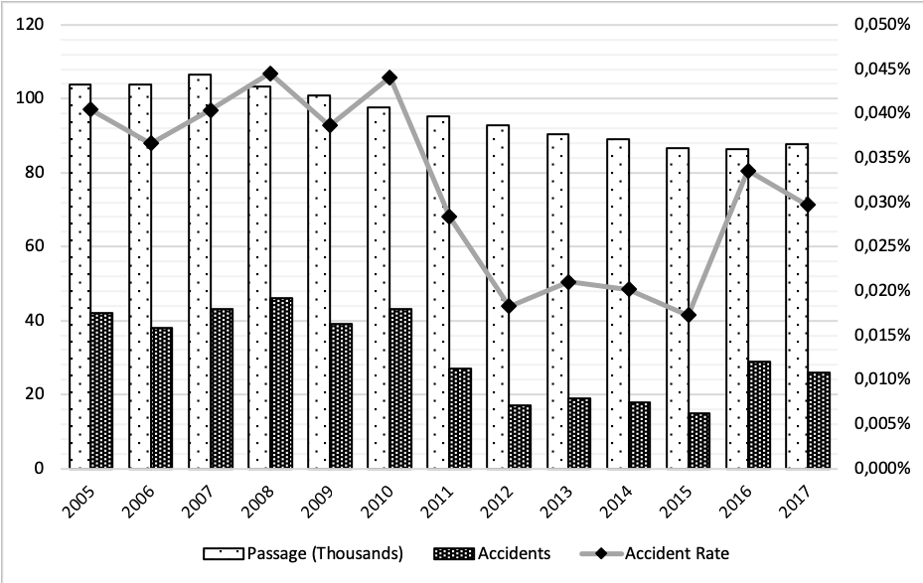
Figure 1: Accident Statistics for the Turkish Straits
Source: Kıyı Emniyeti Genel Müdürlüğü, 2018

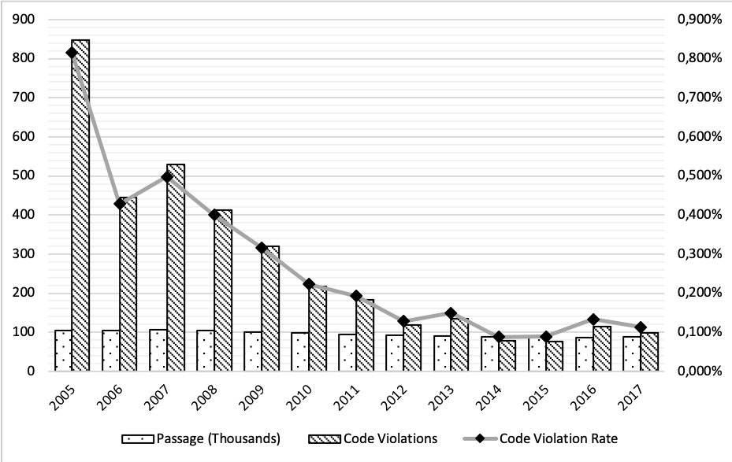
Figure 2: Code Violation Statistics for the Turkish Straits
Source: Kıyı Emniyeti Genel Müdürlüğü, 2018

Figure 1 shows the accident rate in the Turkish Straits measured from 2005 to 2017. Figure 2 shows the code violation rate over the same period. A downward trend can be observed in both cases. The decrease in the accident rate is consistent with the expected outcome of IMO’s actions over this time period. The decrease in the code violation rate also suggests the increased effectiveness of IMO regulations targeting human factors such as the training and competencies of the sailors.
Despite these positive developments, shipping accidents continue to occur and further improvements are both possible and necessary.

IMO Surveys

IMO Regulations define the requirements that a ship and its crew must satisfy in order for a ship to be considered safe and seaworthy. A survey is an inspection conducted on a ship to determine whether or not a given ship meets these requirements. The survey is the primary mechanism through which compliance with IMO Regulations is monitored and noncompliance penalized.

3.1. Content of the Survey

Over recent years, the IMO has been making many decisions regarding both the underlying requirements and the inspection procedures through which compliance with these requirements is checked. Each of these cover both technical and human-related issues.

Technical issues are mainly related to the technical specifications of the ship itself and the equipment it carries on board. The IMO compiles lists of devices that are made mandatory because they are necessary to improve safety. During the survey, inspectors check that these devices are available and are functioning correctly.

The IMO has been defining an increasing number of requirements regarding human-related issues over recent years. These are concerned with the training, qualifications and competencies that seafarers are required to have. This includes both officers and the crew. The IMO makes decisions regarding the content of maritime training programs, the evaluation procedures and principles of the survey, examination questions and necessary certifications. From the standpoint of compliance assurance, it is extremely important for these competencies to be thoroughly documented and are then presented during the survey.

3.2. Implementation of the Survey

As mentioned in Section 2, the IMO does not have the means to enforce its own decisions. Rather, it defines the necessary mechanisms that transfer this responsibility to member states.

The current method used for the systematic monitoring and enforcement of IMO Regulations worldwide is through surveys conducted both port state authorities at visited ports and by the flag state of the ship.

Inspections done by port authorities, Port State Control (PSC), is the principle mechanism and is critical to ensuring the effectiveness of the implementation. Unlike inspections done by the flag state, Flag State Control (FSC), PSC is performed on foreign ships that have travelled to the country where the survey is being done. Hence, there is a stronger incentive to detect noncompliance.

While not all countries perform FSC on their own ships, FSC can be an effective complement to PSC. Specifically, it can allow detecting and rectifying problems early on that could potentially result in a ship being detained later during a PSC, damaging the reputation and flag state of the country.

Another aspect of the FSC is that, a country is free to make amendments to IMO Regulations, as long as these do not contradict IMO Regulations. This means, countries can impose stricter safety requirements on their own ships than prescribed by the IMO. However, PSC inspections on foreign ships are limited to compliance with IMO Regulations.

3.3. Benefits of Surveys

It is possible to list four advantages of the survey mechanism.
- First, unsafe ships that are found to be in violation of the regulations can be identified and detained, thereby preventing them from posing a safety hazard for its own crew and other ships.
- Secondly, it creates an incentive for shipowners to take the necessary actions to ensure their vessels are compliant with the regulations in order to minimize the probability that their ships will be detained.
- Thirdly, if many ships bearing the same state flag are detained, that state flag is blacklisted. This has a negative impact on the maritime trade potential and transportation means of that state. Avoiding this requires states to pay the necessary attention to this issue.
- Forth, it allows the collection of valuable data that can be used to evaluate the effectiveness of existing regulations, and to make improvements by means of modifications or the introduction of new regulations.
Because of these reasons, the IMO has been producing regulations at an increasing rate over the recent years that define the necessary conditions that need to be met by a ship in order to be considered safe, particularly those that are used in maritime trade.

3.4. Difficulties in Implementation

While maritime safety is in the shared interest of all parties, it is not realistic to assume that all stakeholders are equally willing and capable of enforcing the security regulations prescribed by the IMO. As the comprehensive work due to Knapp shows, it is possible to observe significant discrepancy within the worldwide application area, amongst regional MoU regimes, based on detention probabilities (Knapp, 2007; Knapp and Franses, 2008; Mitroussi, 2003). Even though the IMO giving this responsibility to administrations has led to various problems due to the differences in the approaches of the various administrations, it has not been possible to follow a different implementation approach either (Knudsen and Hassler, 2011).

First, it is necessary to state that there is always a cost necessary for taking the necessary actions to implement these kind of security regulations. Ship owners need to make an investment to make their vessels compliant with the regulations. While this investment is necessary to minimize the risk of incurring much greater costs in the future resulting from an accident, it is not possible to dismiss the possibility that there may nevertheless be an incentive to avoid having to make an immediate payment and instead opt for accepting an as of yet unrealized risk.

Secondly, even if the economic cost of adhering to regulations is not prohibitive, it is possible that either negligence or incompetence is. Therefore, compliance with IMO regulations has to be strictly monitored and assured.

Another problem that has to be mentioned at this point is due to such monitoring and actions not being done directly by IMO, but rather by member states (Tzannatos and Kokotos, 2009). Similar to what has been said above, it is not realistic to expect the effectiveness with which this can be done to be homogeneous across all nations. Because there are numerous factors affecting the IMO-related decisions of governments including but not limited to priorities, available resources, policies and pressure from shipping companies and other third parties.

Even though we stated above that PSC inspections are the primary inspection mechanism due to their advantages over FSC with regards to their deterrent effectiveness, there are nevertheless certain issues that often come up in PSC. These include organizational, language barriers and differences in action and strategy (Alter and Meunier, 2009; Hassler, 2008).

Analysis of Developments in Turkey

We see a continual improvement in the status of ships bearing the Turkish flag over the period starting from the early 2000’s. Turkey had been in the IMO blacklist until 2006. At this point, it entered the graylist, and later the whitelist in 2008 where it still remains.

The IMO rules create a direct relationship between the performance of ships bearing a country’s flag in surveys, and the flag status of that country as assigned by the IMO. Based on this relationship, the transition from the blacklist to the whitelist implies that Turkish ships have started to get better results in surveys during this period. Figure 3 shows the inspection and detention statistics for Turkish ships over this period and also supports this argument. The fact that the improvement trend has lasted over a decade strongly indicates that this is not a spurious pattern, but rather is the result of some underlying change.

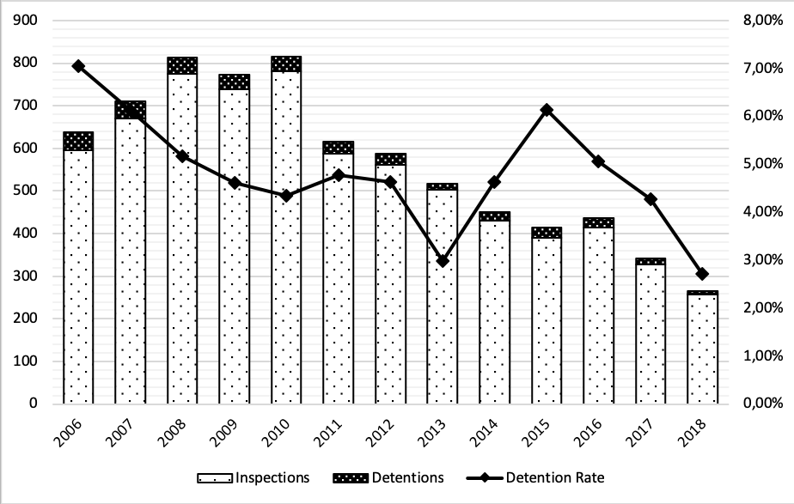
Figure 3: Inspection and Detention Statistics for Turkish Ships
Source: Deniz Ticareti Genel Müdürlüğü, 2018

As we have discussed in the Section 3.4., the effectiveness of the implementation of IMO surveys is subject to significant discrepancies, and there are many situations where the various reasons identified limit the utility of surveys. However, as we have also noted, ship accidents that result in loss of life continue to occur and so every effort should be expended in looking for ways to improve the situation.

It is therefore necessary to conduct an analysis of the developments in Turkey, seeking to discover what the underlying reasons for the observed positive trend may be. If the observed result is due to specific actions taken by the Turkish state, then it is likely that these actions constitute a repeatable recipe that could yield similar improvements when applied to other countries looking to improve their status.

Methodology

Our methodology was to research Turkish legislation that was developed leading up to and during the period under analysis. We compiled a list of all decisions (national regulations, notices and directives) regarding maritime affairs issued by the Ministry of Transportation and Infrastructure as the authorized institution on behalf of the Turkish State. Next, we identified the legislation that are related either directly or indirectly to surveys and the enforcement of IMO regulations. We analyzed this legislation in order to identify the causes of the observed phenomenon.

Results

The list of Turkish legislation (national regulations, notices and directives) regarding maritime affairs issued by the Ministry of Transportation and Infrastructure as the authorized institution on behalf of the Turkish state that have been found to be related to surveys and the enforcement of IMO regulations is given in Appendix A.

Our analysis revealed that the most likely cause of the improvement observed is having developed legislation related to inspections performed on Turkish ships (FSC).

Disussion

During the period under analysis, the Turkish Government has developed legislation that led to FSC inspections being carried out extensively and frequently on Turkish ships. This type of inspection makes it possible to detect and rectify problems prior to PSC inspections. This avoids many situations where a ship would be detained during a PSC, damaging the flag status.

It can be said that the IMO has developed its incentive and deterrent mechanisms for precisely this to happen – however, the factors identified in Section 3.4 can cause realizing this to be difficult. Doing so requires taking the necessary actions in order to tighten control over the enforcement of IMO regulations while ensuring that a variety of different stakeholders remain receptive to the changes.

In this respect, we argue that the list of legislation that we present provides an important resource for countries; as it provides them with a concrete example that has been shown to be beneficial in practice.

Conclusion

The purpose of the IMO is to reduce the number of shipping accidents. It does this by deciding how maritime activities should be perform in order to be safe and efficient. It formalizes these decisions into regulations that it publishes. It follows that, better compliance with IMO regulations is expected to decrease accident risk, and the downward trend in accident rate observed worldwide in the recent decades is indicative of this.

However, we have shown that there are numerous difficulties in enforcing these regulations. Many of these difficulties stem from the fact that the IMO is an international organization without executive control.

Turkey was a country that had such difficulties, but as we have shown, these difficulties have largely been solved as the result of actions taken by the Turkish State. This shows that, with the correct approach, the difficulties in enforcing IMO regulations through surveys can be overcome. Specifically, the role of inspections carried out by the state on its own ships is significant. Doing so has been identified as the main factor contributing to the improvement of the performance of Turkish ships in IMO surveys, which in turn enabled Turkey’s transition from the blacklist to the whitelist.

As we have discussed, there can still be challenges in establishing such mechanisms. On the other hand, the list of legislations that we have produced provides a reference for decision makers in other countries that are having similar difficulties. Following the example set by these actions is likely to have similar results. In this case, similar results means less accidents. This means less cargo and ships being lost and more efficient trading due to being in the whitelist. But most importantly, it means less people die because of ship accidents.

References

Alter, K. J. and Meunier, S. (2009). The politics of international regime complexity. Perspectives on politics, 7(1), 13-24.

Bloor, M., Datta, R., Gilinskiy, Y. and Horlick-Jones, T. (2006). Unicorn among the cedars: On the possibility of effective ‘smart regulation’ of the globalized shipping industry. Social & Legal Studies, 15(4), 534-551.

Hassler, B. (2008). Environmental conventions, pro-active countries and unilateral initiatives—Sweden and the case of oil transportation on the Baltic Sea. Journal of Environmental Policy & Planning, 10(4), 339-357.

Kim, D. J. and Kwak, S. Y. (2011). Evaluation of human factors in ship accidents in the domestic sea. Journal of the Ergonomics Society of Korea, 30(1), 87-98.
Knapp, S. S. (2007). The Econometrics of Maritime Safety:" Recommendations to Enhance Safety at Sea", Doctoral Thesis, Erasmus University Rotterdam, Erasmus Research Institute of Management (ERIM).

Knapp, S. and Franses, P. H. (2008). Econometric analysis to differentiate effects of various ship safety inspections. Marine Policy, 32(4), 653-662.

Knudsen, O. F. and Hassler, B. (2011). IMO legislation and its implementation: Accident risk, vessel deficiencies and national administrative practices. Marine Policy, 35(2), 201-207.

Mitroussi, K. (2003). The evolution of the safety culture of IMO: a case of organisational culture change. Disaster Prevention and Management: An International Journal, 12(1), 16-23.

Sampson, H. and Bloor, M. (2007). When Jack gets out of the box: the problems of regulating a global industry. Sociology, 41(3), 551-569.

Tzannatos, E. (2010). Human element and accidents in Greek shipping. The Journal of Navigation, 63(1), 119-127.

Tzannatos, E. and Kokotos, D. (2009). Analysis of accidents in Greek shipping during the pre-and post-ISM period. Marine Policy, 33(4), 679-684.

Internet References

Deniz Ticareti Genel Müdürlüğü. (2018). Paris Mutabakatı Kapsamında Tutulan TBG Analizi. https://atlantis.udhb.gov.tr/istatistik/files/DIGER_ISTATISTIKLER/GEMI_DENETIM_ISTATISTIKLERI/2018/Paris_Mutabakati_KapsamindaTutulan_Turk_Bayrakli_Gemi_istatistikleri.xls. Erişim Tarihi: 04.02.2019.

Kıyı Emniyeti Genel Müdürlüğü. (2018). Kaza Analizi İstatistikleri, https://www.kiyiemniyeti.gov.tr/resmi_istatistikler. Erişim Tarihi: 20.01.2019.

APPENDIX A: TURKISH LEGISLATION ASSOCIATED WITH TURKEY’S IMPROVED PERFORMANCE IN IMO SURVEYS

Year | Title
 | NATIONAL REGULATIONS
23.02.2006 | Balıkçı Gemilerinin Emniyeti Hakkında Yönetmelik
18.01.2017 | Gemiler İçin Yetkilendirilmiş Kuruluşlar Yönetmeliği
10.11.2006 | Gemilerin Genel Denetimi ve Belgelendirilmesi Hakkında Yönetmelik
17.11.2009 | Gemilerin Teknik Yönetmeliği
31.10.2010 | İç Sularda Çalışan Gemi ve İç Su Araçları Yönetmeliği
26.03.2006 | Liman Devleti Denetimi Yönetmeliği
30.01.2008 | RO-RO Yolcu Gemileri ve Yüksek Hızlı Yolcu Tekneleri Yönetmeliği
27.10.2009 | Uluslararası Emniyet Yönetimi Kodunun Türk Bayraklı Gemilere ve İşletmecilerine Uygulanmasına Dair Yönetmelik
20.03.2007 | Uluslararası Gemi ve Liman Tesisi Güvenlik Kodu Uygulama Yönetmeliği
12.12.2007 | Yolcu Gemilerinin Emniyetine ve Gemilerdeki Yolcuların Kayıt Altına Alınmasına İlişkin Yönetmelik
13.02.2016 | DENİZCİLİK EĞİTİMİ DENETLEME VE KALİTE STANDARTLARI ESASLARI HAKKINDA YÖNETMELİK
22.04.2007 | Gemi Adamları Yetiştirme Kursları Yönetmeliği
11.08.2006 | SOLAS ve MARPOL Sözleşmelerine Göre Bildirimlerine İlişkin Yönetmelik
 | NOTICES
18.04.2007 | Kondüsyon Değerlendirme Sörveyi Hakkında Genelge (Genelge 2007/3)
02.06.2011 | IMO-PERGE Teknik Performans Analiz ve Geliştirme Sistemi Hakkında Genelge (2011/4)
30.09.2010 | Uluslararası Denizcilik Örgütü (IMO) Tavsiye Kararlarının İç Hukukumuza Aktarılması Hakkında Genelge (2010/8)
07.01.2011 | Uluslararası Denizcilik Örgütü (IMO) Sözleşmeleri Gereği Yapılacak Zorunlu Bildirimler ve Raporlar Hakkında Genelge (2011/01)
11.11.2010 | Uluslararası Denizcilik Örgütü Stratejisi Hakkında Genelge (2010/23)
30.01.2018 | İlkel Yapılı Ahşap Gemiler Hakkında Genelge (2018/01)
 | DIRECTIVES
31.07.2013 | Bayrak Devleti Denetimi Uzmanları Etik Kuralları Talimatı
18.04.2013 | Bayrak Devleti İsteği Üzerine Gemiyi Alıkoyma Talimatı
18.04.2013 | Belge Asıllarının Gemide Bulunmaması Talimatı
18.04.2013 | Can Filikalarında Oluşan Kazalar Talimatı
23.07.2013 | Can Kurtarma Filika Talimleri Talimatı
23.07.2013 | Gemilerde Bulunan Hız Ölçüm Cihazları Talimatı
2.08.2013 | Gemilerde bulundurulacak Sertifikalar ve IMO yayınları Talimatı
18.04.2013 | Gemilerdeki Teknik İşletme ve Bakım El Kitapları Talimatı
23.07.2013 | Gemiye Giriş- Çıkış Ekipmanlarının Emniyeti Talimatı
18.04.2013 | Genişletilmiş Sörvey Programına Tabi Olmayan Gemiler Talimatı
18.04.2013 | IMO Numarasının Gemi Planlarına İşlenmesi Talimatı
1.04.2013 | IMO ORTAK YORUMLARININ (UIs) UYGULANMASI Talimatı
18.04.2013 | IMO Sözleşmelerinde Özel Durumlar Uygulaması Talimatı
19.04.2013 | IMO Şirket Numarası Talimatı
23.09.2013 | ISM Kod Gereklilikleri Hakkında Talimat
18.04.2013 | ISM Kod ile İlgili Hususlar Talimatı
18.04.2013 | İlgili Belgelerde STCW Sözleşmesine Yapılan Referans Talimatı
18.04.2013 | İlk Sörvey Teriminin Uygulanması Talimatı
31.07.2013 | Liman Devleti Denetimi(PSC)Uygulama Talimatı
02.04.2014 | Liman Devleti Denetimleri (PSC) Hk. Talimat
18.04.2013 | Liman Devleti Denetimlerinde Dökme Yük Gemilerinin Yapısal Durumunun Kontrolleri Talimatı
18.04.2013 | Liman Devleti Kontrolü Uzmanları Etik Kuralları Talimatı
26.07.2013 | LRIT Sisteminin Sürvey ve Belgelendirmesi Talimatı
03.09.2013 | Mevcut Sertifikaların Yeni Düzenlemelere Göre Yenilenmesi Süreci Hk. Talimatı
25.09.2013 | Muafiyet ve Eşdeğer Uygulamalar hk. Talimat
06.08.2013 | Muafiyetlerin IMO’ya Bildirimi Hakkında Talimat
18.04.2013 | Nükleer Gemilerin Özel Kontrolleri Talimatı
23.09.2013 | Periyodik Sürvey Teriminin Anlamı Hakkında Talimat
18.04.2013 | Ro-Ro Yolcu Gemilerinin Sörvey ve Denetimleri Talimatı
07.05.2013 | Sertifikalar ve Kontrol Listeleri Talimatı
03.09.2013 | Sintine Pompalarının Deniz Çıkışları Hk. Talimat
18.04.2013 | SOLAS Bölüm II-1 hakkında Talimat
18.04.2013 | SOLAS 74 Kural I/18in uygulanması Talimatı
18.04.2013 | Sürekli Özet Kayıt Belgesindeki Bilgiler Talimatı
24.01.2014 | Sürvey Rehberi Talimatı
18.04.2013 | Sürvey Tamamlanma Tarihinin Belirlenmesi Talimatı
23.07.2013 | Tamamen Kapalı Can Filikalarında Dalış Elbiselerinin Giyilmesi Talimatı
18.04.2013 | Tutulma Durumunda Bayrak Devletini Bilgilendirme Talimatı
19.04.2013 | Türk Bayraklı Gemilere Düzenlenen Belgelerin Geçerlilik Süresi Talimatı
19.04.2013 | Türk Bayraklı Gemilere IMO Sözleşmeleri Kapsamında Düzenlenen Belge Formları Talimatı
25.09.2013 | Türk Bayraklı Gemilerin Genel Denetimi Hk. Talimatı
03.09.2013 | Uluslararası Hava Kirliliğini Önleme Sertifikası Ekine ait Revizyonlar Talimatı
2.04.2014 | Uygulama Talimatları
18.04.2013 | Yabancı Bayraklı Gemilere Sertifika Düzenlenmesi Talimatı
18.04.2013 | Yolcu Gemilerindeki Gemiyi Terk ve Yangın Talimlerinin Periyodik Denetimi Talimatı
25.09.2013 | Yolcu Gemilerinin Emniyetinin Artırılması Talimatı
20.09.2013 | Yüksek Hızlı Teknelerin Bakım-Tutum ve Kontrol Gerekleri Talimatı
18.04.2013 | Yüksek Hızlı Teknelerin İşletme İzinlerinde Özel Koşullar Talimatı
29.04.2013 | MLC 2006 Kapsamında Programdışı Denetim Uygulaması Talimatı
15.07.2013 | Uluslararası Emniyet Yönetimi Kodu Talimatı (Ulusal sefer yapan petrol tankerleri, kimyasal ve gaz taş.)
03.10.2017 | Uluslararası sefer yapan gemilerde DPA görevlendirilmesi (2017 yılı itibarıyla Genel Müdürlük Talimatı)
05.01.2017 | Türk Bayraklı gemilerin Tutulmasının Engellenmesi (Aylık Önsörvey Genel Müdürlük Talimatı)
19.12.2014 | Denetim ve Belgelendirme İşlemleri (Bakanlık Oluru - Koordinatör Liman Başkanlığı Uygulaması)
11.01.2017 | Tutulan gemilere yönelik uygulamalar (İlave Denetimler - Genel Müdürlük Talimatı)
05.11.2015 | Muayene ve Test Sertifikasi Düzenleme Yetkisine İlişkin Uygulama Rehberi
21.08.2017 | Gemi Sicili İçin Gemi Cinsleri Tanımlamaları Genel Müdürlük Oluru

Asst. Prof. Tayfun ACARER, Bilgi University, tayfun.acarer@bilgi.edu.tr

