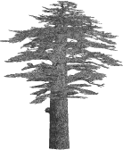
An Early Byzantıne Lıvıng Cross Relıef from Caunus
cedrus.akdeniz.edu.tr
Cedrus VI (2018) 453-463
DOI: 10.13113/CEDRUS/201821

CEDRUS
The Journal of MCRI

Kaunos’tan erken Bİzans dönemİne aİt bİr yaşam haçı kabartması
Nilüfer PEKER∗
Abstract: Caunus is known as a city in Caria which is located coast of Dalyan (Calbis) bay near Köyceğiz in Muğla. According to ancient sources and several ecclesiastical documents Caunus was christianized at an early date and when the Roman Empire officially adopted the Christian faith, its name changed into Hagia-Caunus. Today, there are five churches in different places of the city which come to light thanks to the excavations. It is argued that a domed church on Palaestra Terrace which has been constructed between the first half of VIth century and the mid. VIIth centuries. Undoubtedly findings of around the church shed light on the Byzantine period of the city. There are a lot of remarkable architectural sculptures at the around and inside of domed church on Palaestra Terrace. One of these examples is found at the 1998 excavation season. The front face of the marble block is carved relief technique which is a cross motive with stylized leaves and the alpha (Α) and omega (ω) that depends from arms of the cross. As it is known in Byzantine Art, cross is used to symbolize the Christ’s sufferings, his sacrifice and the hope of salvation. Besides the alpha (Α) and omega (ω) means beginning and end in Christian belief refer to the eternal nature of God. Cross varieties are commonly used in Byzantine depiction art. It seems that the carved marble block must have been used as an architectural stone in the church. Thus in this paper I have tried to examine meaning of the composition and to give careful consideration to a series of questions linked to the context of use of the cross carved block in the church as well as discuss its significance within regional (Caunus ve Caria) and broader cultural contexts of Early Byzantine art. |  | Öz: Bir Karia kenti olan Kaunos Muğla’ya bağlı Köyceğiz yakınlarında Dalyan Çayı’nın kıyısındadır. Antik kaynaklara ve birkaç konsil belgesine göre erken bir tarihte Hıristiyanlaşan Kaunos’un adı bu dönemde Hagia-Kaunos olarak değiştirilmiştir. Bugün, kentin farklı yerlerinde bulunan beş kilise Kaunos kazıları sayesinde ortaya çıkarılmıştır. Bunlardan biri olan Palaestra terasında yer alan kubbeli kilisenin VI. yüzyılın ilk yarısı ile VII. yüzyılın ortalarında yapılmış olduğu düşünülür. Kuşkusuz kilisenin çevresindeki buluntular kentin Doğu Roma Dönemi’ne ışık tutmaktadır. Kazılarda Palaestra terasındaki kubbeli kilisenin içinde ve etrafında pek çok dikkate değer mimari plastik parça ele geçmiştir. Bu örneklerden biri 1998 kazı sezonunda bulunmuştur. Sözü edilen örnek olasılıkla mimari bir yapının parçası olarak kullanılmıştır. Örneğin ön yüzünde kabartma tekniğinde bir haç motifi ile stilize yapraklar ve haçın kollarından sarkan alpha (A) ve omega (ω) harfleri görülür. Doğu Roma sanatında haç İsa’nın çektiklerini, kurban edilişini ve kurtuluş umudunu sembolize etmek için kullanılır. Bunun yanı sıra Hıristiyan inancında başlangıç ve son anlamına gelen alpha (A) ve omega (ω) Tanrı’nın ezeli doğasına işaret eder. Haçın çeşitleri Doğu Roma tasvir sanatında yaygın olarak kullanılır. Bu makalede, sözü edilen kompozisyonun anlamını tartışmayı ve haç betimli bloğun kilisedeki kullanımını değerlendirerek betimin önemini Doğu Roma sanatının bölgesel (Kaunos ve Karia) ve genel kültürel bağlamlarında tartışmayı deniyoruz.
Keywords: Caunus • Early Byzantine Period • Architectural Relief • Living Cross • Alpha and Omega |  | Anahtar Kelimeler: Kaunos • Erken Doğu Roma Dönemi • Mimari Kabartma • Yaşam Haçı • Alfa ve Omega

Description of the Relief Cross
The domed church on Palaestra terrace in the city is one of the most important examples of masonry architecture surviving in Caria from the early Byzantine period (Fig. 1). The excavation in the Palaestra terrace has been conducted by B. Schmaltz, and the current excavations in Caunus are being led by Cengiz Işık.
A marble block found in 1998 at the church excavation has a high quality technique and style (Fig. 2). The diamond-shaped block is decorated with a highly deep relief living (leaved) cross on the front face (Fig. 3). The cutting technique on the side faces of the block suggests that the block is a spolia (fig. 4). It is likely that it might have been carried from the theatre located at the southeast of the church and must been reshaped and carved in order to be reused. The cross’ equal arms are decorated with pearl-shaped knobs at the corners in imitation of Byzantine metal works. The top arm is flanked by symmetrical acanthus leaves, which connect to both side arms (Fig. 5). An alpha (A) and an omega (ω), the first and the last letters in Greek alphabet, dangle with chains from both side arms (Fig. 6). There is a tang at the foot of the cross similar to the ones that can be seen in processional crosses.
The iconography of the decoration and its meaning
The imagery called the living cross in Byzantine material culture is composed of a cross with variations of leaves attached to its arms. On the other hand, Byzantine cross compositions that include letters of alpha and omega are mostly seen in processional material. The decoration of the marble block represents a combination of the living cross and a processional cross, which is quite exceptional in terms of both composition and iconography.
First, let us consider the meaning of the living cross and its interpretation in Christian sources. In Byzantine culture the living cross derives particularly from the tree of life (the tree of knowledge) in Paradise, as the following quotation attests: “In the middle of the garden were the tree of life and the tree of the knowledge of good and evil.” (Genesis 2:9). On the other hand, initial forms of this symbolic image called living cross were originally brought together to present different concepts of paradisiac gardens, many of which previously existed in Pagan, Iranian and Semitic worlds. Talbot Rice suggests that these symbols might have evolved in Mesopotamian art long before Christianity and then passed from there to the later cultures of both East and West. In Early Christianity, the tree of life, planted in the middle of the Eden for Adam by God, is identified with the crucifix. The apostle Paul sets up a comparison between Adam and Christ as well. (1 Cor. 15:22, 45, 47; Rom. 5:12–21; 6:5, 9-11). Indeed, in Early Christianity the Syriac Fathers established a semantic link between the tree of life and the cross. According to them, Genesis and the Crucifixion are like the two faces of a coin. Especially Ephrem the Syrian, in his Hymns, forges links between the tree of life and the tree of cross. S. Brock indicates that he prefers to dwell on the typological contrast between the tree of knowledge, whose fruit brought death to Adam, and the tree of the cross, whose fruit restores life to humanity. As Ephrem the Syrian states:

In his love there came to us the blessed Tree: the one wood undid the work of the other, the one fruit was annulled by the other, that which brought death by that which is alive. (Hymn on Virginity VIII.1)
The actual relic of the True Cross was interpreted to have come from the Tree of Life in Eden; but, saturated by the blood of Christ, it became imperishable and a witness to salvation and Paradise. Thus, in early Byzantine period, all foliated crosses signified Paradise. In the VIth century A.D., Leontius compared the cross and the tree of life in Eden as follows:
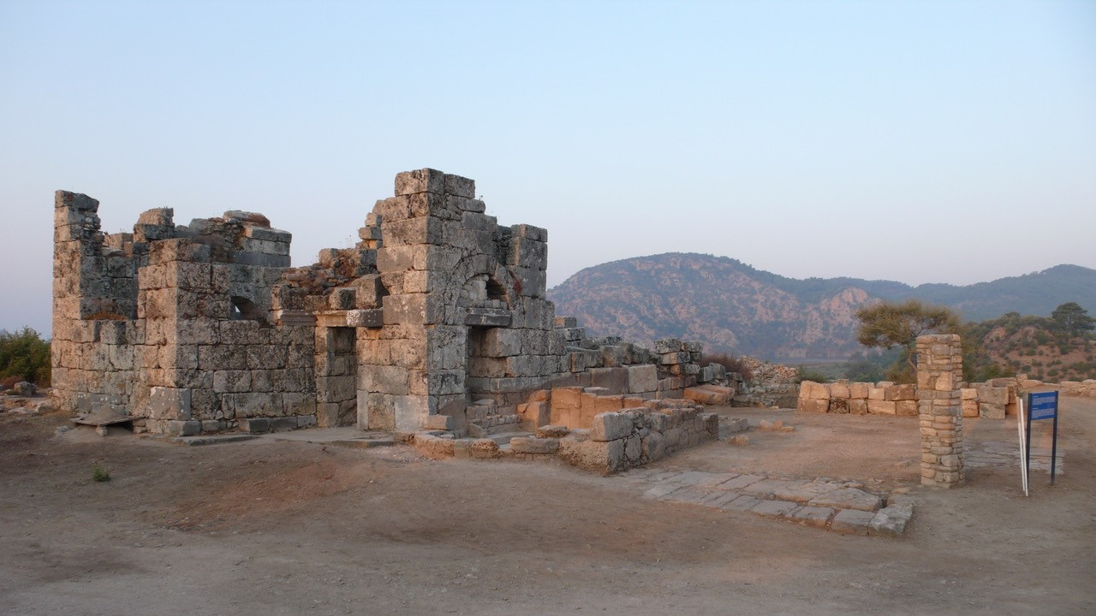 | 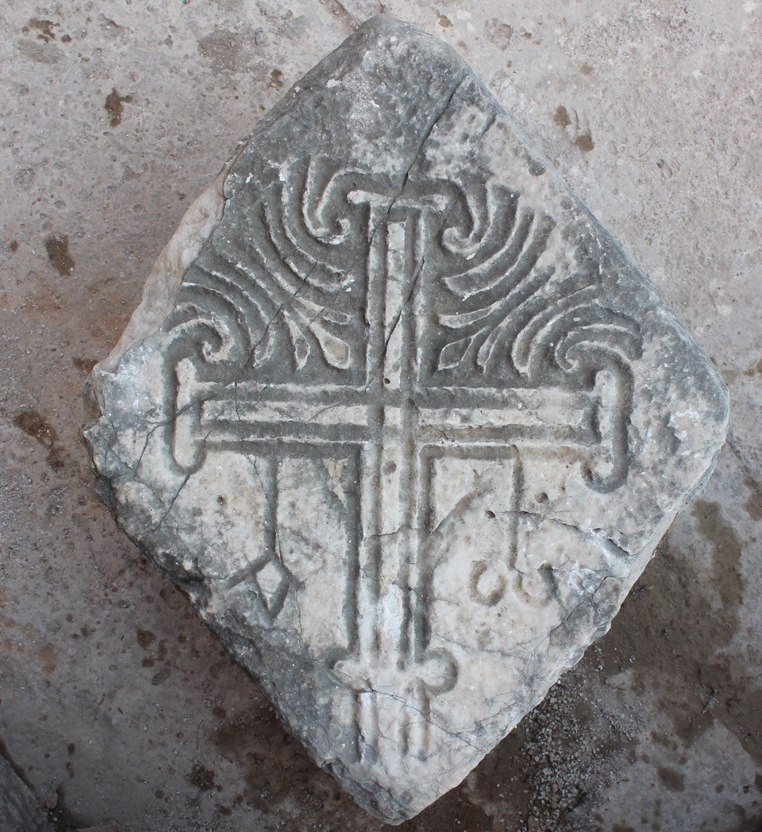
Fig. 1. The Domed Church, general view. | Fig. 2. The Cross Carved Marble Block, front face.
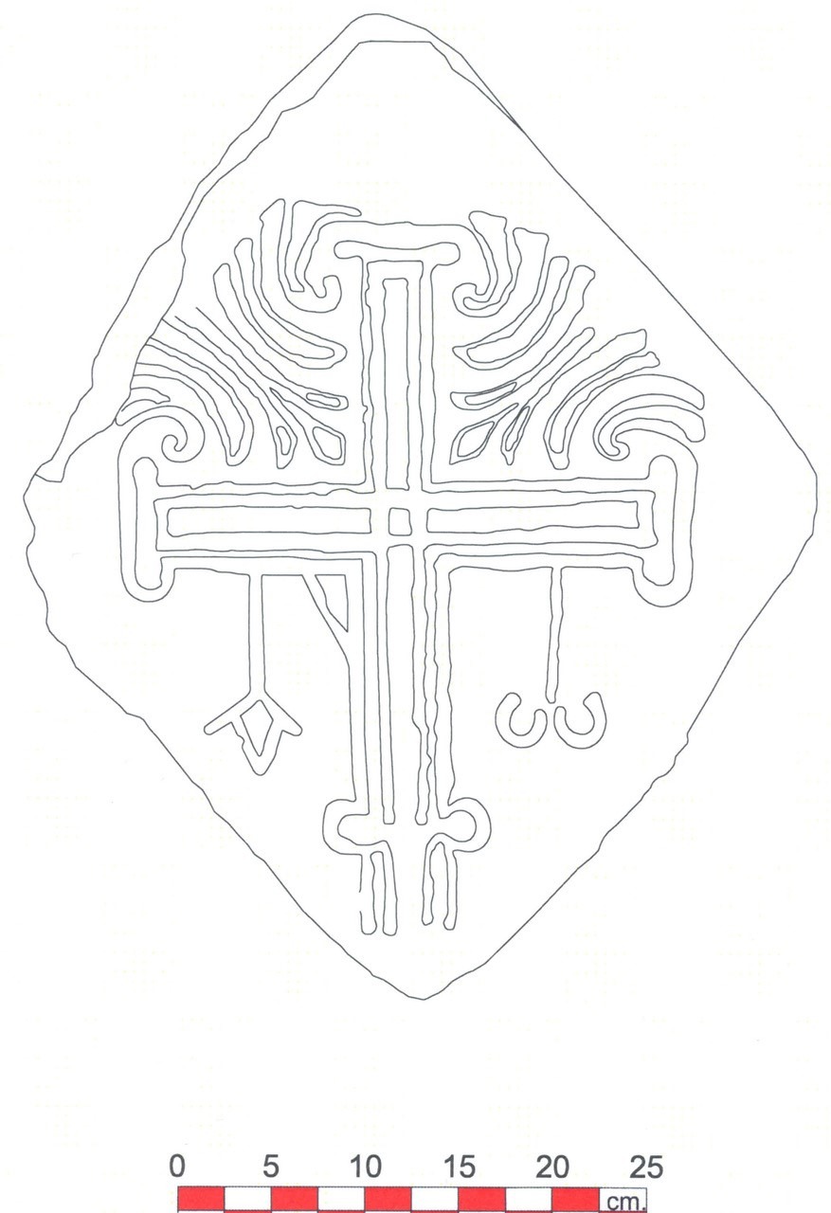 | 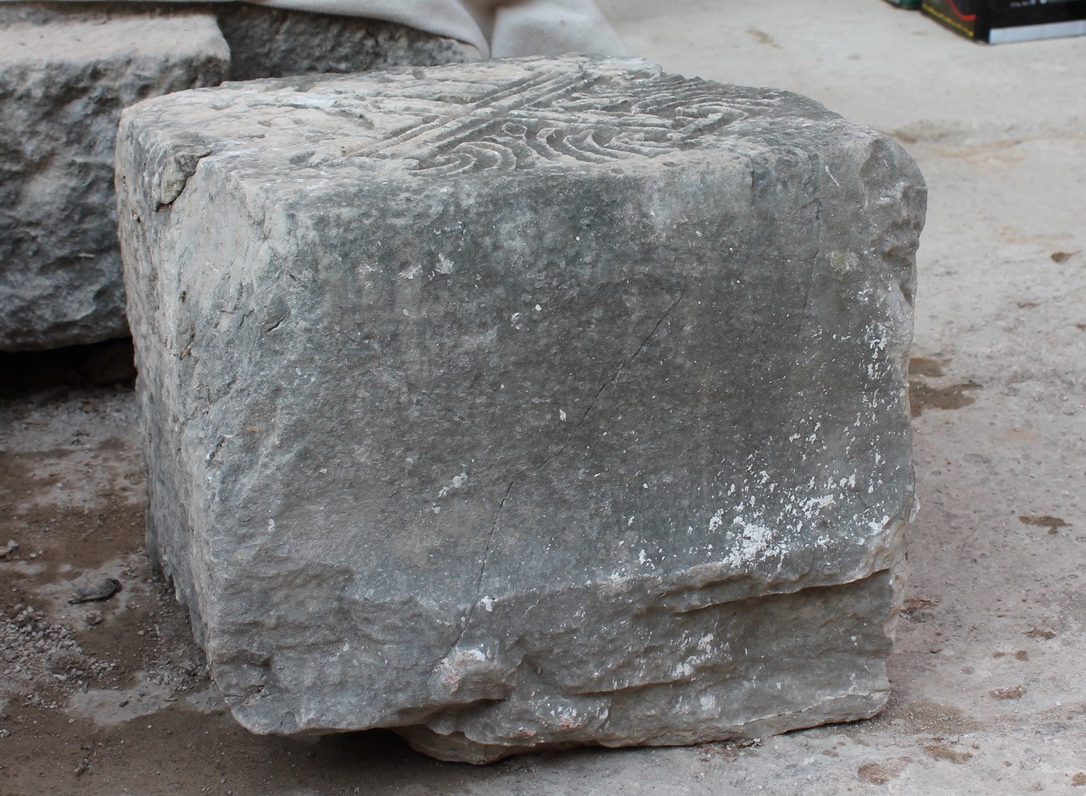
Fig. 3. The Cross Carved Marble Block (drawing: Aykut Fenerci) | Fig. 4. The Cross Carved Marble Block, side face.
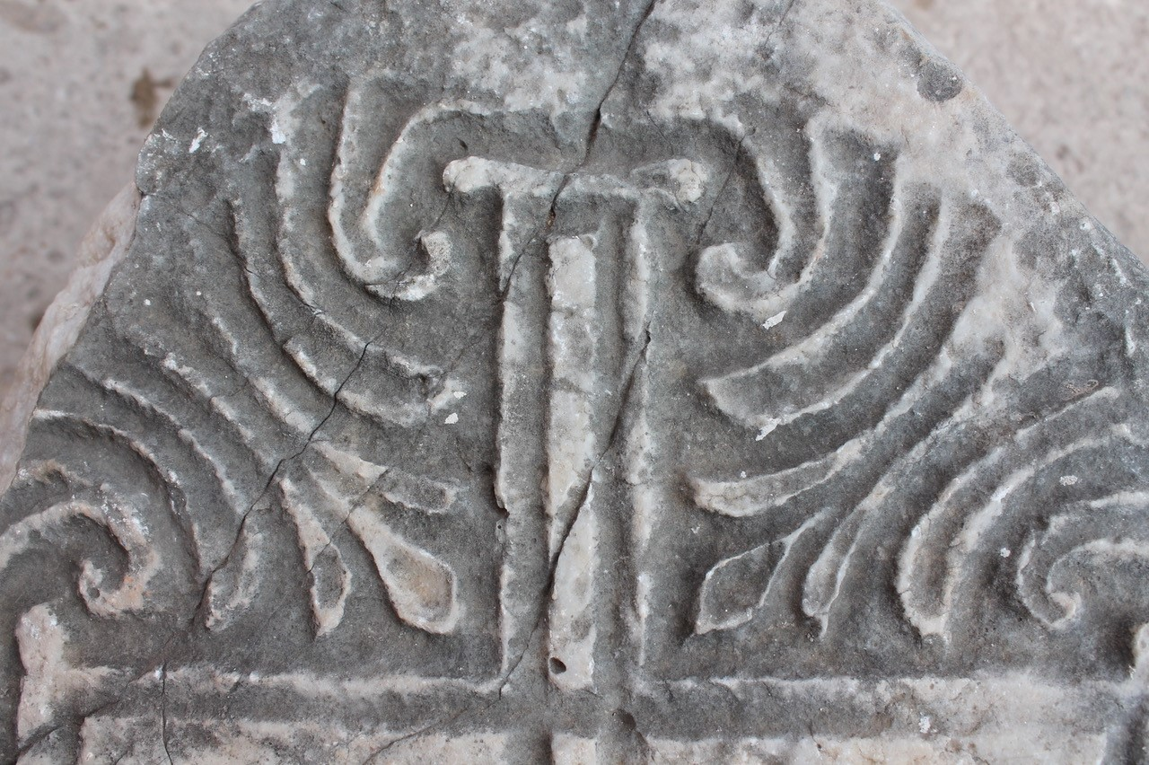 | 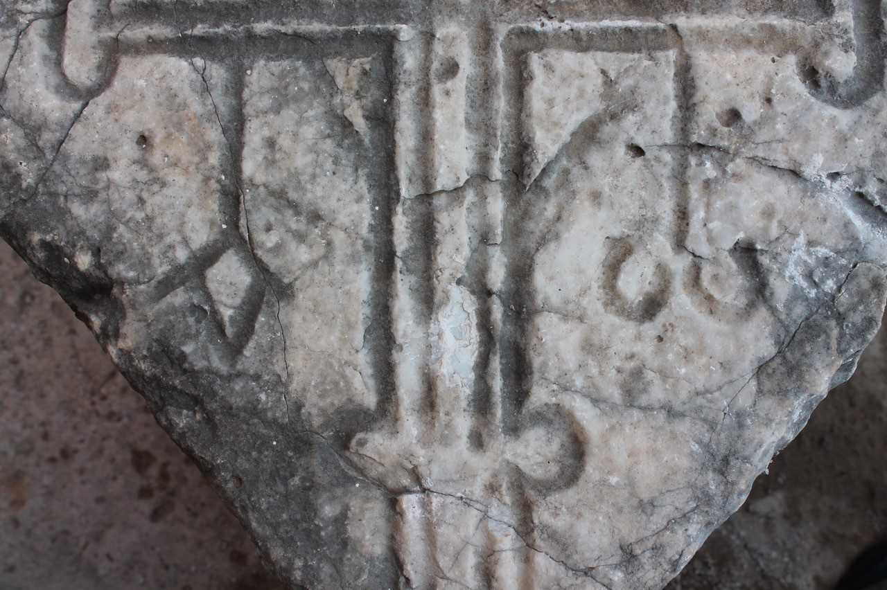
Fig. 5. The Cross Carved Marble Block, acanthus leaves. | Fig. 6. The Cross Carved Marble Block, alpha and omega.
“He has planted a tree which brings a curse, I am building a cross which brings a blessing; he has hewn a grave, I am making it an altar; he has abandoned me to the Jews to be killed, I am quicker in strangling him.” (Leontius homilies, VIII. 2, 10).
Romanos the Melodist, in his Kontakia, used the same word for the cross and the tree, as well as describing the cross as the second tree. He focused on the correction of sins and the perfection of humanity, which God achieves by becoming, in Jesus Christ, the second Adam. As the Devil conquered Adam through the wood of the tree of life, so Christ overcomes Hell through the wood of the cross, leading human beings, who were held captive there, to freedom. Undoubtedly, as E. Cruikshank Dodd states, the cross was the single most powerful symbol in the church, evocative of triumph over death and the everlasting life, in the late VIth and VIIth centuries A.D.. At the same time, in Byzantine culture True Cross referred to victory-bearers or victory-makers.
In Byzantine material culture, living cross consists of a plant or leaves, which extend upwards as far as the arms of the cross and then turn inwards. Besides, leaves can also stem from the upper arm of the cross as it can be seen in the Caunus relief. Talbot Rice indicates that the earliest example of the living cross motive is on a slab dating to the VIth century A.D at Sts. Sergius and Bakhos church in Istanbul. A group of early Byzantine capitals from Istanbul and Asia Minor contain the relief of the living cross. Another remarkable example dating to between the VIth and the VIIIth centuries was found in the excavation of St. Nicolaos Church in Myra. It seems that the living cross had already emerged by the VIth century A.D. in Byzantine art. Indeed, the aforementioned liturgical texts from the VIth century A.D that are related to the living cross support the appearance of the living cross in this century.
As I have mentioned before, the decoration of the marble block that contains a living cross is also composed as a processional cross. The alpha (A) and omega (ω) that dangle from both side arms are the first and the last letters in the Greek alphabet. As it is known, the Revelation is the most powerful reference to understand the meaning of these symbols in Christianity:
“I am Alpha and Omega, the beginning and the ending, saith the Lord, which is, and which was, and which is to come, the Almighty.” (1:8);
“I am the first and the last” (1:17); “I am Alpha and Omega, the beginning and the end, the first and the last.” (22:13) .
Clearly, these letters indicate the beginning and the end, which refer to the eternal nature of God as well as being references to the Last Judgment in Christian belief in terms of symbolizing the end of the universe. For that reason, these letters can be seen in burial places as well. Among early Christian interpretations, the exegesis of Clement of Alexandria about these symbols is quite remarkable. In his commentary called The Stromata, the meaning of these letters is interpreted by way of Christ’s integrity. He comments as follows:
“And the Son is neither simply one thing as one thing, nor many things as parts, but one thing as all things; whence also He is all things. For He is the circle of all powers rolled and united into one unity. Wherefore the Word is called the Alpha and the Omega, of whom alone the end becomes beginning, and ends again at the original beginning without any break. Wherefore also to believe in Him, and by Him, is to become a unit, being indissolubly united in Him; and to disbelieve is to be separated, disjoined, divided.”.
“Thus the Lord Himself is called “Alpha and Omega, the beginning and the end, by whom all things were made, and without whom not even one thing was made.”.
One of the earliest depictions, dating to the IIIrd century A.D., is on a tomb’s plaque in the Catacomb of Callixtus in Rome. A wall-painting from the catacomb of Commodilla presents Christ as the Lord of the Universe, whose head is flanked by alpha and omega. An in-situ cross relief with these letters is on the south apse wall in Karabel church located at Batı Asarcık settlement in Lycia. In the same place, a cross carved slab with an alpha and an omega dangle with chains from both side arms. Both are dated from the VIth century A.D. Another example comes from Gemiler Ada dating to the VIth century A.D., which is presented in a fresco tabula ansata. Doubtlessly, some compositions from the VIth century A.D. are quite remarkable in terms of their similarities to the Caunus relief. One of them is in the catacomb of Pontianus, which is composed as a living cross with alpha and omega. The other similar example is located on a tomb’s wall at the church IVth in Gemiler Ada, which presents a living cross along with alpha and omega at the lower part. In Metropolitan museum, a lintel fragment from the northern Syria dating to between 400 and 550, contains alpha and omega which are located at the upper part of the cross. There is an equal armed cross as a variant of the Christogram and leaves at the lower part of the cross. Another architectural fragment, from Kafaca village located ca. 9 km north west of Milas in Caria, corresponds to the Caunus relief with a carved cross along with dangled alpha and omega, and two isolated flowers on the upper part of the cross.
The decoration of the Caunus relief including a living cross and a processional cross combination does not seem to be accidental, but rather is part of a pattern reflecting a specific theological meaning. The decoration undoubtedly is a kind of echo that expresses the eternal triumph over death as well as symbolizing paradise. Concordantly, this composition conveys messages similar to the Last Judgment because of its nature. The living cross that replaces the tree of life in paradise, as Romanos states in his kontakia, leads humankind to return to paradise. Romanos refers to the theme of the cross with its role for humanity in his kontakia as follows:
“Let us all all boast in Thy cross: we shall nail our hearts upon it, in order that we may hang on it our instruments and sing to Thee, Lord of universe, from the odes of Zion. A ship from Tarshish once furnished gold to Solomon at just the right time, as it is written; Thy cross gives us untold wealth daily and at time of the Last Judgement, for it leads us all again into Paradise.”.
In apocalyptic discourse, the eternal triumph over the death of Christ, who is the beginning and the end, is indicated with alpha and omega letters. The living cross became popular particularly in the VIth century A.D., which can be already seen in the presence of depictions and rise of the exegetical and literary traditions. Although the living cross was also depicted in later times in Byzantine material culture, alpha and omega disappeared after the VIIth century A.D. To understand the disappearance of this symbolic image, we have to turn to the new imperial perspective of the empire in late VIth century A.D. With Justin II (565-574) imperial ceremonies were transformed, which is a powerful visual sign for the transformation of this period. Indeed, as A. Cameron states the inauguration of Justin II marks the exact turning-point. The secular and some pagan elements are still there, but each of these is given a religious interpretation in the panegyric. As a result of this transformation, both symbolic and figurative images of Christ deriving from Old Testament prophetic types and pagan figures were forbidden at the council of Trullo (692). The council decreed:
“In some pictures of the venerable icons, a lamb is painted to which the Precursor points his finger, which is received as a type of grace, indicating beforehand through the Law, our true Lamb, Christ our God. Embracing therefore the ancient types and shadows as symbols of the truth, and patterns given to the Church, we prefer "grace and truth," receiving it as the fulfilment of the Law. In order therefore that "that which is perfect" may be delineated to the eyes of all, at least in coloured expression, we decree that the figure in human form of the Lamb who taketh away the sin of the world, Christ our God, be henceforth exhibited in images, instead of the ancient lamb, so that all may understand by means of it the depths of the humiliation of the Word of God, and that we may recall to our memory his conversation in the flesh, his passion and salutary death, and his redemption which was wrought for the whole world.”.
As it is known, alpha and omega, which are the first and last letters in the Greek alphabet, are used before Christianity as well. Both in Jewish literature and Mithraic cult some remarkable evidence about the use of these letters can be traced in visual and written remains.

A Dating Suggestion for the Cross Relief
Eventually, how should we suggest a date for the depiction of the Caunus relief within the broader cultural contexts of the Early Byzantine art? First of all I would like to draw a historical framework about Caunus. In the ecclesiastical documents, the city is called Hagia, which is one of the suffragan of Myra in Lycia. Furthermore, the episcopal lists include the names of four bishops from Caunus that attended to different councils, namely Basileus (359 Seleukiea in Isauria), Antipatros (451 Khalkedon), Nikolaos (457 the synod of Leon I) and Stephanos (787 Nicea). Although Caunus was placed in Caria by Stephanos of Byzantium, as I have mentioned before, ecclesiastical documents state its dependence on Myra in Lycia. A. Zäh also indicates that the city might have been attached to the eparchy of Lycia by the IInd century A.D.. After Arab invasion in the VIIth and VIIIth centuries, it seems that Caunus turned into a small fortress. Caunus fortress, as a kastron, must have been built in this period as well. Clearly stability was not regained until the 10th century in the city. With the administrative reform of Byzantine Empire and the consequent transformation of the Eparchies into larger administrative units of the themes, Caunus became part of the naval theme Kibyraiôton. In de Thematibus of the Emperor Constantine Porphyrogenitus (913-959), the city was called Hagiapolis. During the 12th and the 13th centuries Caunus was one of the suffragan of Myra in Lycia. By the end of the 13th century the stability came to an end when Turks dominated in Caria.
The domed church on the palaestra terrace has three naves and a three-faceted apse which is situated between the bath and the theatre. Given the archaeological evidence, the main nave is domed, and the northern and the southern naves are covered with barrel vaults although its roof is damaged. There are two rectangular chapels with apses at the north-eastern and the south-eastern corners which apparently postdate the church. Also the narthex at the west is the same. The material of the building is finely cut stone and limited spolia marble, and the latter might have been brought from the other buildings. Zäh, who has published an extensive book about the church, has dated the building to between ca. 540 and the middle of the VIIth century A.D. through examining the excavation findings. Gençler Güray has dated the glass findings discovered in the church excavation to between the Vth and the VIIth centuries in terms of both their forms and production techniques. A miliaresion from Constantine VI (780-797) period is founded in the uppermost stratigraphic layer. Although the coin is the latest finding from this area, it is identified without contextualized material by B. Schmaltz, who has conducted the palaestra terrace excavation.
Indeed our analysis has emphasized the stylistic details, and the iconographic meaning of the Caunus relief and the historical framework of the city tell parallel stories. As I have mentioned before, alpha and omega in Byzantine material culture are used till the end of the VIIth century A.D., which is the solid evidence to securely date it. Furthermore, the relief’s stylistic features have some connections with the examples dated to the VIth century A.D. Some remarkable fragments of the architectural sculpture at Batı Asarcık settlement in Lycia, found in and around of the reliquary chapel, are similar to the Caunus relief in terms of style and production techniques. These notable stylistic similarities and using of the letters alpha and omega encourage us to think that the Caunus relief must be dated to the VIth century A.D.
Conclusion
The block is diamond-shaped, including the cross relief, which seems to have belonged to the theatre. I have argued that the marble block was reused; and, indeed, it is most likely to have been carried from the theatre in order to be used in the first phase of the domed church as well. Because of its diamond-shape it must have been used between the two arches in the church. N. Güzererler Sağman suggests restitution for the building by drawing analogies with Byzantine domed churches in the VIth century A.D. (Fig 7). The restitution offers that the apse is composed with a doubled window. On the basis of this design, we may hypothesize that the cross carved block might have been located between the apse’s doubled window.
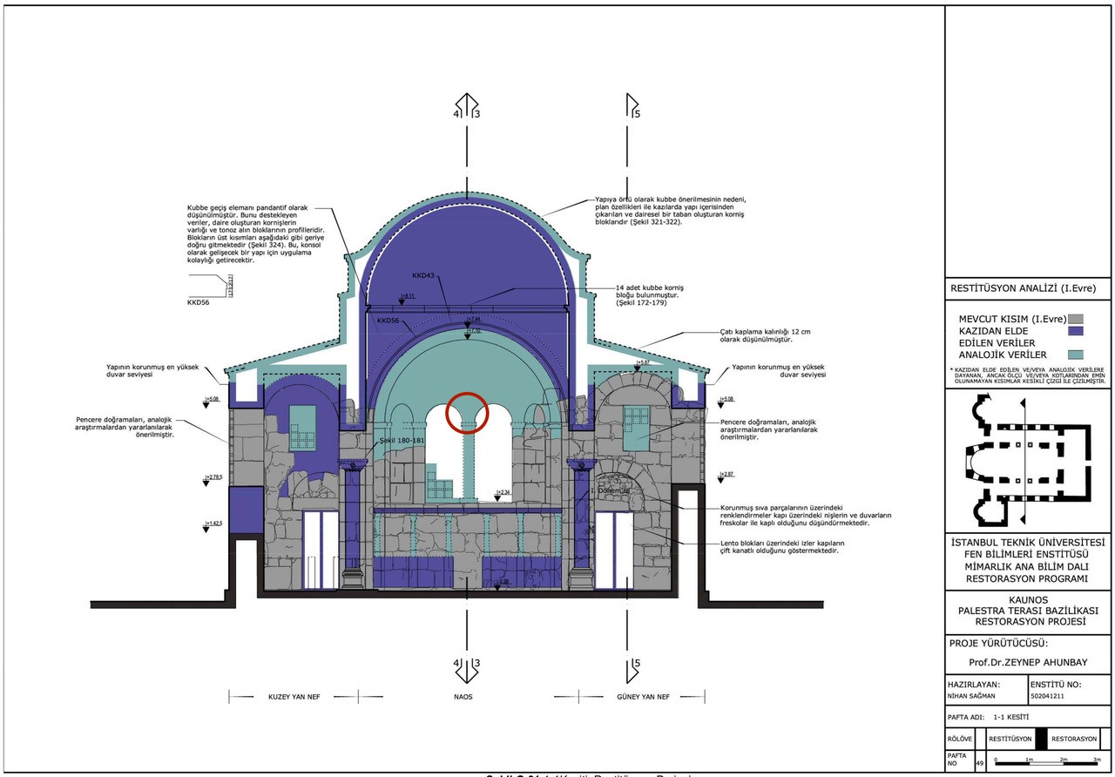
Fig. 7. The Domed Church, section (after Güzererler-Sağman 2007).
Furthermore, the relief is quite convenient in terms of not only shape but also meaning for the apse’s window. As N. Teteriatnikov emphasizes, in Byzantine church the apse was understood as a place of Paradise. She also states that the cross depictions in the apse conch refer to the cross in Paradise. As I have already mentioned above, the living cross derives from the tree of life in Paradise. No doubt the composition of the Caunus relief including a living cross with an alpha and omega combination is part of a pattern reflecting the eternal triumph over death and returning of humankind to paradise. Furthermore, the cross depiction located between windows is also associated with light of life, which refers to Christ’s divine nature. The doctrine of the light of life is formulated from the John 8:12. Among the commentators, Ephrem the Syrian and Romanos the Melodist wrote extensive interpretations concerning the light of Christ. When we interpret all of the above, although this location that I have offered for the cross carved block is quite likely, it is certainly always open to contrastive approaches and new arguments as well.
Ultimately, it seems that the iconography of the Caunus relief reflects an early Byzantine symbolism. Moreover, paradise exegesis and apocalyptic discourse of the VIth century A.D. in Byzantine world finds their visual echo in the Caunus relief within their historical and religious context.

BIBLIOGRAPHY
Aydın 2011 A. Aydın, “Das Fussbodenmosaik des Annexbaus in der Kuppelkirche in Kaunos”. Ed. M. Şahin, 11th. International Colloquium on Ancient Mosaics. İstanbul (2011) 31-42.
Brock 1992 S. P. Brock, The Luminous Eye: The Spiritual World Vision of Saint Ephrem. Michigan 1992.
Cameron 1979 A. Cameron, “Images of Authority: Elites and Icons in late sixth-century Byzantium”. Past & Present 84 (1979) 3-35.
Clem. Clement of Alexandria, The Stromata, or Miscellanies: Ante-Nicene Fathers Translations of The Writings of the Fathers down to A.D. 325. Eds. A. Roberts, J. Donaldson – A. C. Coxe. Edinburg 2001.
Const. Constantine Porphyrogenitus, De Thematibus. Ed. A. Pertusi. Vatican 1952.
Cotsonis 1994 J. A. Cotsonis, Byzantine Figural Processional Crosses. Washington 1994.
Cruikshank-Dodd 1987 E. Cruikshank Dodd, “Three Early Byzantine Silver Crosses”. Dumbarton Oaks Papers 41 (1987) 165-179.
Çizmeli-Öğün 2007 Z. Çizmeli Öğün, “Kaunos Kentinin Bizans Donemi Sikke Buluntuları (1965-2002)”. Eds. C. Işık – Z. Çizmeli Öğün, Calbis, Baki Öğün’e Armağan. Ankara (2007) 39-63.
Darrouzès 1981 J. Darrouzès, Notitiae episcopatuum Ecclesiae Constantinopolitanae / texte critique, introduction et notes. Paris 1981.
Eph. 1 Ephrem the Syrian, Hymns. Trasl. K. E. McVey. New York 1989.
Eph. 2 Saint Ephrem the Syrian, Hymns on Paradise. Trasl. S. Brock. New York 1990.
Evans et al. 2001 H. Evans, M. Holcomb – R. Hallman, “The Arts of Byzantium”. The Metropolitan Museum of Art Bulletin 58 (2001) 4-68.
Ferguson 2003 E. Ferguson, Backgrounds of early Christianity. Michigan 2003.
Gador-Whyte 2017 S. Gador-Whyte, Theology and Poetry in Early Byzantium, the Kontakia of Romanos Melodist. Cambridge 2017.
Gençler-Güray 2010 Ç. Gençler Güray, “Kaunos’un Erken Bizans Dönemi Cam Buluntuları”. Anadolu 36 (2010) 215-226.
Grabar 1980 A. Grabar, Christian Iconography: A study of Its Origins. Princeton 1980.
Güzererler-Sağman 2007 N. Güzererler Sağman, Kaunos Palaestra Terası Kubbeli Bazilikası Restorasyon Projesi. Yayımlanmamış Yüksek Lisans Tezi, İstanbul Teknik Üniversitesi. İstanbul 2007.
Harrison 1963 R. M. Harrison, “Churches and chapels of central Lycia”. Anatolian Studies 13 (1963) 117-151.
İşler 2009 B. İşler, Likya Bölgesindeki Karabel Asarcık’taki Erken Bizans Dönemi Yerleşimi. Yayınlanmamış Doktora Tezi, Hacettepe Üniversitesi. Ankara 2009.
İşler 2017 B. İşler, “Karabel Asarcık’taki Sion Manastırı Mezar Odası ve Bizans Lahitleri”. Seleucia 7 (2017) 161-185.
Le Quien 1740 M. Le Quien, Oriens christianus, in quatuor patriarchatus digestus, quo exhibentur Ecclesiae, patriarchae, caeterique praesules totius Orientis, 1. Paris 1740.
Leont. Leontius Presbyter of Constantinople, Fourteen Homilies. Trans. P. Allen – C. Datema. Leiden – Boston 1991.
Mendel 1914 G. Mendel, Catalogue des Sculptures Grecques, Romaines et Byzantines, vol. 2. İstanbul 1914.
Nedungatt – Featherstone 1995
G. Nedungatt – M. Featherstone, The Council in Trullo Revisited. Rome 1995.
Niewöhner 2006 P. Niewöhner, “Frühbyzantinische Steinmetzarbeiten in Kütahya Zu Topographie, Steinmetzwesen und Siedlungsgeschichte einer zentralanatolischen Region”. Istanbuler Mitteilungen 56 (2006) 407-473.
Osborn 2005 E. Osborn, Clement of Alexandria. Cambridge 2005.
Ötüken 2007 S. Y. Ötüken, “Işık-Yaşam PWC-ZWH”. Eds. C. Işık – Z. Çizmeli Öğün, Calbis, Baki Öğün’e Armağan. Ankara (2007) 131-136.
Özyurt-Özcan 2011 H. Özyurt Özcan, “Muğla, Milas ve Bodrum Arkeoloji Müzesi’nde Bulunan Erken Hıristiyanlık ve Bizans Dönemi’ne Ait Taş Eserler Üzerine İncelemeler”. AST XXVIII/1 (2011) 389-400.
Podskalsky 1991 G. Podskalsky, “Cross”. The Oxford Dictionary of Byzantium I (1991) 549-550.
Rom. Romanos, Kontakia of Romanos, Byzantine Melodist: On the Person of Christ. Trans. M. Carpenter. Columbia 1970.
Ruggieri 2005 V. Ruggieri, La Caria Bizantina: Topografia, Archeologia ed Arte: Mylasa, Stratonikeia, Bargylia, Myndus, Halicarnassus. Rubbettino 2005.
Schmaltz 2000 B. Schmaltz, “Die sogenannte Palästraterasse in Kaunos”. Archäologischer Anzeiger (2000) 17-54.
Sheppard 1969 C. D. Sheppard, “Byzantine Carved Marble Slabs”. The Art Bulletin 51/1 (1969) 65-71.
Spitzing 1989 G. Spitzing, Lexikon Byzantinisch-Christlicher Symbole: die Bilderwelt Griechenlands und Kleinasiens. Diederichs 1989.
Steph. Stephani Byzantii, Ethnikon, Quae Supersunt. Ed. A. Westermann. Leipzig 1839.
Talbot-Rice 1950 D. Talbot-Rice, “The Leaved Cross”. Byzantinoslavica 11 (1950) 69-81.
Teteriatnikov 1995 N. Teteriatnikov, “The Hidden Cross and Tree Program in the Brickwork of Hagia Sophia”. Byzantinoslavica 56 (1995) 689-699.
Tsuji 1995 S. Tsuji, The Survey of Early Byzantine Sites in Ölüdeniz Area (Lycia, Turkey): The First Preliminary Report. Osaka 1995.
Wilpert 1903 J. Wilpert, Die Malereien der Katakomben Roms. Freiburg 1903.
Zäh 2001 A. Zäh, “Das Spätantike und Byzantische Kaunos”. Istanbuler Mitteilungen 51 (2001) 403-413.
Zäh 2003 A. Zäh, Zur Typologie Kirchlicher Architektur im Südwestlichen Kleinasien. Maintal 2003.
Zolt 1994 T. Zollt, Kapitellplastik Konstantinopels vom 4. bis 6. Jahrhundert n. Chr.: mit einem Beitrag zur Untersuchung des ionischen Kämpferkapitells. Habelt 1994.

∗ Dr. Öğr. Üyesi, Hacı Bektaş Veli Üniversitesi, Fen-Edebiyat Fakültesi, Arkeoloji Bölümü, Nevşehir. pekernilufer@gmail.com
I am grateful to Prof. Dr. Cengiz Işık for giving me the opportunity to work Byzantine materials in Caunus.
0,40 x0,37x 0,35 m.
Sheppard 1969, 65.
Talbot Rice 1950, 77.
For further information about the theological approach to the tree of life by Ephrem the Syrian see, Brock 1992.
Eph.2, 61
Sheppard 1969, 66.
Leont. 108.
Gador-Whyte 2017, 74-78.
Romanos uses three main rhetorical techniques to explore some ideas of correcting human wrongs and perfecting the human race: typology, comparison and metaphor. Types for Christ, Mary and the cross show Christ as the second Adam, Mary as the second Eve and the cross as the second Tree (of Life or Knowledge), all demonstrating that by the life and death of Jesus Christ God restores humans to life. For further information see Gador-Whyte 2017, 54, 72-79.
Podskalsky 1991, 550.
Cruikshank Dodd 1987, 165-179, 169.
Cotsonis 1994, 49.
Talbot Rice 1950, 69, pl. 1; Mendel 1914, 524, no:726.
Zolt 1994, tafel 1-3, 4.9, 6.14-15, 8.22-23, 26.113, 28.133-134, 29.136, 31.152-156a; Niewöhner 2006, 407-473, 409, 413, kat. 20, 21, abb.13, 14.
Ötüken 2007, 131-136, figs.1-2.
For further theological discussion see Osborn 2005, 124-127.
Clem. 438.
Clem. 513.
Spitzing 1989, 29.
Grabar 1980, fig. 81.
The cross is composed as a monogram-cross, inscribed ZωΗ. Harrison 1963, 132, pl. XLa; İşler 2017, 172-173, pls. 14-15.
İşler 2017, 172-173, pls. 16-17.
Tsuji 1995, 119, fig. III. 4.
Wilpert 1903, 497, pl. 259.
Tsuji 1995, 123, fig. III. 11.
Evans, Holcomb, Hallman 2001, 20.
Ruggieri 2005, 88, fig. II/49.
Rom., 237-238, strophe 18.
For further discussion see Cameron 1979, 3-35.
Nedungatt, Featherstone 1995, canon LXXXII, 162-163.
For further discussion and the pre-Christian examples see Ferguson 2003, 553-554.
Notitia 7 (the beginning of the 10th century) 333, Notita 9 (946) 215, Notitia 10 (the end of the10th- the beginning of the 11th century) 264, Notitia 13 (12th century) 267. Darrouzès 1981, 279, 300, 318, 358.
Le Quien, 1740, 981-982.
Steph. 164.
Zäh 2003, 6.
Const.78-79.
Zäh 2003, 20–21.
The southern chapel has a remarkable mosaic floor composed of a floral ornament with a cantharus. For further information see Aydın 2011, 31-42.
Zäh 2001, 412; Zäh 2003, 48.
Gençler-Güray 2010, 215-226.
Çizmeli-Öğün 2007, 54.
Schmaltz 2000, 17-54.
İşler 2009, 199, cat. no 118-119; Harrison identified this building as domed chapel. Harrison 1963, 134-135, pl. XLI.
Güzererler Sağman 2007, 63-76.
Teteriatnikov 1995, 693.
Teteriatnikov 1995, 693-694.
Eph.1, 276, 281, 283.

