Determination of Plant Height for Crop and Weed Discrimination by Using Stereo Vision System

Ürün ve Yabancı Ot Ayrımı için Stereo Görme Sistemi Kullanılarak Bitki Yüksekliğinin Belirlenmesi
Ömer Barış ÖZLÜOYMAK¹
Abstract
The stereo vision experiments were conducted under the laboratory conditions by using LabVIEW programming language. An artificial crop plant and six types of artificial weed samples were used in the experiments. The information related to the plant height is a relevant feature to classify the crop plant and weed, especially in the early growth stage. A binocular stereo vision system was established by using two identical webcams with parallel optical axes and a laptop computer to discriminate the artificial crop plant and six types of weeds correctly. The calculated depth values were compared with the physical measurements for the same points. While the measurement error of the system was less than 3.50% for the artificial crop plant, it was less than 4.20% for six artificial weed samples. There were also strong, positive and significant linear correlations between the stereo vision and physical height measurements for artificial crop plant and weed samples. Calculated correlation values (R²) between the stereo vision and physical height measurements were 0.962 for the artificial crop plant and 0.978 for the artificial weed samples, respectively. That stereo vision system could be integrated into automatic spraying systems for intra-row spraying applications.
Keywords: 3D depth measurement, LabVIEW, Spraying, Stereo vision, Weed
Öz
Stereo görme denemeleri, LabVIEW programlama dili kullanılarak laboratuvar koşullarında yapılmıştır. Denemelerde, yapay bir ürün bitkisi ile altı tür yapay yabancı ot örneği kullanılmıştır. Bitki yüksekliği ile ilgili bilgi; özellikle ilk büyüme döneminde, ürün bitkisi ile yabancı otların sınıflandırılması için önemli bir özelliktir. Yapay ürün bitkisi ile altı tür yabancı otu doğru şekilde birbirlerinden ayırt etmek için paralel optik eksenli iki özdeş web kamerası ve bir dizüstü bilgisayar kullanılarak, bir binoküler stereo görme sistemi geliştirilmiştir. Hesaplanan derinlik değerleri, aynı noktalardan alınan fiziksel ölçümlerle karşılaştırılmıştır. Sistemin ölçüm hatası; yapay ürün bitkisi için %3.50'den az iken, altı tane yapay yabancı ot örneği için %4.20'den az olmuştur. Yapay ürün bitkisi ve yabancı ot örnekleri için stereo görme ile fiziksel yükseklik ölçümleri arasında; güçlü, pozitif ve anlamlı doğrusal bir korelasyon vardır. Stereo görme ve fiziksel yükseklik ölçümleri arasındaki hesaplanan korelasyon değeri (R²), yapay ürün bitkisi için 0.962; yapay yabancı ot örnekleri için ise 0.978’dir. Bu stereo görme sistemi, sıra üzeri ilaçlama uygulamaları için otomatik ilaçlama sistemlerine entegre edilebilir.
Anahtar Kelimeler: 3D derinlik ölçümü, LabVIEW, İlaçlama, Stereo görme, Yabancı ot

Nowadays, machine vision on spraying systems has been successfully used for weed segmentation. Widespread use of smart sprayers has improved spraying efficiencies and reduced the negative impact of agrochemical inputs on the environment. Farmers and consumers tend to consume natural and organic foods with no or limited traces of toxic chemicals.
Recently herbicide usage is reduced significantly through inter-row application in weed control without damaging the environment and compromising on efficacy by using new technologies, such as optical sensors and machine vision. Real-time site-specific herbicide application systems were tested and evaluated under laboratory and field conditions with the help of agricultural robots and automation (Yang et al., 2002; Yang et al., 2003; Timmermann et al., 2003; Jafari et al., 2006a; Loghavi and Mackvandi, 2008; Tellaeche et al., 2008; Shirzadifar et al., 2013; Loni et al., 2014; Gonzalez-de-Soto et al., 2016; Özlüoymak et al., 2019).
Although various studies have been introduced on inter-row weed control systems, not much research has been conducted on intra-row weed sensing applications based on robotics operated by machine vision algorithms. Both the crop and the weed are green, they cannot be separated from each other by using colour-based image processing techniques. That’s why 2D imaging using a single camera is inadequate for identifying crops and weeds in automatic spraying systems.
3D imaging, which is used by electromagnetic energy for describing surfaces and spatial objects, is especially preferred to non-destructive testing and remote sensing applications. Stereo vision, structured light systems, Time-of-Flight, light-field imaging and laser scanning methods could be classified under three-dimensional imaging methods (Li et al., 2017; Xiong et al., 2017).
In order to obtain 3D imaging of greenhouse plants, Li et al. (2017) established a stereo vision system using portable low-cost cameras. And the imaging accuracy under different baseline settings was investigated. Piron et al. (2011) described a coded, structured-light method to acquire high-quality stereoscopic images of small-scale field scenes. In that study, stereoscopic data was used to differentiate weeds from the crop. While the classification accuracy was 66% without correction, it reached up to 83% with the help of the corrected plant height. Xia et al. (2009) proposed a three-dimensional leaf position measurement method by using stereo vision on the agricultural autonomous robot guidance system. But the measurement accuracy error between real and calculated depths reached up to 10% during the experiments. To reconstruct the 3D canopy structure of rape seedlings, Xiong et al. (2017) established a stereo vision system. Plant height and leaf area could be extracted by using that stereo-imaging system. While the mean absolute percentage error of automatic leaf area measurements was 3.68%, the mean absolute percentage error of plant height measurements was 6.18% compared with the manual measurements. And the squares of the correlation coefficients (R²) were found 0.984 and 0.845, respectively. To measure plant features from a single top-view image and a disparity map, Lin et al. (2011) developed a non-destructive stereo vision system. The three-dimensional features such as plant height and volume were estimated. While the R² value was 0.9185 for plant volume, it was 0.9046 for plant height. The estimation errors for volume and plant height were determined as 13.0 ± %8.7 and 10.1 ± %8.6, respectively. Andersen et al. (2005) mentioned the potential use of stereo vision system under controlled conditions for analysis of the geometric properties of wheat plants. Whereas leaf area and plant height could be correctly estimated by using this method, some parameters such as growth stages, different plant canopy geometries, etc. still needs to be proven under the actual field conditions.
In this study, stereo vision-based 3D depth measurement for differentiating the artificial crop plants from weeds was investigated and evaluated. A binocular stereo vision platform equipped with double identical top-view cameras was established and controlled by a laptop computer in an indoor laboratory. Even though various techniques have been used for weed segmentation in the robotic weed control systems, not much research has been carried out by using the stereo imaging technique as mentioned before. The stereo vision results were compared with the physical measurement results. It was observed that developed binocular stereo vision system can estimate the depth of artificial crop and weeds accurately and it looks reliable for the use of automatic spraying systems.

Materials and Methods
Material
The proposed stereo vision platform was established in the automation laboratory at the Department of Agricultural Machinery and Technologies Engineering of Çukurova University, Turkey. The whole hardware assembly of the stereo vision system is depicted in Figure 1.
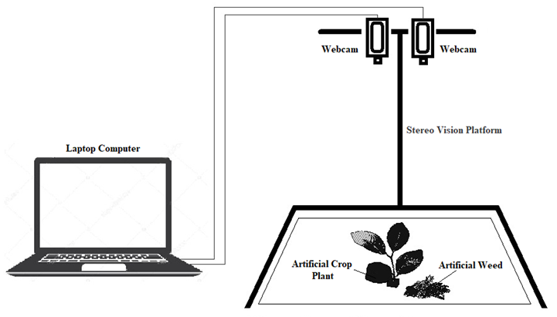
Figure 1. The binocular stereo vision system
The stereo image system was designed and set up by using two webcams (Logitech C270) located parallel to each other. While the working distance between the artificial plants and lens was 385 mm, the baseline distance between the camera lenses was 70 mm. Cameras, which had 4 mm focal length and a resolution of 640 × 480 pixels, were equipped with CMOS sensors. The processing unit of the real-time stereo vision system was a laptop computer (Acer, Aspire E15) with 4 GB RAM and an Intel Core i5-5200U CPU. An image processing software for the depth measurements of both the artificial crop plant and artificial weeds was developed using the LabVIEW (National Instruments Corporation, Austin-Texas-USA) programming language.
An artificial crop plant and a total of 6 artificial weeds were used as an experiment subject to compare the actual depth measurements with the stereo vision measurements.
Method
As mentioned before, various studies have been introduced on inter-row weed detection and the greenness method was used to distinguish green objects in the image. Many researchers used the same method on their studies (Yang et al., 2002; Yang et al., 2003; Jafari et al., 2006b; Shirzadifar et al., 2013; Loni et al., 2014; Sabancı and Aydın, 2014; Sabanci and Aydin, 2017; Özlüoymak et al., 2019). The purpose of this method is to detect the greenness of the colour. However, colour methods used to distinguish the green objects from the background (i.e. soil, etc.) doesn’t work for intra-row weed management because crop plants and weeds are in the same colour.
The most important parameter for distinguishing the crop plant and weed from each other is the plant height method especially in the early stage of growth. Binocular stereo vision is more important method than the other imaging methods at the automatic plant classification for crop/weed discrimination in the intra-row site-specific spraying process applied only onto the weed. The obtained depth information would be valuable for controlling the spraying applications.

Stereo vision
A stereo vision system was developed in order to calculate the artificial crop plant and weed heights. Real-time images were obtained with the help of two identical webcams under a constant light source. The flow diagram of three-dimensional depth map construction was shown in Figure 2.
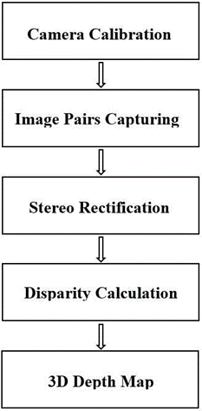
Figure 2. Software flow chart of a three-dimensional depth map
The accuracy of three-dimensional depth map reconstruction depends on the camera calibration, stereo rectification and disparity calculation. Two sets of images were taken for the calibration process, (for left and right calibrations) each containing five images. A pattern with 16x12 array of dots was used to calibrate the cameras. It was affixed to a flat board to ensure accurate camera calibration. And image pairs were acquired by changing the pattern orientation to calculate both the distortion of the image and the exact spatial relationship between two cameras as shown in Figure 3.
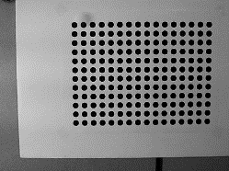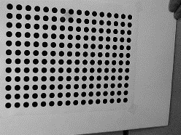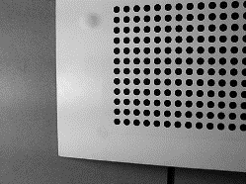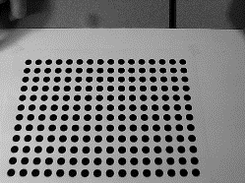
(a)
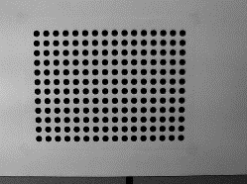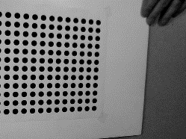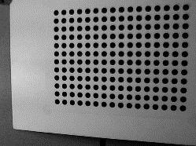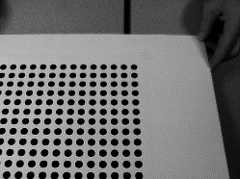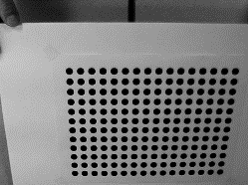
(b)
Figure 3. Stereo vision calibration process (a) Left camera calibrations, (b) Right camera calibrations

The calibrated image was used in the stereo rectification to rectify the image pairs. To remove the lens distortions and obtain the standard configuration, stereo rectification process was carried out. Especially first and last horizontal lines should be imbricated with dots on the lines to verify the stereo rectification as shown in Figure 4.
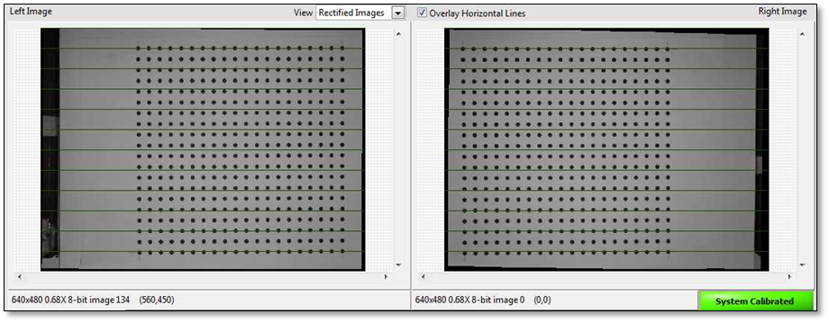
Figure 4. The rectification process on the pattern images
In the last step, disparity calculation was carried out and a 3D depth map was achieved with the help of the binocular stereo system. Holonec et al. (2014) mentioned that disparity information is a linear function of the depth information. Xia et al. (2009) stated that the triangulation method could be used for calculating the depth information (the distance between the object and camera optical centre) of an object with the help of the binocular vision system. Stereo vision system principle of a binocular stereo vision setup was illustrated as shown in Figure 5 (Holonec et al., 2014).
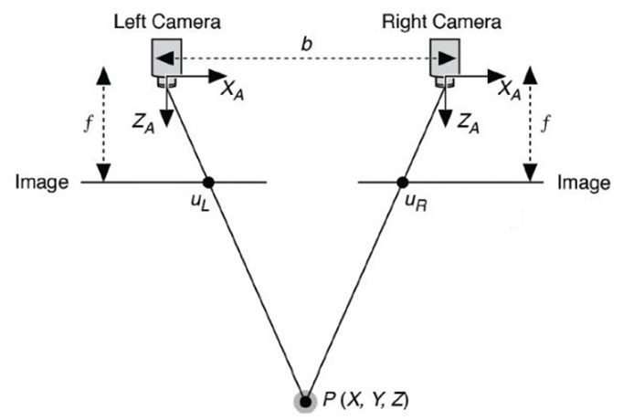
Figure 5. Stereo vision system principle
where f is the focal length of both cameras; b is the distance between the two cameras (baseline); X_{A} and Z_{A} are the X-axis and the optical axis of a camera, respectively; U_{L} and U_{R} are the projections of a scene point on the two image planes; P (X, Y, Z) is a real-world point (Xia et al., 2009; Holonec et al., 2014).
$$U_{L}=f×\frac{X}{Z}$$ | Eq. (1)
$$U_{R}=f×\frac{(X-b)}{Z}$$ | Eq. (2)
$$Disparity=U_{L}-U_{R}=f×\frac{b}{Z}$$ | Eq. (3)
$$Depth=Z=f×\frac{b}{Disparity}$$ | Eq. (4)
The disparity can be defined as the distance between the two projected points. By using the disparity value, the depth information (the distance between the stereo vision system and the real-world point) was calculated (Xia et al., 2009; Lin et al., 2011; Holonec et al., 2014; Li et al., 2017). In order to calculate the disparity value from the NI Vision library, Semi-Global Block-Matching algorithm was used (Birchfield and Tomasi, 1999).

Results and Discussion
All experiments were performed in the laboratory conditions to verify the accuracy performance of the binocular stereo vision system. Two identical webcams were used for capturing image pairs and the image resolution was 640 by 480 pixels. An artificial crop plant and six artificial weed samples were chosen for the experiments as shown in Figure 6.
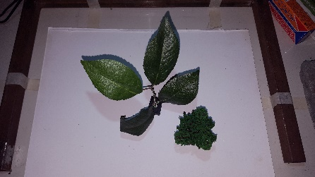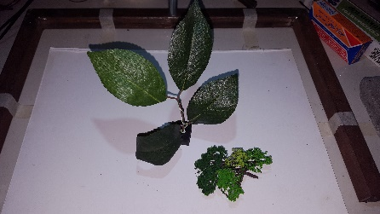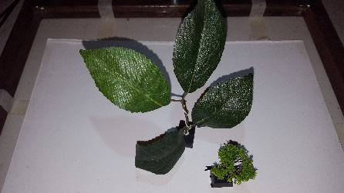
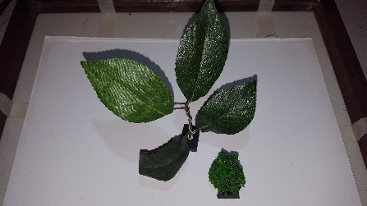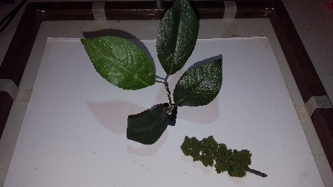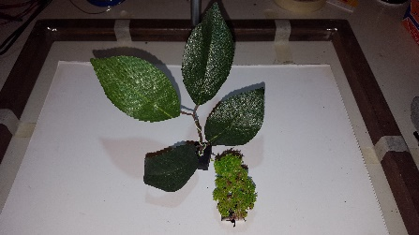
Figure 6. Locations of artificial crop plant and weeds at the stereo vision system
By using Equation 4, the depth image map was simultaneously constructed from the image pairs. The depth information was revealed by comparing the disparity and image pairs. Images acquired from two webcams and the depth map during the experiments were shown in Figure 7 and Figure 8, respectively. These image pairs and depth maps were obtained for artificial crop plant and weed samples standing next to each other to simulate intra-row weed sensing applications.

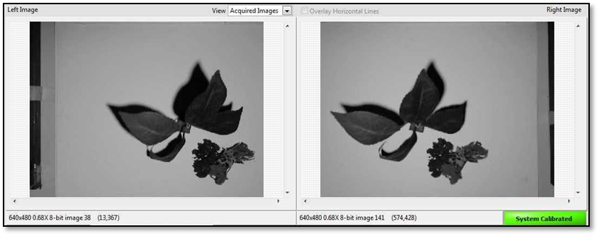
Figure 7. Captured image pairs from left and right cameras
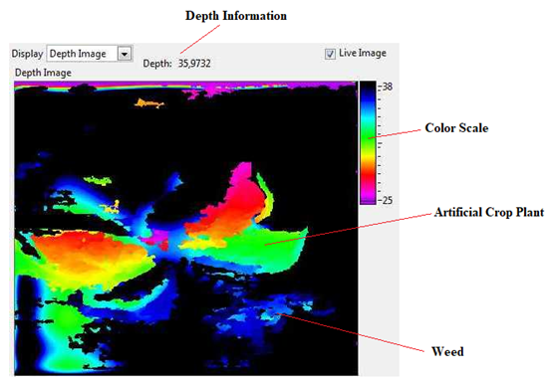
Figure 8. The depth map obtained during the experiments
Measurements were carried out both by using the depth map and physically. Some region of interest for the artificial crop plant and six artificial weed samples were determined and measurements were taken from the relevant regions. As shown in Table 1 and Table 2; while the measurement error was less than 3.50% for the artificial crop plant, the measurement error was less than 4.20% for six artificial weed samples. According to the results, the binocular stereo vision system was reliable and acceptable for the intra-row spraying applications with an extremely high degree of measurement accuracy.
Table 1. Depth comparison between stereo vision and physical measurements for artificial crop plant
Region | Stereo Vision (cm) | Physical Measurement (cm) | Error (%)
1 | 25.91 | 25.63 | 1.09
2 | 27.72 | 27.68 | 0.13
3 | 30.17 | 30.80 | 2.04
4 | 28.65 | 27.74 | 3.27
5 | 29.31 | 28.68 | 2.19
6 | 30.38 | 30.92 | 1.75
7 | 32.25 | 31.18 | 3.41
8 | 32.27 | 32.42 | 0.45
9 | 33.69 | 34.42 | 2.11
10 | 34.25 | 33.63 | 1.87
11 | 34.35 | 34.18 | 0.49
12 | 34.65 | 34.92 | 0.75

Table 2. Depth comparison between stereo vision and physical measurements for artificial weeds
Artificial Weed | Region | Stereo Vision (cm) | Physical Measurement (cm) | Error (%)
1 | 1 | 34.64 | 33.68 | 2.85
 | 2 | 32.77 | 32.18 | 1.83
 | 3 | 33.77 | 33.24 | 1.57
2 | 1 | 37.58 | 37.13 | 1.22
 | 2 | 34.75 | 34.18 | 1.65
 | 3 | 37.41 | 36.80 | 1.66
3 | 1 | 35.73 | 34.30 | 4.17
 | 2 | 33.81 | 33.13 | 2.07
 | 3 | 36.65 | 35.80 | 2.39
4 | 1 | 37.17 | 36.36 | 2.22
 | 2 | 35.14 | 34.68 | 1.31
 | 3 | 37.78 | 36.80 | 2.67
5 | 1 | 37.33 | 36.30 | 2.84
 | 2 | 34.78 | 34.24 | 1.58
 | 3 | 36.65 | 35.80 | 2.37
6 | 1 | 36.39 | 35.80 | 1.64
 | 2 | 32.19 | 31.80 | 1.22
 | 3 | 36.38 | 35.63 | 2.11

Bivariate correlation analysis method was applied to the obtained data according to the stereo vision and physical height measurements of the artificial crop plant and the artificial weeds. Pearson correlation analysis results were given in Table 3 for the artificial crop plant measurements and in Table 4 for the artificial weed measurements, respectively.
Table 3. Correlation analysis results for the artificial crop plant measurements
Correlations^{b}
 |  | Stereo Vision | Physical Measurement
Stereo Vision | Pearson Correlation | 1 | .981**
 | Sig. (2-tailed) |  | .000
Physical Measurement | Pearson Correlation | .981** | 1
 | Sig. (2-tailed) | .000
**. Correlation is significant at the 0.01 level (2-tailed)
b. Listwise N=36

Table 4. Correlation analysis results for the artificial weed measurements
Correlations^{b}
 |  | Stereo Vision | Physical Measurement
Stereo Vision | Pearson Correlation | 1 | .989**
 | Sig. (2-tailed) |  | .000
Physical Measurement | Pearson Correlation | .989** | 1
 | Sig. (2-tailed) | .000
**. Correlation is significant at the 0.01 level (2-tailed)
b. Listwise N=54
As shown in Table 3 and Table 4; there were very strong, positive and significant linear correlations (p<0.01) between the stereo vision and physical height measurements. Correlation coefficients (R) were calculated as 0.981 for the artificial crop plant and 0.989 for artificial weeds. Accordingly, it can be said that as the stereo imaging measurements increase, the physical measurements will increase. Scatter diagrams showing the linear correlations between the stereo vision and physical height measurements for the artificial crop plant and artificial weeds were also given in Figure 9 and Figure 10, respectively. While the calculated correlation value (R²) between the stereo vision and physical height measurements for the artificial crop plant was 0.962, it was 0.978 for artificial weeds.
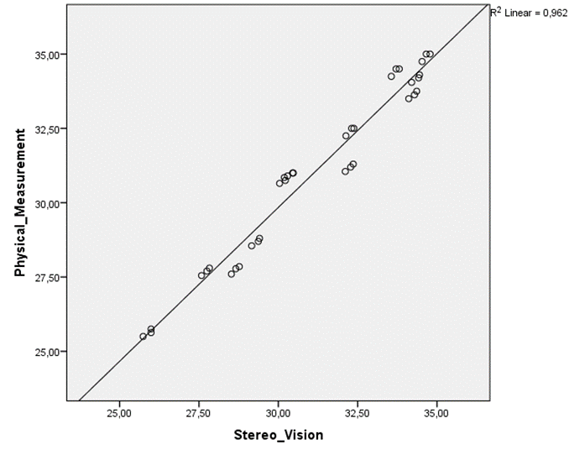
Figure 9. The correlation between the stereo vision and physical measurements for artificial crop plant

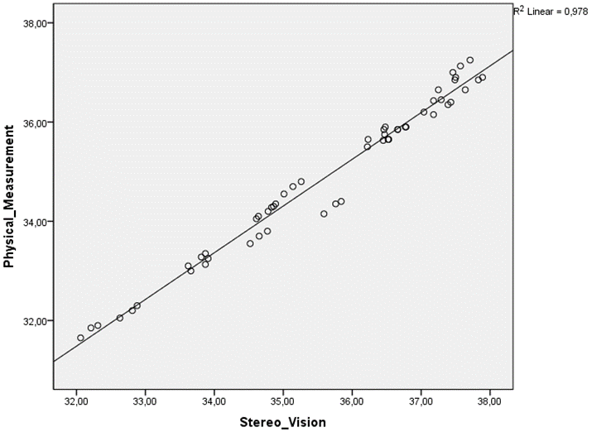
Figure 10. The correlation between the stereo vision and physical measurements for artificial weeds

Conclusions
In this study; a stereo vision system consisted of two identical and parallel cameras was designed and developed for determining the plant height measurement accuracy. A LabVIEW based image processing software was developed to acquire the depth information belonging to the artificial crop plant and weeds. The acquired image pairs were used to measure the distance between the artificial plants and stereo vision system. The experimental results showed that developed stereo vision system was found to be successful at measuring the depth information and it could be used on intra-row automatic site-specific spraying systems.
This study will be a model for researchers, who aim to work on stereo vision systems, and it will have a positive effect on spraying system design in agricultural vehicles for real-time applications.

References
Andersen, H.J., Reng, L., Kirk, K. (2005). Geometric plant properties by relaxed stereo vision using simulated annealing. Computers and Electronics in Agriculture, 49, 219–232.
Birchfield, S., Tomasi, C. (1999). Depth discontinuities by pixel-to-pixel stereo. International Journal of Computer Vision, 35(3), 269–293.
Gonzalez-de-Soto, M., Emmi, L., Perez-Ruiz, M., Aguera, J., Gonzalez-de-Santos, P. (2016). Autonomous systems for precise spraying-evaluation of a robotised patch sprayer. Biosystems Engineering, 146, 165-182.
Holonec, R., Copindean, R., Dragan, F., Dan Zahara, V. (2014). Object tracking system using stereo vision and LabVIEW algorithms. Acta Electrotehnica, 55(1-2), 71-76.
Jafari, A., Mohtasebi, S.S., Jahromi, H.E., Omid, M. (2006a). Weed detection in sugar beet fields using machine vision. International Journal of Agriculture & Biology, 8(5), 602-605.
Jafari, A., Mohtasebi, S.S., Jahromi, H.E., Omid, M. (2006b). Color segmentation scheme for classifying weeds from sugar beet using machine vision. Iranian Journal of Information Science & Technology, 4(1), 1-12.
Li, D., Xu, L., Tang, X., Sun, S., Cai, X., Zhang, P. (2017). 3D imaging of greenhouse plants with an inexpensive binocular stereo vision system. Remote Sensing, 9, 508, 1-27.
Lin, T., Lai, T., Liu, C., Cheng, Y. (2011). A three-dimensional imaging approach for plant feature measurement using stereo vision. Journal of Agricultural Machinery Science, 7(2), 153-158.
Loghavi, M., Mackvandi, B.B. (2008). Development of a target oriented weed control system. Computers and Electronics in Agriculture, 63: 112-118.
Loni, R., Loghavi, M., Jafari, A. (2014). Design, development and evaluation of targeted discrete-flame weeding for inter-row weed control using machine vision. American Journal of Agricultural Science and Technology, 2(1), 17-30.
Özlüoymak, Ö.B., Bolat, A., Bayat, A., Güzel, E. (2019). Design, development, and evaluation of a target oriented weed control system using machine vision. Turkish Journal of Agriculture and Forestry, 43, 164-173.
Piron, A., Van der Heijden, F., Destain, M.F. (2011). Weed detection in 3D images. Precision Agriculture, 12, 607–622.
Sabancı, K., Aydın, C. (2014). Image processing based precision spraying robot. Journal of Agricultural Sciences, 20, 406-414.
Sabanci, K., Aydin, C. (2017). Smart robotic weed control system for sugar beet. Journal of Agricultural Science and Technology, 19, 73-83.
Shirzadifar, A.M., Loghavi, M., Raoufat, M.H. (2013). Development and evaluation of a real time site-specific inter-row weed management system. Iran Agricultural Research, 32(2), 39-54.
Tellaeche, A., Burgos-Artizzub, X.P., Pajaresa, G., Ribeirob, A. (2008). A vision-based method for weeds identification through the bayesian decision theory. Pattern Recognition Society, 41, 521-530.
Timmermann, C., Gerhads, R., Kühbauch, W. (2003). The economic impact of site-specific weed control. Precision Agriculture, 4, 249-260.
Xia, C., Li, Y., Chon, T., Lee, J. (2009). A stereo vision based method for autonomous spray of pesticides to plant leaves Paper presented at the IEEE International Symposium on Industrial Electronics (ISIE 2009), Seoul-Korea, 909-914.
Xiong, X., Yu, L., Yang, W., Liu, M., Jiang, N., Wu, D., Chen, G., Xiong, L., Liu, K., Liu, Q. (2017). A high-throughput stereo-imaging system for quantifying rape leaf traits during the seedling stage. Plant Methods, 13(7), 1-17.
Yang, C., Prasher, S.O., Landry, J., Kok, R. (2002). A vegetation localization algorithm for precision farming. Biosystems Engineering, 81(2), 137-146.
Yang, C., Prasher, S.O., Landry, J., Ramaswamy, H.S. (2003). Development of an image processing system and a fuzzy algorithm for site-specific herbicide applications. Precision Agriculture, 4, 5-18.

