|  |
| --- |
|  |
| ***Journal of Gastronomy And Travel Research***  **(ISSN: 2602-4144)**  ***In Memory of Prof. Dr. Irfan Arikan*** |

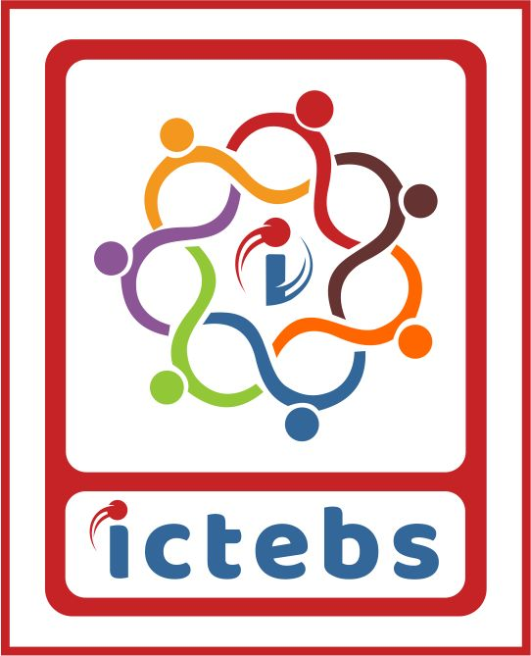

Vol. 6 No 3 (Special Issue: ICTEBS)

***5. Uluslararası Turizm, Ekonomi ve İşletme Bilimleri Kongresi Özel Sayısı***

*Special Issue of 5th International Congress on Tourism, Economic and Business Sciences*

**Sayı Editörü (leri)/ Guest Editor (s)**

Prof. Dr. H. Suavi AHİPAŞAOĞLU

Doç. Dr. Tülay ÜZÜMCÜ

**CONGRESS HONORARY BOARD**

Prof. Dr. Sadettin HÜLAGÜ - Kocaeli University

Prof. Dr. Mehmet DURMAN - Beykoz University

Prof. Dr. Mehmet KARATAŞ- Founder of ICTEBS

**ICTEBS - CONGRESS HONORARY CHAIRMAN**

Prof. Dr. Suavi AHİPAŞAOĞLU- Beykoz University

**ICTEBS 2022- CONGRESS CHAIRMAN**

Assoc.Prof. Dr. Bilsen BİLGİLİ- Kocaeli University

**CONGRESS COORDINATORS**

Assoc. Prof.Dr. Tülay ÜZÜMCÜ- Kocaeli University

Assoc. Prof.Dr. Pınar ACAR- Beykoz University

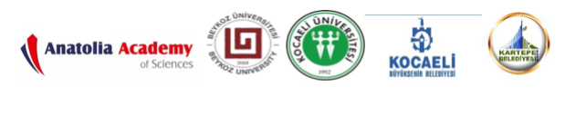

Gastroia: Gastronomi ve Seyahat Araştırmaları Dergisi

(ISSN: 2602-4144)



**Sahibi/Proprietor**

Çanakkale Onsekiz Mart Üniversitesi

**Editör/Editor**

Doç. Dr. Oğuz DİKER

**Yazı İşleri Müdürü/Editor-in-Chief**

Dr. Öğr. Üyesi Bilge ÇAVUŞGİL KÖSE

**Yayın Kurulu/Editorial Board**

Prof. Dr. Ferah ÖZKÖK

Prof. Dr. Dr. Lütfi ATAY

Doç. Dr. Ş. Okan MERCAN

Doç. Dr. Murat AKSU

Doç. Dr. Hacı Mehmet YILDIRIM

Doç. Dr. Serdar SÜNNETÇİOĞLU

***INDEX***

CiteFactor/ Directory of Research Journal Indexing (DRJI)

RootIndexing/ ScienceGate/ Scilit/ Türkiye Turizm Indeksi/ İdeal Online/ SOBIAD/

**ADVISORY BOARD**

Prof. Dr. Suavi AHİPAŞAOĞLU- Beykoz University-TURKEY  
Prof. Dr. Baki AKSU- Beykoz University-TURKEY  
Prof. Dr. Sinan ALÇIN- Beykoz University- TURKEY  
Prof. Dr. Cihan ÇOBANOĞLU- University of South Florida-USA  
Prof. Dr. Ahmet K.ÇETİN-Ankara Hacı Bayram Veli University- TURKEY  
Prof. Dr. Füsun İSTANBULLU DİNÇER-İstanbul University-TURKEY  
Prof. Dr. Onur GÜLBAHAR- Batman University- TURKEY  
Prof. Dr. Ayşe GÜNSEL- Kocaeli University-TURKEY  
Prof. Dr. Muhsin HALİS- Kocaeli University-TURKEY  
Prof. Dr. Orhan İÇÖZ- Yaşar University-TURKEY  
Prof. Dr. Derman KÜÇÜKALTAN- Kavram University- TURKEY  
Prof. Dr. Emrah ÖZKUL- Kocaeli University- TURKEY  
Prof. Dr. Y. Birol SAYGI- Bahçeşehir University- TURKEY  
Prof. Dr. Haluk TANRIVERDİ-İstanbul University-TURKEY  
Prof. Dr. Cafer TOPALOĞLU- Muğla Sıtkı Koçman University- TURKEY  
Prof. Dr. Muharrem TUNA- Ankara Hacı Bayram Veli University- TURKEY  
Prof. Dr. Öcal USTA- Kent University- TURKEY

**SCIENCE COUNCIL**

Prof. Dr. Suavi AHİPAŞAOĞLU- Beykoz University -TURKEY  
Prof. Dr. Baki AKSU-Beykoz University-Turkey  
Prof.Dr. Ümit ALNIAÇIK- TURKEY  
Prof. Dr. Neil CARR- University of Otago, NEW ZEALAND  
Prof. Dr. Burcu CANDAN ÇAM- Kocaeli University-TURKEY  
Prof. Dr. Hülya ÇEKMECELİOĞLU- Kocaeli University-TURKEY  
Prof. Dr. Aysun ÇELİK ÇANGA- Gaziosmanpaşa University- TURKEY  
Prof. Dr. Cihan ÇOBANOĞLU- University of South Florida-USA  
Prof. Dr. Zeynep ÇOPUR – Hacettepe University - TURKEY  
Prof. Dr. Thomas R. GILLPATRICK – Portland State University - USA  
Prof. Dr. Nihat ERDOĞMUŞ- Yıldız Teknik University- TURKEY  
Prof. Dr. Gülten EREN GÜMÜŞTEKİN- Çanakkale University- TURKEY  
Prof. Dr. Sibel ERKAL – Hacettepe University – TURKEY  
Prof. Dr. Nurullah GENÇ- Central Bank- TURKEY  
Prof. Dr. Onur GÜLBAHAR- Batman University- TURKEY  
Prof. Dr. Ayşe GÜNSEL- Kocaeli University-TURKEY  
Prof. Dr. Doğan GÜRSOY- Washington State University- USA  
Prof. Dr. Muhsin HALİS – Kocaeli University - TURKEY  
Prof. Dr. Orhan İÇÖZ- Yaşar University-TURKEY  
Prof. Dr. Abdullah KARAMAN – Selçuk University - TURKEY  
Prof. Dr. Vicky KATSONI- West Attica University- GREECE  
Prof. Dr. Hasan KILIÇ Doğu Akdeniz University- KKTC  
Prof. Dr. Derman KÜÇÜKALTAN- Kavram University-TURKEY  
Prof. Dr. Saime KÜÇÜKKÖMÜRLER- Korkut Ata University-TURKEY  
Prof. Dr. Zafer ÖTER- Katip Çelebi University-TURKEY  
Prof. Dr. Emrah ÖZKUL- Kocaeli University-TURKEY  
Prof. Dr. Naser RAİMİ- University of Tetova- MACEDONIA  
Prof. Dr. Cem SAATÇİOĞLU- İstanbul University-TURKEY  
Prof. Dr.  Erkan SAĞLIK- Sivas Cumhuriyet University- TURKEY  
Prof. Dr. Jennifer SCHNEIDER - Rochester Institute of Technology-  USA  
Prof. Dr. Emre ŞAHİN DÖLARASLAN-Çankırı Karatekin Univ.- TURKEY  
Prof. Dr. Gökalp Nuri SELÇUK – Atatürk University – TURKEY  
Prof. Dr. Mete SEZGİN-Selçuk University- TURKEY  
Prof. Dr. Christian STECKENBAUER**-**University of Applied Sciences Munich- GERMANY  
Prof. Dr. Rátz TAMARA- Kodolányi János University - HUNGARY  
Prof. Dr. Haluk TANRIVERDİ-İstanbul University-TURKEY  
Prof. Dr. Cafer TOPALOĞLU- Muğla Sıtkı Koçman University- TURKEY  
Prof. Dr. Adnan TÜRKSOY- Ege University-TURKEY  
Assoc. Prof. Dr. Pınar ACAR- Beykoz University- TURKEY  
Assoc. Prof. Dr. Nükhet Adalet AKPULAT- Ege University-TURKEY  
Assoc. Prof. Dr. Ömür ALYAKUT-  Kocaeli University-TURKEY  
Assoc. Prof. Dr. Ezgi UZEL AYDINOCAK- Beykoz University- TURKEY  
Assoc. Prof. Dr. Bilsen BİLGİLİ- Kocaeli University-TURKEY  
Assoc. Prof. Dr. İbrahim ÇETİN- Akdeniz University-TURKEY  
Assoc. Prof. Dr. Mariana DODOUROVA- Middlesex University-ENGLAND  
Assoc. Prof. Dr. Hatice NERGİS GÜÇLÜ- Kocaeli University- TURKEY  
Assoc. Prof. Dr. Mehriban İMANOVA-Nakhchivan State University  
Assoc. Prof. Dr. Muhammed KESGİN–Rochester Inst. of Technology- USA  
Assoc. Prof. Dr. Füsun NEMUTLU- Çanakkale University-TURKEY  
Assoc. Prof. Dr. Gönül KAYA ÖZBAĞ- Kocaeli University-TURKEY  
Assoc. Prof.Dr. Kazım Ozan ÖZER- Kocaeli University-TURKEY  
Assoc. Prof. Dr. Ali ÖZTÜREN- Cyprus International University – KKTC  
Assoc. Prof. Dr. Tülay POLAT ÜZÜMCÜ – Kocaeli University - TURKEY  
Assoc. Prof. Dr. Aktolkin ABUBAKIROVA-Ahmet Yesevi Üniversitesi- KAZAKHİSTAN  
Dr. Katia IANKOVA, Institute of Higher Education Abu Dhabi, UAE  
Dr. Catheryn KHOO-Griffith University- AUSTRALIA  
Dr. Ali ZAK, Yield Planet-ENGLAND

**ORGANIZING COMMITTEE**

Prof. Dr. Haluk TANRIVERDİ-İstanbul University- TURKEY   
Prof. Dr. Hülya ÇEKMECELİOĞLU-Kocaeli University-TURKEY   
Assoc.Prof.Dr. Ömür ALYAKUT- Kocaeli University-TURKEY  
Ass.Prof.Dr. Özgür Burçak GÜRSOY YENİLMEZ- Beykoz University-TURKEY  
Asst. Prof.Dr. Nihan AKDEMİR- Kocaeli University- TURKEY  
Research Asst. Güler SAĞLAM- Beykoz University- TURKEY   
Lecturer Deniz GÜÇLÜ- Kocaeli University- TURKEY  
Research Asst. Dilek GÜNGÖRMEZ- Beykoz University- TURKEY  
Lecturer Ramazan BULUZ- Kocaeli University- TURKEY

**In Memory of Prof. Dr. Irfan Arikan**

1st. International Congress on Tourism, Economic and Business Sciences (ICTEBS) was held for the first time in cooperation with Nobel Science and Research Center, Kocaeli University, Tetova University and FH Krems University in 2017 on 01-05 November 2017 in Skopje / Macedonia under the chairmanship of our dear scientist Prof. Dr. Irfan ARIKAN.

2nd ICTEBS was held on 04-07 October 2018 in cooperation with Nobel Science and Research Center, Kocaeli University, Austria Krems University and Kartepe Municipality in Kocaeli-Kartepe under the chairmanship of our dear scientist Prof. Dr. Irfan ARIKAN.

3rd ICTEBS was held on 20-22 June 2019 with the contributions of Anatolia Sciences Academy, Kocaeli University, Sivas Cumhuriyet University and Kartepe Municipality on 20-22 June 2019 in Sivas under the chairmanship of our dear scientist Prof. Dr. Suavi AHİPAŞAOĞLU.

4th ICTEBS was held in Online in collaboration with Anatolia Science Academy, Beykoz University and Kocaeli University, in administration of Beykoz University under the chairmanship of our dear scientist Prof. Dr. Baki AKSU.

5th ICTEBS will be held on hybrid model basis in cooperation with Anatolia Sciences Academy, Beykoz University, Kocaeli University, Kocaeli Metropolitan Municipality and Kartepe Municipality on 20-22 October 2022, in administration of Kocaeli University under the chairmanship of our dear scientist Prof. Dr. Suavi AHIPASAOGLU.

ICTEBS 2022 congress will be held in memory of our founding chairman and esteemed doyen scientist Prof. Dr.Irfan ARIKAN.

The verbal presentations and poster summaries presented at the congress will be published in the abstract/full text booklet of the International Congress on Tourism, Economics and Business Sciences (www.ictebs.org), and if required by the authors, they will be directed to be published in Beykoz Academy Journal or IJTEBS journal after the scientific evaluations by the referee committees of the journal with blind referee method regarding the author's wish/request.

The purpose of ICTEBS is to bring together the academicians and researchers studying on topics of tourism, business and economics, to create an environment for scientific sharing and discussions, and to offer the opportunity to meet and interact with the academic world. ICTEBS is open to the researchers and students doing research in Tourism, Business, Economics and related fields.

