Research Article

National Vulnerability in Wheat's Future: GIS-based Crop Climate Suitability Analysis by CHELSA Climate dataset for Wheat (Triticum aestivum L.) in Turkey
Fulya Aydin-Kandemir¹
¹ Antalya Metropolitan Municipality Climate Change and Zero Waste Department, Antalya, Turkey
¹Hydropolitics Association, 06680 Kavaklıdere/Ankara, Turkey
E-mail: fulya.aydin.kandemir@hpacenter.org ORCID NO: 0000-0001-5101-6406
Abstract
Wheat is critical to Turkey's national agricultural production. While the mechanisms by which climate change affects the wheat's spatial suitability, less is known about high-quality climate datasets for climate change-based estimation studies. Using the high-resolution climate dataset CHELSA and two Shared Socio-economic Pathways (SSP126 and SSP370), I sought insights into the future temperature and precipitation projections' impact on the wheat spatial suitability. I observed that the future spatial suitability of wheat is decreasing by more than 40% for all wheat areas (for rainfed/irrigated croplands and 2010-based wheat harvested areas). Moreover, more than 10% of the areas have low suitability within the areas with availability.
In contrast, in low emission (SSP126) and high emission scenarios (SSP370), the most significant difference is seen in the "best suitability" class. These data demonstrate that the suitability of wheat in 2050 (2041–2070 period) will decrease throughout Turkey while suitable areas will be confined to very narrow areas. Due to growing concerns about wheat and food security, future research is urgently needed. Consequently, it is also seen that climate datasets and Crop Climate Suitability Models (CCSM) play an essential role in the projections for crop spatial suitability.
Keywords: climate change, wheat, spatial suitability, CHELSA, climate dataset, Shared Socio-economic Pathways, Geographic Information Systems, Crop Climate Suitability Modelling, vulnerability, Turkey

This article is licensed under a Creative Commons Attribution 4.0 International License.

1. Introduction
The food system is impacted by climate change and non-climatic stresses (such as population growth, rising incomes, and increasing demands for animal products). These climatic and non-climatic stresses affect the four aspects of food security (availability, access, use, and stability) (Kourat and others, 2022). Climate change, which is described as significant long-term changes in meteorological variables like temperature and rainfall, affects food security and accelerates the problems (Sharma and others, 2022). The impacts of a changing climate are a universal occurrence that cannot be avoided. This is concerning since changes in climatic factors impact crop productivity. This is even more alarming given that, by 2050, 9.8 billion people will need food security, which means that cereal production must rise by 70–100% (Sharma and others, 2022).
Cereals need the most land of any crop since they give humans and animals the greatest calories and nutrients. The most significant contributor to the rise in global temperature is human activity, which includes burning fossil fuels, deforestation, and changes to land cover (MacCracken, 2008; Fatima and others, 2020; Sharma and others, 2022). Additionally, droughts have lasted longer and been more intense during the twenty-first century, resulting in a fivefold decrease in agricultural water supplies (Aydin and others, 2020; Sharma and others, 2022). By 2050, the global mean temperature will continue to climb by 1.50 °C (Sharma and others, 2022).
According to the crop, the region, the amplitude, and the shift in the climatic variables, the severity of the impact of the climate on yield varies. Therefore, the effects of global warming are uneven, especially in countries with large areas. Nevertheless, the scientific community generally thinks that the current trends would be suitable for Russia, Ireland, Canada, and Finland in cereal output but harmful for tropical and subtropical regions of Africa, the Middle East, South and Southeast Asia (Sharma and others, 2022). This suggests that climate change reveals the winning or losing species and countries (Aydın ve Sarptaş, 2018; Demir ve Aydin-Kandemir, 2022).
Turkey, in particular, depends heavily on wheat production, primarily grown in rainfed environments (Vanli and others, 2019). In 2022, the annual wheat production in Turkey was approximately 17 million tonnes (Index mundi, see https://www.indexmundi.com/agriculture/?country=tr&commodity=wheat&graph=production; United States Department of Agriculture, 2022) (Figure 1a). Although the annual growth rate decreased in 2021, it increased in 2022 (Figure 1b). The top annual growth rates were also in 1971, 1975, 1990 and 2015.
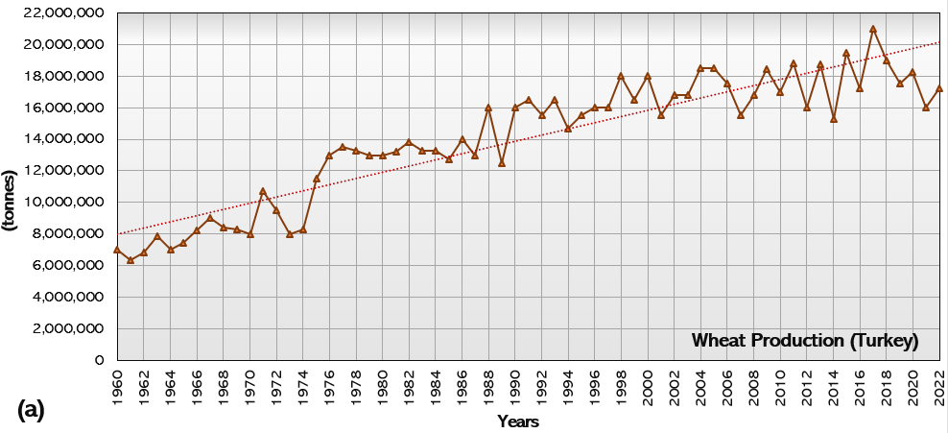
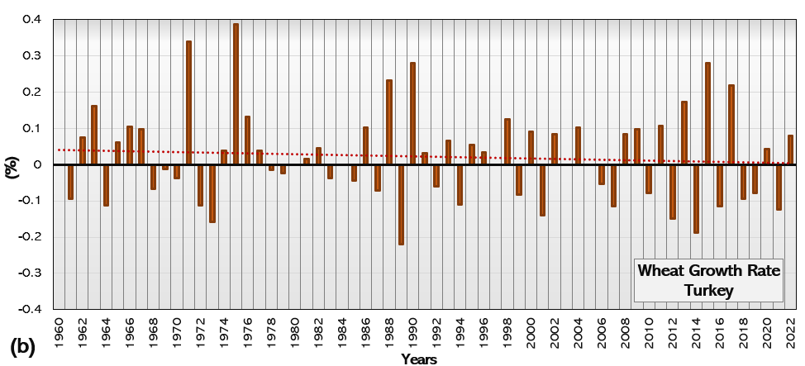
Figure 1. Wheat production in tonnes in Turkey (a) and annual growth rate (b).
Wheat yield decreases under arid and semi-arid climates due to variations in temperature and rainfall patterns. Rising temperatures generally reduce growth time and speed up phenological processes. The length of the growing season was found to be shortened by high temperatures, which in turn reduced wheat output by lowering light interception, grain number, and grain size. For example, a 2 °C increase in temperature and a 35% decrease in precipitation will cause a decline in wheat output of between 12 and 20% in northeastern Turkey between 2040 and 2060 (Vanli and others, 2019).
Various research on wheat crop vulnerability to climate change has been conducted based on GIS. To project the geographic-climatic adaptability of maize, safflower, canola (rape), cotton, wheat, and switchgrass for 2070, for instance, Aydın ve Sarptaş (2018) used a study, and the present and future conditions were compared. To create the climatic suitability maps for each crop for the present and the future, they used the Terrset Climate Change Adaptation Modeler's Crop Climate Suitability Modelling sub-model with climate data from the average of 1950–2000 (for the present) and HADGEM2-ES GCM's RCP 8.5 (for the future). To assess the effects of climate change on wheat in Turkey's southeast, Vanli and others (2019) conducted a study. Data from eight examined farms were used to calibrate and assess the CERES-wheat crop simulation model. Four farms were used for analysis, and the other four for adjustment. For the research sites in Islahiye and Nurdagi, climate change scenarios were created for the middle of the 21st century (2036-2065) and the end of the century (2066-2095) under typical concentration trajectories (RCPs 4.5 and 8.5). The influence of future climate change on rainfed durum wheat, an essential crop in Algeria, was evaluated by Kourat and others (2022). They used the AquaCrop crop model and the downscaled EURO-CORDEX climate predictions with the ICHEC KNMI model under RCP 4.5 and RCP 8.5 to examine the effects of climate change on the rainfed Mexicali wheat cultivar. They used a delta method to fix the uncertainties in two experimental sites in Algeria's Eastern High Plains, Sétif and Bordj Bou Arreridj (BBA), raw climatic forecasts (EHPs). Sharma et al. (2022) studied how the daily maximum temperature (Tmax), daily minimum temperature (Tmin), and rainfall affected the yield of the three main cereal crops in the Southeast United States: corn (Zea mays L.), rice (Oryza sativa L.), and wheat (Triticum aestivum L.). The authors used a fixed-effect model (panel data approach) to apply the production function on panel data from 1980 to 2020 from 11 southeastern United States (SE-US) states.
In addition to some crop suitability models, some climate data sets are used to assess the wheat's future vulnerability, such as Worldclim (Aydın ve Sarptaş, 2018) and Marksim (Dhakal and others, 2018). In the studies, high-resolution climatic data are essential to many questions and applications, mainly in environmental research and ecology (Karger and others, 2017).
A credible prediction of these changes must be based on reliable data on climate-related variables, considering various climate change scenarios. To close the knowledge gaps about the effects of climate change on the Earth system, pertinent climate-related data with high spatiotemporal resolution must be made available for both the current situation and the decades to come (Brun and others, 2022). Since climatologies with high resolution for the Earth's land surface areas are a famous repository for climate data, ecological studies require unique and powerful initiatives like CHELSA (Brun and others, 2022). The Swiss Federal Institute for Forest, Snow and Landscape Research WSL is now hosting the global downscaled climate data collection CHELSA (Climatologies at high resolution for the Earth's land surface areas), which has a very high resolution (30 arcsec, or 1 km). It is continually updated and improved to offer free access to high-resolution climate data for research and application. It has climate layers for various times and conditions, from the Last Glacial Maximum to the present and several possible futures. The freely accessible CHELSA system is based on a mechanical statistical downscaling of global reanalysis data or global circulation model output (CHELSA-climate, 2022).
This study aims to combine the wheat geospatial suitability analysis with high resolution dataset CHELSA for accurate and reliable results for Turkey in future projections because wheat production consists of the fundamental agricultural activities of the country. Therefore, the results are crucial to interpret the future national vulnerabilities, agricultural water usage and agricultural water utilization projections. Subsequently, agricultural water management can be discussed for the country's wheat cultivation activities.
2. Material And Methods
2.1. Database Definition
In this study, geospatial wheat suitability was assessed by Crop Climate Suitability Model (CCSM) with CHELSA climate data as monthly minimum temperature (Tasmin (°C)), monthly mean temperature (Tas (°C)) and monthly total precipitation (Pr) for 2041-2070 period in Turkey.
The study used the CHELSA V2 for the climatic suitability analysis. CHELSA (Climatology at high resolution for the Earth's land surface areas) is a very high resolution (30 arcsec, ~1km) global downscaled climate data set currently hosted by the Swiss Federal Institute for Forest, Snow and Landscape Research WSL. It is built to provide free access to high-resolution climate data for research and application and is constantly updated and refined (Karger and others, 2017; Stefanidis and others, 2022). In the present study, the Coupled Model Intercomparison Project (CMIP)6 scenario was preferred as MPI-ESM1-2-HR in the CHELSA environment.
The Max Planck Institute for Meteorology has a track record of creating adaptable, cutting-edge climate models (Roeckner and others, 1989). MPI climate models support the following research, both within the institute and globally: The model code is freely accessible for academic research and takes part in some group model comparisons, including the Coupled Model Intercomparison Project's impending sixth phase (CMIP6; Eyring and others, 2016; Mauritsen and others, 2019). In addition, the model is used to solve various scientific and practical issues, all of which involve unique computational demands that are mostly determined by the horizontal resolution of the atmosphere and ocean, as well as difficulties in describing processes or occurrences. Five different coupled model setups with a wide range of computing costs (coarse resolution CR, low-resolution LR, higher resolution HR, ocean-eddy resolving ER, and very high-resolution XR) were developed (Mauritsen and others, 2019).
This study selected Shared Socio-economic Pathways (SSP) 1-2.6 for low Greenhouse Gas (GHG) emissions scenario and SSP 3-7.0 for high GHG scenario to integrate the CCSM interface. The SSP1, in this case, stands for Sustainability - Choosing the Green Way. Slowly but surely, the globe is moving toward a more sustainable course, stressing more inclusive development that honours perceived natural constraints. The management of the global commons gradually gets better, expenditures in education and healthcare speed up the demographic change, and the focus turns from economic growth to a broader emphasis on human well-being. Inequality is declining within and within countries, driven by a growing commitment to reaching development goals. Low material growth and low resource and energy intensity are the main goals of consumption (Hausfather, 2018). Around 2075, according to SSP 1-2.6, the CO₂ emissions will be net zero. This scenario projects warming of 1.7°C for 2041 to 2060, 1.8°C for 2081 to 20100, and quite likely between 1.3 and 2.4°C for 2081 to 2100. (IPCC, 2021).
SSP3 stands for Regional Rivalry - A Rocky Road, on the other hand. Countries are being pushed to concentrate more on internal or, at most, regional issues by a resurgence of nationalism, worries about competitiveness and security, and regional conflicts. Over time, policies change to become more focused on global and domestic security issues. Countries prioritize regional growth at the expense of accomplishing their own regions' energy and food security goals. Investments in technological advancement and education are declining. Inequalities endure or worsen over time, spending is materialistic, and economic development is gradual. Population growth is high in emerging nations and low in industrialized countries. Environmental issues receive little international attention, which causes severe environmental degradation in some areas (Hausfather, 2018). By 2100, the CO₂ emissions in SSP 3-7.0 will have doubled. This scenario predicts warming of 2.1°C for 2041 to 2060, 3.6°C for 2081 to 20100, and quite likely between 2.8 and 4.6°C for 2081 to 2100. (IPCC, 2021).
In the study, the current cropland data was also taken as the basis for comparing the results with today. For this, the United Nations Food and Agriculture Organization's (UN FAO) Land Cover Classification System (LCCS) dataset provided by Copernicus Climate Change Service was examined (CDS, 2022). The spatial resolution of this dataset is 300 m, and temporal coverage from 1992 to the present with one year delay (CDS, 2022). In addition, 2020 land use data was downloaded from the dataset and integrated into GIS software for the study. The land use classes listed here are given in Figure 2.
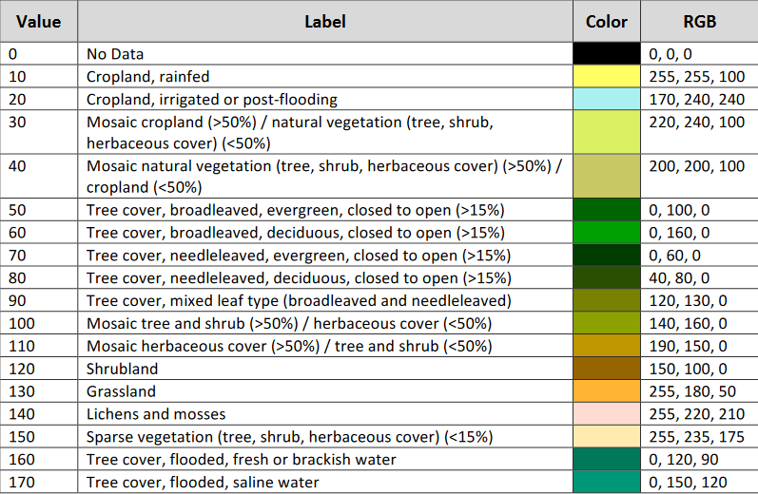
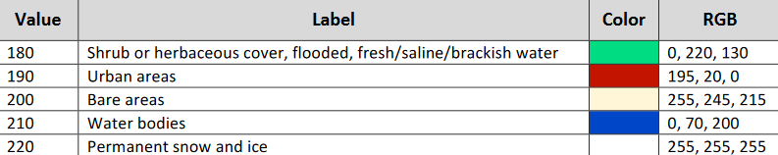
Figure 2. The LC maps ' level 1 (or global) legend based on the UN-LCCS (Source: CCCS, 2021).
In the study, 10. class in Figure 2 were treated as rainfed cropland, and 20. class were treated as irrigated cropland. It is based on the fact that these areas are potential wheat cultivation areas today.
In this study, apart from the above-mentioned 2020 land use data, Global Agro-ecological Zones (GAEZ) data to be evaluated directly as the wheat area was also used. This data is most recently included in the database for the year 2010. GAEZ v4 Data Portal is a portal of the Food and Agriculture Organization (FAO) (see the dataset https://gaez.fao.org/pages/data-viewer-theme-5). The data sub-theme was Actual Yields and Production, and spatial layers have five arc-minute resolutions for 26 major crops/crop groups, separately in rain-fed and irrigated cropland. Country totals are based on FAO statistics for the years 2009-2011. Also included are estimates of the spatial distribution of total crop production value and the production values of major crop groups (cereals, root crops, oil crops), all valued at the year 2000 international prices, separately for rain-fed and irrigated cropland (FAO, 2022). In this study, harvested area value was not taken on a pixel basis as the amount of harvest area; instead, each area where the harvest was made was evaluated as the wheat area on a spatial basis.
2.2. Crop Climate Suitability Modelling (CCSM)
The model used in the study is an analysis method in which temperature and precipitation parameters and plant-based temperature and precipitation requests are used. The model, which is based on the climatic suitability of plants, was applied in DIVA-GIS as a method/model developed by Hijmans and others (2001) in 2001 (Aydın, 2015). Ramirez-Villegas and others (2013) calibrated this model in 2011 (Eastman, 2015; Eitzinger and others, 2018). The model's working principle is that temperature and precipitation suitability on an areal or geographical (spatial) basis are determined separately according to the suitability of the plant for growing (plant ecological demands). As a result, the climatic suitability of the region is calculated according to the determined temperature-precipitation suitability (Aydın ve Sarptaş, 2018).
The plant ecological requirements integrated into the model in the study were Tmin (absolute minimum temperature average), Topmin (optimal minimum temperature average), Topmax (optimal maximum temperature average), and Tmax (absolute maximum temperature average); Pmin (absolute minimum precipitation average), Popmin (optimum minimum precipitation average), Popmax (optimum maximum precipitation average), Pmax (absolute precipitation average), and Tkill (killing temperature) (Aydın, 2015; Aydin ve Sarptas, 2018; Demir ve Aydin-Kandemir, 2022). Climate datasets for SSPs (SSP126 & SSP370 MPI-ESM1-2-HR) include the monthly average minimum temperature (°C) Tmin, monthly average maximum temperature (°C) Tmax, and monthly total precipitation (mm) Ptot for 12 months of the year (for future climate projections) for (Aydın ve Sarptaş, 2018; Demir ve Aydin-Kandemir, 2022) (Figure 3).
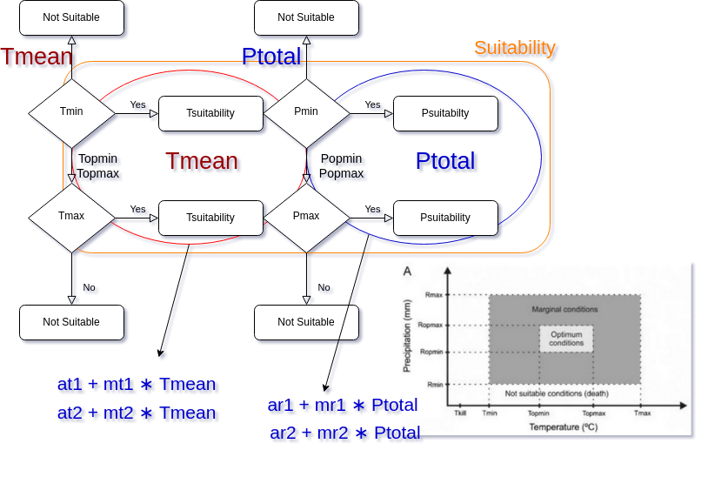
Figure 3. CCSM configuration illustrated via draw.io software in the PARDUS environment.
In Figure 3, if the Tmean value, which is the temperature parameter, falls within the range of Tmin and Tmax, which are the ecological requirements of the plant, the temperature suitability is calculated by the formulas specified in blue. If Tmean falls within the range of Topmin and Topmax, the suitability is 100% for the temperature parameter. Where at1 and mt1 represent the intersection and slope of the regression curve between [Tmin,0] and [Topmin, 100], respectively; at2 and mt2 give the intersection and slope of the regression curve between [Topmax,100] and [Tmax,0], respectively (Laderach ve Eitzinger, 2013; Aydın ve Sarptaş, 2018). The same approach is followed for precipitation. If Ptotal is located between Popmin and Popmax, the precipitation suitability is 100%. Optimum conditions prevail in the region where Tmean and Ptotal are in the optimum temperature and precipitation range, while the maximum temperature and precipitation limit represent marginal conditions. The climatic suitability value is determined by calculating temperature and precipitation suitability separately and multiplying these conformity values (Aydın ve Sarptaş, 2018).
For this investigation, values for the CCSM's plant ecological demand parameters were acquired from the Ecoocrop database. The Food and Agriculture Organization of the United Nations (FAO) created the Ecocrop database in 1992, mainly used to assess a crop's appropriateness for a given environment. This program already has a library of the environmental demands for various crops and species; therefore, it can be used for crops in any place by altering the necessary climatic factors. The creators preserved the whole dataset of these ecological requirements libraries two years ago, despite the fact that this database has been inactive (offline) for several months. Readers can use the R-tool to access these libraries. (ecocrop: Ecocrop Model, 2022; Demir ve Aydin-Kandemir, 2022). Accordingly, the parameters of the ecological requirements for wheat are given in Table 1.
Table 1. Ecocrop-based crop ecological requirements for wheat (ecocrop: Ecocrop Model, 2022).
Wheat (common) - Triticum aestivum L.
T (°C) |  |  |  |  |  | P (mm)
Tkill | Tmin | Topmin | Topmax | Tmax |  | Pmin | Popmin | Popmax | Pmax
0 | 5 | 15 | 23 | 27 |  | 300 | 750 | 900 | 1600
Gmin | Gmax | Gused
90 | 250 | 170
Tkill: absolute temperature that kills the crop
Gmin: minimum days of the growing season
Gmax: maximum days of the growing season
Gused: Average growing season
In the study, the software used to run Crop Climate Suitability Modelling (CCSM) was Terrset, developed by Clark Labs (Eastman, 2015) and the Crop Climate Suitability Model, which is a submodule of the Climate Change Adaptation Modeler (CCAM) here, was used. Terrset software was again used in the analysis of the suitability results. In addition, ArcGIS v2.18 (Environmental Systems Research Institute, 2022) was used to map the results, and the results were mapped based on the GCS global coordinate system and the WGS 84 datum.
3. Results and Conclusion
In this study, using the CHELSA dataset, the spatial suitability of wheat for both SSP126 and SSP370 for the year 2050 (according to the reference 2041-2070) was analyzed by CCSM. The study included separate analyses for the two SSPs. Classes included in the suitability results; (1) Low suitability (0-0.25), (2) Moderate suitability (0.25-0.50), (3) Good suitability (0.50-0.75) and (4) Best suitability (0.75-1.00). In the first stage of the study, the overall CCSM result for SSP 126 is given (Figure 4).
Areas of the suitability classes included in Figure 4, regardless of the land use range throughout the country, Low suitability: 10,980,922 ha, Moderate suitability: 19,585,302 ha, Good suitability: 10,263,250 ha and Best suitability: 1,887,064 ha.
In the study, the results in Figure 4 were subjected to detailed analysis according to the places used as cropland today. The rainfed and irrigated cropland land use classes in the 2020 data from UN-LCCS land use data were taken as the basis. These two land use classes were omitted from the data of all land use classes and coincided with the result in Figure 4.
According to UN-LCCS data, there was 10,769,659 ha of rainfed cropland in Turkey in 2020. Within this area, the areal distribution of suitability classes is 1,622,631 ha for Low suitability, 2,458,536 ha for Moderate suitability, 1,050,285 ha for Good suitability and 196,418 ha for Best suitability. The total suitability scored area constitutes 5,327,870 ha (49.47% of the total rainfed cropland area). The distribution of suitability classes within the rainfed cropland is given in Figure 5.

Figure 4. General CCSM results for 2050 (2041-2070 period) with SSP126-based temperature and precipitation data analysis.
Figure 5. CCSM SSP126 results for wheat in current rainfed cropland areas (2020) (UN-LCCS Class10).

According to Figure 5, the suitability class with the highest area in today's rainfed cropland area is the Moderate suitability class. There are also regions where suitability is in the lower class. Even if these areas are used as rainfed cropland today, about 15% of these areas will be in low availability in the future.
When we look at the irrigated cropland area, the areas of the suitability classes (Figure 6) within a total area of 7,912,470 ha in Turkey are 1,080,357 ha for Low suitability, 1,680,138 ha for Moderate suitability, 618,070 ha for Good suitability and 33,991 ha for Best suitability (3,412,556 ha for all the suitability classes; 43.13% of the total irrigated cropland). Today, according to the results, medium and low suitability are foreseen as a future projection in irrigated cropland areas.
Looking at Figure 6, the future suitability of wheat in the areas used as irrigated cropland today will be medium and low suitability. In the Çukurova region of Adana, it is seen that there are areas in the Good suitability class. According to the SSP 126 projection in 2050, about 13.6% of the areas used as irrigated cropland will remain in low availability.
In the other part of the study, CCSM analyses were performed for SSP 370, a high GHG scenario. Accordingly, regardless of land use classes across the country, the suitability results are revealed in Figure 7. According to Figure 7, for SSP 370, suitability classes with Low suitability 10,672,323 ha, Moderate suitability 17,063,287 ha, Good suitability 10,003,257 ha and Best suitability 1,698,711 ha were formed. When the spatial distributions of these suitability classes are examined according to current rainfed and irrigated croplands, the results are given in Figure 8 and Figure 9.
According to Figure 8, the distributions of the suitability classes of the SSP 370 projection within current rainfed croplands (10,769,659 ha) are 1,499,020 ha for Low suitability, 2,005,437 ha for Moderate suitability, 887,267 ha for Good suitability and 152,415 ha for Best suitability (totally scored suitability area was found as 4,544,139 ha). About 14% of today's rainfed cropland will have low availability here. The area of the best suitable class decreased compared to the SSP 126. It is seen that 42.2% of the total area has a suitability score. This shows that the suitability areas for total rainfed cropland have decreased by half.

Figure 6. CCSM SSP126 results for wheat in current irrigated cropland areas (2020) (UN-LCCS Class20).
Figure 7. General CCSM results for 2050 (2041-2070 period) with analyzing of SSP370-based temperature and precipitation data.

Figure 8. CCSM SSP370 results for wheat in current rainfed cropland areas (2020) (UN-LCCS Class10).
Figure 9. CCSM SSP370 results for wheat in current irrigated cropland areas (2020) (UN-LCCS Class20).

In Figure 9, the results of CCSM analyses according to SSP 370 within current irrigated cropland areas (7,912,470 ha) were 1,071,441 ha for Low suitability, 1,602,784 ha for Moderate suitability, 596,265 ha for Good suitability and 42,746 ha for Best suitability (the total scored area was found as 3,313,236 ha, the 41.9% of the total irrigated cropland area). The amount of low suitable area for today's irrigated croplands in 2050 is 13.54% of the total area. The remarkable result here is that in SSP 370, some of the areas that are Best Suitable (Aydın i.e.) and some of the Good Suitable areas (Muş i.e.) have switched to a lower suitability class when it is compared with SSP 126 (Figure 6).
In addition to all these analyses, wheat suitability was examined with the 2010 wheat harvested areas' spatial data taken from the GAEZ database. The results of this assessment are given in Figure 10 for SSP126 and Figure 11 for SSP370.
In the study, the wheat irrigated harvested area for 2010 was 10,863,596 ha. Within these areas, Low suitability was 1,477,164 ha, Moderate suitability was 2,224,382 ha, Good suitability was 828,261 ha, and Best suitability was 72,745 ha (Figure 10), according to SSP 126. In areas used for irrigated wheat harvesting in 2010, there will be a 13.6% decrease in spatial suitability, according to SSP126, in 2050. Moderate suitable areas will constitute 20.48% of the harvested area. Only 0.67% of the total harvested area will be the best suitable. As a result of the analysis, 4,602,552 ha of the 10,863,596 ha area was scored as a result of the suitability analysis. Other areas have become non-suitable.
The results of SSP370 analyses of the study again contain significant findings for irrigated wheat fields. According to the study results, Low suitability was 1,516,606 ha, Moderate suitability was 1,951,006 ha, Good suitability was 755,402 ha, and Best suitability was 39,394 ha (Figure 11). In the SSP370 results, the best suitability class was reduced by half compared to SSP126. This shows that the spatial suitability will lose a lot of area in the best suitability class according to the high emission scenario. 4,262,408 ha of the total area had a suitability score, which means almost halving the total harvested area of 10,863,596 ha. The total harvested area, in this way, in the future, will have a size in which the spatial suitability of wheat will decrease.

Figure 10. The SSP126-based suitability classes in the 2010 GAEZ database-presented wheat (irrigated) harvested areas.
Figure 11. The SSP370-based suitability classes in the 2010 GAEZ database-presented wheat (irrigated) harvested areas.

Rainfed wheat harvested areas of GAEZ are also evaluated in the study. These areas were integrated into SSP126 and SSP370-based CCSM results, and the suitability classes were examined. The results are given in Figure 12 and Figure 13. Rainfed wheat harvested areas account for a total of 32,115,322 ha. In these areas, the suitability results based on SSP126 are given in Figure 12, and for SSP370 in Figure 13.
According to Figure 12, the suitability classes for rainfed wheat harvested areas are 5,127,271 ha for Low suitability, 7,922,157 ha for Moderate suitability, 3,184,376 ha for Good suitability and 531,977 ha for Best suitability. The total area with the suitability score was 16,765,781 ha, accounting for approximately 52.2% of the total rainfed wheat harvested area in 2010. About half of the harvested areas here have lost their suitability, while about 15.9% have had low availability.
According to Figure 13, the CCSM results according to the SSP370 scenario were 4,518,276 ha for Low suitability, 6,569,163 ha for Moderate suitability, 3,013,308 ha for Good suitability and 489,082 ha for Best suitability. The area with the suitability score accounts for about 45.43% of the total harvested area (14,589,829 ha). Therefore, 54.6% of the total harvest area has wholly lost its suitability.
As seen in this study, the spatial distribution of future suitability within the 2010 wheat harvest area was reduced by almost half for both scenarios. In regions with a spatial suitability score, the suitability is low and moderate. The areas that we call the best suitable areas and where the suitability is between 75%-100% have declined considerably compared to the total area. This situation confines wheat agriculture to a much narrower area compared to today.
Turkish agriculture is sensitive to drought, climate change (Dellal ve McCarl, 2010), and climate change affects the agricultural sector more than other sectors. Here, in cases where the prevention of climate change and the reduction of its effects are inevitable, the thing to do is for farmers to adapt to it (Karakaş, 2022). Climate change adaptation is possible by trying to predict the future of agriculture with climate models and ensuring that measures are taken now with future models.

Figure 12. The SSP126-based suitability classes in the 2010 GAEZ database-presented wheat (rainfed) harvested areas.
Figure 13. The SSP370-based suitability classes in the 2010 GAEZ database-presented wheat (rainfed) harvested areas.

A correct understanding of climate change by farmers is the first step to solving the climate problem. Although there are many studies on climate change adaptation, farmers generally tend to adapt to climate change and change their behaviour when they see a benefit (Asseng ve Pannell, 2013). Similarly, after making a cost-benefit calculation by acting rationally, farmers will take the necessary steps to adapt to the changing conditions if the benefit is above the cost (Karakaş, 2022). In this case, if studies are carried out on the future of crop crops with future models, farmers will be able to rationally evaluate the findings that will emerge as a result of these studies and will be willing to adapt to the foreseen changing conditions or spatial changes.
According to Karakaş (2022), determining farmer intentions is very effective in formulating agricultural policies to reduce national vulnerabilities. For example, a study conducted in Vietnam reported that the high risk of perceived climate change was more effective in helping farmers adapt. In contrast, the denial of the risk of climate change and fatalism reduced farmers' intentions to adapt. Therefore, modelling studies are critical in predicting the future and creating awareness by showing people to eliminate farmers' sense of fatalism, especially climate change.
In this study, analyses were employed on how the spatial suitability of wheat, an important agricultural product plant for our country, will change due to future temperature and precipitation parameters. This study used low and high-emission scenarios, and future spatial suitability was revealed. According to the results of the study, it was seen that the suitability scores will decrease in the regions that are seen as harvested areas today, and even the suitability will disappear in some places. This situation shows that wheat will have national vulnerabilities in the future. It is obvious that the sensitivities about wheat, an important agricultural product plant in the national sense, will affect the country's food security. Furthermore, the situation is not promising for croplands because it was predicted in the study that 58% of these areas would lose their relevance.
The effect of topography and soil on the suitability of the land for the cropping system was not taken into account in this study. Future assessments would produce more detailed and accurate results if they took them into account. Furthermore, by measuring the evapotranspiration potential and available soil water, the irrigation scheduling system (containing irrigation water amount) can be enhanced (Tuan and others, 2011).
As seen in this study, cropland suitability is not constant; fluctuations in regions and suitabilities are anticipated as the climate changes. Climate models and land resource planning tools, like the CCSM approach, give essential insights into how these changes may reallocate the land used to raise various crops and livestock and identify potential effects on productivity and yield gaps (FAO, 2021).
ACKNOWLEDGEMENT
The author prepared this study for the National Agriculture Food Union Association's (UTGB) "System Dynamics in Wheat" research.
REFERENCES
Asseng, S., & Pannell, D.J. (2013). Adapting dryland agriculture to climate change: Farming implications and research and development needs in Western Australia, Climatic Change, 118(2): 167–181.
Aydın, F. (2015). Enerji bitkisi yetiştirilebilecek alanların Coğrafi Bilgi Sistemleri, uzaktan algılama ve Analitik Hiyerarşi Prosesi desteği ile tespiti. (MSc. Dissertation), Ege University, İzmir, Turkey.
Aydın, F., & Sarptaş, H. (2018). İklim değişikliğinin bitki yetiştiriciliğine etkisi: model bitkiler ile Türkiye durumu. Pamukkale University Journal of Engineering Sciences, 24(3), 512-521. doi: 10.5505/pajes.2017.37880.
Aydin, F., Erlat, E., & Türkeş, M. (2020). Impact of climate variability on the surface of Lake Tuz (Turkey), 1985–2016. Regional Environmental Change, 20, 68. https://doi.org/10.1007/s10113-020-01656-z.
Brun, P., Zimmermann, N. E., Hari, C., Pellissier, L., & Karger, D. N. (2022). Global climate-related predictors at kilometer resolution for the past and future. Earth System Science Data, 14, 5573–5603, https://doi.org/10.5194/essd-14-5573-2022.
CDS (2022). Land cover classification gridded maps from 1992 to present derived from satellite observations. https://cds.climate.copernicus.eu/cdsapp#!/dataset/satellite-land-cover?tab=doc Accessed 5 September 2022.
CCCS (2021). Product User Guide and Specification: ICDR Land Cover 2016-2020. ECMWF Copernıcus Report.
CHELSA-climate (2022). Future (CMIP6). https://chelsa-climate.org/cmip6/ Accessed 20 September 2022.
Dellal, İ., & McCarl, B. A. (2010). The economic impacts of drought on agriculture: The case of Turkey. Options Méditerranéennes, 95, 169-174.
Demir, A., & Aydin-Kandemir, F. (2022). Evaluation of Climate Change Impacts on the Geographic Distribution of Fritillaria imperialis L. (Liliaceae) (Turkey). Acta Societatis Botanicorum Poloniae, 91, 919. DOI: 10.5586/asbp.919.
Dhakal, K., Kakani, V., & Linde, E. (2018). Climate Change Impact on Wheat Production in the Southern Great Plains of the US Using Downscaled Climate Data. Atmospheric and Climate Sciences, 8, 143-162. doi: 10.4236/acs.2018.82011.
Eastman, J.R. (2015). TerrSet Manual. Clark University, Worcester, MA, USA.
ecocrop: Ecocrop model. (2022). RDocumentation. https://www.rdocumentation.org/packages/dismo/versions/1.3-3/topics/ecocrop
Eitzinger, A., Carmona, S., Argote, K., Laderach, P., & Jarvis, A. (2018). Climate impacts and resilience in Caribbean agriculture: Assessing the consequences of climate change on cocoa and tomato production in Trinidad & Tobago and Jamaica (CIRCA). https://cgspace.cgiar.org/bitstream/handle/10568/569 80/circawp2presentacionjamaica.pdf?sequence=3&isAll owed=y.
Environmental Systems Research Institute. (2022). ArcGIS pro [Computer software]. https://www.arcgis.com/ Accessed 15 June 2021.
Eyring, V., Bony, S., Meehl, G. A., Senior, C. A., Stevens, B., Stouffer, R. J., & Taylor, K. E. (2016). Overview of the Coupled Model Intercomparison Project Phase 6 (CMIP6) experimental design and organization. Geoscientific Model Development, 9(5), 1937–1958. https://doi.org/10.5194/gmd-9-1937-2016
Fatima, Z., Ahmed, M., Hussain, M., Abbas, G., Ul-Allah, S., Ahmad, S., Ahmed, N., Arif Ali, M., Sarwar, G., ul Haque, E., Iqbal, P., & Hussain, S. (2020). The fingerprints of climate warming on cereal crops phenology and adaptation options. Scientific Reports, 10(1), 1–21. https://doi.org/10.1038/s41598-020-74740-3.
FAO (2021). The State of the World's Land and Water Resources for Food and Agriculture – Systems at breaking point. Synthesis report 2021. Rome. https://doi.org/10.4060/cb7654en.
FAO (2022). Actual Yields and Production. https://gaez-data-portal-hqfao.hub.arcgis.com/pages/theme-details-theme-5 Accessed 2 December 2022.
Giorgetta, M. A., Jungclaus, J., Reick, C. H., Legutke, S., Bader, J., & Böttinger, M., et al. (2013). Climate and carbon cycle changes demo 1850 to 2100 in MPI-ESM simulations for the Coupled Model Intercomparison Project phase 5. Journal of Advances in Modeling Earth Systems, 5, 572–597. https://doi.org/10.1002/jame.20038.
Hausfather, Z. (2018). Explainer: How 'Shared Socioeconomic Pathways' explore future climate change. CarbonBrief, https://www.carbonbrief.org/explainer-how-shared-socioeconomic-pathways-explore-future-climate-change/ Accessed 10 October 2022.
Hijmans, R. J., Guarino, L., Cruz, M., & Rojas, E. (2001) Computer tools for spatial analysis of plant genetic resources data: 1. DIVA-GIS. Plant Genetic Resources Newsletter, 127, 15-19.
Indexmundi. https://www.indexmundi.com/agriculture/?country=tr&commodity=wheat&graph=production Accessed 6 October 2022.
IPCC (2021). Climate Change 2021: The Physical Science Basis-Summary for Policymakers.
Karakaş, G. (2022). Barriers to Climate Change Adaptation of Wheat Producing Farmers; the Case of Çorum Province-Türkiye. Turkish Journal of Agriculture, 10(5): 879-885, 2022 https://doi.org/10.24925/turjaf.v10i5.879-885.5104.
Karger, D. N., Conrad, O., Böhner, J., Kawohl, T., Kreft, H., Soria-Auza, R. W., Zimmermann, N. E., Linder, H. P., & Kessler, M. (2017). Climatologies at high resolution for the Earth's land surface areas. Scientific Data, 4, 170122. DOI: 10.1038/sdata.2017.122.
Kourat, T., Smadhi, D., & Madani, A. (2022). Modeling the Impact of Future Climate Change Impacts on Rainfed Durum Wheat Production in Algeria. Climate, 10, 50, https://doi.org/10.3390/cli10040050.
Laderach, P., & Eitzinger, A. (2013). Ecocrop suitability modeling. Data Analysis Workshop and Adaptation Strategy Development, Arusha, Tanzania, 04-06 June.
MacCracken, M. C. (2008). Prospects for future climate change and the reasons for early action. Journal of the Air & Waste Management Association, 58(6), 735–786. DOI:10.3155/1047-3289.58.6.735.
Mauritsen, T., Bader, J., Becker, T., Behrens, J., Bittner, M., & Brokopf, R., et al. (2019). Developments in the MPI-M Earth System Model version 1.2 (MPI-ESM1.2) and its response to increasing CO₂. Journal of Advances in Modeling Earth Systems, 11, 998–1038. https://doi.org/10.1029/ 2018MS001400.
Ramirez-Villegas, J., Jarvis, A., & Laderach, P. (2013). Empirical approaches for assessing impacts of climate change on agriculture: The EcoCrop model and a case study with grain sorghum. Agricultural and Forest Meteorology, 170, 67-78.
Roeckner, E., Dümenil, L., Kirk, E., Lunkeit, F., Ponater, M., & Rockel, B., et al. (1989). The Hamburg version of the ECMWF model (ECHAM), Tech. Rep. 13. Geneva, Switzerland: World Meteorological Organization.
Sharma, R. K., Kumar, S., Vatta, K., Bheemanahalli, R., Dhillon, J., & Reddy, K. N. (2022). Impact of recent climate change on corn, rice, and wheat in southeastern USA. Scientific Reports, 12, 16928. https://doi.org/10.1038/s41598-022-21454-3.
Stefanidis, S., Alexandridis, V., Spalevic, V., & Mincato, R. L. (2022). Wildfire Effects on Soil Erosion Dynamics: The Case of 2021 Megafires in Greece. Agriculture and Forestry, 68 (2): 49-63. doi:10.17707/AgricultForest.68.2.04.
Tuan, N. T., Jian-jun, Q. I. U., Verdoodt, A., Hu, L. I., & Van Ranst, E. (2011). Temperature and Precipitation Suitability Evaluation for the Winter Wheat and Summer Maize Cropping System in the Huang-Huai-Hai Plain of China. Agricultural Sciences in China, 10(2): 275-288
Vanli, Ö., Ustundag, B. B., Ahmad, I., Hernandez-Ochoa, I. M., & Hoogenboom, G. (2019). Using crop modeling to evaluate the impacts of climate change on wheat in southeastern turkey. Environmental Science and Pollution Research, 26, 29397–29408. https://doi.org/10.1007/s11356-019-06061-6.

Received: 23 December 2022
Accepted: 24 January 2023

