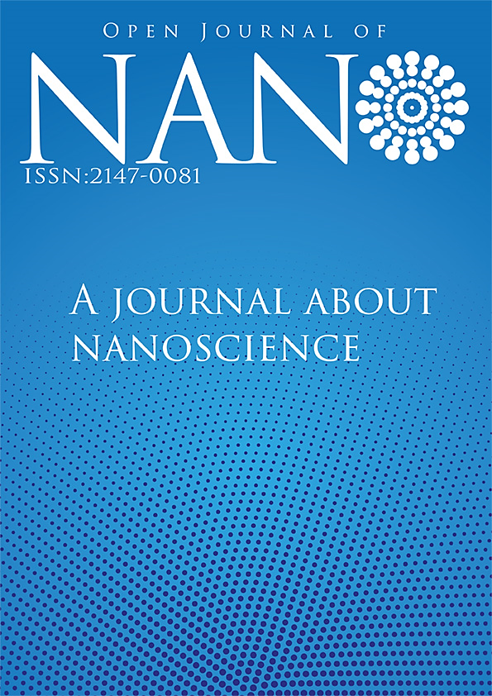
Volume :8, Issue: 2, Year: 2023

  - Volume 8 / Issue 2

Open Journal of Nano

ISSN: 2147-4575

Editor in Chief
Dr. Mustafa CAN, Sakarya University of Applied Sciences, Turkey

mustafacan@subu.edu.tr

Editorial Board

Dr. Mithat ÇELEBİ, Yalova University, Turkey.
mithat.celebi@yalova.edu.tr
Dr. Hamza ŞİMŞİR, Karabuk University, Turkey.
hamzasimsir@karabuk.edu.tr
Dr. Harun GÜL, Sakarya University of Applied Sciences, Turkey.
harungul@subu.edu.tr
Dr. Mustafa Zahid YILDIZ, Sakarya University of Applied Sciences, Turkey.
mustafayildiz@sakarya.edu.tr
Dr. Numan GÖZÜBENLİ, Harran University, Turkey.
gnuman@harran.edu.tr

Dr. Oğuz SARIBIYIK, Gümüşhane University, Gumushane, Turkey.
oysaribiyik@gumushane.edu.tr

Dr. Tuğrul ÇETİNKAYA, Sakarya University, Turkey.
tcetinkaya@sakarya.edu.tr
Dr. Niyaz Mohammad MAHMOODI
Institute for Color Science and Technology, Iran.
mahmoodi@icrc.ac.ir
Dr. Gang Andy SHI
Rice University, USA.
gshi@rice.edu
Dr. Abdülkadir KIZILASLAN,
Sakarya University, Sakarya, Turkey.
akizilaslan@sakarya.edu.tr

Dr. Emrah ÖZAKAR, Ataturk University, Erzurum, Turkey.
emrahozakar@atauni.edu.tr
Dr. Zafer Ömer ÖZDEMİR
University of Health Sciences
Istanbul, Turkey.
emrahozakar@atauni.edu.tr

Field Editors

Dr. Hasan HACIFAZLIOĞLU, İstanbul University-Cerrahpaşa, İstanbul, Turkey.
hasanh@istanbul.edu.tr
Dr. Erol ALVER, Hitit University, Turkey.
erolalver@hitit.edu.tr
Dr. Kamal YUSOH, University Malaysia Pahang, Malaysia.
kamal@ump.edu.my

Dr. Tetiana TEPLA, Lviv Polytechnic National University, Ukraine.
tetiana.l.tepla@lpnu.ua
Dr. Deniz ŞAHİN, Gazi University, Turkey.
dennoka1k@hotmail.com
Dr. Menekşe SAKİR,
Erciyes University,
Nanotechnology Application and Research Center, Erzurum, Turkey.
meneksesarihan@erciyes.edu.tr
Dr. Birgül BENLİ, Istanbul Technical University, Turkey.
benli@itu.edu.tr

  - Volume 8 / Issue 2

Open Journal of Nano

ISSN: 2147-4575

Field Editors

Dr. Mümin Mehmet KOÇ,
Kırklareli University,
Kırklareli, Turkey.
muminmehmetkoc@klu.edu.tr
Dr. Raşit Fikret YILMAZ,
National Defence University, Istanbul, Turkey.
rasitfikretyilmaz@gmail.com
Dr. İrem DENİZ,
Manisa Celal Bayar University, Manisa, Turkey.
iremdenz@gmail.com
Dr. Mahmut YILDIZ,
Gebze Technical University,
Kocaeli, Turkey.
yildizm@gtu.edu.tr
Dr. Mehmet Berat TAŞKIN,
Leibniz Institute for Polymer Research,
Dresden, Germany.
berattaskin@gmail.com
Dr. Maria Taj Muhammad,
Jinnah University for Women,
Karachi, Pakistan.
maariaataj@gmail.com
Dr. Mohamed Mahmoud NASEF,
Universiti Teknologi Malaysia Kuala Lumpur, Kuala Lumpur, Malaysia.
mahmoudeithar@mailcity.com, mahmoudeithar@cheme.utm.my
Dr. Ramzi KHIARI,
Higher Institute of Technological Studies in Ksar-Hellal, Ksar-Hellal, Tunisia.
khiari_ramzi2000@yahoo.fr

Statistics Editor

Dr. Özer UYGUN, Sakarya University, Sakarya, Turkey.
ouygun@sakarya.edu.tr

Language Editors

Dr. Yasin AKGÜL,
Karabuk University, Turkey.
yasinakgul@karabuk.edu.tr
Dr. Tuğrul ÇETİNKAYA,
Sakarya University, Turkey.
tcetinkaya@sakarya.edu.tr
Dr. Abdülkadir KIZILASLAN,
Sakarya University, Sakarya, Turkey.
akizilaslan@sakarya.edu.tr
Dr. Mehmet Berat TAŞKIN,
Leibniz Institute for Polymer Research,
Dresden, Germany.
berattaskin@gmail.com

Dr. Maria Taj Muhammad,
Jinnah University for Women,
Karachi, Pakistan.
maariaataj@gmail.com

  - Volume 8 / Issue 2

Open Journal of Nano

ISSN: 2147-4575

Editorial Assistants

Mücahid SARI, Sakarya University of Applied Sciences, Sakarya, Turkey.
https://dergipark.org.tr/en/pub/@mucahidsari
Engin Deniz PARLAR, Sakarya University of Applied Sciences, Sakarya, Turkey. denizparlar-97@hotmail.com
Nadir ATMACA, The Istanbul Metropolitan Municipality, Istanbul, Turkey.
nadiratmaca@gmail.com
Halid ÖZGÜR, FreshForty Media, Turkey
halid@freshforty.media
Enis AKSOY, Areya illüstrasyon, Sakarya, Turkey
enisaksoy@gmail.com

