Supplement

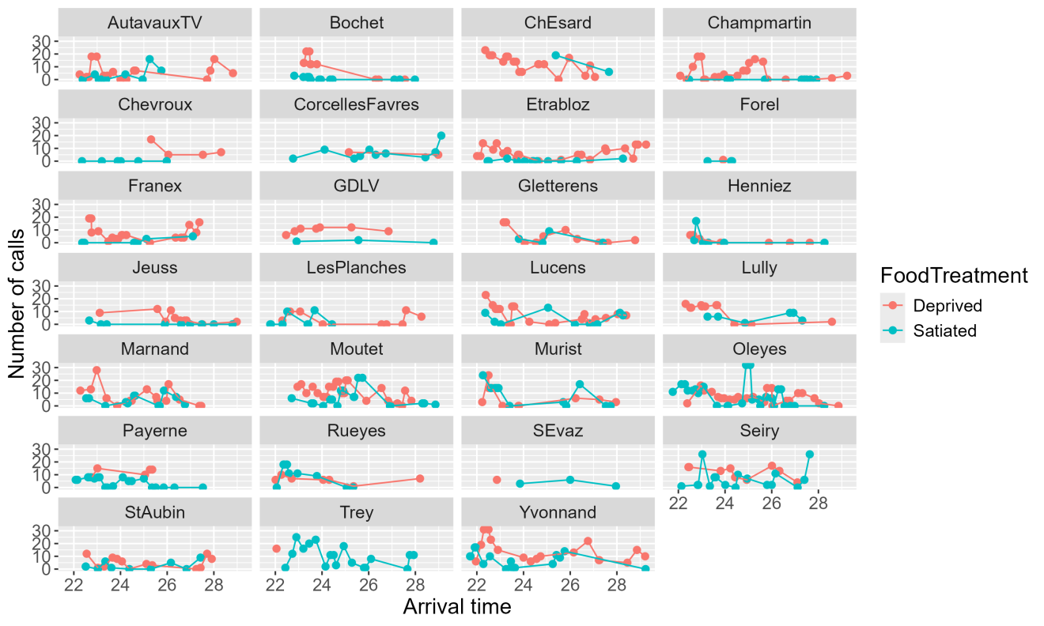

Figure 1.Temporal patterns of sibling negotiation calls.

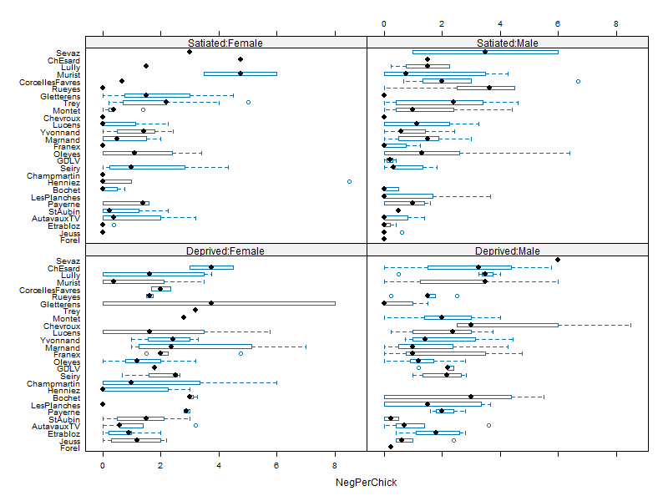

Figure 2.Box plot of negative behaviors per chick by treatment and sex of parent.

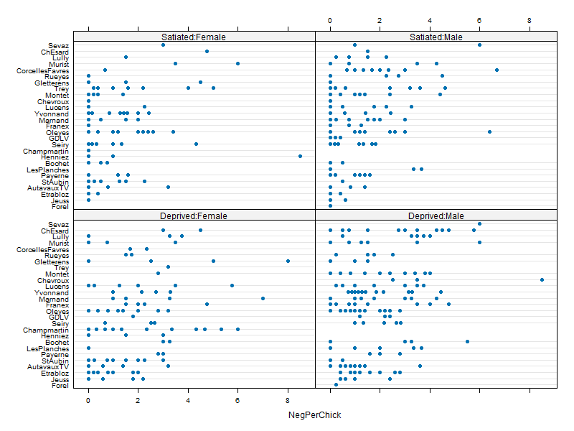

Figure 3.Dot plot of negative behaviors per chick by treatment and sex of parent.

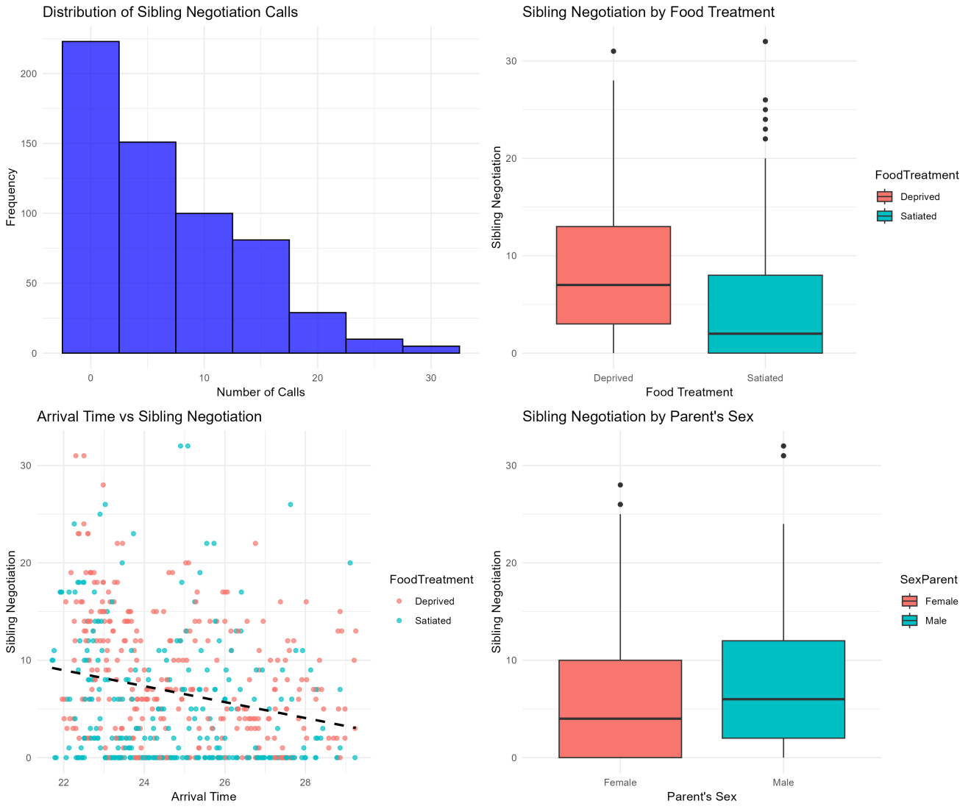

Figure 4.Combined summary of sibling negotiation and parental effects.

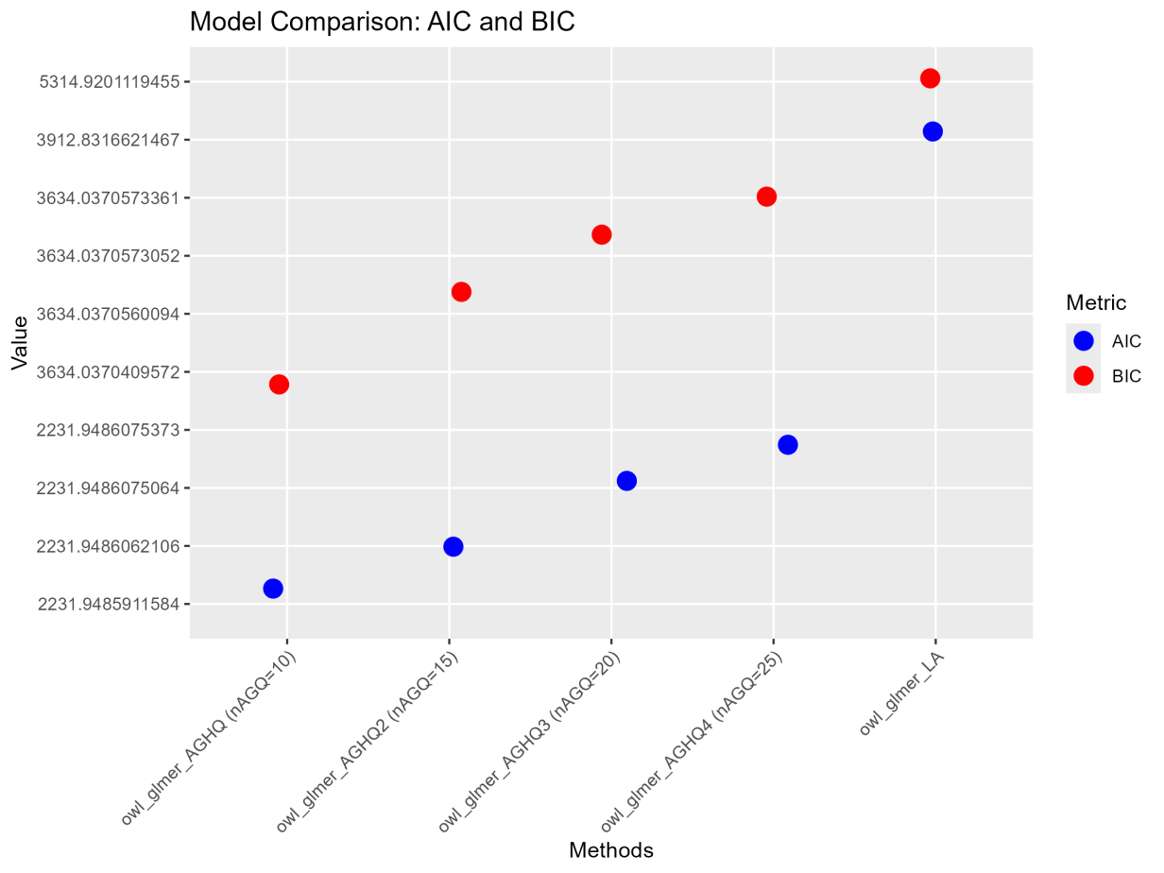

Figure 5**.** Comparison of AIC and BIC metrics for models on owl chicks' begging behavior.

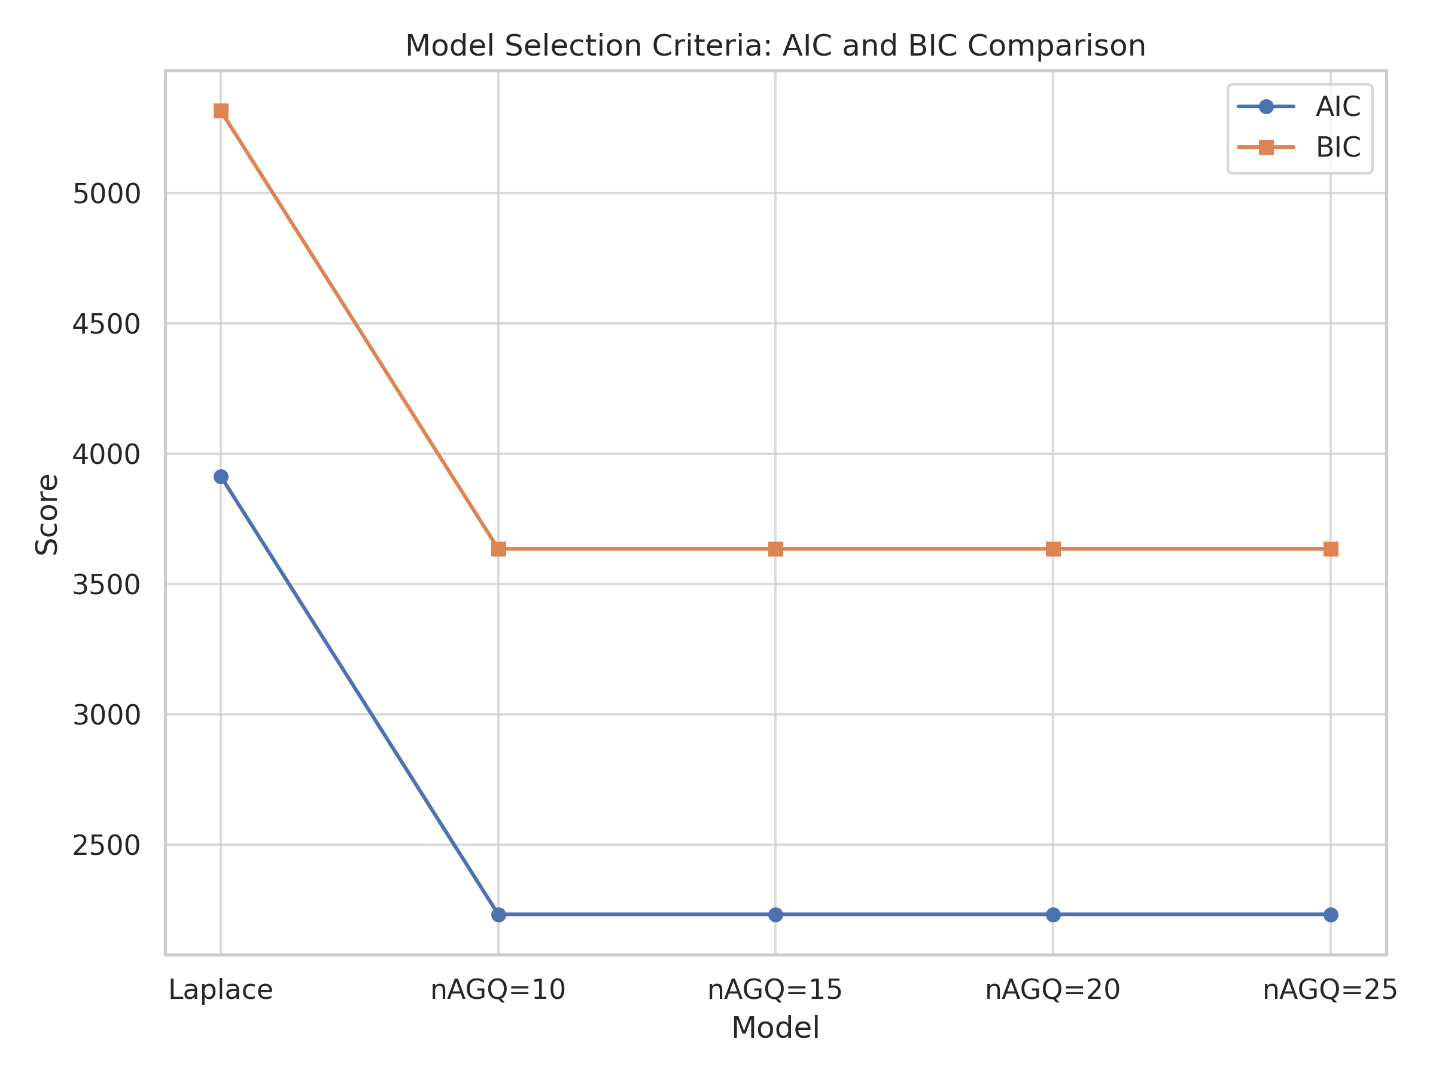

Figure 6**.** AIC and BIC comparison for different model fitting methods.

Table 1.Model results for Laplace approximation.

| **Variable** | **Estimate** | **Std. Error** | **z. value** | **Pr(>|z|)** |
| --- | --- | --- | --- | --- |
| Intercept | -1.54790 | 0.40080 | -3.86204 | 0.00011 |
| Log (Brood Size) | 0.68469 | 0.22015 | 3.11006 | 0.00187 |
| Food Treatment | -0.67366 | 0.05552 | -12.13288 | 0.00000 |
| ArrivalTime23.48 | -2.75630 | 1.06140 | -2.59686 | 0.00941 |
| ArrivalTime24.08 | -0.92798 | 0.44114 | -2.10360 | 0.03541 |
| ArrivalTime25.8 | -0.89584 | 0.38899 | -2.30301 | 0.02128 |
| ArrivalTime26.85 | -0.94379 | 0.40517 | -2.32937 | 0.01984 |
| ArrivalTime27.1 | -1.48646 | 0.47644 | -3.11994 | 0.00181 |
| ArrivalTime28.98 | -1.44874 | 0.52533 | -2.75776 | 0.00582 |
| ArrivalTime29.23 | -1.82770 | 0.66243 | -2.75908 | 0.00580 |
| ${\hat{σ}}_{nest}=$ 0.39309 |  |  |  |  |

Table 2.Model results for nAGQ=10.

| **Variable** | **Estimate** | **Std. Error** | **z. value** | **Pr(>|z|)** |
| --- | --- | --- | --- | --- |
| Intercept | 1.67074 | 0.45851 | 3.64387 | 0.00027 |
| Log (Brood Size) | 0.67588 | 0.22002 | 3.07188 | 0.00213 |
| Food Treatment | -0.66344 | 0.05468 | -12.13311 | 0.00000 |
| ArrivalTime23.48 | -2.74836 | 1.06073 | -2.59101 | 0.00957 |
| ArrivalTime24.08 | -0.92386 | 0.43998 | -2.09977 | 0.03575 |
| ArrivalTime25.8 | -0.86196 | 0.38782 | -2.22260 | 0.02624 |
| ArrivalTime26.85 | -0.93784 | 0.40372 | -2.32299 | 0.02018 |
| ArrivalTime27.1 | -1.47450 | 0.47542 | -3.10147 | 0.00193 |
| ArrivalTime28.98 | -1.41889 | 0.52128 | -2.72191 | 0.00649 |
| ArrivalTime29.23 | -1.83531 | 0.66229 | -2.77113 | 0.00559 |
| ${\hat{σ}}_{nest}=$ 0.39316 |  |  |  |  |

Table 3.Model results for nAGQ=15.

| **Variable** | **Estimate** | **Std. Error** | **z. value** | **Pr(>|z|)** |
| --- | --- | --- | --- | --- |
| Intercept | 1.67111 | 0.45852 | 3.64457 | 0.00027 |
| Log (Brood Size) | 0.67570 | 0.22004 | 3.07084 | 0.00213 |
| Food Treatment | -0.66346 | 0.05468 | -12.13329 | 0.00000 |
| ArrivalTime23.48 | -2.74771 | 1.06041 | -2.59118 | 0.00956 |
| ArrivalTime24.08 | -0.92383 | 0.43998 | -2.09971 | 0.03575 |
| ArrivalTime25.8 | -0.86211 | 0.38782 | -2.22296 | 0.02622 |
| ArrivalTime26.85 | -0.93790 | 0.40372 | -2.32311 | 0.02017 |
| ArrivalTime27.1 | -1.47458 | 0.47542 | -3.10161 | 0.00192 |
| ArrivalTime28.98 | -1.41903 | 0.52130 | -2.72213 | 0.00649 |
| ArrivalTime29.23 | -1.83538 | 0.66231 | -2.77118 | 0.00559 |
| ${\hat{σ}}_{nest}=$ 0.39320 |  |  |  |  |

Table 4.Model results for nAGQ=20.

| **Variable** | **Estimate** | **Std. Error** | **z. value** | **Pr(>|z|)** |
| --- | --- | --- | --- | --- |
| Intercept | 1.67111 | 0.45852 | 3.64457 | 0.00027 |
| Log (Brood Size) | 0.67570 | 0.22004 | 3.07084 | 0.00213 |
| Food Treatment | -0.66346 | 0.05468 | -12.13329 | 0.00000 |
| ArrivalTime23.48 | -2.74771 | 1.06041 | -2.59118 | 0.00956 |
| ArrivalTime24.08 | -0.92383 | 0.43998 | -2.09971 | 0.03575 |
| ArrivalTime25.8 | -0.86211 | 0.38782 | -2.22296 | 0.02622 |
| ArrivalTime26.85 | -0.93790 | 0.40372 | -2.32311 | 0.02017 |
| ArrivalTime27.1 | -1.47458 | 0.47542 | -3.10161 | 0.00192 |
| ArrivalTime28.98 | -1.41903 | 0.52130 | -2.72213 | 0.00649 |
| ArrivalTime29.23 | -1.83538 | 0.66231 | -2.77118 | 0.00559 |
| ${\hat{σ}}_{nest}=$ 0.39320 |  |  |  |  |

Table 5.Model results for nAGQ=25.

| **Variable** | **Estimate** | **Std. Error** | **z. value** | **Pr(>|z|)** |
| --- | --- | --- | --- | --- |
| Intercept | 1.67111 | 0.45852 | 3.64457 | 0.00027 |
| Log (Brood Size) | 0.67570 | 0.22004 | 3.07084 | 0.00213 |
| Food Treatment | -0.66346 | 0.05468 | -12.13329 | 0.00000 |
| ArrivalTime23.48 | -2.74771 | 1.06041 | -2.59118 | 0.00956 |
| ArrivalTime24.08 | -0.92383 | 0.43998 | -2.09971 | 0.03575 |
| ArrivalTime25.8 | -0.86211 | 0.38782 | -2.22296 | 0.02622 |
| ArrivalTime26.85 | -0.93790 | 0.40372 | -2.32311 | 0.02017 |
| ArrivalTime27.1 | -1.47458 | 0.47542 | -3.10161 | 0.00192 |
| ArrivalTime28.98 | -1.41903 | 0.52130 | -2.72213 | 0.00649 |
| ArrivalTime29.23 | -1.83538 | 0.66231 | -2.77118 | 0.00559 |
| ${\hat{σ}}_{nest}=$ 0.39320 |  |  |  |  |

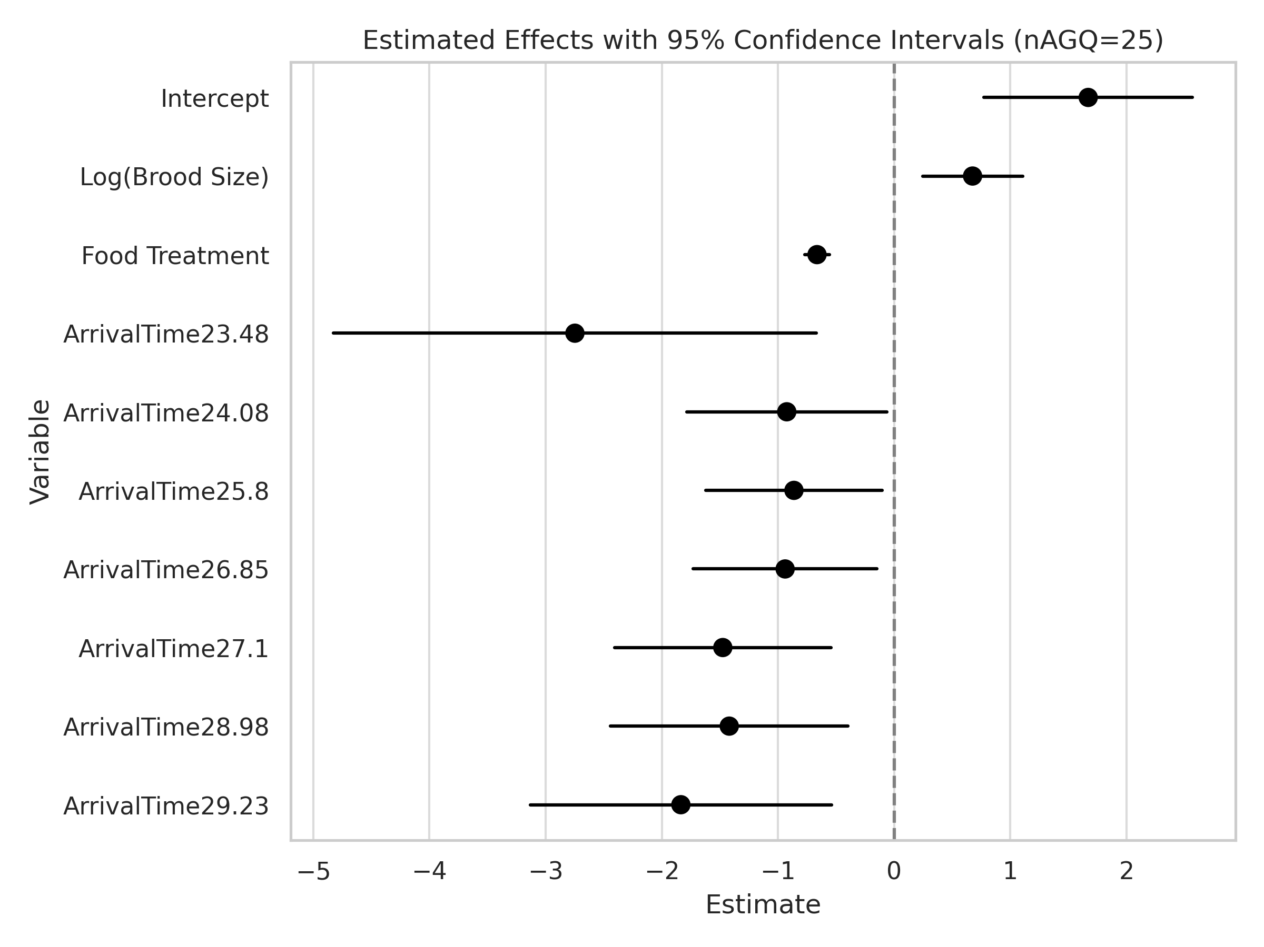

Figure 7**.** Estimated effects of predictors on owl nestling call behavior using nAGQ=25.

Table 6.Comparison of AIC, BIC, and Log-Likelihood for different GLMM models.

| **Model** | **AIC** | **BIC** | **Log-Likelihood** |
| --- | --- | --- | --- |
| owl_glmer_LA | 3912.8316621467 | 5314.9201119455 | -1637.4158310734 |
| owl_glmer_AGHQ (nAGQ=10) | 2231.9485911584 | 3634.0370409572 | -796.9742955792 |
| owl_glmer_AGHQ2 (nAGQ=15) | 2231.9486062106 | 3634.0370560094 | -796.9743031053 |
| owl_glmer_AGHQ3 (nAGQ=20) | 2231.9486075064 | 3634.0370573052 | -796.9743037532 |
| owl_glmer_AGHQ4 (nAGQ=25) | 2231.9486075373 | 3634.0370573361 | -796.9743037687 |