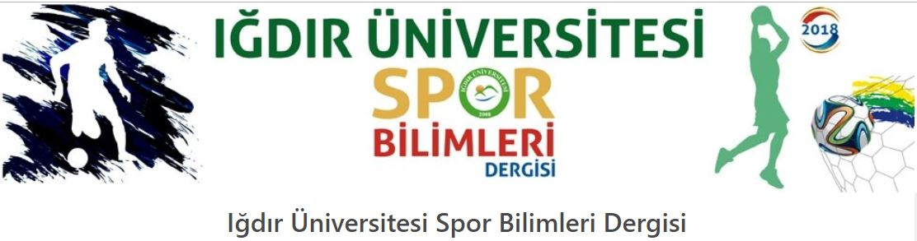
http://dergipark.gov.tr/igdirsbd
İÇİNDEKİLER CONTENTS
CİLT 5, SAYI 1, ARALIK 2022 VOLUME 5, ISSUE 1, DECEMBER 2022

DERLEME MAKALELERİ RESEARCH ARTICLES

2020 SONRASI SPORDA YETENEK SEÇİMİNDE ULAŞILAN NOKTA VE TEMEL TARTIŞMALAR
ACHIEVED POINT AND BASIC DISCUSSIONS IN TALENT SELECTION IN SPORTS AFTER 2020
Gülhan Erdem SUBAK, Recep Sürhat MÜNİROĞLU, Kaan KAYA …………………………………….1-11

ARAŞTIRMA MAKALELERİ RESEARCH ARTICLES
BASKETBOL VE FUTBOL SPOR OKULLARINDAKİ SPORCULARININ FAİR PLAY ANLAYIŞLARININ KARŞILAŞTIRILMASI
COMPARISON OF FAIR PLAY APPROACHES OF ATHLETES IN BASKETBALL AND FOOTBALL SPORTS SCHOOLS
Cüneyt SEYDİOĞLU, İhsan YAĞCI…………………………………………………………12-22

