TITLE

ABSTRACT
The abstract should briefly state the main objective of the research, indicate the methodology used, and present the main conclusions and should not exceed 250 words. The abstract and title also should not contain any mathematical formulas.
Keywords:
A list of 4–6 keywords should be provided and should express the precise content of the manuscript. Keywords should be aligned to the left and should be written with lowercase letters. Keywords must be separated by commas and contain no abbreviations.

INTRODUCTION
The introduction should include the aim and scope of the study, the reasons for consideration, the literature on the study objectives and outcomes, and the study hypothesis. Specific terms and concepts other than general terms should be explained by authors. Authors should refer the results of previous studies to support the hypotheses. The introduction should not be a review of the subject area. Primarily, the articles published in the last decade should be cited for this section. The introduction should end with a statement including the purpose of the study and its general and specific objectives. This section should not contain the results of the study.

MATERIALS AND METHODS
Materials and methods should describe every aspect of the experiment, in a level of detail enabling the reader to repeat the experiments, and related literature should be cited. If established methods were used without changes, the reference that is the first published article about that method should be cited. If the standard techniques were modified, then the changes should be described.
Subheadings
Subheadings can be used to separate different methodologies if desired and should be written in italics with the first letter capitalized.

RESULTS
The results section should report the results of all experiments performed during the study without interpretation. The main goal of the results is to enable narrative support for the tables and figures in which the actual results of the experiments are reported. Results that are not included in figures and tables should also be written in this section. The results should not contain any in-text citations. Also, neither materials and methods nor discussion should be included in this section. Results and discussions can either be combined into one section under the heading of “Results and Discussion” which is encouraged for the short manuscripts.
Subheadings
Subheadings can be used for Results section if desired and should be written in italics with the first letter capitalized.

DISCUSSION

In the discussion section, researchers should discuss the implications of the results by comparing those with the published literature. The discussion section should also provide interpretations for readers by taking into consideration the literature review and purpose statement presented in the introduction. Authors should provide some conclusions without repeating the study findings. Figures and tables should not be referred in this section. The points underlined in the Discussion should be in correspond with the title of the manuscript. The final paragraph should emphasize the main conclusions of the study including recommendations for future research.

ACKNOWLEDGMENT
Persons and institutions that support the research should be given by specifying the subjects they contribute. If the research is a full or a part of the thesis, this should be stated in this section. Whether the abstract is published in a scientific meeting (congress, symposium, etc.) should also be written in this section.

REFERENCES
Sources in the text should be cited in the original language. ‘and’ and ‘et al.’ (no extra comma) should be used to cite a publication with two authors and three or more authors respectively (e.g. Disney et al. (2008), Kansu et al. (2005)). Lowercase letters should be used after the publication date for references that have same authors and same publications date (e.g. Kansu 2002a, 2002b).

Citation in text
All references cited in the text should be written in alphabetical order, then in chronological order from most recent to oldest. Examples of literature publications are given below;

Rule for single author:
At the end of the sentence: ………...(Alkan 2017, Evlice 2018, FAO 2013, Anonim 2008).
At the beginning of the sentence: Alkan (2017) ……………… TUIK (2014)……….

Rule for two authors:
At the end of the sentence: ………..(Evlice and Alkan 2018, Wesemael and Moens 2016).
At the beginning of the sentence: Evlice and Alkan (2018)….…, Wesemael and Moens (2016).....

Rule for three or more authors:
At the end of the sentence: ……….(Evlice et al. 2018, Wesemael et al. 2016).
At the beginning of the sentence: Alkan et al. (2018)….… Wesemael et al. (2016)…….

If more than one literature is written as a group, the sources should be ordered first alphabetically and then further sorted chronologically.
……..(Alkan 2016a, 2016b, 2017; Evlice ve Alkan 2018)

Reference List:
The references should be ordered first alphabetically and then further sorted chronologically. More than one reference by an author in the same year should be distinguished in order of publication using a lower-case letter after the year of publication. Examples of different kinds of literature are given below. The title of a journal should be written explicitly.

Journal articles:
Evlice E., Ökten M. E., 2008. Ankara ili armut (Pyrus communis L.) bahçelerinde saptanan Tylenchida (Nematoda) takımına ait bitki paraziti nematodlar. Bitki Koruma Bülteni, 48 (4), 1-8.
Alkan M., Gökçe A., Kara K., 2017. Bazı bitki ekstraktlarının Patates böceği (Coleoptera: Chrysomelidae) üzerindeki mide zehiri etkileri. Bitki Koruma Bülteni, 57 (3), 305-315.

Books:
Smith D., Onions A.H.S., 1994. The preservation and maintenance of living fungi. CAB International, Bakeham Lane Egham, 112 p.

Book chapters:
Scurrah M.I., Niere B., Bridge J., 2005. Nematode parasites of Solanum and sweet potatoes. In: Plant parasitic nematodes in subtropical and tropical agriculture. Luc, M., Sikora, R.A., Bridge, J. (Eds.). CABI Publishing, London, 193-219 p.

Thesis or Dissertations:
Ulutaş E., 2010. Ege Bölgesi Patates Üretim Alanlarında Bulunan Önemli Bitki Paraziti Nematodların Belirlenmesi ve Bitki Gelişimine Etkileri. Ege Üniversitesi Fen Bilimleri Enstitüsü, Basılmamış Doktora Tezi, 92 s., Bornova, İzmir.

Electronic sources:
EPPO, 1996. Occurrence of Meloidogyne chitwoodi in Germany. Reporting Service No. 11, 96/205. https://archives.eppo.int/EPPOReporting/1996/Rse-9611.pdf (Date accessed 14.04.2014).

FIGURES AND TABLES
Each of the figures and tables includes in the manuscript must be referred to the text and should be placed on a separate page. Captures should indicate the figures and tables regardless of the text. Full scientific names should be written in figures and charts (Tuta absoluta). Punctuation should be avoided at the end of the captions of figure and tables. A point should be used as a decimal separator (e.g. 1.25 instead of 1,25). The degree symbol should be written with no spaces between the symbol and the letters (°C). The percent sign and the number should not be separated by space (%100). There should be a space between the numerical value and unit symbol (10 cm).
The figures should be in jpg format, and the resolution should be at least 120 pixels. All figures, tables, and graphics contained in the manuscript should be prepared as a separate file and submitted with the text.
After all, is selected and grouped, they should be added as "picture" into the Word document. If the modification of the figure is desired, all changes should be made in the Powerpoint document then should be moved into the Word document.
ALL ILLUSTRATIONS IN THE MANUSCRIPT MUST BE UPLOADED IN THE SYSTEM

TABLES
Table 1. Mortality races causing different concentrations of Trans-Anethole at 25°C, %65 RH for 72 hours
Treatment | Mortality (%)±SE
 | T. castaneum | R. dominica | S. oryzae
2.0 ml/l | 47.62±0.16a* | 100.00±0.00a | 100.00±0.00a
2.5 ml/l | 23.53±0.66b | 100.00±0.00a | 100.00±0.00a
3.0 ml/l | 47.37±0.57a | 100.00±0.00a | 100.00±0.00a
3.5 ml/l | 26.67±0.09b | 100.00±0.00a | 100.00±0.00a
4.0 ml/l | 2.11±0.19c | 100.00±0.00a | 100.00±0.00a
5.0 ml/l | 6.25±0.00c | 100.00±0.00a | 100.00±0.00a

*Different letters within the same column are statistically significant (Tukey test, P<0,05). SE: Standart error.
Table 2. Toxic effect of Trans-Anethole on Sitophilus oryzae and Rhyzopertha dominica at 25°C, %65 RH for 72 hours
Species | Slope±SE* | LC₅₀ ml/l  (Confidence intervals) | LC₉₉ ml/l  (Confidence intervals)
S. oryzae | 2.081±0.282 | 1.414  (1.319-1.530) | 2.533  (2.257-2.999)
R. dominica | 2.283±0.331 | 1.272  (1.179-1.360) | 2.291  (2.059-2.697)

*Standard error
FIGURES
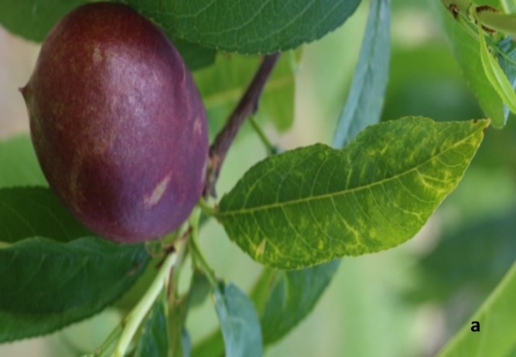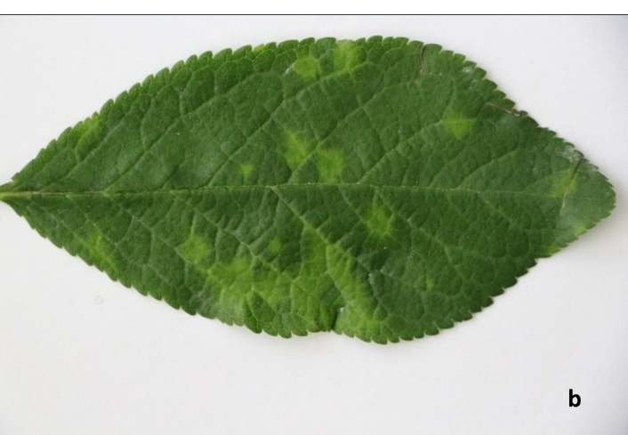
Figure 1. a) PPV-infected nectarine leaves showing vein yellowing and deformity, b) PPV-infected plum leaves showing chlorotic ring patterns

Temperature (^{O}C)-Relative humidity (%)

Adult/Trap
Figure 2. The adult populations of Archips rosana and Pandemis cerasana in the peach orchard in Yapildak village (Central district) in 2012
PLANT PROTECTION BULLETIN
ABBREVITIONS
Some of the abbreviations that can be used in the artizle for Plant Protection Bulletin are given below. If the scientific terms are not included in this table, abbreviations that are frequently used for institutions, organizations and place names should be preferred. The Système International d’Unités, (IS units)” should be used for all units as a measurement system. Abbreviations for institutions, organisations and place names can be accessed from the "Turkish Language Association" web page (http://www.tdk.gov.tr/index.php?option=com_content&id=198:Kisaltmalar). Abbreviations other than those should be used only when a case can be made for necessity, such as terms that are extremely long and can cause repetition in the manuscript. Each abbreviation should be defined and introduced in parentheses the first time it is used then these abbreviations should be used in related places. Abbreviations should not be used in the title.

Some international abbreviations:
Tanım / Description | Kısaltma / Abbrevition
Adenin | A
Adenosine triphosphate | ATP
Amper | A
amplified fragment length polymorphism | AFLP
Angstrom ( = 0.0001 of a micron) | A
base pair / baz çifti | bp
bovine serum albumine | BSA
calorie | cal
Candidatus | Ca.
centiliter | cl
centimeter | cm
colony forming units | CFU
complementary DNA | cDNA
complementary RNA | cRNA
cubic kilometer | km³
cubic meter | m³
cubic millimeter | mm³
cytochrome | cyt
cytosine / sitozin | C
dakika | dk.
Dalton | Da
day | d
decare / dekar | da
deciliter | dl
decimeter | dm
deoxyribonucleic acid / deoksiribonükleik asit | DNA
deoxyribonuclease | Dnase
deoxynucleotide-triphosphates | dNTPs
desilitre | dl
desimetre | dm
desimetrekare | dm²
desimetreküp | dm³
dimethyl sulfoxide | DMSO
double-stranded DNA / çift sarmallı DNA | dsDNA
double-stranded RNA / çift sarmallı RNA | dsRNA
Electron microscope / Elektron mikroskop | EM
enzyme linked immuno sorbent assay | ELISA
ethidium bromide | EtBr
ethylenediaminetetraacetic acid | EDTA
extracellular polymeric substance | EPS
fatty acid methyl ester | FAME
fluorescein isothiocyanate | FITC
Gibberellic acid | GA
gram | g
Guanin / Guanine | G
hectare / hektar | ha
hectoliter / hektolitre | hl
hectometer / hektometre | hm
high pressure liquid chromatography | HPLC
hour | h
immuno fluorescent antibody staining | IFAS
Immunoglobulin A | IgA
Immunoglobulin G | IgG
Immunoglobulin M | IgM
indole—3— acetic acid | IAA
internal transcribed spacer | ITS
international unit | IU
kilobase / kilobaz | kb
kilocalorie / kilokalori | kcal
kilodalton | kDa
kilogram | kg
kilohertz | KHz
kilometer / kilometre | km
kilometrekare | km²
kilometreküp | km³
kilopascal | kPa
Lethal Dose | LD
Lethal Dose %50 | LD₅₀
Liquid Chromatography | LC
litre / liter | l
loop-mediated amplification | LAMP
logarithm | log
lumen | lm
lux | lx
matrix assisted laser desorption ionization-time of flight mass spectrometry | MALDI-TOF MS
maximum | max
messenger RNA | mRNA
meter / metre | m
metrekare | m²
metreküp | m³
micro / mikro | µ
microgram / mikrogram | µg
micrometer / mikrometre | µm
micromole / mikromol | µmol
microliter / mikrolitre | µl
miliamper / milliamper | mA
milibar / millibar | mbar
miligram / milligram | mg
millimeter / milimetre | mm
milimetrekare | mm²
milimetreküp | mm³
milimetre-civa | mm-Hg
milimolar / millimolar | mM
milyonda kısım | ppm
minimum | min
minimal inhibitory concentration | MIC
minute | min
molarity | M
molecular weight | MW
monoclonal antibody | Mab
multilocus sequence typing | MLST
nanometer / nanometre | nm
nanomole / nanomol | nmol
nicotinamide adenine dinucleotide | NAD
nicotinamide adenine dinucleotide phosphate | NADP
nicotinamide adenine dinucleotide phosphate oxidized | NADP⁺
nicotinamide adenine dinucleotide reduced | NADH
nicotinamide adenine dinucleotide phosphate reduced | NADPH
normalite | N
number | No.
optical density | OD
örnek | ör.
pascal | Pa
phosphate-buffered saline | PBS
picogram | pg
picomole | pmol
polyacrylamide gel electrophoresis | PAGE
polymerase chain reaction | PCR
pounds per square inch | psi
random amplified polymorphic DNA | RAPD
real-time polymerase chain reaction | RT PCR
relative humidity | RH
restriction fragment length polymorphism | RFLP
reverse transcription-polymerase chain reaction | RT-PCR
ribonuclease | RNase
ribonucleic acid / ribonükleik asit | RNA
ribosomal RNA | rRNA
Your | h
saniye | sn.
degree Celcius | ⁰C
centimeter | cm
Square centimeter | cm²
cubic centimeter | cm³
second | s
sequence characterized amplified Rregion | SCAR
simple sequence repeat | SSR
single nucleotide polymorphism | SNP
small interfering RNA | siRNA
sodium dodecyl sulfate | SDS
square centimeter | m²
square decimeter | dm²
square kilometer | km²
square meter | m²
square millimeter | mm²
standard atmosphere | atm
Thermus aquaticus | Taq
technical atmosphere | at
thin layer chromatography | TLC
thymine / timin | T
transfer RNA | tRNA
tris(hydroxymethyl)aminomethane | tris
ton | t
ultraviole / ultraviolet | UV
unit | U
uracil / urasil | U
ve benzeri, ve benzerleri | vb.
ve devamı, ve diğerleri | vd.
versus | vs
volt | V
volume | vol
watt | W
week | wk
weight | wt
year | yr
yüzyıl | yy

Reminders:
- Full scientific names should be written in the title of the manuscript.
- Scientific names of bacteria, fungi, viruses, nematodes and invertebrate organisms should be written in italics.
- 'http://www.apsnet.org/publications/commonnames/Pages/default.aspx' can be used for common English names for plant diseases.
- Invertebrate organism names should be written in accordance with the International Code of Zoology Nomenclature (http://www.iczn.org/iczn/index.jsp). Full scientific names should be written with the author name and date in the first time it is used by placing genus and family in parenthesis (e.g. Ceratitis capitata (Wiedemann, 1824) (Diptera: Tephritidae), Megachile anatolica Rebmann, 1968 (Hymenoptera: Megachilidae)). After the first writing of the scientific names, they should be given in abbreviated form, except for figure and table headings (e.g. C. capitata, M. anatolica).
- Full scientific names of the nematodes should be written with the author's name for the first time it is used (e.g. Meloidogyne chitwoodi, Globodera pallida). After the first writing, they should be given in abbreviated form, except for figure and table headings (e.g. M. chitwoodi, G. pallida). For author names of plant parasitic nematodes, 'http://www.nce.nu/pages/nomenclature/search.html' link can be used. ‘https://www.eppo.int/QUARANTINE/diag_activities/EPPO_TD_1056_Glossary.pdf' is also available for morphological terms used in nematology.
- The scientific name of the bacterium should be written in accordance with ‘Approved Lists of Bacterial Names’ (http://www.bacterio.net/-alintro.html). Full scientific names of the bacteria and fungi should be written with the author's name in the first time it is used (e.g. Agrobacterium tumefaciens (Smith and Townsend) Conn, Venturia inaequalis Cooke (Wint.), Rhizoctonia solani Kühn). After the first usage of the scientific name, they should be given in abbreviated form, except for figure and table headings (e.g. A. tumefaciens, V. inaequalis, R. solani).
- Virus names should be written in italics (e.g., Potato Y virus, Alfalfa mosaic virus) and should be those approved by the International Committee on Taxonomy of Viruses (ICTV) (http://www.ictvonline.org/virusorthography.asp).
- The term "Candidatus" used for non-culturable bacteria and phytoplasmas should be written in italic, and the following genus and species name should be written in non-italic (e.g. Candidatus Phytoplasma solani, Candidatus Liberibacter solanacearum). After the first usage of the scientific name, they should be given in abbreviated form, except for figure and table headings (e.g. Ca. Phytoplasma solani, Ca. Liberibacter solanacearum). The term ‘phytoplasma' should be used instead of ‘mycoplasma’ or ‘mycoplasma-like organisms’.

