 | International Journal of Chemistry and Technology | 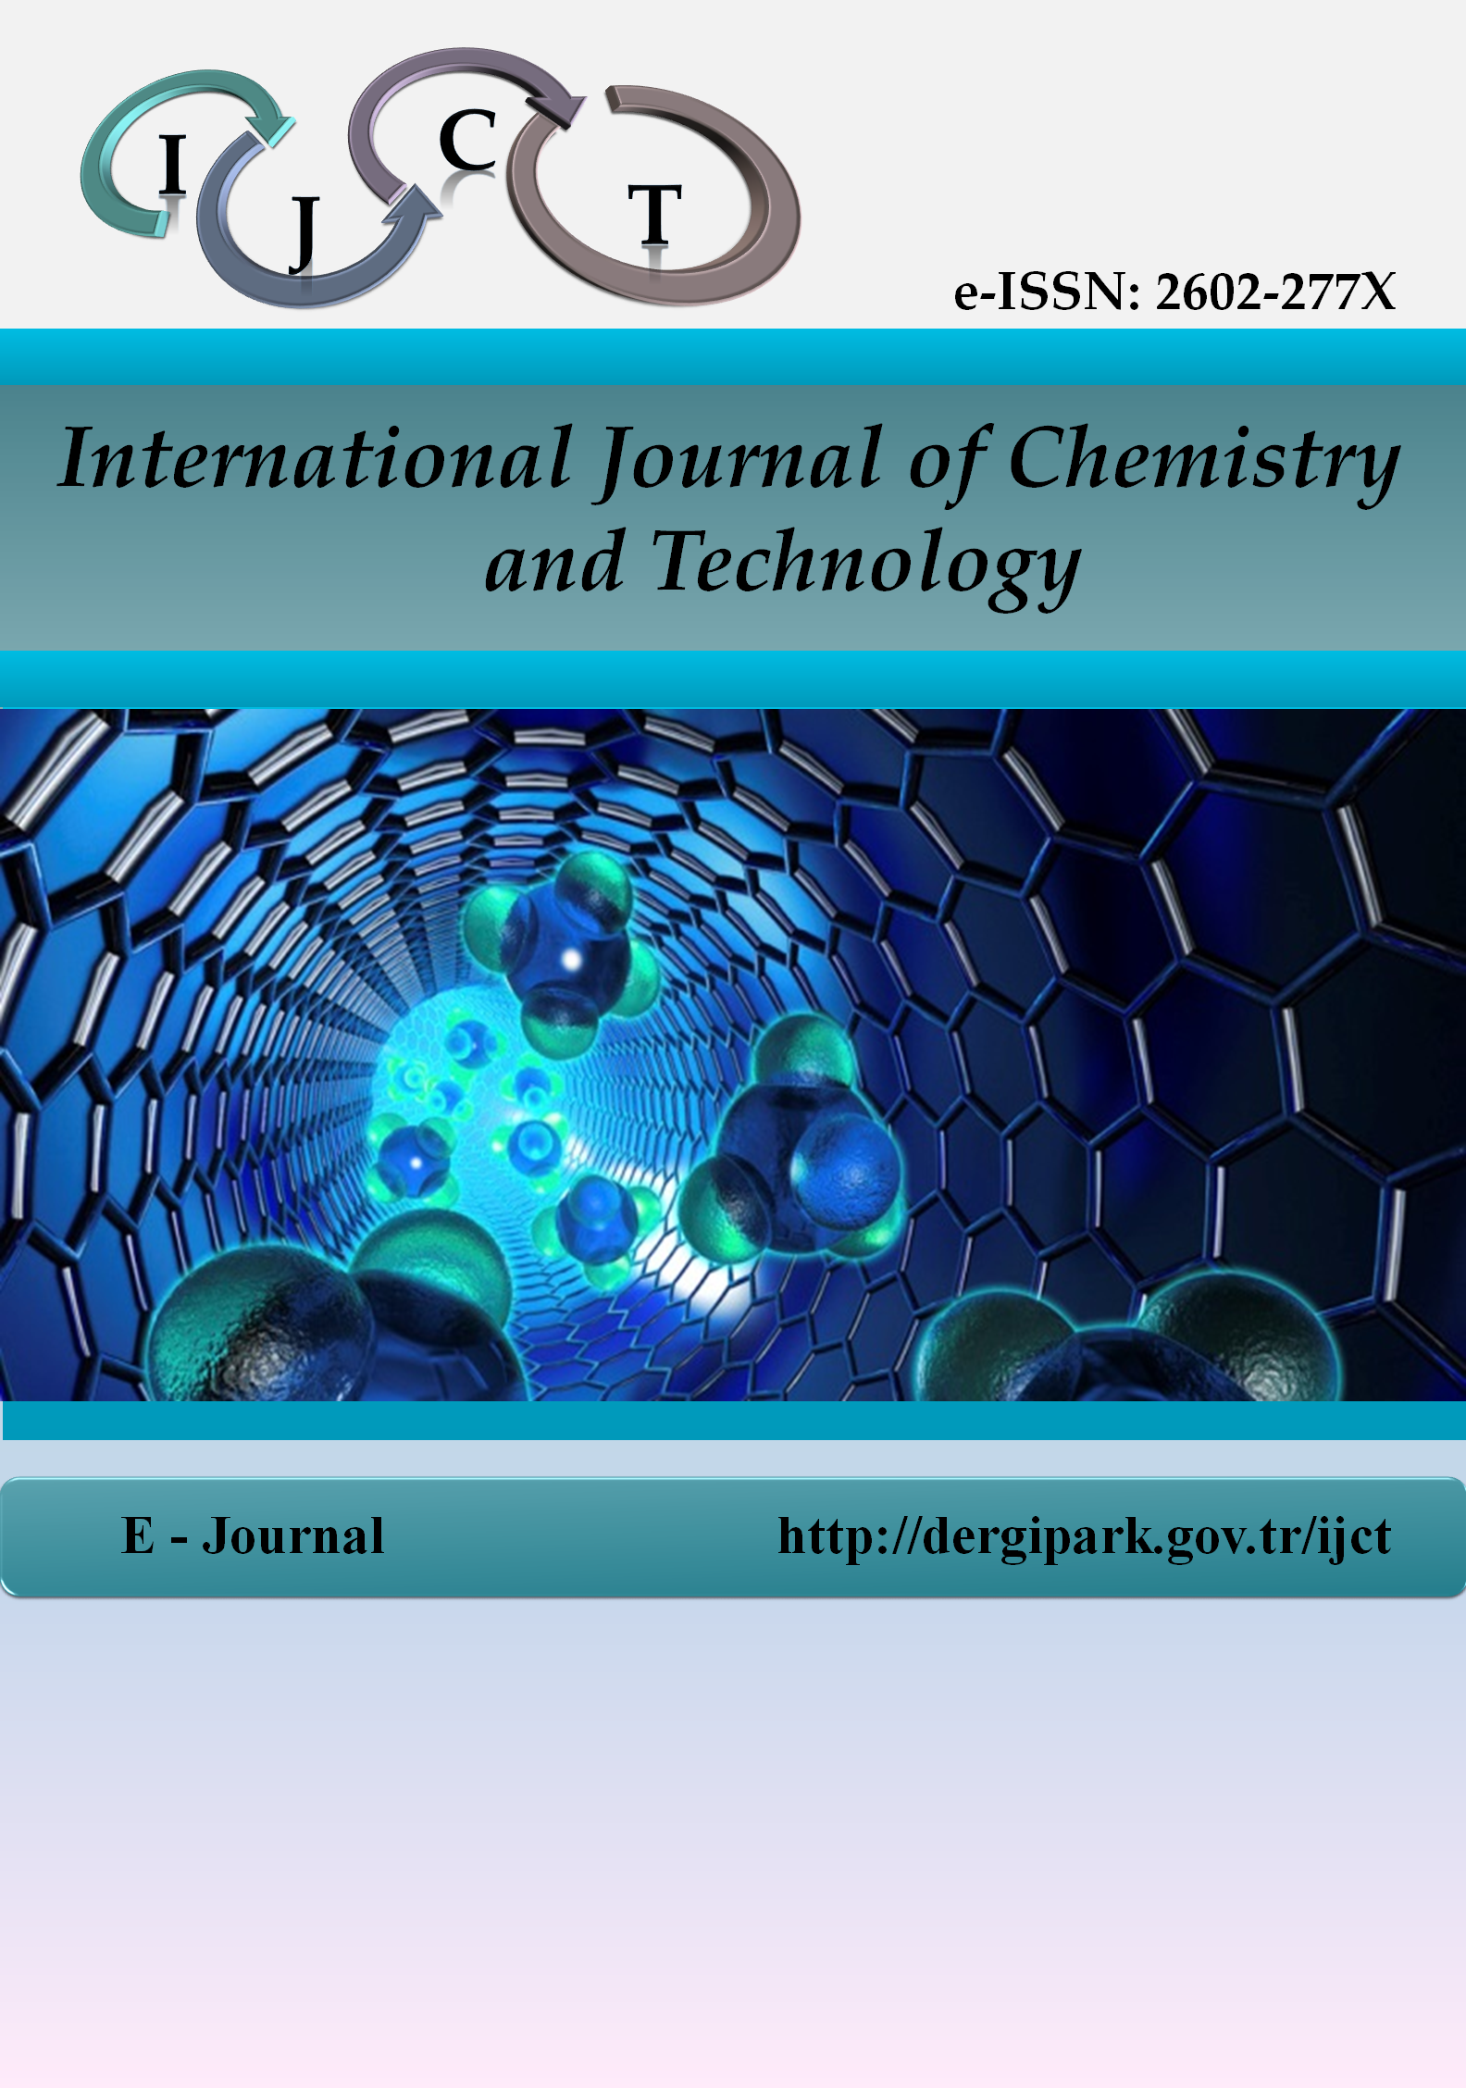

COPYRIGHT AGREEMENT FORM

The submission of this copyright agreement form by author(s) is obligatory for papers published in International Journal of Chemistry and Technology.
Article title
Name-surname of corresponding author
Full address of corresponding author
E-mail of corresponding author
Telephone number of corresponding author
Full names of all authors
(according to the order on the article)

On behalf of all authors, as the corresponding author of the paper, I guarantee that;
- The manuscript submitted is my/our own original work, and it has not been published elsewhere before, and it has been not submitted anywhere for publication at the same time.

- I would like to declare that all authors transfer the copyrights of the article to the International Journal of Chemistry and Technology.

- All data, scheme, figures, illustrations and other materials in the article are belongs to all authors. In the case of received of these from anywhere, a reference will definitely be given in the article.

- I guarantee that all scientific and ethical responsibilities of the paper belong to all authors.

Corresponding Author | Signature | Date

