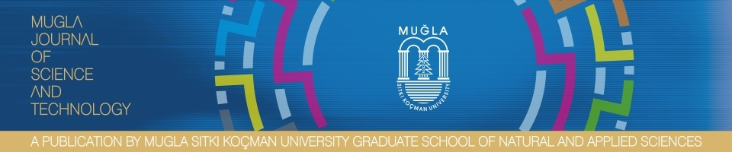
AGREEMENT FOR THE TRANSFER OF COPYRIGHT,

The undersigned authors release “MUĞLA JOURNAL OF SCIENCE AND TECHNOLOGY (MJST)” from all responsibility concerning the manuscript entitled “……………………….. “.
The undersigned authors warrant that the article is original, is not under consideration by another journal, has not been published in whole or in part, any permission necessary to publish it in the above mentioned journal has been obtained and provided to “ MUĞLA JOURNAL OF SCIENCE AND TECHNOLOGY (MJST)” together with the original copyright notice. We sign for and accept the responsibility for releasing this material.
Copyright to above article is hereby transferred to “MUĞLA JOURNAL OF SCIENCE AND TECHNOLOGY (MJST)” effective upon acceptance for publication. However, the following rights are reserved by the authors:
-All proprietary rights other than copyright, such as patent rights;
-The right to use, free of charge, all or part of this article in the future works of their own, such as books or lectures;
-The right to reproduce the article for their own purposes even for sale
The authors should be aware of the fact that readers have the right to;
-copy and redistribute the material in any medium or format;
-remix, transform and built upon the material for any purpose, even commercially according to our CC (Creative Common) policy.

I declare that this work is completely unique in that it does not constitute any part of a work conducted before or it is translation of a study.

In all of the above cases, the article’s publication by “MUĞLA JOURNAL OF SCIENCE AND TECHNOLOGY (MJST)” must be appropriately stated as a complete reference

To be signed by all authors:

Authors Name, Surname Date Signature

*Correspondence address, telephone and e-mail:

