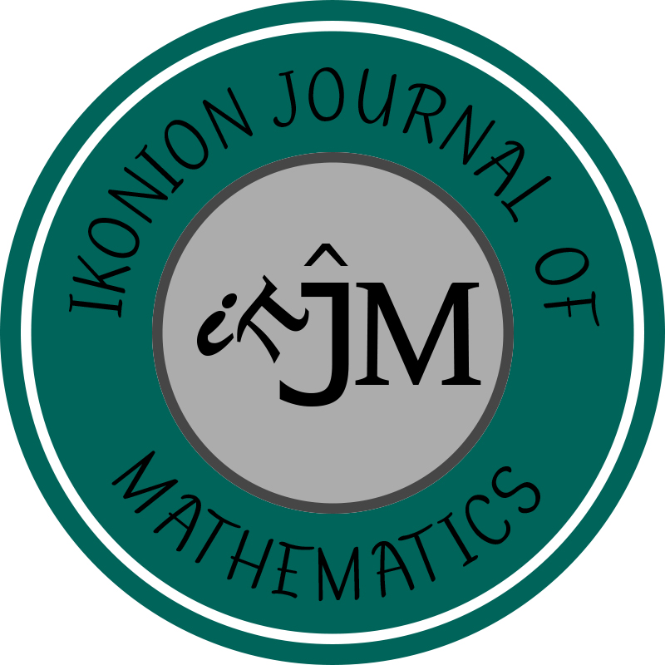 HITTITE JOURNAL OF SCIENCE AND ENGINEERING

IKONION JOURNAL OF MATHEMATICS
Copyright Release form

Manuscript Title: ….………………………………………………………………………………………..........
……………………………………………………………………………………………………………………….
……………………………………………………………………………………………………………………….
Full Name(s) of Authors (in order to appear on manuscript):…………………………………………..
……………………………………………………………………………………………………………………….
……………………………………………………………………………………………………………………….

The undersigned, on behalf of all authors as the corresponding author of manuscript, hereby transfers, to the extent that there is copyright to be transferred, the exclusive copyright interest in the above cited manuscript, including the published version in any format (subsequently called the "work"), to the Ikonion Journal of Mathematics subject to the following (If the manuscript is not accepted by IKJM or withdrawn prior to acceptance by IKJM, this transfer will be null and void.):

1. The undersigned author and all coauthors retain the right to revise, adapt, prepare derivative works, present orally, or distribute or transmit their own paper, provided that copyright credit is given to the source and IKJM, that recipients are informed that they may not further disseminate or copy the paper, and that all such use is for the personal noncommercial benefit of the author(s) and is consistent with any prior contractual agreement between the undersigned and/or coauthors and their employer(s). Authors/employers may post the title of the paper, abstract (no other text), tables, and figures of their own papers on their own Web sites, and include these items in their own scholarly, research papers.

2. Where a work is prepared as a "work made for hire" for an employer, the employer(s) of the author(s) retain(s) the right to revise, adapt, prepare derivative works, publish, reprint, reproduce, and distribute the work in print format, and to transmit it on an internal, secure network for use by its employees only, and additional rights under A, provided that all such use is for the promotion of its business enterprise and does not imply endorsement by IKJM.

3. Whenever the IKJM is approached by third parties for individual permission to use, reprint, or republish specified articles (except for classroom use, library reserve, or to reprint in a collective work) the undersigned author's or employer's permission will also be required.

4. No proprietary right other than copyright is claimed by the IKJM.

5. IKJM reserves the right to use on the publication cover all figures submitted with the manuscript.

Corresponding Author’s Full Name and Signature

