Marakli, S., A Brief Review of Molecular Markers to Analyse Medicinally Important Plants. International Journal of Life Sciences and Biotechnology, 2018. 1(1): p. 29-36. (please do not touch this section)

A Brief Review of Molecular Markers to Analyse Medicinally Important Plants

We use double-blind per reviewer system. Then please delete your names, emails etc before you send the manuscript. After the article is accepted, the names of the authors should be written here and the authors information should be written at underside of the page as a footnote.
KEYWORDS
Potato, production, antioxidant
ARTİCLE HİSTORY
Received 23.10.2018
Accepted 23.10.2018
ABSTRACT
Potatoes, a member of the Solanacae family, is one of the world's most important vegetable plants. In terms of production, it ranks fourth in the world after rice, wheat and corn, and about 400 million tons are produced globally every year. The potato plant, an annual crop, was discovered as a wild form on Alpine mountains and was first cultivated in Europe. Potatoes became highly preferred because of the high amount of nutrients and antioxidant contents. In addition, it contains abundant amounts of carbohydrates, proteins, vitamins and minerals. Due to these and similar characteristics, it was defined as a "hidden treasure" by FAO in 2008. Today, there are about two hundred potatoes varieties forming tubers. Potatoes plants are undoubtedly among the crops in which there are great difficulties in production due to the increasing negative effects of diseases and environmental stress factors in the years. Overall potatoes production in Turkey has increased with every passing year. In this study, the general characteristics of potatoes plant were investigated by using the current sources. Potatoes, a member of the Solanacae family, is one of the world's most important vegetable plants. In terms of production, it ranks fourth in the world after rice, wheat and corn, and about 400 million tons are produced globally every year. The potato plant, an annual crop, was discovered as a wild form on Alpine mountains and was first cultivated in Europe. Potatoes became highly preferred because of the high amount of nutrients and antioxidant contents. In addition, it contains abundant amounts of carbohydrates, proteins, vitamins and minerals. Due to these and similar characteristics, it was defined as a "hidden treasure" by FAO in 2008. Today, there are about two hundred potatoes varieties forming tubers.

Introduction or Background
Herbal medicines play a significant role as an alternative to synthetic pharmaceuticals, reaching $115 billion by 2020 [1]. For this reason, conservation of endemic, threatened and endangered medicinal species, improving high-quality cultivars with desirable traits and even knowledge of the germplasm diversity have gained importance in the past decades [2]. Hence, different molecular markers have been commonly used for these purposes to give detailed information about genomes which is not possible with phenotypic methods.
DNA barcoding provides species-level identifications using short standard DNA regions, known as DNA barcodes or markers [3]. Ideal DNA markers should be highly polymorphic in nature, codominant inheritance, frequent occurrence in the genome, fast and easy testing, high reproducibility, and even easy exchange of data among laboratories [4]. DNA barcoding has been widely applied to answer a broad range of questions related to taxonomy, molecular phylogenetic, population genetics, and biogeography [5, 6, 7], as well as trade control of flora, fauna and food products [8, 9, 10].

Fig 1 The distribution of potato plants to the world countries

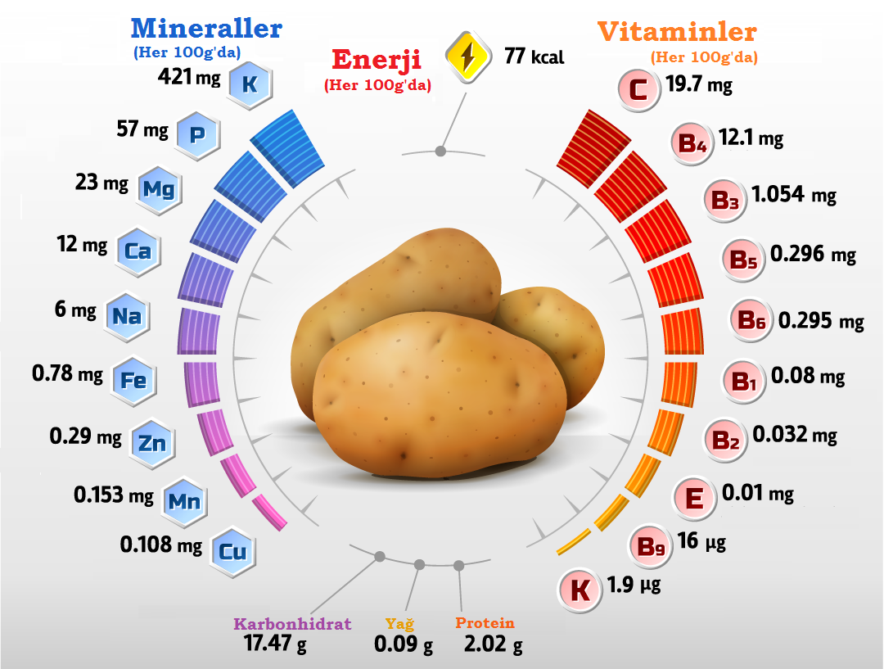
Fig 2 Nutritional values ​​of potato plants [1]
Material and Methods
This technique is based on the amplification of genomic DNA with single primer of an arbitrary nucleotide sequence with no previous information about the genome. Since most of the RAPD markers are dominant, it is not possible to distinguish whether the amplified DNA segment is heterozygous (two different copies) or homozygous (two identical copies) at a specific locus. However, in some cases, codominant RAPD markers, obtained as different-sized DNA segments amplified from the same locus, could be detected [11].
Table 1 Major potato producers in the World [2]
Sıra | Ülkeler | Ekim alanı (ha) | Üretim (ton)
 | Çin | 5.815.140 | 99.122.420
 | Hindistan | 2.130.000 | 43.770.000
 | Rusya | 2.030.858 | 31.107.797
 | Ukrayna | 1.311.600 | 21.750.290
 | ABD | 407.810 | 19.990.950
 | Almanya | 242.500 | 10.772.100
 | Bangladeş | 475.699 | 9.474.099
 | Polonya | 311.620 | 8.872.445
 | Fransa | 175.225 | 6.834.680
 | Hollanda | 155.594 | 6.534.338
 | Belarus | 292.401 | 5.985.810
 | İngiltere | 139.000 | 5.373.000
 | İran | 161.771 | 5.164.891
 | Mısır | 184.592 | 5.029.022
 | Cezayir | 156.196 | 4.782.690
 | Türkiye | 144.706 | 4.750.00
 | Kanada | 141.157 | 4.620.000
 | Peru | 318.380 | 4.570.670
 | Malawi | 172.870 | 4.535.960

Results and Discussion
Antioxidant properties of potato plant
Extraction of plant of antibactarial activity have been widely investigated in many studies (33). Three different types of experimental bacteria were used in this study, five of which were negative for the Escherichia coli, Samonell,. Typhimurium. One of them is positive for the chroma dye: Staphylococcus aureu, Aspergillus niger. These microorganisms have been chosen as common causes of some human and animal diseases and are contaminants that cause damage to certain foods and their resistance to antibiotics (22). The results in Table 2 show the chemical content of the seeds of the fenugreek if the moisture content is 4.90 % Was less than the result obtained by (23) 9.3% and that (24) received a result of 3.4%, which is less than our results.
Conclusion
Molecular markers with low assay cost, convenience and fast and easy application and automation are undoubtedly valuable tools for population genetics and plant breeding programs [60, 61]. Although each method has its benefits and limitations, suitable choice of one marker and/or combination of different markers could be easily used to overcome these disadvantages. Information provided in this brief review shows the basic description of different molecular techniques used in molecular diversity studies performed in medicinal plant species.

Abbreviations
AMPA: α-amino-3-hydroxy-5-methyl-4-isoxazolepropionic acid; BMI: Body Mass Index; CFIA: Canadian Food Inspection Agency; CV: Coefficient of Variance; EFSA: European Food Safety Authority; ESI: Electrospray Ionization; FDA: Food and Drugs Administration; GC-MS: Gas Chromatography-Mass Spectrophotometery; GLY: Glyphosate; HPLC/MS: High Performance Liquid Chromatography-tandem Mass Spectrometry; IQR: Inter-Quartile Range; LC/MS/MS: Liquid Chromatography-tandem Mass Spectrometry; LOD: Limit of Detection; LOQ: Limit of Quantification; NA: Not applicable; NR: Not reported; SD: Standard Deviation

Acknowledgements
We sincerely thank the staff and administration of the St. Franciscan Health obstetrical practice in Indianapolis for their assistance and support in this study.

Funding
This study is funded by the Indiana Clinical and Translational Science Institute, which is supported by the National Institutes of Health under a Clinical and Translational Sciences Award (UL1TR001108).

Availability of data and material
Please contact the corresponding author for any data request.

References

1. Kaya, Y., Regeneratıon of Dalapon Tolerant Nicotıana Tabacum By Expressıng Dehalogenase E Gene Through Agrobacterıum Tumefaciens – Medıated Transformatıon. 2013, Universiti Teknologi Malaysia: Malaysia.
2. Kaya, Y., et al., Evaluation of transgenic Nicotiana tabacum with dehE gene using transposon based IRAP markers. American Journal of Plant Sciences, 2013. 4(08): p. 41.
3. Aksoy, H.M., Y. Kaya, and T. Hamid, The Role of Dspf, The Type Iii Secretion Chaperone of Dspa/E of Erwinia Amylovora, In Pathogenicity In Host And Non-Host Plants. The Journal of Animal and Plant Sciences (in press, 2017), 2017.
4. Aksoy, H.M., et al., Pseudomonas putida–Induced response in phenolic profile of tomato seedlings (Solanum lycopersicum L.) infected by Clavibacter michiganensis subsp. michiganensis. Biological Control, 2017. 105: p. 6-12.
5. Aksoy, H.M., Y. Kaya, and T.H. Tengku Abdul Hamid, Expression of the dspA/E gene of Erwinia amylovora in non-host plant Arabidopsis thaliana. Biotechnology & Biotechnological Equipment, 2017. 31(1): p. 85-90.

* Correspondence: ijlsb@intsa.org

