Title of a manuscript

Name Surname^{1,*}, Name Surname²

¹ Affiliation of the 1st author, City, Country, email, ORCID: 0000-XXXX-XXXX-XXXX

² Affiliation of the 2nd author, City, Country, email, ORCID: 0000-XXXX-XXXX-XXXX
ABSTRACT | ARTICLE INFO
In this section a short abstract indicating the novelty and main findings of the work should be written. The text of abstract should be written fully justified and 10 pt. The abstract should include approximately 150-350 words and should not contain any non-common abbreviations and citations. | Research article  Received: **/**/****  Accepted: **/**/****  Keywords:  biosorption,  lead,  polyporus squamosus,  response surface methodology  *Corresponding author

Introduction
MANAS Journal of Engineering is an international peer-reviewed open access journal at the field of Engineering Science (applied mathematics, food, ecology, chemical and computer engineering, biological chemistry, environmental analysis, geochemistry, materials science etc.) which aims to contribute to universal knowledge by publishing original works (full papers, short communications, technical notes etc.) at international level with scientific qualifications.
Only English Language is allowed writing the manuscript in MJEN. The following rules should be considered in submitting papers.

1.1 Page settings
The paper size must be A4, where the left, right, upper and lower fields are 2 cm. Line spacing single. All text, except for the header must be written in Times New Roman in black and size 12 point and aligned in width. Before and after each section, it is necessary to leave a small gap (spacing before and after paragraph). All first-level headings should be written in bold Times New Roman font size of 12 points. The remaining headings should be written in bold letters, with each word begins with a capital letter.

1.2. Symbols and Abbreviations
All symbols in the article should be inserted using MS Word special symbols section: "Insert \ symbol" Microsoft Word program. For example, use the symbol "×" to indicate multiplication instead of the "х" character.

1.3. Citation
References in the article should be in square brackets [16] at the end of the sentence with the relevant number of the source. In case several sources must be indicated, write all inside the brackets [1, 3, 5] for no successive and [1-5] for successive references.

1.4. Tables
If you need to show a source of the table or figure, write within square brackets with the relevant number of literature in the end. Example: Table 1. The names of the tables and the text inside a table Align Left, figures in the center, the size is 10-point font.

.

Table 2. Table Title.
Column 1 | Column 2 | Column 3
Item 1 | Description 1 | Description 1
Item 2 | Description 2 | Description 2  Description 3
Item 3 | Description 3 | Description 2  Description 3

1.5. Graphs, Pictures and equation
In the manuscript all the graphs, equations and patterns aligned in the center. However depending on the size of a figure, it can be placed either in two columns (ex. Figure 1), or within one column (ex. Figure 2). The names of the image should be below the picture in one interval. Image resolution should be at least 300 dpi.

Figure 1. Figure caption.

If a figure can be placed within one column, it should be arranged so that it fits the length of a column as it is shown below.
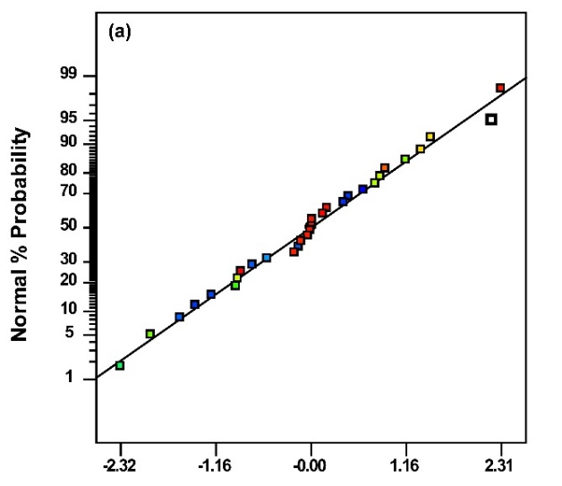
Figure 2 Figure capture

Formula should be performed by MS Equation editor.

References

REFERENCES
Latin letters should be used to indicate the sources of literature. Please use the following format to cite sources.
For Books
[1-4] Author A.A., “Title of chapter in the book,” in Title of Published Book, xth ed. City of Publisher, Country: Abbrev. of Publisher, year, ch. x, sec. x, pp. xxx–xxx.
- Stein L., “Random patterns,” in Computers and You, J. S. Brake, Ed. New York: Wiley, 1994, pp. 55-70.
- Klaus B. and Horn P., Robot Vision. Cambridge, MA: MIT Press, 1986.
- Myer R.L., “Parametric oscillators and nonlinear materials,” in Nonlinear Optics, vol. 4, P. G. Harper and B. S. Wherret, Eds. San Francisco, CA: Academic, 1977, pp. 47-160.
- Young G.O., “Synthetic structure of industrial plastics,” in Plastics, vol. 3, Polymers of Hexadromicon, J. Peters, Ed., 2nd ed. New York: McGraw-Hill, 1964, pp. 15-64.
Thesis
[5, 6] Author A.A., “Title of thesis,” M.S. thesis, Abbrev. Dept., Abbrev. Univ., City of Univ., Abbrev. State, year.
- Williams J.O., “Narrow-band analyzer,” Ph.D. dissertation, Dept. Elect. Eng., Harvard Univ., Cambridge, MA, 1993.
- Boluşbek Uulu A., “Konferans Ve Dergi İçerik Yönetim, Değerlendirme, Düzenleme Ve Yayınlama Sistemi Geliştirmesi,” M.S. thesis, Dept. Comp. Eng., Kyrgyz-Turkish Manas Univ., Bishkek, Kyrgyzstan, 2018.
For Journal Papers
[7-9] Author A.A., "Title of article," Title of Journal, vol. # (issue. #), pp. #.
- Kahraman T., “Smarandache Curves of Null Quaternionic Curves in Minkowski 3-space”, Manas Journal of Engineering, 6, (2018), 1-6.
- Cevat A., Ozcan M., Some Physico-Mechanic Properties of Terebinth (Pistacia terebinthus L) Fruits, Journal of Food Engineering, 52, (2002), 97-101.
- Üstündağ, İ., Erkal, A., Üstündağ, Z., Solak, A. O. “Electrochemical Detection of Cadmium and Lead in Rice on Manganese dioxide Reinforced Carboxylated Graphene Oxide Nanofilm”, Manas Journal of Engineering, 6, (2018), 96 - 109.
For Sources from conferences
[10] Author A.A. and Author B.B., "Title of paper," in Title of Published Proceedings: Proceedings of the Title of Conference: Subtitle of conference, Month Date, Year, Location, A. Editor and B. Editor, Eds. Place of publication: Publisher, Year. pp. inclusive page numbers.
- Liu L., and Miao H., "A specification based approach to testing polymorphic attributes," in Formal Methods and Software Engineering: Proceedings of the 6th International Conference on Formal Engineering Methods, ICFEM 2004, Seattle, WA, USA, November 8-12, 2004, J. Davies, W. Schulte, M. Barnett, Eds. Berlin: Springer, 2004. pp. 306-19.
For Sources from internets
[11] Authors of Paper, "Title of paper," in Proceedings of the Title of Conference: Subtitle of conference, Month Date, Year, Location. Place of publication: Publisher, Year. Available: Database Name (if appropriate), internet address. [Accessed: date of access].
- Lach J., "SBFS: Steganography based file system," in Proceedings of the 2008 1st International Conference on Information Technology, IT 2008, 19-21 May 2008, Gdansk, Poland. Available: IEEE Xplore, http://www.ieee.org. [Accessed: 10 Sept. 2010].
For Online sources
[12] Author, A.A., Title of E-book. Place: Publisher, Date of original publication. [Format] Available: Source.
- Bass L., Clements P., and Kazman R., Software Architecture in Practice, 2nd ed. Reading, MA: Addison Wesley, 2003. [E-book] Available: Safari e-book.
For Internet documents
[13] Author A, "Document title," Webpage name, Source/production information, Date of internet publication. [Format]. Available: internet address. [Accessed: Date of access].
- Author A, European Telecommunications Standards Institute, “Digital Video Broadcasting (DVB): Implementation guidelines for DVB terrestrial services; transmission aspects,” European Telecommunications Standards Institute, ETSI TR-101-190, 1997. [Online]. Available: http://www.etsi.org. [Accessed: Aug. 17, 1998].
For Patents and standards
Patents
[14] Author A.A., “Title of patent,” U.S. Patent x xxx xxx, Abbrev. Month, day, year.
- Wilkinson J.P., “Nonlinear resonant circuit devices,” U.S. Patent 3 624 125, July 16, 1990.
For Standards
[15] Title of Standard, Standard number, date.
- Letter Symbols for Quantities, ANSI Standard Y10.5-1968.

