Journal of Teacher Education and Educators

Research Article/Review Article
Title of the Manuscript Goes Here
(Received on…… -

Abstract
This paper provides a template for preparing papers for Journal of Teacher Education and Educators. Abstract describing the essence of the manuscript must be between 150-200 word. Abstract must be written in font 10 and Times New Roman. Authors must select up to 5 key words below the abstract. This paper provides a template for preparing papers for Journal of Teacher Education and Educators. Abstract describing the essence of the manuscript must be between 150-200 word. Abstract must be written in font 10 and Times New Roman. Authors must select up to 5 key words below the abstract. This paper provides a template for preparing papers for Journal of Teacher Education and Educators. Abstract describing the essence of the manuscript must be between 150-200 word. Abstract must be written in font 10 and Times New Roman. Authors must select 3-5 keywords below the abstract.

Keywords: keyword1, keyword2, keyword3, keyword4, keyword5

Introduction
Provide information on the background of the study, the objectives of the study and the importance of the study. The introduction therefore has to say what the reader is going to encounter in the paper, as well as why it is important. Provide information on the background of the study, the objectives of the study and the importance of the study. The introduction therefore has to say what the reader is going to encounter in the paper, as well as why it is important. Provide information on the background of the study, the objectives of the study and the importance of the study. The introduction therefore has to say what the reader is going to encounter in the paper, as well as why it is important. Provide information on the background of the study, the objectives of the study and the importance of the study. The introduction therefore has to say what the reader is going to encounter in the paper, as well as why it is important. Provide information on the background of the study, the objectives of the study and the importance of the study. The introduction therefore has to say what the reader is going to encounter in the paper, as well as why it is important.
Provide information on the background of the study, the objectives of the study and the importance of the study. The introduction therefore has to say what the reader is going to encounter in the paper, as well as why it is important. Provide information on the background of the study, the objectives of the study and the importance of the study. The introduction therefore has to say what the reader is going to encounter in the paper, as well as why it is important. Provide information on the background of the study, the objectives of the study and the importance of the study. The introduction therefore has to say what the reader is going to encounter in the paper, as well as why it is important.

Theoretical Framework and Literature Review
Provide the theoretical framework of your study and information about the previous research. Provide the theoretical framework of your study and information about the previous research. Provide the theoretical framework of your study and information about the previous research. Provide the theoretical framework of your study and information about the previous research. Provide the theoretical framework of your study and information about the previous research. Provide the theoretical framework of your study and information about the previous research. Provide the theoretical framework of your study and information about the previous research. Provide the theoretical framework of your study and information about the previous research.

Theoretical framework
Provide the theoretical framework of your study and information about the previous research. Provide the theoretical framework of your study and information about the previous research. Provide the theoretical framework of your study and information about the previous research. Provide the theoretical framework of your study and information about the previous research. Provide the theoretical framework of your study and information about the previous research. Provide the theoretical framework of your study and information about the previous research.

Theoretical framework
Provide the theoretical framework of your study and information about the previous research. Provide the theoretical framework of your study and information about the previous research. Provide the theoretical framework of your study and information about the previous research. Provide the theoretical framework of your study and information about the previous research. Provide the theoretical framework of your study and information about the previous research. Provide the theoretical framework of your study and information about the previous research.

Theoretical framework
Provide the theoretical framework of your study and information about the previous research. Provide the theoretical framework of your study and information about the previous research. Provide the theoretical framework of your study and information about the previous research. Provide the theoretical framework of your study and information about the previous research. Provide the theoretical framework of your study and information about the previous research. Provide the theoretical framework of your study and information about the previous research.

Methodology
Provide information on about your research design, the participants, data collection tools, data analysis process, etc. Provide information on about your research design, the participants, data collection tools, data analysis process, etc. Provide information on about your research design, the participants, data collection tools, data analysis process, etc. Provide information on about your research design, the participants, data collection tools, data analysis process, etc. Provide information on about your research design, the participants, data collection tools, data analysis process, etc. Provide information on about your research design, the participants, data collection tools, data analysis process, etc.
Provide information on about your research design, the participants, data collection tools, data analysis process, etc. Provide information on about your research design, the participants, data collection tools, data analysis process, etc. Provide information on about your research design, the participants, data collection tools, data analysis process, etc. Provide information on about your research design, the participants, data collection tools, data analysis process, etc.

Findings
Provide information on your findings. Use the APA-7 style for tables and figures. Provide information on your findings. Use the APA-7 style for tables and figures. Provide information on your findings. Use the APA-7 style for tables and figures. Provide information on your findings. Use the APA-7 style for tables and figures. Provide information on your findings. Use the APA-7 style for tables and figures. Provide information on your findings. Use the APA-7 style for tables and figures. Provide information on your findings. Use the APA-7 style for tables and figures. Provide information on your findings. Use the APA-7 style for tables and figures. Provide information on your findings. Use the APA-7 style for tables and figures. Provide information on your findings. Use the APA-7 style for tables and figures. Provide information on your findings. Use the APA-7 style for tables and figures.

Figures (example):

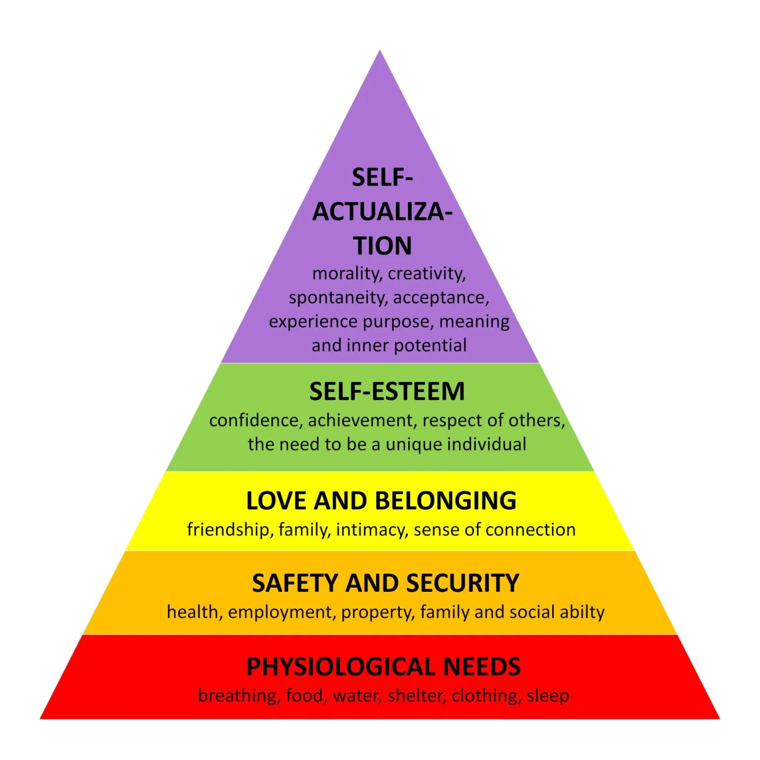
Figure 1: Maslow’s Hierarchy of Needs
Tables (example):
Table 1
Pearson Correlations Between Occupational Incentive indices and Teacher
Retention
Variable 1 | 2 3 4 | 5
1. Job Security - | .412** .431** .369* | .452**
2. Remuneration | - .371* .771** | .467**
3. Promotion | - .394* | .435**
4. Welfare | - | .482**
5. Teacher Retention |  | -
** Correlation is significant at the 0.01 level (2-tailed)
* Correlation is significant at the 0.05 lAevel (2-tailed)

Discussion
Discuss and interpret your findings based on the theoretical framework and the previous research. Discuss your findings based on the theoretical framework and the previous research. Discuss your findings based on the theoretical framework and the previous research. Discuss your findings based on the theoretical framework and the previous research. Discuss your findings based on the theoretical framework and the previous research. Discuss your findings based on the theoretical framework and the previous research. Discuss your findings based on the theoretical framework and the previous research. Discuss your findings based on the theoretical framework and the previous research. Discuss your findings based on the theoretical framework and the previous research. Discuss your findings based on the theoretical framework and the previous research. Discuss your findings based on the theoretical framework and the previous research

Conclusion
Conclude your study briefly. Draw attention to significant findings. Give limitations if there is any. Conclude your study briefly. Draw attention to significant findings. Give limitations if there is any. Give recommendations for next research and practical manners. Conclude your study briefly. Draw attention to significant findings. Give limitations if there is any. Conclude your study briefly. Draw attention to significant findings. Give limitations if there is any. Give recommendations for next research and practical manners. Conclude your study briefly. Draw attention to significant findings. Give limitations if there is any. Conclude your study briefly. Draw attention to significant findings. Give limitations if there is any. Give recommendations for next research and practical manners.

References
(Consider APA-7 for references and in-text citations.)

- The reference list should be arranged in alphabetical order by the first author's last name.

- If there is more than one work by the same author, list them in chronological order, from oldest to newest.

- Use "&" instead of "and" when listing multiple authors in a reference list entry.

- The first line of each reference entry is left-aligned, and all subsequent lines are indented using a hanging indent (1 cm).

- Italicize the titles of books, journals, and web documents. However, journal article titles and book chapter titles are NOT italicized.

- All types of sources (books, journal articles, web documents, brochures, etc.) should be arranged alphabetically in a single reference list—not separated by type.

- If a work has 20 or fewer authors, list all of them. If a work has 21 or more authors, list the first 19 authors, followed by an ellipsis (...), and then include the final author’s name (without an ampersand before the last author).

- If available, always include the DOI as a clickable link (https://doi.org/xxxxx).

- For serial/journal articlers; (1) do not use “Vol.” before the number, (2) include all page numbers in full (e.g., 102–115, not 102-15).

Reference (examples):
Caram, C. A., & Davis, P. B. (2005). Inviting student engagement with questioning. Kappa Delta Pi Record, 42(1), 18–23. https://doi.org/10.1080/00228958.2005.10532080
Gokce, F. (2009). Behaviour of Turkish elementary school principals in the change process. Educational Management Administration & Leadership, 37(2), 198–215. https://doi.org/10.1177/1741143208100298

OTHER NOTES:
- For the purposes of blind review, the full name of each author with current affiliation and email and ORCID ID details should be supplied on a separate paper. The corresponding author should upload this separate paper as ‘Title Page’
- Headings must be organized in the following way:
Heading level 1 – Teacher Education
Heading level 2 – Teacher education
Heading level 3 – Teacher education
Heading level 4 – Teacher education

