Research Article
Click and type the title of your paper, only capitalize first word
(Times New Roman, Font 14)
First Author ª , Second Author ^{b,}* and Third Author ^{a,b}
(Times New Roman, Bold, Italic, Font 12)

(Times New Roman, Italic, Font 9)

ARTICLE INFO |  | ABSTRACT
Article history:  Received 00 January 2021  Revised 00 February 2021  Accepted 00 March 2021 |  | An abstract is required for every paper; it should succinctly summarize the reason for the work, the main findings, and the conclusions of the study. The abstract should be no longer than 300 words and line space should be 1. Abstract is not included artwork, tables, elaborate equations or references to other parts of the paper or to the reference listing at the end. The reason is that the Abstract should be understandable in itself to be suitable for storage in textual information retrieval systems. (Times New Roman, font 9)
Keywords:
At least three keywords. Each keyword to start on a new line in alphabetical order.
(Times New Roman, font 8, upper case at the beginning of each keyword)

- Introduction
The IAREJ template was updated in February 2020 for new submissions.
This document is a template for Microsoft Word. If you are reading a paper or PDF version of this document, please download the electronic file (.docx), from the http://dergipark.org.tr/en/pub/iarej so you can use it to prepare your manuscript.
Introduction section should be included current studies and contribution of the study. All text will be prepared by Times News Roman and font 10. The full manuscript should be between 5–12 pages and line space should be 1,15.
ORCID link must be added on figure for all authors. If authors don’t have ORCID, they get by https://orcid.org/

2. New Section (Times New Roman, Font 10.5, Bold)
2.1 Subsection (Times New Roman, 10, Italic, Bold)
The second part consisting of the paper body must be edited in double column format. Figures and tables should be located at top or bottom of either column.
Clear original figures should be used. Equations should be numbered consecutively throughout the paper and located at the right margin as in Equation (1) below. Figures and tables should be placed at the top or at the bottom of each column as in Figure 1 and Table 1. Large size figures or tables can be placed in one column as given Figure 2 at the top or at the bottom of each page. Click for submission.

Table 1. Ram position details of the motion segments (Times New Roman, 9)

Segment | Time(s) | Ram Position(m)
1 | 0 | 0.20
2 | 0.5 | 0.04

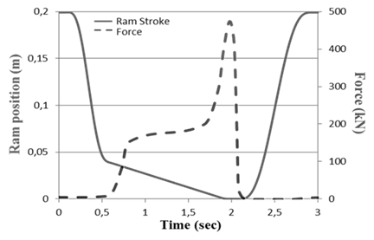
Figure 1. Motion scenario (Times New Roman, 9)

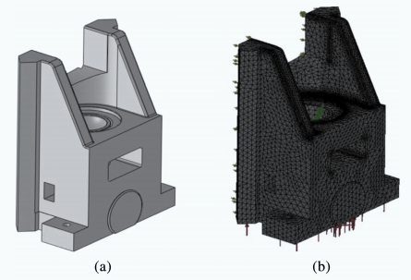
Figure 2. Part assembly a) design, b) design with mesh
For instance, Lagrangian function states the difference between system kinetic energy and potential energy as in Equation (1) in which L, T and V refer to Lagrange function, kinetic energy, and potential energy of system, respectively.
$$L=T-V$$ | (1)
Long equations that do not fit in a single column should be given in Appendix by referring in the text.
All Figures and Tables should be cited in the text.
2.2 Manuscript Structure
The structure of an article should include Abstract, Introduction, Material and Methods (can be presented with different titles), Result and Discussion (can be presented with different titles), Conclusion. The sections can be increased. Last paragraph of Introduction section should emphasize the contribution of your study.
2.3 Ethical Standards

You must check the journal ethical standard before the submission by the journal web page https://dergipark.org.tr/en/pub/iarej/page/4240. If ethical committee permission is required for the study, please add the information in manuscript and load the permission to the journal when you submit a new article.

2.4 Reference
References should be referred in text by numerals in square brackets in order like ….. [1], …… [2]. Examples in text: …… [1, 2], ……… [2-5], ……… [3, 4-6], Cetinkunt [5] …… Halicioglu et al. [2, 4, 6] ……. Please also check the published articles. References list (in font 9) should appear in a separate bibliography at the end of the paper. All journal articles must include volume, number, and pages. “Numbered” style can be used by EndNote. For web pages, please write date of the available data.

3. Conclusions
The review process will be conducted on the Journal Manuscript Submission System, with the least two blind reviewers. The article should be prepared in journal format. Published articles can help authors for preparing the manuscript. Please click for IAREJ archive.

Declaration

The author(s) declared no potential conflicts of interest with respect to the research, authorship, and/or publication of this article. The author(s) also declared that this article is original, was prepared in accordance with international publication and research ethics, and ethical committee permission or any special permission is not required. (You can revise this section according to your study. If you have ethical committee permission, please mention committee and decision ID)

Author Contributions
F. Author developed the methodology. S. Author performed the analysis. T. Author supervised and improved the study. F. Author and S. Author wrote the manuscript together. T. Author proofread the manuscript. …….. (This is an example. You must write all author contributions depending on your study period.)

Acknowledgment
This work supported by the Department of Engineering under Research Project (project no:XXXXX), Country Name.

Nomenclature
E : (Effective) work potential
P : Power

References
- Qingyu, S., G. Baofeng, and L. Jian, Drawing motion profile planning and optimizing for heavy servo press. The International Journal of Advanced Manufacturing Technology, 2013. 69(9-12): p. 2819-2831.
- Halicioglu, R. and L.C. Dulger, Krank Pres Mekanizması: Kinematik Analizi ve Benzetimi, in 16th UMTS. 2013. Erzurum: p. 451-458.
- Beckhoff. [cited 2015 29 June]; Available from: http://www.beckhoff.com.tr/english.asp?twincat/.
- Halicioglu, R., Design, synthesis and control of a mechanical servo press: An industrial application, in Mechanical Engineering2015, Gaziantep University: Turkey. p. 197.
- Cetinkunt, S., Mechatronics. 2007, USA: John Wiley & Sons, Inc.
- Halicioglu, R., L.C. Dulger, and A.T. Bozdana, Mechanisms, classifications, and applications of servo presses: A review with comparisons. Proceedings of the Institution of Mechanical Engineers, Part B: Journal of Engineering Manufacture, 2016. 230(7): p. 1177-1194.
- Halicioglu, R., L.C. Dulger, and A.T. Bozdana, Servo pres tasarımı ve dinamik modeli: uygulamalı bir örnek. in 17th UMTS. 2015. Izmir: IYTE publishing. p. 963-970.

Appendix
If Appendix section is necessary, it must be at the end of the references.

