**Afyon Kocatepe Üniversitesi Uluslararası Mühendislik Teknolojileri ve Uygulamalı Bilimler Dergisi**

**Afyon Kocatepe University International Journal of Engineering Technology and Applied Sciences**

|  |  |
| --- | --- |
| AKÜ IJETAS Cilt **6(2)** (2023) Aralık (XX-XX s)  **DOI:10.53448/akuumubd.XXXXX** | AKU IJETAS **Vol 6(2)** (2023) December (XX-XX pp) |

Araştırma Makalesi / Research Article

*e-ISSN 2667-4165 (https://dergipark.org.tr/akuumubd*

**Türkçe Başlık 16 Punto, Sola Hizalı ve İlk Harfleri Büyük Olmalıdır (ve, ile vs. hariç)**

**Name Surname, Name Surname, Name Surname, Name Surname (Author names and Orcid number must be written without name and title, 12 pt, should be dark and left aligned.)**

**1** *Afyon Kocatepe University, Faculty of Engineering, Department of Metallurgical and Materials Engineering, Afyonkarahisar.*

*2,* *Karabuk University, Faculty of Technology, Production Engineering, Karabük (Address information must be 10 pt, italic and left aligned.*

*e-mail: 10 pt, italic and left aligned.ORCID ID:http://orcid.org/0000-0000-0000-0000*

The arrival date: ; Date of Acceptance:

|  |  |
| --- | --- |
| **Anahtar Kelimeler**  Keywords  Key points must be a maximum of 6, 9 points, and centered. The initial letters of the keywords must be large and separated by “;” . | **Öz** |
| Türkçe özet 250 kelimeyi aşmamalı ve paragraf kullanılmamalıdır. Özet 9 punto ve iki yana hizalı olmalıdır. |

**Title 16 Pt, Left Aligned and Initial Letters must be Capital (and, wirt etc. except)**

|  |  |
| --- | --- |
| ***Keywords***  Keywords  Key points must be a maximum of 6, 9 points, and centered. The initial letters of the keywords must be large and separated by “;” . | **Abstract** |
| In accordance with the Turkish abstract, it should not exceed 250 words and the paragraph should not be used. Must be 9 points and should be aligned on both sides. |

© Afyon Kocatepe Üniversitesi

# Metin

The manuscript consisting of the Introduction, Material and Method, Results, Discussion and Conclusion should be formatted in 11 pt. Findings and Discussion can be given together if necessary. In this case, the result should be given under a separate title. Text may contain numbered subheadings if required..

# 1. Introduction

The aim of the study and the work between the past is the section that gives place. In the last paragraph of the introduction, the aim of the study should be clearly stated.

**2. Material ve Metod**

Experimental methods used for experimental studies should be given in a detailed and descriptive manner. The method used should be descriptive to be repeated by others. For the theoretical studies, if the derivation is made elsewhere, the formulas should be given with reference to each quantity and the final formula should be written and the required derivation should be made outline.

***2.1 Second-order title***

If desired, the information given using the second order subheading can be presented in a systematic state. The second degree titles should be written in italics, left-justified, bold and in 11 font size.

***2.2 Second-order title***

Each subheading should be listed under the main heading. For example; 2.1, 2.2, 2.3 etc.

**3. Results**

The findings obtained in this section should be clearly and explicitly provided with tables, figures and graphs if necessary.

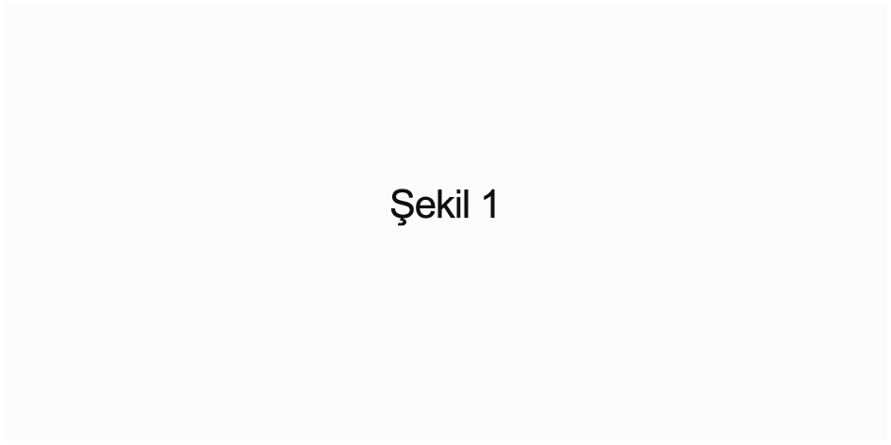

**Figure 1.** All figures must be in JPEG or TIFF format, not in Excel extension. Shapes should be embedded in the article and submitted as a separate file during the article presentation. Figures should be presented in black and white or grayscale. The width of the figures should not exceed 8 cm for two columns and 17 cm for one column.

If the figures, tables, or graphs do not fit in the columns, the entire page can be used as a single column without exceeding 17 cm. For example;

(Attention: Tables should not have vertical lines and shading.)



**Figure 2.** All figures should be in JPEG or TIFF format and should not be presented as Excel extension. The width of shapes should not exceed 8 cm for two columns and 17 cm for single column..

**Table 1.** The effect of Cr (VI) stress on stem and root length of 8 barley varieties in early seedling stage..

|  |  |  |  |
| --- | --- | --- | --- |
| **Barley** | **Cr(VI)**  **(µM)** | **Body length**  **(cm plant-1)** | **Root length**  **(cm plant-1)** |
| Angora | 0 | 23.2 ± 0.34 a | 10.1 ± 0.13 a |
| 75 | 18.6 ± 0.30 b | 8.0 ± 0.11 b |
| 150 | 13.9 ± 0.26 c | 7.0 ± 0.13 c |
| 225 | 12.1 ± 0.30 d | 7.0 ± 0.12 c |
| Aydanhanım | 0 | 18.7 ± 0.25 a | 12.2 ± 0.26 a |
| 75 | 16.6 ± 0.26 b | 7.0 ± 0.11 b |
| 150 | 14.4 ± 0.27 c | 6.5 ± 0.13 c |
| 225 | 11.3 ± 0.22 d | 6.1 ± 0.11 c |
| Başgül | 0 | 22.9 ± 0.28 a | 11.0 ± 0.18 a |
| 75 | 22.0 ± 0.37 a | 7.9 ± 0.14 b |
| 150 | 18.2 ± 0.28 b | 6.3 ± 0.12 c |
| 225 | 14.1 ± 0.39 c | 5.9 ± 0.09 d |

a-d;The different letters in the column of a criterion indicate statistically significant differences between the averages (P <0.05). Each value is the average of 12 replicates of three replicates (n = 36). Standard error (± SH).

## *3.1. Second-order title*

Findings can be supported with figures, charts or graphs. In the text, tables, figures or graphic numbers should be given in the relevant fields and the tables, figures and graphics explained below should be given.

The table names should be written at the top of the chart and the figure and graphic names should be written in 10 pt below the figure or graph.

**4. Discussion and Conclusion**

The similarities and differences of the results with other studies should be given and the possible causes of the results should be discussed. The importance and contribution of the results to science should be emphasized. The results should be interpreted without any unnecessary duplication.

**Acknowledgment**

This section must be formatted to be 10 point, 1 line spaced and justified. A short thank you to the institutions or people who support the study or to the experts who make recommendations for the research done.

**5. References**

***References are given in the text;***

Erol (2017)

Panda and Frankenstein (2014)

Bağcı et al. According to (2003)

At the end of the sentence;

If single author; (Samantaray2002)

National source:

With two authors; (Domestic and Has 2017)

Foreign source:

With two authors; (Panda andChoudhury 2005)

National source:

If there are more than two authors; (Baybura et al. 2017)

Foreign source:

If there are more than two authors; (Hankset al. 2009)

Internet resources; (IntKyn. 1)

When referring to more than one source;

(Domestic and Has 2017, Hankset al. 2009, Baybura et al. 2017)

In the Resources directory;

When the sources are written down, the first-order authors should be arranged in alphabetical order.

If the source is an article;

Author's surname, initials, year of publication. Title of article. The long name of the journal (italics), volume number, number number (if any bold), page range.

For example;

Bağcı, S.A., Ekiz, H. and Yılmaz, A., 2003. Determination of the salt tolerance of some barley genotypes and the characteristics affecting tolerance. *Turkish Journal of Agriculture and Forestry*, **27**, 253-260.

Panda, S.K. andChoudhury, S., 2005.Chromium stress in plants.*Brazilian Journal of Plant Physiology*, **17**, 95–102.

Samantaray, S., 2002. Biochemical responses of Cr–tolerant and Cr–Sensitive mung bean cultivars grown on varying levels of chromium. *Chemosphere*, **47**, 1065–1072.

*ıf the source is a book;*

*Author's last name, initial letter (s), year. Name of the book. skin number, editor (s), publisher, page range.*

*For example;*

*Taiz, L. and Zeiger, E., 2008. Plant Physiology. Professor Dr. Ismail Turkan (translation), Palme Publishing, 350-252.*

*The source is the thesis;*

*Author's surname, first letter of his / her name, year of thesis. Name of thesis, type of thesis (Master's degree, PhD), institute where the thesis is presented, place of presentation, total page.*

*For example;*

*Farmer, E. A., 2010. Some of the genetic differences in wheat varieties grown in Turkey determination by RAPD-PCR method. PhD Thesis, Uludag University, Institute of Science and Technology, Bursa, 118.*

*Internet resource; At the end of the resources, internet resources are given under the sub-heading.*

*Internet resources*

1-http://www.kgm.gov.tr, (07.12.2016)

2-http://www.koeri.boun.edu.tr, (07.07.2017)

3-https://igscb.jpl.nasa.gov/components/prods_cb.html, (27.04.2007)