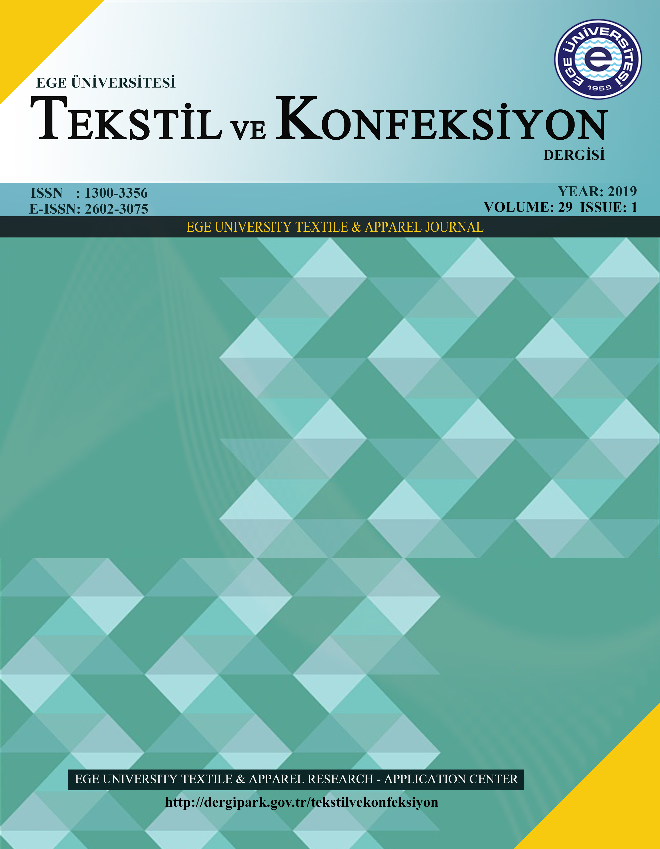
TEKSTİL VE KONFEKSİYON

Title of the Paper

Author Name Surname¹, Author Name Surname²

¹ University / Institution / Company Address
² University / Institution / Company Address

Corresponding Author: Name Surname, E-mail

ABSTRACT
An abstract not exceeding 150 words should contain some basic information of the paper only in English.

KEYWORDS
4-5 Keywords

- INTRODUCTION

This is a template for the articles that can be published in Tekstil ve Konfeksiyon. The paper must be written in English. It should be structured in the following way: INTRODUCTION (application area, research course), MATERIAL AND METHOD (method used), RESULTS and DISCUSSION, CONCLUSION and REFERENCES It is expected that authors will submit carefully written and proofread material. Spelling and grammatical errors, as well as language usage problems, is on the responsibility of the authors.
Introduction should include the aim of the study and results from previous notable studies.
Tables and Figures should be cited in the text and placed after their first reference. They should be numbered using Arabic numerals. Tables should present new information rather than duplicating what is in the text. Figures should be in high resolution (1200 dpi for line art, 600 dpi for grayscale and 300 dpi for color, at the correct size).
Equations are numbered in parentheses to the right; they are referred to in the text as Equation (2), Equation (6b), etc., with parentheses. Footnotes should be avoided. The journal requires the use of The International System of Units (SI) for all numerical data.
Citation in the text should be placed by square brackets, e.g. [1].

Figure 1. Description of the figure

MATERIAL AND METHOD

2.1 Material

Each new section and subsection should have a heading consisting of an Arabic numeral followed by a period. Please a single space before and after the section title (see this template).

2.2 Method
Each new section and subsection should have a heading consisting of an Arabic numeral followed by a period. Please a single space before and after the section title (see this template).

Table 1. Description of the table

Code | Materials | Abbreviation | g/m²
A1 | Sample 1 | PP | 0
B2 | Sample 2 | PA | 0
C3 | Sample 3 | PE | 0
D4 | Sample 4 | CO | 0

RESULTS AND DISCUSSION
3.1 Subtitle
This is a template for the articles that can be published in Tekstil ve Konfeksiyon. The paper must be written in English. It should be structured in the following way: INTRODUCTION (application area, research course), MATERIAL AND METHOD (method used), RESULTS and DISCUSSION, CONCLUSION and REFERENCES It is expected that authors will submit carefully written and proofread material. Spelling and grammatical errors, as well as language usage problems, is on the responsibility of the authors.
Tables and Figures should be cited in the text and placed after their first reference. They should be numbered using Arabic numerals. Tables should present new information rather than duplicating what is in the text. Figures should be in high resolution (1200 dpi for line art, 600 dpi for grayscale and 300 dpi for color, at the correct size).
Equations are numbered in parentheses to the right; they are referred to in the text as Equation (2), Equation (6b), etc., with parentheses. Footnotes should be avoided. The journal requires the use of The International System of Units (SI) for all numerical data.
Citation in the text should be placed by square brackets, e.g. [1].

CONCLUSION
The general results of the research, the limitations and also the future studies of the subject are discussed in this section. Tables and Figures should be cited in the text and placed after their first reference. They should be numbered using Arabic numerals. Tables should present new information rather than duplicating what is in the text. Figures should be in high resolution (1200 dpi for line art, 600 dpi for grayscale and 300 dpi for color, at the correct size).
Equations are numbered in parentheses to the right; they are referred to in the text as Equation (2), Equation (6b), etc., with parentheses. Footnotes should be avoided. The journal requires the use of The International System of Units (SI) for all numerical data.
Citation in the text should be placed by square brackets, e.g. [1].

Acknowledgement
Please supply all ldetails required by your funding and also the appreciation for something. For instance: This work was supported by the [Funding Agency] under Grant [number xxxx]. The author(s) wish to thank….
REFERENCES
- Author AA. Year. Title of article. Journal Title volume(issue), pages.
- Author AA, Author B, Author C. Year. Title of article Journal Title volume(issue), pages.

The references should be listed in the same order as cited in the text. Please note that all references listed in the references section must be directly cited in the body of the text.
REFERENCE LIST
Journal
Basic format (with one author) | Author AA. Year. Title of article. Journal Title volume(issue), pages.
Two or more authors | Author AA, Author B, Author C. Year. Title of article Journal Title volume(issue), pages.
Article published online ahead of placement in an issue | Author A. Year. Title of article. Journal Title Advance online publication. [Retrieved from URL] or [DOI]
Book
Basic format (with one author) | Author AA. Year. Title of book. Place: Publisher.
Two authors | Author AA, Author B. Year. Title of book. Place: Publisher.
Chapter in an edited book | Author AA. Year. Chapter title. In E. E. Editor (Ed.), Title of book. Place: Publisher, pages.
Conference
Proceedings | Author AA. (Ed.). Year, Month. Proceedings of the XXX Symposium, City, Country.
Paper in proceedings | Author AA, Author B. Year, Month. Title of the paper. In E.E. Editor (Ed.), Proceedings of the XXX symposium (pages). City, Country.
Dissertation / Thesis
PhD | Author AA. Year. Title of doctoral dissertation (Doctoral dissertation). Retrieved from/Available from Name of database. (Accession or Order number)  Author AA. Year. Title of doctoral dissertation (Unpublished doctoral dissertation). Name of Institution, Location.
Master’s | Author AA. Year. Title of a master’s thesis (Master’s thesis). Retrieved from/ Available from Name of database. (Accession or Order number)  Author AA. Year. Title of a master’s thesis (Unpublished master’s thesis). Name of Institution, Location.
Technical report
Report | Author AA. Year. Title of work (Report No. xxx). Place: Institution.
Online sources
Web page | Author AA. Year, Month Day. Title of document [Format description]. Retrieved from http://URL
Other reference types
Review | Reviewer RR. Year. Title of review [Review of the publication Title of the publication, by A. A. Author]. Periodical Title, Volume(issue), pages.
Patent | Inventor AA. Year of the issue. Patent Number. Place: Office Issuing the Patent.

