Article name (12 pts., Times New Roman, Bold)
Author Name, Surname (Must be blank for blind review)
Affiliation, City, Country, email address

ABSTRACT | The abstract should be maximum 200 words and typed by using Times New Roman.
Keywords: | Three - seven key words

Citation: | Surname, N. (YYYY). Article name. International Sport Science Student Studies Journal, v(i), pp-pp.  DOI: 10.19128/i4s.

1. Introduction
Moral is defined as a cognitive structure which include an individual’s innate or acquired attitudes and behaviours, reasoning consciously about subjects such as justice-injustice, right-wrong, good-bad, and making a decision to act (Çitemel, 2010).

2. Methodology
The present study prepared as a qualitative study. Qualitative research method is defined as a research type. It aims to show events by following a process which is included with qualitative collection such as document analysis, interview and observation by realistic and integrative way (Yıldırım and Şimşek; 2013, p. 45); it contains, as an umbrella term, trying to reach terms and techniques about solving, interpreting and making sense (Merriam, 2013, p. 13).
2.1. Study Group: It consists of 11 young elite athletes from different branches. For determining study group, maximum sampling was used.
2.2. Process of Data Collection: Semi-structured method was used for interview to determine what national athletes think..….
2.3. Analysis
The interviews made with athletes, were recorded and textualized in computer by the researcher.
3. Findings
4. Discussion and Conclusion
References

General Rules
- It is recommended to submit your article via logging into https://dergipark.org.tr/tr/pub/i4s, Studies not sent via the system are not accepted. Writing rules are as follows;

- Font: Times New Roman

- Font Size: Title 12, Abstract 10, Text 12

- Page Margins: 2.5 cm from all sides.

- English translation should be supported by competent persons and institutions.

- Paragraph indentation should not be used in the manuscript, and the line spacing should be “single” and 0 nk. There should be single line spacing after headings and paragraphs.

- Tables, charts, figures, etc. The headings of the images should be 12 pt., the content should be 10 pt. (7-10 pt. if necessary) and should be prepared according to APA style.

- Study pages and References should not be numbered.

- The article will include Introduction, Methods, Results, Discussion, Conclusion and Reference. Titles are flush left and the first letter will be capitalized.

- Copyright Form is requested from the authors by the editorial board when the study is uploaded to the system.

- Plagiarism evaluation of the studies is carried out by the Pre-Review Editor. The maximum percentage for similarity is 20% and single source match is <3% in the study. Studies, do not have the desired value ranges, are rejected.

- Manuscripts should be uploaded to the system in Microsoft Word format. While preparing your manuscript please use the I4S Manuscript Template

- It is mandatory to include extended summary according to the language of the publication.

- Reference must be 10 pt. and Indent must be special (hanging) and line gap must be 0 pt (before and after) and single.

- Abstract should not exceed 200 words.
- Extended summary should be on the last page of the study and at least 750 words.

- 3-7 keywords related to the content of the study should be given and keywords should be separated by commas.

Figures: Figure text and the number should be written in italics and the text part should be written normally. The example is given below.
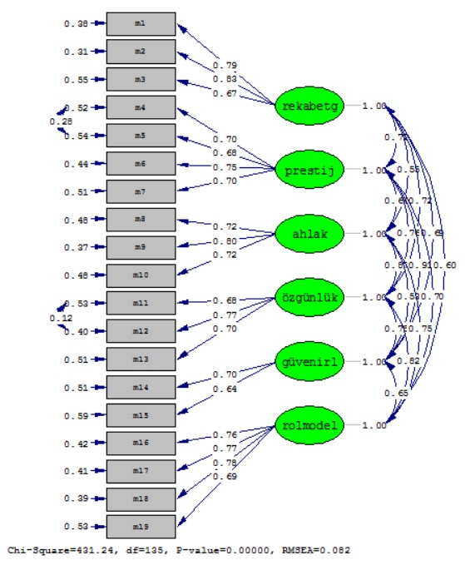
Figure 1. Path diagram of the first level confirmatory factor analysis

For Tables: Table text and the number should be written normal. The text should be written in italics in second line. The example is given below.

Tablo 1.
Reliability results of scale application
Dimensions | Internal consistency | Split-half reliability
Competitiveness | .91 | .91
Prestige | .86 | .90
Morality | .86 | .85
Authenticity | .84 | .90
Credibility | .77 | .78
Role Model Influence | .90 | .91
Whole Scale | .95 | .96

Citations
For International Sport Science Student Studies journal wants from the author to use APA 7th edition (American Psychological Association) for in-text and end-text citations. The detailed information from APA publication can be retrieved from http://www.apastyle.org/manual/index.aspx

For in-text citations
Author type | Parenthetical citation | Narrative citation
One author | (Luna, 2020) | Luna (2020)
Two authors | (Salas & D’Agostino, 2020) | Salas and D’Agostino (2020)
Three or more authors | (Martin et al., 2020) | Martin et al. (2020)

References
For Journal articles:
Grady, J. S., Her, M., Moreno, G., Perez, C., & Yelinek, J. (2019). Emotions in storybooks: A comparison of storybooks that represent ethnic and racial groups in the United States. Psychology of Popular Media Culture, 8(3), 207–217. https://doi.org/10.1037/ppm0000185

For books:
Rabinowitz, F. E. (2019). Deepening group psychotherapy with men: Stories and insights for the journey. American Psychological Association. https://doi.org/10.1037/0000132-000
Sapolsky, R. M. (2017). Behave: The biology of humans at our best and worst. Penguin Books.

Chapter in a Book:
Aron, L., Botella, M., & Lubart, T. (2019). Culinary arts: Talent and their development. In R. F. Subotnik, P. Olszewski-Kubilius, & F. C. Worrell (Eds.), The psychology of high performance: Developing human potential into domain-specific talent (pp. 345–359). American Psychological Association. https://doi.org/10.1037/0000120-016

Dictionary Entry
Merriam-Webster. (n.d.)*. Culture. In Merriam-Webster.com dictionary. Retrieved September 9, 2019, from https://www.merriam-webster.com/dictionary/culture

Webpage on a Website
Fagan, J. (2019, March 25). Nursing clinical brain. OER Commons. Retrieved September 17, 2019, from https://www.oercommons.org/authoring/53029-nursing-clinical-brain/view
National Institute of Mental Health. (2018, July). Anxiety disorders. U.S. Department of Health and Human Services, National Institutes of Health. https://www.nimh.nih.gov/health/topics/anxiety-disorders/index.shtml

Tweet
APA Databases [@APA_Databases]. (2019, September 5). Help students avoid plagiarismWeb emoji of crossing hands and researchers navigate the publication process. More details available in the 7th edition @APA_Style table [Tweet]. Twitter. https://twitter.com/APA_Databases/status/1169644365452578823

Gates, B. [@BillGates]. (2019, September 7). Today, it’s difficult for researchers to diagnose #Alzheimers patients early enough to intervene. A reliable, easy and accurate diagnostic would [Thumbnail with link attached] [Tweet]. Twitter. https://twitter.com/BillGates/status/1170305718425137152

Facebook Post
News From Science. (2019, June 21). Are you a fan of astronomy? Enjoy reading about what scientists have discovered in our solar system—and beyond? This [Image attached] [Status update]. Facebook. https://www.facebook.com/ScienceNOW/photos/a.117532185107/10156268057260108/?type=3&theater

YouTube Video
Harvard University. (2019, August 28). Soft robotic gripper for jellyfish [Video]. YouTube. https://www.youtube.com/watch?v=guRoWTYfxMs

Government Report
National Cancer Institute. (2019). Taking time: Support for people with cancer (NIH Publication No. 18-2059). U.S. Department of Health and Human Services, National Institutes of Health. https://www.cancer.gov/publications/patient-education/takingtime.pdf

Newspaper Article
Carey, B. (2019, March 22). Can we get better at forgetting? The New York Times. https://www.nytimes.com/2019/03/22/health/memory-forgetting-psychology.html

* For works with no date, use “n.d.” in the in-text citation

APPENDIX 1. (If the Manuscript has APPENDIXES Should Be Given After Reference List)

