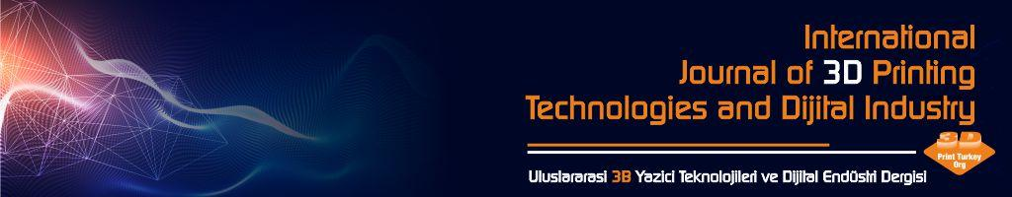
COPYRIGHT FORM

Name of Journal: International Journal of 3D Printing Technologies and Digital Industry
Name of Manuscript: ...............................................................................................................................................................................................................................................................................................................................................................................................................................................................................................................................................................
Author (s) Name and Surname (the manuscript respectively): ..........................................................................................................................................................................................................................................................................................................................................................................
.....................................................................................................................................................................................
.....................................................................................................................................................................................
.....................................................................................................................................................................................
.....................................................................................................................................................................................
.....................................................................................................................................................................................
Corresponding Author:
TC Identification number:...........................................................................
E-mail: ....................................................................................
Mobile Phone: ......................................................................
On behalf of all authors as responsible author:
a) the submitted article is the original work of the author (s);
b) the article is neither published in another peer-reviewed journal nor under review in another journal for publication. Moreover, the article does not infringe any existing copyright or third party rights.
c) that all authors participated in this study individually and took all responsibility for this study;
d) that all authors have seen and approved the final version of the manuscript submitted;
e) that the e-mail and postal addresses of all authors are entered correctly in the Article Submission and Evaluation System at https://dergipark.org.tr/en/pub/ij3dptdi;
f) the article is not published elsewhere or submitted for publication;
g) I agree and undertake that the text, figures and documents contained in the article do not infringe the Copyrights of other parties.
Nevertheless, the author (s) or, if any, the employer of the author (s): a) patent rights; b) the right of the author (s) to use the entire article free of charge in future books or other works; c) intellectual property rights, such as the right to reproduce for its own purposes, provided that the article is not sold. I undertake that there are no criminal elements or unlawful statements in the article, that I do not use any materials and methods that are unlawful during the research, that I have obtained all legal permissions and that I act in accordance with ethical rules.
 | Name Surname | Date | Sign
Corresponding Author

