**Research Article/Review Article**

Article Title in English

**Abstract**

The abstract should be 200-250 words and indicate the purpose, scope, method, importance, and originality of the study, together with its contribution to the relevant research field. Any information not included in the manuscript should not be given in the abstract. The abstract should not include definitions, descriptions, figures, tables, citations or references.

**Keywords**: Keyword 1; Keyword 2; Keyword 3; Keyword 4; Keyword 5 (The keywords should provide information about the topic, scope and the content of the manuscript. Up to 5 keywords can be given. Keywords should be separated via semi colon (;) and written in lower case with the first letter capitalized.)

**Araştırma Makalesi/Derleme Makale**

Makalenin Türkçe Başlığı

**Öz**

Öz, çalışmanın amacını, kapsamını, yöntemini, önemini, özgün yönü ile incelediği alana getirdiği katkıyı belirtilecek şekilde 200-250 kelime uzunluğunda olmalıdır. Makale içeriğinde yer almayan bilgiler, özde yer almamalıdır. Özü oluşturan metinde tanım, tanımlayıcı bilgi, görsel, tablo, alıntı veya kaynak bulunmamalıdır.

**Anahtar Sözcükler**: Anahtar sözcük 1; Anahtar sözcük 2; Anahtar sözcük 3; Anahtar sözcük 4; Anahtar sözcük 5 (Seçilecek anahtar sözcükler, yazının konusu, kapsamı ve içeriği hakkında bilgi vermelidir. Anahtar sözcüklerin sayısı en fazla beş olmalıdır. Anahtar sözcükler noktalı virgül işareti (;) ile birbirinden ayrılarak ve ilk harfi büyük kalanı ise küçük harflerle yazılmalıdır.)

# INTRODUCTION

The introduction must clearly indicate the research topic, the purpose, the scope and importance of the study. The sections between introduction and conclusion should be named in relation to the content of the study. The main sections may include literature, methodology, results, and discussion. Acknowledgements (if applicable) and references should be given in the end. For the text, use Normal style in the template.

# SECTION TITLE

Section titles are to be in capital letters, bold and 11 pt. For section titles, use Heading 1 style in the template. No punctuation mark should be used after the section titles. While there is no empty line before or after the title.

The main body of the paper is to be 11 pt in upper and lower case letters, justified, single line spacing and 6pt line spacing between paragraphs.

For in-text citations; use Emphasis style in the template. Any quotation longer than 40 word should be placed in a free standing block of typewritten lines in italic cases without quotation marks, starting with 1 cm margin from the left. Other quotations shorter than 40 words should be enclosed in double quotation marks in the main body of the text. In direct quotations, the page number from which the quote is taken should also be included in the in-text citation within parentheses.

All citations in the text should follow the rules of American Psychological Association [APA] 7th version (see: https://apastyle.apa.org/style-grammar-guidelines). More detailed information about references could be found at the end of this template.

## Secondary Title

For secondary titles, use Heading 2 style in the template. The secondary titles are to be in lower case letters with first letter capitalized, bold and 11 pt, without any punctuation mark before and after.

For figure captions, use Caption style in the template. In text, references to each figure should be given (Figure 1). The edge of the visual materials (photographs, pictures, graphics, maps, etc.) should be between 6-18 cm. The figures should be prepared at a minimum of 300 DPI resolution and be submitted in jpeg format in addition to the manuscript. The figure and figure caption should be horizontally centered in the page. Figure caption in 10 pt, should be given below the figure and without an empty line after the figure, as shown in Figure 1. When the figures are sequential, one empty line should be left between them. The text ‘Figure’ and its number should be bold. Only the first letters in figure descriptions should be capitalized. Aside from the example below, APA Style 7th version can be used in the preparation of figures and references.

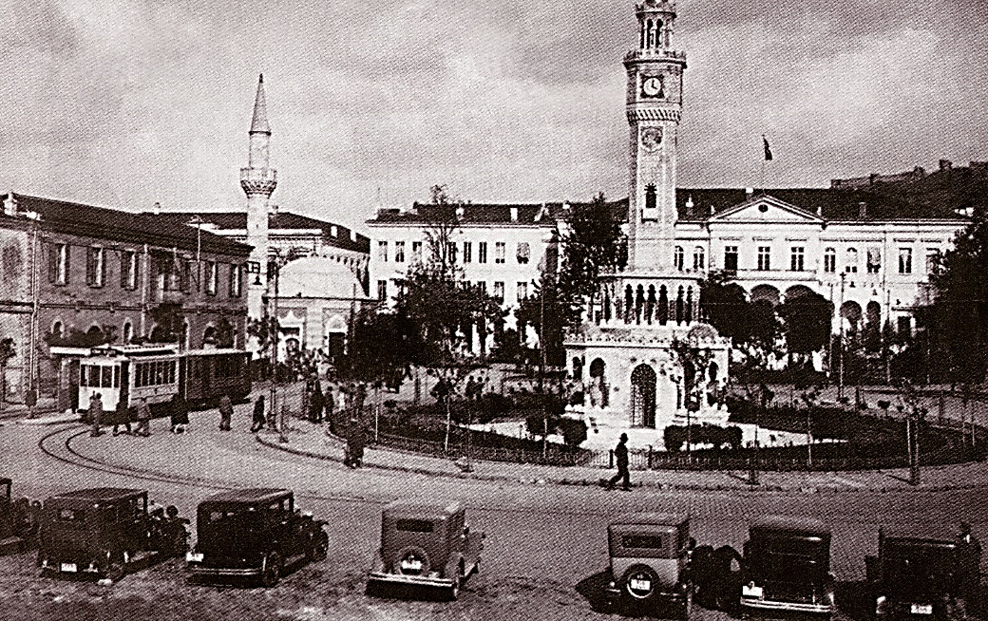

**Figure 1.** A photograph of Konak Square (Reference: APIKAM, 2019).

For table captions, use Caption style in the template. In text, references to each table should be given (Table 1). Tables as in the example below (e.g. Table 1 and Table 2) should be clear, readable and comprehensible (not less than 8 pt). Table caption should be given above the figure, in 10 pt and with no empty line before or after the caption, as shown in the examples of Table 1 and Table 2. After the table, one empty line should be left. The text ‘Table’ and its number should be bold. Only the first letter of the table description should be capitalized. Tables should be prepared with all borders.

**Table 1**. Table caption (Reference: Authors).

|  |  |  |
| --- | --- | --- |
| **Country** | **Number of person** | **%** |
|  |  |  |
|  |  |  |
|  |  |  |
|  |  |  |

**Table 2.** Table caption (Reference: ...).

|  |  |  |
| --- | --- | --- |
| **Space** | **m²** | **Function** |
|  |  |  |
|  |  |  |
|  |  |  |
|  |  |  |

In text, reference to each equation should be given (Equation 1). Submit each equation as an editable text, not as images (use the equation editor). Variables in equations should be presented in italics and defined in the text. If applicable, citations to equations should be given in the text according to APA Style 7th version. Use the international system of units (*Système International d'Unités - SI*) for equations. Equations are numbered in order. According to the length of the equation, simple equations should be written in 10 pt and italic and centered in the page as in the example below. The number of the equation should be indicated in parenthesis in bold and right aligned after the variable descriptions.

$$P=\sum_{i=1}^{n}{y\frac{x}{z}}πr^{2}$$

*P: Population*

*y: years*

**(Equation 1)**

# CONCLUSION

The contribution of the study to the literature, the extent to which the findings support the previous studies and theories and the applied value should be discussed in this section. Figures, tables and long citations are not recommended in this section.

# ACKNOWLEDGEMENT

Any individual, public or private organization, who provided technical or scientific help or funding for the study must be listed in this section. Aside from this section, do not include any acknowledgements on other parts of the article.

# REFERENCES

All cited references in the text must be given in this section. References are given in alphabetical order, without separating into sub sections. The second and following lines of each reference should have 1 cm indentation from the left. References should be prepared according to APA Style 7th version. Examples of this style are given at the end of this guide.

# APPENDIX FOR WRITING STYLE:

## Important Notes on Format

The Tahoma font is to be used throughout the manuscript. The manuscript has to be uploaded in .doc or .docx format on a vertically aligned A4 page. The page margins are set to 2 cm. from the left and right sides and 2.5 cm from above and below the page (They can be set in Page Layout > Margins > Custom Margins in MSWord software). The paragraphs are justified; 0 cm indentation from either the left or the right; The spaces in paragraphs are single spacing with 0 nk Before and 6 nk After (They can be set in Paragraph > Indents and Spacing in MSWord software).

Author names and related information should not be included in the manuscript. Author names and affiliations should be included in the Title Page that is submitted as a separate file.

Article title, bold, 14 pt, single line spacing, first letter capitalized and centered. Title style in the template.

Abstract, 10 pt, single line spacing and justified. Normal style in the template.

Keywords, 10 pt, single line spacing and justified. Normal style in the template.

Section titles, bold, 11 pt, single line spacing, capitalized and left aligned. Heading 1 style in the template.

Secondary titles, bold, 11 pt, single line spacing, each word starts with a capital and left aligned. Heading 2 style in the template.

Main text, 11 pt, single line spacing and justified. Normal style in the template.

Figure captions, 10 pt, single line spacing and centered. Caption style in the template.

Table captions, 10 pt, single line spacing and centered. Caption style in the template.

Equation captions, 10 pt, single line spacing and right aligned in parenthesis.

(If applicable) Footnotes, 9 pt, single line spacing and justified.

(If applicable) Acknowledgement, 10 pt, single line spacing and justified.

References, 10 pt, single line spacing and justified. Reference style in the template. One empty line should be left between each reference.

## Writing and Citation Rules according to APA Style 7th Version

Citations and References should be prepared according to APA Style 7th version. For more detailed information, please see https://apastyle.apa.org/style-grammar-guidelines.

Use the author – date system to cite references in the manuscript. In-text citations may be parenthetical or narrative. In parenthetical citations, use an ampersand (&) between names for a work with two authors or before the last author when all names must be included. In narrative citations, use “and” instead of ampersand (&).

**Table 3.** In-text citations (Reference: APA, 2020)

|  |  |  |
| --- | --- | --- |
| **Author type** | **Parenthetical citation** | **Narrative citation** |
| One author | (Luna, 2020) | Luna (2020) |
| Two authors | (Salas & D’Agostino, 2020) | Salas and D’Agostino (2020) |
| Three or more authors | (Martin et al., 2020) | Martin et al. (2020) |
| Group author with abbreviation  First citation a  Subsequent citations | (National Institute of Mental Health [NIMH], 2020)  (NIMH, 2020) | National Institute of Mental Health (NIMH, 2020)  NIMH (2020) |
| Group author without abbreviation | (Stanford University, 2020) | Stanford University (2020) |

a Define the abbreviation for a group author only once in the text, where it is introduced for the first time, choosing either the parenthetical or the narrative format. Thereafter, use the abbreviation for all mentions of the group in the text.

Below are examples regarding the reference styles.

**Journal Article**

Edwards, A. A., Steacy, L. M., Siegelman, N., Rigobon, V. M., Kearns, D. M., Rueckl, J. G., & Compton, D. L. (2022). Unpacking the unique relationship between set for variability and word reading development: Examining word- and child-level predictors of performance. *Journal of Educational Psychology*, 114(6), 1242–1256. https://doi.org/10.1037/edu0000696

**Online Magazine Article**

Thomson, J. (2022, September 8). Massive, strange white structures appear on Utah’s Great Salt Lake. *Newsweek*. https://www.newsweek.com/mysterious-mounds-great-salt-lake-utah-explainedmirabilite-1741151

**Print Magazine Article**

Nicholl, K. (2020, May). A royal spark. *Vanity Fair*, 62(5), 56–65, 100.

**Online Newspaper Article**

Roberts, S. (2020, April 9). Early string ties us to Neanderthals. *The New York Times*. https://www.nytimes.com/2020/04/09/science/neanderthals-fiber-string-math.html

**Print Newspaper Article**

Reynolds, G. (2019, April 9). Different strokes for athletic hearts. *The New York Times*, D4.

**Authored Book**

Kaufman, K. A., Glass, C. R., & Pineau, T. R. (2018). *Mindful sport performance enhancement: Mental training for athletes and coaches*. American Psychological Association. https://doi.org/10.1037/0000048-000

**Edited Book Chapter**

Zeleke, W. A., Hughes, T. L., & Drozda, N. (2020). Home–school collaboration to promote mind– body health. In C. Maykel & M. A. Bray (Eds.), *Promoting mind–body health in schools: Interventions for mental health professionals* (pp. 11–26). American Psychological Association. https://doi.org/10.1037/0000157-002

**Online Dictionary Entry**

American Psychological Association. (n.d.). Internet addiction. In *APA dictionary of psychology*. Retrieved April 24, 2022, from https://dictionary.apa.org/internet-addiction

**Report by a Group Author**

World Health Organization. (2014). *Comprehensive implementation plan on maternal, infant and young child nutrition*. https://apps.who.int/iris/bitstream/handle/10665/113048/WHO_NMH_NHD_14.1_ eng.pdf?ua=1

**Report by Individual Authors**

Winthrop, R., Ziegler, L., Handa, R., & Fakoya, F. (2019). *How playful learning can help leapfrog progress in education. Center for Universal Education at Brookings*. https://www.brookings.edu/wp-content/ uploads/2019/04/how_playful_learning_can_help_leapfrog_progress_in_education.pdf

**Press Release**

American Psychological Association. (2020, March 2). *APA reaffirms psychologists’ role in combating climate change* [Press release]. https://www.apa.org/news/press/releases/2020/03/combatingclimate-change

**Conference Session**

Davidson, R. J. (2019, August 8–11). *Well-being is a skill* [Conference session]. APA 2019 Convention, Chicago, IL, United States. https://irp-cdn.multiscreensite.com/a5ea5d51/files/uploaded/APA2019_ Program_190708.pdf

**Dissertation From a Database**

Horvath-Plyman, M. (2018). Social media and the college student journey: An examination of how social media use impacts social capital and affects college choice, access, and transition (Publication No. 10937367). [Doctoral dissertation, New York University]. ProQuest Dissertations and Theses Global.

**Preprint Article**

Latimier, A., Peyre, H., & Ramus, F. (2020). A meta-analytic review of the benefit of spacing out retrieval practice episodes on retention. PsyArXiv. https://psyarxiv.com/kzy7u/

**Data Set**

O’Donohue, W. (2017). *Content analysis of undergraduate psychology textbooks* (ICPSR 21600; Version V1) [Data set]. Inter-university Consortium for Political and Social Research. https://doi.org/10.3886/ ICPSR36966.v1

**Film or Video**

Docter, P., & Del Carmen, R. (Directors). (2015). *Inside out* [Film]. Walt Disney Pictures; Pixar Animation Studios.

**TV Series Episode**

Dippold, K. (Writer), & Trim, M. (Director). (2011, April 14). Fancy party (Season 3, Episode 9) [TV series episode]. In G. Daniels, H. Klein, D. Miner, & M. Schur (Executive Producers), *Parks and recreation*. Deedle-Dee Productions; Fremulon; 3 Arts Entertainment; Universal Media Studios.

**Artwork**

van Gogh, V. (1889). The starry night [Painting]. The Museum of Modern Art, New York, NY, United States of America. https://www.moma.org/learn/moma_learning/vincent-van-gogh-the-starry-night-1889/

**Art Exhibition**

Design for eternity: Architectural models from the ancient Americas [Exhibition]. The Metropolitan Museum of Art, New York, NY, United States of America. https://www.metmuseum.org/exhibitions/listings/2015/design-for-eternity

**Webpage on a News Website**

Machado, J., & Turner, K. (2020, March 7). *The future of feminism*. Vox. https://www.vox.com/ identities/2020/3/7/21163193/international-womens-day-2020

**Webpage With a Retrieval Date**

Center for Systems Science and Engineering. (2020, May 6). *COVID-19 dashboard by the Center for Systems Science and Engineering (CSSE) at Johns Hopkins University (JHU)*. Johns Hopkins University & Medicine, Coronavirus Resource Center. Retrieved May 6, 2020, from https://coronavirus.jhu.edu/map.html

## Figures (images, illustrations, photographs, maps, charts) and Tables

Cite and reference the sources of all figures and tables in the caption as in-cite references (as exemplified above). If the figures and/or tables are specifically prepared by the authors for this manuscript, they should be referenced in the caption (as exemplified above). The references for the figures and tables should be given in the References together with other sources.

## Other Issues about references and citations:

* References should be listed alphabetically.
* If an author has many studies published in the same year, letters (a, b, c) should be used (e.g. according to Berndt (1981a) ...).
* If authors have the same surname, the first letter of their first names should be used to prevent confusion (e.g. E. Johnson, 2001; L. Johnson, 1998).
* When there is more than one citation, they should be given in alphabetical order with semicolons between the two studies (e.g. (Akar, H. 2010; Çalışkan, 2008; Dinçer & Kolaşin, 2009; Engin-Demir, 2009; Tunç, 2007).
* The APA recommends the use of “&” instead of “and” in citations and references.
* If the number of authors are three or more, refer only to the first author’s surname as (e.g. (Aron et al., 2019).
* The use of footnotes and endnotes are not preferred in APA style. Footnotes can only be used if there is a very pressing need.

**Note:** When there is a situation not explained in this template regarding the writing of an article or citations, rules for writing scientific articles should be taken as a basis. The responsibility of the articles that do not comply with these rules and principles belongs to the author(s), and in such cases, the Editor has the right to edit or reject the article.