Research Article or Review Article (Select one type)

Makale başlığı (İngilizce olması durumunda yer değiştirilir)

First Author1,*, Second Author1,2

1 Department, Faculty, University, City, Country

2 Department of Transportation Engineering, Faculty of Engineering and Natural Sciences, Bandırma Onyedi Eylül University, Bandırma, Turkey

\**Correspondence:* [*jitsa@bandirma.edu.tr*](mailto:jitsa@bandirma.edu.tr)

**Özet:** Bu doküman, yazarlar tarafından Akıllı Ulaşım Sistemleri ve Uygulamaları Dergisine yapılan araştırmaların gönderilmesi için oluşturulan bir şablondur. Makalenin başlığı ilk sözcük ve özel isimler haricinde küçük harfle 13 Punto’da yazılmalıdır (örnek başlıktaki gibi). Yazar isimleri eksiksiz olarak verilmelidir, ad ve soyadı (soyadları) ilk harfleri büyük harflerle yazılmalıdır. Yazar adresleri sırayla İngilizce olarak verilmelidir: Bölüm, Fakülte, Üniversite, Şehir, Ülke, her yazarın adının arkasından üst simgesiyle birlikte adresini belirtin. Dipnotlar adresler için kullanılmamalıdır. İlgili yazarın e-posta adresine bir yıldız işaretiyle açıkça verilmelidir. Özet 150-200 kelime arasında olmalı ve çalışmanın amacını ve sonuçlarını açıkça belirtmelidir. Makalenin başlığı ve özetinde matematiksel formüller bulunmamalıdır. Özette referans atıfları bulunmamalıdır. En az iki anahtar kelime olmalı ve virgülle ayrılmalıdır ve kısaltmaları içermemelidir. Başlık, yazar bilgileri, adres, özet ve abstract bölümleri satır aralığı 1 satır olmalıdır. Her bir paragraf aralığı (sonra 6 nk) boşluk bırakılmalıdır. Sayfa yapısının her bir tarafı (sağ-sol, üst-alt) için kenar boşlukları 2,5 cm olmalıdır. Sayfa numaraları, sayfanın sağ alt köşesinde yer almalıdır.

**Anahtar Kelimeler:** Akıllı ulaşım sistemleri, kent içi ulaşım, akıllı şehirler

Manuscript template full title must be in sentence case

**Abstract:** This document is a template for use by authors sending manuscripts to the *Journal of Intelligent Transportation Systems and Applications.* The title of the manuscript must be written in lower case except for the first word and proper nouns, size 13. Author names must be given in full, with surnames (family names) first alphabet in capitals. Author addresses must be given in English in the following order: Department, Faculty, University, City, Country, with numbers in superscript after each author name to indicate his/her address. Footnotes must not be used for addresses. The corresponding author’s email address must be clearly given, marked with an asterisk. The abstract must be between 150–200 words and must clearly state the study’s purpose and results. The manuscript’s title and abstract must not contain mathematical formulae. The abstract must not contain any reference citations. The key words must be separated by commas and should not include acronyms. Title, author information, address, abstract sections should have 1 line spacing. Each paragraph must be spaced (after 6 nk). For each side of the page structure (right-left, top-bottom) the margins should be 2.5 cm. The page numbers should be located at the bottom right corner of the page.

**Keywords:** Intelligent transportation systems, urban transportation, smart cities

1. Introduction

The Introduction should argue the case for the study, outlining only essential background, and should not include the findings or the conclusions. It should not be a review of the subject area, but should finish with a clear statement of the question being addressed. All main text paragraphs, including the abstract, must be fully (left and right) justified (justify text). All text, including title, authors, headings, captions and body, will be Times New Roman font. The title of the manuscript is to be written in 13 pt. Other titles are to be written in 11 pt and bold.

* 1. Manuscript content

Authors should use this template when preparing a manuscript for submission to the *Journal of Intelligent Transportation Systems and Applications*. The manuscript should be written in Microsoft Word 2007 or later. The text in the relevant sections of the template can be replaced by typing or copying and pasting, or the Styles given in the template can be used. Styles can be applied to selected sections of the text as shown in the Figure and Table.

**Table 1**. Heading and text fonts of manuscript

|  |  |  |
| --- | --- | --- |
| **Text** | **Alignment** | **Font and** |
| Title | Centre | 13 pt. Bold, 1.0 line spacing |
| Authors, Addresses | Centre | 11 pt. 1.0 line spacing |
| emails | Centre | 10 pt. italic |
| Abstract and Keywords heading | Centre | 11 pt. bold, 1.0 line spacing |
| Abstract and Keywords text | Centre | 11 pt. 1.0 line spacing |
| Section headings | Left | 11 pt. bold |
| Sub-section heads | Left | 11 pt. bold |
| Other all body texts | justify text | 11 pt. 1.5 line spacing |
| Figure and tables captions | Centre | 11 pt. |
| References | Centre | 11 pt. (as shown) |
| All text | Times New Roman, 2,5-cm margins | |

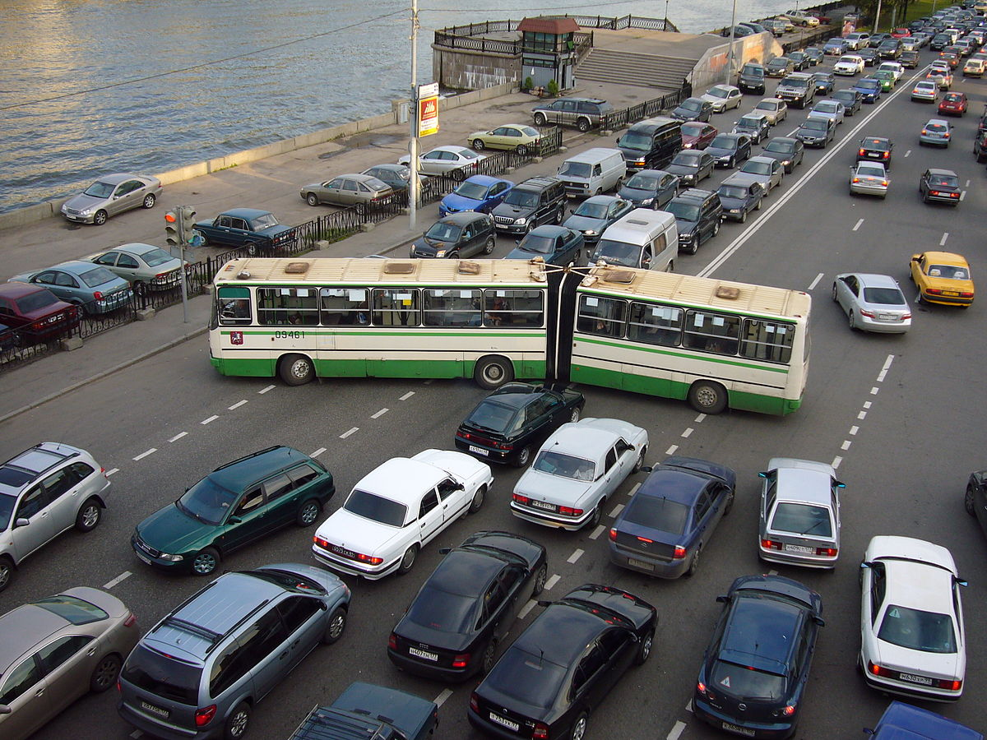

**Figure 1.** Negative effects of traffic accidents on society.

All figures, tables, etc. must have a caption, centre-justified in 11 pt. Captions precede tables but follow figures. Tables and figures must appear as close to their point of reference as satisfactory formatting of the final document permits.

Research articles should be divided into the sections listed below. Principal sections should be numbered consecutively (1. Introduction, 2. Materials and methods, etc.) and subsections should be numbered 1.1., 1.2., etc. Do not number the Acknowledgements or References sections.

Manuscripts must be written in Turkish or English. Contributors who are not native English speakers are strongly advised to ensure that a colleague fluent in the English language or a professional language editor has reviewed their manuscript. Concise English without jargon should be used. Repetitive use of long sentences and passive voice should be avoided. It is strongly recommended that the text be run through computer spelling and grammar programs.

All manuscripts are checked for their compliance with the Instructions for Authors. Manuscripts not complying with the instructions will not be submitted to referees for evaluation. Every page of the manuscript, including the title page, references, tables, etc., should be numbered. The manuscript must also have line numbers starting with 1 on each consecutive page.

* 1. Symbols, units, and abbreviations

In general, the journal follows the conventions of *Scientific Style and Format, The CSE Manual for Authors, Editors, and Publishers*, Council of Science Editors, Reston, VA, USA (7th ed.). If symbols such as ×, µ, η, or ν are used, they should be added using the Symbol menu of Word. Degree symbols (°) must be used from the Symbol menu, not superscripted letter o or number 0. Multiplication symbols must be used (×), not the letter x. Spaces must be inserted between numbers and units (e.g., 3 kg) and between numbers and mathematical symbols (+, –, ×, =, <, >), but not between numbers and percent symbols (e.g., 45%). Please use SI units. All abbreviations and acronyms should be defined at first mention. Latin terms such as et al., in vitro, or in situ should not be italicised. Use hectare instead of acre or decare. Use either SI (MKS) or CGS as primary units. (SI units are strongly encouraged.)

* 1. Reference citations

References are cited with the surname of author and year. In the references section, the references are listed alphabetically according to the surname of the author.

Citing of a reference at the beginning of or within a sentence must be as Boran (2003), whereas a citation at the end of a sentence must be as (Boran, 2003). The full-stop is placed directly after the citation.

A reference with two authors must be cited as Yılmaz and Johnson (2004) at the beginning of or within a sentence, or as (Yılmaz and Johnson, 2004) at the end of a sentence.

A reference with more than two authors must be cited as Yılmaz et al. (2004) at the beginning of or within a sentence, or as (Yılmaz et al, 2004) at the end of a sentence.

Different publications of an author published in the same year must be cited as Feray (2005a), Feray (2005b).

While citing a part of a publication; the number of the page the cited material (chapter, table, figure, or equation) is on must be indicated. While citing, the expression “page” must be abbreviated, but “chapter” must not. For example; (Centers for Disease Control and Prevention, 2005, p. 10), (Shimamura, 1989, Chapter 3).

Citing multiple publications in one pair of brackets; (Berndt, 2002; Harlow, 1983)

Citing personal communication in main text body; (V.–G. Nguyen, personal communication, September 28, 1998), (J. Smith, personal communication, August 15, 2009).

In the references section, reference tags must be listed according to the surname of author.

For citing of secondary references (In case the reference cites another reference), the secondary reference must be cited in brackets. In the references section, the reference tag is organized according to the secondary reference, the original reference must not be used as a tag. For example; In his e-mails, Smith argued that asynchronous line dancing would be the next Internet meme (as cited in Jones, 2010).

1. Materials and methods

Please provide concise but complete information about the materials and the analytical and statistical procedures used. This part should be as clear as possible to enable other scientists to repeat the research presented. Brand names and company locations should be supplied for all mentioned equipment, instruments, etc.

1. Results

The same data or information given in a Table must not be repeated in a Figure and vice versa. It is not acceptable to repeat extensively the numbers from Tables in the text or to give lengthy explanations of Tables or Figures.

* 1. Tables and figures

All illustrations (photographs, drawings, graphs, etc.), not including tables, must be labelled “Figure”. Figures must be submitted both in the manuscript and as separate files. All tables and figures must have a caption and/or legend and be numbered (e.g., Table 1, Figure 2), unless there is only one table or figure, in which case it should be labelled “Table” or “Figure” with no numbering. Captions must be written in sentence case (e.g., Macroscopic appearance of the samples.). The font used in the figures should be Times New Roman. If symbols such as ×, μ, η, or ν are used, they should be added using the Symbol menu of Word.

All tables and figures must be numbered consecutively as they are referred to in the text. Please refer to tables and figures with capitalisation and unabbreviated (e.g., “As shown in Figure 2…”, and not “Fig. 2” or “figure 2”). The tables and figures themselves should be given at the end of the text only, after the references, not in the running text.

The resolution of images should not be less than 118 pixels/cm when width is set to 16 cm. Images must be scanned at 1200 dpi resolution and submitted in jpeg or tiff format.

Graphs and diagrams must be drawn with a line weight between 0.5 and 1 point. Graphs and diagrams with a line weight of less than 0.5 point or more than 1 point are not accepted. Scanned or photocopied graphs and diagrams are not accepted.

Charts must be prepared in 2 dimensions unless required by the data used. Charts unnecessarily prepared in 3 dimensions are not accepted.

Figures that are charts, diagrams, or drawings must be submitted in a modifiable format, i.e. our graphics personnel should be able to modify them. Therefore, if the program with which the figure is drawn has a “save as” option, it must be saved as *.ai or *.pdf. If the “save as” option does not include these extensions, the figure must be copied and pasted into a blank Microsoft Word document as an editable object. It must not be pasted as an image file (tiff, jpeg, or eps) unless it is a photograph. Tables and figures, including caption, title, column heads, and footnotes, must not exceed 16 × 20 cm and should be no smaller than 8 cm in width. For all tables, please use Word’s “Create Table” feature, with no tabbed text or tables created with spaces and drawn lines.

Tables must be clearly typed, each on a separate sheet, and double-spaced. Tables may be continued on another sheet if necessary, but the dimensions stated above still apply.

1. Discussion

Statements from the Introduction and Results sections should not be repeated here. The final paragraph should highlight the main conclusions of the study. The Results and Discussion sections may be combined.

**Researchers’ Contribution Rate Statement**

Names and contribution rates -and any other contribution-related information- of each author must be given here.

Acknowledgment and/or disclaimers, if any

Names of funding organizations should be written in full.

**Conflict of Interest Statement, if any**

The authors certify that they have NO affiliations with or involvement in any organization or entity with any financial interest (such as honoraria; educational grants; participation in speakers’ bureaus; membership, employment, consultancies, stock ownership, or other equity interest; and expert testimony or patent-licensing arrangements), or non-financial interest (such as personal or professional relationships, affiliations, knowledge or beliefs) in the subject matter or materials discussed in this manuscript.

or

The authors report the following details of affiliation or involvement in an organization or entity with a financial or non-financial interest in the subject matter or materials discussed in this manuscript: Please specify the nature of the conflict.

References

Do not include personal communications, unpublished data, websites, or other unpublished materials as references, although such material may be inserted (in parentheses) in the text. If the author of a reference is an organization or corporation, use its name in the reference list (using an abbreviation in the citation, if appropriate); do not use “Anonymous”. In the case of publications in languages other than English, the published English title should be provided if one exists, with an annotation such as “(article in Turkish with an abstract in English)”. If the publication was not published with an English title, provide the original title only; do not provide a self-translation.

All authors should be included in reference lists unless there are 10 or more, in which case only the first 10 should be given, followed by ‘et al.’. References should be formatted as follows (please note the punctuation and capitalization):

**Abrahart, R. J., and See, L.** (1998). Neural Network vs. ARMA Modelling: Constructing Benchmark Case Studies of River Flow Prediction. In GeoComputation ’98. *Proceedings of the Third International Conference on GeoComputation*, University of Bristol, United Kingdom, 17–19 September (CD-ROM).

***ASTM standards on geosynthetics*.** (2000). West Conshohocken, Penn: ASTM.

**ASTM** (2012). *Standard Practice for Sampling of Geosynthetics and Rolled Erosion Control Products(RECPs) for Testing* (ASTM D4354-12). Retrieved from http://enterprise.astm.org/filtrexx40.cgi?+REDLINE_PAGES/D4354.htm

**Bilim** (t.y.). V*ikipedi.* Erişim: 05 Şubat, 2013, <http://tr.wikipedia.org/wiki/Bilim>

**Bilim etiği ve bilimde sahtekarlık.** (t.y.). Erişim: 04 Nisan 2006, http://www.aek.yildiz.edu.tr/bilim.htm

**Box, G. E. P. & Jenkins, J. M.** (1976). *Time Series Analysis: Forecasting and Control*. San Francisco, CA.: Holden-Day.

**Burger, J., Gochfeld, M., Jeitner, C., Burke, S., Stamm, T., Snigaroff, R., ..... Weston, J.** (2007). Mercury levels and potential risk from subsistence foods from the Aleutians. *Science of The Total Environment, 384,* 93-105. doi:10.10162007.05.004.

**LePichon, X**. (1997). Kişisel görüşme. 15 Mayıs, ISTANBUL.

**Leroux, G.** (2008). The phantom of the opera. Retrieved from http://books.google.com/books (Original work published 1911)

**Mynne, B. M.** (2003). *U.S. Patent No. 6,606,963.* Washington, DC: U.S. Patent and Trademark Office.

**O’Keefe, E.** (t.y.). *Egoism & the crisis in Western values.* Retrieved January 7, 2013 from http://www.

**Star trek planet classifications**. (n.d.). *Wikipedia.* Retrieved October 14, 2010, from <http://en.wikipedia.org>........

**Şengör, haritalarını bağışladı**. (2013, 23 Ekim). *Cumhuriyet,* s.20.

**Url-1** *<http://www.mohid.com>*, erişim tarihi 29.06.2012.

**Url-2** <*http://www.elet.polimi.it/*>, erişim tarihi 10.01.2013.

**Url-3** *<http://www.mohid.com>*, date retrieved 29.06.2006.

**3458 Sayılı Mühendislik ve Mimarlık Hakkında Kanun.** (1938). *T. C. Resmi Gazete, 3945,* 28 Haziran 1938.