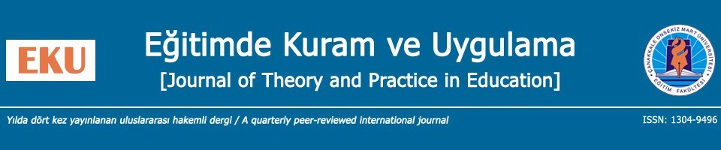

For the author(s),

Journal of Theory and Practice in Education (JTPE) is the scholarly journal of Faculty of Education, Canakkale Onsekiz Mart University, Turkey (Eğitim Fakültesi, Çanakkale Onsekiz Mart Üniversitesi, Türkiye). JTPE editorial team operates double-blind peer-review evaluation, at least assigning two reviewers, on submitted manuscripts.

JTPE also supports The Budapest Open Access Initiative (BOAI) and provides immediate open-access to its content on the principle that making research freely available to the public supports a greater global exchange of knowledge. Therefore, when the manuscript is accepted in JTPE, the article format is published in the open-access platform of DergiPark. Further, JTPE adheres to the “Creative Commons Attribution 4.0 International (CCA4.0I)” licence. The legal codes permit unrestricted use, distribution, and reproduction in any medium, provided the original work is properly cited.

Based on the BOAI and the CCA4.0I licence, author(s) have all intellectual property rights of his/her/their article published in JTPE. Aside his/her/their ownership in JTPE, with this agreement, author(s) accept(s) to allow beneficiaries to use his/her/their article(s), data set(s), graphic(s) and appendix(ces) in data mining applications, search engines, web sites, blogs and other platforms by providing appropriate references.

Date: …/…/…… (day/month/year)
Corresponding Author: ……………………………… (on the behalf of all authors in the manuscript)
Signature:

See details of BOAI: http://www.budapestopenaccessinitiative.org/boai-10-recommendations
See details of CCA4.0I: https://creativecommons.org/licenses/by/4.0/

