 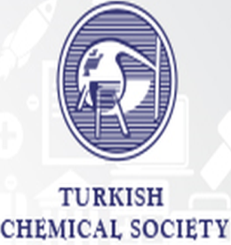

**COPYRIGHT TRANSFER FORM**

The corresponding author hereby declares that the article is original, has not been published anywhere else, and has not been in examination by another entity, and they also declare that if the article is derived from a graduate thesis, a symposiom, a congress, etc., they will put an asterisk (*) at the end of the article title and gives the necessary information in a footnote.

The authors accept the transfer of their work to the Turkish Chemical Society by signing this form. Please complete this form on your computer, get a printout, sign, and send the scanned document.

|  |  |
| --- | --- |
| Name of the corresponding author: |  |
| E-mail address of the corresponding author: |  |
| Title of the article: |  |
| Date: |  |
| Signature: |  |

Journal of the Turkish Chemical Society Section C: Chemical Education (JOTCS-C)

Halaskargazi Cad. No: 53(15)/8 Harbiye-Şişli-İstanbul

E-posta: jotcsc@turchemsoc.org