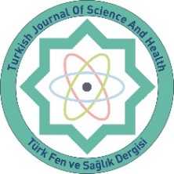 | TÜRK FEN VE SAĞLIK DERGİSİ (TFSD)  (TURKISH JOURNAL of SCIENCE and HEALTH)  SİVAS-TÜRKİYE  https://dergipark.org.tr/tr/pub/tfsd  ISSN: 2717-7173 | 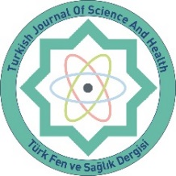

COPYRIGHT TRANSFER FORM
We, the authors with the following names, declare that we take an active role in planning, doing and analyzing the data, as well as writing this article, and accept all responsibilities related to this study. We believe that the article contributes to scientific literature. The final version of the article has been reviewed by all authors. We undertake that this article is not published anywhere else or submitted for publication. We also guarantee to send all the data related to the article to the editors, if necessary. In the event that this article is evaluated and published by the Turkish Journal of Science and Health, we declare and accept that we transfer all our copyrights related to the article to the Turkish Journal of Science and Health.

Title of Manuscript

Author Name Date Signature
…………………………….. ………………… ……………………………………...
…………………………….. ………………… ……………………………………...
…………………………….. ………………… ……………………………………...
…………………………….. ………………… ……………………………………...
…………………………….. ………………… ……………………………………...
…………………………….. ………………… ……………………………………...
…………………………….. ………………… ……………………………………...
…………………………….. ………………… ……………………………………...
…………………………….. ………………… ……………………………………...

