RESEARCH ARTICLE

Title Page and Extensive English Abstract Page for All Articles in JSTER Journal

* ORCID logoFirst Author, 1 ORCID logoSecond B. Author, and 2 ORCID logoThird B. Author

*University Jster, Faculty of Engineering, Electrical Engineering Department, City, Country

email.[abcd@xxxx.com](mailto:abcd@xxxx.com), [Orcid.0000-xxx-xxxx-xxxx](https://orcid.org/0000-xxx-xxxx-xxxx),

1Northern Canada University, Toronto, Canada

[xxxxx.abcd@xxxx.com](mailto:xxxxx.abcd@xxxx.com), [Orcid.0000-xxx-xxxx-xxxx](https://orcid.org/0000-xxx-xxxx-xxxx),

2University Abcd, Faculty Engineering, Machine Engineering Department, Ankara, Turkey

email.[abcd@xxxx.com](mailto:abcd@xxxx.com), [Orcid.0000-xxx-xxxx-xxxx](https://orcid.org/0000-xxx-xxxx-xxxx)

|  |  |  |
| --- | --- | --- |
| **HIGHLIGHTS** |  | **GRAPHICAL ABSTRACT** |
| * *Effect and important of this article in literature* * *Exchange between sources in related subjects of this article* * *Contribution and strongest impact on the related sobject of this article* * *Examined study and obtained results why is important* |  | This section should state the purpose of the research. Times New Roman fonts 10 pts and italic style. The extended abstract is a mandatory to capture the attention of a wide readership. It contains different titles such as graphical/tabular abstract, purpose of your manuscript, theory and methods, etc. It should not exceed one page. The graphical/tabular abstract summarizes the contents of the article in a concise. Results and findings should be clear and concise. Authors must provide images and data that clearly represent the work described in the article. The image should be readable at a size of 6 × 14 cm (h x w) using a regular screen resolution of 96 dpi. The table should be editable. Use the Times New Roman fonts 10 pts in your graphical/tabular abstract.    **Figure A. or Table A** The name figure or table about given info and results |
| **Keywords:** |  |
| * Keywords 1 * Keywords 2 * Keywords 3 * Keywords 4 * Keywords 5 |  |

**Article Info:**

|  |  |
| --- | --- |
| *Received :* 01 February 2023 *Accepted :* 15 March 2023  **DOI:** [10.53525/jster.9886](https://doi.org/10.53525/jster.988672)xx    **\*Correspondence:**  Author Name Surname  [author.email@email.edu.tr](mailto:author.email@email.edu.tr)  Phone: +90 123 4567890 | **Aim of Article :** *This section should state the purpose of the research. Times New Roman fonts 10 pts and italic style.*  **Theory and Methodology :** *The experimental method or theory of the study should be given briefly. References should be avoided, but if essential, then cite the author(s) and year(s). Use the Times New Roman fonts 10 pts and italic style.*  **Findings and Results:** *Results and findings should be clear and concise. The most attractive results of the research should be given in this section. Use the Times New Roman fonts 10 pts and italic style.*  **Conclusion :** *The main conclusions of the study must be presented in the Conclusions section. Use the Times New Roman fonts 10 pts and using italic form. a conclusion may review the main points of the paper, do not replicate the abstract as the conclusion. A conclusion might elaborate on the importance of the work or suggest applications and extensions.* |

ARAŞTIRMA MAKALESİ ­| RESEARCH ARTICLE

Türkçe Yazım Dilindeki JSTER Makale Yazım Kılavuzu ve Makale Şablonu

* ORCID logoBirinci Yazar, 1 ORCID logoİkinci Yazar, 2ORCID logoÜçüncü Yazar

*1Jster Üniversitesi, Mühendislik Fakültesi, Elektrik-Elektronik Mühendisliği Bölümü, Ankara, Türkiye

email.[abcd@xxxx.com](mailto:abcd@xxxx.com), [Orcid.0000-xxx-xxxx-xxxx](https://orcid.org/0000-xxx-xxxx-xxxx)

1Araştıma Üniversitesi, Teknoloji Fakültesi, Elektronik Mühendisliği Bölümü, Şehir, Ülke.

email.[abcd@xxxx.com](mailto:abcd@xxxx.com), [Orcid.0000-xxx-xxxx-xxxx](https://orcid.org/0000-xxx-xxxx-xxxx)

2Üniversite, Bölüm Fakülte veya Kurum, Şehir, Ülke.

email.[abcd@xxxx.com](mailto:abcd@xxxx.com), [Orcid.0000-xxx-xxxx-xxxx](https://orcid.org/0000-xxx-xxxx-xxxx)

|  |  |  |
| --- | --- | --- |
| **Alıntı /** *Citation* **:**  Yazar, B., Yazar, A. (2023). *The Problems Encountered in the Process of Publishing Articles in the Journal and Investigation of the Solutions*, [Journal of Science Technology and Engineering Research](https://dergipark.org.tr/en/pub/jster), 4(1): 12-34. DOI: [10.53525/jster.9886](https://doi.org/10.53525/jster.988672)xx | | |
| **Ö N E Ç I K A N L A R /** *H I G H L I G H T S* | | |
| * *Bu makalenin literatürdeki etkisi ve önemi* * *Bu makalenin ilgili konularındaki kaynaklar arasında değişim* * *Bu makalenin ilgili konusu üzerindeki katkı ve en güçlü etki* * *İncelenen çalışma ve elde edilen sonuçlar neden önemlidir* | | |
| **Makale Bilgileri /** *Article Info* |  | **ÖZET /** *ABSTRACT* |
| *Geliş Tarihi :* 01 Şubat 2022  *Kabul Tarihi :* 15 Mart 2022  **DOI:** [10.53525/jster.9886](https://doi.org/10.53525/jster.988672)xx |  | *Bu Microsoft Word belgesi Bilim, Teknoloji ve Mühendislik Araştırmaları dergisi’ne gönderilecek olan makaleler için örnek olması amacıyla hazırlanmıştır. Dergimize gönderilmek üzere hazırlanan makalelerin bu şablona bağlı olarak hazırlanması makalenin düzenlenme, değerlendirilme ve yayımlanma aşamalarını hızlandıracaktır.Özet kısmında çalışmanın yenilikleri ve temel bulguları vurgulanmalıdır. Türkçe ve İngilizce özet kısımları Times New Roman yazı tipi ile yazılmalıdır ve 10 punto büyüklüğü, Ana metin için 11 Punto seçilmelidir. seçilmelidir. Özet kısmının yazımında tek satır aralığı seçilmelidir. Makale özetinin en fazla 150-300 kelime olmasına dikkat edilmelidir. Türkçe ve İngilizce özetlerin 1 sayfayı geçmemesi önerilmektedir. Anahtar kelime sayısı en az 3 en fazla 6 olmalıdır. Bu Microsoft Word belgesi Bilim, Teknoloji ve Mühendislik Araştırmaları dergisi’ne gönderilecek olan makaleler için örnek olması amacıyla hazırlanmıştır. Dergimize gönderilmek üzere hazırlanan makalelerin bu şablona bağlı olarak hazırlanması makalenin düzenlenme, değerlendirilme ve yayımlanma aşamalarını hızlandıracaktır. Özet kısmının yazımında tek satır aralığı seçilmelidir.*  **Anahtar Kelimeler:** *Anahtar Kelime1, Anahtar Kelime2, Anahtar Kelime3,**Anahtar Kelime4* |
| **\*Sorumlu Yazar:** |  |
| Adı Soyadı, [author.email@email.edu.tr](mailto:author.email@email.edu.tr)  Tel: +90 123 4567890 | |

# **GİRİŞ [**INTRODUCTION**]**

This document is a template for Microsoft *Word* versions 6.0 or later. If you are reading a paper or PDF version of this document, please download the electronic file, trans_jour.docx, from the IEEE Web site at [www.ieee.org/authortools](http://www.ieee.org/authortools) so you can use it to prepare your manuscript. If you would prefer to use LaTeX, download IEEE’s LaTeX style and sample files from the same Web page. If your paper is intended for a conference*,* please contact your conference editor concerning acceptable word processor formats for your particular conference.

# **MAKALE HAZIRLAMA KILAVUZU [**Guidelines For Manuscript Preparation**]**

When you open trans_jour.docx, select “Page Layout” from the “View” menu in the menu bar (View | Page Layout), (these instructions assume MS 6.0. Some versions may have alternate ways to access the same functionalities noted here). Then, type over sections of trans_jour.docx or cut and paste from another document and use markup styles. The pull-down style menu is at the left of the Formatting Toolbar at the top of your *Word* window (for example, the style at this point in the document is “Text”). Highlight a section that you want to designate with a certain style, and then select the appropriate name on the style menu. The style will adjust your fonts and line spacing. Do not change the font sizes or line spacing to squeeze more text into a limited number of pages.Use italics for emphasis; do not underline. To insert images in *Word,* position the cursor at the insertion point and either use Insert | Picture | From File or copy the image to the Windows clipboard and then Edit | Paste Special | Picture (with “float over text” unchecked).

## Kısaltmalar (Abbreviations and Acronyms)

Define abbreviations and acronyms the first time they are used in the text, even after they have already been defined in the abstract. Abbreviations such as IEEE, SI, ac, and dc do not have to be defined.

## Other Recommendations

Use one space after periods and colons. Hyphenate complex modifiers: “zero-field-cooled magnetization.” Avoid dangling participles, such as, “Using (1), the potential was calculated.” [It is not clear who or what used (1).] Write instead, “The potential was calculated by using (1),” or “Using (1), we calculated the potential.”

A parenthetical statement at the end of a sentence is punctuated outside of the closing parenthesis (like this). (A parenthetical sentence is punctuated within the parentheses.) In American English, periods and commas are within quotation marks, like “this period.” Other punctuation is “outside”! Avoid contractions; for example, write “do not” instead of “don’t.” The serial comma is preferred: “A, B, and C” instead of “A, B and C.”

If you wish, you may write in the first person singular or plural and use the active voice (“I observed that ...” or “We observed that ...” instead of “It was observed that ...”). Remember to check spelling. If your native language is not English, please get a native English-speaking colleague to carefully proofread your paper.

# **TEORI VE YÖNTEM [**THEORY AND METHODOLOGY**]**

## Denklemler (Equations)

Number equations consecutively with equation numbers in parentheses flush with the right margin, as in (1). First use the equation editor to create the equation. Then select the “Equation” markup style. Press the tab key and write the equation number in parentheses. To make your equations more compact, you may use the solidus ( / ), the exp function, or appropriate exponents. Use parentheses to avoid ambiguities in denominators. Punctuate equations when they are part of a sentence, as in eq.(1).

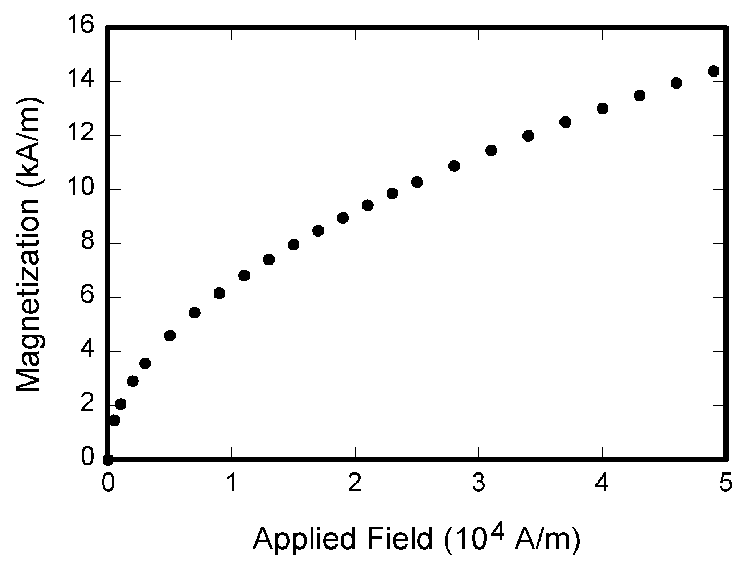

**Figure. 1.** Magnetization as a function of applied field. Note that “Fig.” is abbreviated. There is a period after the figure number, followed by two spaces. It is good practice to explain the significance of the figure in the caption.

# **ŞEKİL HAZIRLAMA KILAVUZU [**Guidelines for Graphics Preparation**]**

The following list outlines the different types of graphics published in IEEE journals. They are categorized based on their construction, and use of color / shades of gray:

### Color/Grayscale figures

### Figures that are meant to appear in color, or shades of black/gray. Such figures may include photographs, illustrations, multicolor graphs, and flowcharts.

### Line Art figures

### Figures that are composed of only black lines and shapes. These figures should have no shades or half-tones of gray, only black and white.

### Author photos

### Head and shoulders shots of authors that appear at the end of our papers.

### Tables

### Data charts which are typically black and white, but sometimes include color.

## Accepted Fonts Within Figures

When preparing your graphics IEEE suggests that you use of one of the following Open Type fonts: Times New Roman, Helvetica, Arial, Cambria, and Symbol. If you are supplying EPS, PS, or PDF files all fonts must be embedded. Some fonts may only be native to your operating system; without the fonts embedded, parts of the graphic may be distorted or missing.

**Table I.**

Units for Magnetic Properties

|  |  |  |
| --- | --- | --- |
| Symbol | Quantity | Conversion from Gaussian and  CGS EMU to SI a |
| Φ | magnetic flux | 1 Mx → 10−8 Wb = 10−8 V·s |
| *B* | magnetic flux density,  magnetic induction | 1 G → 10−4 T = 10−4 Wb/m2 |
| *H* | magnetic field strength | 1 Oe → 103/(4π) A/m |
| *m* | magnetic moment | 1 erg/G = 1 emu  → 10−3 A·m2 = 10−3 J/T |
| *M* | magnetization | 1 erg/(G·cm3) = 1 emu/cm3  → 103 A/m |
| 4π*M* | magnetization | 1 G → 103/(4π) A/m |
| σ | specific magnetization | 1 erg/(G·g) = 1 emu/g → 1 A·m2/kg |
| *j* | magnetic dipole  moment | 1 erg/G = 1 emu  → 4π× 10−10 Wb·m |
| *J* | magnetic polarization | 1 erg/(G·cm3) = 1 emu/cm3  → 4π× 10−4 T |
| χ*,*κ | susceptibility | 1 → 4π |
| χρ | mass susceptibility | 1 cm3/g → 4π× 10−3 m3/kg |
| μ | permeability | 1 → 4π× 10−7 H/m  = 4π× 10−7 Wb/(A·m) |
| μr | relative permeability | μ→μr |
| *w, W* | energy density | 1 erg/cm3→ 10−1 J/m3 |
| *N, D* | demagnetizing factor | 1 → 1/(4π) |

## Using Labels Within Figures

Figure axis labels are often a source of confusion. Use words rather than symbols. As an example, write the quantity “Magnetization,” or “Magnetization *M*,” not just “*M*.” Put units in parentheses.

### Subfigure Labels in Multipart Figures and Tables

Multipart figures should be combined and labeled before final submission. Labels should appear centered below each subfigure in 8 point Times New Roman font in the format of (a) (b) (c).

## Checking Your Figures: The IEEE Graphics Analyzer

The IEEE Graphics Analyzer enables authors to pre-screen their graphics for compliance with IEEE Transactions and Journals standards before submission. The online tool, located at <http://graphicsqc.ieee.org/>, allows authors to upload their graphics in order to check that each file is the correct file format, resolution, size and colorspace; that no fonts are missing or corrupt; that figures are not compiled in layers or have transparency, and that they are named according to the IEEE Transactions and Journals naming convention. At the end of this automated process, authors are provided with a detailed report on each graphic within the web applet, as well as by email..

# **SONUÇ VE DEĞERLENDİRME [**Conclusion**]**

## A conclusion section is not required. Although a conclusion may review the main points of the paper, do not replicate the abstract as the conclusion. A conclusion might elaborate on the importance of the work or suggest applications and extensions.

## In a conclusion paragraph, you summarize what you’ve written about in your paper. When you’re writing a good conclusion paragraph, you need to think about the main point that you want to get across and be sure it’s included. If you’ve already written a fabulous introductory paragraph, you can write something similar with different wording.

## Remember that it’s important to wrap up your writing by summarizing the main idea for your readers. This brings your writing to a smooth close and creates a well-written piece of work.

**ÇIKAR ÇATIŞMASI**[CONFLICTS OF INTEREST]

Yazarlar arasında ve ilgili kurumları arasında herhangi çıkar çatışması olmadığını bildirmişlerdir.

# **ETİK KURALLARA UYGUNLUK**[Compliance With Ethical Rules]

## Yazarlar bu makalenin etik kurul onayı veya herhangi bir özel izin gerektirmediğini beyan ederler.

**TEŞEKKÜR** [Acknowledgment]

## Makale çalışmasına yapılan destekleri açıklamak için, çoğu durumda, sponsor ve mali destek bildirimleri ve katkılara teşekkür burada belirtilmelidir.

**KAYNAKLAR [**References**]**

1. G.O.Young,“Synthetic structure of industrial plastics,”in *Plastics,* 2nd ed., vol. 3, J. Peters, Ed. New York, NY, USA: McGraw-Hill,1964,pp.15–64.
2. W.-K.Chen, *Linear Networks and Systems.*Belmont, CA, USA:Wadsworth, 1993, pp. 123–135.
3. J. U. Duncombe, “Infrared navigation—Part I: An assessment of feasibility,” *IEEE Trans. Electron Devices*, vol. ED-11, no. 1, pp. 34–39, Jan. 1959,10.1109 /TED.2016.2628402.
4. E. E. Reber, R. L. Michell, and C. J. Carter, “Oxygen absorption in the earth’s atmosphere,” Aerospace Corp., LosAngeles, CA, USA, Tech. Rep. TR-0200 (4230-46)-3, Nov. 1988.
5. G. O. Young, “Synthetic structure of industrial plastics,” in Plastics, vol. 3, Polymers of Hexadromicon, J. Peters, Ed., 2nd ed. New York, NY, USA: McGraw-Hill, 1964, pp. 15-64. [Online]. Available: http://www.bookref.com.
6. J. S. *Turner*, “New directions in communications,” *IEEE J. Sel. Areas Commun*., vol. 13, no. 1, pp. 11-23, Jan. 1995.
7. W. P. Risk, G. S. Kino, and H. J. Shaw, “Fiber-optic frequency shifter using a surface acoustic wave incident at an oblique angle,” *Opt. Lett.*, vol. 11, no. 2, pp. 115–117, Feb. 1986.
8. P. Kopyt *et al., “*Electric properties of graphene-based conductive layers from DC up to terahertz range,” *IEEE THz Sci. Technol.,* to be published. DOI: 10.1109/TTHZ.2016.2544142.
9. PROCESS Corporation, Boston, MA, USA. Intranets: *Internet technologies deployed behind the firewall for* cor*porate productivity. Presented at INET96 Annual Meeting*. http://home.process.com/Intranets/wp2.htp
10. D. B. Payne and J. R. Stern, “Wavelength-switched pas- sively coupled single-mode optical network,” n *Proc. IOOC-ECOC,* Boston, MA, USA, 1985, pp. 585–590.
11. D.EbehardandE.Voges,“Digital single side band detection for interferometric sensors,”presented at the *2nd Int. Conf. Optical Fiber Sensors,*Stuttgart,Germany,Jan.2-5, 1984.
12. R. Fardel, M. Nagel, F. Nuesch, T. Lippert, and A. Wokaun, “Fabrication of organic light emitting diode pixels by laser-assisted forward transfer,” Appl. Phys. Lett., vol. 91, no. 6, Aug. 2007, Art. no. 061103.
13. J. Zhang and N. Tansu, “Optical gain and laser characteristics of InGaN quantum wells on ternary InGaN substrates,” IEEE Photon. J., vol. 5, no. 2, Apr. 2013, Art. no. 2600111

OPSIYONEL (Bu kısım Zorunlu değildir)

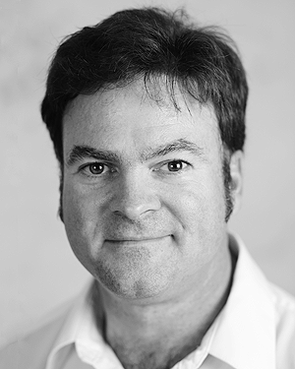**Second B. Author**was born in Greenwich Village, New York, USA in 1977. He received the B.S. and M.S. degrees in aerospace engineering from the VirginiaUniversity, Charlottesville, in 2001, the Ph.D. degree in mechanical engineering from Drexel University, Philadelphia, in 2008.

From 2001 to 2004, he was a Research Assistant with the Princeton Plasma Physics Laboratory. Since 2009, he has been an Assistant Professor with the Mechanical Engineering Department, Texas A&M University. His research interests include high-pressure and high-density nonthermal plasma discharge processes and applications, microscale plasma discharges and innovation plasma applications

Dr. Author was a recipient of the International Association of Geomagnetism and Aeronomy Young Scientist Award for Excellence in 2008, and the IEEE Electromagnetic Compatibility Society Best Symposium Paper Award in 2011.