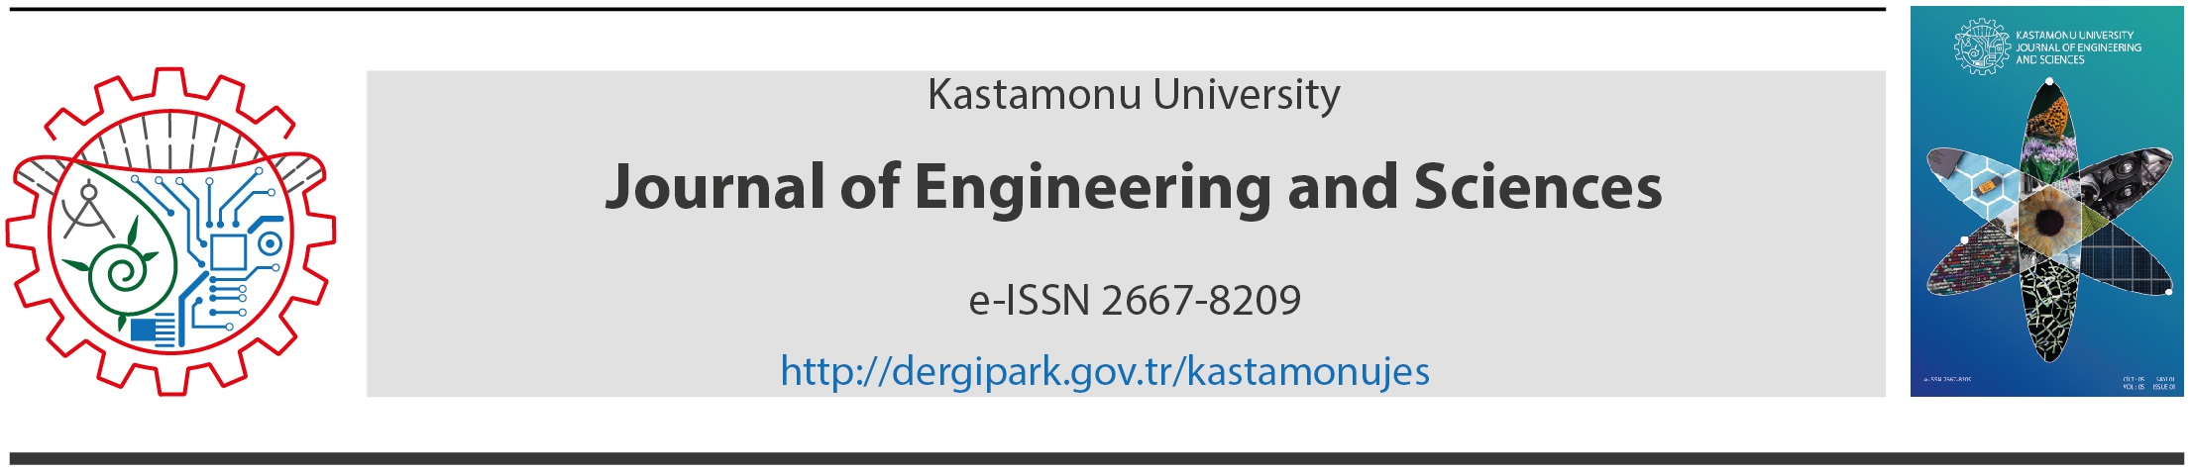
Slow City Movement: A Case Study Perşembe-Ordu
Şeyma Şengür*^{, a}, Ömer Atabeyoğlu^{b}
ª Department of Landscape Architecture, Faculty of Agriculture, Ordu University, Ordu, Turkey
e-mail: example@mail.com
ORCID ID: 0000-0000-0000-0000
^{b} Department of Landscape Architecture, Faculty of Agriculture, Ordu University, Ordu, Turkey
e-mail: example@mail.com
ORCID ID: 0000-0000-0000-0000
ARTICLE INFO | ABSTRACT
RESEARCH ARTICLE  Received: August: 04.2018  Reviewed: September: 05. 2018  Accepted: October: 17. 2018 | The 'slow city' movement that considered in the context of sustainable local development, has emerged as the continuation of the 'Slow food' movement in Italy that occurred in response to the global food chains destroying local delicacies in the 1990s.  The concept of a slow city which emerges as an alternative to modern urbanization, offers to local people the opportunity to live in a city which is far from environmental problems and where the natural and cultural resources unique to it are protected.
Keywords:
Slow city,
Perception,
Local government,
Local people,
Perşembe-Ordu.
Corresponding Author:
*E-mail: seymasengur@gmail.com
 | ÖZ
Anahtar Kelimeler:  Yavaş şehir,  Algı,  Yerel yönetim,  Yerel halk,  Perşembe-Ordu. | Sürdürülebilir yerel kalkınma bağlamında düşünülen ‘Yavaş şehir’ akımı İtalya’da 1990’lı yıllarda küresel yemek zincirlerinin lokal lezzetleri yok etmesine tepki olarak doğan ‘Slow food’ hareketinin devamı olarak ortaya çıkmış ve kentin bütününe yayılan bir sisteme dönüşmüştür.  Günümüz modern şehirleşme anlayışına alternatif olarak ortaya çıkan yavaş şehir kavramı, o şehirde yaşayan yerel halka, kendine özgü doğal ve kültürel kaynakların korunduğu, çevre kirliliğinden uzak bir yaşam ortamında yaşama imkânı sunmaktadır.
1. Introduction
Today, Globalization appears to be an unstoppable, irreversible and irresistible developmental process in today’s world. Globalization is a process with economic, social, political and cultural dimensions and has a wide range of influential field. The most obvious part of the area of influence is the cities [9].
One of the most important areas of globalization is 'cultural globalization'. Increased transportation opportunities, technological developments and the use of the internet have led to spread different cultures and ideas between the societies and that the cultural differences have disappeared.
2. Material and Method
The material of the study is the Perşembe-Ordu which was declared a slow city on 21 October 2012. Perşembe is a coastal county of the Ordu Province in the Middle Black Sea Region of Turkey.
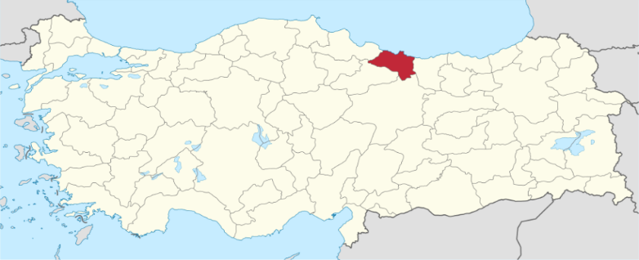

Figure 1. Geographic Location of Perşembe-Ordu (Original,2018)
Table 1. The Origins of Respondents
% of Non-native People of Perşembe | Years
% 20,1 | 1-5
% 14,8 | 6-15
% 31,9 | 16-30
% 24,7 | 31-50
% 7,2 | 51-80
% 3 | >80

3. Result and Discussion
The participants' profile has been determined according to gender, age, education, employment and their origin (from Perşembe or come from another city). According to survey data the gender of respondents is % 35,90 female and %64,10 male. The ages of the respondents are % 4,3 (0-18 age), % 25,3 (19-30 age), % 30,3 (31-40), % 36,5 (41-65) and % 3,6 (>65).

All manuscripts must contain the following sections under the heading.
Please see below for details on the information to be included in these sections.
If any of the sections are not relevant to your manuscript, please include the heading and write 'Not applicable' for that section.

Competing Interest / Conflict of Interest
All financial and non-financial competing interests must be declared in this section.
If you do not have any competing interests, please state "The authors declare that they have no competing interests" in this section.

The authors declare that they no conflict of interest. The none of the authors have any competing interests in the manuscript.

Funding
There is no financial support and commercial support.

Acknowledgements
We declare that all Authors equally contribute.

4. References
[1] Çelik, A., (2002). Perşembe’de Şehirsel Gelişme. Yüksek Lisans Tezi, İstanbul Üniversitesi Fen Bilimleri Enstitüsü, Coğrafya Anabilim Dalı, 79s., İstanbul.
[2] Özkan, H.C., (2011). Bir Sürdürülebilir Kent Modeli: Yavaş Şehir Hareketi. Yüksek Lisans Tezi, Yıldız Teknik Üniversitesi Fen Bilimleri Enstitüsü, İstanbul.
[3] Kaya, S., (2012). Toplumun McDonaldlaştınlması Çağdaş Toplum Yaşamının Değişen Karakteri Üzerine Bir İnceleme-George Ritzer. Ayrıntı Yayınları, ISBN 978-975-539-577-7, İstanbul.
[4] Gibson and Murray, (2012). Global Village, encyclopedia entry in Encyclopedia of Media and Communication, ed. M. Danesi. (University of Toronto Press, 2012), 312-313.
[5] Yüksel, U. C., (2012). Secret Economy Behind The Walls. Conference paper, Agriindustrial Design Congress, 9p., Izmir.

