|  |  |  |
| --- | --- | --- |
|  | **International Journal of Exercise Psychology**  Uluslararası Egzersiz Psikolojisi Dergisi  e-ISSN: 2687-6051 | **RESEARCH/REVIEW ARTICLE** |

Article English Title

Article Turkish Title

First Author1, Second Author2*, Third Author1,2

1Laboratory X, Institute X, Department X, Organization X, City X, State XX (only USA, Canada and Australia), Country

2Laboratory X, Institute X, Department X, Organization X, City X, State XX (only USA, Canada and Australia), Country

**Correspondence:**

*1. Author's Name SURNAME*

*mail@address.com*

*2. Author's Name SURNAME*

*mail@address.com*

*3. Author's Name SURNAME*

*mail@address.com*

**ABSTRACT:** In this section, you should place the English abstract of your article. The abstract should be written in 10 font size, justified and not exceeding 260 words. You can delete this part without destroying the formatting and write your abstract instead.

**Keywords:** keyword 1, keyword 2, keyword 3 (keywords should not exceed 3- 5 words).

**ÖZ:** In this section, you should place the Turkish abstract of your article. The abstract should be written in 10 font size, justified and not exceeding 260 words. You can delete this part without destroying the formatting and write your abstract instead.

**Anahtar Kelimeler:** keyword 1, keyword 2, keyword 3 (keywords should not exceed 3- 5 words).

**1. INTRODUCTION**

Section titles should be written in capital letters, 12 font size and bold. In the articles, the problem should be clearly stated in the introduction. The introduction should follow the method, results, discussion and/or conclusion sections, respectively.

The texts in the sections should be written in 11 font size and single line gap spaced, without any formatting. The article should not exceed 9000 words. ***Otherwise, the article will be rejected to the author without being examined.***

***1.1. First Letters of Each Word in Second Level Subtitles Should Be Capitalized. (11 size, bold and italic)***

Subtitles should be written in capital letters, bold, italic and in the format above. As in here, attention should be paid to this format in the sub-sections.

“Yılmaz et al. (2016) women's physical activity in a similar study …” in the form, reference can also be made to the source in the sentence. It should be noted here that the date part is italic. When reference is made to more than one source, a comma is placed between the name and the year, the sources are separated by semicolons and the citation is written in italics (Arıkan, 2003; Atav, 1998; Şenli, 2006).

***1.1.1 In the third level subtitles, only the first letter of the title should be written in capital letters and other characters should be written in lowercase. (11 size, bold and italic)***

2. METHOD

In research articles, the method section should be added here, and the suggestions above should be considered.

***In this section, a statement about the approval of the ethics committee must be written for the study. (In social sciences, ethics committee permission is required for all research conducted by qualitative or quantitative methods, where data is collected from participants using survey, interview, focus group work, observation, experiment and interview techniques)***

3. RESULTS

Please use APA 7 style when formatting your tables. <https://apastyle.apa.org/style-grammar-guidelines/tables-figures/sample-tables>

**Sample demographic characteristics table**

**Table 1**

*Sociodemographic Characteristics of Participants at Baseline*

|  |  |  |  |  |  |  |  |  |
| --- | --- | --- | --- | --- | --- | --- | --- | --- |
| Baseline characteristic | Guided self-help | | Unguided self-help | | Wait-list control | | Full sample | |
|  | *n* | *%* | *n* | *%* | *n* | *%* | *n* | *%* |
| Gender |  | |  | |  | |  | |
| Female | 25 | 50 | 20 | 40 | 23 | 46 | 68 | 45.3 |
| Male | 25 | 50 | 30 | 60 | 27 | 54 | 82 | 54.7 |
| Marital status |  |  |  |  |  |  |  |  |
| Single | 13 | 26 | 11 | 22 | 17 | 34 | 41 | 27.3 |
| Married/partnered | 35 | 70 | 38 | 76 | 28 | 56 | 101 | 67.3 |
| Divorced/widowed | 1 | 2 | 1 | 2 | 4 | 8 | 6 | 4.0 |
| Other | 1 | 1 | 0 | 0 | 1 | 2 | 2 | 1.3 |
| Children a | 26 | 52 | 26 | 52 | 22 | 44 | 74 | 49.3 |
| Cohabitating | 37 | 74 | 36 | 72 | 26 | 52 | 99 | 66.0 |
| Highest educational     level |  |  |  |  |  |  |  |  |
| Middle school | 0 | 0 | 1 | 2 | 1 | 2 | 2 | 1.3 |
| High school/some      college | 22 | 44 | 17 | 34 | 13 | 26 | 52 | 34.7 |
| University or      postgraduate degree | 27 | 54 | 30 | 60 | 32 | 64 | 89 | 59.3 |

*Note.* *N* = 150 (*n* = 50 for each condition). Participants were on average 39.5 years old (*SD* = 10.1), and participant age did not differ by condition.

a Reflects the number and percentage of participants answering “yes” to this question.

The title of the table to be used in the article should be used as shown above. Table content should be 10 points and the titles in the table should be bold.

The table should fit on the page (click on the icon in the upper left corner of the table 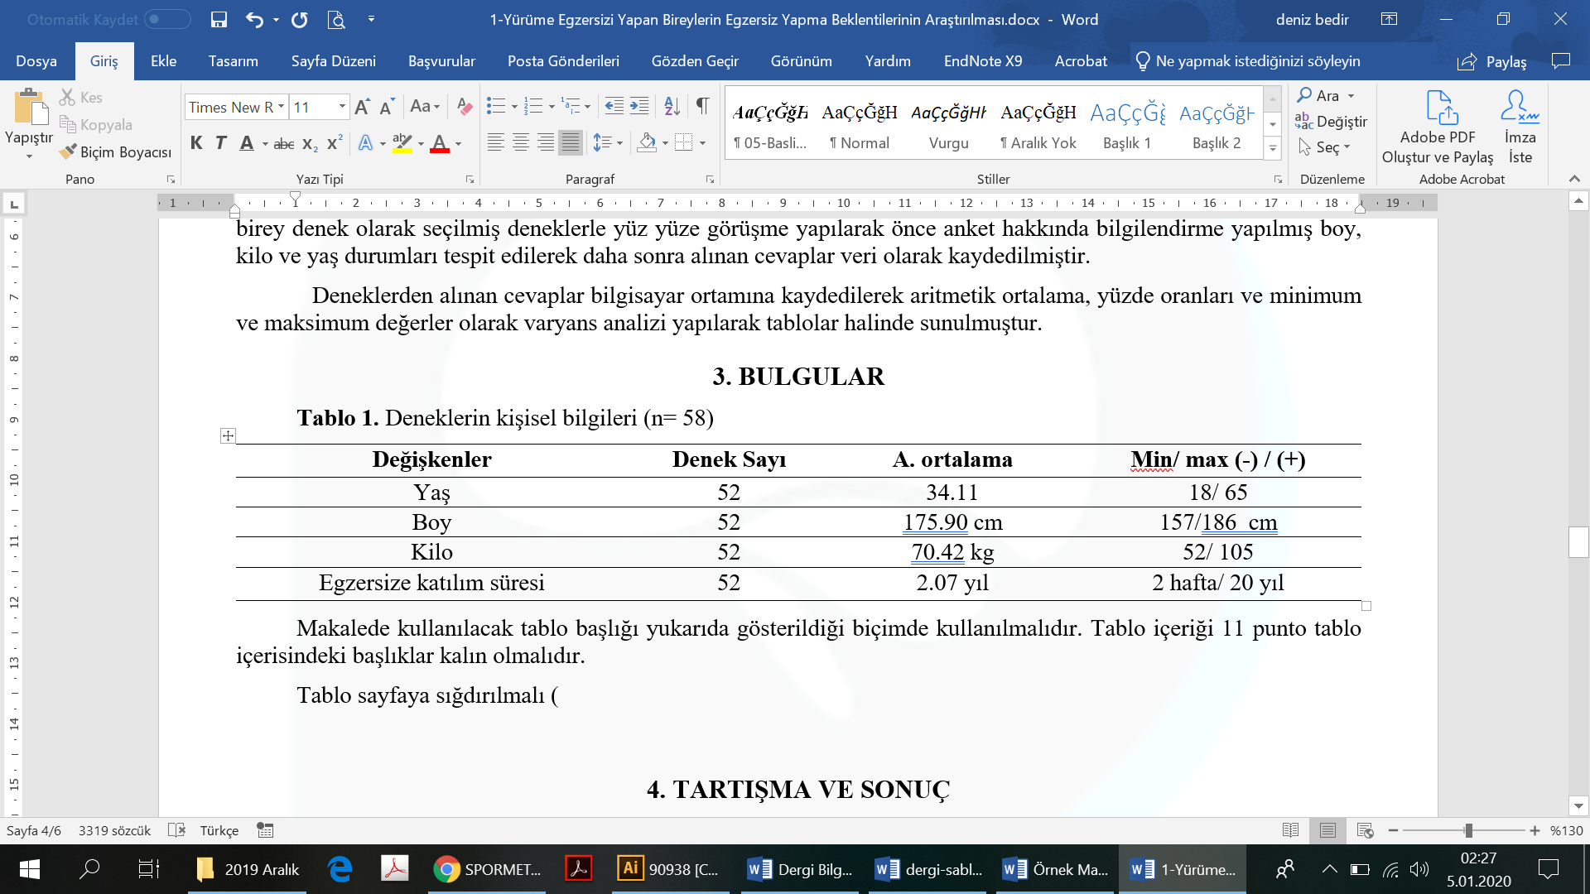, click Auto fit> Auto fit window) and make sure that it is APA style, free from vertical lines.

**Sample results of several t tests table**

**Table 2**

*Results of Curve-Fitting Analysis Examining the Time Course of Fixations to the Target*

|  |  |  |  |  |  |  |  |
| --- | --- | --- | --- | --- | --- | --- | --- |
| Logistic parameter | 9-year-olds | | 16-year-olds | | *t*(40) | *p* | Cohen's *d* |
|  | *M* | *SD* | *M* | *SD* |  |  |  |
| Maximum asymptote, proportion | .843 | .135 | .877 | .082 | 0.951 | .347 | 0.302 |
| Crossover, in ms | 759 | 87 | 694 | 42 | 2.877 | .006 | 0.840 |
| Slope, as change in proportion per ms | .001 | .0002 | .002 | .0002 | 2.635 | .012 | 2.078 |

*Note.* For each subject, the logistic function was fit to target fixations separately. The maximum asymptote is the asymptotic degree of looking at the end of the time course of fixations. The crossover point is the point in time the function crosses the midway point between peak and baseline. The slope represents the rate of change in the function measured at the crossover. Mean parameter values for each of the analyses are shown for the 9-year-olds (*n* = 24) and 16-year-olds (*n* = 18), as well as the results of *t* tests (assuming unequal variance) comparing the parameter estimates between the two ages.

**Sample correlation table**

**Table 1**

*Descriptive Statistics and Correlations for Study Variables*

|  |  |  |  |  |  |  |  |  |  |  |
| --- | --- | --- | --- | --- | --- | --- | --- | --- | --- | --- |
| Variable | *n* | *M* | *SD* | 1 | 2 | 3 | 4 | 5 | 6 | 7 |
| 1. Internal–      external status a | 3,697 | 0.43 | 0.49 | — |  |  |  |  |  |  |
| 2. Manager job      performance | 2,134 | 3.14 | 0.62 | −.08** | — |  |  |  |  |  |
| 3. Starting salary b | 3,697 | 1.01 | 0.27 | .45** | −.01 | — |  |  |  |  |
| 4. Subsequent promotion | 3,697 | 0.33 | 0.47 | .08** | .07** | .04* | — |  |  |  |
| 5. Organizational tenure | 3,697 | 6.45 | 6.62 | −.29** | .09** | .01 | .09** | — |  |  |
| 6. Unit service      performance c | 3,505 | 85.00 | 6.98 | −.25** | −.39** | .24** | .08** | .01 | — |  |
| 7. Unit financial      performance c | 694 | 42.61 | 5.86 | .00 | −.03 | .12* | −.07 | −.02 | .16** | — |

a 0 = internal hires and 1 = external hires.

b A linear transformation was performed on the starting salary values to maintain pay practice confidentiality. The standard deviation (0.27) can be interpreted as 27% of the average starting salary for all managers. Thus, ±1 SD includes a range of starting salaries from 73% (i.e., 1.00 – 0.27) to 127% (i.e., 1.00 + 0.27) of the average starting salaries for all managers.

c Values reflect the average across 3 years of data.

*p < .05. **p < .01.

**Sample analysis of variance (ANOVA) table**

**Table 1**

*Means, Standard Deviations, and One-Way Analyses of Variance in Psychological and Social Resources and Cognitive Appraisals*

|  |  |  |  |  |  |  |
| --- | --- | --- | --- | --- | --- | --- |
| Measure | Urban | | Rural | | *F*(1, 294) | η2 |
|  | *M* | *SD* | *M* | *SD* |  |  |
| Self-esteem | 2.91 | 0.49 | 3.35 | 0.35 | 68.87*** | .19 |
| Social support | 4.22 | 1.50 | 5.56 | 1.20 | 62.60*** | .17 |
| Cognitive appraisals |  |  |  |  |  |  |
| Threat | 2.78 | 0.87 | 1.99 | 0.88 | 56.35*** | .20 |
| Challenge | 2.48 | 0.88 | 2.83 | 1.20 | 7.87*** | .03 |
| Self-efficacy | 2.65 | 0.79 | 3.53 | 0.92 | 56.35*** | .16 |

\*\*\**p* < .001.

**Sample factor analysis table**

**Table 1**

*Results From a Factor Analysis of the Parental Care and Tenderness (PCAT) Questionnaire*

|  |  |  |  |
| --- | --- | --- | --- |
| PCAT item | Factor loading | | |
|  | 1 | 2 | 3 |
| Factor 1: Tenderness—Positive |  |  |  |
| 20. You make a baby laugh over and over again by making silly faces. | **.86** | .04 | .01 |
| 22. A child blows you kisses to say goodbye. | **.85** | −.02 | −.01 |
| 16. A newborn baby curls its hand around your finger. | **.84** | −.06 | .00 |
| 19. You watch as a toddler takes their first step and tumbles gently back         down. | **.77** | .05 | −.07 |
| 25. You see a father tossing his giggling baby up into the air as a game. | **.70** | .10 | −.03 |
| Factor 2: Liking |  |  |  |
| 5. I think that kids are annoying (R) | −.01 | **.95** | .06 |
| 8. I can’t stand how children whine all the time (R) | −.12 | **.83** | −.03 |
| 2. When I hear a child crying, my first thought is “shut up!” (R) | .04 | **.72** | .01 |
| 11. I don’t like to be around babies. (R) | .11 | **.70** | −.01 |
| 14. If I could, I would hire a nanny to take care of my children. (R) | .08 | **.58** | −.02 |
| Factor 3: Protection |  |  |  |
| 7. I would hurt anyone who was a threat to a child. | −.13 | −.02 | **.95** |
| 12. I would show no mercy to someone who was a danger to a child. | .00 | −.05 | **.74** |
| 15. I would use any means necessary to protect a child, even if I had to         hurt others. | .06 | .08 | **.72** |
| 4. I would feel compelled to punish anyone who tried to harm a child. | .07 | .03 | **.68** |
| 9. I would sooner go to bed hungry than let a child go without food. | .46 | −.03 | **.36** |

*Note.* *N* = 307. The extraction method was principal axis factoring with an oblique (Promax with Kaiser Normalization) rotation. Factor loadings above .30 are in bold. Reverse-scored items are denoted with an (R). Adapted from “Individual Differences in Activation of the Parental Care Motivational System: Assessment, Prediction, and Implications,” by E. E. Buckels, A. T. Beall, M. K. Hofer, E. Y. Lin, Z. Zhou, and M. Schaller, 2015, *Journal of Personality and Social Psychology*, *108*(3), p. 501 (<https://doi.org/10.1037/pspp0000023>). Copyright 2015 by the American Psychological Association.

**Sample regression table**

**Table 3**

*Moderator Analysis: Types of Measurement and Study Year*

|  |  |  |  |  |  |
| --- | --- | --- | --- | --- | --- |
| Effect | Estimate | *SE* | 95% CI | | *p* |
|  |  |  | *LL* | *UL* |  |
| Fixed effects |  |  |  |  |  |
| Intercept | .119 | .040 | .041 | .198 | .003 |
| Creativity measurement a | .097 | .028 | .042 | .153 | .001 |
| Academic achievement measurement b | −.039 | .018 | −.074 | −.004 | .03 |
| Study year c | .0002 | .001 | −.001 | .002 | .76 |
| Goal d | −.003 | .029 | −.060 | .054 | .91 |
| Published e | .054 | .030 | −.005 | .114 | .07 |
| Random effects |  |  |  |  |  |
| Within-study variance | .009 | .001 | .008 | .011 | <.001 |
| Between-study variance | .018 | .003 | .012 | .023 | <.001 |

*Note*. Number of studies = 120, number of effects = 782, total *N* = 52,578. CI = confidence interval; *LL* = lower limit; *UL* = upper limit.

a0 = self-report, 1 = test. b0 = test, 1 = grade point average. c Study year was grand centered. d 0 = other, 1 = yes. e 0 = no, 1 = yes.

**Sample qualitative table with variable descriptions**

**Table 2**

*Master Narrative Voices: Struggle and Success and Emancipation*

|  |  |
| --- | --- |
| Discourse and dimension | Example quote |
| Struggle and success a |  |
| Self-actualization as member of a larger gay community is the end goal of healthy sexual identity development, or “coming out” | “My path of gayness ... going from denial to saying, well this is it, and then the process of coming out, and the process of just sort of, looking around and seeing, well where do I stand in the world, and sort of having, uh, political feelings.” (Carl, age 50) |
| Maintaining healthy sexual identity entails vigilance against internalization of societal discrimination | “When I'm like thinking of criticisms of more mainstream gay culture, I try to ... make sure it's coming from an appropriate place and not like a place of self-loathing.” (Patrick, age 20) |
| Emancipation b |  |
| Open exploration of an individually fluid sexual self is the goal of healthy sexual identity development | “[For heterosexuals] the man penetrates the female, whereas with gay people, I feel like there is this potential for really playing around with that model a lot, you know, and just experimenting and exploring.” (Orion, age 31) |
| Questioning discrete, monolithic categories of sexual identity | “LGBTQI, you know, and added on so many letters. Um, and it does start to raise the question about what the terms mean and whether ... any term can adequately be descriptive.” (Bill, age 50) |

a The struggle and success master narrative states that same-sex desire/behavior is a natural if relatively uncommon developmental variant distinguishable from heterosexuality. Healthy sexual development entails “coming out” as well as joining a larger gay community in a shared struggle to overcome societal discrimination and be socially recognized as normal.

b The emancipation master narrative states that discrete, monolithic, and mutually exclusive categories of homosexuality and heterosexuality are social constructions, conceptually suspect in their ability to fully capture the idiosyncrasies of sexual subjectivities, desires, and behaviors. This circumscription of sexual self within culturally contingent and hegemonic sexual identity categories must be resisted.

**Sample mixed methods table**

**Table 3**

*Integrated Results Matrix for the Effect of Topic Familiarity on Reliance on Author Expertise*

|  |  |  |
| --- | --- | --- |
| Quantitative results | Qualitative results | Example quote |
| When the topic was more familiar (climate change) and cards were more relevant, participants placed less value on author expertise. | When an assertion was considered to be more familiar and considered to be general knowledge, participants perceived less need to rely on author expertise. | Participant 144: “I feel that I know more about climate and there are several things on the climate cards that are obvious, and that if I sort of know it already, then the source is not so critical ... whereas with nuclear energy, I don't know so much so then I'm maybe more interested in who says what.” |
| When the topic was less familiar (nuclear power) and cards were more relevant, participants placed more value on authors with higher expertise. | When an assertion was considered to be less familiar and not general knowledge, participants perceived more need to rely on author expertise. | Participant 3: “[Nuclear power], which I know much, much less about, I would back up my arguments more with what I trust from the professors.” |

*Note*. We integrated quantitative data (whether students selected a card about nuclear power or about climate change) and qualitative data (interviews with students) to provide a more comprehensive description of students’ card selections between the two topics.

4. DISCUSSION

The results should be discussed based on the scientific literature. The conclusion and recommendations section, if any, should be written by continuing the numbering (5. Conclusion and Recommendations).

5. ACKNOWLEDGMENTS

If you are in the research process, you can write whatever you want to thank.

6. ETHICS STATEMENT

In this section, you should write the information about the Ethics Committee Permission (name of the board, date and number).

7. AUTHOR CONTRIBUTIONS

In this section, you can indicate the contributions of the authors in the study by using the initials of their names and surnames. For example; DB and SE designed the research. DB collected the data.

8. REFERENCES

APA7 style should be used in writing the references. Click here for the required information: