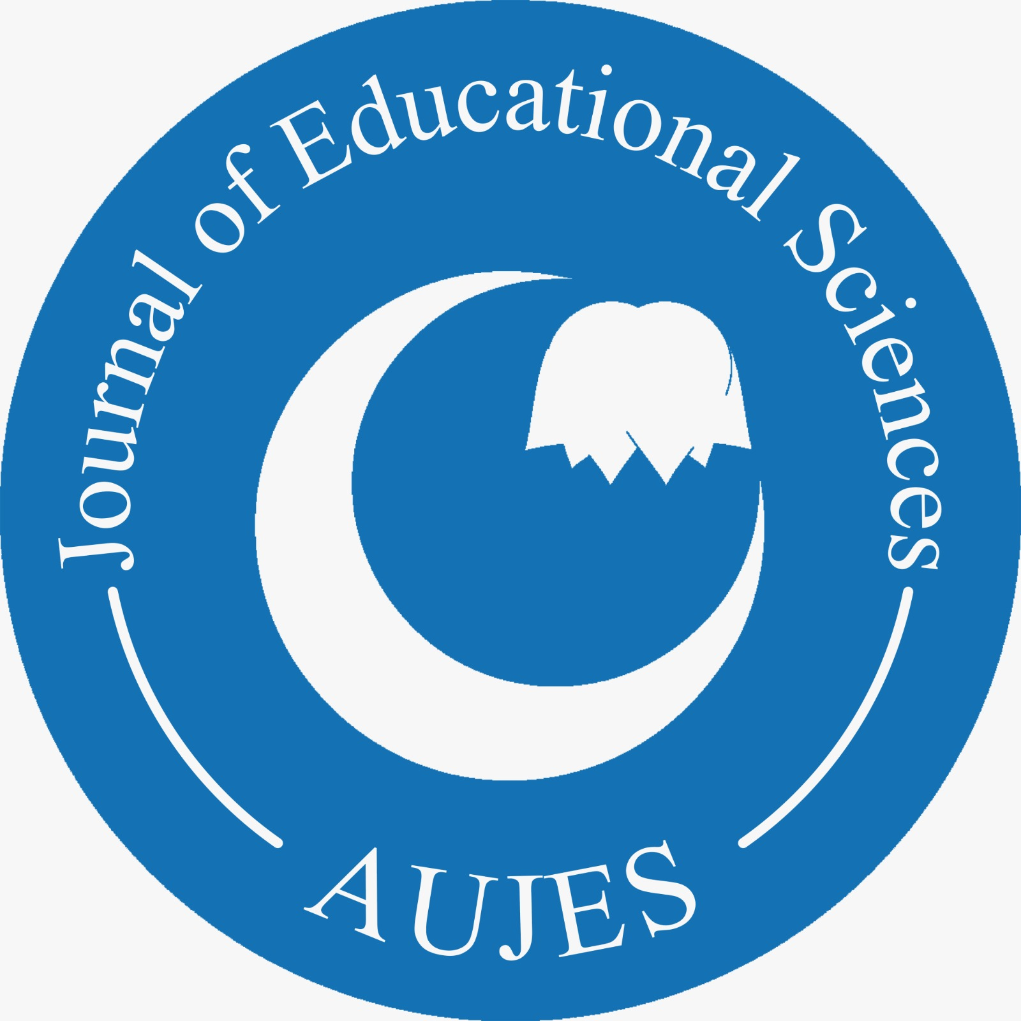ADIYAMAN UNIVERSITY  Journal of Educational Sciences (AUJES) | https://dergipark.org.tr/tr/pub/adyuebd  Put the English Title Here (14-point, Tittle Case, Centered, Bold)  Name Surname¹, Name Surname²  ¹Affiliation  ²Affiliation
To cite this article:

Surname, N. & Surname, N. (Year). The title of the paper. Adiyaman Univesity Journal of Educational Sciences, Vol(No), Page X-Page Y.

Put the English Title Here (14-point Bold)

Name Surname¹, Name Surname²
¹Affiliation
²Affiliation

Abstract
Please use 14-point bold for the article title, with an initial capital letter for any proper nouns. Please margin the article title to the center. All the authors of the paper should include their full names, affiliations, postal addresses, telephone and email addresses on the title page of the manuscript. One author should be identified as the Corresponding Author. Please use one line for all author names and one line for all author information. An informative 10-point bold abstract (100 to 200 words) will present the main points of the paper and conclusions. Please include descriptive keywords (4 to 5). Separate keywords with a comma. Capitalize the first letter of each keyword (e.g., Teacher training, School readiness, Curriculum and instruction). Add your abstract here.
Key words: Keyword, Keyword, Keyword
Introduction
Please use 10-point font size. Margin the text to the justified. Manuscripts should be single spaced. Do not use footnotes and endnotes. All relevant information should be included in main text. Do not indent the first paragraph under each heading, but the following paragraphs will be indented. Italicize the words to be emphasized, if needed. Before submitting your manuscript, ensure that every in-text citation has a corresponding reference in the reference list.
Do not use numbers for sections and subsections, use short meaningful sub-headings instead. Limit heading use to three levels. Please use 12-point bold for first-level headings, 10-point bold for second-level headings, and 10-point italics for third-level headings with an initial capital letter for any proper nouns. Space paragraph as 6nk after 0nk before. Do not use blank lines after or before the headings instead space as 6nk before and after. Spacing for consecutive headings is also as 6nk before and after. Margin all headings to the left.
Second Level Headings
Please use 10-point font size. Margin the text to the justified. Manuscripts should be single spaced. Do not use footnotes and endnotes. All relevant information should be included in main text. Do not indent the first paragraph under each heading, but the following paragraphs will be indented. Italicize the words to be emphasized, if needed. Before submitting your manuscript, ensure that every in-text citation has a corresponding reference in the reference list.
Do not use numbers for sections and subsections, use short meaningful sub-headings instead. Limit heading use to three levels. Please use 12-point bold for first-level headings, 10-point bold for second-level headings, and 10-point italics for third-level headings with an initial capital letter for any proper nouns. Space paragraph as 6nk after 0nk before. Do not use blank lines after or before the headings instead space as 6nk before and after. Spacing for consecutive headings is also as 6nk before and after. Margin all headings to the left.
Third Level Headings
Tables and figures should be embedded in appropriate areas within the document and centered. Tables and figures should not exceed the page margins. Provide captions (maximum length: 10 words) for each table or figure. Centre the caption above the table and below the figure. Please reference the table or figure in the text (Table1). Please ensure that the tables are designed according to APA 7 style. For figures, JPEG (JPG) is the preferred format.

Table 1. Centre the caption above the table
Gender | N |  | SS | t | p
Male | 362 | 107.97 | 22.70 | 2.536 | .01
Female | 288 | 103.30 | 24.10
df=648
Tables and figures should be embedded in appropriate areas within the document and centered. Tables and figures should not exceed the page margins. Provide captions (maximum length: 10 words) for each table or figure. Centre the caption above the table and below the figure. Please reference the table or figure in the text (Table1). Please ensure that the tables are designed according to APA 7. For figures, JPEG (JPG) is the preferred format.
Method
Second Level Headings
Do not leave blank lines after and before headings, instead space the heading and consecutive headings as 6 nk before and after. Margin all heading to the left. Do not leave blank lines after and before headings, instead space the heading and consecutive headings as 6 nk before and after. Margin all heading to the left. Do not indent the first paragraph under each heading but the following paragraphs should be indented. Spacing for the paragraph should be as 6 nk after and 0 nk before.
Do not leave blank lines after and before headings, instead space the heading and consecutive headings as 6 nk before and after. Margin all heading to the left. Do not leave blank lines after and before headings, instead space the heading and consecutive headings as 6 nk before and after. Margin all heading to the left. Do not indent the first paragraph under each heading but the following paragraphs should be indented. Spacing for the paragraph should be as 6 nk after and 0 nk before.
Third Level Headings
Do not leave blank lines after and before headings, instead space the heading and consecutive headings as 6 nk before and after. Margin all heading to the left. Do not leave blank lines after and before headings, instead space the heading and consecutive headings as 6 nk before and after. Margin all heading to the left. Do not indent the first paragraph under each heading but the following paragraphs should be indented. Spacing for the paragraph should be as 6 nk after and 0 nk before.
Do not leave blank lines after and before headings, instead space the heading and consecutive headings as 6 nk before and after. Margin all heading to the left. Do not leave blank lines after and before headings, instead space the heading and consecutive headings as 6 nk before and after. Margin all heading to the left. Do not indent the first paragraph under each heading but the following paragraphs should be indented. Spacing for the paragraph should be as 6 nk after and 0 nk before.
Results and Discussion
Add results and discussion here. This section should set out your results whether they are significant or not. All the results relevant to the research question should be included. Set out the result in order from the most to the least important in answering your research question.
In discussion, interpret and explain your results, answer your research question, justify your approach and, critically evaluate your research. Findings should be reviewed in context of the relevant literature.
All tables and figures should be embedded in appropriate areas within the document and centered. They should not exceed the page margins.
Add your results and discussion here. Add your results and discussion here. Add your results and discussion here. Add your results and discussion here. Add your results and discussion here. Add your results and discussion here.
Second Level Headings
Add results and discussion here. This section should set out your results whether they are significant or not. All the results relevant to the research question should be included. Set out the result in order from the most to the least important in answering your research question.
In discussion, interpret and explain your results, answer your research question, justify your approach and, critically evaluate your research. Findings should be reviewed in context of the relevant literature.
All tables and figures should be embedded in appropriate areas within the document and centered. They should not exceed the page margins.
Add your results and discussion here. Add your results and discussion here. Add your results and discussion here. Add your results and discussion here. Add your results and discussion here. Add your results and discussion here.

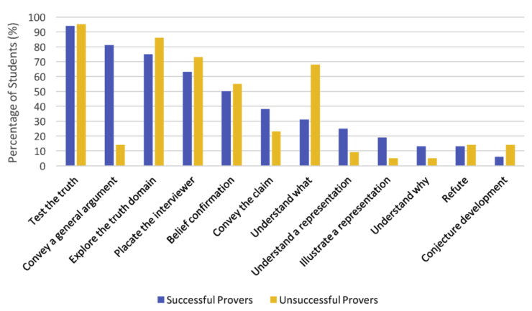
Figure 1. Centre the caption below the figure

Tables and figures should be embedded in appropriate areas within the document and centered. Tables and figures should not exceed the page margins. Provide captions (maximum length: 10 words) for each table or figure. Centre the caption above the table and below the figure. Please reference the table or figure in the text (Table1). Please ensure that the tables are designed according to APA 7. For figures, JPEG (JPG) is the preferred format.
Conclusion
This section includes a brief summary of the key findings, the conclusion drawn from your findings, why this research is important for researchers and practitioners, and a final paragraph rounding off the study.
This section includes a brief summary of the key findings, the conclusion drawn from your findings, why this research is important for researchers and practitioners, and a final paragraph rounding off the study.
This section includes a brief summary of the key findings, the conclusion drawn from your findings, why this research is important for researchers and practitioners, and a final paragraph rounding off the study.
Add your conclusion here.
Recommendations
This section can be combined with conclusion or presented as and separate section. In this section address limitations of the study and suggest how they can be overcome in future or with use various methods.
This section can be combined with conclusion or presented as and separate section. In this section address limitations of the study and suggest how they can be overcome in future or with use various methods.
Add your recommendations here.
Acknowledgements or Notes
Please collate acknowledgements or notes in a separate section at the end of the article before the references.
References
References and citations should be prepared in the APA 7 style. We strongly recommend using a citation manager. For authors preferring to design references section manually, a detailed list of references is given below.

The main improvements of APA 7th on APA 6th are as follow;
- When citing any work with three or more authors in text, right from the first citation, only the first author’s name and “et al.” will be included.
- Publisher location is not included in the reference for books.
- The seven-author inclusion limit in reference list for a single work has changed to 20 authors.
- DOI numbers are formatted as URLs.
- Unless the retrieval date is needed, URLs are not preceded by “Retrieved from”.
- E-book formats are not included in reference, and the publisher is included.

Comparison of changes on samples
 | APA 6th Edition | APA 7th Edition
1 | (Akpunar, Kazu, & Erdamar, 2018) | (Akpunar et al., 2018)
2 | Taşpinar, M. (2018). Kuramdan uygulamaya öğretim ilke ve yöntemleri.Ankara:Pegem | Taşpinar, M. (2018). Kuramdan uygulamaya öğretim ilke ve yöntemleri. Pegem
3 | Ertugay, S., Kudisoğlu, T., Şen, T., Yıldırır, A., Vural, A. H., Demir, A., … Coşkun, F.İ. (2019). Consensus Report on Patient Blood Management in Cardiac Surgery by Turkish Society of Cardiovascular Surgery (TSCVS), Turkish Society of Cardiology (TSC), and Society of Cardio-Vascular-Thoracic Anaesthesia and Intensive Care (SCTAIC). Turkish Journal of Thoracic and Cardiovascular Surgery, 27(4), 429-450. DOI: 10.5606/tgkdc.dergisi.2019.01902 | Ertugay, S., Kudisoğlu, T., Şen, T., Yıldırır, A., Vural, A. H., Demir, A., Ünal, E. U., Toprak, H. İ., Erdil, N., Aydınok, Y., Bozok, Ş., Kadiroğulları, E., Atay, Y., Öztürk, T., Tuncer, O. N., Şenay, Ş., Akansel, S., Acarel, M., Kısa, … Çoşkun, F.İ. (2019). Consensus Report on Patient Blood Management in Cardiac Surgery by Turkish Society of Cardiovascular Surgery (TSCVS), Turkish Society of Cardiology (TSC), and Society of Cardio-Vascular-Thoracic Anaesthesia and Intensive Care (SCTAIC). Turkish Journal of Thoracic and Cardiovascular Surgery, 27(4), 429-450. https://doi.org/10.5606/tgkdc.dergisi.2019.01902
4 | DOI:10.1080/2331186X.2016.1179614 | https://doi.org/10.1080/2331186X.2016.1179614
5 | Sellgren, K. (2020, 13 Şubat). Hareketsiz çocuklarda depresyon ihtimali artıyor. BBC News Türkçe. Erişim adresi: www.bbc.com/turkce/haberler-dunya-51475067 | Sellgren, K. (2020, 13 Şubat). Hareketsiz çocuklarda depresyon ihtimali artıyor. BBC News Türkçe. www.bbc.com/turkce/haberler-dunya-51475067
6 | Flanagan, R., Allen, K. ve Levine, E. (2015). Cognitive and behavioral interventions in the schools. [Kindle sürümü]. Erişim adresi: https://doi.org/10.1007/978-1-4939-1972-7 | Flanagan, R., Allen, K. ve Levine, E. (2015). Cognitive and behavioral interventions in the schools. Springer-Verlag. https://doi.org/10.1007/978-1-4939-1972-7

Other Reference Examples
- Books

  - Book (One author)

Turkcapar, H. (2019). Fark et dusun hısset yasa: Kendi kendine psikoterapi rehberi. [Realize think feel live: The guide of self-psychotherapy]. Epsilon.

(Turkcapar, 2019)
Turkcapar (2019)

  - Book (More than one authors)

Yavuzer, H. & Demir, I. (2016). Yeni kusak anne-babalar ve cocuklari [New generation parents and their children]. Remzi.

(Yavuzer & Demir, 2016).
Yavuzer & Demir (2016)

  - Book (Different editions)

Beck, A. T., Freeman, A. & Davis, D. (2006). Cognitive therapy of personality disorders (2nd ed). The GuilfordPress.

(Beck et al., 2006)
Beck et al. (2006)

  - Translated Book

Harris, R. (2016). Act’i kolay öğrenmek [Act made simple] (Çev. H. T. Karatepe). Litera.

(Harris, 2016: 147)
Harris (2016: 147)

  - Dictionary
American Psychological Association. (n.d.). APA dictionary of psychology. Retrieved June 14, 2019, from https://dictionary.apa.org/
  - Edited Book
Ozabaci, N. S. (Ed.). (2019). Cocuk psikolojisi [Child psychology]. Nobel.
(Ozabaci, 2019: 65)
Ozabaci, (2019:65)
  - Book Chapter

Yildiz, M. A. (2019). Bilissel terapi. In Yasemin Yavuzer & Zeynep Karatas (Ed.), Psikolojik Danısma ve Psikoterapi Kuramları [Psychological Counselling and Psychotherapy Theories] (2nd ed., s.313-353). Pegem. https://doi.org/10.14527/9786052413135

(Yildiz, 2019: 325)
Yildiz, (2019: 325)

  - Book (Same author, same date)

Freud, S. (1977a). Inhibitions, symptoms and anxiety (Trans. Ed. J. Strachey). WW Norton & Company.
Freud, S. (1977b). Introductory lectures on psychoanalysis (Trans. J. Strachey). WW Norton & Company.

(Freud, 1977a: 28) (Freud, 1977b: 87)
Freud (1977a: 28) Freud (1977b: 87)

- Articles

  - Journal Article (One author)

Akdemir, H. (2020). Yaratici drama yonteminin ogretmen adaylarinin ogretmenlik meslegine yonelik tutum ve mesleki benlik saygı duzeylerine etkisi [The effect of creative drama method on teacher candidates’ attitude and self-esteem level towards teaching profession]. Yaratici Drama Dergisi, 15(1), 113-130. https://doi.org/10.21612/yader.2020.007

(Akdemir, 2020)
Akdemir (2020)

  - Journal Article (Two authors)

Tumkaya, S. & Altunkaynak, M. (2020). Ogretmen adaylarının aile katılımının etkililigi ve aile katılımına yönelik engelleri ile ogretmenlige iliskin tutum ve mesleki oz yeterliklerinin iliskisi [The effectiveness of pre-service teachers' family participation and their barriers to family participation and the relationship between attitude and professional self-efficacy]. OPUS Uluslararası Toplum Araştırmaları Dergisi, 15(21), 604-632. https://doi.org/10.26466/opus.657336
(Tumkaya & Altunkaynak, 2020)
Tumkaya & Altunkaynak (2020)

  - Journal Article (3-20 authors)

Bilac, O., Onder, A., Kavurma, C., Dogan, Y., Uzunoglu, G., Isıldar, Y., Sapmaz, S. Y. (2020). Okul oncesi donemde cocuk psikiyatrisi poliklinigine basvuran cocukların annelerinin tutumlarının, yeterliliklerinin ve baglanma bicimlerinin degerlendirilmesi. [Evaluation of the parental attitudes, parental competency and attachment styles of the mothers of the children at pre-school period who were admitted to child psychiatry]. Klinik Psikiyatri, (23), 83-91. https://doi.org/10.5505/kpd.2020.07078

(Bilac et al., 2020)
Bilac et al. (2020)

  - Journal Article (20+ authors)

Ertugay, S., Kudisoglu, T., Sen, T., Yıldırır, A., Vural, A. H., Demir, A., Unal, E. U., Toprak, H. I., Erdil, N., Aydınok, Y., Bozok, Ş., Kadirogulları, E., Atay, Y., Ozturk, T., Tuncer, O. N., Senay, S., Akansel, S., Acarel, M., Kısa, … Çoskun, F.I. (2019). Consensus Report on Patient Blood Management in Cardiac Surgery by Turkish Society of Cardiovascular Surgery (TSCVS), Turkish Society of Cardiology (TSC), and Society of Cardio-Vascular-Thoracic Anaesthesia and Intensive Care (SCTAIC). Turkish Journal of Thoracic and Cardiovascular Surgery, 27(4), 429-450. https://doi.org/10.5606/tgkdc.dergisi.2019.01902

(Ertugay et al., 2019)
Ertugay et al. (2019)

  - Journal Article (Unknown or anonymous author)

If author is unknown or cannot be determined, the title of article is moved to the author position.

Title of article. (2010).
(Title of article, 2010).

Only if, the article is signed anonymous, use “Anonymous” as the author name.

Anonymous. (1996).
(Anonymous, 1996)
  - Journal Article (The same author and different date)

Sort the references from old to new.

Yavuzer, Y. (2011). Okullarda saldırganlık/siddet: Okul ve ogretmenle ilgili risk faktorleri ve onleme stratejileri [Violence and aggression in schools: Risk factors related to teachers and schools and prevention strategies]. Milli Egitim Dergisi, 41(192), 43-61. https://dergipark.org.tr/en/pub/milliegitim/issue/36186/406825

Yavuzer, Y. (2013). Investigation of relationship between aggression and sociometric popularity in adolescents. Educational Sciences: Theory and Practice, 13(2). 775-780.
https://www.researchgate.net/publication/286687267

(Yavuzer, 2011) Yavuzer (2011)
(Yavuzer, 2013) Yavuzer (2013)

  - Journal Article (The same author and date)

Nazlı, S. (2014a). Career development of upper primary school students in Turkey. Journal of Psychologists and Counsellors in Schools, 24(1). https://doi.org/49-61. 10.1017/jgc.2013.7

Nazlı, S. (2014b). Polis Akademisi kapsamlı gelisimsel rehberlik programının orta vadeli degerlendirilmesi [Medium-term evaluation of Police Academy comprehensive developmental guidance program]. Türk Psikolojik Danışma ve Rehberlik Dergisi, 5(41). 103-116. https://dergipark.org.tr/tr/pub/tpdrd/issue/21461/229953
(Nazlı, 2014a) (Nazlı, 2014b)
Nazlı (2014a) Nazlı (2014b)
- Webpages and Websites

  - Webpage on a news website

Sellgren, K. (2020, February 13). Hareketsiz cocuklarda depresyon ihtimali artıyor. BBC News Türkçe. www.bbc.com/turkce/haberler-dunya-51475067

(Sellgren, 2020)
Sellgren (2020)

  - Webpage on a website with a group author

World Health Organization. (2020, March 13). Considerations in the investigation of cases and clustres of COVID-19. https://www.who.int/publications-detail/considerations-in-the-investigation-of-cases-and-clusters-of-covid-19

(World Health Organization, 2020)
World Health Organization (2020)

  - Webpage on a website with individual author

Diaz, J. (2009, August 27). Back to school madness!. ACA. https://www.counseling.org/news/aca-blogs/aca-member-blogs/aca-member-blogs/2009/08/27/back-to-school-madness

(Diaz, 2009)
Diaz (2009)

  - Webpage on a website with no date

If there is no date of webpage, write “n.d.” into the paranthesis instead of date.

Author, A. (n.d.). Webpage. Url.
(Author, n.d.)

  - Webpage on a website with a retrieval date

Federal Bureau of Investigation. (n.d.). Hate crime statistics. Retrieved March 5, 2020, from https://www.fbi.gov/services/cjis/ucr/hate-crime

(Federal Bureau of Investigation, n.d.)
Federal Bureau of Investigaiton (n.d.)

- Dissertations and Thesis

  - Dissertation or Master’s Thesis, Published

Lastname, F. M. (Year). Title of dissertation/thesis (Publication No.) [Doctoral dissertation/Master’s thesis, Name of Institution Awarding the Degree]. Database or Archive Name.

Angeli, E. L. (2012). Networks of communication in emergency medical services (Publication No. 3544643) [Doctoral dissertation, Purdue University]. ProQuest Dissertations Publishing.

Note: If the dissertation or thesis is not published in a database, include the URL of the site where the document is located.
(Angeli, 2012)
Angeli (2012)

  - Dissertation or Master’s Thesis, Unpublished

Lastname, F. M. (Year). Title of dissertation/thesis [Unpublished doctoral dissertation/master’s thesis]. Name of Institution Awarding the Degree.

Samson, J. M. (2016). Human trafficking and globalization [Unpublished doctoral dissertation]. Virginia Polytechnic Institute and State University.

Piaget, J. (1950). La construction du réel chez l'enfant [The child’s construction of reality]. Neuchâtel, Delachaux, & Niestlé.
(Samson, 2016) (Piaget, 1950)
Samson (2016) Piaget (1950)

- Conference Presentations

  - Paper Presentation

Demirtaş, A. S. (2019, April 12-April 14). Pathways to happiness of Turkish university students: Optimism cognitive flexibility and adjustment to university life [Paper Presentation]. 3rd Eurasian Congress on Positive Psychology, Istanbul, Turkey.

(Demirtaş, 2019)
Demirtaş (2019)

  - Poster Presentation

Karakaş, Y. Ç., Sapmaz, S. Y. & Tekinsav, S. S. (2018, September 12- September 15). Eating behavior and social environment pressure in male and female adolescents [Poster Presentation]. The 16th European Association for Research on Adolescence Biennial Conference, Ghent, Belgium.

(Karakaş et al., 2018)
Karakaş et al. (2018)

Corresponding Author: Name Surname, email@email.com

