IMPORTANT NOTICES

- Text should be prepared in accordance with the requirements of this template. Author names should not be included in this template, should be given in the Presentation page to editor and Cover page (Templates for these files can be downloaded from Instructions to Authors, located in journal webpage).
- Presentation page to editor, Cover page, body of the text in this template, copyright transfer forms, and shapes / images should be uploaded to the system as separate files.
- If you will use this template while writing your article (if you will write on the template), continue deleting this first page including notices.
- This template should be used for Review Article

TITLE IN ENGLISH

ABSTRACT
(Abstract has contain maximum 250 words for Review and the abstract should be written unstructured, that is, it does not contain subtitles)

Key Words: should consist of 2-6 words and be separated each other with semicolon (;). Only the first letter of first key word should be written in upper case, others in lower case (For example, Word 1; word 2; word 3 etc.). There should not be abbreviations in this section.

TITLE IN TURKISH

ÖZ
(Derleme için en fazla 250 kelimeden oluşmalıdır. Yapılandırılmamış formda hazırlanmalıdır)

Anahtar Sözcükler: 2-6 adet olmalı ve sözcükler birbirinden noktalı virgül (;) ile ayrılmalıdır. Anahtar sözcüklerden sadece birincisinin ilk harfi büyük harf olmalı, diğerleri küçük harfle yazılmalıdır (Örneğin, Sözcük 1; sözcük 2; sözcük 3 gibi). Bu kısımda kısaltma olmamalıdır.

INTRODUCTION

Manuscripts should be prepared as Microsoft Word ® documents, and written using "Times New Roman" font-type with 1.5 space, 12-point font size, justified. The margins should be 2.5 cm on all sides of page and page numbers should be placed at the right top corner of page.
If any table, figure or photograph to be used in this section, refer to the requirements in the Results section.
References should be cited by numbers in parentheses at the end of the relevant sentence, according to the order of appearance in the text.
For example; …… (1). or …… (1,2). or …… (3-5). etc.
The last paragraph of the Introduction section should include the aim of the study.

OTHER TITLES OR SUBTITLES (The title can be written in different ways)

If necessary, Subtitles related the method can use. Notations should be as Statistical analysis subtitle.
If any table, figure or photograph to be used in this section, refer to the requirements in the Results section.

CONCLUSIONS
The conclusions and recommendations made in the study should be explained.
References should be cited by numbers in parentheses at the end of the relevant sentence, according to the order of appearance in the text.
For example; …… (1). or …… (1,2). or …… (3-5). etc.

Acknowledgement
If any, thanks to the relevant institutions or persons should be written in this section.

Financial Supporting
No financial resources are used for this article.

Conflict of Interest
There is no conflict of interest regarding this article.

REFERENCES
Vancouver style is accepted for References. The number of references for review articles should not exceed 60. Samples are shown below.
- For Original Articles
Abaraogu UO, Tabansi-Ochuogu CS. As Acupressure Decreases Pain, Acupuncture May Improve Some Aspects of Quality of Life for Women with Primary Dysmenorrhea: A Systematic Review with Meta-Analysis. J Acupunct Meridian Stud. 2015;8(5):220
- For Books
Murray, PR, Rosenthal KS, Kobayashi GS, Pfaller MA. (2002), Medical microbiology. 4th ed. St. Louis: Mosby.

SAMPLE TABLE and FIGURE FORMATS

Table 1. Descriptive and clinical characteristics of groups
 | Patient (n:54) | Control (n:40) | p
Age | 53.78±14.61 | 62.48±13.77 | 0.004
Female | 8 (14.8) | 9 (22.5) | 0.338
Male | 46 (85.2) | 31 (77.5)
DM | 25 (46.3) | 20 (50.0) | 0.722
HT | 26 (48.1) | 23 (57.5) | 0.370
* DM: Diabetes mellitus, HT: Hypertension

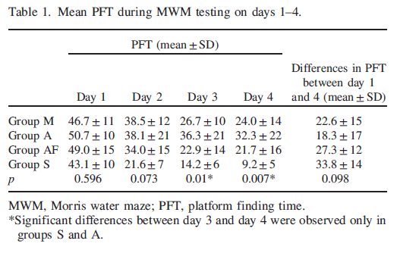

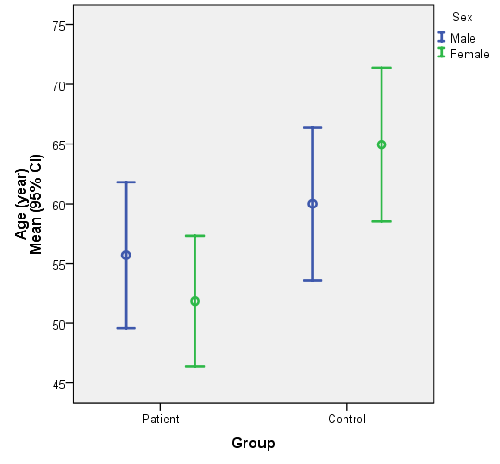
Figure 1. Age of patient and control groups

