IMPORTANT NOTICES

- Text should be prepared in accordance with the requirements of this template. Author names should not be included in this template, should be given in the Presentation page to editor and Cover page (Templates for these files can be downloaded from Instructions to Authors, located in journal webpage).
- Presentation page to editor, Cover page, body of the text in this template, copyright transfer forms, and shapes / images should be uploaded to the system as separate files.
- If you will use this template while writing your article (if you will write on the template), continue deleting this first page including notices.
- This template should be used for Original Article

TITLE IN ENGLISH

ABSTRACT
(Abstract has contain maximum 300 words for Original Article as Aim, Material and Methods, Results, Conclusion subtitles)
Aim:
Methods:
Results:
Conclusion:

Keywords: should consist of 2-6 words and be separated each other with semicolon (;). Only the first letter of first key word should be written in upper case, others in lower case (For example, Word 1; word 2; word 3 etc.). There should not be abbreviations in this section.

TÜRKÇE BAŞLIK

ÖZ
(Öz Orijinal Araştırma için en fazla 300 sözcük olmalıdır. Orijinal araştırma için Amaç, Gereç ve Yöntemler, Bulgular, Tartışma ve Sonuç şeklinde yapılandırılmış alt başlıklar olmalıdır)
Amaç:
Yöntemler:
Bulgular:
Sonuç:

Anahtar Sözcükler: 2-6 adet olmalı ve sözcükler birbirinden noktalı virgül (;) ile ayrılmalıdır. Anahtar sözcüklerden sadece birincisinin ilk harfi büyük harf olmalı, diğerleri küçük harfle yazılmalıdır (Örneğin, Sözcük 1; sözcük 2; sözcük 3 gibi). Bu kısımda kısaltma olmamalıdır.

INTRODUCTION

Manuscripts should be prepared as Microsoft Word ® documents, and written using "Times New Roman" font-type with 1.5 space, 12-point font size, justified. The margins should be 2.5 cm on all sides of page and page numbers should be placed at the right top corner of page.
If any table, figure or photograph to be used in this section, refer to the requirements in the Results section.
References should be cited by numbers in parentheses at the end of the relevant sentence, according to the order of appearance in the text.
For example; …… (1). or …… (1,2). or …… (3-5). etc.
The last paragraph of the Introduction section should include the aim of the study.

MATERIAL AND METHODS

If necessary, Subtitles related the method can use. Notations should be as Statistical analysis subtitle.
If any table, figure or photograph to be used in this section, refer to the requirements in the Results section.
If any statistical evaluations were done in the study, the last subtitle of the Material and Methods section should be written as below.
Statistical analyses
The statistical methods, packet program etc. information used to evaluate the data should be written.

RESULTS

Results of study should be given, method names should not be cited this section.
If any table, figure or photograph will use, it should not be placed in text, should be cited as (Table 1) or (Figure 1) at the end of the relevant sentence. For example; “Descriptive and clinical characteristics of groups were given as a table (Table 1).” or “There is a significant difference between groups in term of age (Figure 1).” etc.
Tables, should be added with headers as each of them in separate pages sequentially right after References. Table headers should be written as the first letter is in upper case (Table 1. Header text, for example; Table 1. Descriptive and clinical characteristics of groups) at the top of the table. If any abbreviation and/or symbol to be used in table, it should be explained as a footnote with 8-point font size below the table.
Figure or photograph should not added the text, should be uploaded to the system (as image quality to be 300 dpi, and in .jpeg, .bmp, .tif etc. format) as a separate file. Legends of figure or photograph, should be written as the first letter is in upper case (Figure 1. Legend text, for example; Figure 1. Age of patient and control groups) sequentially in a separate page, right after the page included the last table. If any abbreviation and/or symbol to be used in figure, it should be explained in parenthesis.

DISCUSSION and CONCLUSION

Discussion and conclusion texts should be written.
References should be cited by numbers in parentheses at the end of the relevant sentence, according to the order of appearance in the text.
For example; …… (1). or …… (1,2). or …… (3-5). etc.

The following information should be written after the references.

Acknowledgement
If any, thanks to related institution or individuals should be written in this section.

Funding Source
This research did not receive any funding.

Conflict of Interest
The authors declare no competing interest.

REFERENCES
Vancouver style is accepted for References. Samples are shown below
- For Original Articles
Abaraogu UO, Tabansi-Ochuogu CS. As Acupressure Decreases Pain, Acupuncture May Improve Some Aspects of Quality of Life for Women with Primary Dysmenorrhea: A Systematic Review with Meta-Analysis. J Acupunct Meridian Stud. 2015;8(5):220

- For Books
Murray, PR, Rosenthal KS, Kobayashi GS, Pfaller MA. (2002), Medical microbiology. 4th ed. St. Louis: Mosby.

SAMPLE TABLE and FIGURE FORMATS

Table 1. Descriptive and clinical characteristics of groups
 | Patient (n:54) | Control (n:40) | p
Age | 53.78±14.61 | 62.48±13.77 | 0.004
Female | 8 (14.8) | 9 (22.5) | 0.338
Male | 46 (85.2) | 31 (77.5)
DM | 25 (46.3) | 20 (50.0) | 0.722
HT | 26 (48.1) | 23 (57.5) | 0.370
* DM: Diabetes mellitus, HT: Hypertension

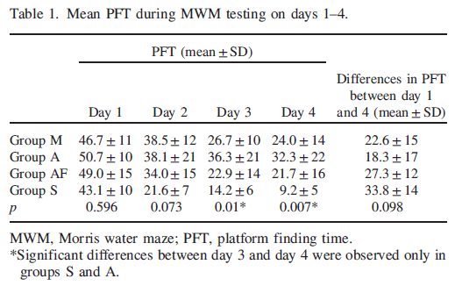

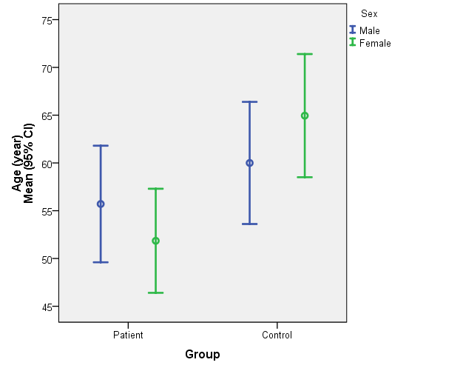
Figure 1. Age of patient and control groups

