RESEARCH ARTICLE
Title Page and Extensive English Abstract Page for All Articles in JSTER Journal
* First Author, ¹ Second B. Author, and ² Third B. Author
*University Jster, Faculty of Engineering, Electrical Engineering Department, City, Country
email.abcd@xxxx.com orcid.0000-xxx-xxxx-xxxx
¹Northern Canada University, Toronto, Canada
xxxxx.abcd@xxxx.com orcid.0000-xxx-xxxx-xxxx
²University Abcd, Faculty Engineering, Machine Engineering Department, Ankara, Turkey
email.abcd@xxxx.com orcid.0000-xxx-xxxx-xxxx

HIGHLIGHTS |  | GRAPHICAL ABSTRACT
- Effect and important of this article in literature  - Exchange between sources in related subjects of this article  - Contribution and strongest impact on the related sobject of this article  - Examined study and obtained results why is important |  | This section should state the purpose of the research. Times New Roman fonts 10 pts and italic style. The extended abstract is a mandatory to capture the attention of a wide readership. It contains different titles such as graphical/tabular abstract, purpose of your manuscript, theory and methods, etc. It should not exceed one page. The graphical/tabular abstract summarizes the contents of the article in a concise. Results and findings should be clear and concise. Authors must provide images and data that clearly represent the work described in the article. The image should be readable at a size of 6 × 14 cm (h x w) using a regular screen resolution of 96 dpi. The table should be editable. Use the Times New Roman fonts 10 pts in your graphical/tabular abstract.  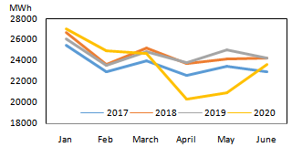  Figure A. or Table A The name figure or table about given info and result
Keywords:
- Keywords 1
- Keywords 2
- Keywords 3
- Keywords 4
- Keywords 5

Article Info:
Received : 01 January 2023 Accepted : 15 March 2023  DOI:  10.53525/jster.9886xx  *Correspondence:  Author Name Surname author.email@email.edu.tr  Phone : +90 123 4567890 | Aim of Article : This section should state the purpose of the research. Times New Roman fonts 10 pts and italic style.  Theory and Methodology : The experimental method or theory of the study should be given briefly. References should be avoided, but if essential, then cite the author(s) and year(s). Use the Times New Roman fonts 10 pts and italic style.  Findings and Results: Results and findings should be clear and concise. The most attractive results of the research should be given in this section. Use the Times New Roman fonts 10 pts and italic style.  Conclusion : The main conclusions of the study must be presented in the Conclusions section. Use the Times New Roman fonts 10 pts and using italic form. a conclusion may review the main points of the paper, do not replicate the abstract as the conclusion. A conclusion might elaborate on the importance of the work or suggest applications and extensions.

RESEARCH ARTICLE

English Title of The Article and Template of Journal Science, Technology And Engineering Research
*First Author, ¹Second B. Author, and ²Third B. Author
*University Jster, Faculty of Engineering, Electrical Engineering Department, City, Country
email.abcd@xxxx.com, Orcid.0000-xxx-xxxx-xxxx
¹Northern Canada University, Toronto, Canada
xxxxx.abcd@xxxx.com, Orcid.0000-xxx-xxxx-xxxx
²University Abcd, Faculty Engineering, Machine Engineering Department, Ankara, Turkey
email.abcd@xxxx.com, Orcid.0000-xxx-xxxx-xxxx

Citation:
Author, A., Author, B. (2023). The Problems Encountered in the Process of Publishing Articles in the Journal and Investigation of the Solutions, Journal of Science Technology and Engineering Research, 4(1): 1-5. DOI: 10.53525/jster.9886xx
H I G H L I G H T S
- Effect and important of this article in literature
- Exchange between sources in related subjects of this article
- Contribution and strongest impact on the related sobject of this article
- Examined study and obtained results why is important

Article Info |  | ABSTRACT
Received : 01 January 2023  Accepted : 03 March 2023  DOI:  10.53525/jster.9886xx |  | for IEEE Transactions and Journals. Use this document as a template if you are using Microsoft Word 6.0 or later. Otherwise, use this document as an instruction set. The electronic file of your paper will be formatted further at IEEE. Paper titles should be written in uppercase and lowercase letters, not all uppercase. Avoid writing long formulas with subscripts in the title; short formulas that identify the elements are fine (e.g., "Nd–Fe–B"). Do not write “(Invited)” in the title. Full names of authors are preferred in the author field, but are not required. Put a space between authors’ initials. The abstract must be a concise yet comprehensive reflection of what is in your article. In particular, the abstract must be self-contained, without abbreviations, footnotes, or references. It should be a microcosm of the full article. The abstract must be between 150–300 words. Be sure that you adhere to these limits; otherwise, you will need to edit your abstract accordingly. The abstract must be written as one paragraph, and should not contain displayed mathematical equations or tabular material.  Keywords: Keyword 1, Keywords 2, Keywords 3, Keywords 4, Keywords 5
*Corresponding Author:
Name Surname author.email@email.edu.tr Phone: +90 123 4567890

INTRODUCTION
This document is a template for Microsoft Word versions 6.0 or later. If you are reading a paper or PDF version of this document, please download the electronic file, trans_jour.docx, from the IEEE Web site at www.ieee.org/authortools so you can use it to prepare your manuscript. If you would prefer to use LaTeX, download IEEE’s LaTeX style and sample files from the same Web page. If your paper is intended for a conference, please contact your conference editor concerning acceptable word processor formats for your particular conference.

MANUSCRIPT PREPARATION
When you open trans_jour.docx, select “Page Layout” from the “View” menu in the menu bar (View | Page Layout), (these instructions assume MS 6.0. Some versions may have alternate ways to access the same functionalities noted here). Then, type over sections of trans_jour.docx or cut and paste from another document and use markup styles. The pull-down style menu is at the left of the Formatting Toolbar at the top of your Word window (for example, the style at this point in the document is “Text”). Highlight a section that you want to designate with a certain style, and then select the appropriate name on the style menu. The style will adjust your fonts and line spacing. Do not change the font sizes or line spacing to squeeze more text into a limited number of pages.Use italics for emphasis; do not underline.

To insert images in Word, position the cursor at the insertion point and either use Insert | Picture | From File or copy the image to the Windows clipboard and then Edit | Paste Special | Picture (with “float over text” unchecked).

Kısaltmalar (Abbreviations and Acronyms)
Define abbreviations and acronyms the first time they are used in the text, even after they have already been defined in the abstract. Abbreviations such as IEEE, SI, ac, and dc do not have to be defined.

Other Recommendations
Use one space after periods and colons. Hyphenate complex modifiers: “zero-field-cooled magnetization.” Avoid dangling participles, such as, “Using (1), the potential was calculated.” [It is not clear who or what used (1).] Write instead, “The potential was calculated by using (1),” or “Using (1), we calculated the potential.”

A parenthetical statement at the end of a sentence is punctuated outside of the closing parenthesis (like this). (A parenthetical sentence is punctuated within the parentheses.) In American English, periods and commas are within quotation marks, like “this period.” Other punctuation is “outside”! Avoid contractions; for example, write “do not” instead of “don’t.” The serial comma is preferred: “A, B, and C” instead of “A, B and C.”

If you wish, you may write in the first person singular or plural and use the active voice (“I observed that ...” or “We observed that ...” instead of “It was observed that ...”). Remember to check spelling. If your native language is not English, please get a native English-speaking colleague to carefully proofread your paper.

METHOD

Denklemler (Equations)
Number equations consecutively with equation numbers in parentheses flush with the right margin, as in (1). First use the equation editor to create the equation. Then select the “Equation” markup style. Press the tab key and write the equation number in parentheses. To make your equations more compact, you may use the solidus ( / ), the exp function, or appropriate exponents. Use parentheses to avoid ambiguities in denominators. Punctuate equations when they are part of a sentence, as in eq.(1).

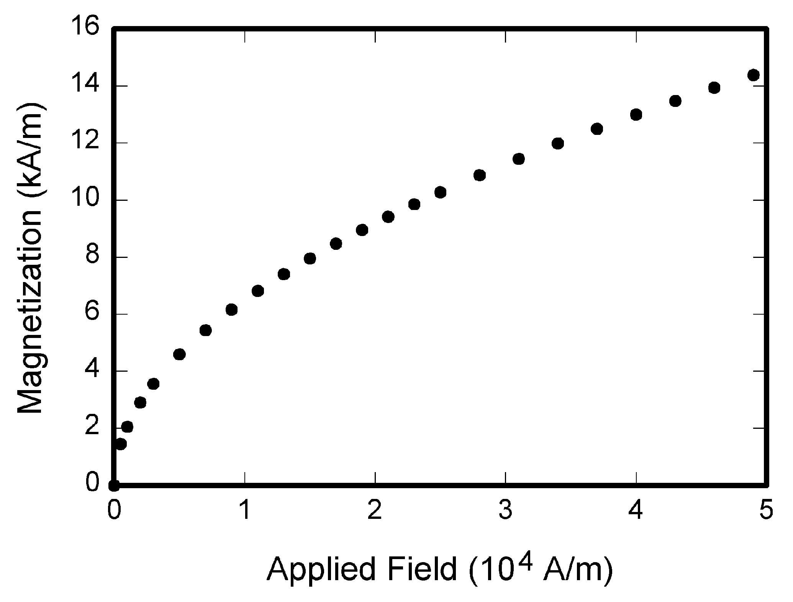
Figure. 1. Magnetization as a function of applied field. Note that “Fig.” is abbreviated. There is a period after the figure number, followed by two spaces. It is good practice to explain the significance of the figure in the caption.

Guidelines for Graphics Preparation
The following list outlines the different types of graphics published in IEEE journals. They are categorized based on their construction, and use of color / shades of gray:

Color/Grayscale figures

Figures that are meant to appear in color, or shades of black/gray. Such figures may include photographs,
illustrations, multicolor graphs, and flowcharts.

Line Art figures

Figures that are composed of only black lines and shapes. These figures should have no shades or half-tones of gray, only black and white.

Author photos

Head and shoulders shots of authors that appear at the end of our papers.

Tables
Data charts which are typically black and white, but sometimes include color.

Accepted Fonts Within Figures
When preparing your graphics IEEE suggests that you use of one of the following Open Type fonts: Times New Roman, Helvetica, Arial, Cambria, and Symbol. If you are supplying EPS, PS, or PDF files all fonts must be embedded. Some fonts may only be native to your operating system; without the fonts embedded, parts of the graphic may be distorted or missing.

Table I.
Units for Magnetic Properties
Symbol | Quantity | Conversion from Gaussian and  CGS EMU to SI ª
Φ | magnetic flux | 1 Mx → 10⁻⁸ Wb = 10⁻⁸ V·s
B | magnetic flux density,  magnetic induction | 1 G → 10⁻⁴ T = 10⁻⁴ Wb/m²
H | magnetic field strength | 1 Oe → 10³/(4π) A/m
m | magnetic moment | 1 erg/G = 1 emu  → 10⁻³ A·m² = 10⁻³ J/T
M | magnetization | 1 erg/(G·cm³) = 1 emu/cm³  → 10³ A/m
4πM | magnetization | 1 G → 10³/(4π) A/m
σ | specific magnetization | 1 erg/(G·g) = 1 emu/g → 1 A·m²/kg
j | magnetic dipole  moment | 1 erg/G = 1 emu  → 4π× 10⁻¹⁰ Wb·m
J | magnetic polarization | 1 erg/(G·cm³) = 1 emu/cm³  → 4π× 10⁻⁴ T
χ,κ | susceptibility | 1 → 4π
χ_{ρ} | mass susceptibility | 1 cm³/g → 4π× 10⁻³ m³/kg
μ | permeability | 1 → 4π× 10⁻⁷ H/m  = 4π× 10⁻⁷ Wb/(A·m)
μ_{r} | relative permeability | μ→μ_{r}
w, W | energy density | 1 erg/cm³→ 10⁻¹ J/m³
N, D | demagnetizing factor | 1 → 1/(4π)

Using Labels Within Figures
Figure axis labels are often a source of confusion. Use words rather than symbols. As an example, write the quantity “Magnetization,” or “Magnetization M,” not just “M.” Put units in parentheses.

Subfigure Labels in Multipart Figures and Tables
Multipart figures should be combined and labeled before final submission. Labels should appear centered below each subfigure in 8 point Times New Roman font in the format of (a) (b) (c).

Checking Your Figures: The IEEE Graphics Analyzer
The IEEE Graphics Analyzer enables authors to pre-screen their graphics for compliance with IEEE Transactions and Journals standards before submission. The online tool, located at http://graphicsqc.ieee.org/, allows authors to upload their graphics in order to check that each file is the correct file format, resolution, size and colorspace; that no fonts are missing or corrupt; that figures are not compiled in layers or have transparency, and that they are named according to the IEEE Transactions and Journals naming convention. At the end of this automated process, authors are provided with a detailed report on each graphic within the web applet, as well as by email..

CONCLUSION

A conclusion section is not required. Although a conclusion may review the main points of the paper, do not replicate the abstract as the conclusion. A conclusion might elaborate on the importance of the work or suggest applications and extensions.

In a conclusion paragraph, you summarize what you’ve written about in your paper. When you’re writing a good conclusion paragraph, you need to think about the main point that you want to get across and be sure it’s included. If you’ve already written a fabulous introductory paragraph, you can write something similar with different wording.

Remember that it’s important to wrap up your writing by summarizing the main idea for your readers. This brings your writing to a smooth close and creates a well-written piece of work.

CONFLICTS OF INTEREST
They reported that there was no conflict of interest between the authors and their respective institutions.

RESEARCH AND PUBLICATION ETHICS
In the studies carried out within the scope of this article, the rules of research and publication ethics were followed.

Acknowledgment
Use the singular heading even if you have many acknowledgments.” In most cases, sponsor and financial support acknowledgments are placed in the unnumbered footnote on the first page, not here.

References
- G.O.Young,“Synthetic structure of industrial plastics,”in Plastics, 2nd ed., vol. 3, J. Peters, Ed. New York, NY, USA: McGraw-Hill,1964,pp.15–64.
- W.-K.Chen, Linear Networks and Systems.Belmont, CA, USA:Wadsworth, 1993, pp. 123–135.
- J. U. Duncombe, “Infrared navigation—Part I: An assessment of feasibility,” IEEE Trans. Electron Devices, vol. ED-11, no. 1, pp. 34–39, Jan. 1959,10.1109 /TED.2016.2628402.
- E. E. Reber, R. L. Michell, and C. J. Carter, “Oxygen absorption in the earth’s atmosphere,” Aerospace Corp., LosAngeles, CA, USA, Tech. Rep. TR-0200 (4230-46)-3, Nov. 1988.
- G. O. Young, “Synthetic structure of industrial plastics,” in Plastics, vol. 3, Polymers of Hexadromicon, J. Peters, Ed., 2nd ed. New York, NY, USA: McGraw-Hill, 1964, pp. 15-64. [Online]. Available: http://www.bookref.com.
- J. S. Turner, “New directions in communications,” IEEE J. Sel. Areas Commun., vol. 13, no. 1, pp. 11-23, Jan. 1995.
- W. P. Risk, G. S. Kino, and H. J. Shaw, “Fiber-optic frequency shifter using a surface acoustic wave incident at an oblique angle,” Opt. Lett., vol. 11, no. 2, pp. 115–117, Feb. 1986.
- P. Kopyt et al., “Electric properties of graphene-based conductive layers from DC up to terahertz range,” IEEE THz Sci. Technol., to be published. DOI: 10.1109/TTHZ.2016.2544142.
- PROCESS Corporation, Boston, MA, USA. Intranets: Internet technologies deployed behind the firewall for corporate productivity. Presented at INET96 Annual Meeting. 2016. http://home.process.com/Intranets/wp2.htp
- D. B. Payne and J. R. Stern, “Wavelength-switched pas- sively coupled single-mode optical network,” n Proc. IOOC-ECOC, Boston, MA, USA, 1985, pp. 585–590.
- D.EbehardandE.Voges,“Digital single side band detection for interferometric sensors,”presented at the 2nd Int. Conf. Optical Fiber Sensors, Stuttgart,Germany,Jan.2-5, 1984.
- R. Fardel, M. Nagel, F. Nuesch, T. Lippert, and A. Wokaun, “Fabrication of organic light emitting diode pixels by laser-assisted forward transfer,” Appl. Phys. Lett., vol. 91, no. 6, Aug. 2007, Art. no. 061103.
- J. Zhang and N. Tansu, “Optical gain and laser characteristics of InGaN quantum wells on ternary InGaN substrates,” IEEE Photon. J., vol. 5, no. 2, Apr. 2013, Art. no. 2600111

OPTIONAL (This part is not mandatory)

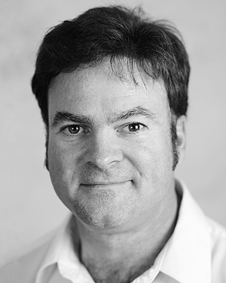
Second B. Authorwas born in Greenwich Village, New York, USA in 1977. He received the B.S. and M.S. degrees in aerospace engineering from the VirginiaUniversity, Charlottesville, in 2001, the Ph.D. degree in mechanical engineering from Drexel University, Philadelphia, in 2008.
From 2001 to 2004, he was a Research Assistant with the Princeton Plasma Physics Laboratory. Since 2009, he has been an Assistant Professor with the Mechanical Engineering Department, Texas A&M University. His research interests include high-pressure and high-density nonthermal plasma discharge processes and applications, microscale plasma discharges and innovation plasma applications
Dr. Author was a recipient of the International Association of Geomagnetism and Aeronomy Young Scientist Award for Excellence in 2008, and the IEEE Electromagnetic Compatibility Society Best Symposium Paper Award in 2011.

