TITLE (Times New Roman[TNR] 14 punto, before 0nk, after 12nk space, capital letters, bold, kalın, centered)
AUTHOR INFO. FIELD

ÖZ (TNR 11 punto, before 0nk, after 6nk space, left-aligned, bold, capital latters)
Turkish Abstract: before 0nk, after 6nk space, TNR 9 punto, justified, italic
Turkish Keywords: TNR 8 punto, italic,left-aligned, min. 3, max. 5 keywords
TURKISH TITLE(TNR 13 punto, before 0nk, after 6nk space, capital letters, italic, centered)
ABSTRACT (TNR 11 punto, before 0nk, after 6nk space, left-aligned, bold, capital letters)
Abstract: before 0nk, after 6nk space, TNR 9 punto, justified, italic
Keywords: TNR 8 punto, italic, left-aligned, min.3, max. 5 keywords

INTRODUCTION (TNR 12 punto, left-aligned, bold, capital letters, before 0nk, after 12nk space)
Text: TNR 11 punto, justified, before 6nk, after 6nk before the paragraphs, after the last paragraph, 18nk space)
TITLE1 (TNR 12 punto, left-aligned, bold, capital letters, before 0nk, after 12nk space)
TNR 11 punto, justified, before 6nk, after 6nk before the paragraphs, after the last paragraph, 18nk space)
Sub-Title (1 TAB Space, TNR 11 punto, left-aligned, bold, first letter capital, before 0nk, after 12nk space)
Text: TNR 11 punto, justified, before 6nk, after 6nk before the paragraphs, after the last paragraph, 18nk space)
Table 1. Characteristic Features (TNR 10 punto, first letter capital, centered)
Source: (Ribble, 2010, p. 653) (Left side of the table, TNR 9 punto, left-aligned)

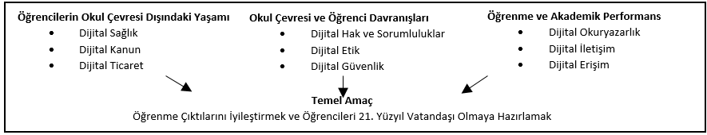
Figure 1. Digital Citizenship Relations (Left side of the table, centered, TNR, 10 punto, firs letter capital)
Source: (Ribble, 2011, p. 44) (Left side of the table, left-aligned, TNR 9 punto)

CONCLUSION(TNR 12 punto, left-aligned, bold, capital letters, before 0nk, after 12nk space)
Text: TNR 11 punto, justified, before 6nk, after 6nk before the paragraphs, after the last paragraph, 18nk space)
REFERENCES (TNR 12 punto, eft-aligned, bold, capital letters, before 0nk, after 12nk space; references hanged 0,6 cm of right side, 1 row spacing, before 6nk, after 6nk space, justified)
Green, A. (2018). Trustworthy technology: the future of digital archives. The National Archives, 29 Haziran 2020 tarihinde https://blog.nationalarchives.gov.uk/blog/trustworthy-technology-future-digitalarchives/ adresinden erişildi.
Harvey, R. ve Weatherburn, J. (2018). Preserving Digital Materials, 3rd ed., MD: Rowman & Littlefield. xxv, 249 pp.
Kandur, H. (2016). The role of institutional competencies for the long term preservation of electronic records: The Experience of the Turkish Public Sector. Qualitative and Quantitative Methods in Libraries (QQML). 5: 527-533.
Ohler, J. (2010). Digital Community, Digital Citizen. Corwin Press: Thousand Oaks.
Onan, K., Sennaroğlu, B. (2009). Comparative Study of Production Control Systems Through Simulation. N. Mastorakis, J. Sakellaris (Ed.), Advances in Numerical Methods içinde, (67-78). New York: London: Springer.

