Paper Title, Times New Roman 11PT Bold, Each Word Starting with Capital Letter Except Conjunctions

Name SURNAME^{*1}, Name SURNAME ¹, Name SURNAME ²

¹ Affiliation, Affiliation Department/Faculty/School/Section, City, Country
² Affiliation, Affiliation Department/Faculty/School/Section, City, Country

*email@email.com

(Alınış/Received: **.**.202*, Kabul/Accepted: **.**.202*, Yayımlama/Published: **.**.202*)

Abstract: It is mandatory to submit your article by editing it on this template. Please do not edit formal properties of this template such as page margins, line/section spacing, font style/size etc. The abstract should be between 100-250 words. Author names start with capital letter and surnames/family names are written in capital. An indicating number is written as a superscript after the surnames in order to address the affiliations of the authors (See the example given above). Common affiliations of the authors are remarked under the same affiliation number. Additionally, a token, " * ", is placed before the affiliation indicator for the corresponding author. In the affiliation section, complete information is provided such as institution/city/country. An ORCID () must be hyperlinked for each author. Please note that failure to comply with the rules mentioned above may result in rejection of the manuscript.

Keywords: Minimum 3, maximum 6 keywords with first letters capitalised here and separated with comma in Times New Roman 10PT.

Makalenin Türkçe Başlığı Bağlaçlar Hariç Her Kelimenin İlk Harfi Büyük
“Times New Roman” Fontunda 10 Punto Olacak Şekilde Buraya Eklenmelidir

Öz: Makalenin şu anda üzerinde çalıştığınız şablon üzerinden hazırlanarak dergimize sunulması zorunludur. Şablon üzerinde biçimsel (kenar boşlukları (3 cm), satır ve paragraf aralıkları, font, punto vb) değişiklik yapmayınız. Çalışmanız hakkında özet bilgiyi bu bölüme Times New Roman fontunda 10 punto, tek satır aralıklı ve yaklaşık 100-250 kelime olacak şekilde ekleyiniz. Yazar adlarının ilk harfi ve soyadlarının tümü büyük harf olacak şekilde yazılmalıdır. Yazarı ve çalışmanın yürütüldüğü yeri ilişkilendirebilmek amacıyla yazarın soyadından sonra ve çalışmanın yürütülmüş olduğu yerden önce üstsimge ile numaralandırılmalıdır (¹, ², ³ vb.). Sorumlu/Yazışılan yazar; soyadından sonra " * " simgesi ile belirtilmelidir. Adres bilgileri içerisinde çalışmanın yürütüldüğü yer, şehir ve ülke adı yer almalıdır. “ ” işaretine Ekle/Köprü üzerinden ORCID bağlantınızı yapınız. Bu şablon üzerinde hazırlanmayan ve bu şablonda belirtilen yazım kurallarına uygun olmayan makaleler reddedilir.

Anahtar kelimeler: En az 3, en fazla 6 anahtar kelime virgül ile ayrılarak her anahtar kelimenin ilk harfi büyük olacak şekilde bu bölüme Times New Roman fontunda 10 punto olarak eklenmelidir.

1. Introduction

This section should contain the purpose of the study and proper literature survey concerning the topic.

Please note that your manuscript should not exceed 12 pages including abstract, bibliography and, resume section. The manuscript should be prepared in Microsoft® Office Word 2010 or higher. Line spacing should be “Single” for text and tables. Auto spacing between paragraphs should be disabled and a single line should be placed between paragraphs. The main text of the manuscript should be justified and written in Times New Roman with 11PT. Headings should be followed by one-line space and auto spacing should be disabled. Details about headings are given in Section 2.1.

IEEE format is accepted for referencing in the manuscript and reference section. Details of the referencing are given in following. References should be placed with a numerical order in manuscript and formatted as squared brackets (Eg. [1], [2]) Referencing with and without author name should be as “Brown et al [3]” and “obtained from [3]”, respectively. It is advised that at least 20% of the resources cited from contemporary publications (Last 20 years). Also, it is considered appropriate to clearly state the contributions of the cited documents to the study. If a citation tool has been used for referencing such as Mendeley, Zotero all auto-field links must be disabled before submitting.

According to journal policy, the primary goal is to publish research articles. If you are interested in publishing a review article, please contact the editorial board. Your request will be considered by the board of members.

2. Method

If your study contains an experimental work, the experimental procedure/method should be explained clearly. In theoretical studies, the theoretical method should be explicitly given. Please bear in mind, if your manuscript does not contain any experiment, method, material or a theoretical approach it is not be classified as a research article.

Equations should be placed in a hidden table with two columns. The equation should be aligned centrally in the left (main) cell and a reference number in parentheses must be written in the cell placed on the right side. Also, they should be preceded and followed by a one-line space. An example is given in the following.

$$A=πr^{2}$$ | (1)

Equations should be mentioned as “Equation 1” without abbreviation. As another example is given in Equation 2.

$$iℏ\frac{∂ψ}{∂t}=Ηψ$$ | (2)

2.1. Heading 2 example

As a general approach, the article should be structured as Introduction, Method, Results and Discussion, and Conclusion. All headings regarding the main manuscript should be numbered and written in Times New Roman, 10PT and bold. Abstract, acknowledgement and reference sections are excluded from heading numbers. Subheadings should be numbered under main heading class (Eg. 2.1., 2.2.). In subheadings, only the first letter should be capital and the writing style should be italic and bold. Except for headings, it is not allowed to use bold in the manuscript.

3. Results and Discussion

SI unit system should be used in the manuscript. Using figures and tables is a very effective way of presenting the results or achievements. Please be aware, with a good design of them, they can represent more information than a plain text. Thus, in this section, it is advised to the authors the results of the study should be summarised in a proper way in this section. This will not only make the readers easily understand your work, but it will also make reviewers work easier during the review process. As a general opinion, tables and figures are the most second popular sections after abstract for general assessment. Also, they help to reduce the number of words in a manuscript.

All type of visual objects (Eg. Photo, illustration, graph, map) except tables should be titled as a figure with a numerical order. These visual objects must have a minimum resolution of 300 dpi and must not exceed 1 MB.

Visual objects should be aligned to the middle. Title of the visual object must be placed under the object in Times New Roman 10 PT with the only first letter capitalised, numbered and without line spacing. A period should not be used at the end of the title. The prefix of the title and number must be written in bold (see the example below). Do not use an abbreviation to refer a figure in the manuscript. An example of referring in the manuscript is given in the next sentence. Please refer to the example in Figure 1.

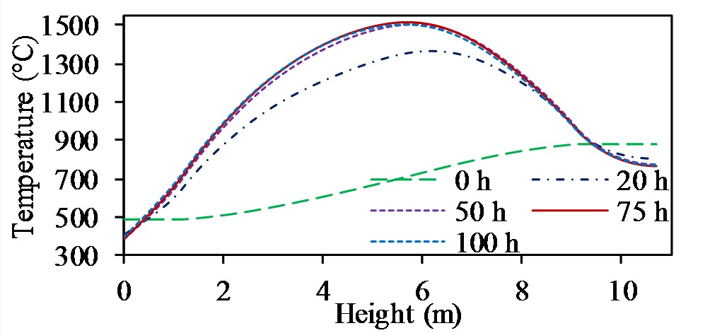
Figure 1. An example of a figure [1]

It is advised to use Times New Roman 10 PT in-figure texts in order to comply with visual conformity. Small pictures may be grouped if they are related. You can find an example in Figure 2.

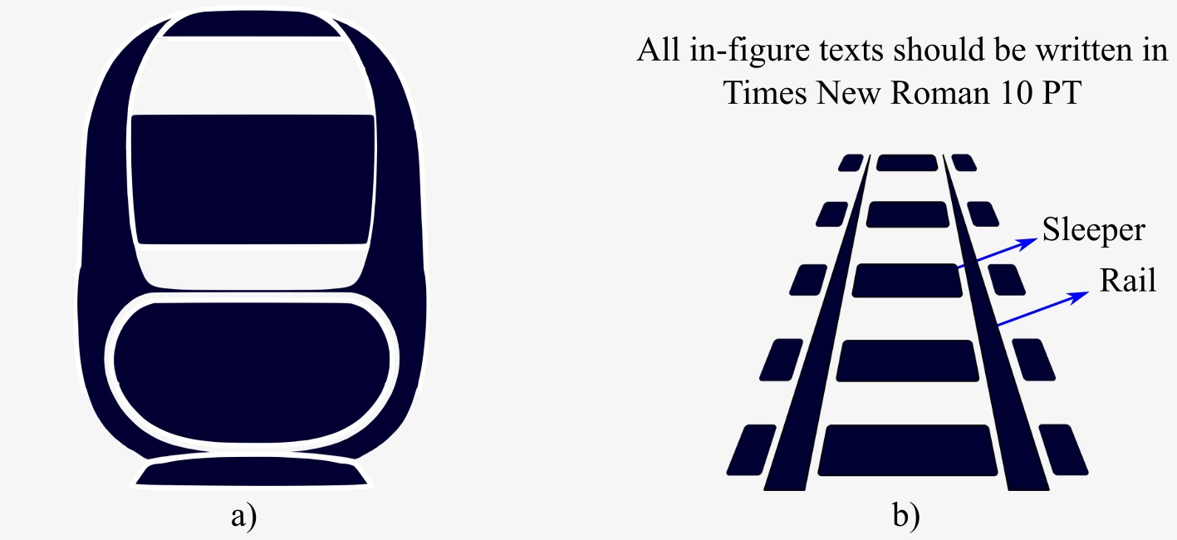
Figure 2. An example of grouping two visual objects under a single figure title. a) Train b) Track

Handwriting is not allowed. Also please avoid using additional text boxes in the word processor. This may cause an imbalance between the manuscript’s text and textbox’s text. If you have to use a textbox, do not modify the template, create your object in another session of a word processor and transfer it after all processing is done.

All figures should be mentioned in the manuscript. Please note that, if the manuscript is created via cross-reference, all auto-field links should be disabled.

All figures preceded and followed by a one-line space also figure titles should be placed under the figure without spacing.

Tables should be aligned to the middle. The title of a table must be placed above in Times New Roman 10 PT, only with the first letter capitalised, numbered and without line spacing. A period should not be used at the end of the title. The prefix of the title and number must be written in bold (see the example below). Do not use an abbreviation to refer a table in the manuscript. An example of referring a table in the manuscript is given in the next sentence. Please refer to the example in Table 1.

Table 1. Example for table
Column Header | Column Header | Column Header
5.25 | Cell Entry | Cell Entry
0.9 | Cell Entry | Cell Entry
100.5 | Cell Entry | Cell Entry
Cell Entry | Cell Entry | Cell Entry
Cell Entry | Cell Entry | Cell Entry
Cell Entry | Cell Entry | Cell Entry
Cell Entry | Cell Entry | Cell Entry
Cell Entry | Cell Entry | Cell Entry
Cell Entry | Cell Entry | Cell Entry

All cell entries should be Times New Roman 10 PT and column headers should not be bold. Please note that tables created as visual objects (Eg. Jpeg, Png) may cause editorial issues. Thus, these object types won’t be accepted.

All tables should be mentioned in the manuscript. Please note that, if the manuscript is created via cross-reference, all auto-field links should be disabled.

A line spacing should be left between the table and the following paragraph.

Be advised, it is unnecessary to optimise the manuscript in order to improve the visual concept. A typesetting editor will modify your manuscript according to the editorial needs after reviewing process. Please bear in mind, undesired manipulation of the template will increase the burden of the typesetting editors.

For multi-author articles, all authors must be registered on the DergiPark system (http://www.dergipark.org.tr). Also, please be sure that all authors are added to the article on the registration system before submitting.

Your manuscript with .docx file type should upload to system. Please do not upload the .pdf file type. All authors must sign “Copyright Transfer Form”, convert the .pdf file type and upload. Please add an explanation which describes the manuscript and its contribution at the Note to Editor.

Be advised, the manuscripts without complying the mentioned editorial rules is rejected before reviewing process.

All articles are checked in blind reviewing by minimum 2 reviewers (3-4 mostly). Please do not hesitate to suggest reviewers. It is expected that at least 2 reviewers are suggested by the corresponding author.

For the articles submitted in English, a proofreading & editing certificate showing that the manuscript has been checked in terms of grammar, spelling, punctuation and usage is mandatory.

4. Conclusion

The conclusion is placed in here with a small summary of the study. This section should be plain and consist of a concrete interpretation of the results or findings.

We would like to thank you for your contribution to railway-related studies.

Acknowledgement

Please write your supporting funds, project and personal acknowledgements in this section.

References

Please bear in mind, the reference section is essential for our journal due to indexing/abstracting. So, the manuscripts which do not comply with the following referencing rules will be definitely rejected in the editorial pre-processing stage.

References should be written in Times New Roman 10 PT and justified alignment. Our journal interiorizes the IEEE reference system. Most significant types of examples are given in the following. Be advised, if you are using a citation tool (Eg. Mendeley, Zotero) disable all autofill links. A formulation of referencing is given under each group as the first reference.

A recent notification has been made to our journal regarding issues about the name and surname writing. In order to avoid false applications, an example with correct and incorrect use is given in following for the name of “Emmett Brown”.

Correct: E. Brown
Incorrect: Brown E., E. BROWN, Brown Emmett, B. Emmett, Emmett Brown, Emmett BROWN

Articles:
- N. Surname, “Title of the paper,” Abbrev. Title of the Journal, vol. x, no. x, pp. xxx–xxx, Abbrev. Month, year, doi: xxx
- R. Li, C. Zheng, H. Wang, D. Zhao, B. Ran, and X. Xue, “Intersection traffic signal optimisation considering the impact of upstream curbside bus stops,” IET Intelligent Transport Systems, vol. 14, no. 8, pp. 880–888, 2020, doi: 10.1049/iet-its.2019.0660
- J. U. Duncombe, "Infrared navigation - Part I: An assessment of feasability," IEEE Trans. Electron. Devices, vol. ED-11, pp. 34-39, Jan. 1959. doi: xxxxxx/xxxx.xxx
- B. Ghadimi, F. Kowsary, and M. Khorami, “Thermal analysis of locomotive wheel-mounted brake disc,” Appl. Therm. Eng., vol. 51, no. 1–2, pp. 948–952, Mar. 2013
- U. Friesen et al., “Bogie-monitoring technology: Extending the detection of derailments to cover applications with slab tracks,” Proc. Inst. Mech. Eng. Part F J. Rail Rapid Transit, vol. 232, no. 10, pp. 2385–2391, Nov. 2018. doi: xxxxxx/xxxx.xxx
- A. Radosavljevic, “Measurement of train traction characteristics,” Proc. Inst. Mech. Eng. Part F J. Rail Rapid Transit, vol. 220, no. 3, pp. 283–291, May 2006.

Conference Paper:
- N. Surname, “Title of the paper,” in Abbrev. Title of the Conference, Location, Year, pp. xxx–xxx (If applicable)
- P. Voltr, “Simulation of wheel rail contact conditions on experimental equipment,” in 22nd International Conference: Current Problems in Rail Vehicles Vol II, Zilina, Slovakia, 2015, pp. 299–306

Book:
- N. Surname, “Title of the book,” City of Publisher, State (If applicable), Country: Abbrev. of Publisher, year
- S. Iwnicki, Handbook of railway vehicle dynamics. Boca Raton: CRC/Taylor & Francis, 2006

Web Site/Document:
- N. Surname or Owner, “Page Title,” Year. [Online]. Available: web address [Accessed date accessed]
- Shift2Rail, "Astrail project overview," 2018. [Online]. Available: https://projects.shift2rail.org/s2r_ip2_n.aspx?p=S2R_ASTRAIL [Accessed August 12, 2019]
- C. Newman, “5AT Advanced Steam Locomotive Project Locomotive and Train Resistance,” 2010. [Online]. Available: http://5at.co.uk/index.php/definitions/terrms-and-definitions/resistance.html#Plots. [Accessed: 17-Sep-2020].

Thesis:
- N. Surname, “Title of thesis/dissertation,” Thesis type, Abbrev. Dept., Abbrev. Univ., City of Univ., Abbrev. State (If applicable), year
- J. O. Williams, “Narrow-band analyzer,” Ph.D. dissertation, Dept. Elect. Eng., Harvard Univ., Cambridge, MA, 1993

Standards:
- Title of standard, Standard number, Corporate author (If applicable), location (If applicable), date
- IEEE Criteria for Class IE Electric Systems, IEEE Standard 308, 1969

Manuals/Software Info
- N. Surname (or Abrrev. Name of Co., City of Co., Abbrev. State, Country), Name of Manual/Handbook/Software, x ed. (year). Accessed: Date. [Online]. Available: http://www.url.com
- Mathworks, MA, USA. MATLAB documentation. Accessed: Aug. 13, 2020. [Online]. Available: https://www.mathworks.com/help/pdf_doc/matlab/index.html

Resume
Name SURNAME
The word quantity in this section should not exceed 70 words. No titles should be used with name-surname. Titles can be mentioned in the text with affiliation or career information. Photo width must be 3.5 cm with a minimum resolution of 300 dpi. The resume may contain; born date, education details starting from bachelor degree, current employment information, research interests.
E-mail: name@surname.com
Name SURNAME
The word quantity in this section should not exceed 70 words. No titles should be used with name-surname. Titles can be mentioned in the text with affiliation or career information. Photo width must be 3.5 cm with a minimum resolution of 300 dpi. The resume may contain; born date, education details starting from bachelor degree, current employment information, research interests.
E-mail: name@surname.com
Ethics Statement:
Authors confirm that the article is original, there is no plagiarism issue.
Contribution of authors: Name SURNAME: Conceptualization, Methodology, Software. Name SURNAME: Resources, Validation, Writing-Original draft preparation. Name SURNAME: Visualization, Investigation. Name SURNAME: Supervision. Name SURNAME: Writing- Reviewing and Editing.
Updated: 28.01.2024

